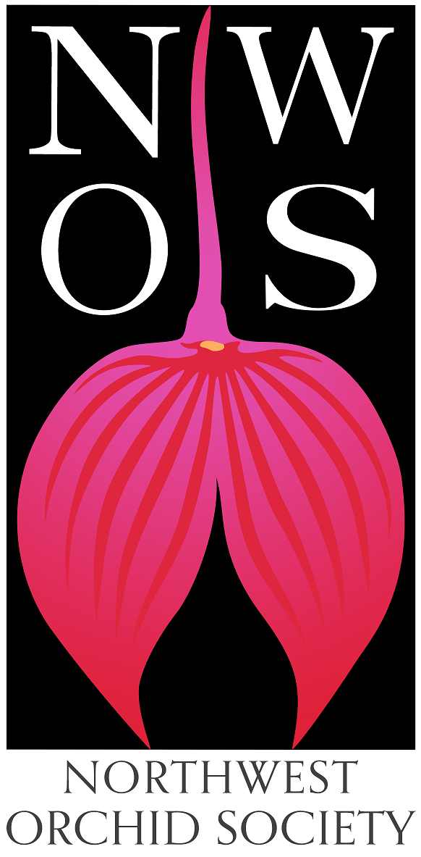
Northwest
Orchid News
October 2022
Volume 75, Issue 9

- About the October Meeting
- Speaker: Tyler Albrecht, “Parvisepalum Paphiopedilum”
- Plant Table
- Sales Table
- Raffle Table
- NWOS Library
- Report from the Nominating Committee
- Holiday Plants
- Volunteer Positions
- 2023 NW Flower & Garden Festival
- Oregon Orchid Society Show
- NWOS Fall Show and Sale
- Report From The September Meeting
- Schedule of Upcoming Events
- Reminder for Officers & Board Members
- NWOS/Amazon Shopping Link
- NWOS Website Links

About the October Meeting
October 10, 2022 7 PM
University of Washington Center for Urban Horticulture
3501 NE 41st Street, Seattle, WA 98105
Hybrid Meeting, In person and via Zoom Zoom Registration

Speaker: Tyler Albrecht, “Parvisepalum Paphiopedilum”.

Tyler spoke to us about Dendrobium kingianum and its hybrids last year. This year he is back to talk to us about the wonderful parvisepalum subgenus of Paphiopedilum.
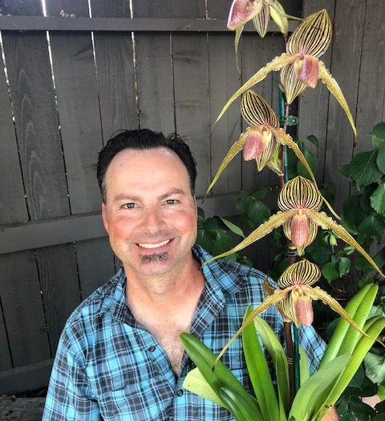
Tyler Albrecht was born and raised in Silicon Valley but currently resides in the foothills of the Sierra Nevada Mountains with his wife Dana and two children Reece and Reagan. Between running Reagan to her horse riding lessons 5 days a week and taking Reece to the Taekwondo studio three days a week. Not forgetting the multiple day competitions for both, Tyler is able to mix in dates with Dana and repotting orchids.

Having always expressed an interest in plants, just like his father, the two of them would often go to the local nurseries every weekend and find something new and exciting to bring home. Tyler’s father is initially responsible for introducing him to orchids with his small collection of Cymbidiums that grew so well outside all year at their Campbell CA home. Soon the small collection they both tended to had grown to several dozen and then a private collection was purchased from an estate that increased the plant count to a couple hundred plants. At this point Tyler had also begun to branch out into other genera and dove headfirst into Paphs and Phrags. It was at this time that regular visits to see Lillian Severin, Dennis Olivas, Gerardus Staal and The Rod McCellan Co in San Francisco. Ever eager to learn more, Orchid Clubs were introduced and as a Junior in High School, Tyler was elected Vice President of The Malini Orchid Society.

After graduating High School, Tyler attended Foothill Junior College to complete his lower requirements for a transfer to a Cal State School, at the same time earning a Certificate in Nursery Management from the Foothill Ornamental Horticulture Department. Completing a degree in Enology and Viticulture from Fresno State University, Tyler began working in that field as a vineyard manager and enologist for small private vineyards in the Santa Cruz Mountain AVA. After a couple years, a call came to help out at the family business and to this day Tyler still is working as an owner of a high end aquarium and pond service and installation company.

Having grown orchids for nearly all his life, with a short break after college, Tyler has been growing for over 30 years and just this year and has started training as a student judge with the AOS.

Plant Table

We will be having an in person plant table this month. For your convenience, you can print out a Plant Table Information Form ahead of time. Click for your version of choice: PDF WORD

For those who aren’t able to attend, please do keep sending your pictures, we will be including them in our online gallery and in next month’s newsletter. Please send them to photos@nwos.org.

Sales Table

Members may bring up to 10 plants to sell. Include an extra tag with your name and the price in the plant.

Raffle Table

The raffle will be held as usual. Win a new orchid for your collection while supporting the Scholarship Fund. If you have any extra Orchids, please consider donating them to the raffle.

NWOS Library

If you'd like to check out a book or tape from our Library, please contact our Librarian Joe Grienauer a minimum of 2 weeks before the next meeting. Besides email, you can give Joe your request at any meeting. For a list of library items please click here NWOS Library.

Report from the Nominating Committee
The Nominating Committee is currently composed of Joe Grienauer.
Here is the currently proposed Slate of NWOS Officers:
Officers, one-year term expiring Dec. 31 2023:
President - OPEN
1st VP - Robert Culver
2nd VP - Ben Johnson
Treasurer - Bill Leicht
Secretary - Sean Hoyt
Director positions, two-year term expiring Dec. 31, 2024:
- Diane Drisch
- OPEN
- OPEN
- OPEN
The above slate of Officers and Directors will be voted on by the membership at the November 14th meeting. In addition to the above slate, the following Directors will continue to serve the remainder of their two-year term expiring Dec. 31, 2023:

Director positions, two-year term expiring Dec. 31, 2023:
- Brad Collins
- Pat Gossler
- Peter Maunsell
- Lori Lederman
- Andy Wright
Past President - Steve Dorsey

We are still searching for members to step forward and fill the following open positions:

President - this person will preside at the meetings of the Society and the Directors. They will have general supervision over the affairs of the Society. They will also make a report at the Annual Meeting in December with the help of the other Officers and Committee Chairs. The President also signs written documents and contracts along with the Secretary..

Director - there are several open positions. No experience is necessary. But we really prefer people who will actively participate! This includes a willingness to freely express your opinion to various presented issues and proposals. This is a good position to learn the inner workings of the Society and help with its direction. There are 6 Board meetings each year and one of them is a potluck dinner. This is a two-year term expiring Dec. 31, 2024.

If you would like to be considered for one of these "open" positions or have questions, please contact any of the Nominating Committee members below. Or just send an email to nwos@nwos.org and it will be routed to the appropriate people.

Respectfully submitted, ~ Joe Grienauer, Joff Morgan and Robert Culver
NWOS Nomination Committee

Holiday Plants

This is a heads up to our members as to how we are executing the Holiday Plant Gift this season. Members of the NWOS who are paid in full as of midnight Nov. 14th and attend the December meeting will receive a free orchid as a way of saying thank you from the NWOS for being a loyal, supporting member.

PLEASE ensure you have paid your dues NO LATER THAN NOV. 14TH! Anyone paid later than that will sadly miss a plant.

Check with Mike Cory if you have questions about your membership status.
Volunteer Opportunities

There are lots of choices for participating and helping our society utilizing different skills, interests and available time.

Audit Committee - Lillian Otani and Joe Grienauer have volunteered to serve. We need one more person to join them so we can close the books for last year.

NW Flower & Garden Festival - Joe Grienauer will be needing volunteers to help with the design and planning of this coming year's garden. Please talk to Joe Grienauer if you are interested in helping.

2023 NW Flower & Garden Festival

Our next big event is the 2023 NW Flower & Garden Festival. The work begins now.

Oregon Orchid Society Show

The NWOS was invited down to Portland to participate in the 2022 Fall OOS Show. Ben Johnson and the Grantham’s took down members’ plants and set up the show. Here are some images from the society display as well as highlights from the show. It was very nice to participate after being away for a few years. Many thanks to all of our members who generously shared their blooming plants to help make our display a success. For more photos NWOS Show Photo Gallery

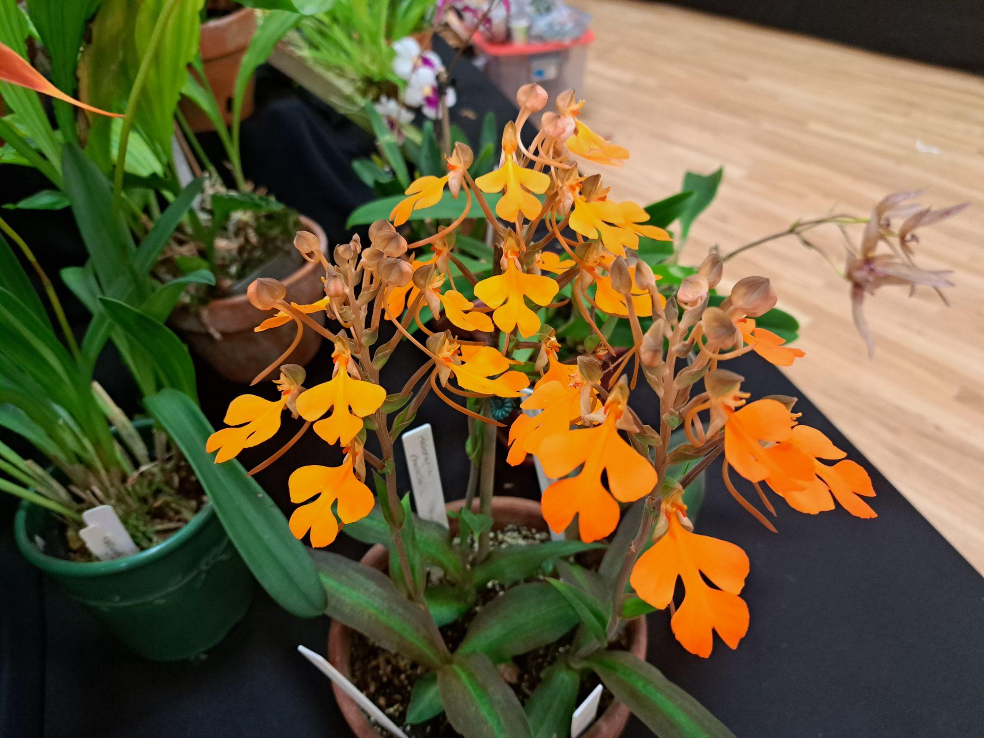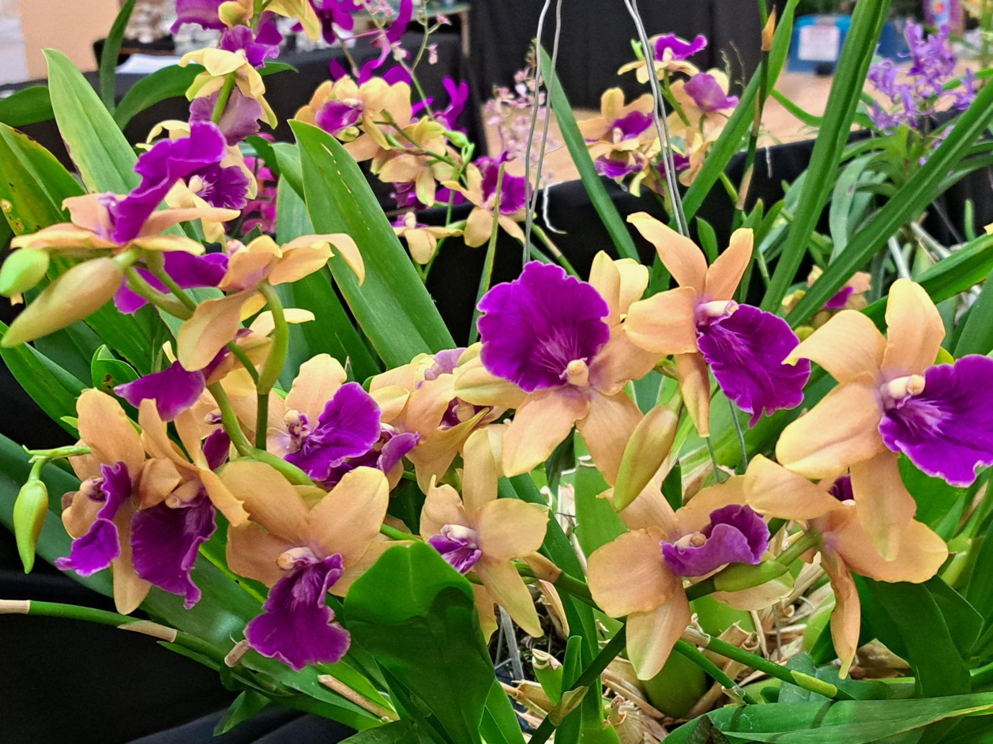
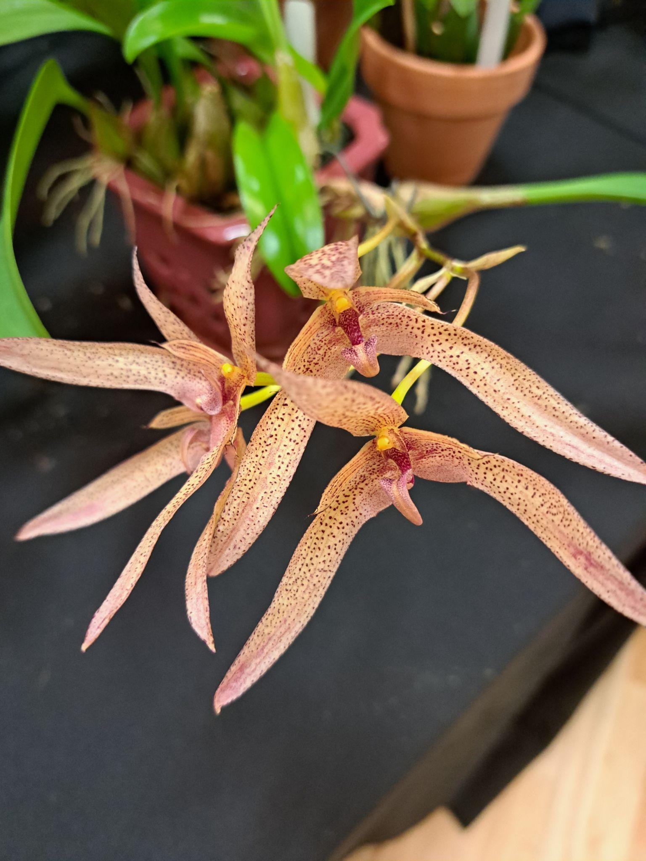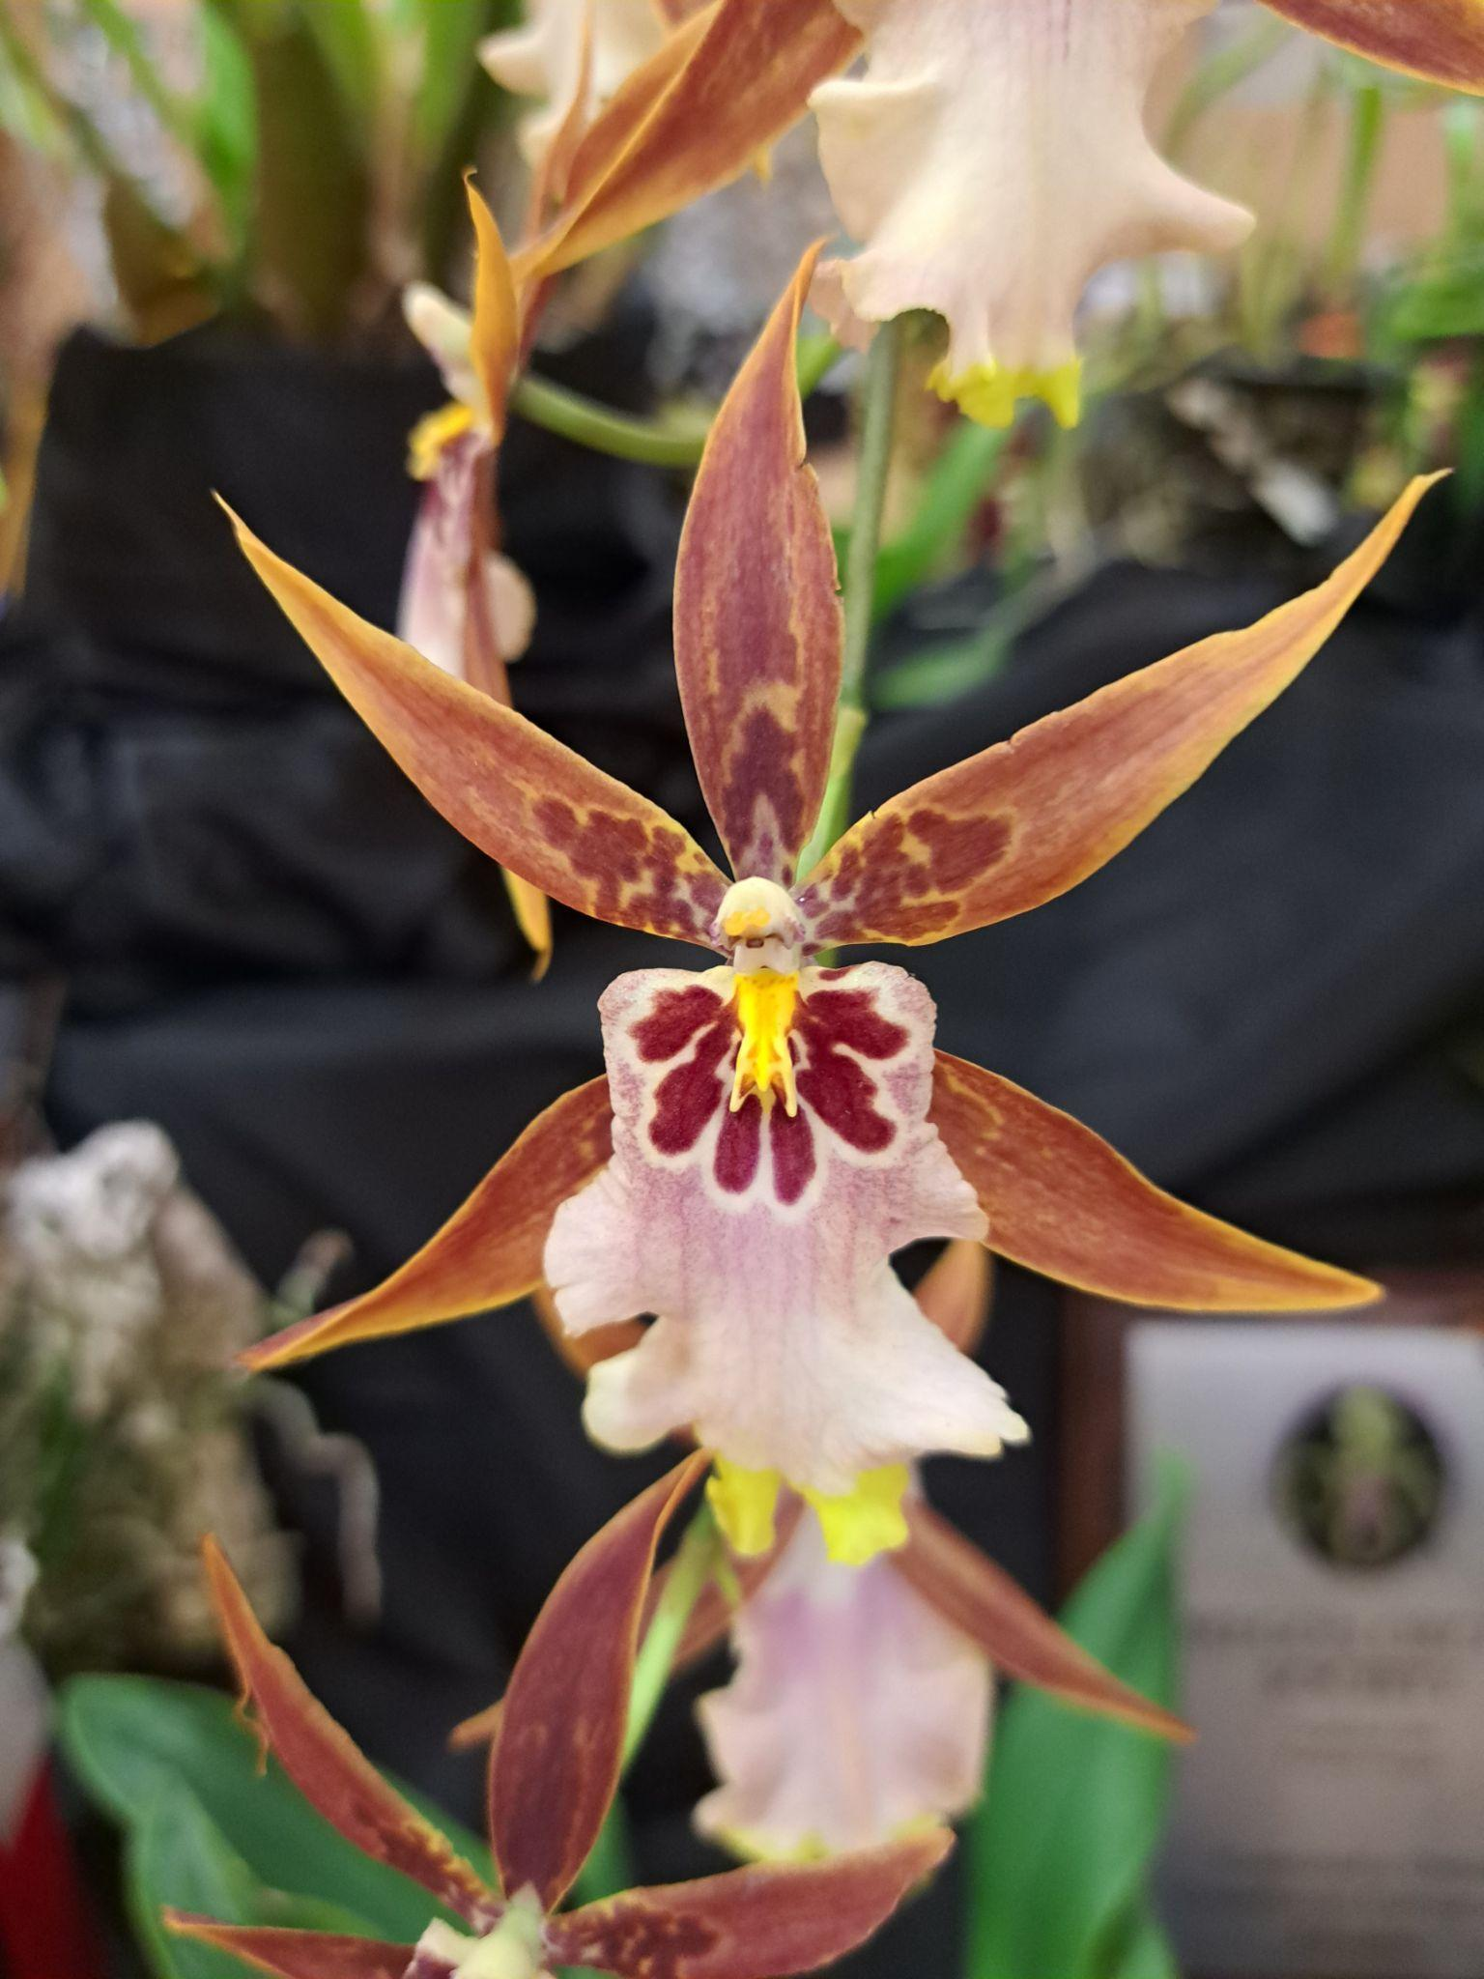
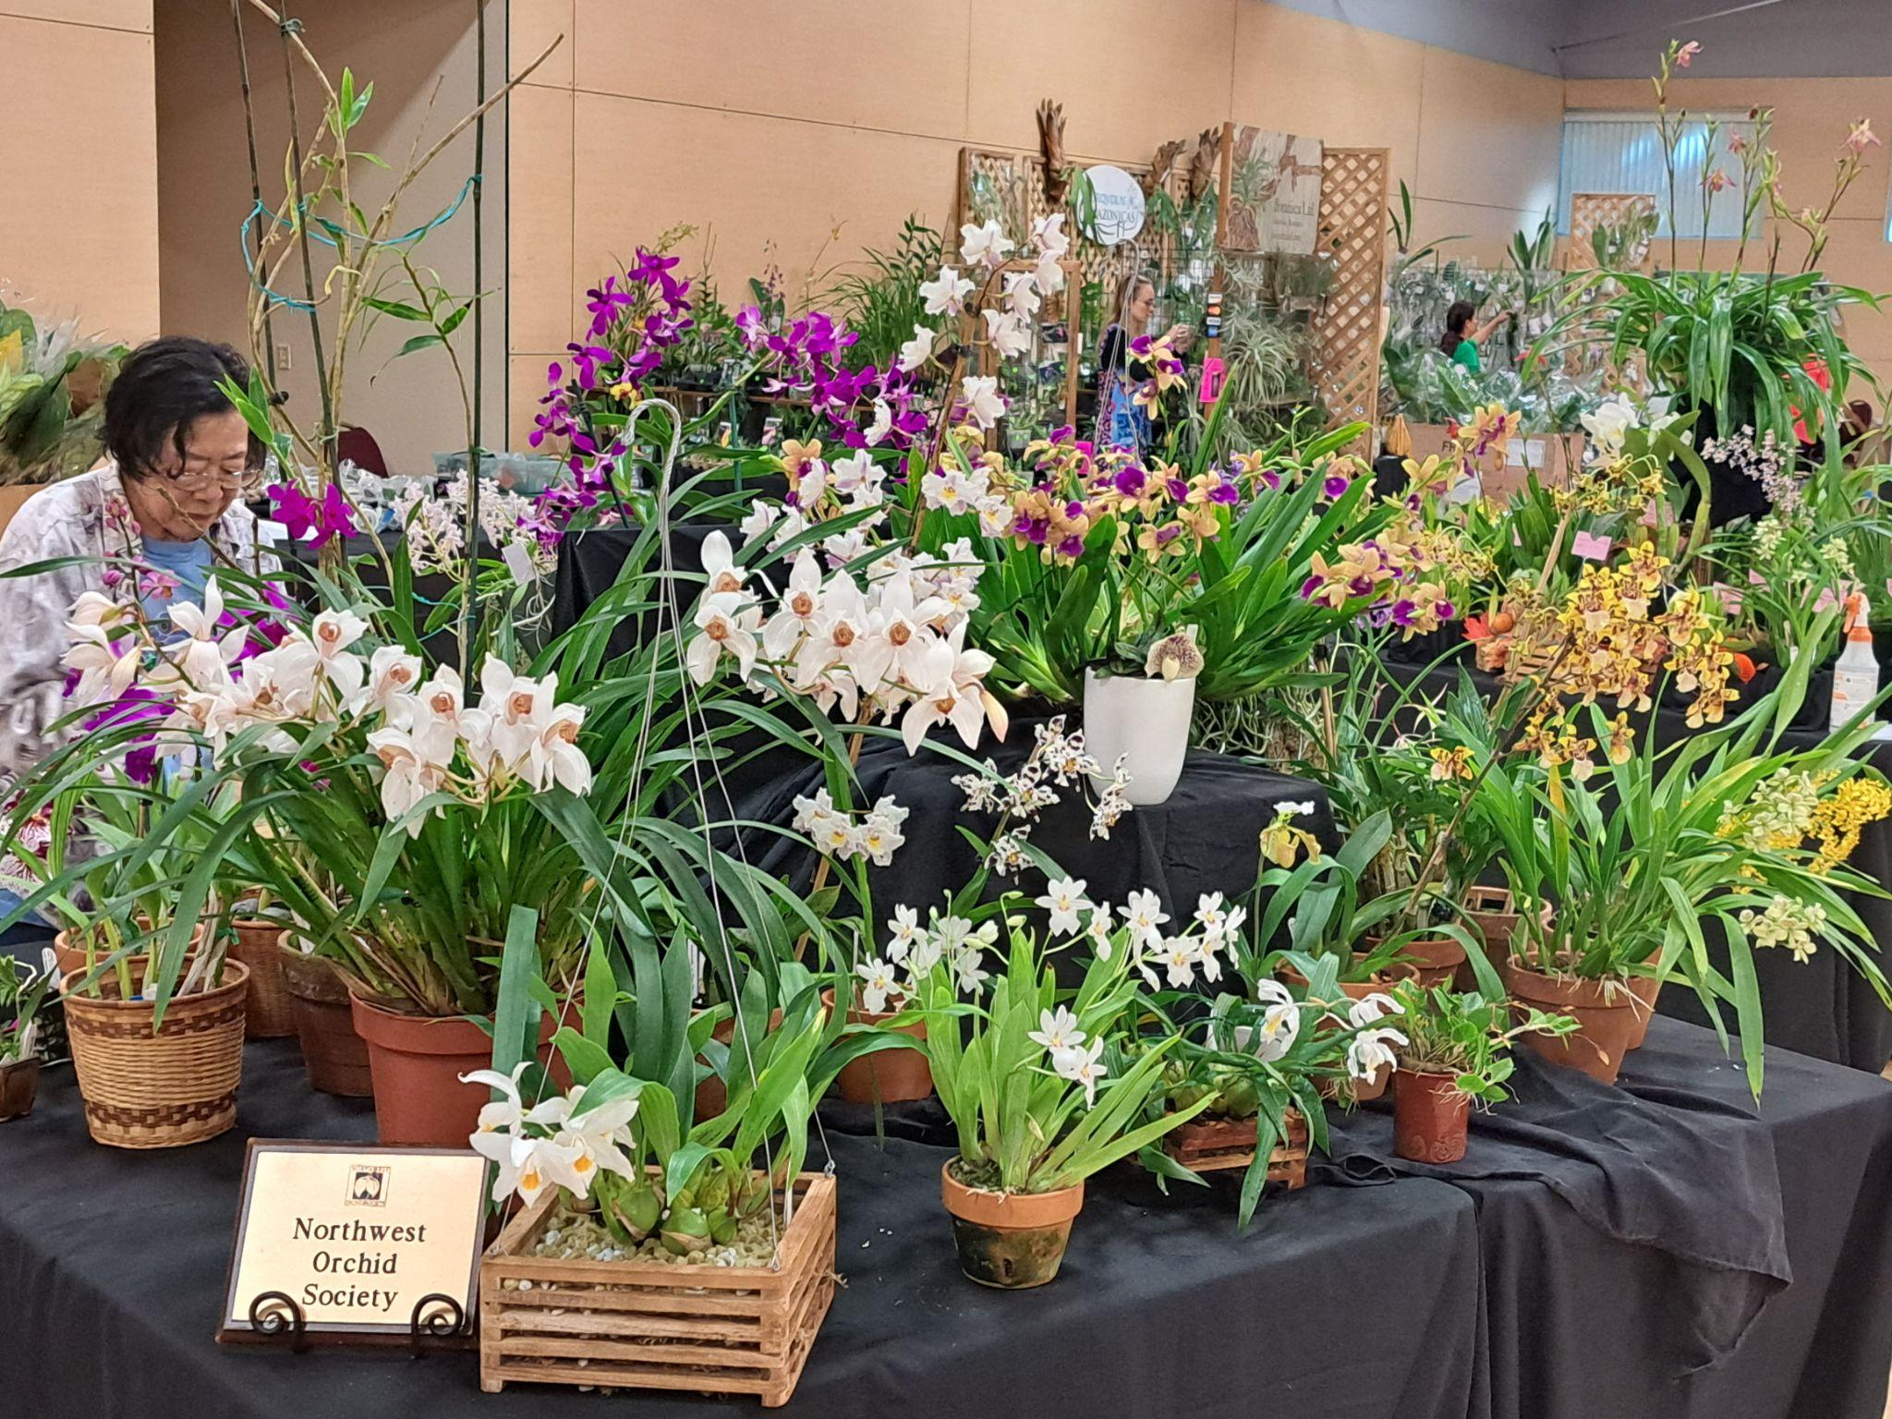

NWOS Fall Show and Sale

The NWOS had a show and sale during the first weekend of October 2022. It was held at the Volunteer Park Conservatory. There were lines every day waiting to come in and see the show. We had local and international vendors at the sale. The show was beautiful, well attended and very successful.
Thank you to the Show Committee, the volunteers and to everyone that brought in plants for making this such a success.
Thanks to our vendors Olympic Orchids, Emerald City Orchids, Orquideas Amazonicas as well as our individual members who sold divisions of their plants. Our photographer, Sean Hoyt, did a great job documenting the event. And you won’t want to miss looking at his video of the show. Check it out here NWOS Show and Sale Gallery
Thanks also to Sean Hoyt Photography for the photos and video.

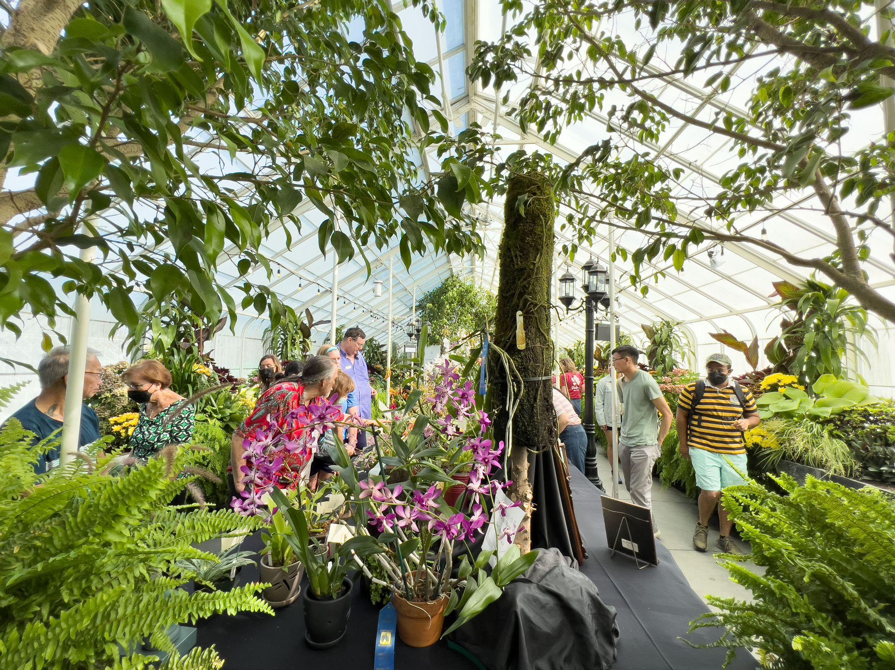
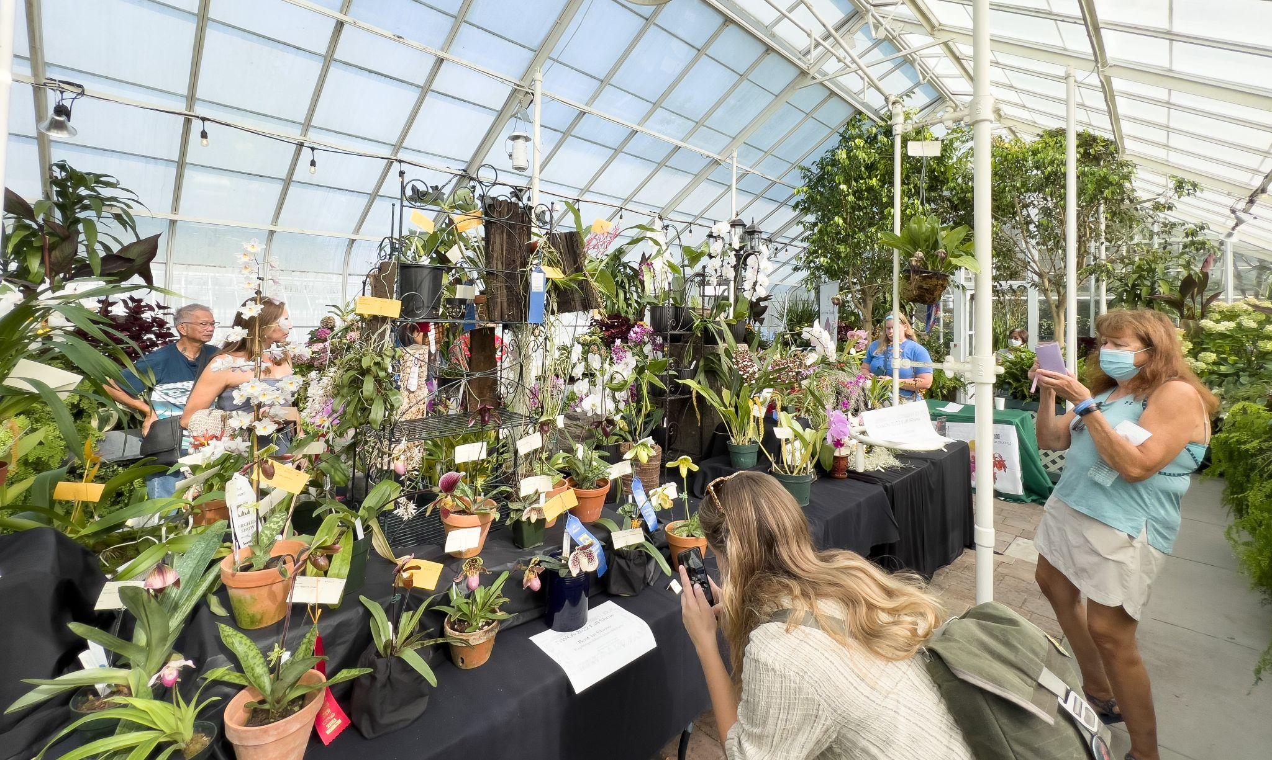
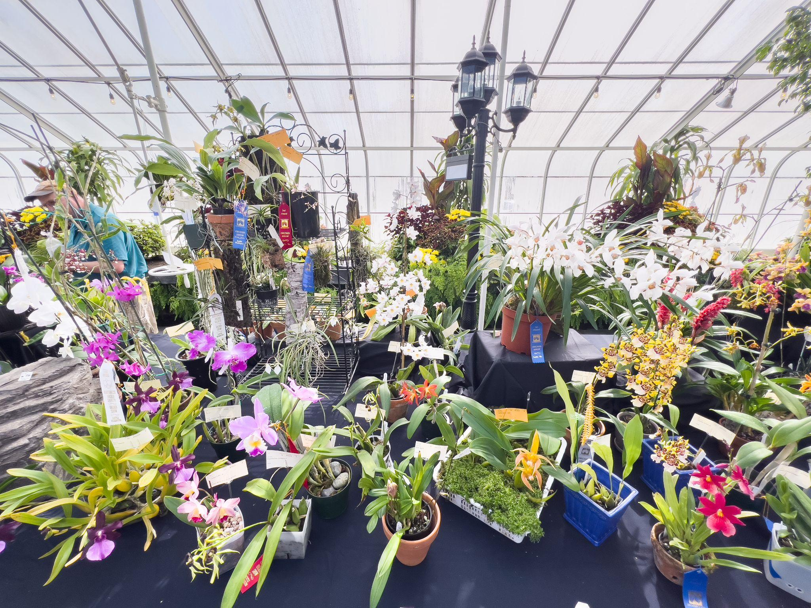

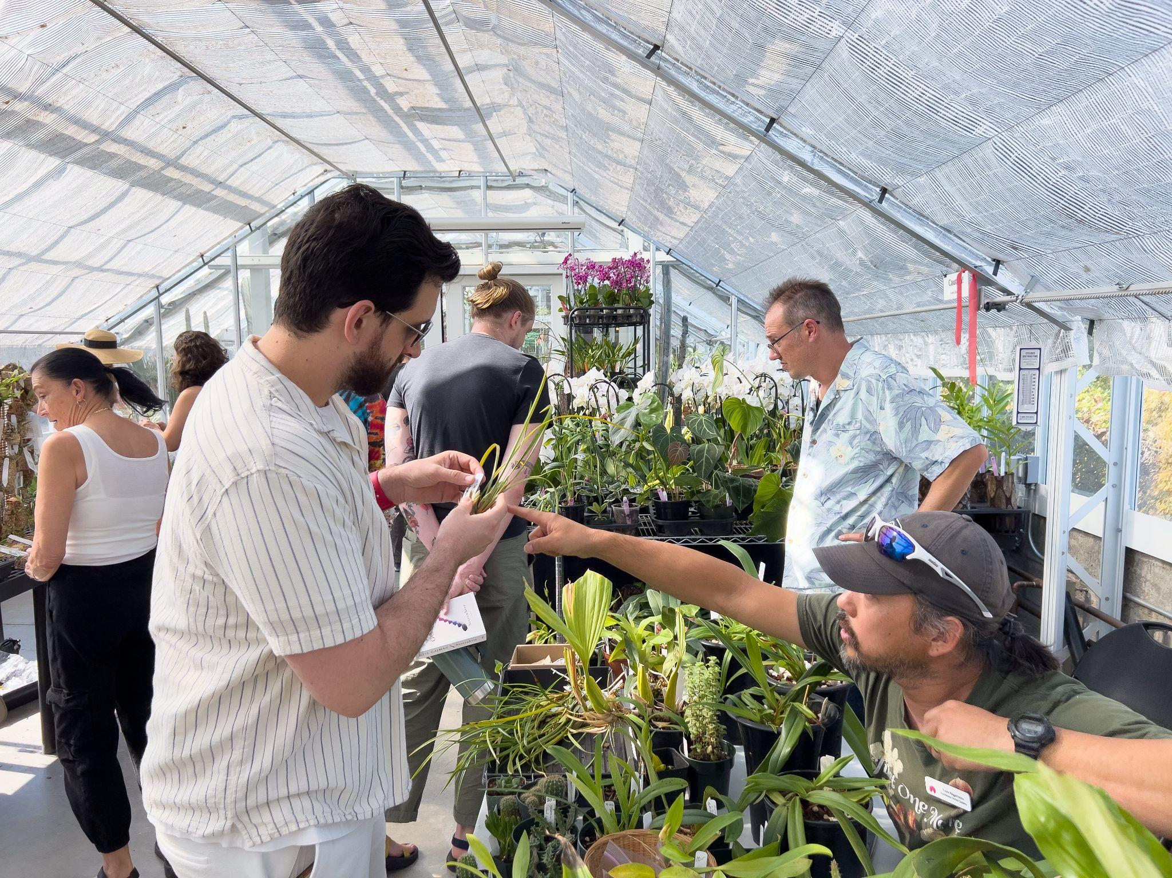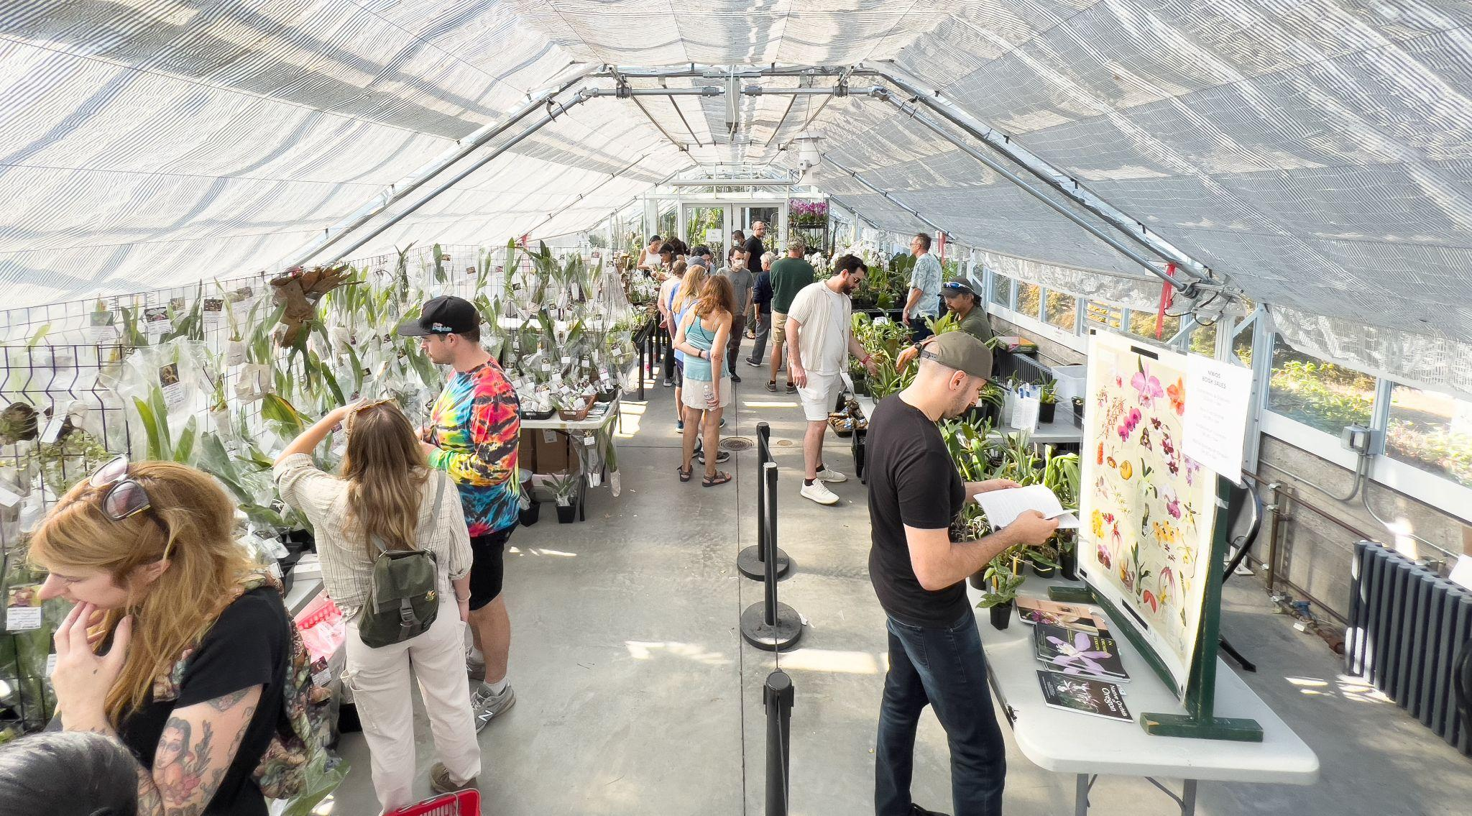
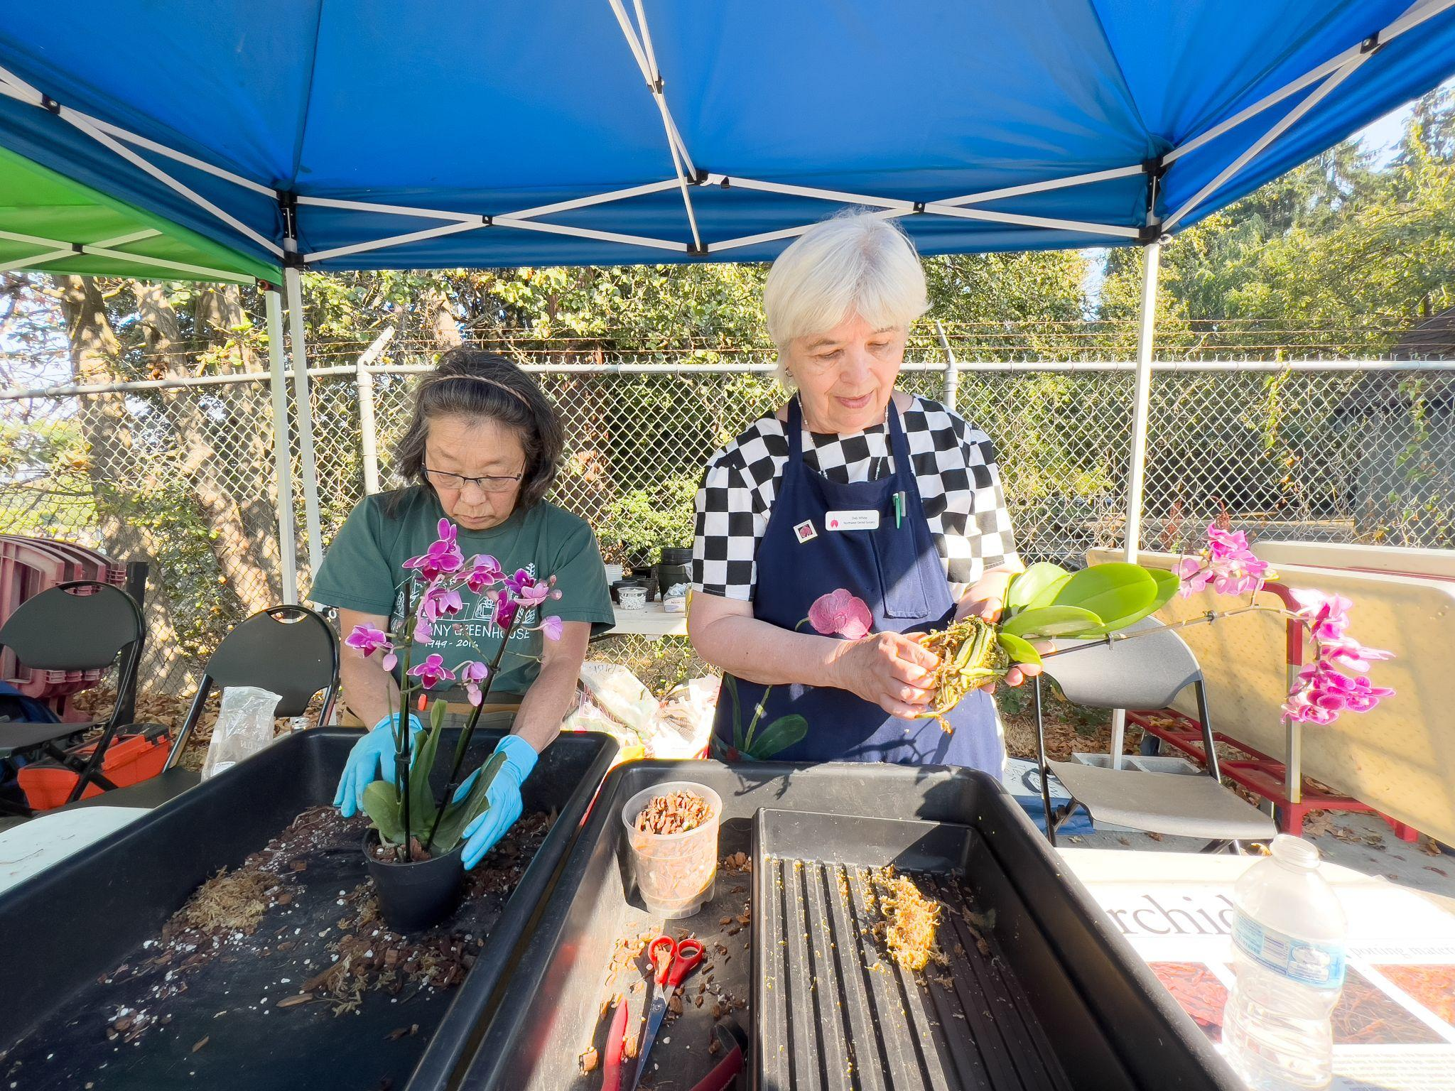

Report From The September Meeting

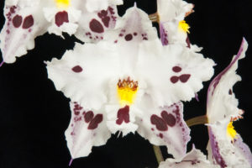
President Steve Dorsey opened the meeting and welcomed new members. He thanked Andy Wright for hosting our August picnic. He announced the need for some short term help with the Nominations and Audit committees and called for volunteers. Steve and George Grantham spoke about George doing a group order of Kiwi Bark from SVO orchids. Contact George by tomorrow to participate. Joe Grienauer reviewed the NWOS Library. Treasurer Bill Leicht asked people to cash checks promptly. Mike Pearson spoke about participation in the WA State Fair and encouraged us to send blooming plants down to the Orchid display. 2nd Vice President Ben Johnson asked for blooming plants that he could take down to the Oregon Orchid Show in Portland.

Show Chair, Abigail Chang, spoke about our own show and sale to be held the weekend of Oct. 1&2 at the Volunteer Park Conservatory. Click on the link in the Newsletter for show information, plant registration and volunteer sign ups which are all located on our website. There will be a Show committee meeting next week and volunteers are welcome.

1st Vice President Robert Culver introduced our speaker Tom Etheridge who gave his presentation via Zoom. His presentation covered Odonts in the classic form that we think of as Odontoglossums while informing us about the current taxonomy which puts them into Oncidiums based on DNA. Tom reviewed the 3 important Odonts: Odontoglossum crispum, nobile and harryanum and how they along with a few other species influenced breeding. He compared trends in breeding of the early 20th century with what is happening now. Tom reviewed the cultural requirements which favor us here in the Pacific NW since they grow in the high Andes and like it bright and cool. They can take higher temps during the day as long as they cool off at night. The preference is for about 60% humidity and they prefer to be kept moist. An evaporative cooler helps keep his greenhouse at the right levels. A very well done, informative program.

NWOS Website Posting

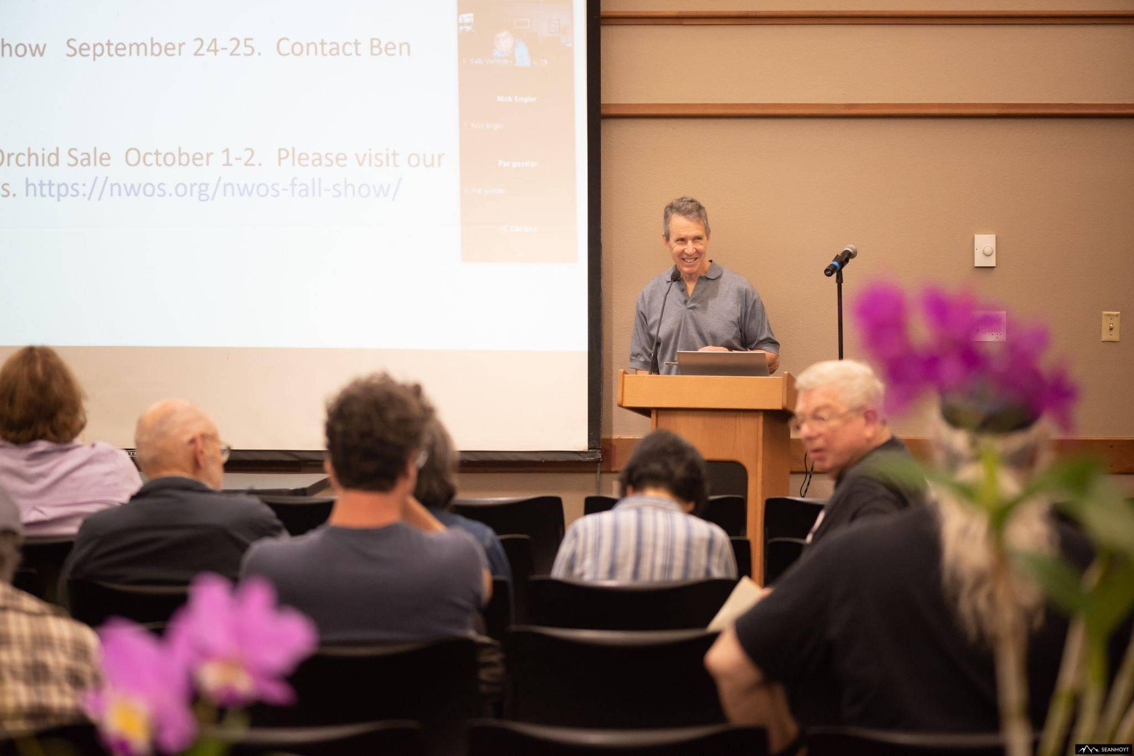
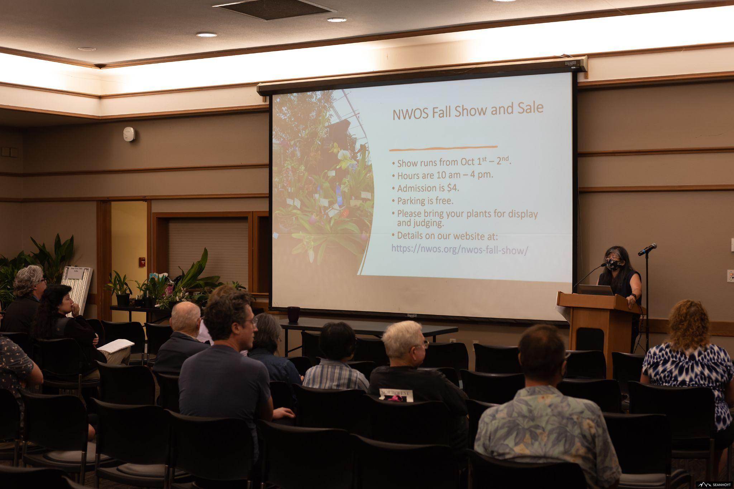
Andy Wright reviewed the plant table with assistance by Sean Hoyt.

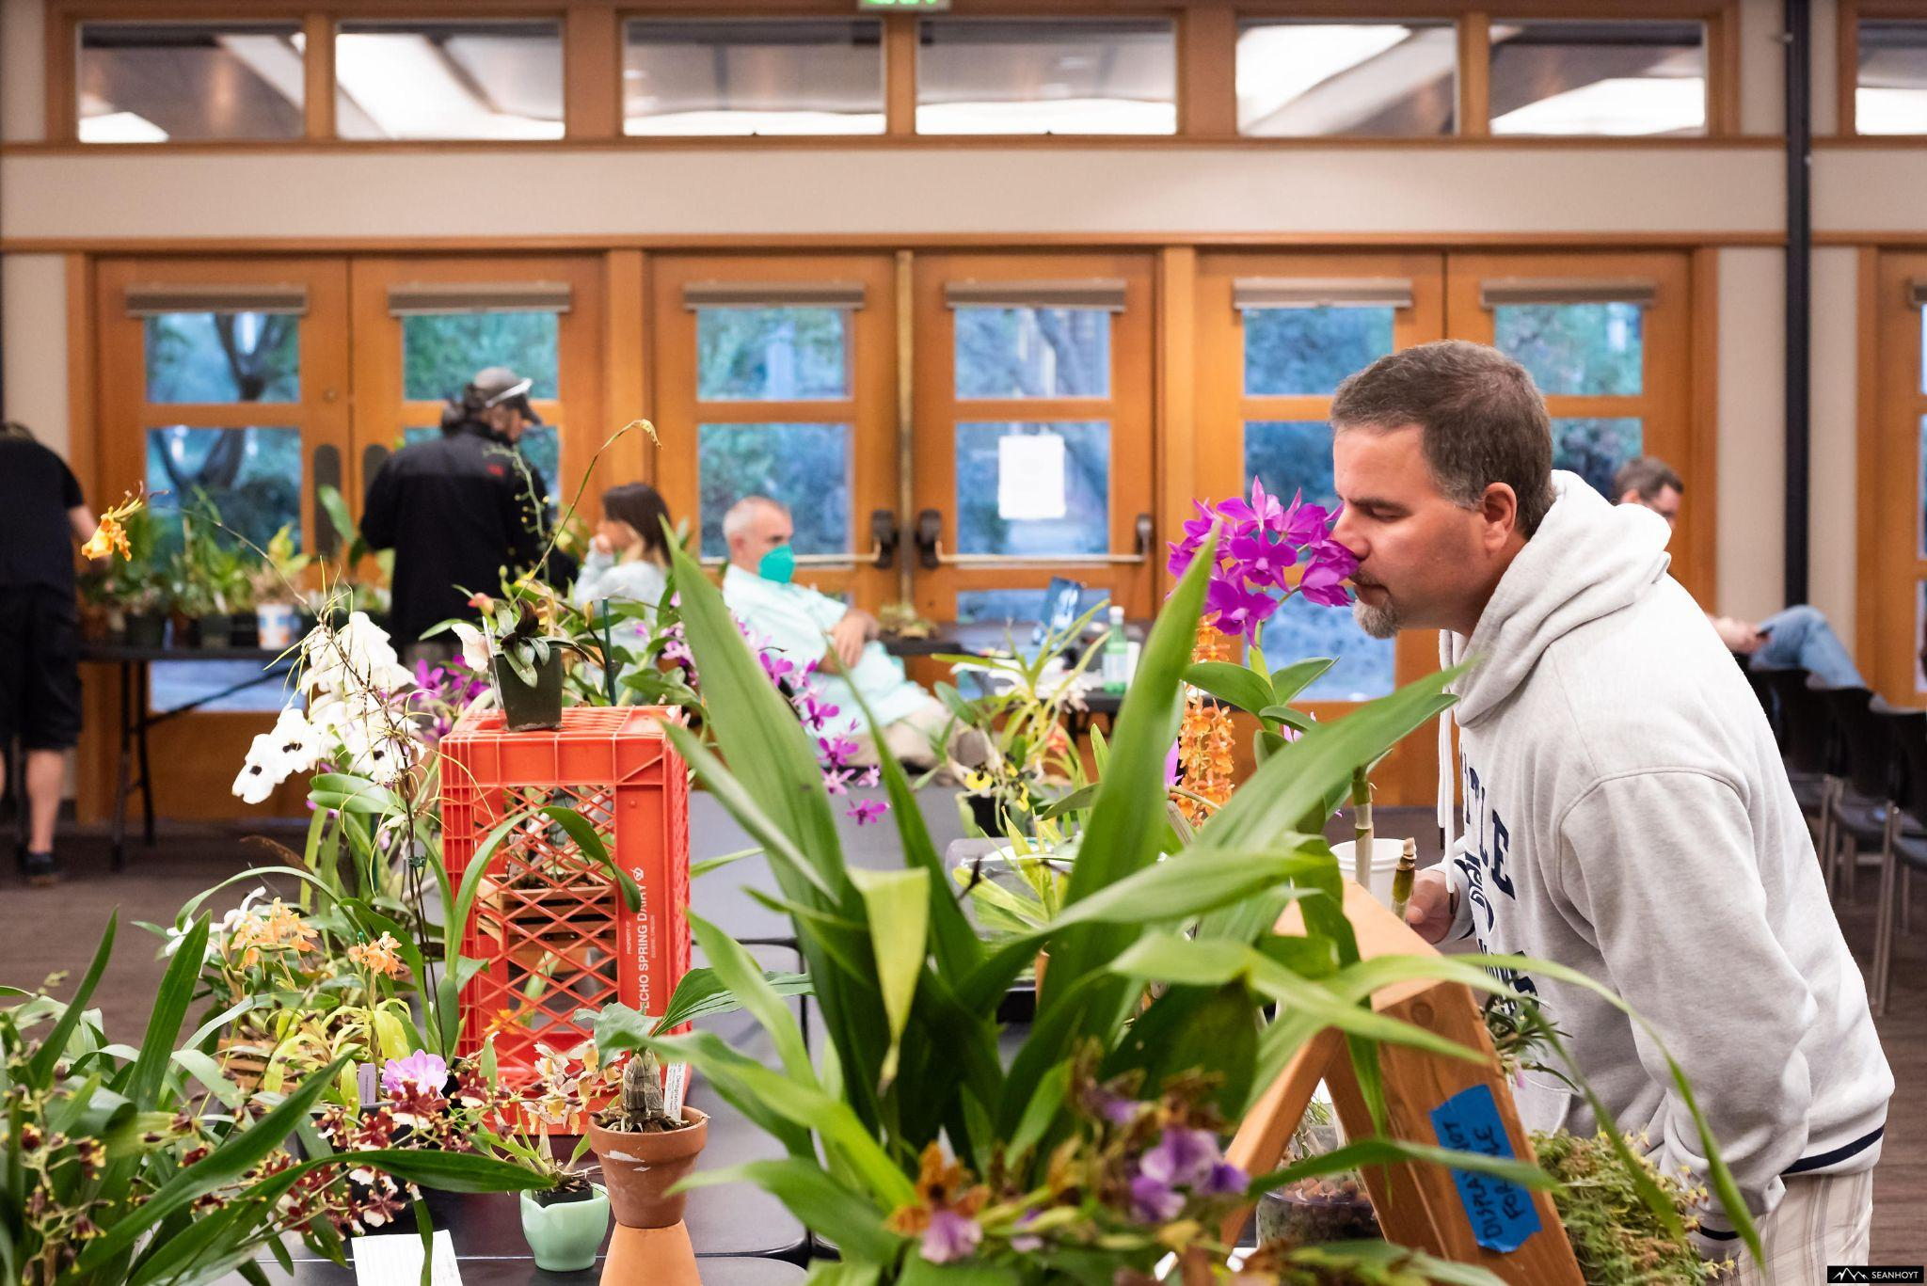

These are several selected images from the September meeting. To see the rest of the photos of September's plant table, please follow the link to go to the online gallery.
Photography by Sean Hoyt Photography
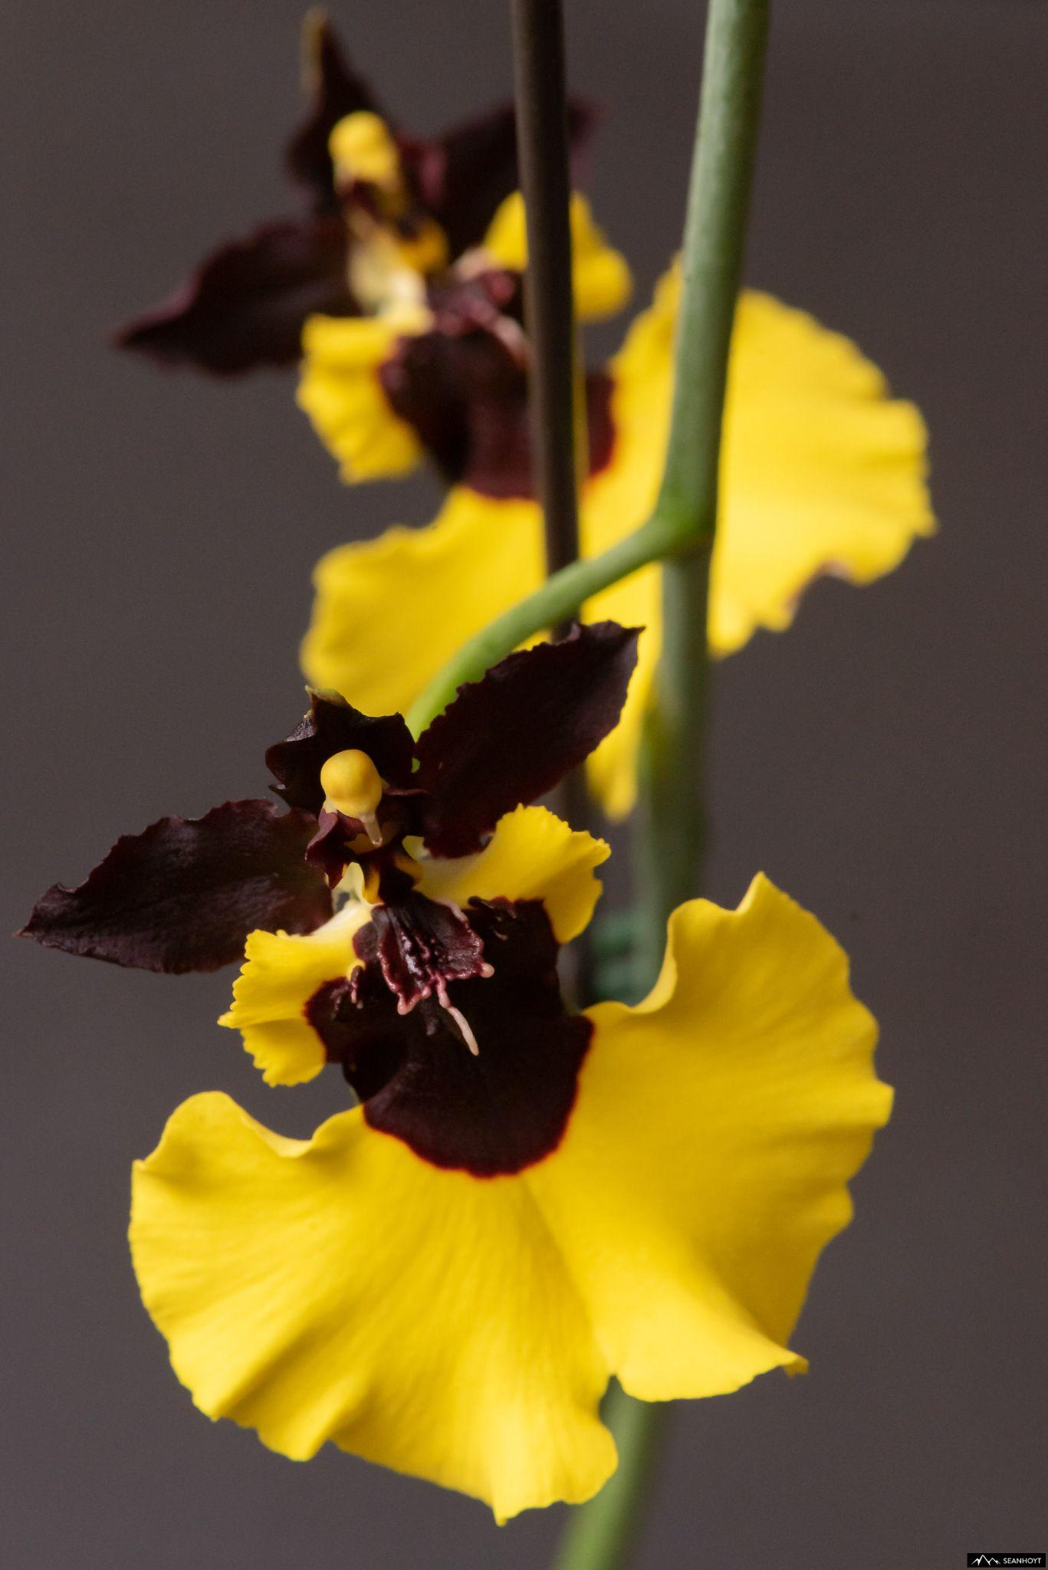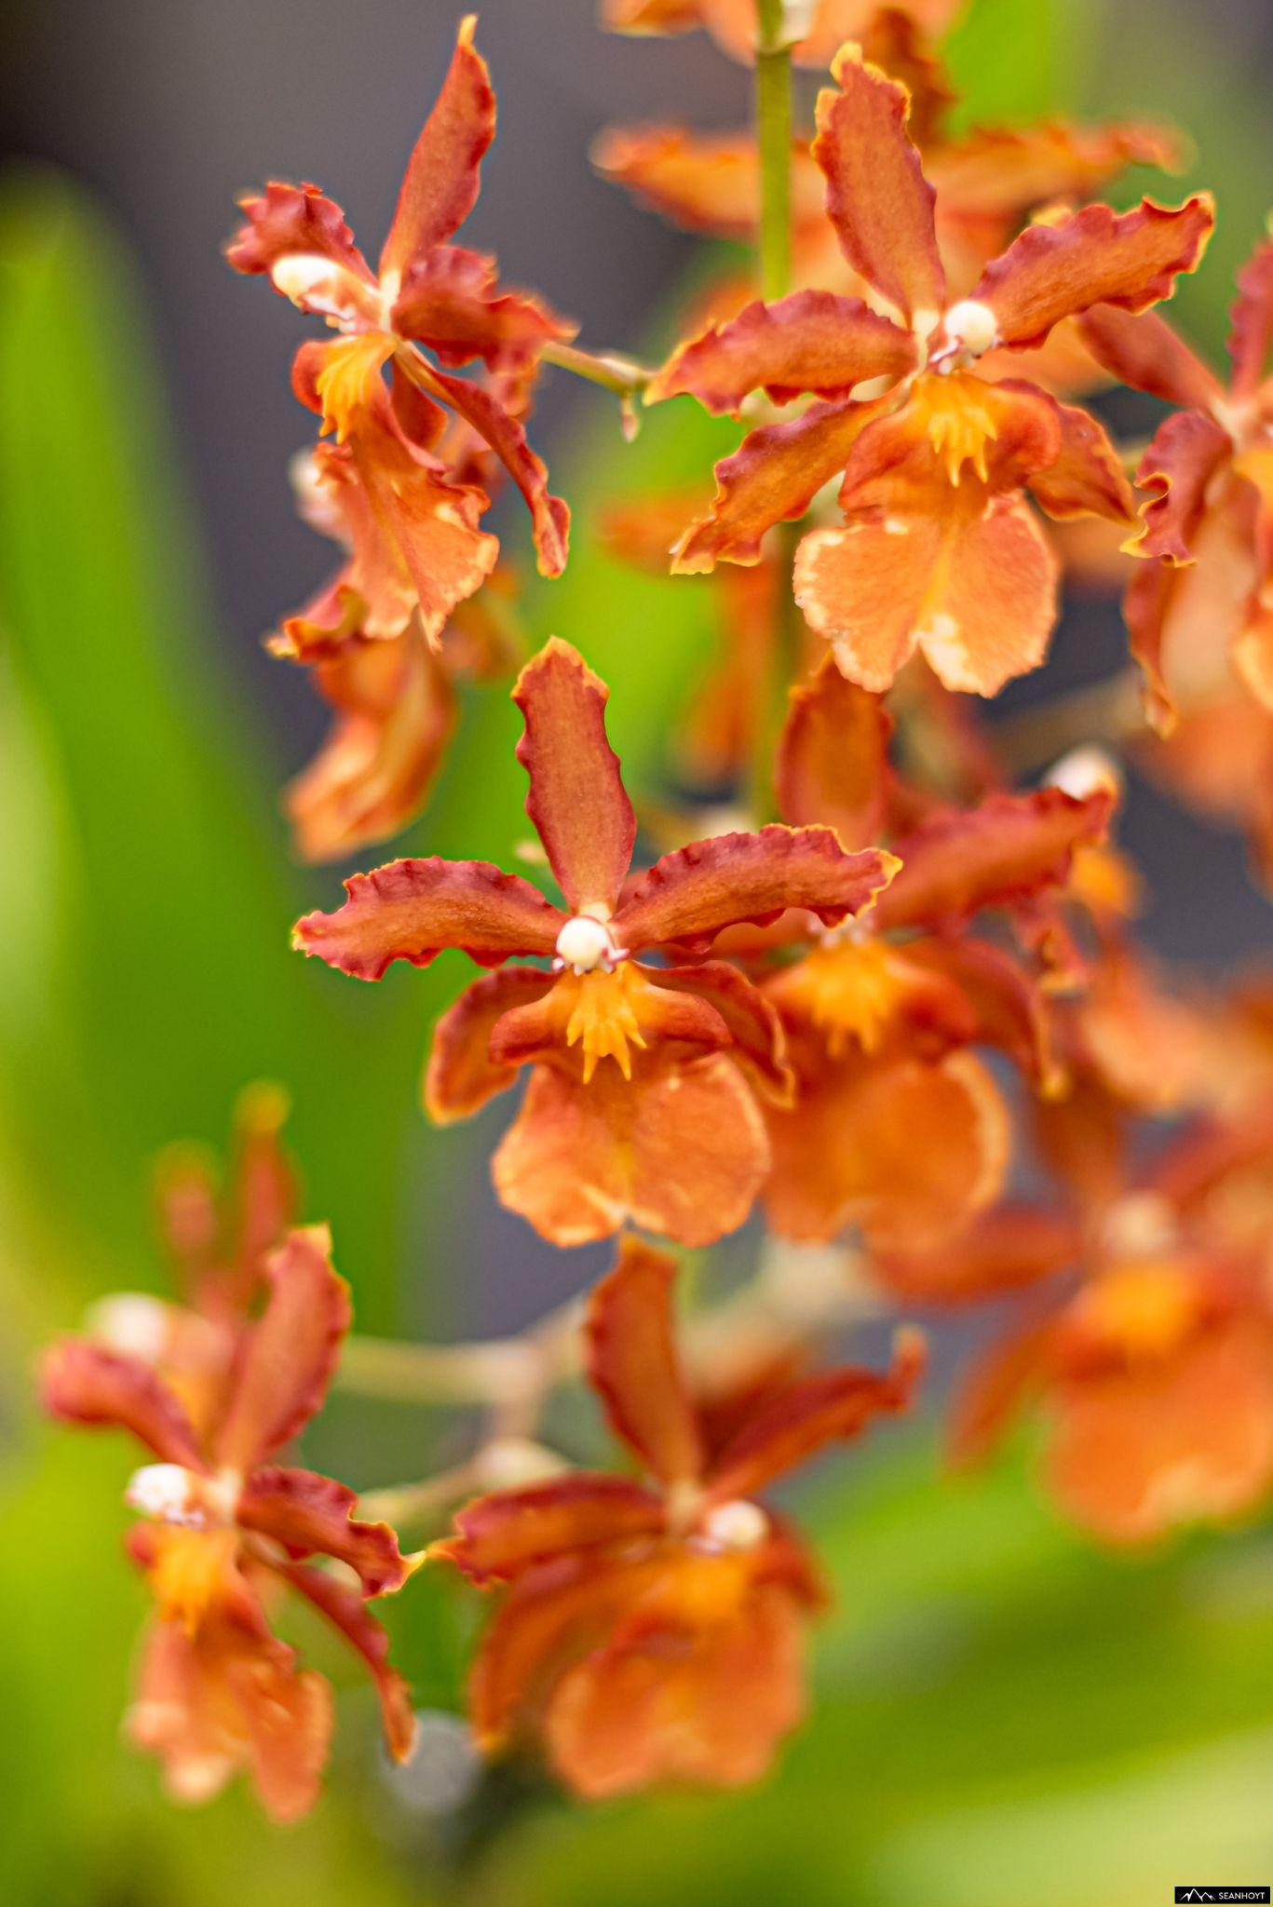
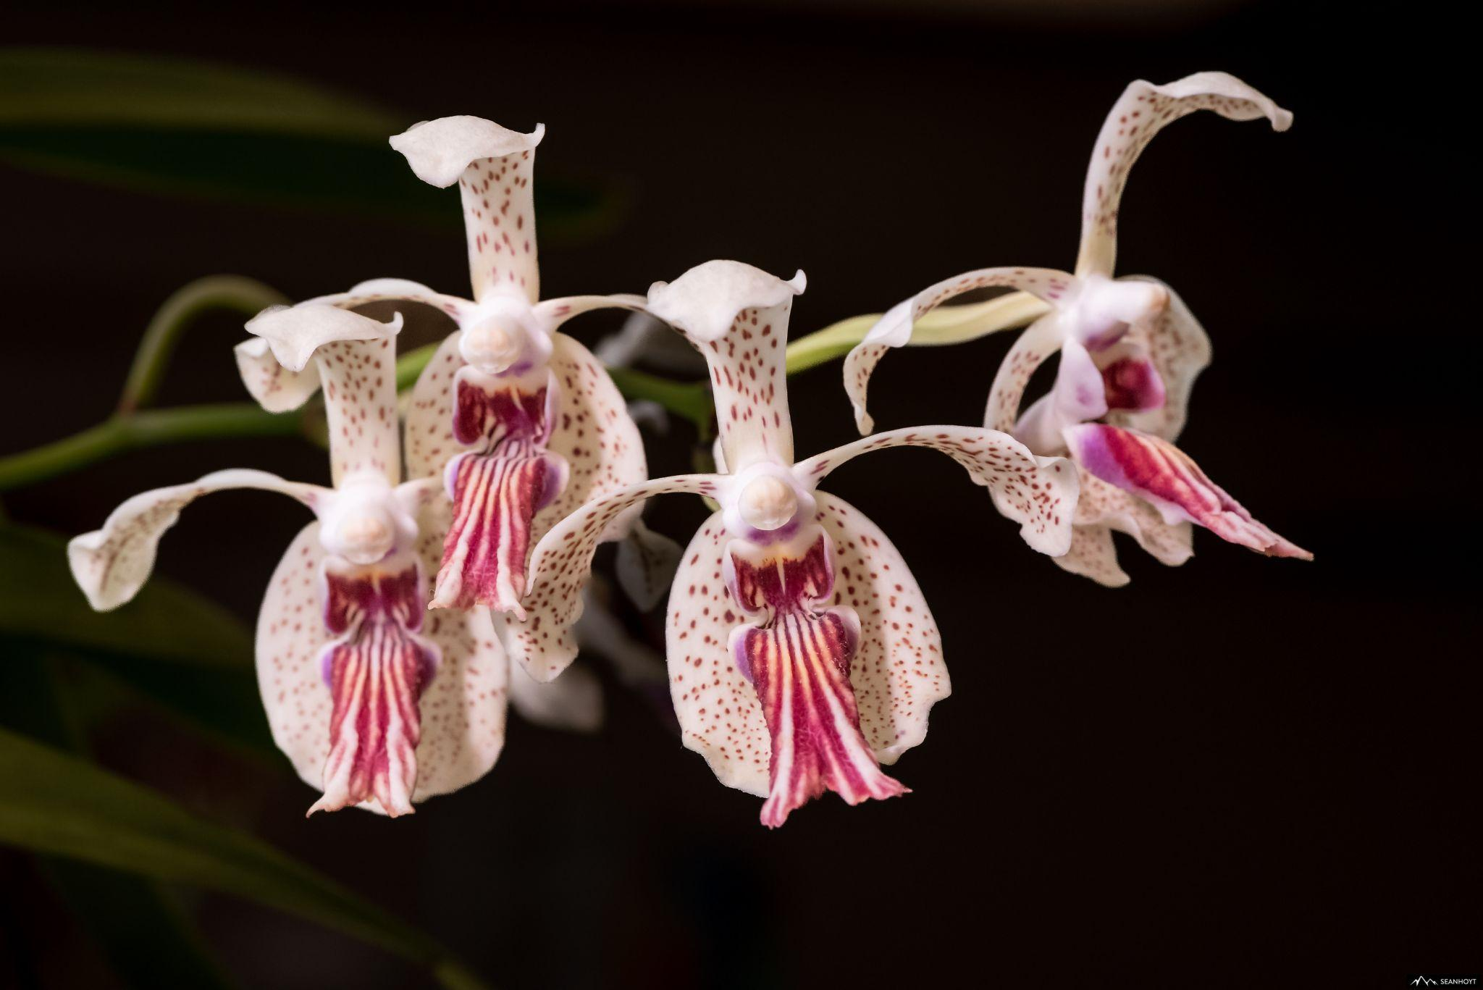
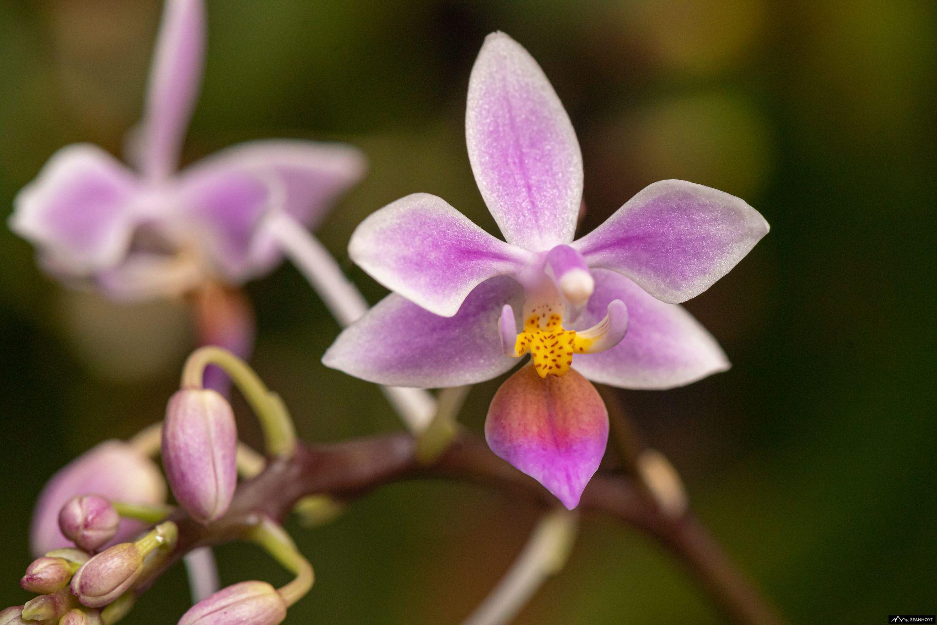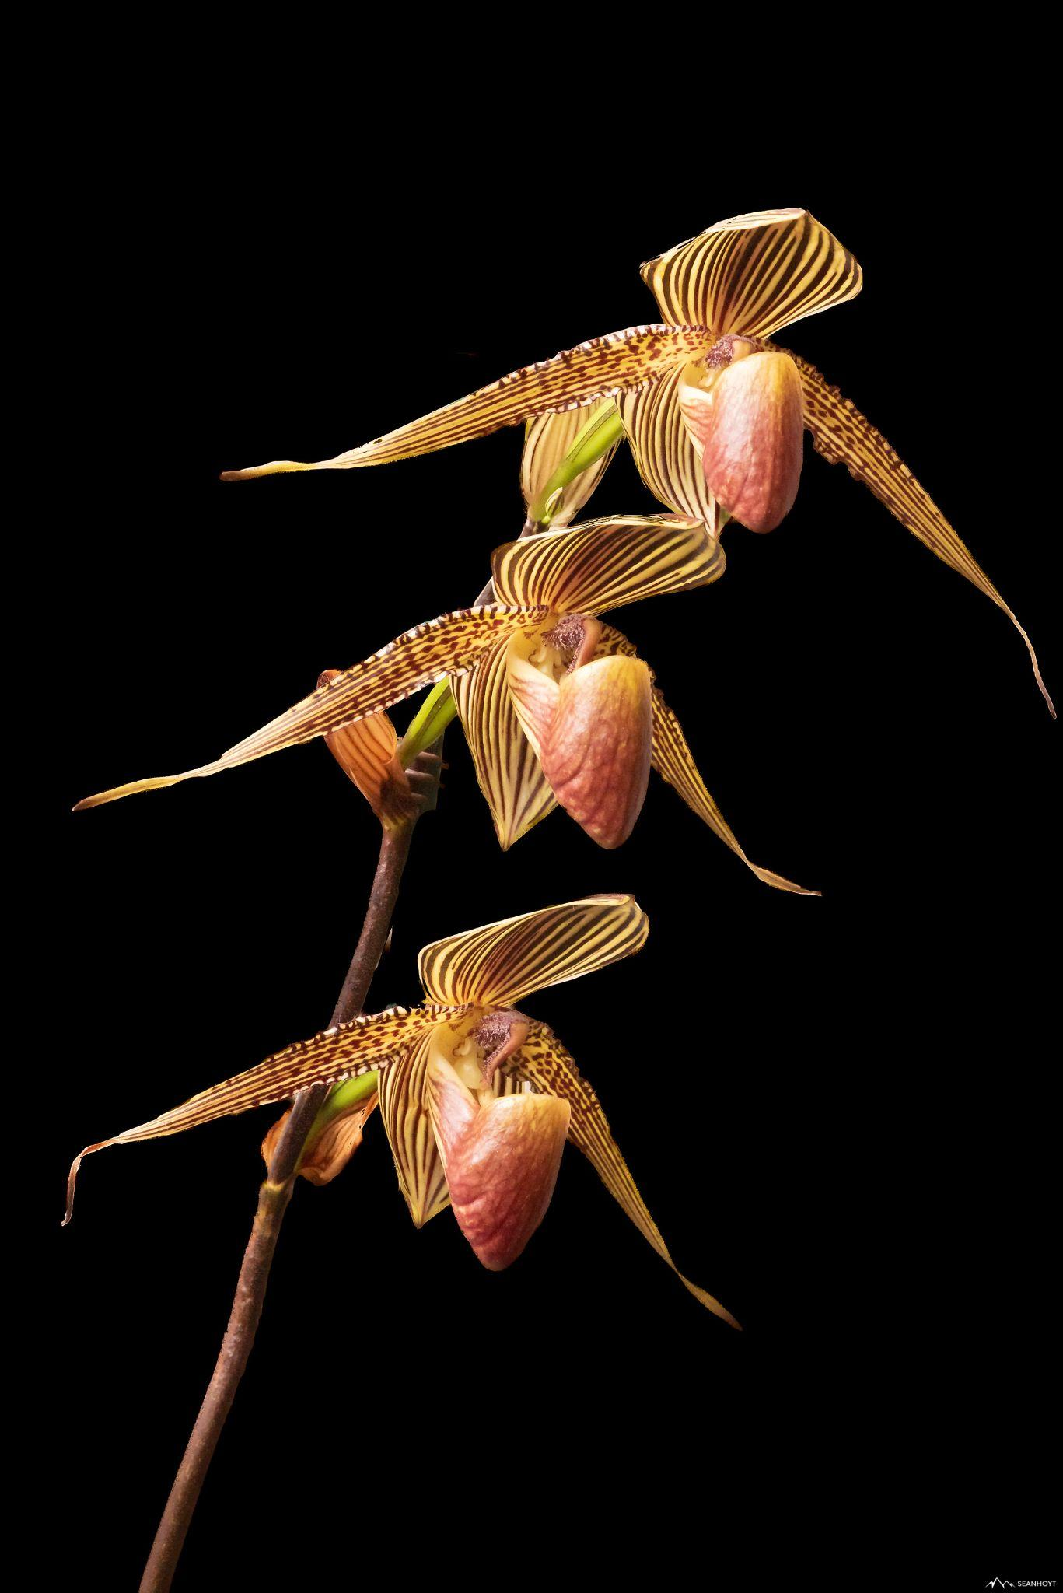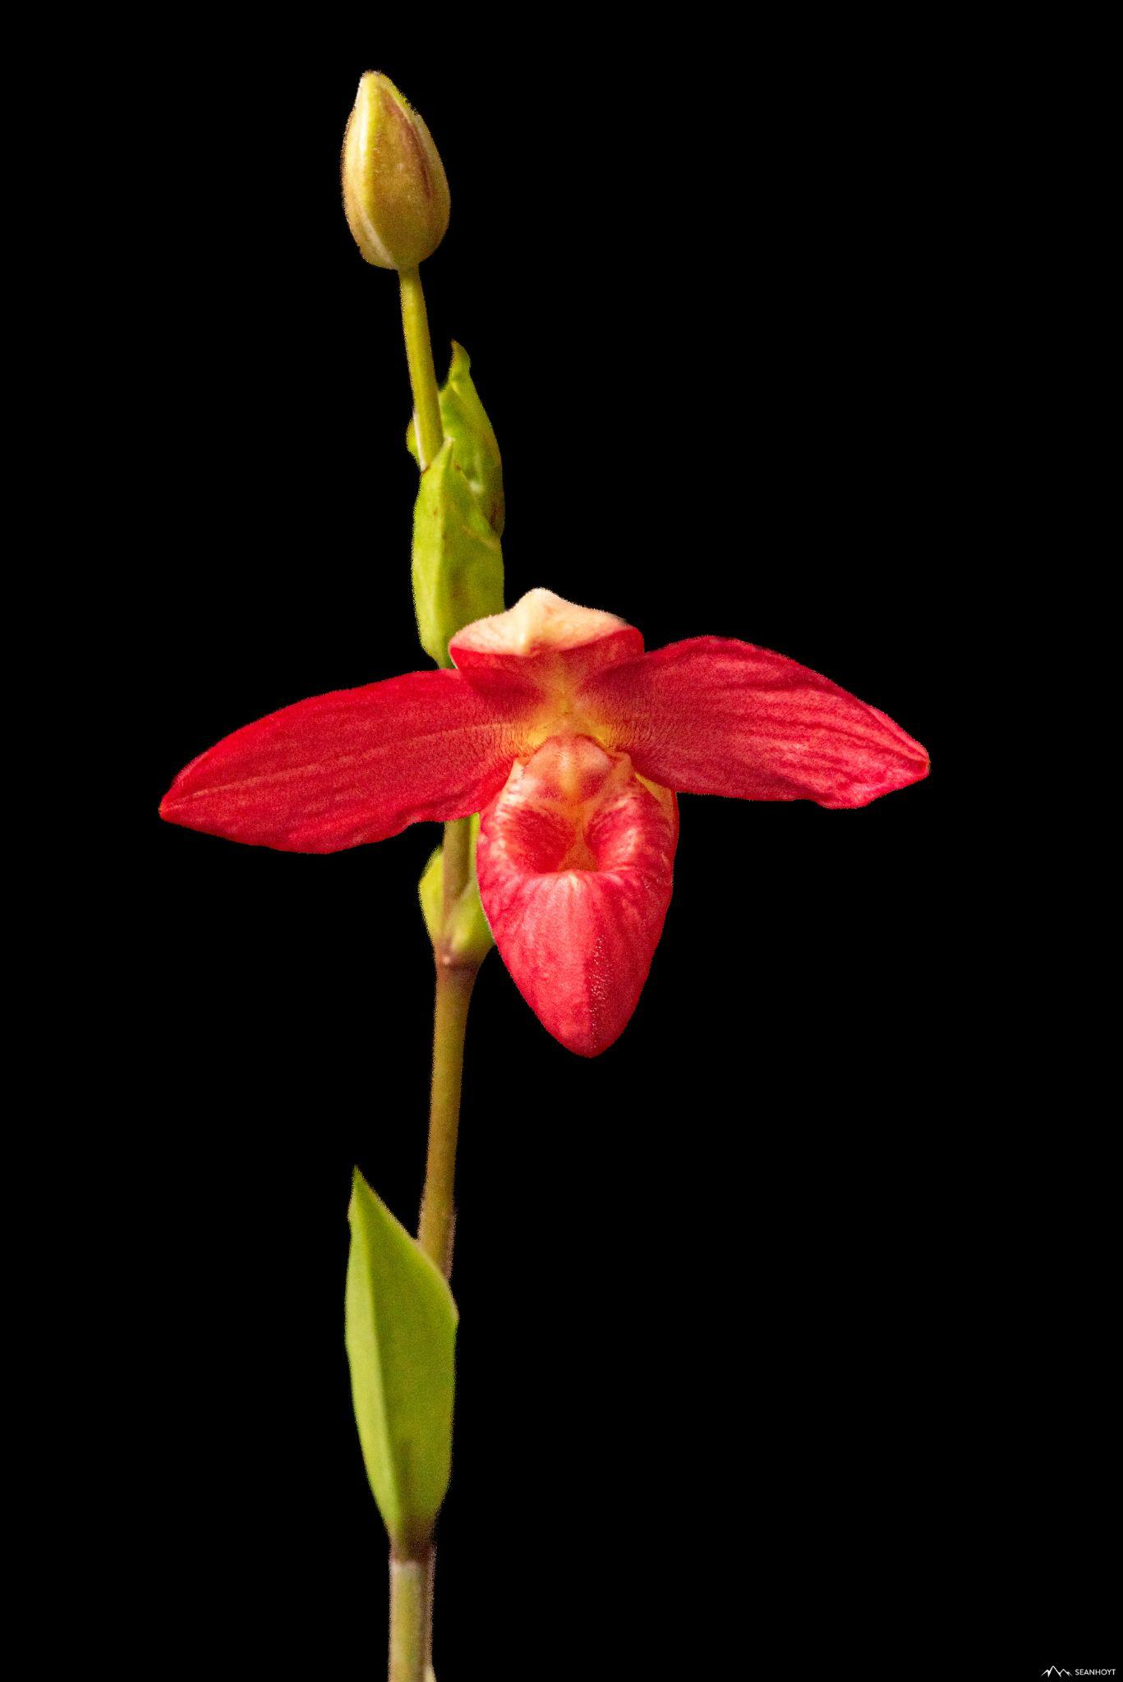
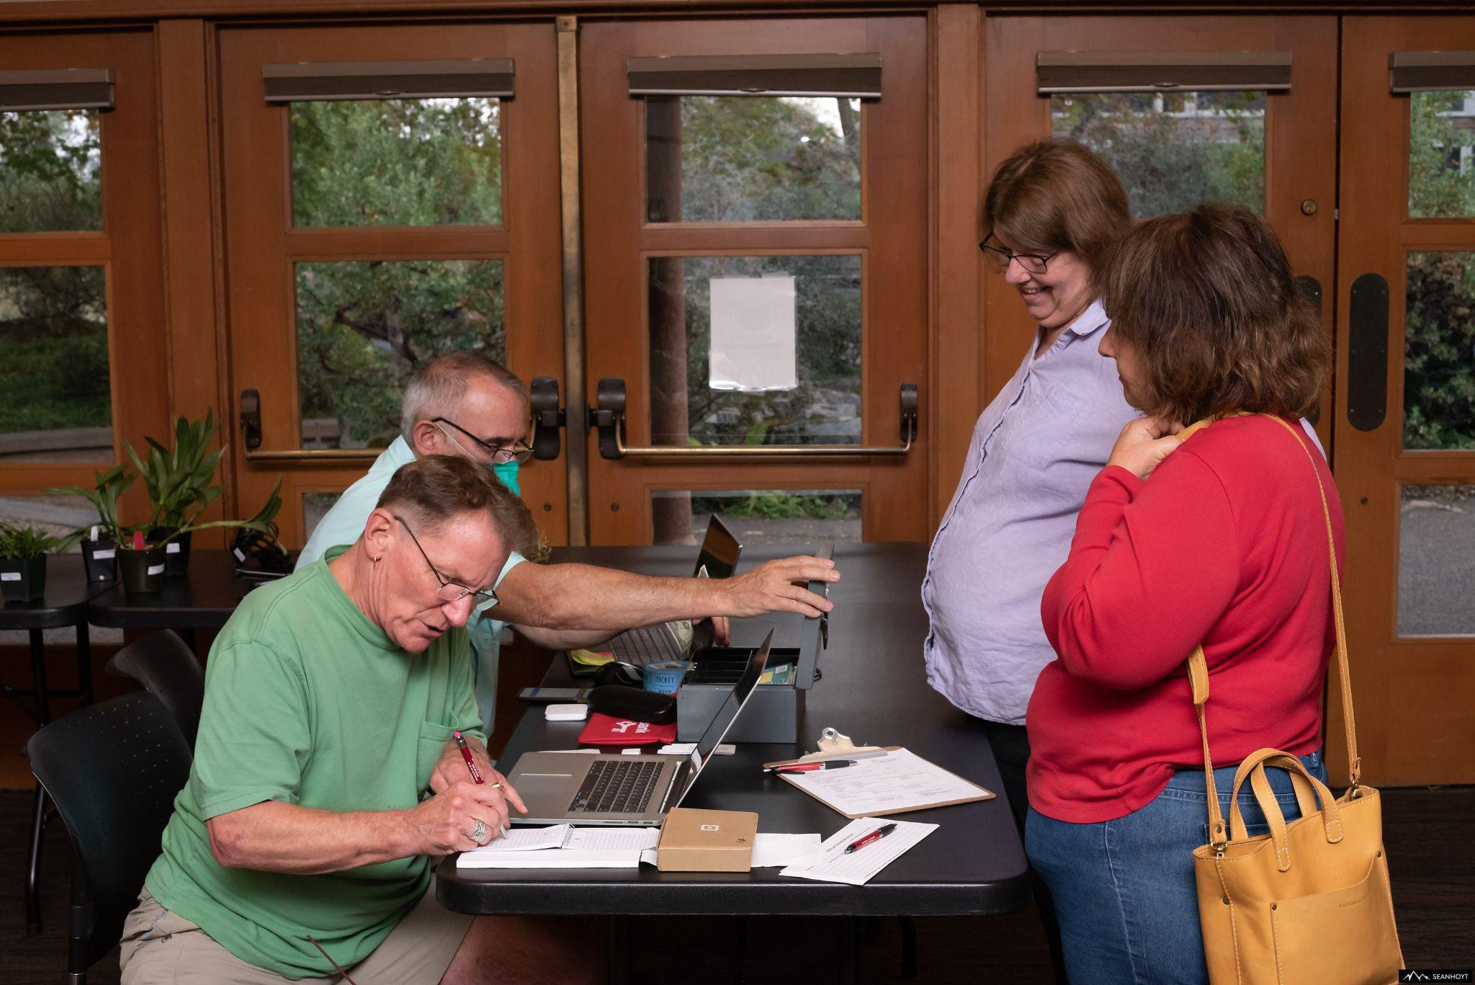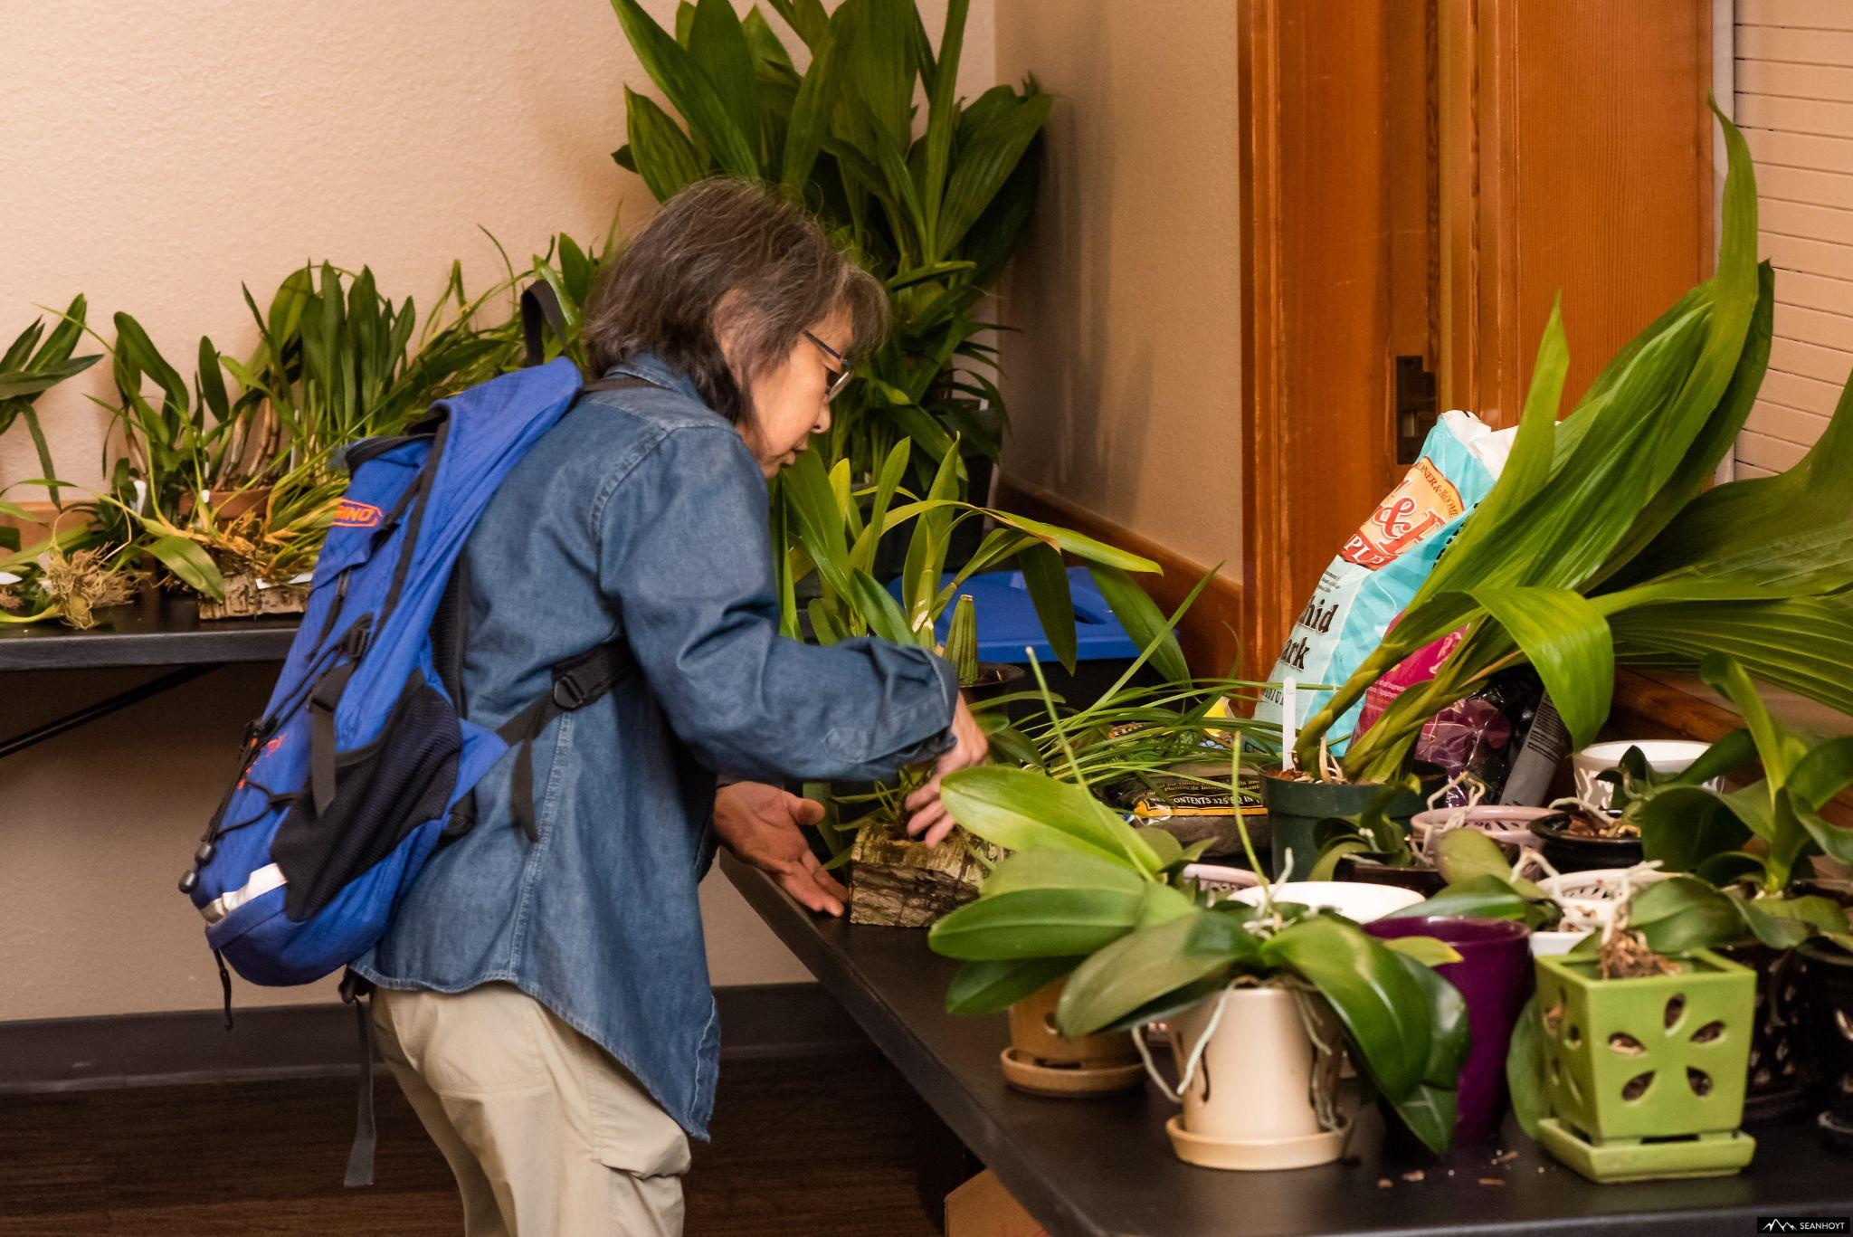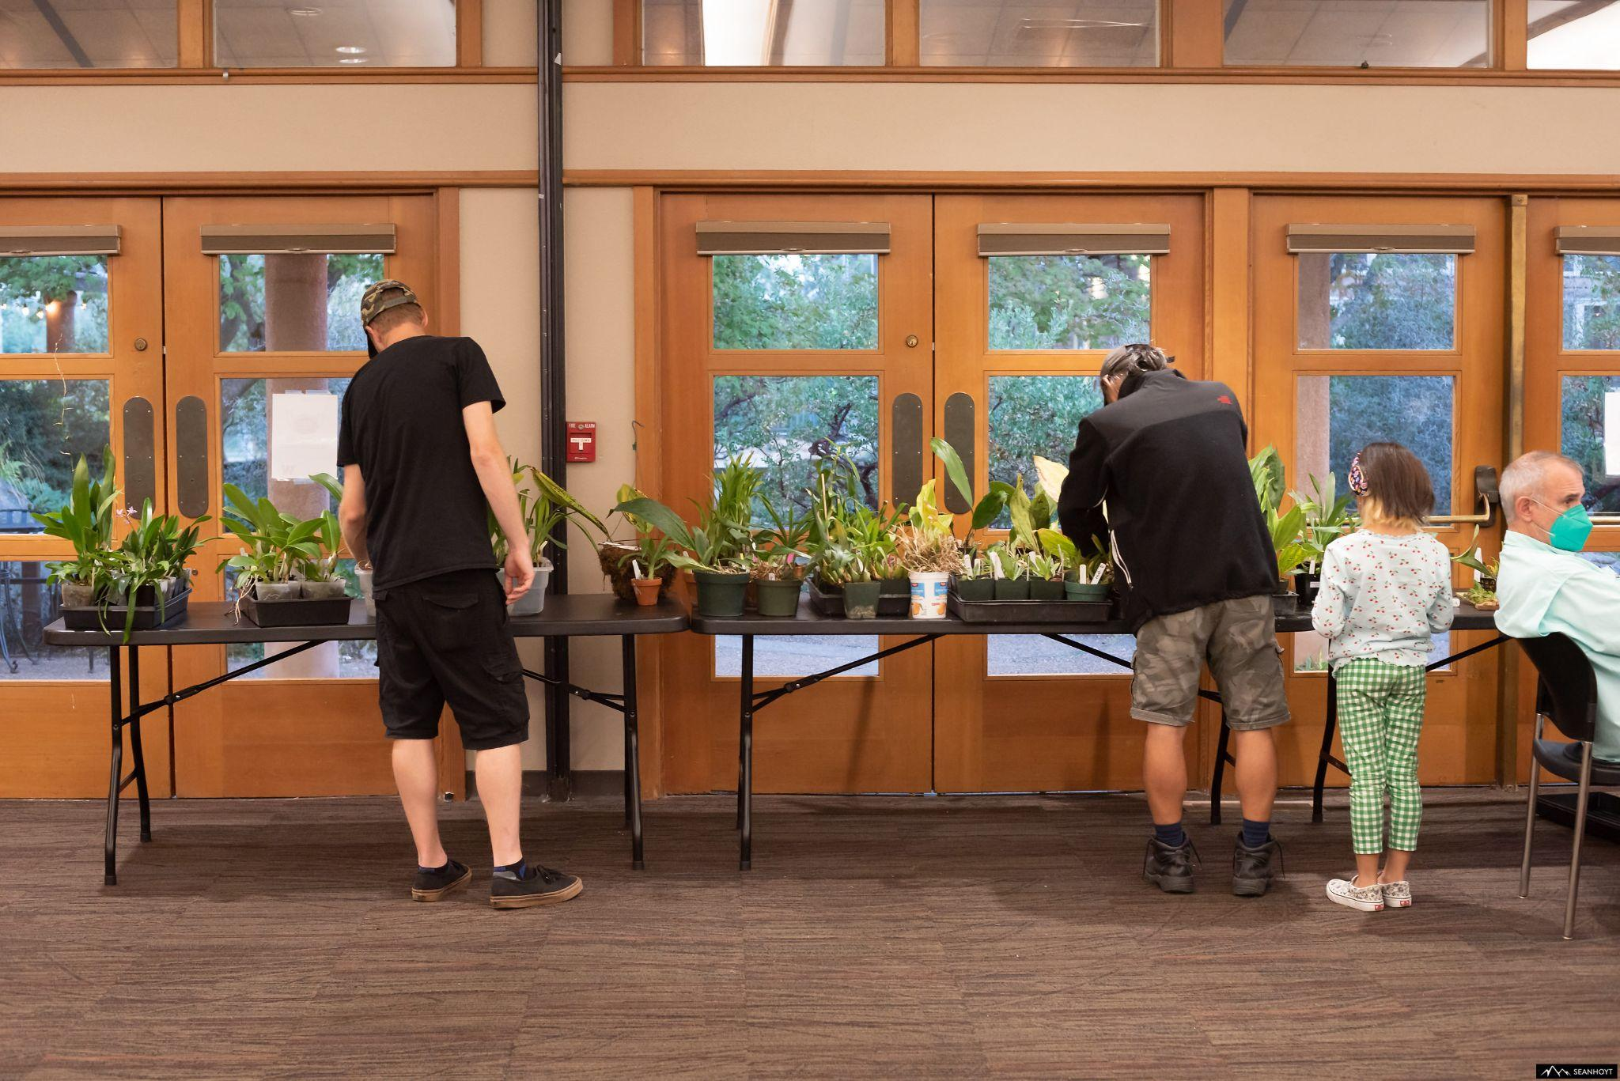
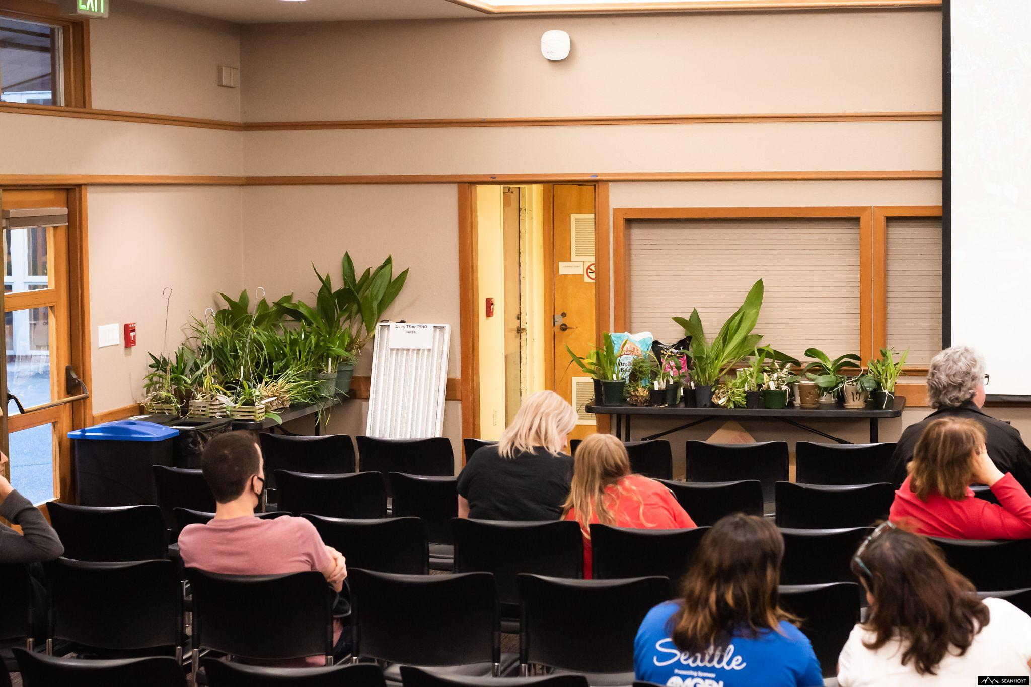
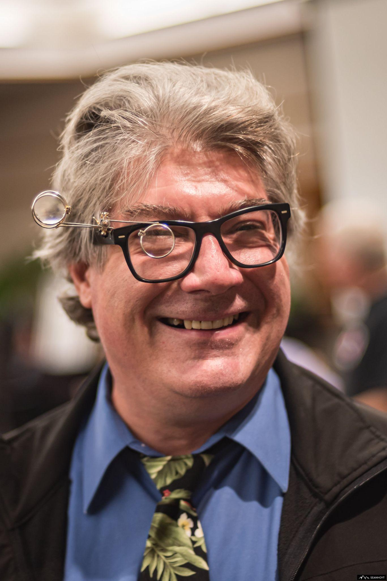

Schedule of Upcoming Events

10/10/22 – NWOS meeting – Speaker: Tyler Albrecht, “Parvisepalum Paphiopedilum” Tyler spoke to us about Dendrobium kingianum and its hybrids last year. This year he is back to talk to us about the wonderful parvisepalum subgenus of Paphiopedilum.

11/14/22 – NWOS meeting – Speaker: Peter Lin, “Neofinetia falcata and its Hybrids”

12/12/22 – NWOS meeting – Scholarship Recipient Report, introduction of new Officers, NWOS Annual Meeting report, Schoenfeld and Northen Orchid Awards, and Holiday Plant gifts.

01/09/23 – NWOS meeting – Speaker: Tennis Maynard, "Trichopilias" Tennis will be speaking to us about this beautiful, yet underrepresented genus in many of our collections.

02/13/23 – NWOS meeting – Annual Culture Clinic: This is our annual clinic when you can bring your questions, your problem plants and whatever is ailing something in your collection and the members that have experience with that plant or problem will answer your questions.

03/13/23 – NWOS Meeting – Annual Auction: This is our annual auction. It starts early with our preview party, nibbles, and bubbly, and ends up with tables and tables of plants for you to bid on. Many of these plants are hard to find and are rarely available outside of private collections.

04/10/23 – NWOS meeting – Speaker: Andew McGinnis, Growing Orchids in Grow Tents, Advanced Indoor Growing.

05/08/23 – NWOS meeting – Speaker: Ron Parsons, “The Genus Dendrobium”

06/12/23 – NWOS meeting – June Food Truck Social: This is our annual social just before we take our summer break. We have a food truck outside and plants inside. We also announce the Gary Baker Service Award at this meeting.

09/11/23 – NWOS meeting – Speaker: Kelly McKracken, “Fragrant Miniatures” The most common question we get asked about plants is “is it fragrant?”; Many orchid growers select their plants based on whether the plant is fragrant. For those of you who grow in limited space, but still love a nose full of floral fragrance, this is the talk for you.

10/09/23 – NWOS meeting – Speaker: TBA

11/13/23 – NWOS meeting – Speaker: Alan Koch, “A New Look at Intergeneric Phalaenopsis” Phalaenopsis have been enjoyed by novice growers for the ease of growth and long lasting flowers. Intergeneric Phalaenopsis hybrids are easier to grow, maintain the long lasting flowers and often bloom more often than a normal Phalaenopsis. Another benefit from this line of breeding has been the creation of many fragrant hybrids. The bright colors, fragrant flowers and smaller hardier plants make this an interesting direction in orchids.

12/11/23 – NWOS meeting – Scholarship Recipient Report, introduction of new Officers, NWOS Annual Meeting report, Schoenfeld and Northen Orchid Awards, and Holiday Plant gifts.

Reminder for Officers & Board Members

Future meetings are scheduled for November 8th via Zoom. The next board meeting is January 3rd which will be a transitional meeting consisting of both outgoing and incoming Officers and Board members. Meet at 7 p.m. at a location to be determined.

Shopping on Amazon? Use this link to earn $$ for the NWOS

If you go to https://smile.amazon.com and sign in to your account, you'll be given information about supporting various non-profits. You can type in "Northwest Orchid Society" and it will then send .5% of your purchase price to the organization.

It's really easy, but you have to remember to go in through the 'smile' subdomain when you place the order, otherwise it will go through as a regular order.

NWOS Website Links

- Main website: Http://www.nwos.org
- Events Calendar: http://www.nwos.org/events
- Membership (including renewals): https://nwos.org/Membership/
- Newsletter - Current Issues: https://nwos.org/newsletters/
- Newsletter - Archived Issues: http://newsletter.nwos.org
- Show Information: https://nwos.org/nwos-fall-show/
- Facebook: http://www.facebook.com/nworchidsociety
- Instagram: https://www.instagram.com/nworchidsociety/
- Twitter: https://twitter.com/nworchidsociety

©2022 Northwest Orchid Society - All Rights Reserved

The opinions and recommendations published herein are those of the authors. The Northwest Orchid Society (NWOS) disclaims responsibility for any losses or damages that may be attributed to the use or misuse of any material or any opinion published in these articles and on the website. This website and the photographs, articles and content are protected by copyright and no part of them may be reproduced or re-used without the permission of the author.

The Special Announcements (SA) section is provided as a courtesy to the readers of this newsletter for events which may be of general interest to the readers. The NWOS (1) makes no promises, warranties, or representations as to SA, including its completeness, accuracy, availability, timeliness, propriety, security or reliability; (2) provide SA on an "AS IS" and "AS AVAILABLE" basis and any risk of using SA is assumed by you.

