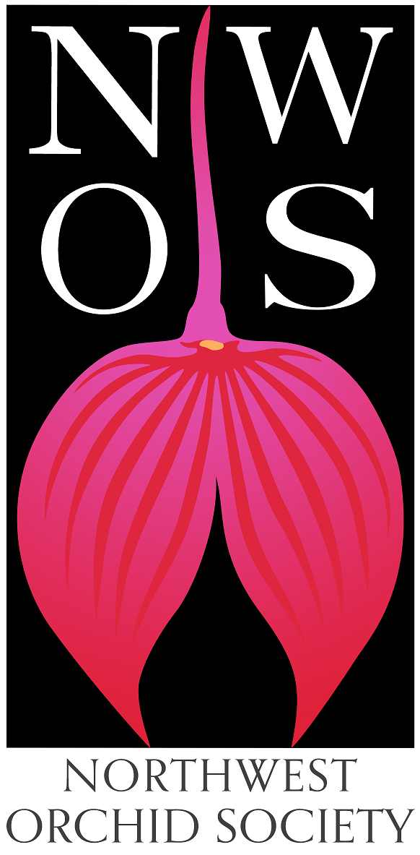
Northwest
Orchid News
March 2022
Volume 75, Issue 3

- About the March Meeting
- Annual Orchid Auction and Preview Party
- It’s time to renew your NWOS Membership in order to sell plants
- NWOS Annual POTTING CLINIC
- Volunteer Positions
- Help Needed for NWOS Scholarship Criteria Review
- A Huge "Thank You" to all Flower & Garden Festival Helpers
- Are You Missing an Orchid?
- What About Next Year?
- Mount Baker Orchid Society Show
- Invitation to Participate in the Five Cities Orchid Society Meeting
- Spokane Orchid Society Show April 9-10
- Orchids: Hidden Stories of Groundbreaking Women
- Report From The February Meeting
- Schedule of Upcoming Events
- Reminder for Officers & Board Members
- NWOS/Amazon Shopping Link
- NWOS Website Links

About the March Meeting
March 14, 2022 7:00 PM
Room opens at 6:00 p.m.
Preview Party starts at 6:30 p.m.

University of Washington Center for Urban Horticulture
3501 NE 41st Street, Seattle, WA 98105

Hybrid Meeting, In person and via Zoom Zoom Registration

We will be meeting in person for the foreseeable future. The Covid protocol for the meetings will be shared monthly for attendees and is available at our web site located here: Covid Response – Northwest Orchid Society (nwos.org)

Masks are required.
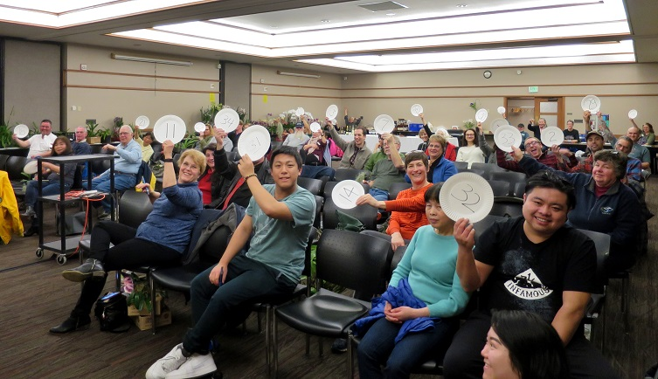
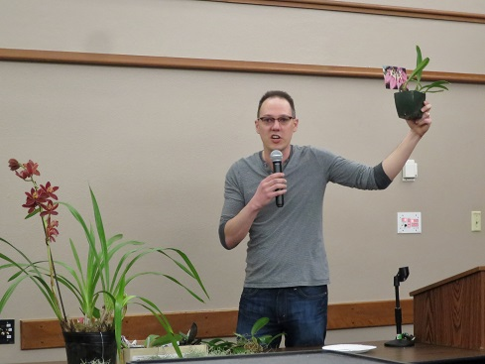

Annual Orchid Auction and Preview Party

The Northwest Orchid Society's biggest orchid selling and buying event outside of our show, this is a chance to find some select plants, sometimes at a great price. And even if it's not dirt cheap, it goes to a good cause. This is also a chance for those with burgeoning collections to winnow out the surplus, earn a few bucks, and make room for new acquisitions. Consider selling plants that you've nurtured, but haven't been able to get to bloom. You can then use the proceeds to buy something that may do better for you.

Bidding: Register when you arrive and get a bidding number to use during the auction. Keep your paddle moving, and after the auction you will use the same number to pay for your winning bids. We can process VISA/Mastercard transactions along with cash and checks.

Selling: Each Current Member may bring up to five plants to auction off, with the NWOS taking a 20% commission. There is no limit on the number of plants you may auction at a 100% donation to the Society. If you have not yet renewed your membership for 2022, please check out the Membership Renewal Reminder article below for details.

Photos: If you have digital photos of the flowers for the plants that you are selling, they could be projected on the screen behind the auctioneers. Hopefully it will work and will help the bidders better visualize what the plant will look like. Send the images to photos@nwos.org.

Registration: To register your plants, please print the Auction Form. Complete both the left and right sides, and bring it with you to the meeting and keep it with your plants. Make sure to mark ONE fund of your choice. SPECIAL NOTE: If you select more than one fund or fail to select a fund, the 20% society commission will default to the General Fund.

There are five fund choices and you must choose ONE of them:

• The Library Fund is used to purchase items for the NWOS Library.
• The UW Greenhouse Fund is used by the U.W. Botany Greenhouse to purchase Species Orchids.
• The Zoo Fund is used by the Woodland Park Zoo Greenhouse to purchase Orchids for display in exhibits.
• The Scholarship Fund provides a grant each year for a college student working on an Orchid related project.
• The General Fund covers everything else, from the programs to the everyday working of your society.

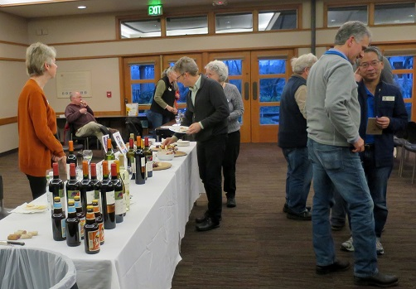
This Auction is the only source of funding for the Library, UW Greenhouse Fund, and Zoo funds. The Scholarship Program receives additional funding from the Raffles held at most meetings.
Preview Party:

We will again have our very popular wine and cheese preview party, hosted by Peter and Kelley Maunsell. There will be refreshments, including a special selection of beverages. Non-members are welcome, but only members and their guests can be served alcoholic beverages.

The room will open at 6:00 pm so you can come early to organize your plants and help with setup. The party will start at 6:30 pm. A brief meeting followed by the auction will start promptly at 7:00 pm

NO Display Table, Sales Table, Raffle or Library this month!

It’s time to renew your NWOS Membership in order to sell plants at the Auction

Non-members can buy plants, but only current Members can sell plants at our annual Auction event. It's time to renew your NWOS membership for 2022. Our membership period now goes by calendar year (Jan. 1 to Dec. 31). You can pay at most meetings by cash, check, or debit/credit card. Click HERE to pay online using Paypal on our Membership page.

You may also mail a check (payable to NWOS) to PO Box 51021, Seattle, WA 98115-1021.

New members may wish to complete the Membership Form and send it to the address above.

Dues are $30 for one person or $40 for two people at the same address. We also have a Youth membership of $15 for one person aged 22 or under. Dues are kept low to encourage membership but they cover only a small portion of the society's expenses.

Each single, dual and youth membership person will be considered an individual full-fledged member entitled to all privileges and benefits of the society (Members-only area of the website, voting, Holiday gift plants, sell plants at meetings/shows/auction, members-only summer BBQ, etc.).
Please contact Mike Cory for questions about your dues.
NWOS Annual POTTING CLINIC

VOLUNTEER PARK CONSERVATORY

Sat, Mar 19 from 11 am – 2 pm
1400 E Galer St, Seattle, WA 98112

Bring up to three average sized orchids to our Annual Potting Clinic at the lower greenhouse at The Volunteer Park Conservatory

Follow the driveway to the right of the main greenhouse down to the lower greenhouse.

Admission is Free for NWOS members and $15 for non-members, which can be applied towards becoming a member.

This clinic has always been popular. Our most experienced members give expert advice on all aspects of repotting your orchids:

- Determining whether and when your orchid needs to be repotted. This can vary by species and time of year.
- Diagnosing potting problems, such as root loss and decomposition of potting mixes, overpotting and under-potting.
- Choosing the right pot type and size.
- What’s the best potting mix for your particular orchid.
- Can it be mounted?
- How your environment and watering habits can affect these choices.

Come with questions, get some answers. Bring up to three plants. Then add some hands-on experience, with guidance from our volunteer members.

Potting media and some pots will be available on site. It’s a time of fun and learning, and your orchids will thank you.

Masks are required.

Volunteer Opportunities

There are lots of choices for participating and helping our society utilizing different skills, interests and available time.

- Potting Clinic Volunteers - We need volunteers for the potting clinic Saturday March 19th at Volunteer Park from 11AM to 2PM. If you are interested in helping please send an email to, volunteers@nwos.org
- Plant Table Photos - We need someone that will take photos of all the plants on the plant table along with their names and collect the sheets and then pass that along to the Communications Committee for the Newsletter and the website.
- Photos in General - We need everyone to send in your photos of events, it’s a lot more enjoyable if there are pictures of what was happening when we are all together, so send them in, photos@nwos.org.
- Scholarship Committee - We need a couple of volunteers to help Kathy Murray review the scholarship criteria. See the writeup below.
- Website Maintenance - We need someone that wants to help manage the society website. This includes building posts and pages in Wordpress, etc. There is plenty of love to go around with this one.

Gary Baker Service Award
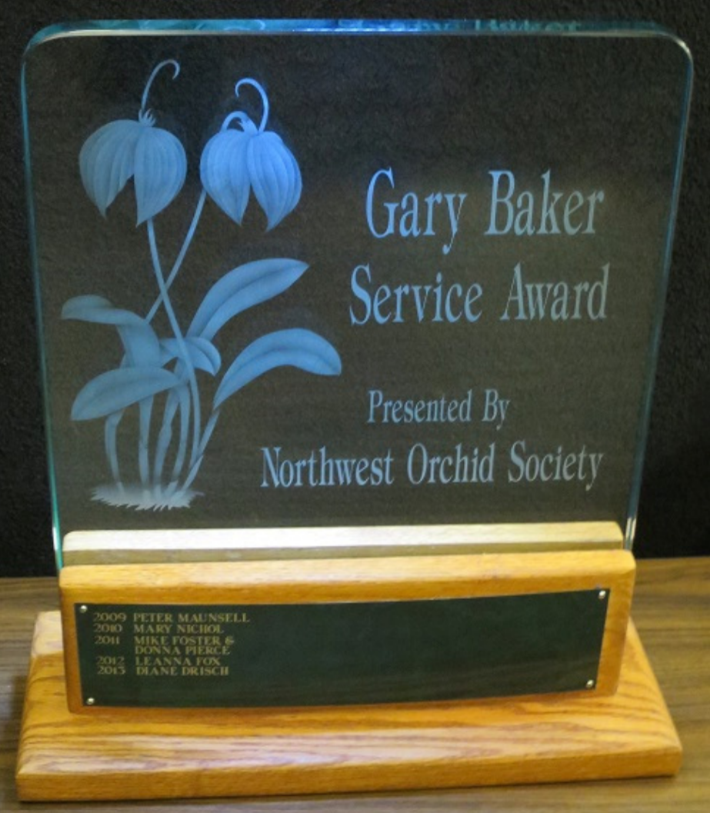
Gary Baker was a long term member of the Northwest Orchid Society. As with another member of our society, Rebeca Northen, Gary has contributed significantly to the orchid world. Gary was a hybridizer with the Beall Orchid Company for decades where he produced many famous crosses, some of which are foundations of orchids still in production today. Later in life he would open a nursery in Woodinville that many of us visited, Baker and Chantry.
There are six hybrids named after Gary, and a Miltoniopsis hybrid with a clone named after Gary.

This award is given annually to the person who has contributed the most to the overall goals of the society in the prior year. The recipient is selected by the board from nominations made by the general membership. Honorees are presented with a crystal perpetual trophy engraved with their name.

At this time the society solicits nominations from the general membership. If you have someone that you would like to nominate for service during the past year, please fill out one of the following forms and return it to Ben Johnson via email.

Gary Baker Service Award - Nomination Form - Word
Gary Baker Service Award - Nomination Form - PDF

Formation of Scholarship Criteria Review Committee

The NWOS has offered scholarships to students in 2 and 4 year institutions, in the Pacific Northwest for orchid related research. Unfortunately, there have been declining research proposals and a failure to complete the research in some cases.

Kathy Murray has been asked by The Board to form a committee to review the processes and criteria for granting our annual scholarships. The purpose of this is to reimagine what can be done with this scholarship.

This is your opportunity to help shape research in a field for a hobby that we are all so passionate about.

Kathy needs at least two volunteers to help shape that vision and provide recommendations to The Board. Please reach out to Kathy Murray, the NWOS Scholarship Chair, at her email address: Riverhaven203@gmail.com

A Huge "Thank You" to all Flower & Garden Festival Helpers
The 2022 NW Flower & Garden Festival is over for another year. The garden was enjoyed by all and we received numerous positive comments and suggestions for future gardens. Hartley-Botanic staff were overjoyed with the garden and their greenhouse stocked with colorful orchid blooms of much variety.
It took us about 30 hours to build this garden over 3.5 days with its numerous (unplanned) wall changes and about 9 hours to dismantle it to the bare floor.
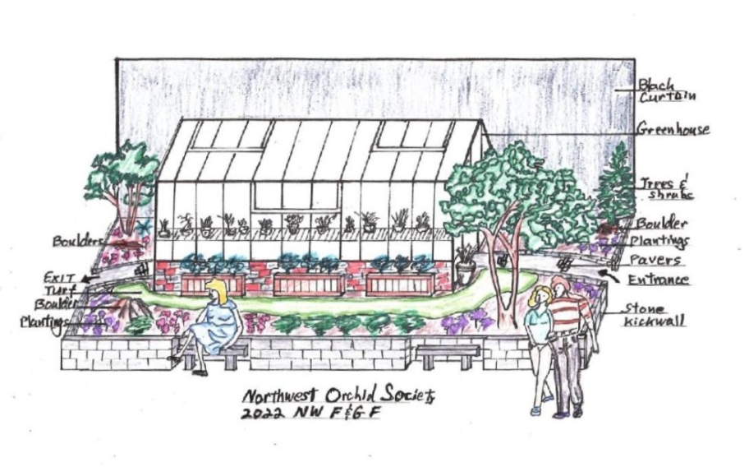
I want to thank Gordon Cromwell for the hours and hours spent drawing up detailed plans of the garden with measurements. It helped to have those drawings to figure out where the walls started and the pavers began, where the greenhouse knee wall was placed, the rock placements, and even where the foliage and orchids would go. Gordon's 94 year old mother, who graduated at age 75 from the UW Landscape Architecture program, made the drawings detailing what our garden would like from a front side view along with an overhead view. In addition, Gordon spent hours visiting and talking with the Mutual Materials and Marenakos Rock Center people about the number of pavers, granite bricks, and boulders needed. He even ventured to Marenakos several times with me in tow to pick out the exact boulders we wanted to place within the garden. Back in October and November, Gordon filled out and submitted on time all of the various forms detailing our garden and its construction. There are about 15 such forms for PR, vehicle move-in and move-out logistics, garden name and details of how much sawdust and electricity is used to name a few. Thank you, Gordon, for all of your help, phone calls, emails, and support in building our garden.
I want to thank our "moss collection" crew - George & Cylvia Grantham, Deb White, Lillian Otani, Bruce & Christiane Ulness, and moi. It turns out we collected just the right amount to completely hide every pot, pot rim, and area of sawdust and dark mulch within the garden. We even had leftovers for tucking into cracks among the pavers and brick walls, and for softening the edges of the pots that framed each greenhouse doorway. Well done! It took us about 2 hours to collect the moss in a steady downpour of rain and fill my van about 3/4 full. Unfortunately, I forgot to take pictures of our efforts, so someone will have to record those next year.
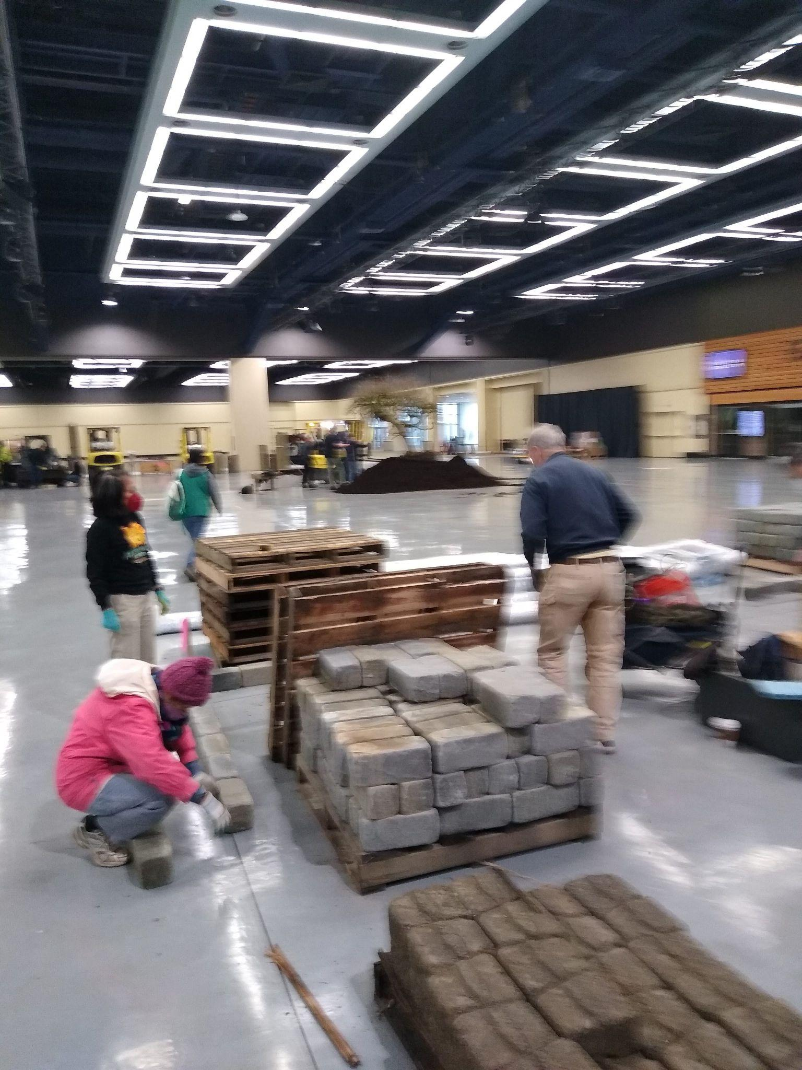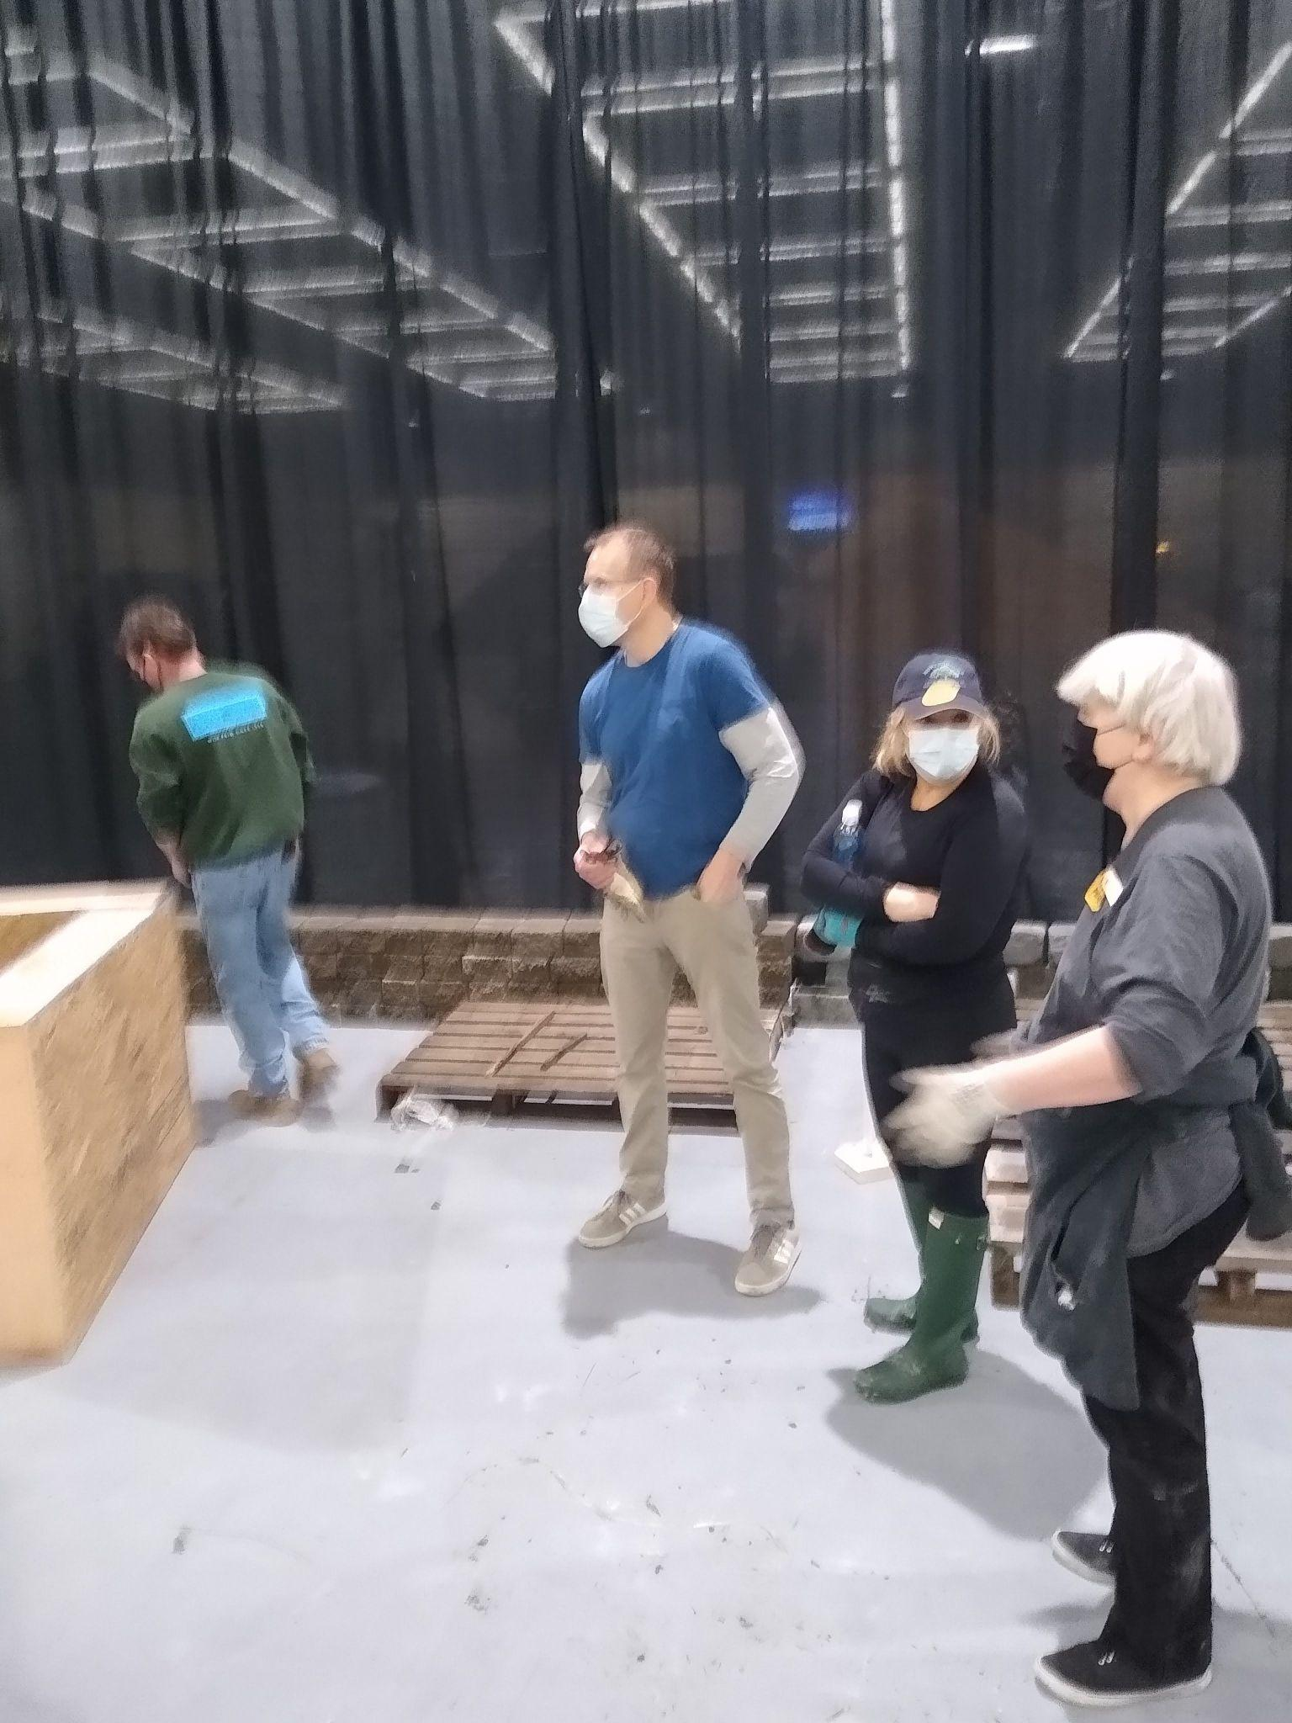
Super thanks to Deb White. She was there every day from Setup Feb 5 through Teardown Feb 13 including moss collection on Feb 3. She was very active engaging people during the Show, making sure they were from the Seattle area, and they knew of Mt Baker's show on March 5 & 6, our upcoming Auction on March 14, and our repotting clinic on March 19. Very few of the 2000 handouts remained at Show's end. Thank you, Deb!
I also want to thank the Horticulture students from Lake Washington Technical College in Kirkland. They provided needed help in building our garden, moving walls, planting foliage and orchids. We could not have done it without them! Thank you, students Ali Black and husband, Yulia, Charles F, Owen, Sarmeny, Marie, Stevie, Roseanne, Nickel, and their teacher / fellow NWOS member Elaine Sawyer.
Saturday, Feb 5 setup was done with help from Chona Horton, Ben Johnson, Maria Gerace, Lisa Ellis, Barb Roberts, Bill Leicht, Deb White, Gordon Cromwell, and myself. Thanks too to the Hartley-Botanic contractors!
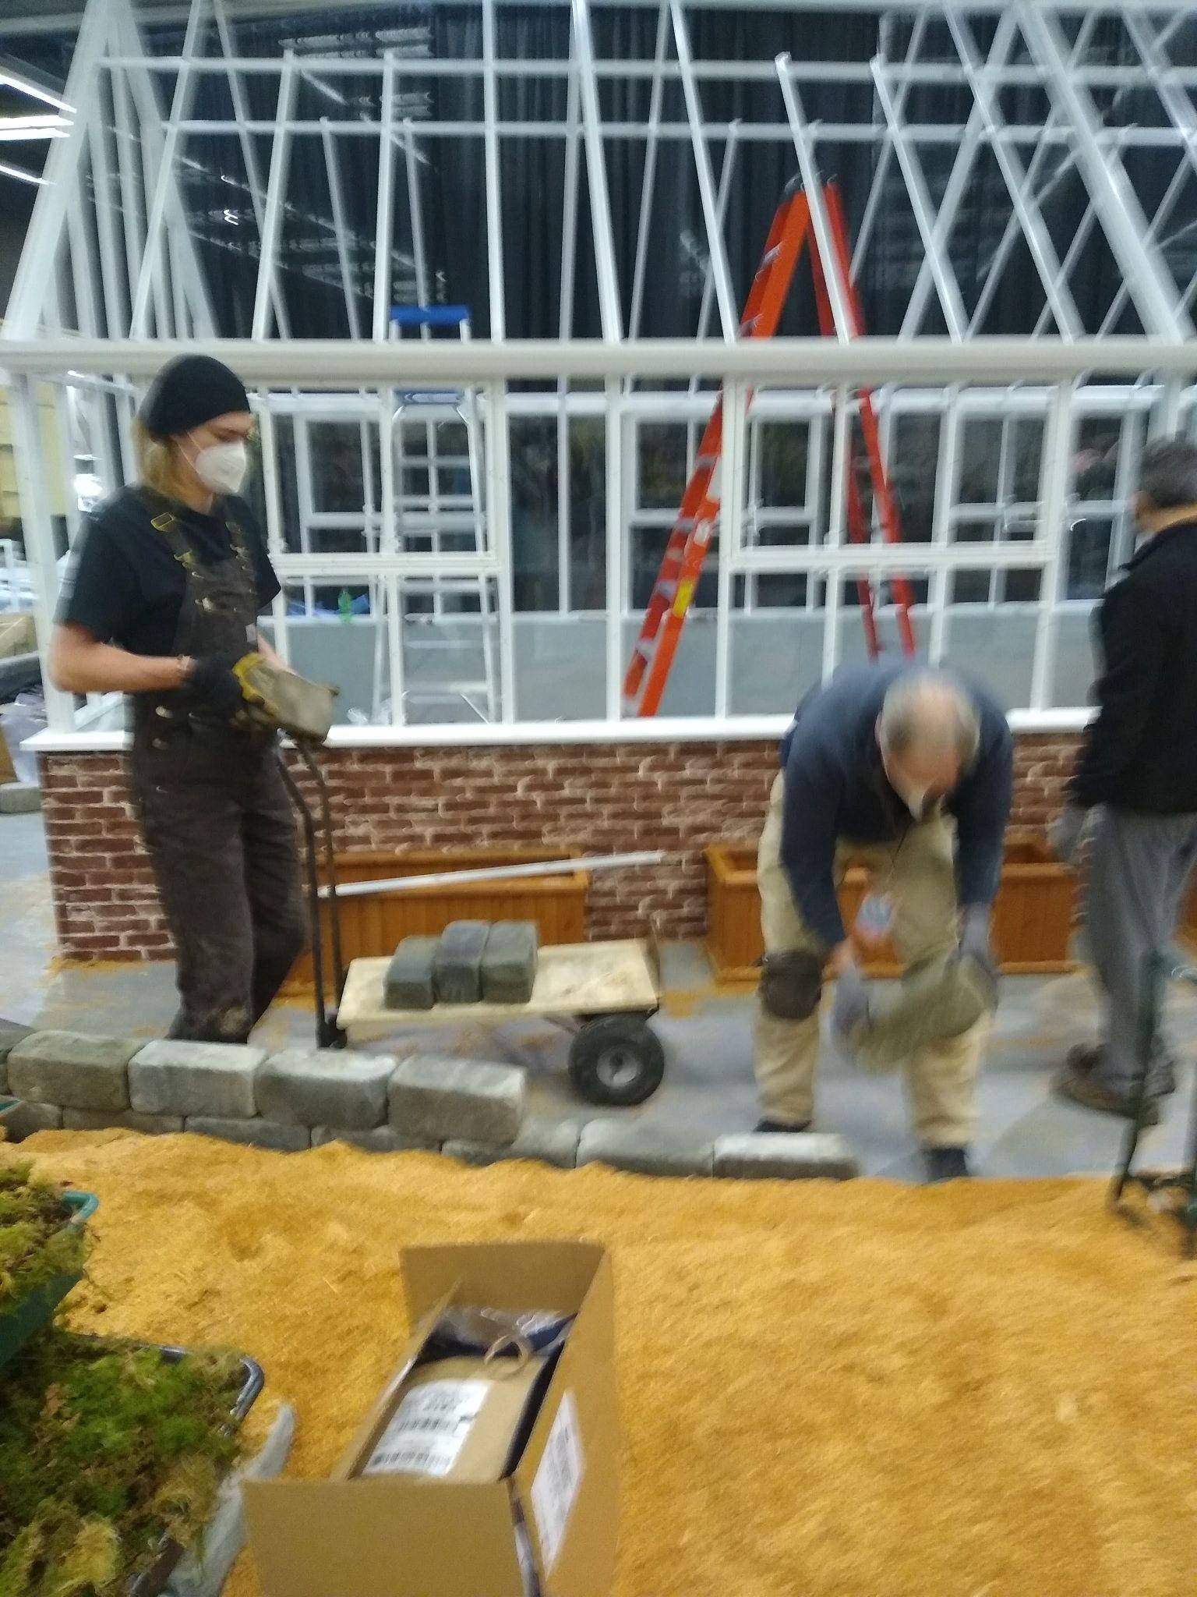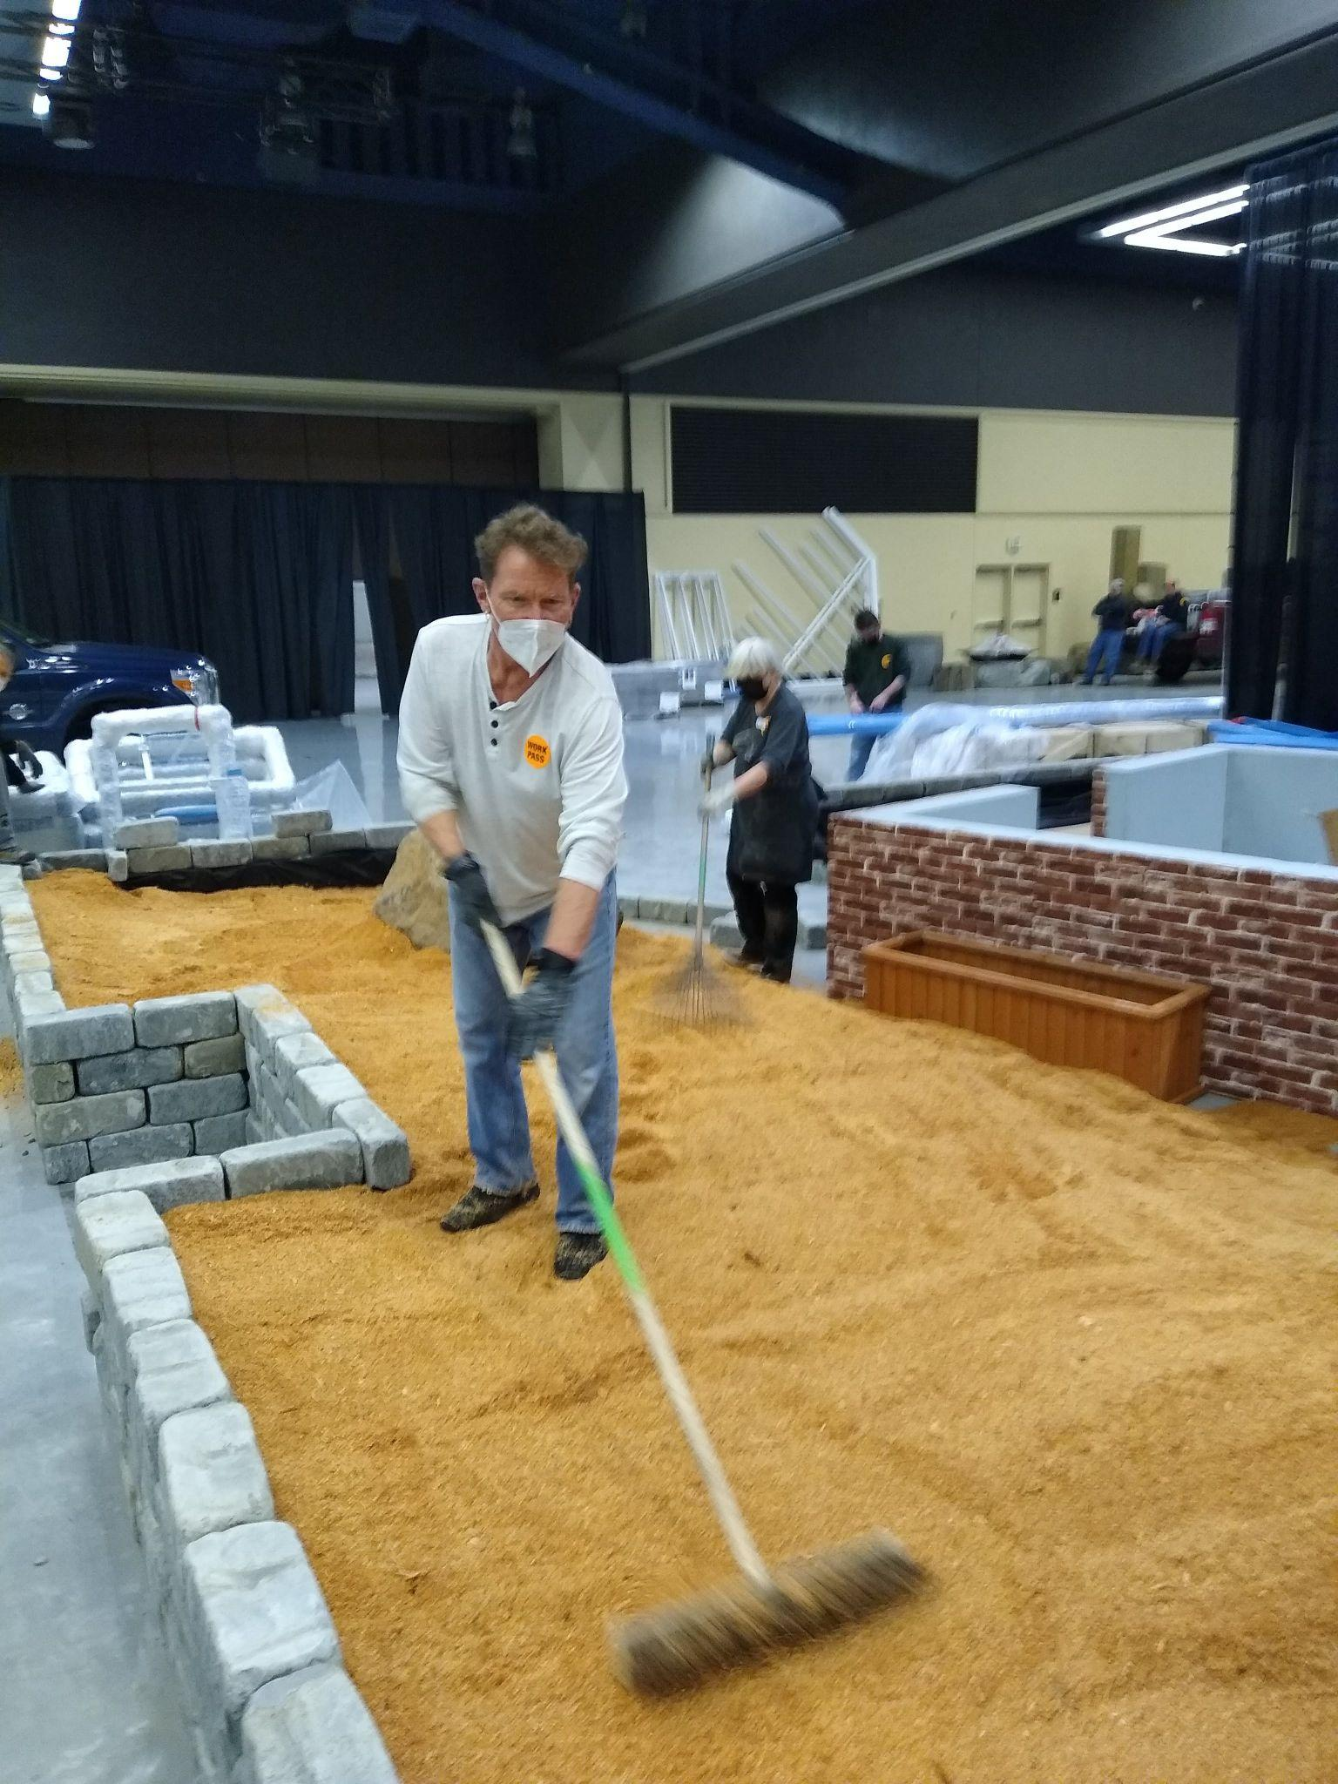
Sunday, Feb 6 setup was done with help from Lillian Otani, George & Cylvia Grantham, Maria Gerace, Bruce & Christiane Ulness, Ben Johnson, Isabel Lewis (a UW Landscape Architecture student recruited by Gordon Cromwell's mother "Jinx"), Deb White, Gordon Cromwell, Robert Culver, and myself. George Grantham did the honors of printing all of the plant tags seen within the garden and the orchids within the greenhouse. NWOS member and head of the Woodland Park Zoo's Horticulture Greenhouses, Katrina Lindahl, and Horticulture crew delivered 3 trucks full of foliage for our garden, several mounted orchids for inside the greenhouse, and two very large Dendrobium speciosum specimen in full bloom. Thank you, Katrina and David.
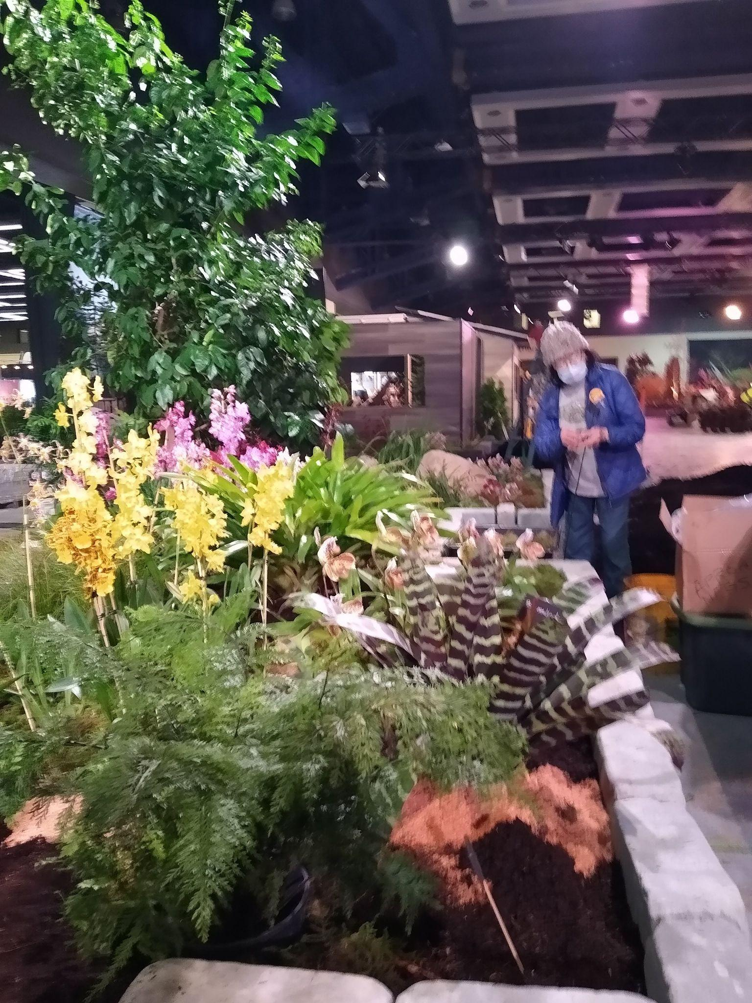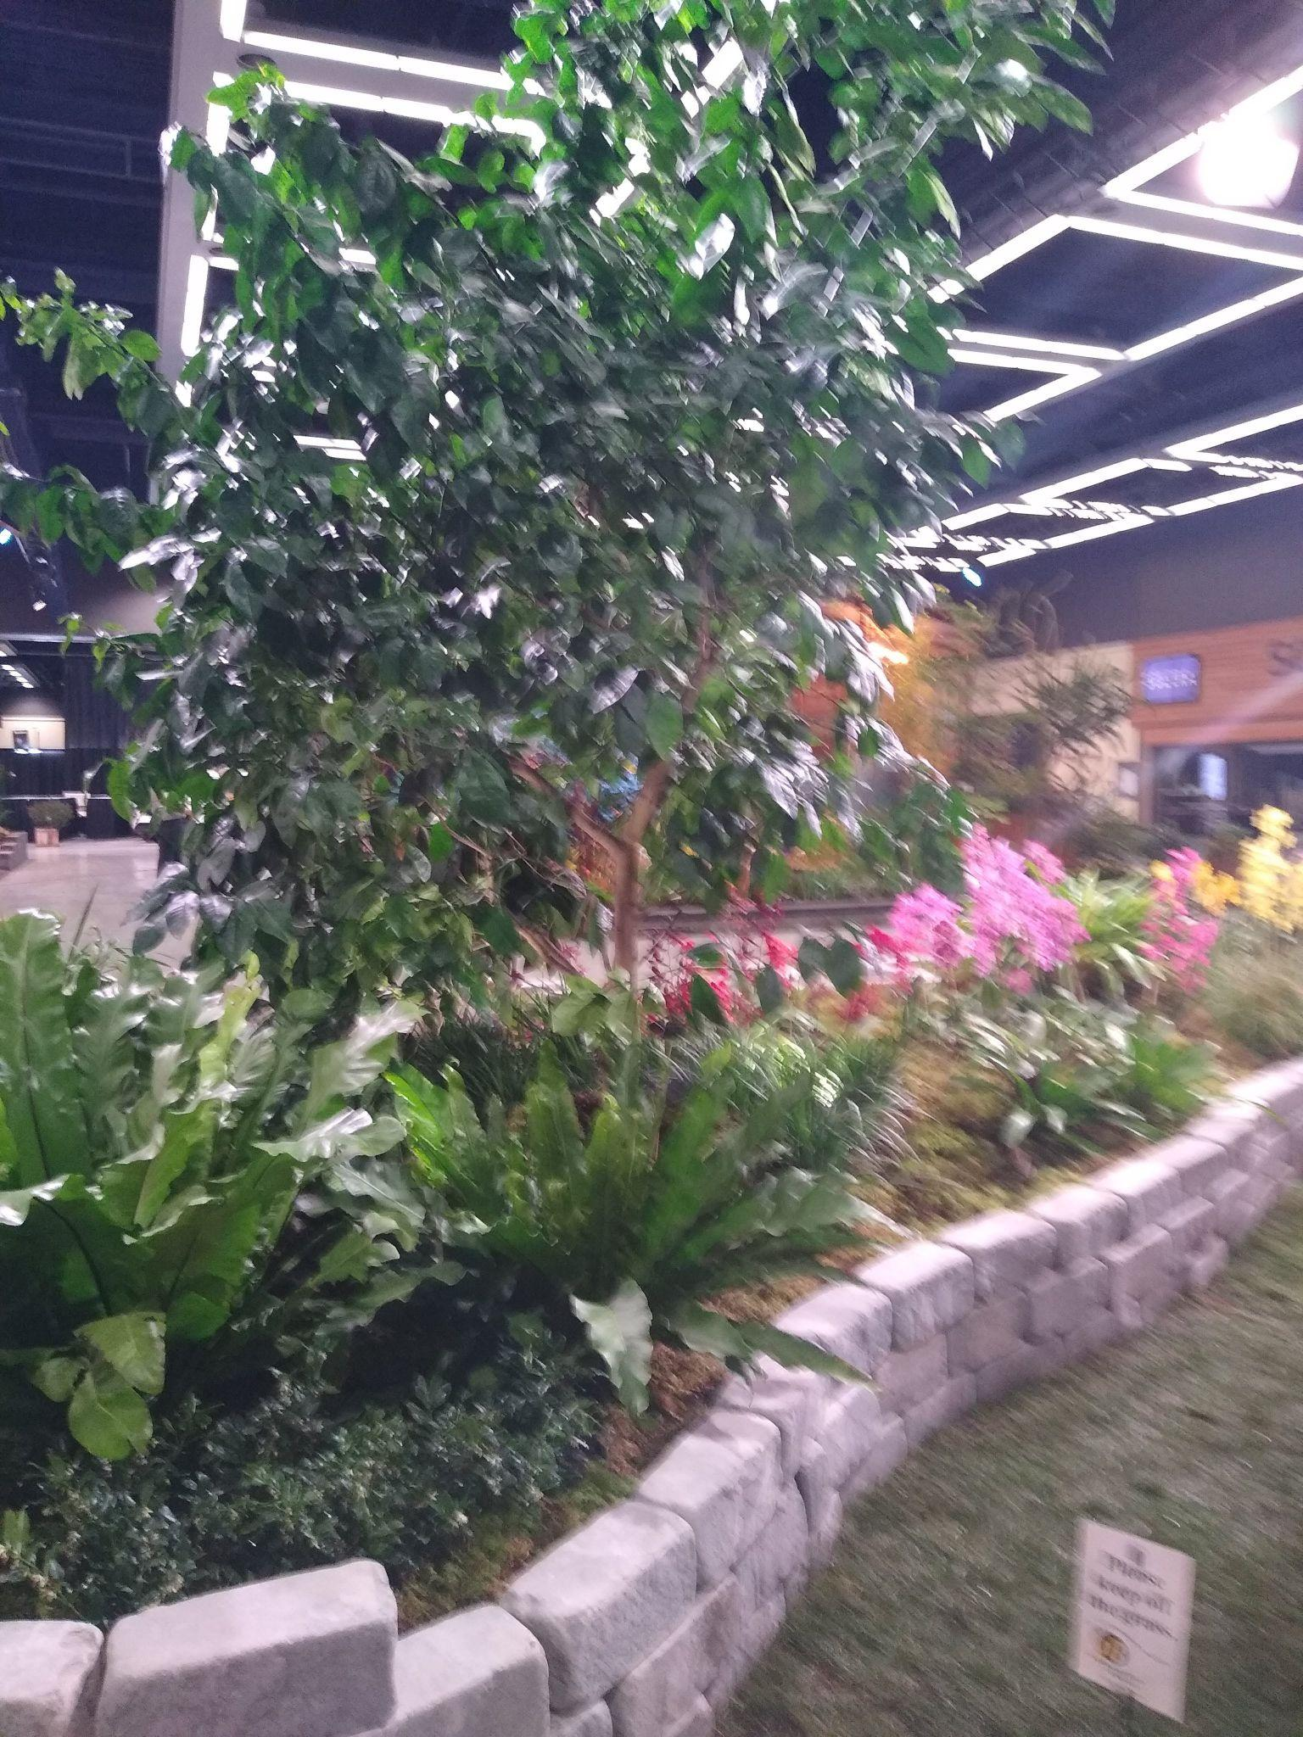
Monday, Feb 7 garden setup was ably built by George & Cylvia Grantham, Lillian Otani, Lynne Shandley, Abigail Chang and Mike Pearson, Yoshi, Nagamatsu, Thuan Nguyen, Isabel Lewis, Deb White, Gordon Cromwell, Robert Culver, and me. Special thanks to Abigail, Yoshi, and Thuan for organizing and installing the NWOS member plants on the benches within the greenhouse. The public loved the display of blooms! The Hartley-Botanic contractors finished building on Sunday afternoon and still returned to clean the windows inside and out on Monday. Thanks guys! The crew from Volunteer Park Conservatory (Mike Cory, Lillian Otani, and Pan Kantiyavong) arrived with 24 blooming orchids for the greenhouse.
Tuesday, Feb 8 gave us a few hours to do finishing touches. I watered all of the foliage and mossed any remaining visible pot rims and areas of visible sawdust, while George & Cylvia Grantham mossed, cleaned/trimmed foliage, and made sure the greenhouse orchids had legible plant labels. Deb White and Gordon Cromwell worked on mossing, cleaning the pavers, and installing the low-voltage spotlights and hiding the wires under the moss.
The Show opened on Wednesday, February 9, and while the foot traffic seemed light at first, there was a steady line of people waiting to view within our greenhouse from 9 am to 3 pm, and then intermittently through the rest of the day. Helpers were Lisa Ellis, Steve Dorsey & Lori Lederman, Thuan Nguyen, Bill Leicht, Abigail Chang & Mike Pearson, Lynne Shandley, George & Cylvia Grantham, Deb White, Gordon Cromwell, and yours truly. The Hartley-Botanic staff were ecstatic with our garden display. Gives me goosebumps just thinking of it.
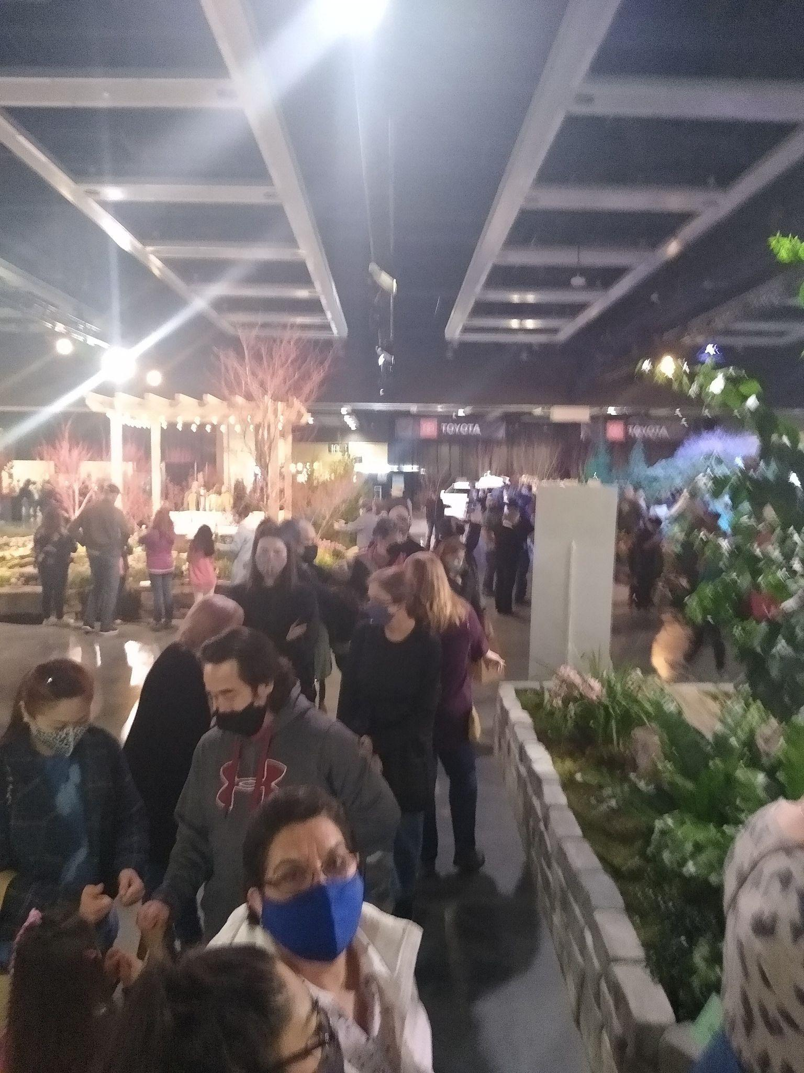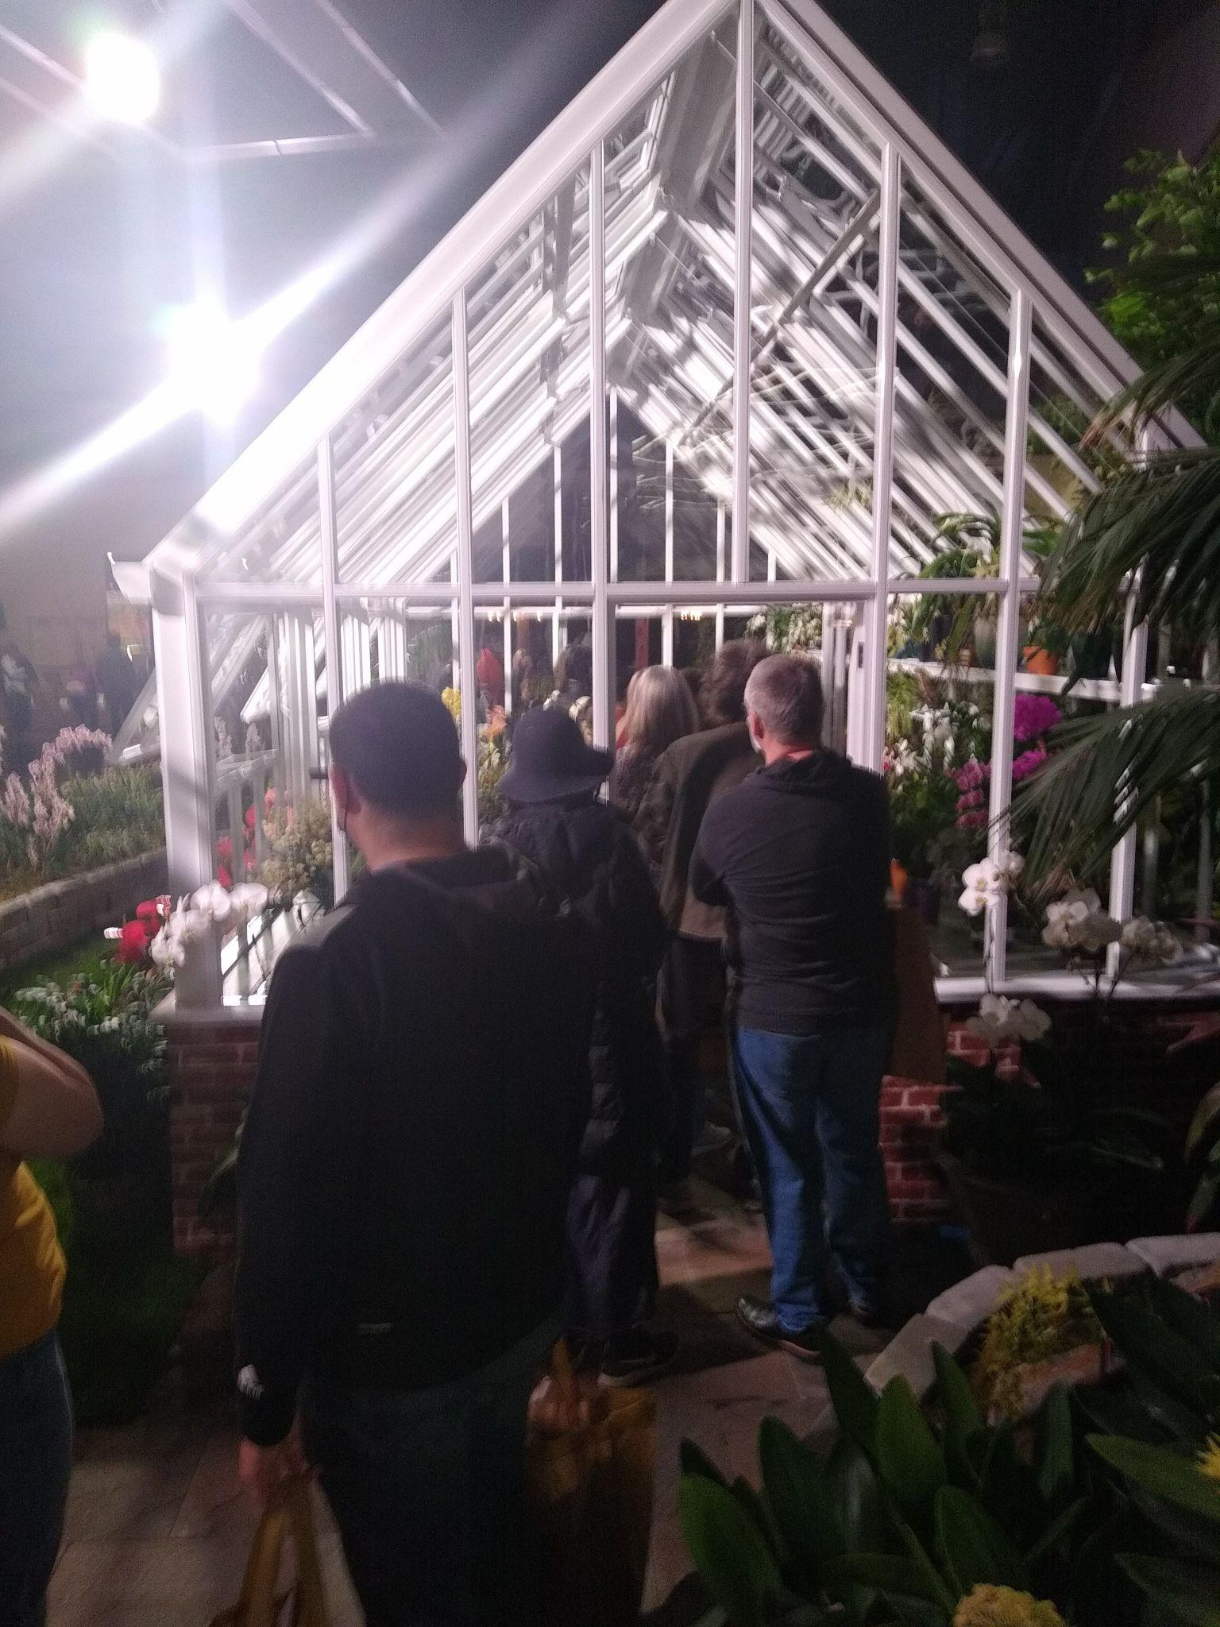
Thursday, Feb 10 helpers were Mike Cory, Lillian Otani, Pat Gossler, Kathy & Mike Murray, Bruce & Christiane Ulness, Yoshi Nagamatsu, Deb White, Chona Horton, and myself.
Friday, Feb 11 helpers were Mike Cory, George & Cylvia Grantham, George Krasle, Deb White, Gordon Cromwell, and myself. Thankfully, foot traffic was relatively light but there always seemed to be a line of people waiting to walk through the greenhouse. The Hartley-Botanic people mentioned overhearing some people say "I don't grow orchids, so I don't need a greenhouse". As a result, should we do this collaboration again with Hartley, we need to stage the greenhouse interior with a bistro table and chairs or lounge chair along one side and other types of non-orchid plantings to give people the idea that the Hartley-Botanic greenhouse can be used for much more than just growing orchids. Many of Hartley's customers use their greenhouses as an extension of their living and entertainment areas and don't use the structures for growing plants. Sacrilegious, I know. <wink>
Saturday, Feb 12 helpers were Mike Cory, Pat & Dennis Gossler, Becky & Steven Schlegel, George & Cylvia Grantham, Lynne Shandley, Deb White, Gordon Cromwell, and myself.
Sunday, Feb 13 helpers were Mike Cory, Bill Leicht, Alan LaMont, Maria Gerace, Tom Donnelly, Thuan Nguyen, George & Cylvia Grantham, Abigail Chang & Mike Pearson, Lillian Otani, Deb White, Isabel Lewis, Gordon Cromwell, and moi. NWOS newsletter Editor Diane Drisch stopped by to take pictures and cheer us on as we began to dismantle the garden. Thank you, Diane!
Sunday teardown began at 6 pm, removing first the orchids from within the greenhouse. Then the moss was bagged and the orchids from the garden were removed to their respective trays. Same goes for the Zoo's foliage plants. Then pallets were unearthed and the granite bricks that made up our garden's walls began getting cleaned and stacked. The last brick was placed on its pallet around 10:30 pm. Thanks to all who helped teardown and stayed to dismantle the brick walls -- Barb Roberts, Thuan Nguyen, Abigail Chang & Mike Pearson, George Krasle and friend, Mary Nichol, George & Cylvia Grantham, Lillian Otani, Mike Cory, Tom Donnelly, Becky & Steven Schlegel, Deb White, Gordon Cromwell, and myself.
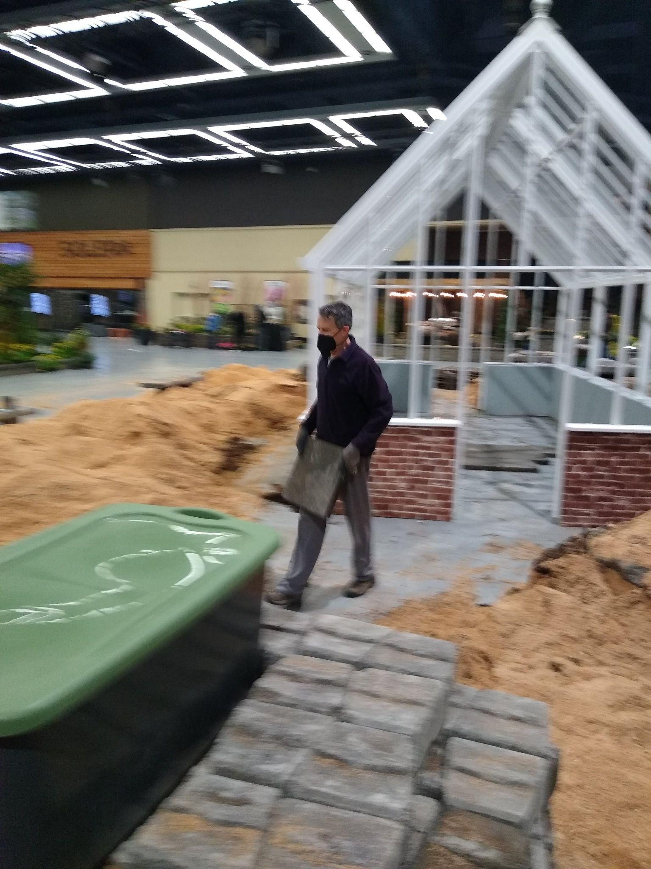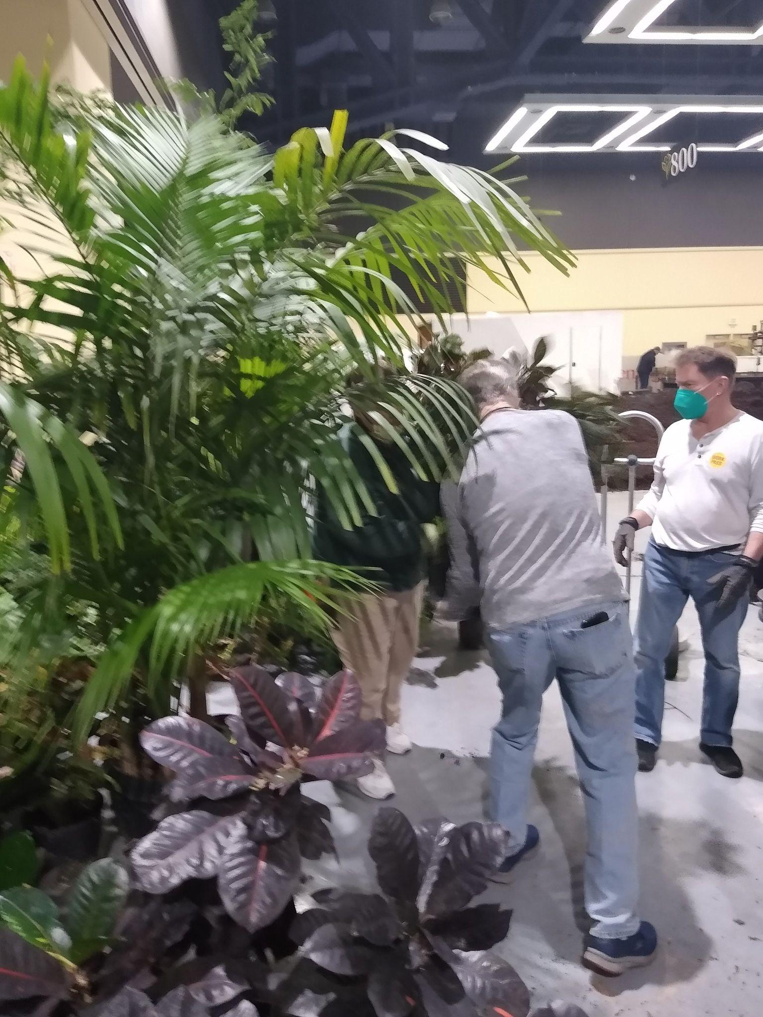
Monday, Feb 14 teardown began at about 7:30 am with the arrival of myself and Steve Dorsey. Steve single-handedly removed each of the 36-pound concrete pavers that made up our walkway through the greenhouse and put them on pallets. I seem to remember there were about 200 of them. By the time Gordon Cromwell arrived at 9:00 am, Steve was just finishing up and they both began unearthing the remaining buried pallets and the blocking underneath the boulders. At about 10:00 am, Nancy Wright's sister's husband and son (sorry, guys, I didn't note your names) arrived to dismantle the two stone benches and one-man stone "feet" to a pallet. Bill Leicht arrived to collect his two green ceramic pots we used for holding the palms at each end of the Anthurium planters. Those worked great, thank you, Bill. Then the Volunteer Conservatory crew (Mike, Lillian, and Pan) arrived to retrieve their flats of orchids. At around 11:00, Katrina Lindahl and the Zoo's Horticulture staff arrived to pick the bags of moss and the 3-trucks worth of foliage plants. We were out of there by Noon.
While I've listed those names who helped, I am sure that I missed a few in the process. Thank you to those people who helped but did not get called out. Your assistance with building, staffing, and tearing down our garden was most appreciated.
Also, I wish to thank Everyone who contributed their orchids to decorate the inside of our greenhouse. Thank you for labeling each of your pots with your name or initials and making the detailed listings of your plants as all of that sped up the grouping of your plants during teardown.
Special thanks to Robert Culver for the use of his 50+ Odontoglossums that just happened to open a week prior to the Show's setup. If it weren't for your Odonts and my ability to transport them, our front garden area would have looked pretty sparse with just 75 bulldog Paphs. Thank you for your efforts on ordering, securing, and tending the orchids we did receive, as well as navigating that pathway to and from the staging greenhouse each weekend to water and preen the orchids prior to the Show's setup. And for reminding said orchid nurseries of their promises to deliver blooming orchids for our garden.
Again, thank you to all of our helpers in designing, building, staffing, and dismantling our award-winning garden this year! Let's see what we can create for next year.

The Build and Teardown Progress - Gallery
A Walkthrough Of Our Garden At The Festival
Sean Hoyt’s Video Walkthrough
~ Joff Morgan
Are You Missing an Orchid?

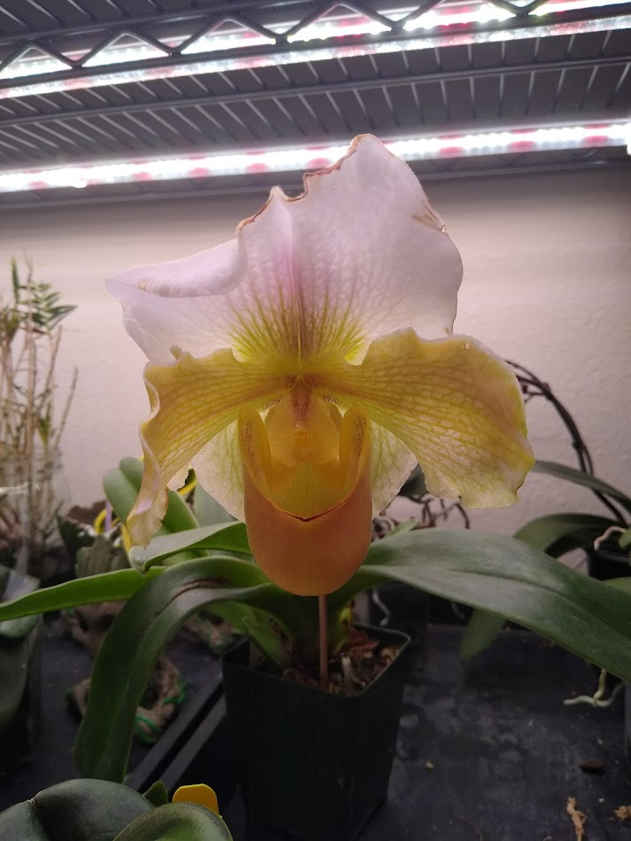
When dismantling the Greenhouse portion of our garden, on Sunday Feb 13 from the NW Flower & Garden Festival, one orchid remained unclaimed.
None of the owner plant listings had it and the owner's name / initials were not on the pot. Moreover, the owner was not present to claim it on Sunday evening nor on Monday's tear down. So the plant went home with me.
This mature plant is in a 4" green pot with multiple new fans emerging, so it will make a spectacular display next season. The plant has a tag with the orchid's name and parents, but no other info on the orchid's owner.
My contact information is in your Roster (login to our website, find the "Roster" under "Member Content") or send an email to FGS@NWOS.ORG with your contact details and include the Paphiopedilum's hybrid name or its awarded parent names to claim it as yours. Thanks!
~ Joff Morgan

What About Next Year?
Which of our NWOS members will band together to co-design an orchid garden for the 2023 NW Flower & Garden Festival? Gordon, Joe, Robert, and I wish to take a break from Garden Creation duty.
Someone, or several someones, will need to step up and take the helm to drive the garden and its ideas forward into 2023 and beyond. The time to begin thinking of a garden is anytime between now and June 30. Though I'd recommend the earlier the group can begin playing around with the overall theme and garden's design the better. The goal is to create the "illusion" of an established outdoor garden. In our case, those gardens made use of member orchids and tropical foliage. There aren't rules against using outdoor ornamental plants with orchid blooms as the colorful accents. Be creative and push the limits of what a "garden" is and can be. Just look at some of the other gardens that were near ours for inspiration and ideas.'
The NW Flower & Garden Festival is a huge money maker for the NWOS. Our garden efforts net a little over $6.00 per square foot before adding in the extras like a $600 credit on ornamental plants from T&L Nursery in Redmond and the $750 stipend for orchid blooms. The plants purchased with the credit and stipend are the Society's to keep or resell. We often resell these plants for extra income for the NWOS at sales and our March Auction.
Anyone who is interested, I can send the 2022 Handbook and Rules PDF document that all Garden Creators must adhere to in making their garden. Send me an email (I'm in the Roster) or send your request to FGS@NWOS.ORG requesting the 2022 Garden Creator's Handbook.
~ Joff Morgan
Mount Baker Orchid Society Show
By Ben Johnson
We had a great show, a large display with approximately 50 plants, submitted via 7 members.
Thanks to members who made the effort in showing their plants: Robert Culver, Ben Johnson, George & Cylvia Grantham, Andy Wright, Joff Morgan, Phuong-Thi Nguyen
Here are some pictures from the event. I didn’t hear how well attended it was, or how much membership was driven for the MBOS.
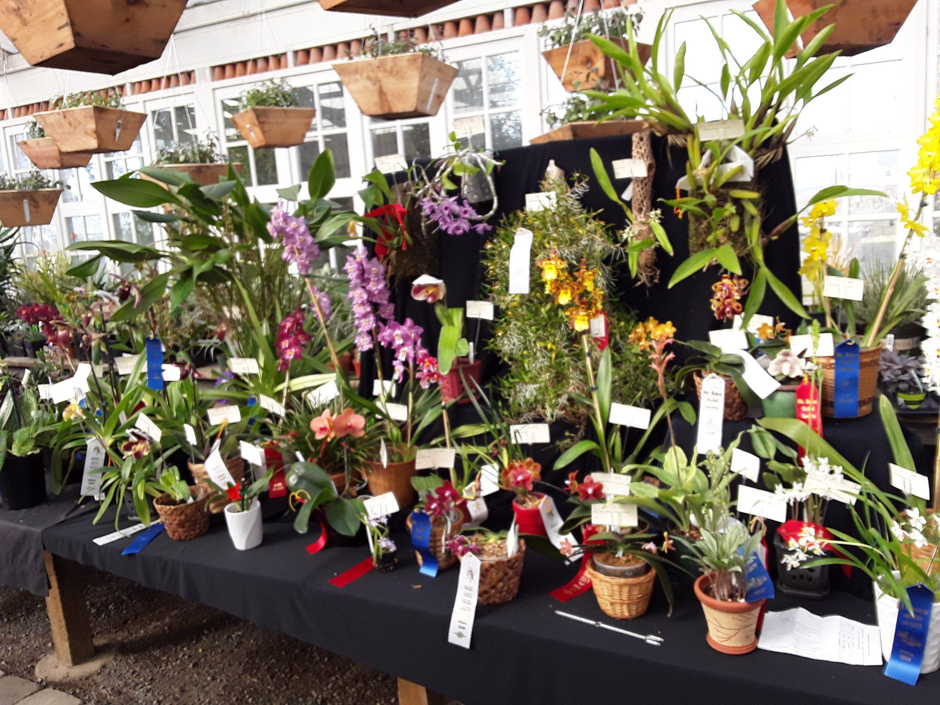
NWOS Table Display
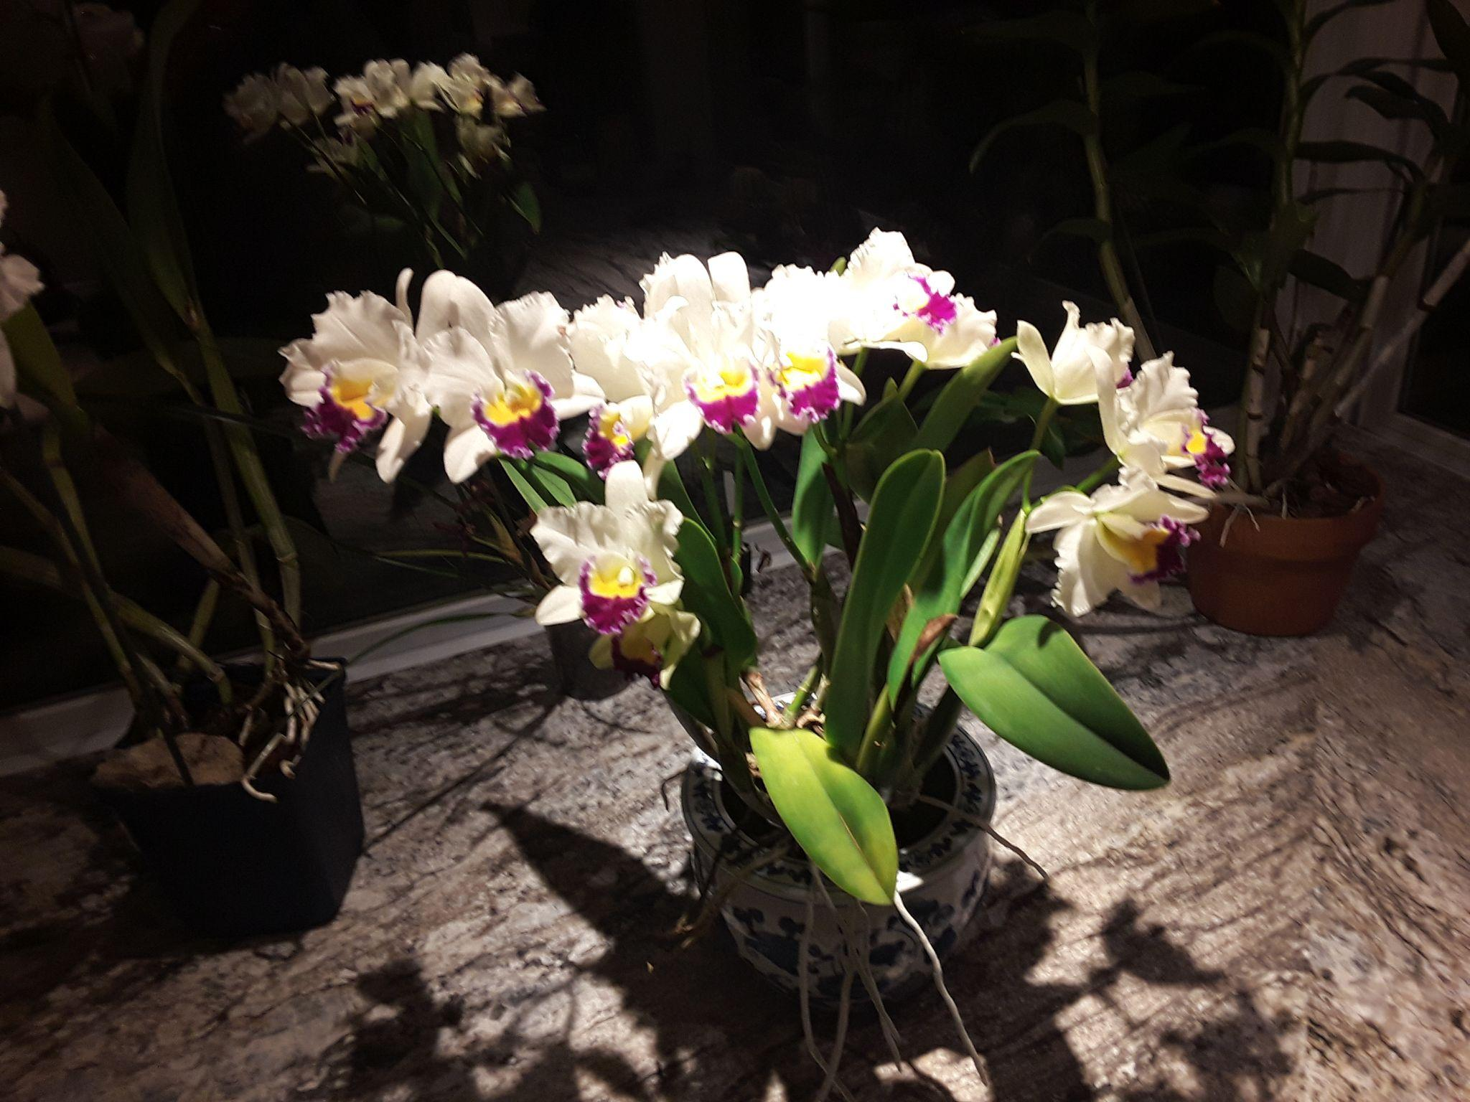
Blc. Catherina ‘Ogashima’, Phuong-Thi Nguyen
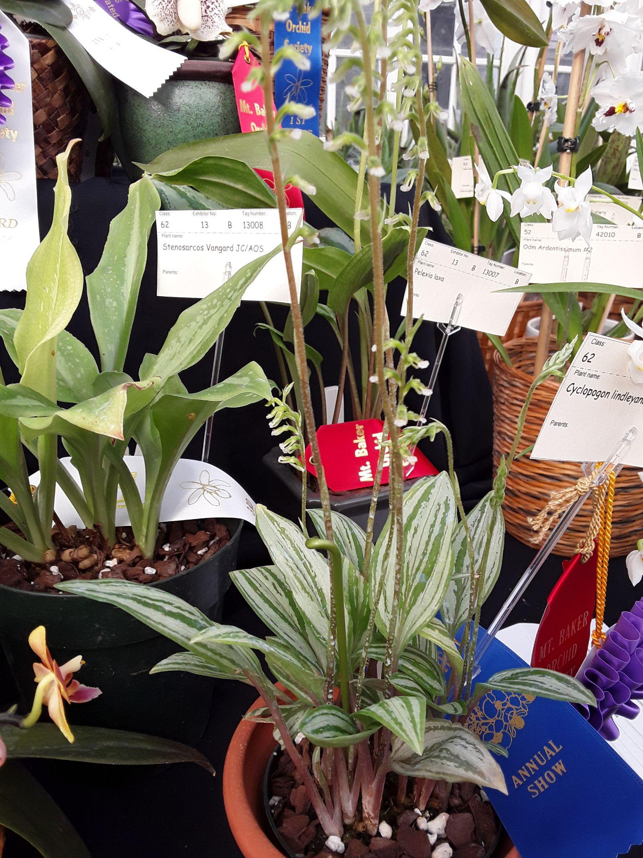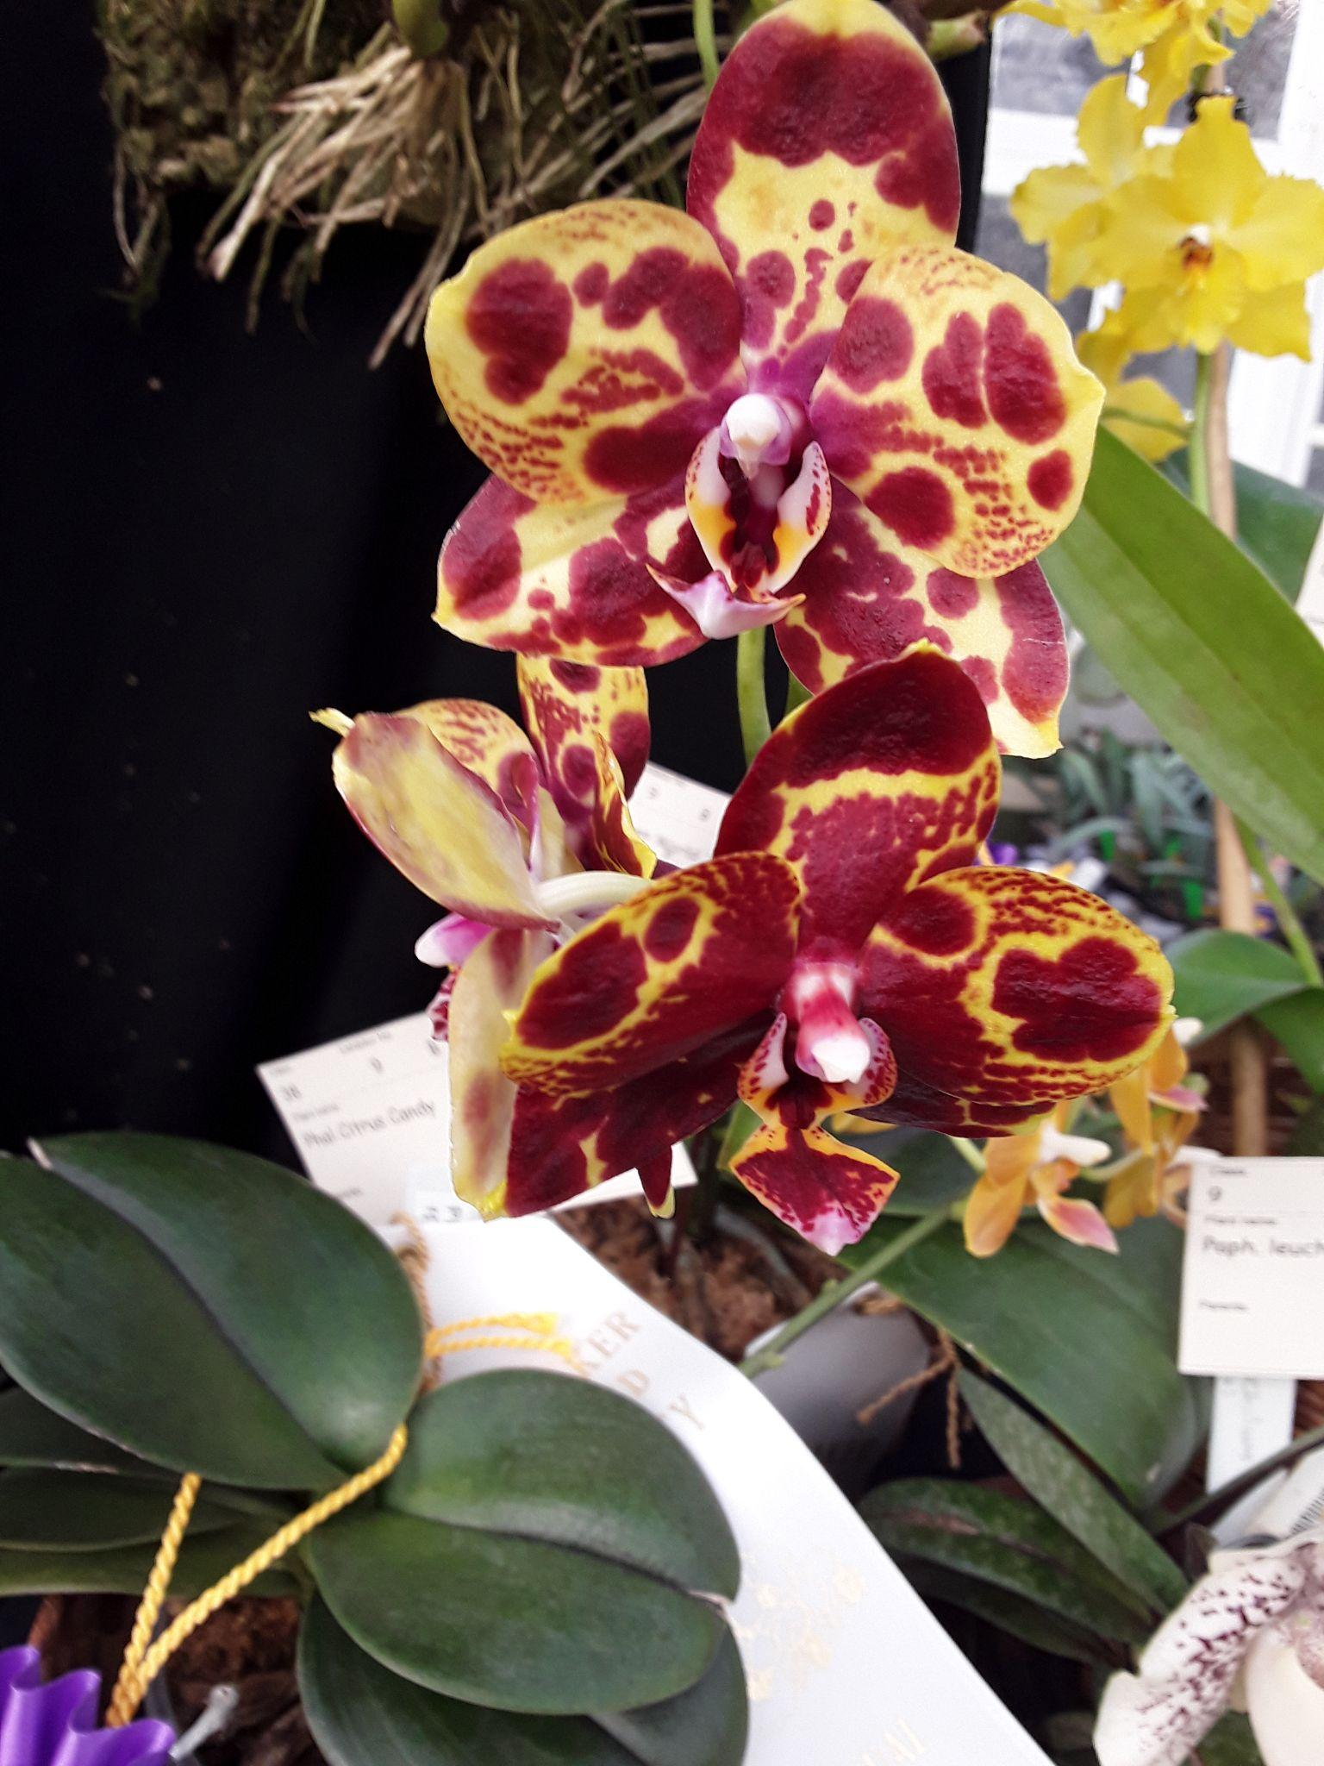
Cyclopogon lindleyanum, Cylvia Grantham Phal GW Green World 'Snakeskin', Joff Morgan
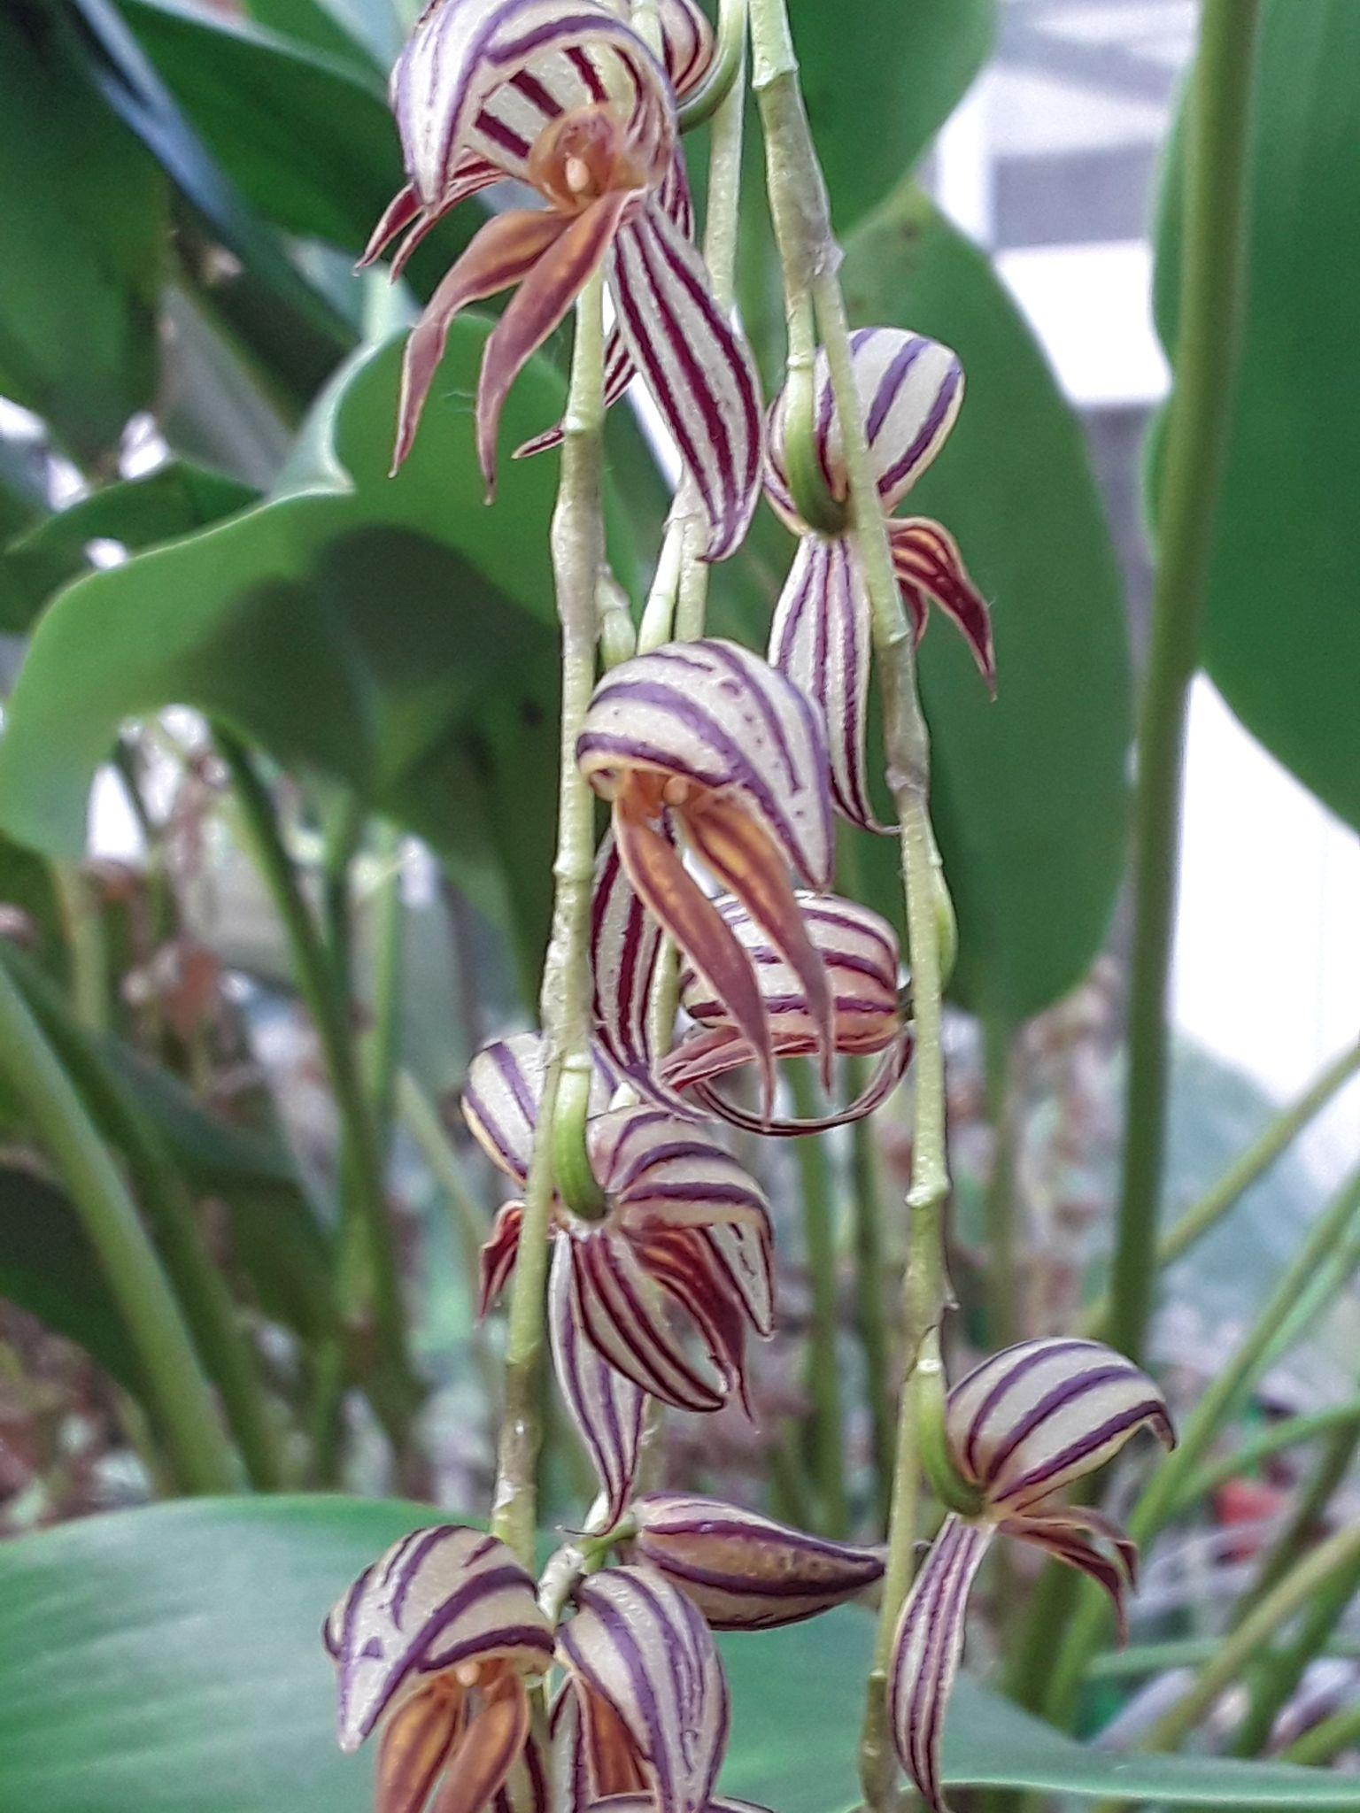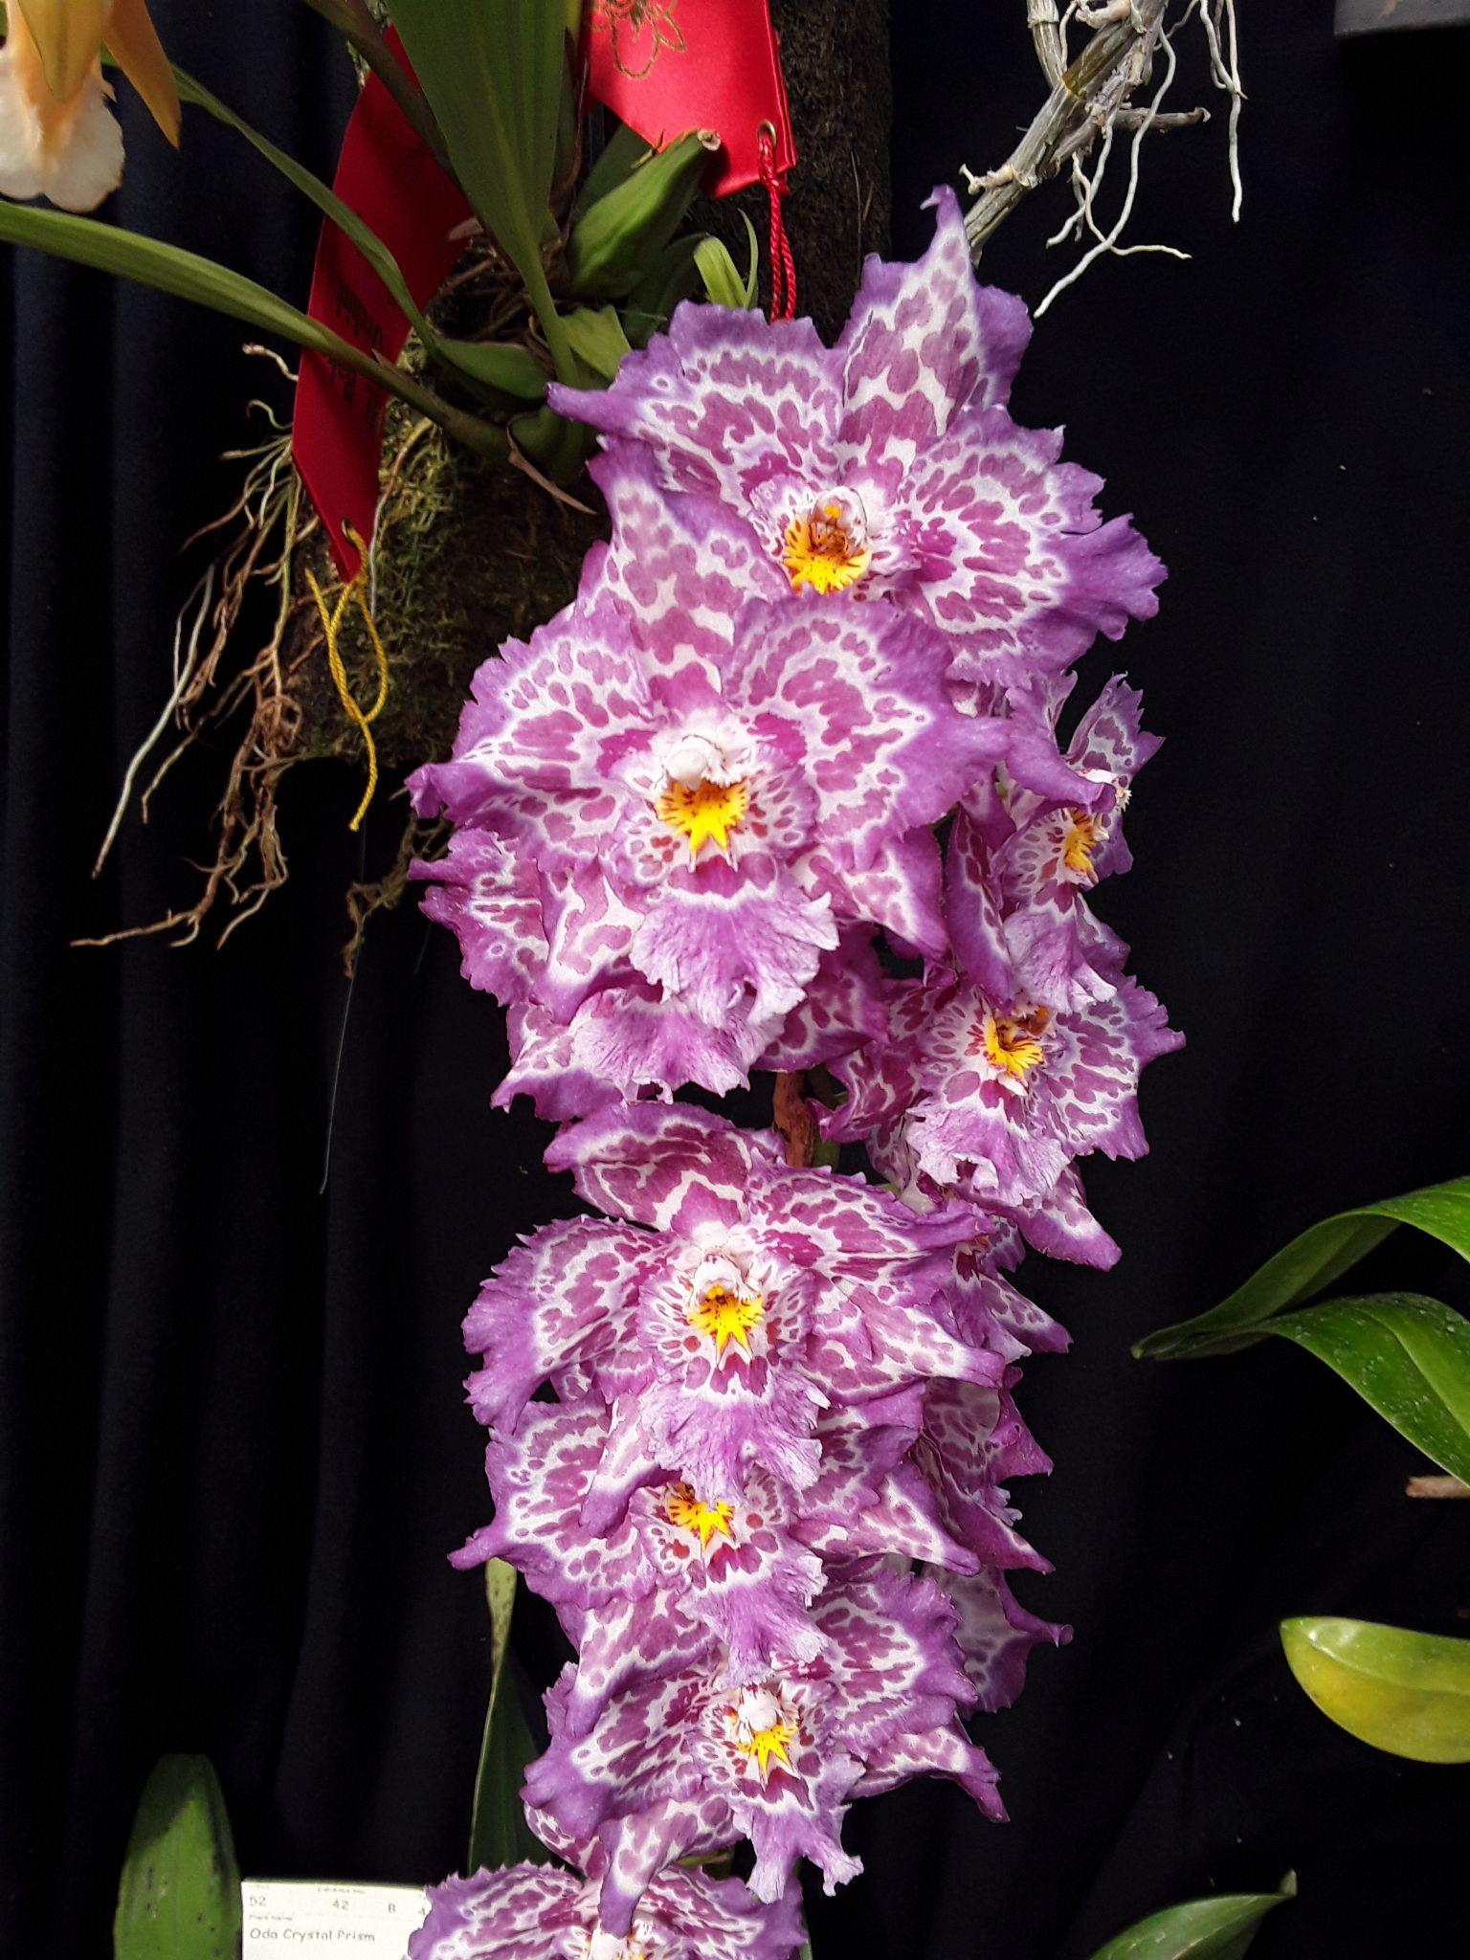
Pleur aff lamellaris, Andy Wright Oda Crystal Prism, Robert Culver
Full Show Report

Invitation to Participate in the Five Cities Orchid Society Meeting

Five Cities Orchid Society Presents:
Ron Parsons: Bulbophyllums and Other Strange Orchids
Thursday, March 10th, 2022 7:00 - 8:30 PM PST
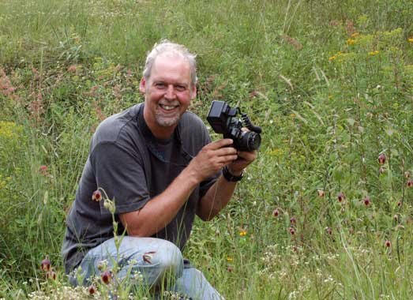
Explore the fascinating world of Bulbophyllums through Ron’s amazing photographs. Ron has traveled the world photographing orchids and he will present images of Bulbophyllums in their natural habitat as well as in hobbyist collections. Learn how to care for these mostly miniature orchids and determine which you should consider growing for your specific growing conditions.

Go to www.fcos.org/subscribe for free newsletter and link to the meeting.

Spokane Orchid Society Show April 9-10
The Spokane Orchid Society has invited us to participate in their 2022 Orchid Show and Sale. It will be held at the Spokane Community College, Lair, 1810 N. Greene St., Spokane, WA 99207. (Maps and directions will be sent out with electronic registration),
Setup and registration will be Friday, April 8, from 4:00-8:00 pm and must be completed before 8:00 am on Saturday. Orchids, educational displays, and artwork on the display tables will be judged and must be registered and labeled during this time. Advanced electronic registration information will be sent out in March.
This will be an AOS judged show. This will be a Bench Show.
For further show information please see the posting on the NWOS Site.

Orchids: Hidden Stories of Groundbreaking Women
Happening now through April 24, 2022

- Barrier-breaking botanists.
- Cutting-edge conservationists.
- Inspired illustrators.

Women have played many roles in the quest to
discover, document, and conserve orchids.

The popular annual Orchid Exhibition produced
by the Smithsonian Gardens
in collaboration with the United States Botanic Garden
runs through April 24, 2022.

This year, the exhibition showcases the work of
women who have enriched our understanding
And appreciation of orchids.

Click HERE to visit the Smithsonian Gardens' wonderful exhibit website with a virtual tour through the specific "planters" featuring everything from orchids in botanical art, to orchid science, and orchid horticulture.

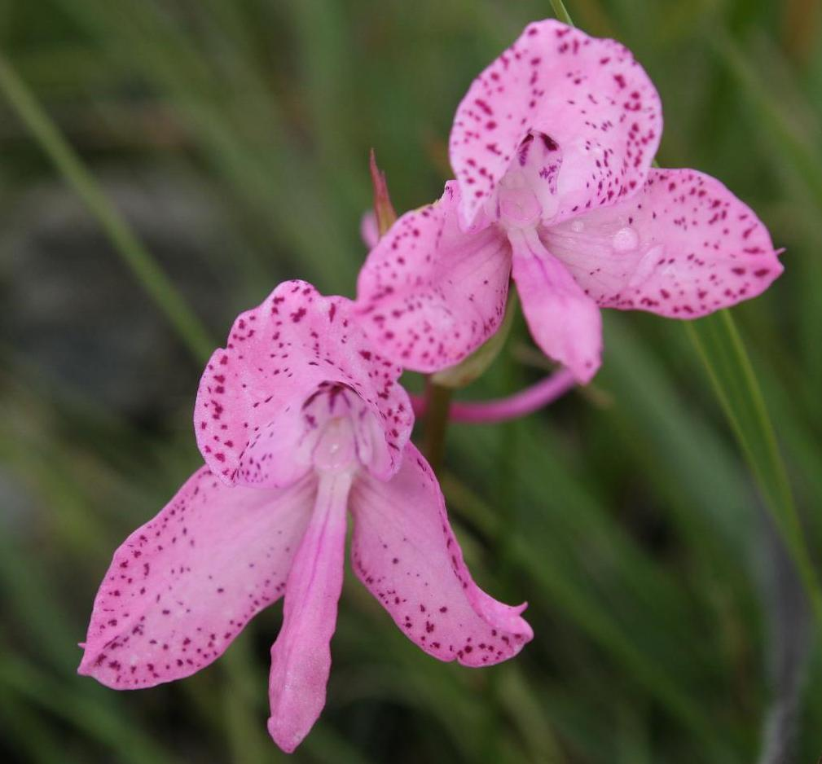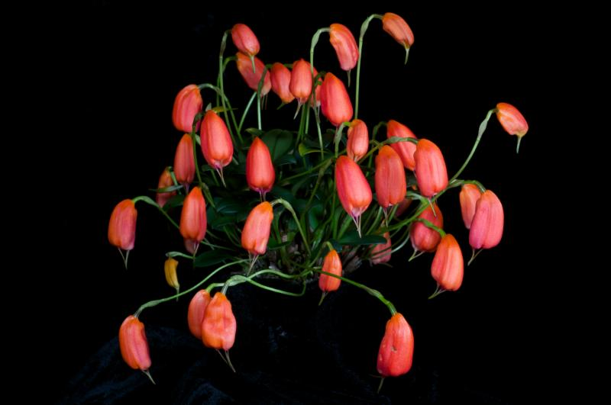

Thanks to our friends at Orchid Digest for sending us this message

Report From February Meeting

President Steve Dorsey welcomed people to our virtual Zoom meeting. He gave thanks for our recent beautiful and successful display at the NW Flower and Garden Festival. He gave special thanks to leaders Gorden Cromwell and Joff Morgan as well as all the volunteers who helped create, staff and dismantle the display along with everyone who lent their blooming orchids.

Steve then updated us on the upcoming Potting Clinic scheduled for Saturday 3/19, the Ecuagenera Pop-Up Event 3/5&6 and our upcoming Orchid Auction on Monday 3/14. He followed with a reminder to renew our membership.

Ben Johnson asked us to make nominations for the prestigious Gary Baker Award. He then talked about the upcoming Mt. Baker Orchid Society Show on March 5-6 at Christianson’s Nursery, Mount Vernon. Ben will be bringing our blooming plants to the show on Friday. He asked for additional volunteers to receive blooming plants from the membership to bring up to the show. Joff will be bringing the blooming plants from our NW Flower & Garden Festival display garden, so it’s a great opportunity to buy one of these beauties.
We then had our main presentation by Andy Wright on Orchid Culture. His presentation covered all the important points of good orchid growing. Andy started by asking us to understand what our specific plants need and what we can provide for them. He encouraged us to know what the natural growing conditions are for the various genera as well as for more complex hybrids. He also gave us an understanding of the basics of Orchid Culture: potting media, water, light, blooming, roots, growing container, fertilizer and pests. It was a well presented, enjoyable, and thorough review of all the best points for good growing and blooming.

After his talk, Andy took many questions from the audience. .He reminded us that our Library is a great resource. The conversation included a general chat about culture as well as specific issues and problems.

Robert Culver reviewed the virtual plant table. Thanks to everyone who sent photos of their blooming orchids for us to enjoy. These are some selected images from the February meeting. You can see the rest of the photos of February's plant table, please follow the link to go to the online gallery.

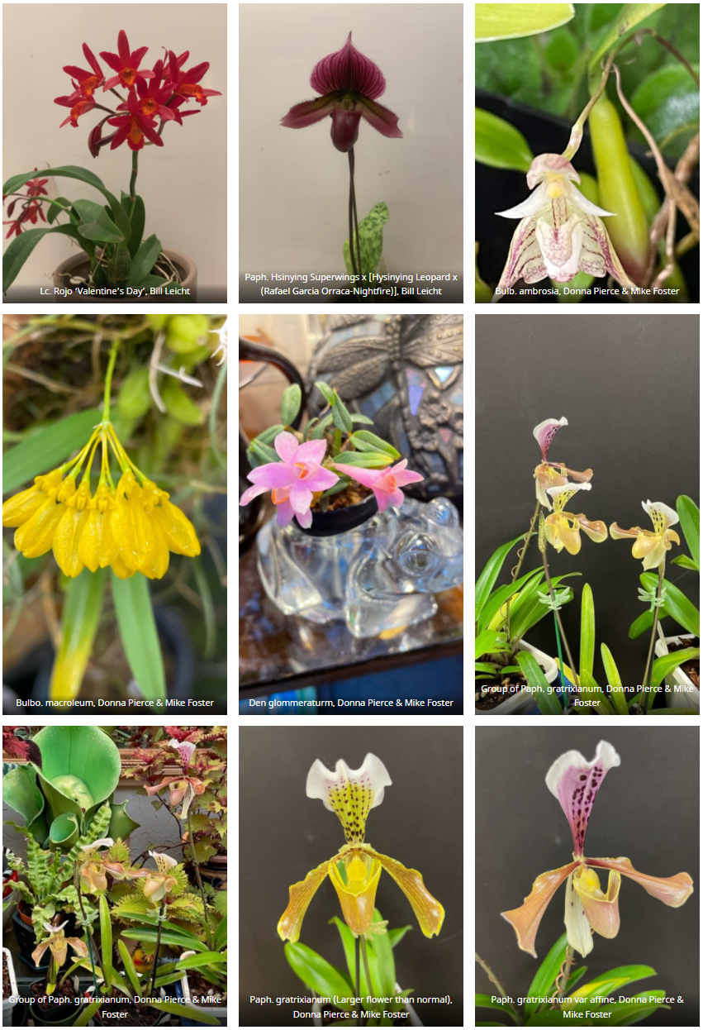

Schedule of Upcoming Events
03/19/22 - Potting Clinic – 11AM to 2PM at the Volunteer Park Conservatory

4/9-10/22 - Spokane Orchid Society Show
04/11/22 – NWOS meeting – Speaker: Kelly McKracken, “Artificial Lighting”
05/09/22 – TBA
06/13/22 – NWOS meeting – June Potluck: The June Potluck is the last meeting before our summer break. Enjoy socializing during dinner. This is also the meeting where we present the Gary Baker service award. Additionally, we are offered a presentation by the past year’s scholarship recipient.
8/xx/22 - NWOS Summer Picnic: The NWOS will have a summer picnic for its members. Check back soon for the date.
09/12/22 – NWOS meeting – Speaker: Tom Ethridge, “Odontoglossums Then and Now, Has Anything Changed?”
09/30/22 – NWOS Annual show setup at the Volunteer Park Conservatory.
10/01-10/02/22 – NWOS Annual show and sale at the Volunteer Park Conservatory.
10/10/22 - NWOS meeting – NWOS meeting – Speaker: Tyler Albrecht, “An Exploration of the Fluffy and Puffy Parvisepalum Paphiopedilums”
11/14/22 - NWOS meeting – Speaker: Peter Lin, “Neofinetia and Its Hybrids”
12/12/22 – NWOS meeting – Speaker:TBA , Scholarship Recipient Report, introduction of new Officers, NWOS Annual Meeting report, Schoenfeld and Northen Orchid Awards, and Holiday Plant gifts.

Reminder for Officers & Board Members

The next board meeting is Tuesday, March 1st which will be at 7 p.m. and hosted over ZOOM. Check your email for the Zoom registration link and agenda. Future meetings are tentatively scheduled for May 3, September 6, and November 8th

Shopping on Amazon? Use this link to earn $$ for the NWOS

If you go to https://smile.amazon.com and sign in to your account, you'll be given information about supporting various non-profits. You can type in "Northwest Orchid Society" and it will then send .5% of your purchase price to the organization.

It's really easy, but you have to remember to go in through the 'smile' subdomain when you place the order, otherwise it will go through as a regular order.

NWOS Website Links

- Main website: Http://www.nwos.org
- Events Calendar: http://www.nwos.org/events
- Membership (including renewals): https://nwos.org/Membership/
- Newsletter - Current Issues: https://nwos.org/newsletters/
- Newsletter - Archived Issues: http://newsletter.nwos.org
- Show Information: http://nwos.orchid-society.net/ShowTime/Show2021/Show.html
- Facebook: http://www.facebook.com/nworchidsociety
- Instagram: https://www.instagram.com/nworchidsociety/
- Twitter: https://twitter.com/nworchidsociety

©2022 Northwest Orchid Society - All Rights Reserved

The opinions and recommendations published herein are those of the authors. The Northwest Orchid Society disclaims responsibility for any losses or damages that may be attributed to the use or misuse of any material or any opinion published in these articles and on the website. This website and the photographs, articles and content are protected by copyright and no part of them may be reproduced or re-used without the permission of the author.

