Northwest
Orchid News
June 2022
Volume 75, Issue 6

- About the June Meeting
- Spring Social
- Plant Table
- Sales Table
- Raffle Table
- NWOS Library
- Proposed Changes to NWOS Bylaws
- 2022 NWOS Fall Show and Sale
- Help a member network in UK
- Summer Is Coming (Probably)
- Mystery Diseases
- Report From The May Meeting
- Schedule of Upcoming Events
- Reminder for Officers & Board Members
- NWOS/Amazon Shopping Link
- NWOS Website Links

About the June Meeting
June 13, 2022 7 PM
University of Washington Center for Urban Horticulture
3501 NE 41st Street, Seattle, WA 98105

We will be meeting in person for the foreseeable future.

Spring Social

Come and join us for our last meeting before summer break when we sit down and have a meal together and socialize. Bring your plants for the plant table and see what’s on the sales or raffle table that you want to go home with.
El Gran Taco, our caterer for the evening, told us to expect about $12 per person. The food truck will be outside at 7:00, so please allow plenty of time to get your food.
This meeting will not be available via Zoom.

Evening Highlights
- Plant Table
- Raffle
- Sales Table
- Gary Baker Service Award
- Society Business

Plant Table

We will be having an in person plant table this month. For your convenience, you can print out a Plant Table Information Form ahead of time. Click for your version of choice: PDF WORD Excel

Diane has taken pictures of the plant table for many years and has requested that someone else take up the torch. We appreciate everything that she has done. For those who aren’t able to attend, please do keep sending your pictures, we will be including them in our online gallery and in next month’s newsletter. Please send them to photos@nwos.org.

Sales Table

Members may bring up to 10 plants to sell. Include an extra tag with your name and the price in the plant.

Raffle Table

The raffle will be held as usual. Win a new orchid for your collection while supporting the Scholarship Fund. If you have any extra Orchids, please consider donating them to the raffle.

NWOS Library

If you'd like to check out a book or tape from our Library, please contact our Librarian Joe Grienauer a minimum of 2 weeks before the next meeting. Besides email, you can give Joe your request at any meeting. For a list of library items please click here NWOS Library.

Proposed Changes to NWOS Bylaws
Page 1, Article I, Section 2 – Regular Membership.

“The members of the Society shall consist of persons who have applied for membership in writing and who have paid one year's dues in advance in accordance with Article VII (Dues). That will be deleted and changed to:

“The members of the Society shall consist of persons who have paid one year's dues in advance in accordance with Article VII (Dues).”

Page 2, Article II – Officers, Section 5 – Secretary

“Prior to the end of the term of membership, the Secretary shall bill the members for their dues by the mailing of statements.”

This statement will be removed.

“The Secretary shall give the notice of all meetings in accordance
with these Bylaws and shall give notice to each person of that
person’s election to office or membership in the Society.”

Notice of all meetings are given in the newsletter and webpage.
This statement shall be removed.

Page 3, Article III, Section 5- Committees and Appointments,
Audit committee.

“....close of the fiscal year ending June 30.”

This will be changed to “...close of the fiscal year ending
December 31.” This was changed at a prior board meeting, but
not revised in the bylaws. The two should match.

Members can access the current version of the Bylaws by logging in to the Member Content Area of the NWOS website.

2022 NWOS Show and Sale at Volunteer Park Conservatory

This year’s Show Chairperson is Abigail Chang. So far committee members are Ben Johnson and Bill Leicht. We know that many of you will be helping out with our upcoming show. Please raise your hand and let us know so we can create a mailing list.

The dates of our show are Friday Oct. 1st - Sunday Oct. 2nd

Help a member network in UK
One of our young members, Michael Sheeran, is asking for our help with an opportunity to further his education and have a great experience. Michael hopes to enter UW next year in the Ecological Restoration program, College of the Environment. He will be in London for about a week in early September (around the 4th –11th) and will visit Chelsea Physic Garden and Kew Gardens. His preference is to volunteer his way through the week.
If any of you have connections or suggestions that could help Michael with his visit to the UK it would be greatly appreciated. To contact him, NWOS members can log in to our website and click on the Members Content section to access the membership roster. You can also simply email his mother Anne Sheeran.
Let’s see if our network can make his trip go from great to spectacular!

Summer Is Coming (Probably)
Last year here in Seattle we had an unusually hot summer. A number of us probably had heat damage to our plants, or at least noticed that some of them were stressed by the heat. This year we thought it would be good to arm you ahead of time in case we suffer another heat wave. Just remember, if you’re hot, they’re hot.
Article by Susan Jones, published on the AOS
Like people, orchids, especially those that prefer cooler, shadier environments, can suffer from heat stress during the hot summer months. The midday sun is intense, especially during the summer, and the high temperatures that bright sunshine brings can burn your orchids quickly, especially the more sensitive types such as phalaenopsis, pleurothallids, paphiopedilums and miltonias.
Heat stress is a condition that occurs in orchids and other plants when excessive heat causes an imbalance in transpiration, the process by which moisture evaporates from the plant’s tissues. When that rate of evaporation exceeds the pace at which moisture is being replaced through water taken up by the orchid’s roots, the plant becomes dehydrated — leaves soft and wilted, pseudobulbs wrinkled and ridged. The instinctive response in this situation is to overwater the orchid to correct the dehydration. This can instead make matters worse by rotting the plant’s root system, further hampering its ability to take in much-needed hydration. The roots can only absorb so much water at one time. In addition to watering, control of heat and humidity play a significant role in the prevention and management of heat stress.
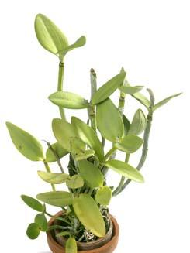
Placing a mounted plant in an empty clay pot can help retain moisture around roots. The microclimate of higher humidity helps prevent heat stress and aids stressed plants in recovering.
Signs of Heat Stress
These symptoms may appear singly, even in otherwise fairly healthy orchids. When they appear in combination, however, it is usually an indication of heat stress or an underlying problem (such as root loss) that has lead to heat stress.
Yellowing of Plants and Leaves
Too much light causes a plant’s chlorophyll to deteriorate, which can turn your orchid an anemic yellow-green, and eventually cause premature loss of leaves. Most healthy orchids receiving appropriate light levels will be a robust light green.
Withered Leaves
The culprit, especially in summer weather, can be overheating. If your plant’s leaves feel warm to the touch, they could be getting too much light, and need increased air circulation and shading, or a move to a more protected area.
Sunburn
Initial signs of sunburn, as in humans, appear as a reddish-purple tint or freckles on leaves and pseudobulbs. In advanced stages, leaf tips and roots may brown, flowers drop, buds blast or flower spikes fail altogether.
Shriveled Pseudobulbs
Your orchid’s pseudobulbs serve as its water-storage organs, so shriveled pseudobulbs indicate a dehydrated orchid – it is in a stressed state, having used up its moisture reserves.
Leathery Leaves
This goes beyond mere wilting, and occurs in the advanced stages of heat stress, indicating severe desiccation and possible damage on the cellular level. Depending on how long the condition has persisted, the type of orchid and its overall health aside from the leaf damage, it may or may not recover once its leaves are parched.
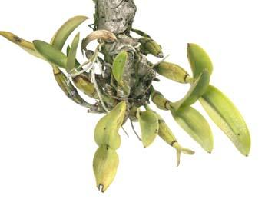
Mounted orchids are particularly sensitive to higher temperatures and require additional water and humidity during hot weather. This Cattleya hybrid exhibits the yellowing leaves and wrinkled pseudobulbs typical of heat-stressed plants.

Prevention
Your orchids need lots of attention during the summer months, especially on hot days. With higher temperatures, orchids require more frequent watering to prevent dehydration. High temperatures quickly dry out mounted orchids, those in baskets and even potted plants.
Maintaining the balance between keeping orchids sufficiently hydrated and over-watering can be a challenge. A simple rule of thumb is that an orchid’s need for water increases and decreases with the ambient temperature, so water thoroughly and more frequently during higher temperatures. Most mounted plants and those in baskets, especially vandaceous orchids and other genera grown with little or no media, will benefit from daily watering in warmer weather.
In addition, keep humidity high and air movement continuous, as both of these factors help plants keep their cool on hot days. Adding a fan to the growing area, or locating your orchids where they receive the caress of summer’s breezes, as well as spacing your plants to allow for sufficient air circulation between orchids, can make a big difference in their environment and overall health. This will also help to keep rots from fungi and bacteria at bay.
The benefits from misting orchids during hot weather do not have much sustained effect, so unless one has a misting system in place to maintain that added humidity throughout the day, it is probably not useful to your plants. When watering or misting, always be certain that plants have ample time to dry before night falls, so as to discourage bacterial and fungal growth.
When moving orchids outside for the season, start them out in a shaded spot and gradually increase their exposure to sunlight to acclimate them to the higher outdoor light levels. Make sure to protect them from the strongest sunlight as midday summer sun has more intense UV rays that can burn tender plants. Check the amount of exposure your plants receive at different times during the day as the sun moves, and throughout the year as the earth’s orbit around the sun makes its gradual seasonal changes, which in turn changes the angle of the exposure your plants receive.
For greenhouse growers, consider using shade cloth for added protection during the summer months. Windowsill growers may want to add a sheer curtain during the summertime to keep sunlight reflected by the window glass from causing sunburn.
Finally, always have someone care for your orchids while you are away on summer vacation.
Treatment
Once an orchid has suffered the effects of heat stress, it may take a long time to rebound. Apply fertilizers sparingly, using a weak solution, and flush the growing medium with clean water between applications of fertilizer, as the salts in fertilizers are difficult for dehydrated plants to assimilate, and a regular dose may further burn the plant. Be especially alert for pests on distressed orchids – insects and viruses are more likely to attack weakened plants.
References
Dodge, Vivian M. 2003. “Sun Protection.” Vivi’s Orchid Corner. 8(6).
__. 2000. “Tips for August.” Vivi’s Orchid Corner. 5(7).
Withner, Carl L. 1997. “Good Orchid Growing or the Concept of Stress on Plants.” Orchid Society of Nova Scotia newsletter, May.
Susan Jones was the editor of Awards Quarterly and assistant editor of Orchids. American Orchid Society, 16700 AOS Lane, Delray Beach, Florida 33446
Reprinted from the SEPTEMBER 2003 issue of Orchids -- The Bulletin of the American Orchid Society. Copyright American Orchid Society -- www.aos.org

Mystery Diseases
By Steve Dorsey

As summer is slowly arriving, our orchids are putting on their new growth as the temps are rising and occasionally the sun peaks through the grayness. Along with this welcomed event come new diseases and pests.

Every year for the last four years, my Pholidota chinensis would be starting to put on the new growth and shortly before that, the existing leaves would turn a strange orange brown at the leaf tips and get some odd spots in the middle of the leaves.
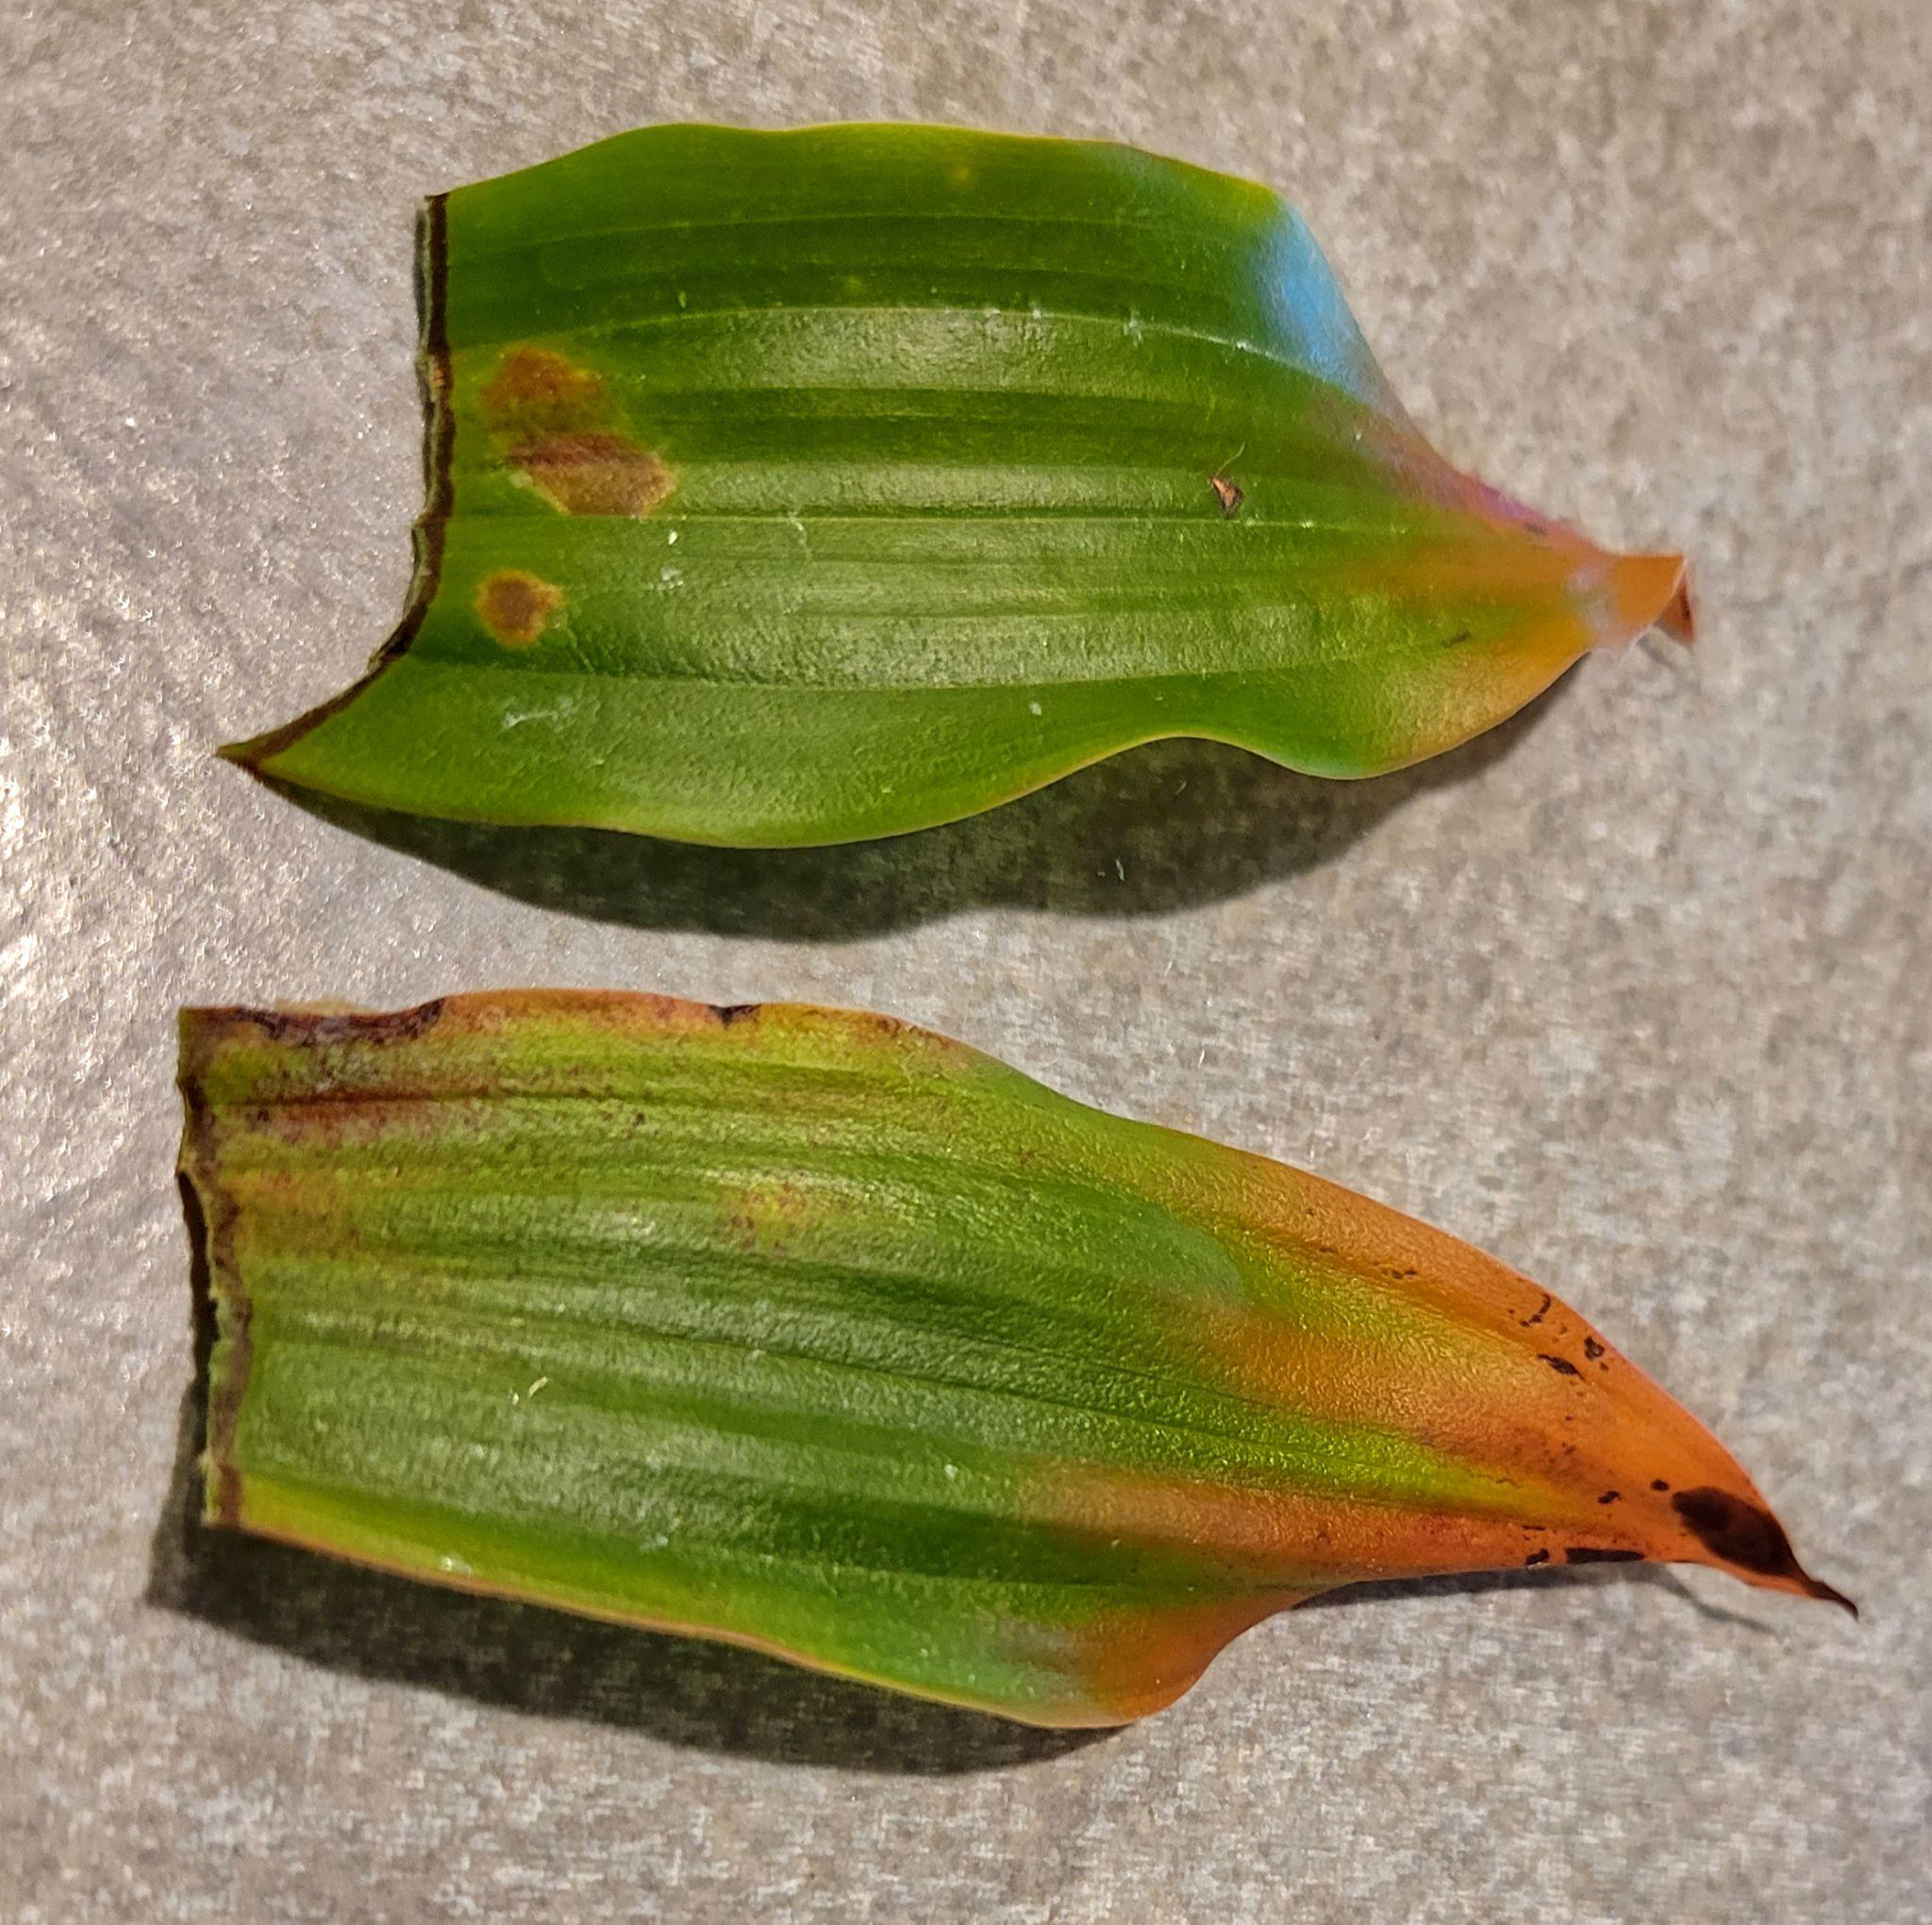
While it may be tempting to default to posting on Facebook for an opinion, you can guarantee that you will get the response of “it’s a fungus”, or “it’s a virus” or sometimes “it’s bacterial”. A picture may be worth a thousand words, but if you want a diagnosis and really want to treat the problem, that’s not enough.
Even though you may feel it is a fungus, you should rule out all the other possibilities to confirm that. The only way to know if it is a virus is to test it. I can present many pictures that look like viruses while those that did not, did have a virus. And the following case I will show demonstrates that insects can be the source of disease, even though not readily visible.
Back to the failing Pholidota. In the past, I had sprayed various fungicides in an attempt to get ahead of the damage. Each year the new growth would develop normally and I thought I had solved the problem. But in the first appearance of the new growth buds, it was the same old thing.

Because I had finally broken down and purchased a stereoscope, I decided that I should really investigate further. The tip of the leaf was unremarkable, and I had noticed that the rings on the leaves had a visible darker dot in the middle. On the top side it was just a dark spot, but on the underside, there was a visible puncture of the surface.

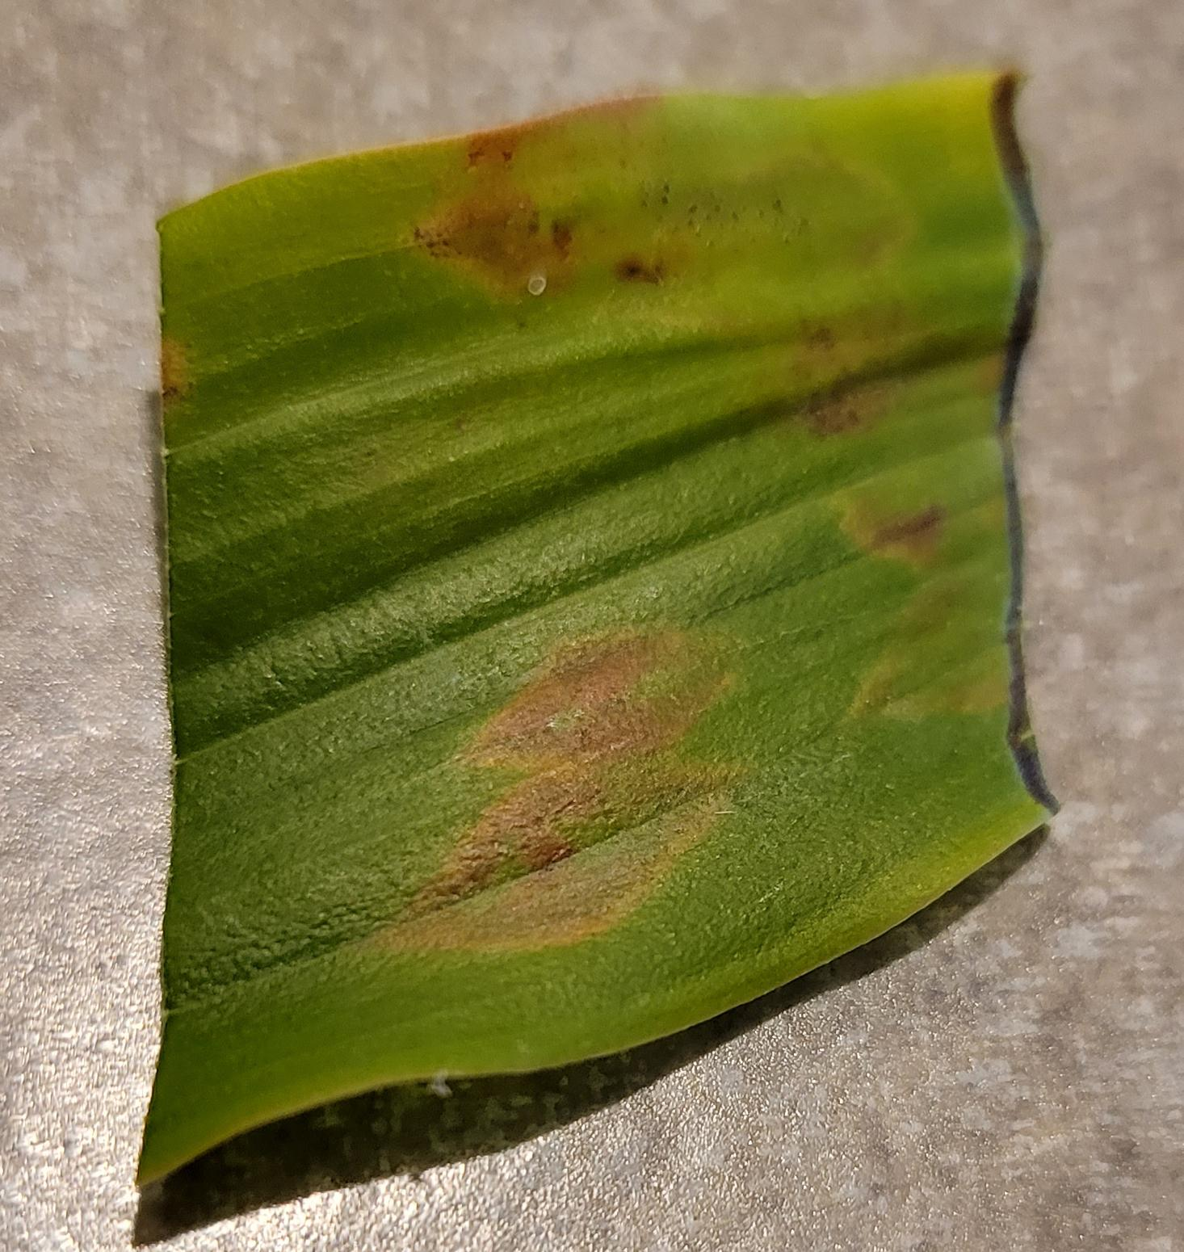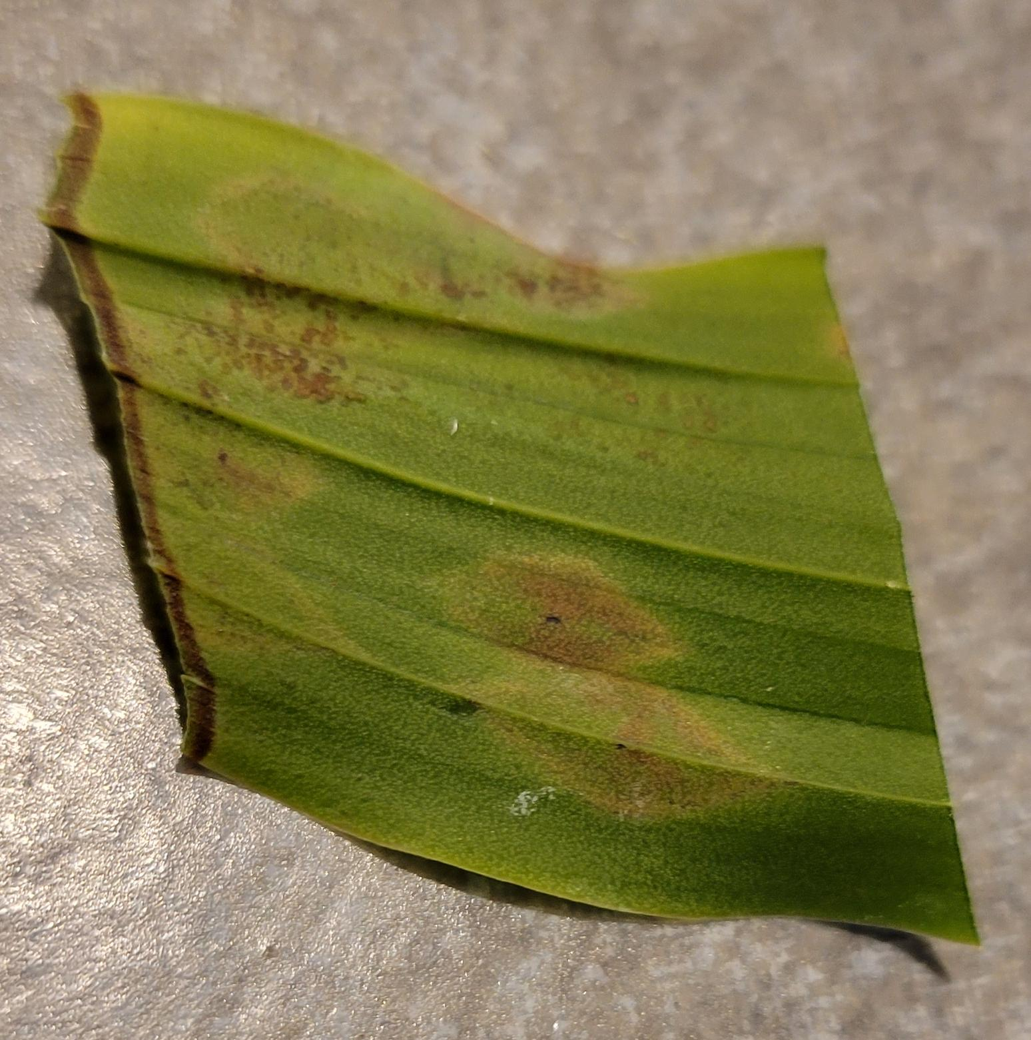
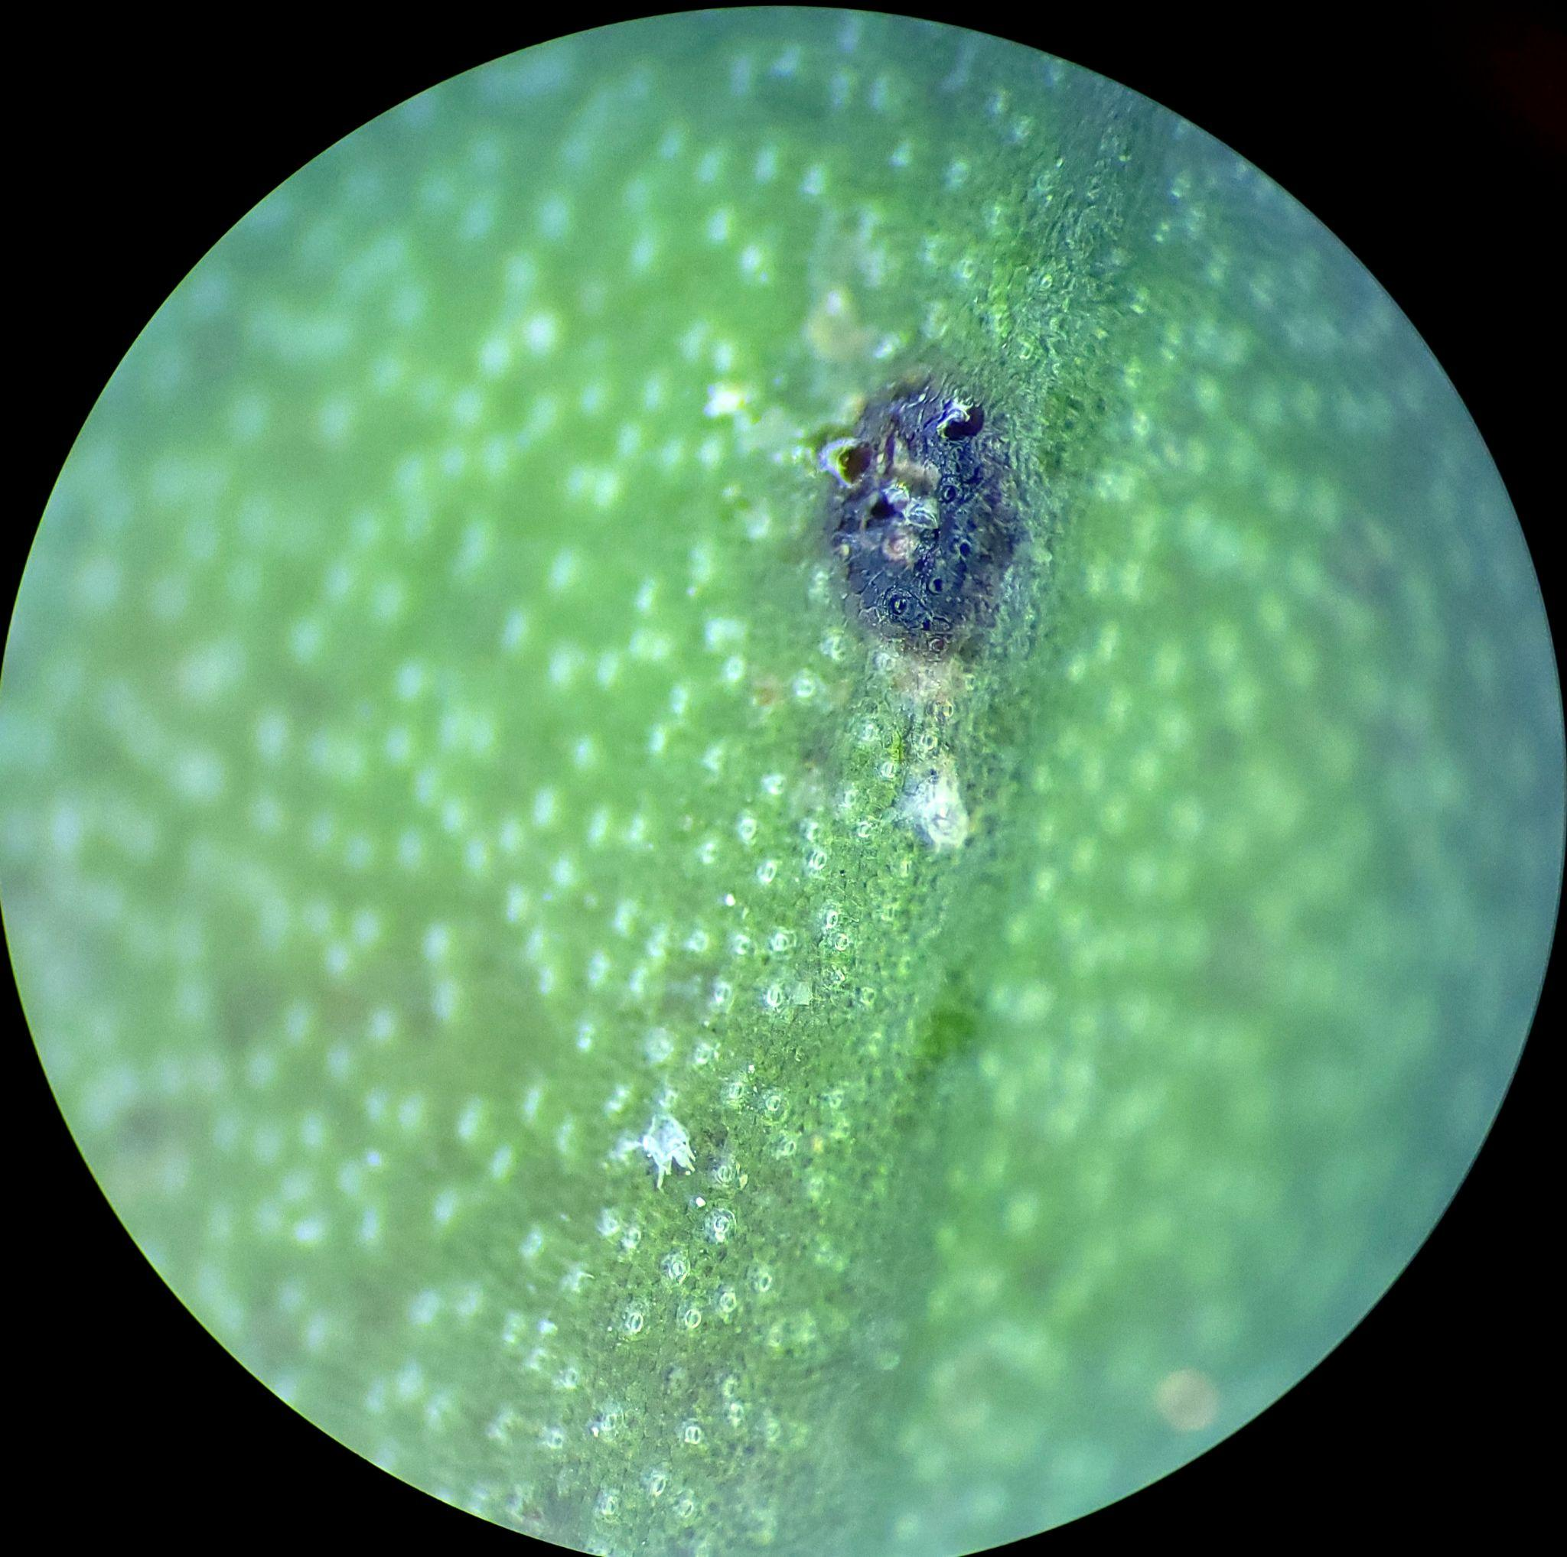

And after looking at a few of these holes, I saw a white carcass next to one.

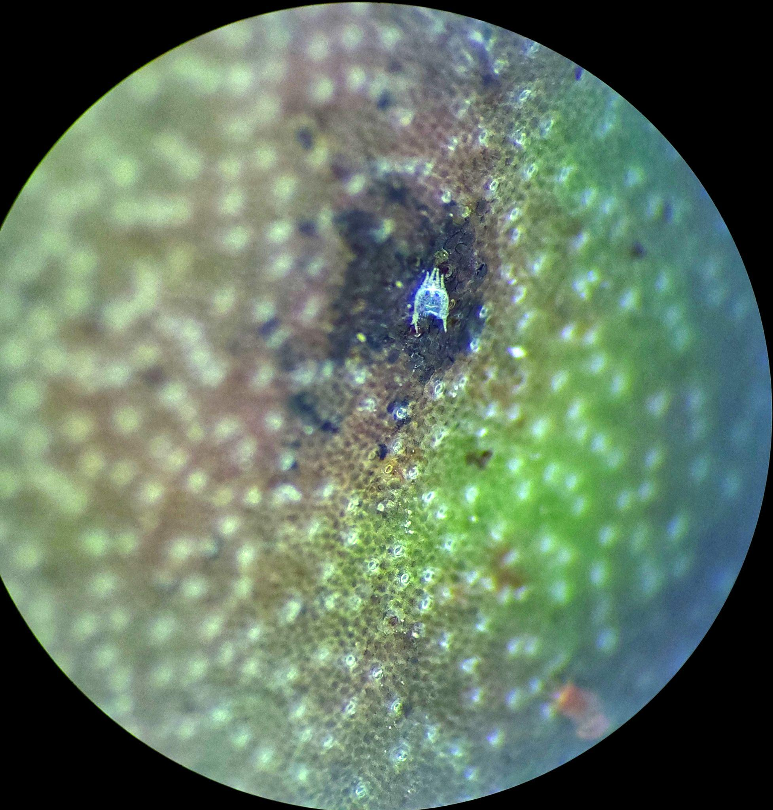

I then scanned the surface for anything else and suddenly I saw something moving. A mite! A tiny mite – Arghh!

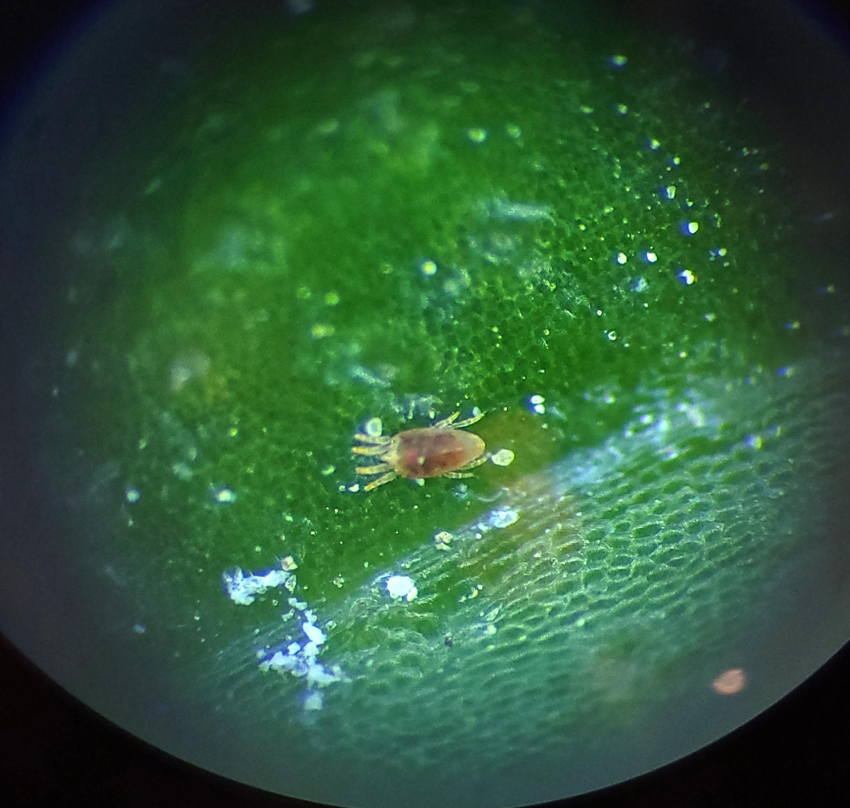

Soft leaved orchids are more susceptible than thick leaves, but all could have infestations. Unlike typical spider mites, these developed no webs such as you typically see. I had similar issues with some Stanhopea that grew well and then suddenly all of them developed a weird light grey look under the leaves with very tiny white spots. As with this plant, I found what was called two spot mites. No webbing with those also.
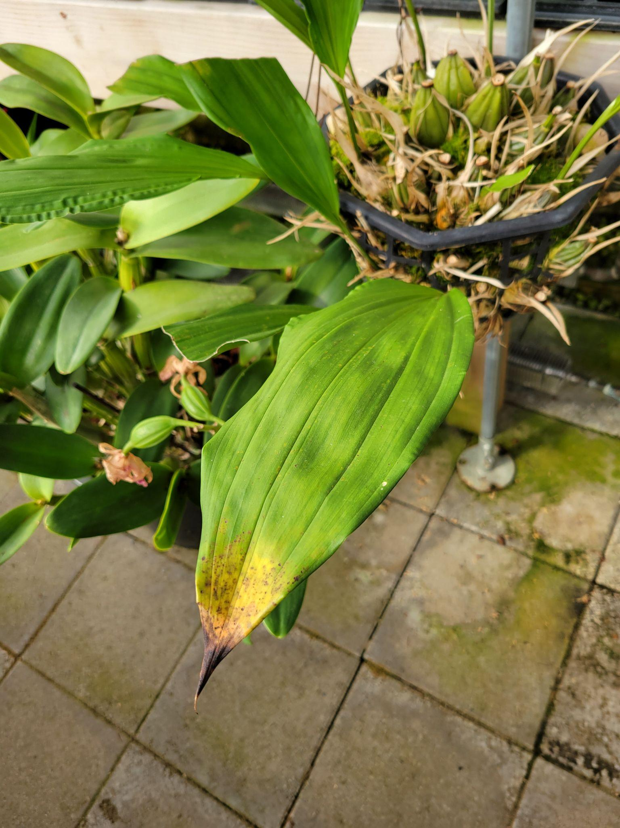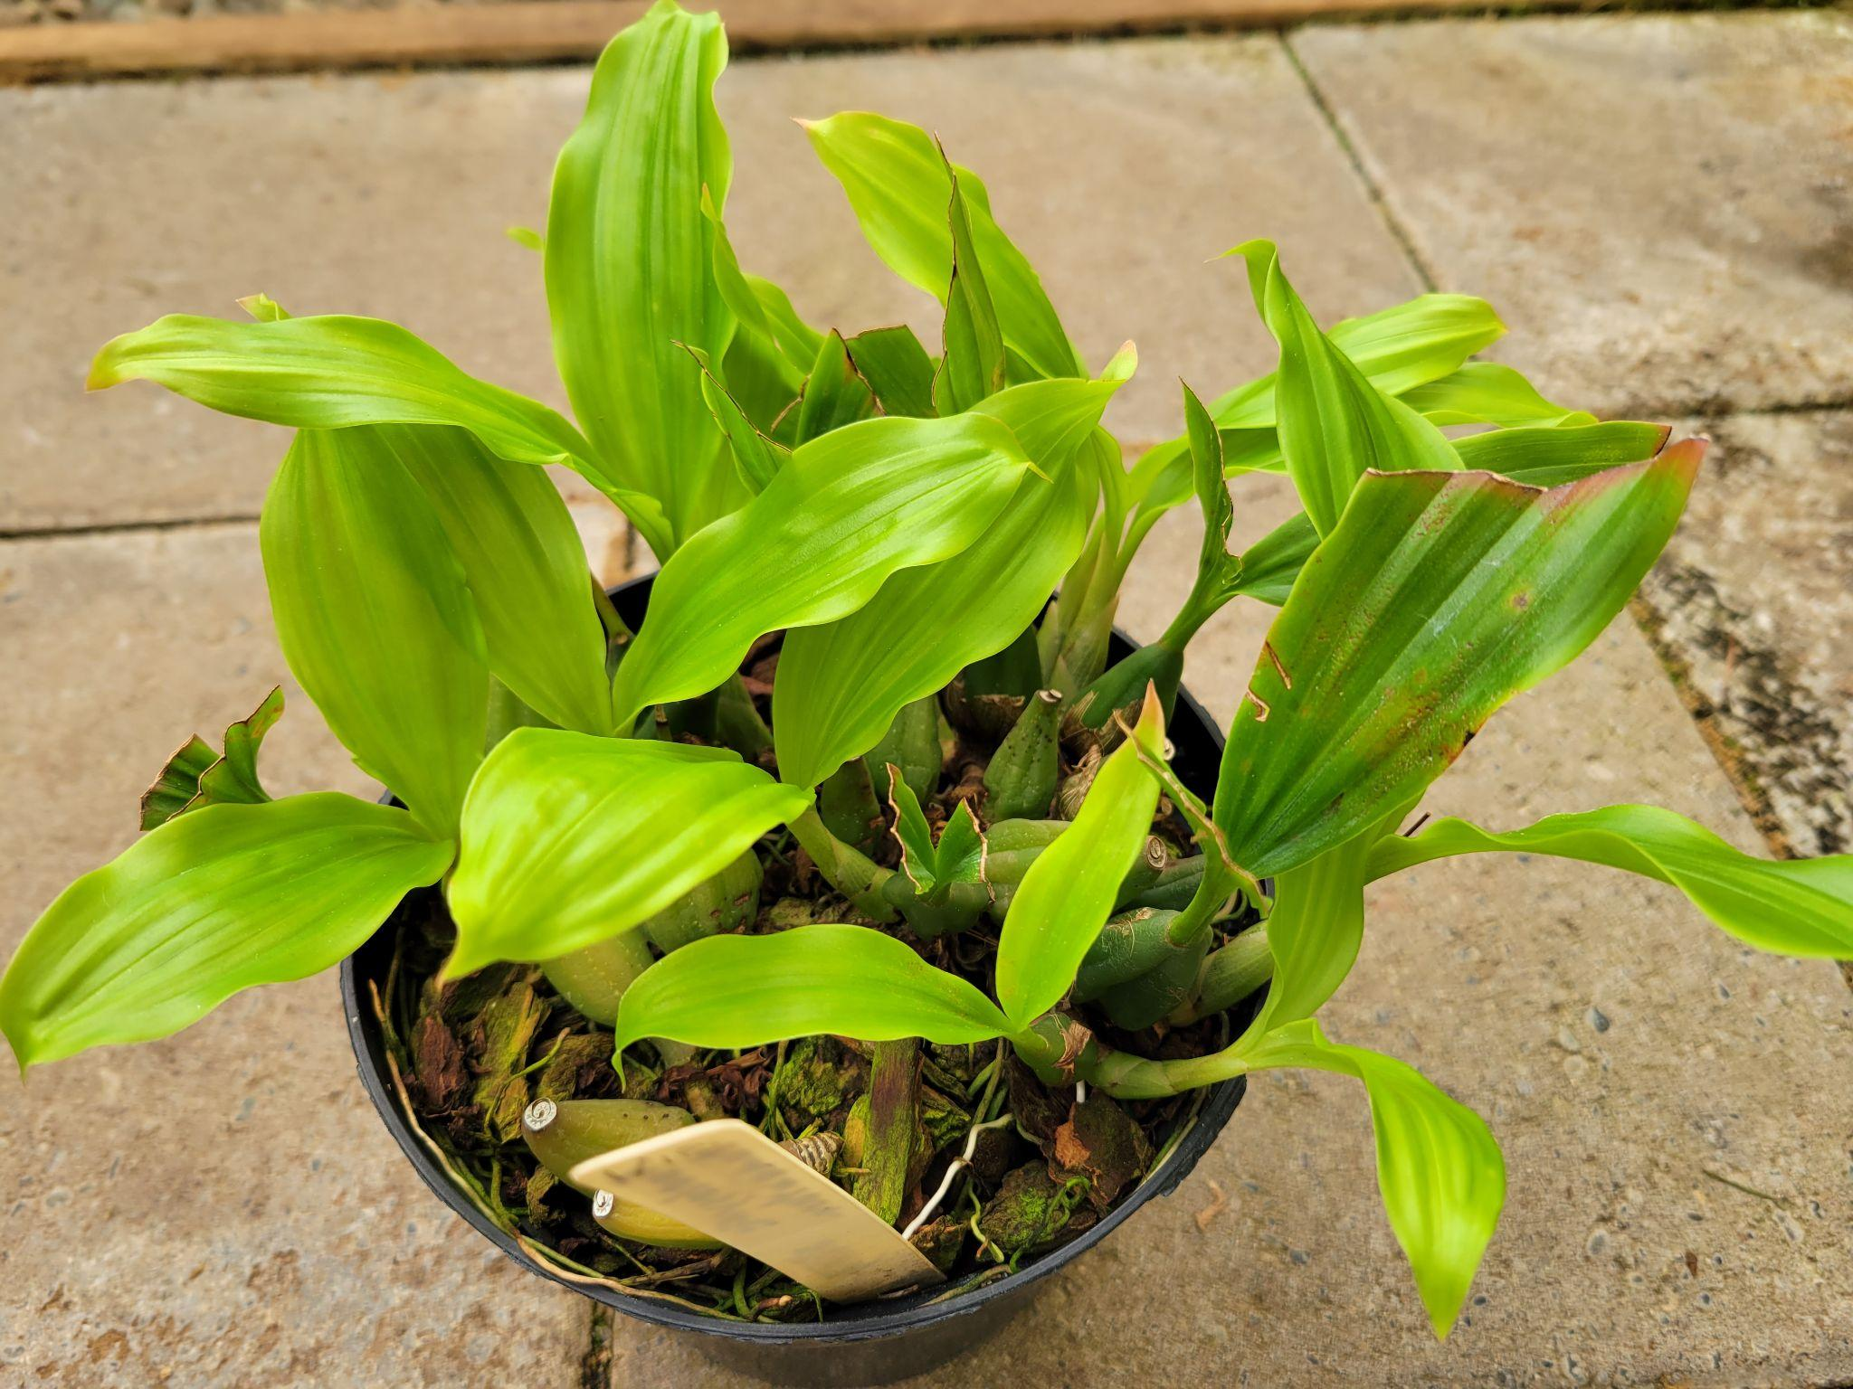

Although you can treat a small amount of mites with soap and isopropyl alcohol, I personally have higher long term success with seasonal application of miticide. Don’t assume the insecticide you use will work on mites. Read the target insects on the product list.

Hopefully you will have a bug free and fungus free summer, but if not, be diligent on investigating the issue. And plants can have more than one at a time, so look at all the possibilities.
Happy Growing and have a blossom filled summer.

Report From The May Meeting

NWOS president Steve Dorsey welcomed new people to our group. We then went right into the night's main event. First vice president Robert Culver introduced our speaker, Bill Goldner, PhD, who came to us via a Zoom presentation. His talk was “New Looks for Miniature Phragmipedium Hybrids and Other New Lines of Breeding.” He compared many crosses and their parents and showed the outcomes of the various breeding attempts. He showed many breakthroughs in breeding and in particular with mini phragmipediums. Some of the results included amazing new colors. He reserved talking about Phrag. Kovachii (the elephant in the room) since he felt that there was ample enough material that it deserved a talk all of its own.
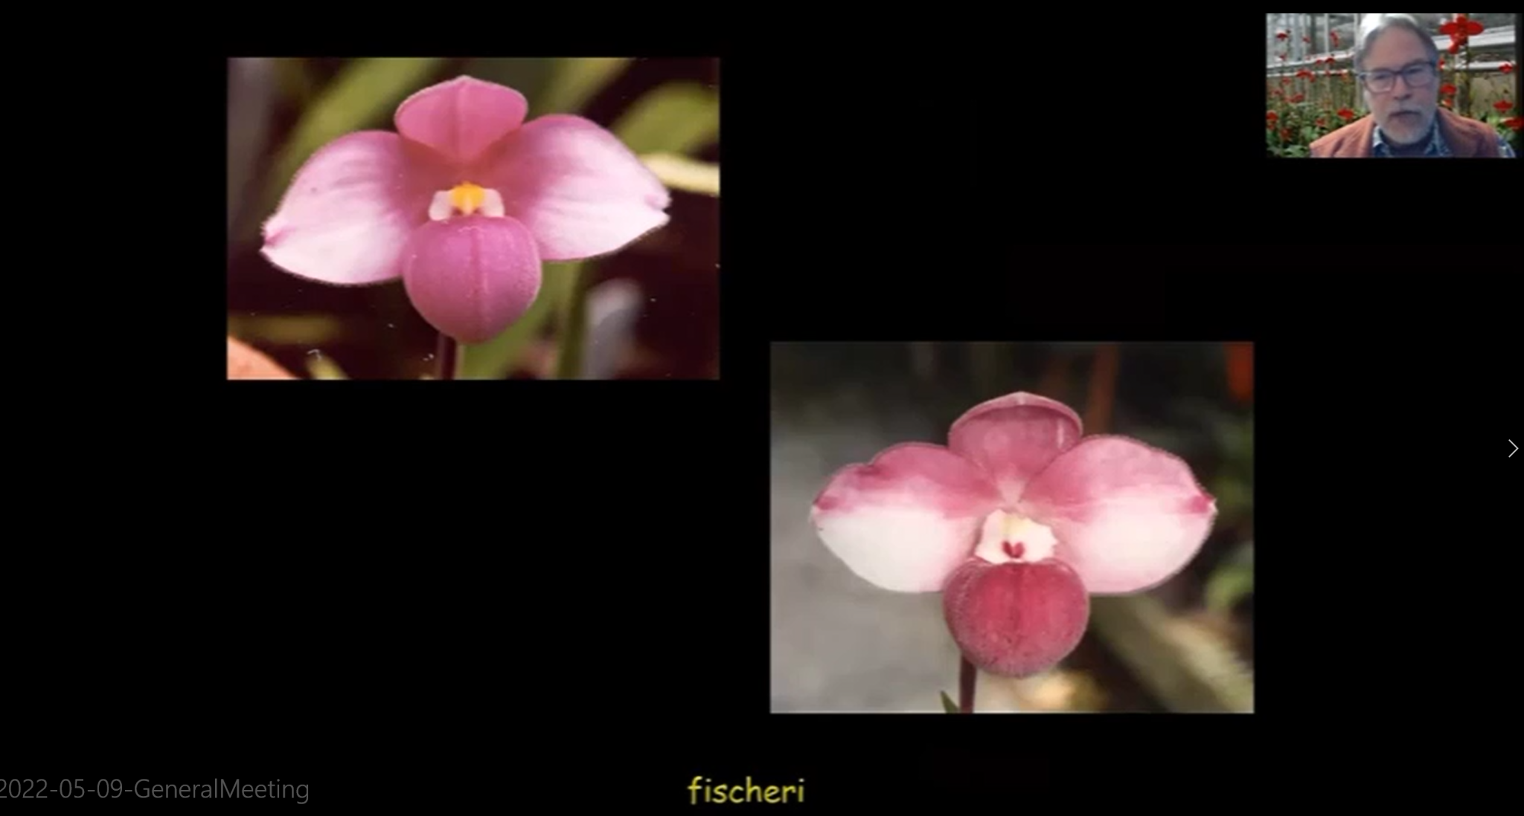
Bill Goldner Discussed New Trends in Phramapedium Breeding

Bill then took many questions from our group of interested growers. Afterwards, he reviewed Phragmipedium culture with us. This included how much to water and fertilize. Bill prefers to pot his plants in Orchiata and repot every 2 years. He recommended that we balance high humidity with fans to create air movement. In terms of light, you know that you have it right if the leaves are at a 45 degree angle. If they are too upright, then you have too much light and if they lie flat then there is too little light.

Bill Goldner’s talk was very well done, comprehensive and enjoyed by our members. He is certainly an expert with a fine ability to share his extensive knowledge. He can be contacted at Woodstream Orchids just outside Washington, DC in Maryland where he hybridizes phrags and epidendrums.

Our plant table was reviewed by Andy Wright with a video assist from Abigail Chang.

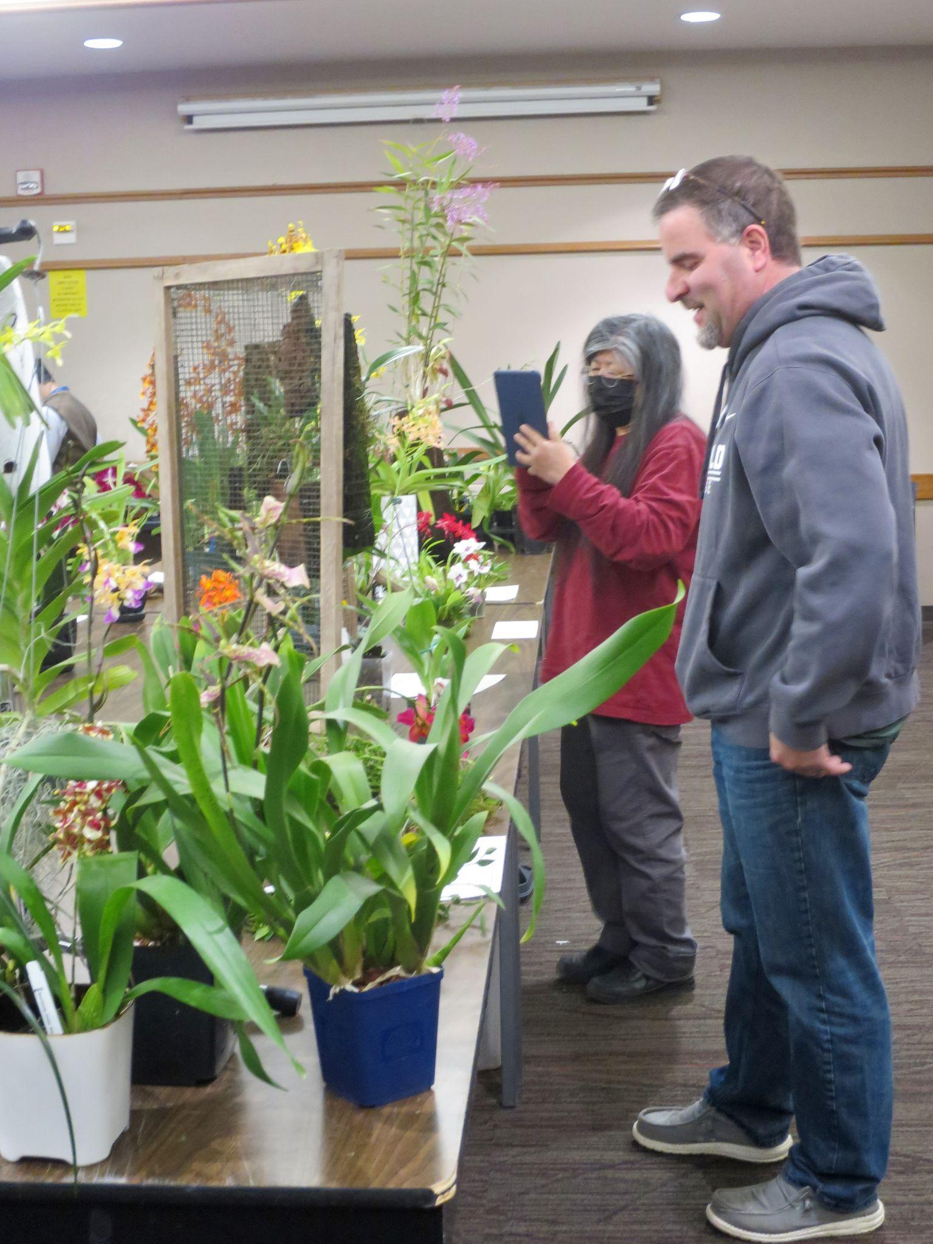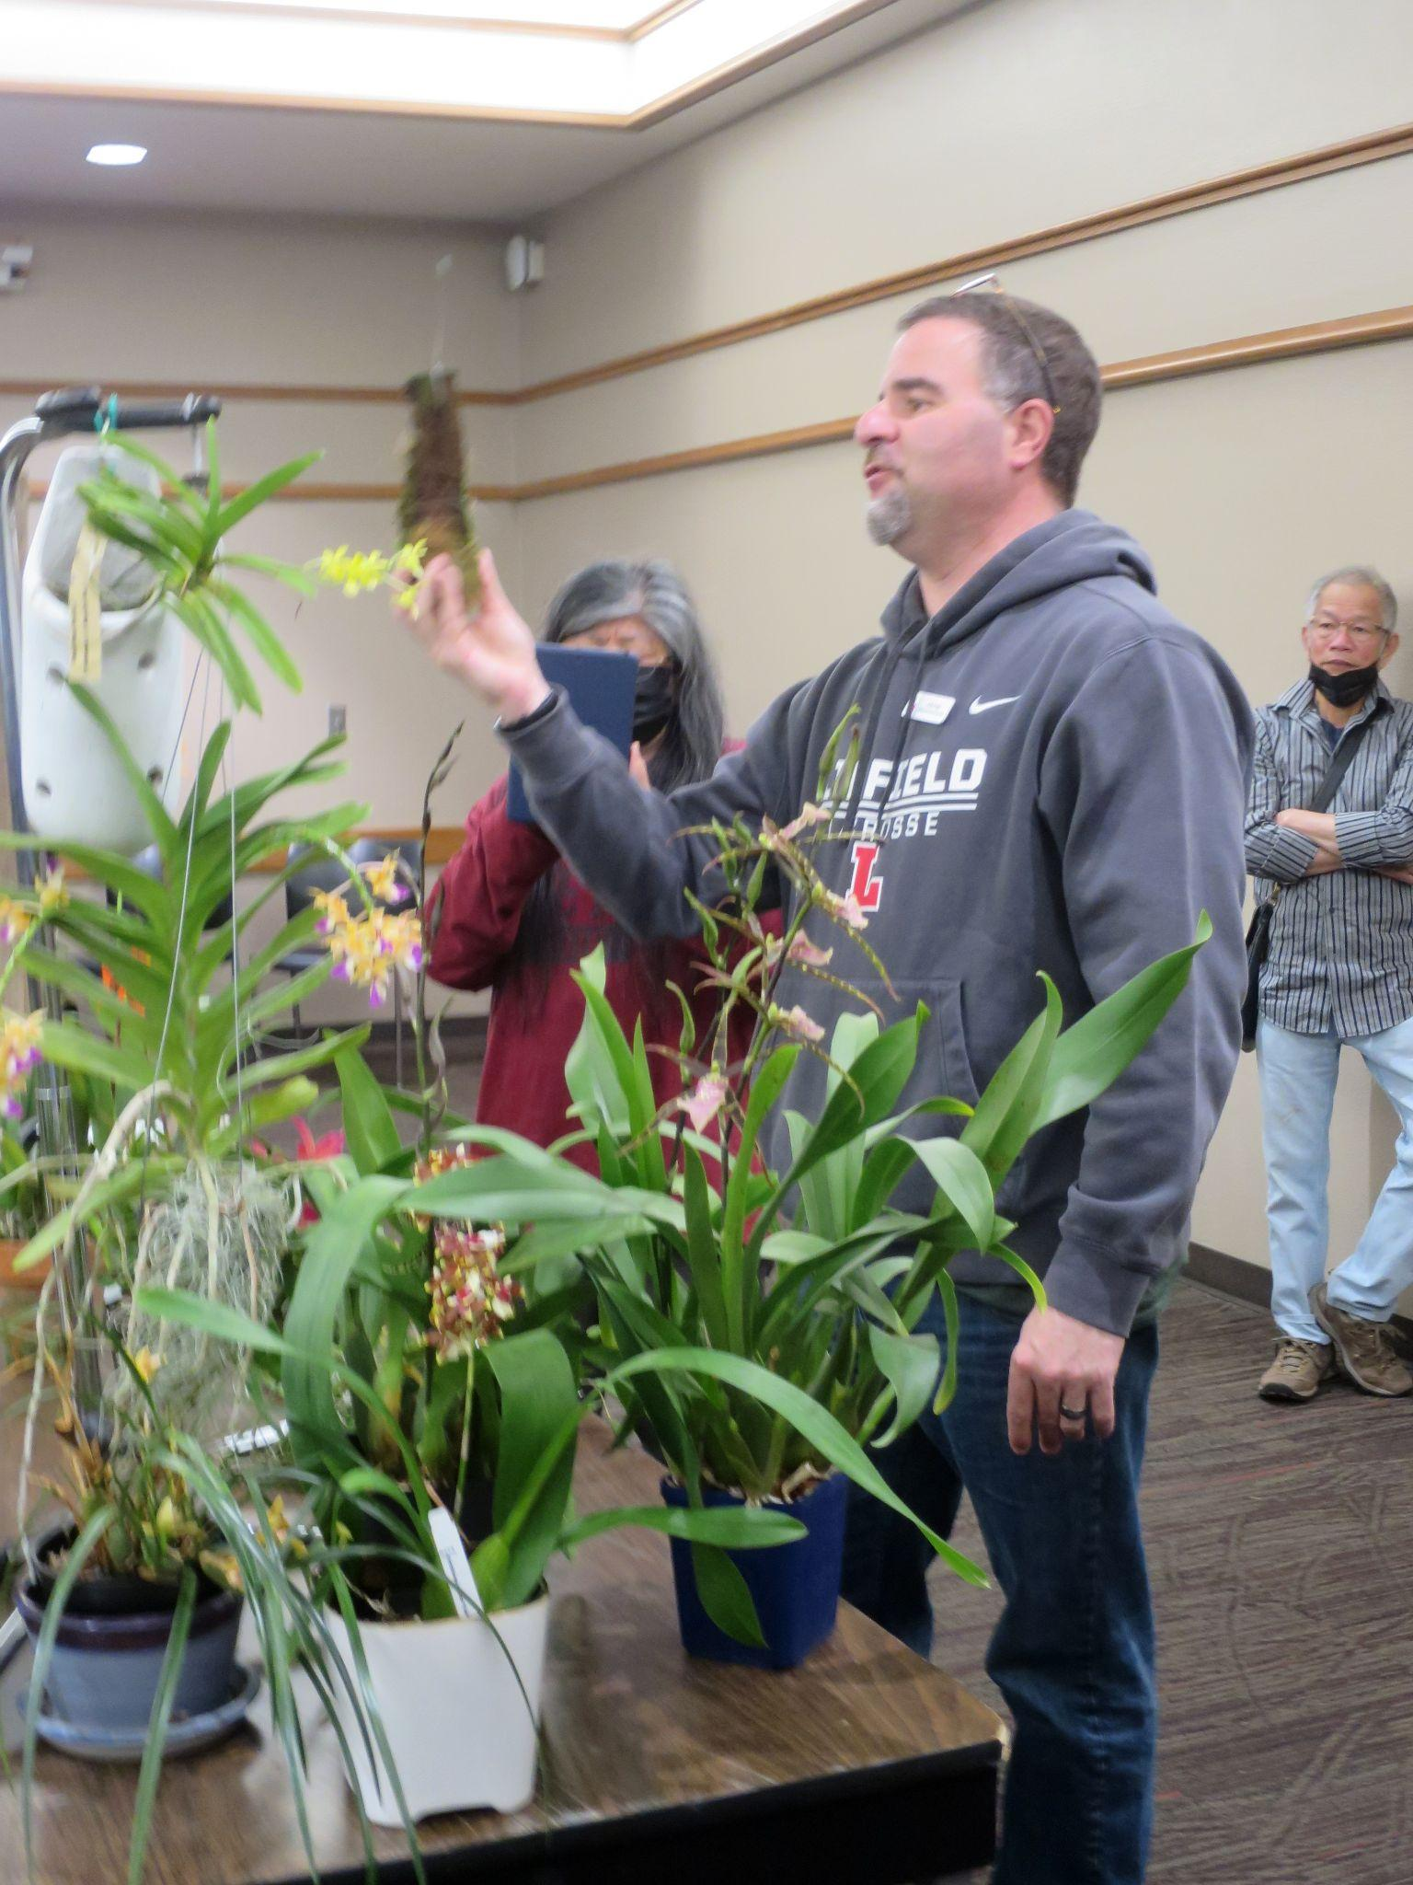
Andy and Abigail Live and Zooming our Plant Table
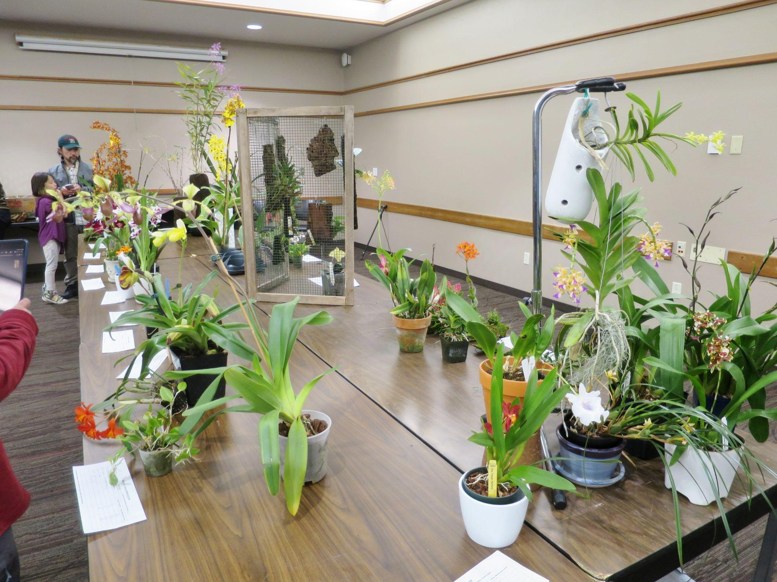
Look at all Those Plants!
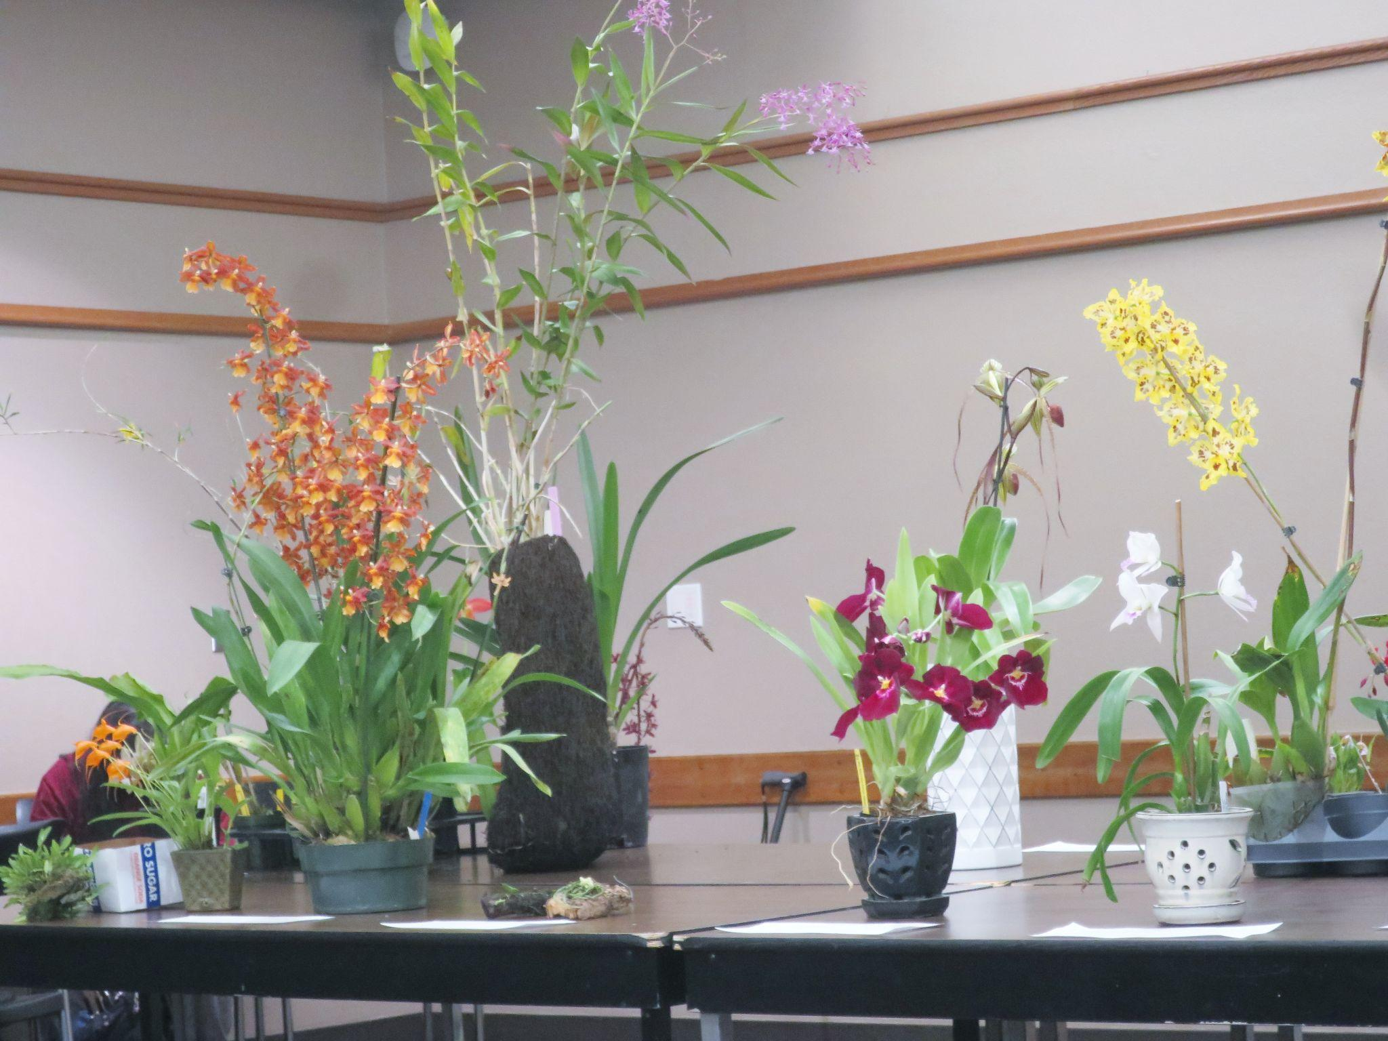
It Was a Great Month for Plants

These are several selected images from the May meeting. To see the rest of the photos of May's plant table, please follow the link to go to the online gallery.

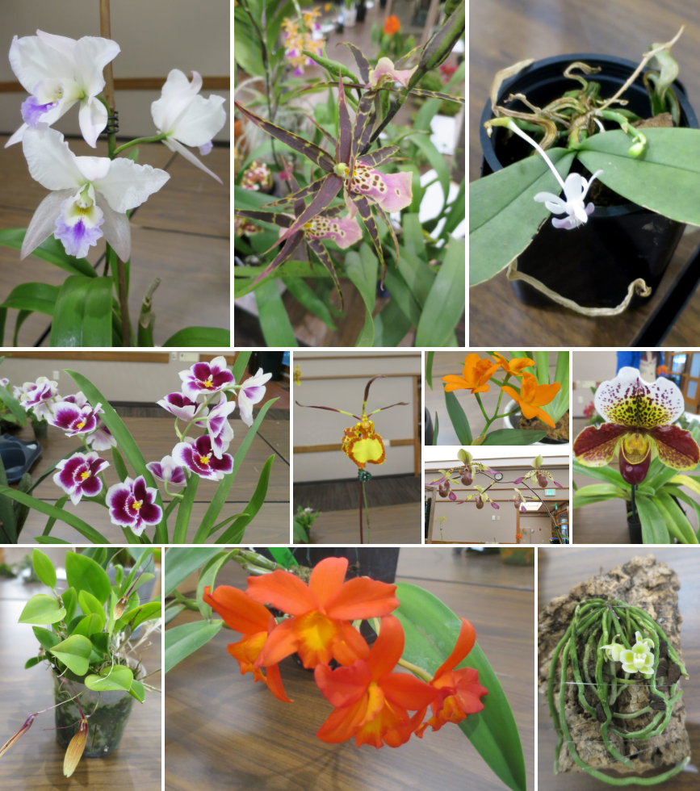

Schedule of Upcoming Events

06/13/22 – NWOS meeting – June Social: The June Social is the last meeting before our summer break. Enjoy socializing during dinner. This is also the meeting where we present the Gary Baker service award.
8/ xx /22 - NWOS Summer Picnic: The NWOS will have a summer picnic for its members hosted at the home of Andy Wright. Check back soon for the date.
09/12/22 – NWOS meeting – Speaker: Tom Ethridge, “Odontoglossums Then and Now, Has Anything Changed?”
09/30/22 – NWOS Annual show SETUP at the Volunteer Park Conservatory.
10/01-10/02/22 – NWOS Annual SHOW AND SALE at the Volunteer Park Conservatory.
10/10/22 - NWOS meeting – Speaker: Tyler Albrecht, “An Exploration of the Fluffy and Puffy Parvisepalum Paphiopedilums”
11/14/22 - NWOS meeting – Speaker: Peter Lin, “Neofinetia and Its Hybrids”
12/12/22 – NWOS meeting – Program:TBA , introduction of new Officers, NWOS Annual Meeting report, Schoenfeld and Northen Orchid Awards, and Holiday Gift Plants.

Reminder for Officers & Board Members

The next board meeting is Sunday, July 10th, the date and time have not yet been determined. Check your email for the details and agenda. Future meetings are tentatively scheduled for September 6, and November 8th.

Shopping on Amazon? Use this link to earn $$ for the NWOS

If you go to https://smile.amazon.com and sign in to your account, you'll be given information about supporting various non-profits. You can type in "Northwest Orchid Society" and it will then send .5% of your purchase price to the organization.

It's really easy, but you have to remember to go in through the 'smile' subdomain when you place the order, otherwise it will go through as a regular order.

NWOS Website Links

- Main website: Http://www.nwos.org
- Events Calendar: http://www.nwos.org/events
- Membership (including renewals): https://nwos.org/Membership/
- Newsletter - Current Issues: https://nwos.org/newsletters/
- Newsletter - Archived Issues: http://newsletter.nwos.org
- Show Information: http://nwos.orchid-society.net/ShowTime/Show2021/Show.html
- Facebook: http://www.facebook.com/nworchidsociety
- Instagram: https://www.instagram.com/nworchidsociety/
- Twitter: https://twitter.com/nworchidsociety

©2022 Northwest Orchid Society - All Rights Reserved

The opinions and recommendations published herein are those of the authors. The Northwest Orchid Society (NWOS) disclaims responsibility for any losses or damages that may be attributed to the use or misuse of any material or any opinion published in these articles and on the website. This website and the photographs, articles and content are protected by copyright and no part of them may be reproduced or re-used without the permission of the author.

The Special Announcements (SA) section is provided as a courtesy to the readers of this newsletter for events which may be of general interest to the readers. The NWOS (1) makes no promises, warranties, or representations as to SA, including its completeness, accuracy, availability, timeliness, propriety, security or reliability; (2) provide SA on an "AS IS" and "AS AVAILABLE" basis and any risk of using SA is assumed by you.

