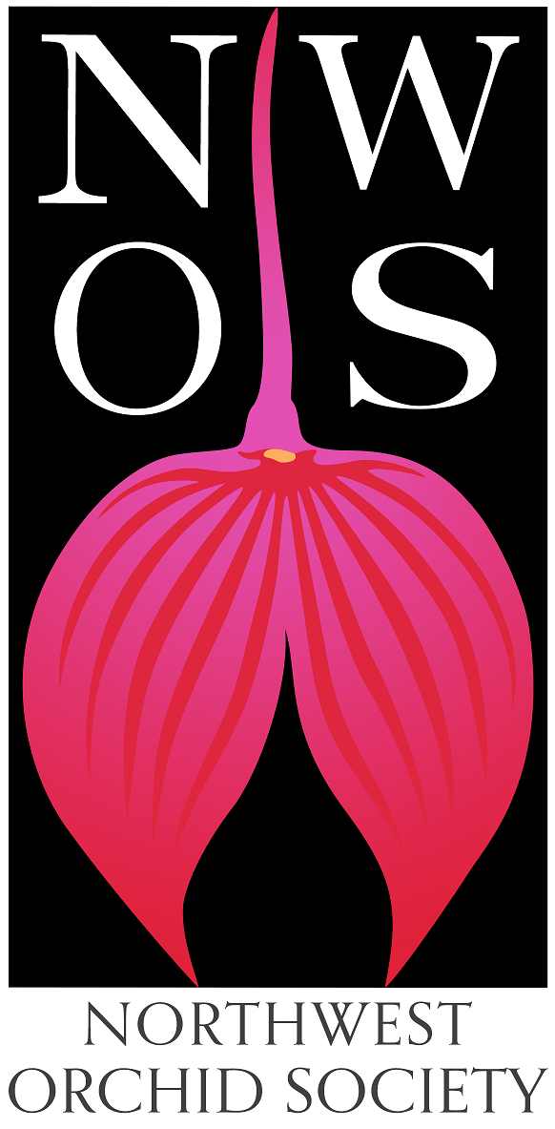
Northwest
Orchid News
February 2023
Volume 76, Issue 2

- About the February Meeting
- Meeting: Annual Auction and Preview Party
- 2023 NW Flower & Garden Festival
  - Festival Plant Pickups
  - Help Dismantling the Show
  - Orchid Vendors
  - Getting There and Back Again
- Membership Renewal Reminder
- Gary Baker Service Award
- NWOS Library
- Volunteer Opportunities
- Upcoming Orchid Shows
- Upcoming Potting Clinics
- Local Judging
- Report From the January Meeting
- Schedule of Upcoming Events
- Reminder for Officers & Board Members
- NWOS Website Links
- Special Announcements

About the February Meeting
Saturday, February 25, 2023 1:00 PM
No meeting Monday, February 13, 2023 (come help us set up as the show)
Room opens at 1:00 p.m.
Preview Party starts at 1:15 p.m.

Shoreline Community College Student Union, Building 9000
16101 Greenwood Ave. N, Shoreline, Washington 98133-5696
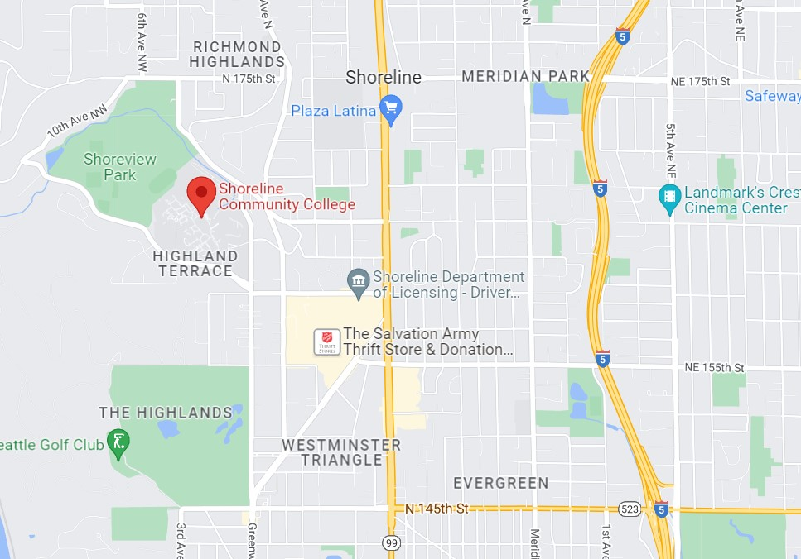

Visitor Parking is the gravel lot on your left as you enter the campus off Greenwood Ave N.

Walk across the road and down the wide pathway to Building 9000, the second building on your right.

If you have a wagon or cart that will be the best way to transport plants to and from the meeting.

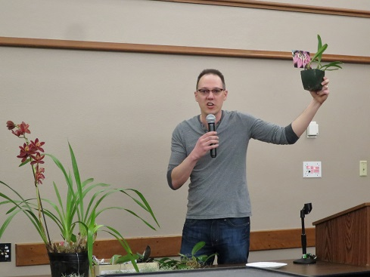  Who wants this orchid? | 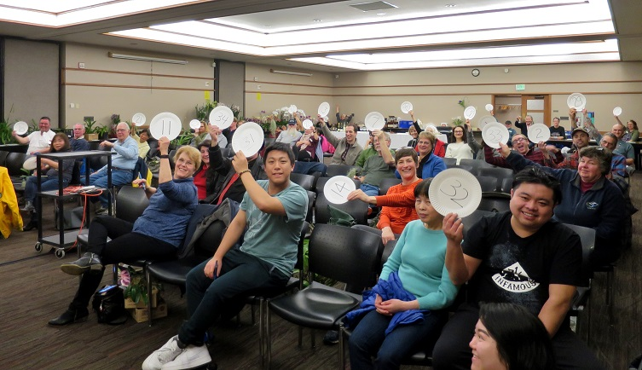  I do!

Annual Orchid Auction and Preview Party

The Northwest Orchid Society's biggest orchid selling and buying event outside of our show, this is a chance to find some select plants, sometimes at a great price. And even if it's not dirt cheap, it goes to a good cause. This is also a chance for those with burgeoning collections to winnow out the surplus, earn a few bucks, and make room for new acquisitions. Consider selling plants that you've nurtured, but haven't been able to get to bloom. You can then use the proceeds to buy something that may do better for you.

Bidding: Register when you arrive and get a bidding number to use during the auction. Keep your paddle moving, and after the auction you will use the same number to pay for your winning bids. We can process VISA/Mastercard transactions along with cash and checks.

Selling: Each Current Member may bring up to five plants to auction off, with the NWOS taking a 20% commission. There is no limit on the number of plants you may auction at a 100% donation to the Society. If you have not yet renewed your membership for 2023, please check out the Membership Renewal Reminder article below for details.

Photos: If you have digital photos of the flowers for the plants that you are selling, they could be projected on the screen behind the auctioneers. Hopefully it will work and will help the bidders better visualize what the plant will look like. Send the images to photos@nwos.org.

Registration: To register your plants, please print the Auction Form. Complete both the left and right sides, and bring it with you to the meeting and keep it with your plants. Make sure to mark ONE fund of your choice. SPECIAL NOTE: If you select more than one fund or fail to select a fund, the 20% society commission will default to the General Fund.

There are five fund choices and you must choose ONE of them:

• The Library Fund is used to purchase items for the NWOS Library.
• The UW Greenhouse Fund is used by the U.W. Botany Greenhouse to purchase Species Orchids.
• The Zoo Fund is used by the Woodland Park Zoo Greenhouse to purchase Orchids for display in exhibits.
• The Scholarship Fund provides a grant each year for a college student working on an Orchid related project.
• The General Fund covers everything else, from the programs to the everyday working of your society.

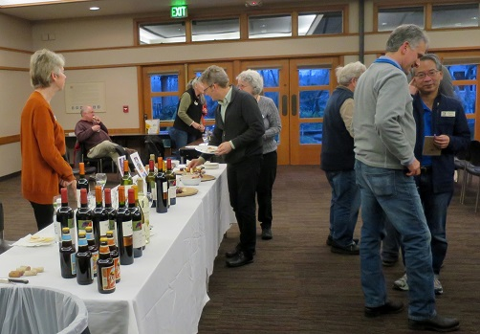
This Auction is the only source of funding for the Library, UW Greenhouse Fund, and Zoo funds. The Scholarship Program receives additional funding from the Raffles held at most meetings.
Preview Party:

We will again have our very popular wine and cheese preview party, hosted by Peter and Kelley Maunsell. There will be refreshments, including a special selection of beverages. Non-members are welcome, but only members and their guests can be served alcoholic beverages.

The room will open at 1:00 pm so you can come early to organize your plants and help with setup. The party will start at 1:15 pm. A brief meeting followed by the auction will start promptly at 1:30 pm

NO Display Table, Sales Table, Raffle or Library this month

2023 NW Flower & Garden Festival

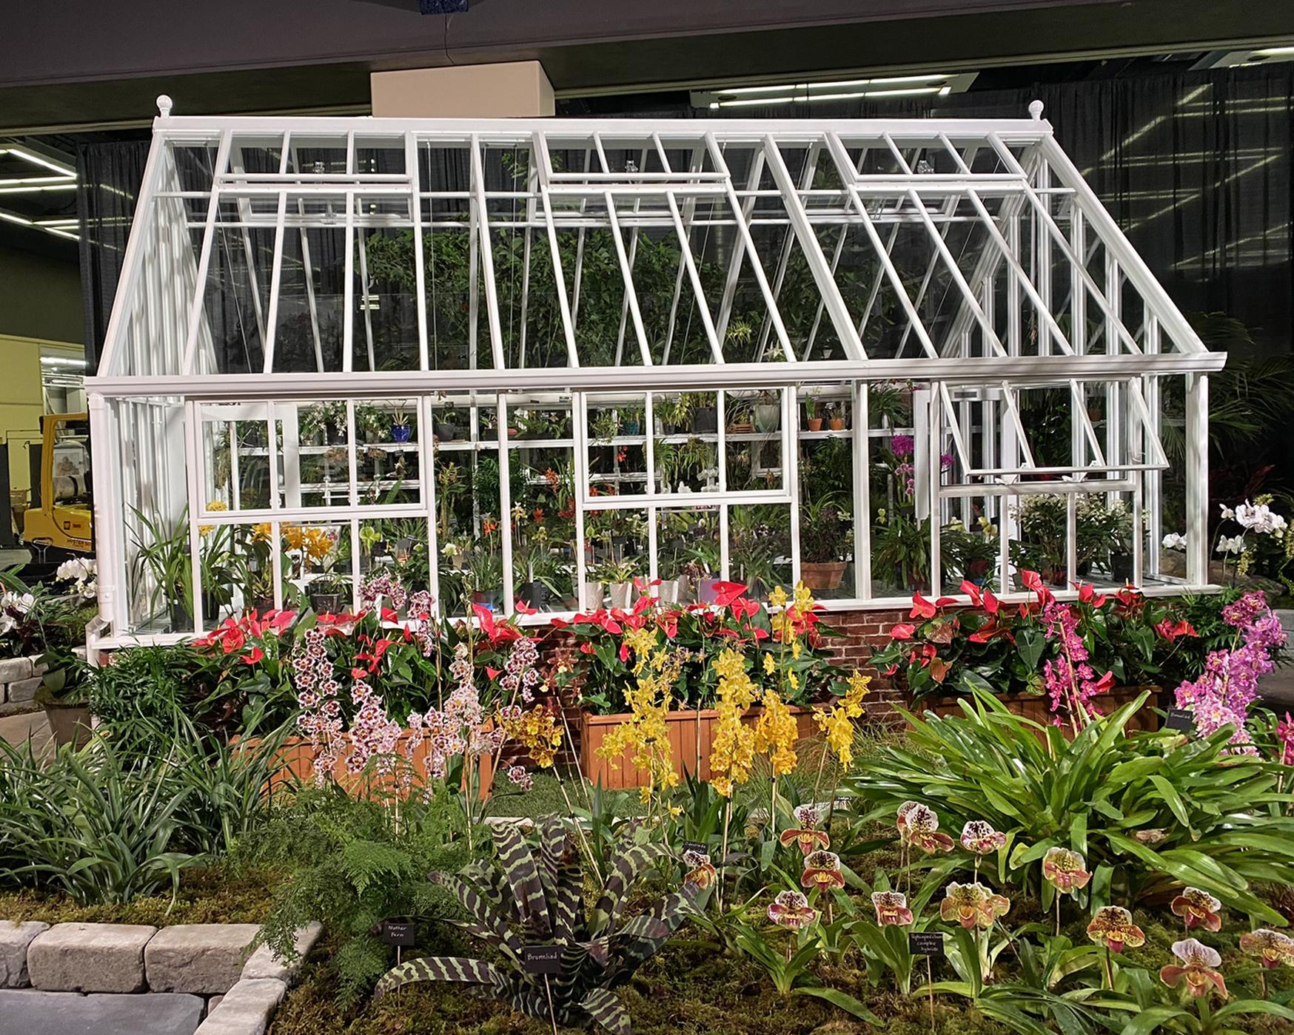

We have great information about how you can help us with our garden, how YOUR ORCHIDS can be the "stars of the Festival" within the garden, along with other garden details. Just check out the January newsletter at, January 2023 Newsletter or our NWOS website post at, January 2023 Newsletter Post .

2023 NW Flower & Garden Festival Plant Pickups
IF YOU BROUGHT ORCHIDS TO DISPLAY IN OUR GARDEN, you may collect them either on Sunday February 19th after 6 pm (and before 8 pm, as the freight elevator stops running at that time) or Monday February 20th between 9 am and 6 pm.
You may also collect them at the meeting held on February 25th at the Shoreline Community College. See the meeting information at the top of the newsletter.
To gain entry to the Garden Floor at the Convention Center on Sunday evening after 6 pm or on Monday, obtain an orange "work pass" sticker from any 4th floor door guard or from the hand-carried freight elevator attendant in the parking garage beneath the Convention Center.
If you need to pick-up your orchids at a different time or day, please contact me by sending an email to FGS@NWOS.ORG. I will try to put you in contact with a member who will be there helping us teardown. Don't wait until Sunday the 19th to do this as I will be out of email range dismantling the garden.
~ Joff Morgan

Want to help us dismantle the 2023 Flower Show Garden?
If you're not doing anything on Monday, February 20th for an hour or two, we could use your help dismantling the rest of our garden and cleaning the site up. Ideally, we want to be finished and out of there by 6 pm. Since we are one of the first gardens to move in, this means we will be one of the last to move out. As a result, we won't be able to drive to our garden and begin loading up until 3 pm.
The more helpers we have, the faster it will all go!
Currently there are 5 of us who will be there at 9 am to continue any dismantling that was not completed the night before. This includes:
- wrapping the tall palms in blankets for transport
- helping to load the foliage and moss on our vehicles at 3 pm
- brushing off debris and placing granite bricks on their pallets
- brushing off debris and placing the slate pieces on their pallet
- stacking remaining pallets for pick up
- removing other items to trash and recycling dumpsters
- sweeping the floor
Do you want to help us?
Send an email to FGS@NWOS.ORG to sign up!
Then report to our garden on the 4th floor of the Convention Center. You will need to wear a mask and obtain an orange "work pass" sticker to gain entry.
The orange "work pass" sticker is available from any 4th floor door guard prior to entering the Show floor or the hand-carried freight elevator attendant in the parking garage (between Pike and Seneca streets on 8th Avenue).
Bring gloves and knee pads if you have them. Thanks much!
~ Joff Morgan

Orchid Vendors and Events and Northwest Flower and Garden Festival

There will be two Orchid Vendors at the 2023 NW Flower & Garden Festival.

Our very own member Joe Grienauer of "Emerald City Orchids" (Booth #2228) will be selling a variety of blooming and budding orchids, as well as dispensing advice on how to care for them.

Andy Philips of "Andy's Orchids" (Booth #2134) will be offering a myriad of mounted and potted orchid species.

So be sure to come to the Show between February 15 and 19. If you volunteer for a shift, you get free entry into the show. What a great opportunity for savings to buy yourself a new plant!

~ Joff Morgan

Getting to The Flower and Garden Festival and Back

I highly recommend that you take Metro or the Light Rail to downtown Seattle (Westlake Center or Union Street stations) instead of messing with parking your car.
Sound Transit (Rail or Bus Service)
King County Metro
The rate for travel on Metro and Light Rail is $2.75 per person per one-way trip. If you are 65 or older, the rate is just $1.00. Plus you can park your car at any of the “Park and Ride” lots for no charge.
For example, if you’re coming from the North end, park your car at the Northgate P&R lot. This lot is located just south of the Northgate Shopping Center, it is right next to the Light Rail station. Buy your ticket for travel or use your ORCA card to pay your fare. In just minutes you will be deposited at the Westlake Center station. Then just walk up Pike Street a few blocks to the Convention Center. There are similar P&R lots scattered about the greater Seattle area.
Compare the above cost with parking your car in downtown Seattle. There are plenty of commercial garages available for parking, but they are expensive this year. Parking in the lot beneath the Convention Center (entry off 8th Avenue between Pike and Seneca streets) is $20 this year for “3 to 4 hours”! The Freeway Park parking garage, one block away, isn’t much better at $19 for the same time frame. You will find similar rates at the other nearby parking garages too.
The Society does not reimburse your parking fees while setting up the garden, tearing it down, or helping during show days. As a volunteer for a non-profit, should you choose to itemize, your travel expenses are deductible.
IRS Deductions – Charities and Their Volunteers
For me, I plan to take the Metro bus in both directions this year. I can’t beat the $1 per trip rate. Hope this helps,
~ Joff Morgan

Membership Renewal Reminder

It's time to renew your NWOS membership for 2023. Our membership period now goes by calendar year (Jan. 1 to Dec. 31). You can pay at most meetings by cash, check, or debit/credit card. Click HERE to pay online using Paypal on our Membership page.
You may also mail a check (payable to NWOS) to PO Box 51021, Seattle, WA 98115-1021.
New members may wish to complete the Membership Form and send it to the address above.
Dues are $30 for one person or $40 for two people at the same address. We also have a Youth membership of $15 for one person aged 22 or under. Dues are kept low to encourage membership but they cover only a small portion of the society's expenses.

Each single, dual and youth membership person will be considered an individual full-fledged member entitled to all privileges and benefits of the society (Members-only area of the website, voting, Holiday gift plants, sell plants at meetings/shows/auction, members-only summer BBQ, etc.).
Please contact Sean Hoyt for questions about your dues.

Gary Baker Service Award

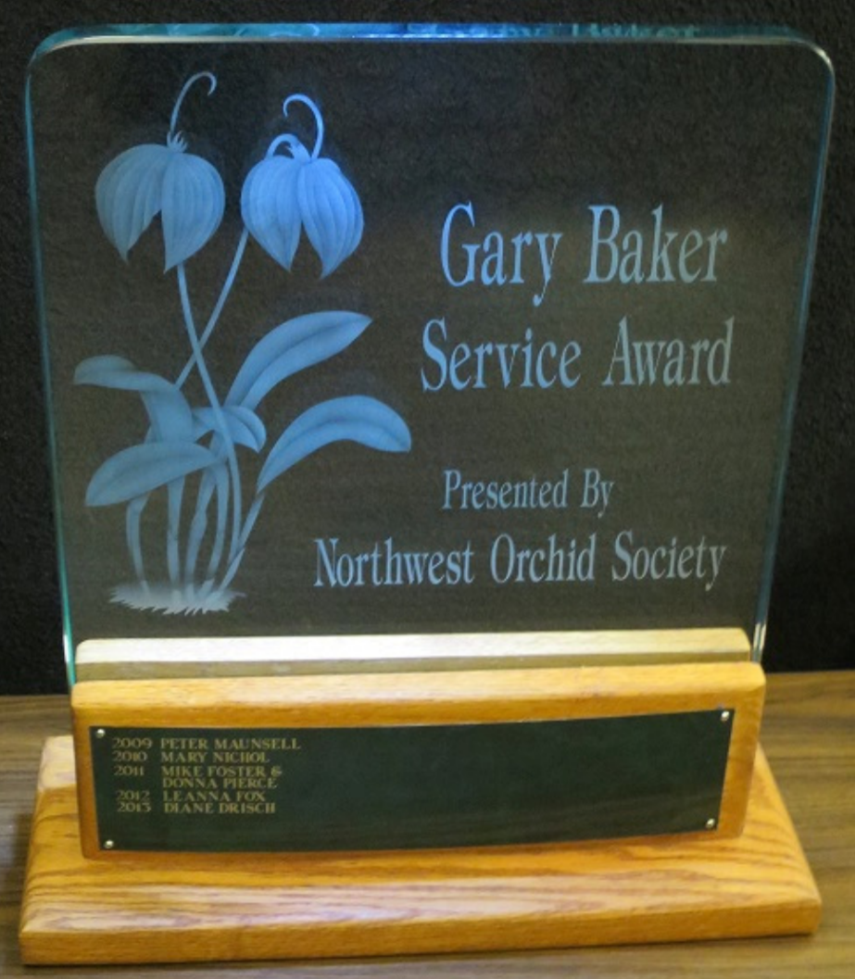
Gary Baker was a long term member of the Northwest Orchid Society. As with another member of our society, Rebeca Northen, Gary has contributed significantly to the orchid world. Gary was a hybridizer with the Beall Orchid Company for decades where he produced many famous crosses, some of which are foundations of orchids still in production today. Later in life he would open a nursery in Woodinville that many of us visited, Baker and Chantry.
There are six hybrids named after Gary, and a Miltoniopsis hybrid with a clone named after Gary.

This award is given annually to the person who has contributed the most to the overall goals of the society in the prior year. The recipient is selected by the board from nominations made by the general membership. Honorees are presented with a crystal perpetual trophy engraved with their name.

At this time the society solicits nominations from the general membership. If you have someone that you would like to nominate for service during the past year, please fill out one of the following forms and return it to Ben Johnson via email.

Gary Baker Service Award - Nomination Form - Word
Gary Baker Service Award - Nomination Form - PDF

NWOS Library

If you'd like to check out a book or tape from our Library, please contact our Librarian Joe Grienauer a minimum of 2 weeks before the next meeting. Besides email, you can give Joe your request at any meeting. For a list of library items please click here NWOS Library.

Volunteer Opportunities
There are lots of choices for participating and helping our society utilizing different skills, interests and available time.

Northwest Flower and Garden Festival Volunteers
- We need volunteers for all shifts. Please contact fgs@nwos.org
Potting Clinic Volunteers - We need volunteers for the following potting clinics.
- Saturday 4/08/2023 – Emerald City Orchids
- Saturday 5/13/2023 – Molbak’s Nursery
- If you are interested in helping please send an email to, volunteers@nwos.org

Upcoming Orchid Shows
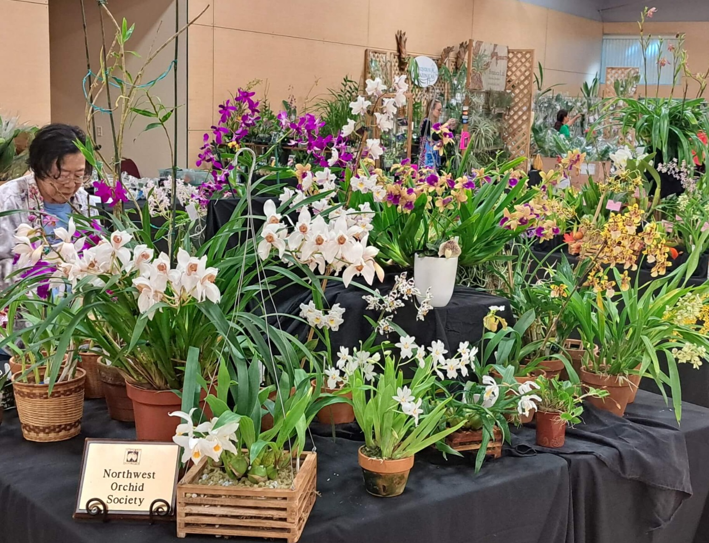
Mount Baker Orchid Society
March 4-5
Christians Nursery, 15806 Best Rd, Mount Vernon, WA 98273
This will be a bench show, that is AOS judged. A “bench show‡” is a show where individual plants are displayed, and there isn’t a “display” for the society. You are encouraged to submit your plants.
For further details see the NWOS posting.

Spokane Orchid Society
April 1-2
Spokane Community College Lair, 1810 N. Greene St., Spokane, WA 99207

This will be a bench show, that is AOS judged. A “bench show‡” is a show where individual plants are displayed, and there isn’t a “display” for the society. You are encouraged to submit your plants.

For further details see the NWOS posting.

Oregon Orchid Society
April 22-23
Oaks Amusement Park, Dance Pavilion, 7805 SE Oaks Park Way, Portland, OR, 97202

The NWOS will be sending a display to the show, your plants will be greatly appreciated.

For further details see the NWOS posting.

‡Exhibition Format (From the AOS Guide to a Successful Show)

Simplest to stage and conduct are "tabletop" or "bench" shows, where all plants are arranged on tables or benches. Plants may be grouped by the classes provided in the show schedule or by exhibitor. Occasionally, a combination of these two formats may be used.

Societies whose members own small orchid collections may find it desirable to undertake a "mini-show," utilizing card tables for each exhibit. One or more flowering plants are placed in an appropriately designed setting not exceeding a card table top in size. This can be a real challenge, calling for skill in scale and arrangement. Where space, experience, and sponsor permit, landscaped exhibits ranging from 25 to 200 or more square feet can be particularly attractive features, stimulating attendance. These exhibits may simulate gardens, natural settings, or other imaginative surroundings, often in keeping with a show theme. This type of display will, however, require far more work both by the staging committee and the individual exhibitor.

Many shows include both tabletop and landscaped displays. Such a combination requires careful attention to the overall show design and a detailed floor plan.

Upcoming Potting Clinics

The NWOS will be holding two potting clinics this spring. We will be promoting these on social media and we will need volunteers to help staff these events.

Emerald City Orchids
Saturday 04/08/2023 11 am - 3 pm
Complete Details

Molbak’s
Saturday 05/13/2023
Details Coming

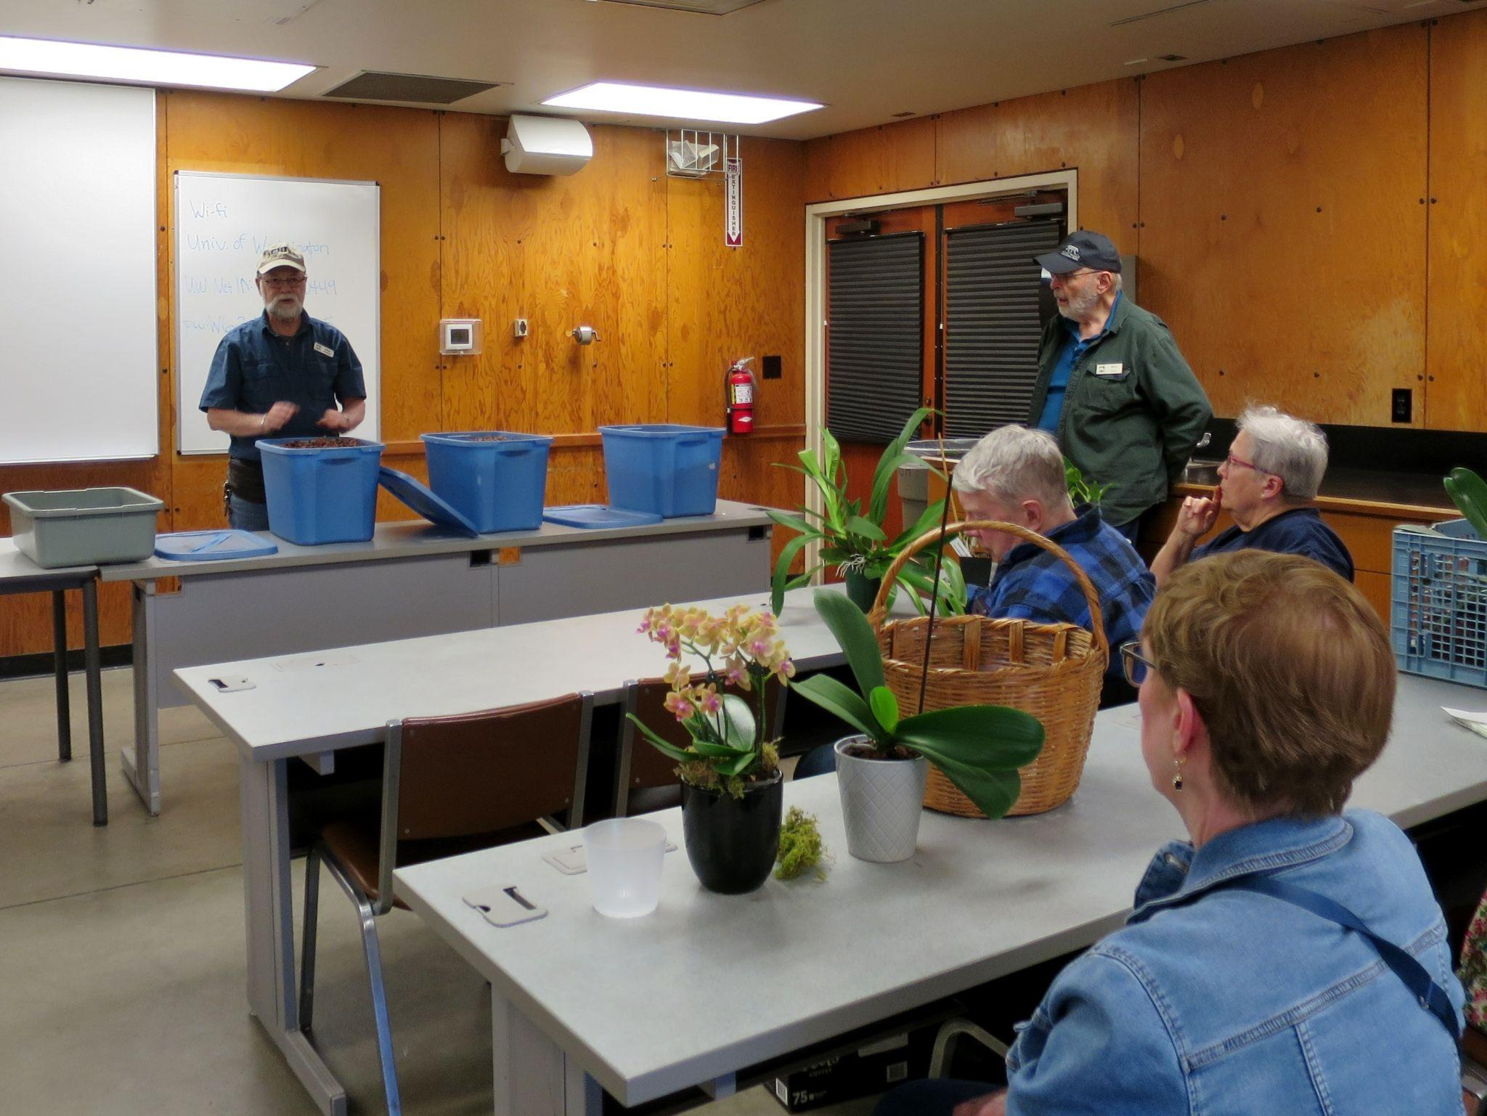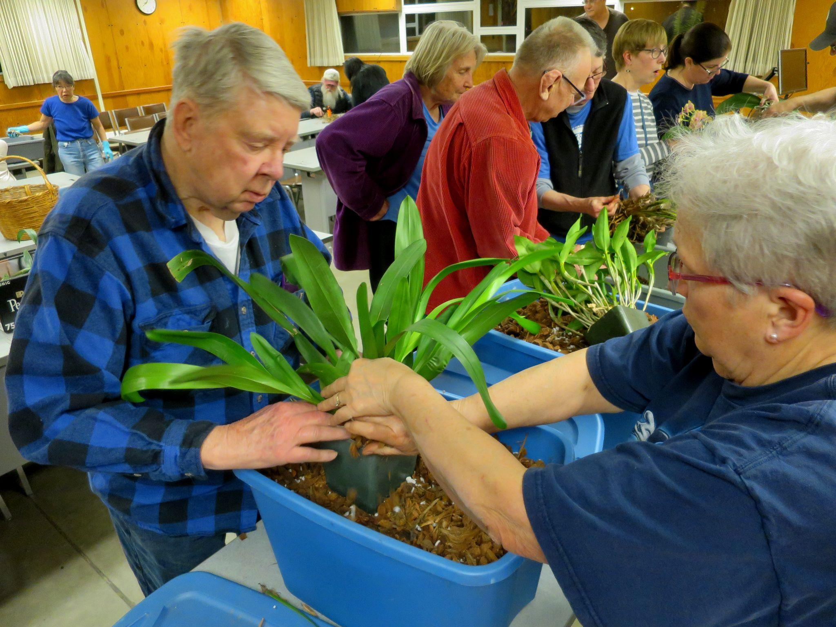

Local Judging

Many of you expressed interest in judging at our shows. Since our next show isn’t until we start to have pumpkin spiced lattes again, we thought we’d share with you the various judging opportunities in our region. We will also be providing the results of the local awards. Hopefully this will encourage those of you who are interested, to go and participate in these judged events.

- February 5, 2023 Monthly AOS Judging 1 PM at Keizer Community Center.
- February 28, 2023 Portland Orchid Society Out Reach Judging
- March 4-5, 2023 Mount Baker Orchid Society Show, Christianson’s Nursery, 15806 Best Road, Mount Vernon, WA. AOS Judging 9 AM March 4.
- March 5, 2023 Monthly AOS Judging 1 PM at Keizer Community Center.
- April 1-2, 2023 Spokane Orchid Society Show, Spokane Community College Student Lair. AOS Judging 8 AM April 1.
- April 1-2, 2023 Cherry City Orchid Society Show, Keizer OR. AOS Judging 8 AM April 1.
- April 2, 2023 Monthly AOS Judging 1 PM at Keizer Community Center.
- April 15-16, 2023 Treasure Valley Orchid Society Show, Hilton Boise Idaho. AOS Judging 8 AM April 15.
- April 22-23, 2023 Oregon Orchid Society Show, Oaks Park dance Pavilion, Portland OR. AOS Judging April 22.
- May 7, 2023 Monthly AOS Judging 1 PM at Keizer Community Center.

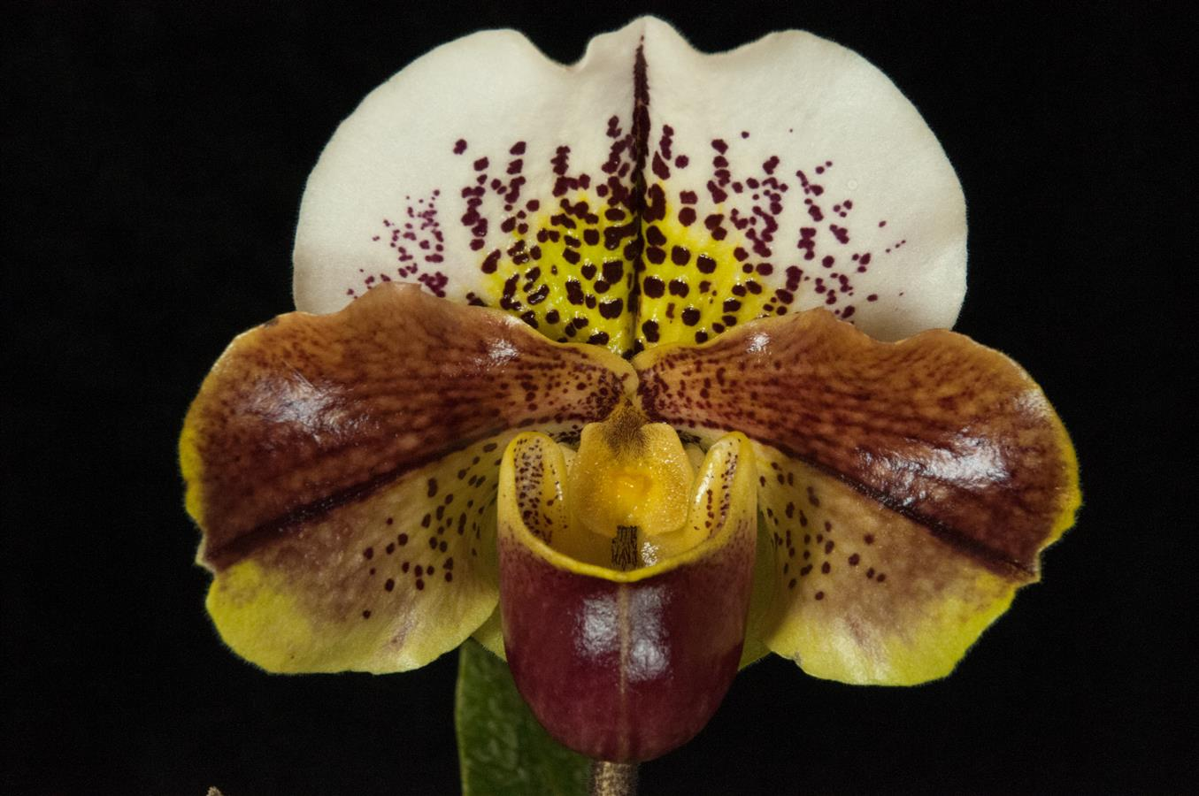
Paphiopedilum Tommy Egger ‘Angel’ HCC/AOS 76, exhibited by Theresa Hill ©Ross Leach
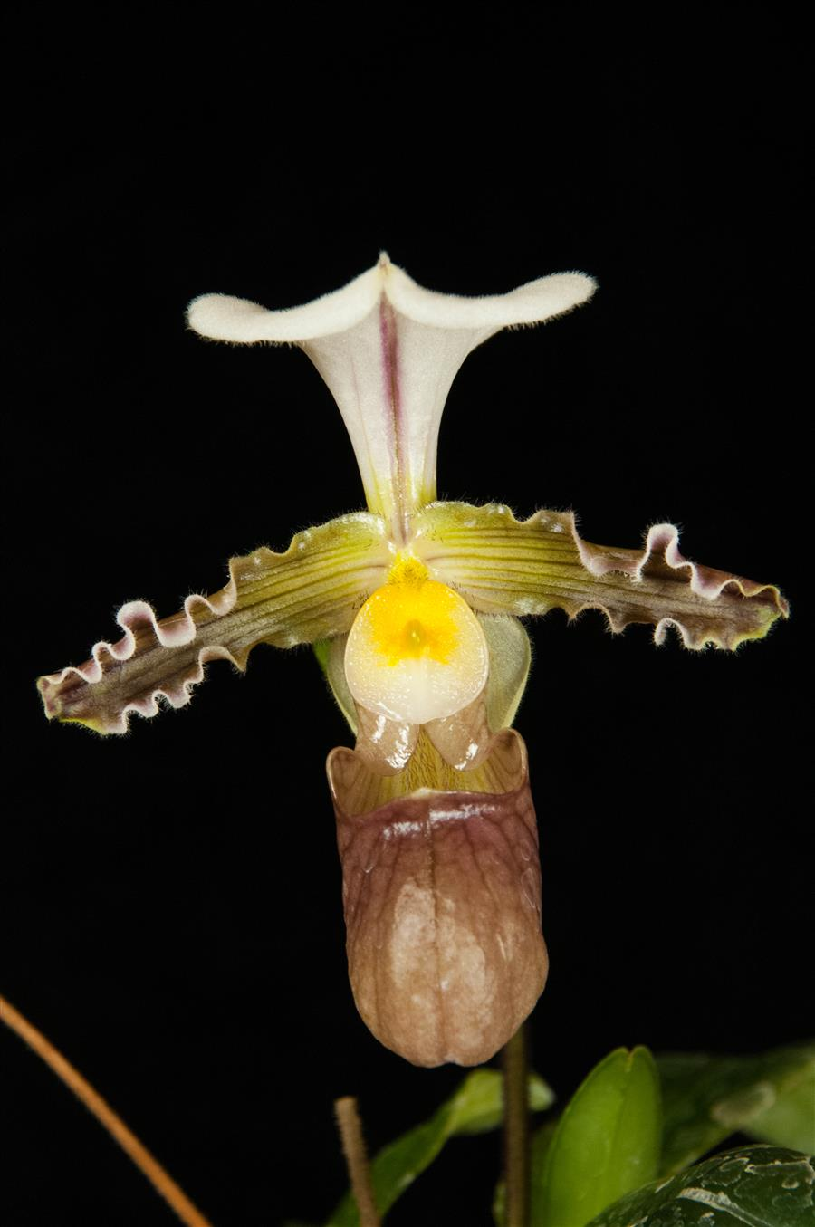
Paphiopedilum tranleinianum ‘Mattie’ HCC/AOS 76 points, exhibited by Susan Heuer ©Ross Leach

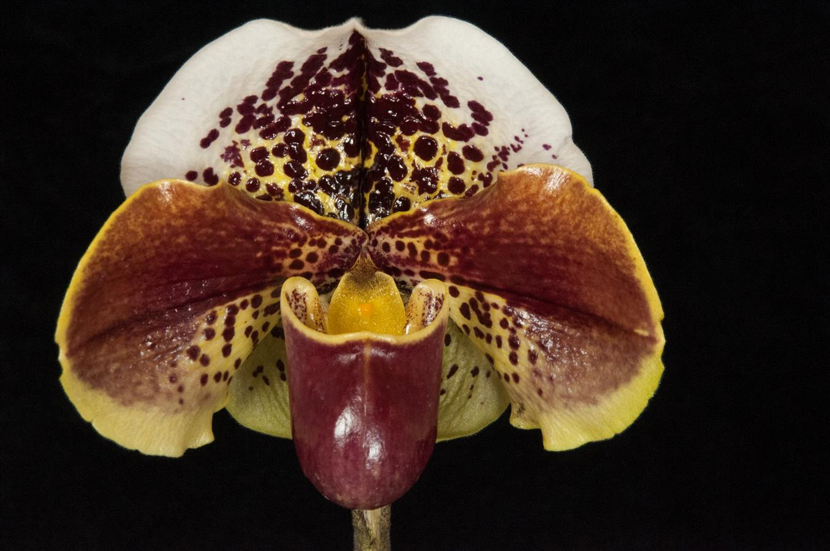
Paphiopedilum Luther Pass ‘Eloise’ AM/AOS 85 points, exhibited by Theresa Hill ©Ross Leach

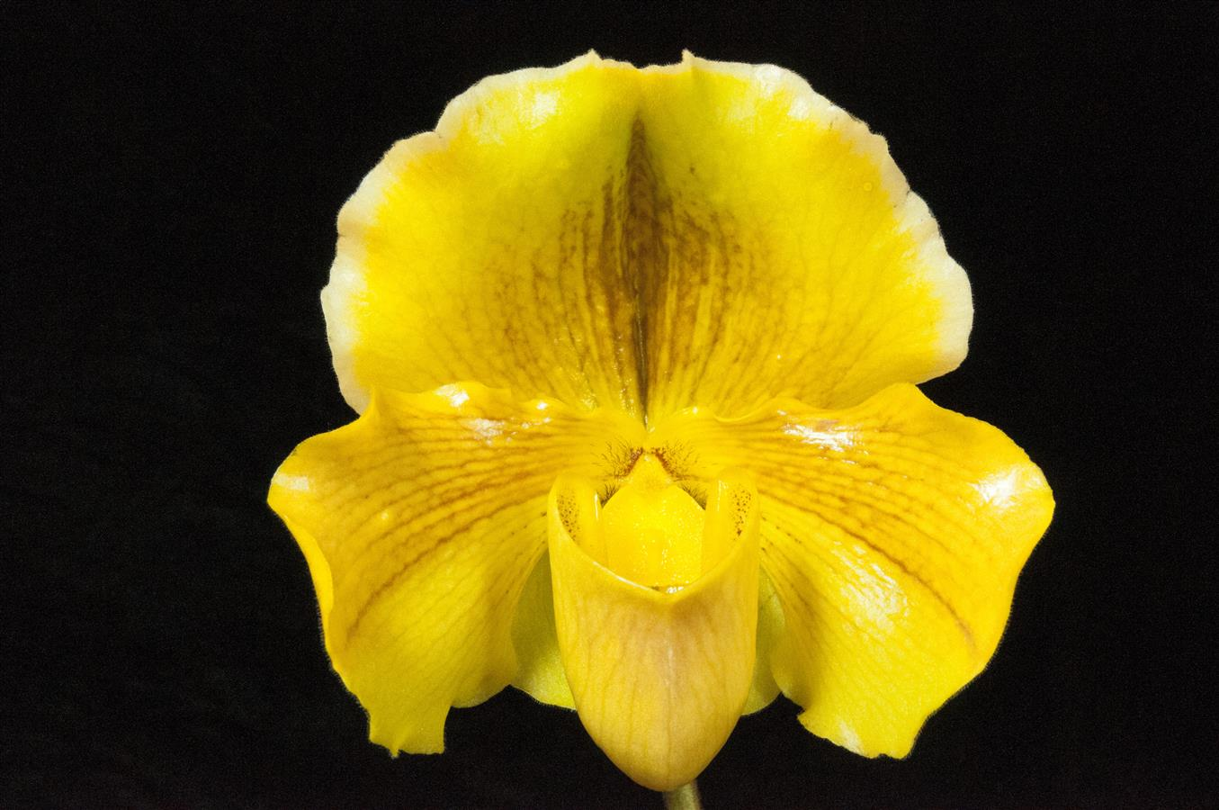
Paphiopedilum Arabesque ‘Debussy’ HCC/AOS 77, exhibited by Theresa Hill ©Ross Leach

Report From The January Meeting

For our January meeting we met at The Center for Urban Horticulture. Our President, Robert Culver, began the meeting by welcoming our new members. Our speaker, Tennis Maynard, joined via Zoom from Ohio so we moved directly into our Speaker Presentation at that point in deference to the time in his time zone.

Tennis spoke on Trichopilias, a genus which is rarely seen in cultivation. He covered many of the species, their cultural needs and some of the primary hybrids produced by these plants. At the end of his presentation he took a number of questions from the audience.

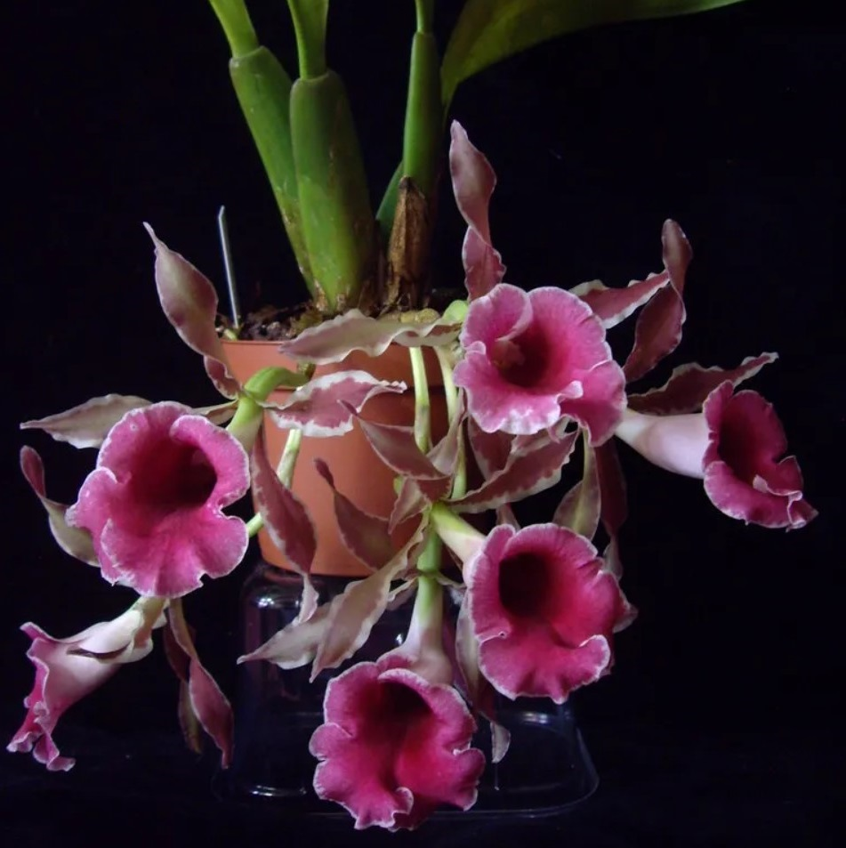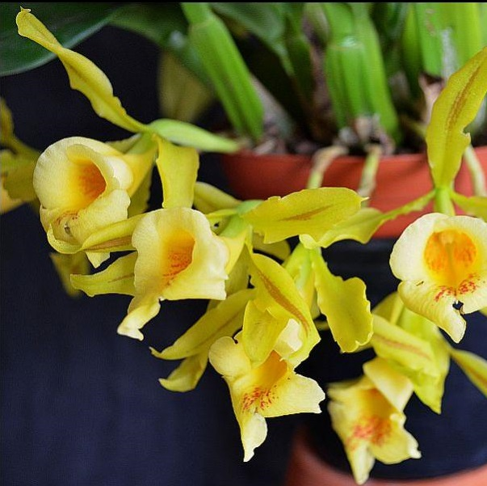
Trichopilia coccinea Trichopilia galeottiana

Robert then thanked the volunteers and everyone else involved with the 2022 fall show. The NWOS was the recipient of the AOS Show Trophy for our display at our fall show. Again, thank you everyone for all your effort and the wonderful plants.

Joe Grienauer updated the club on the status of the 2023 Northwest Flower and Garden Festival. Joe also put out the call for more volunteers.

Ben Johnson updated the club on the status of the 2023 Spring Show. At this time we are working towards a 2024 Spring Show and Ben is looking for volunteers. Contact volunteers@nwos.org if you’re interested in being on the Events Committee.

Bill Leicht asked for a volunteer to help with transactions at sales etc. Mike Cory graciously offered to help Bill.

We are in our new Membership Year. While we work on the new Membership System please continue to renew using PayPal.

Andy Wright covered our Plant Table for us, while Sean Hoyt was our photographer and videographer and Julian Banbury joined Sean taking Photos.

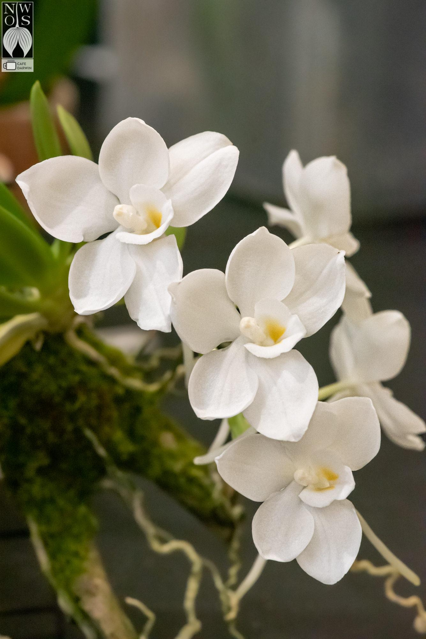
Amesiella Sparkling Jewel - Robert Culver
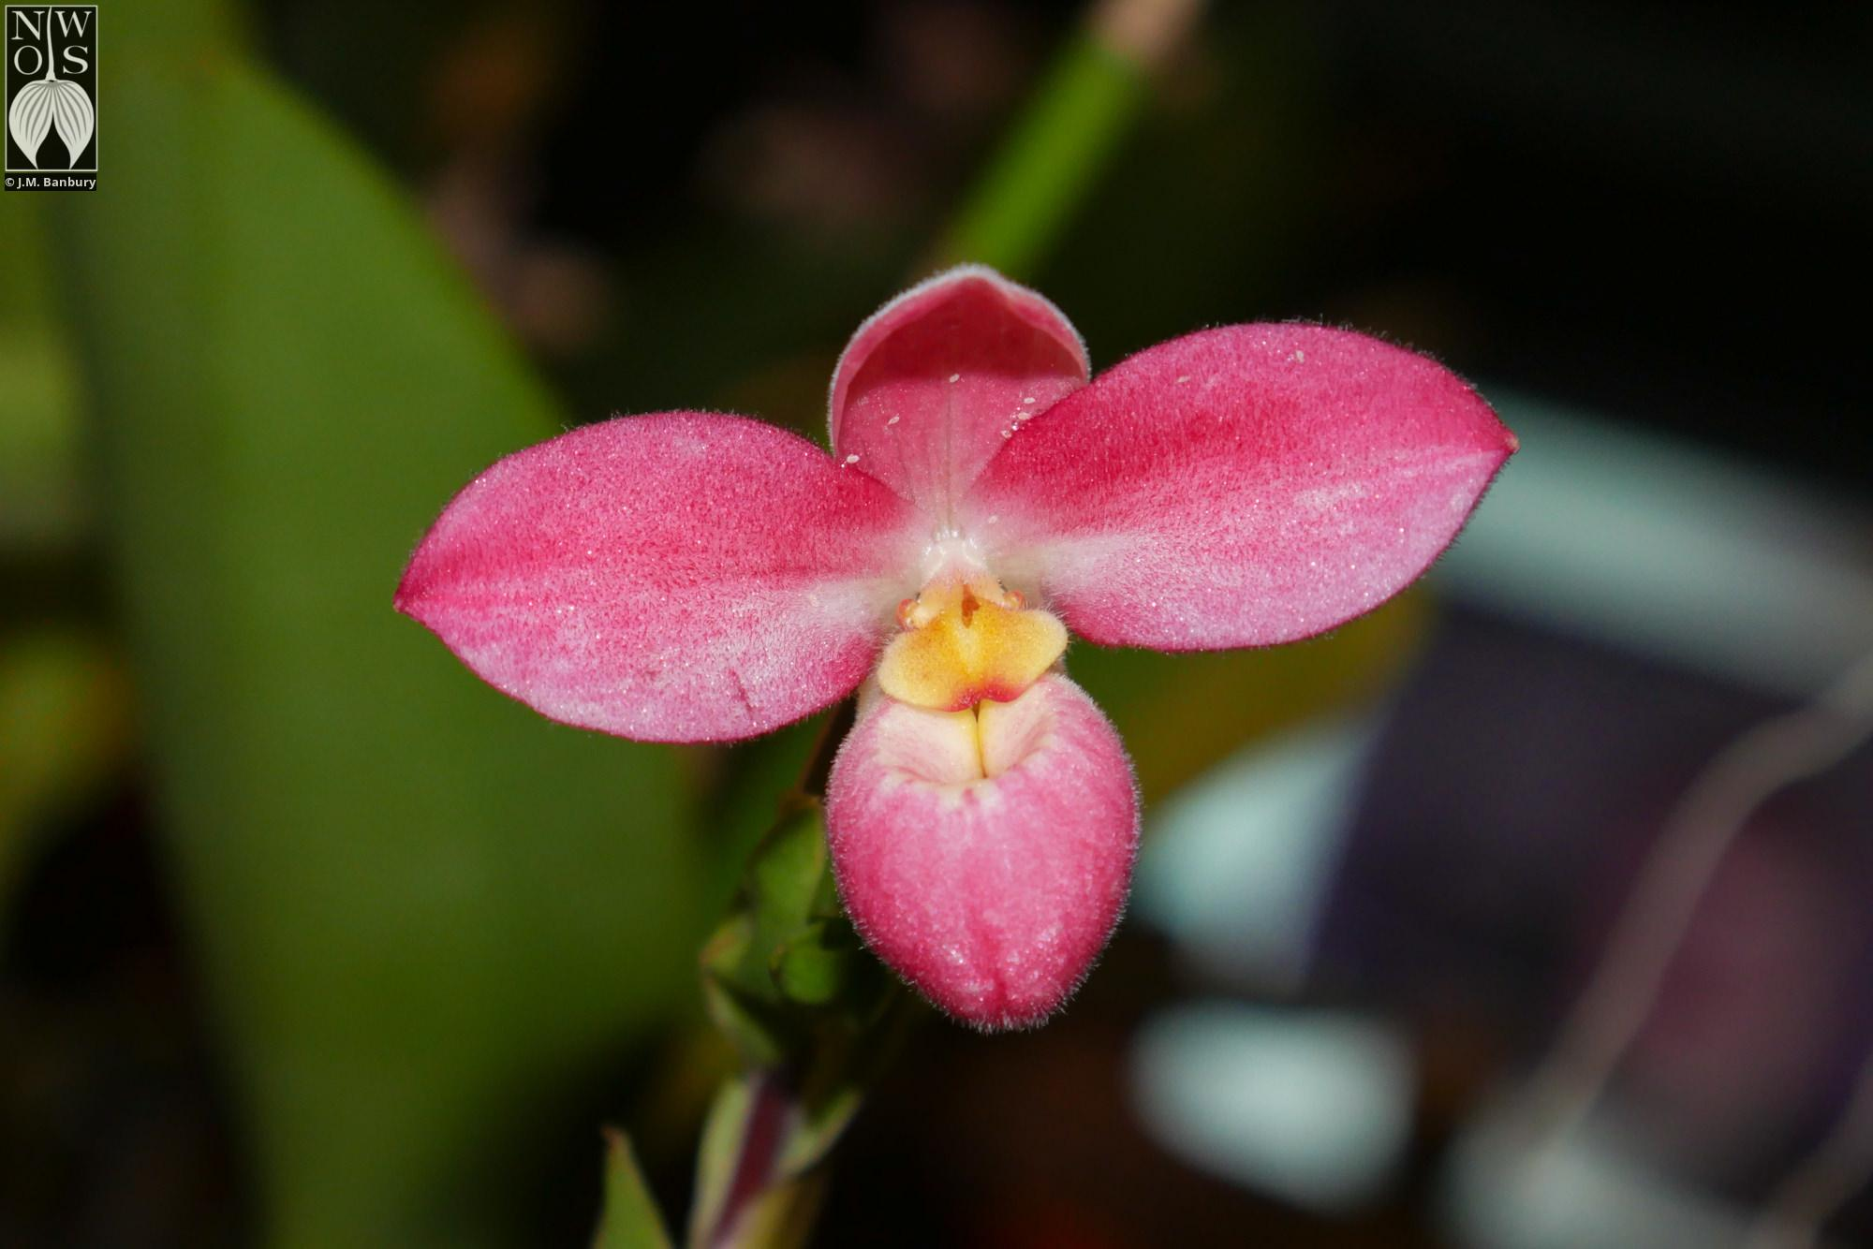
Phrag. Inca Fire 'Crimson Queen' - Yoshi Nagamatsu
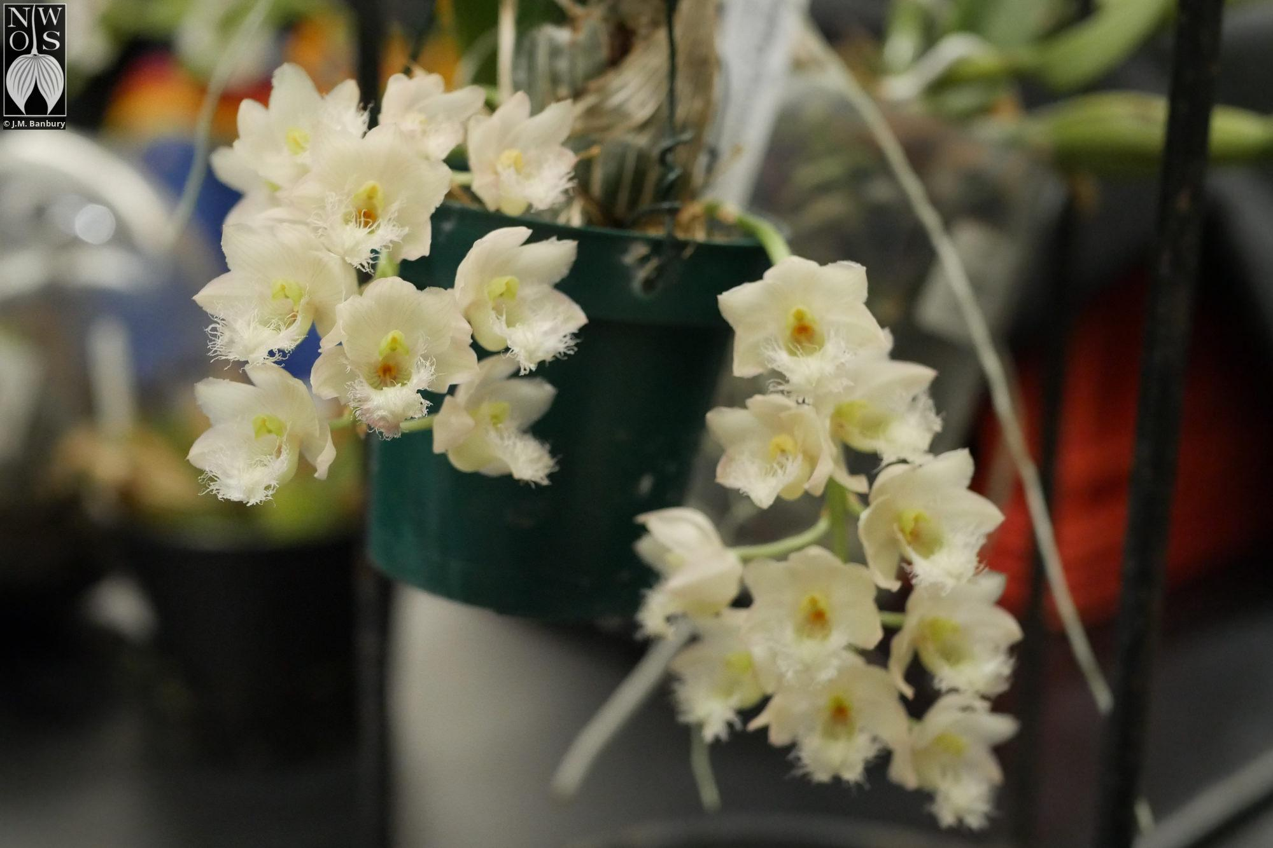
Clowesia Rebecca Northon - Ben Johnson
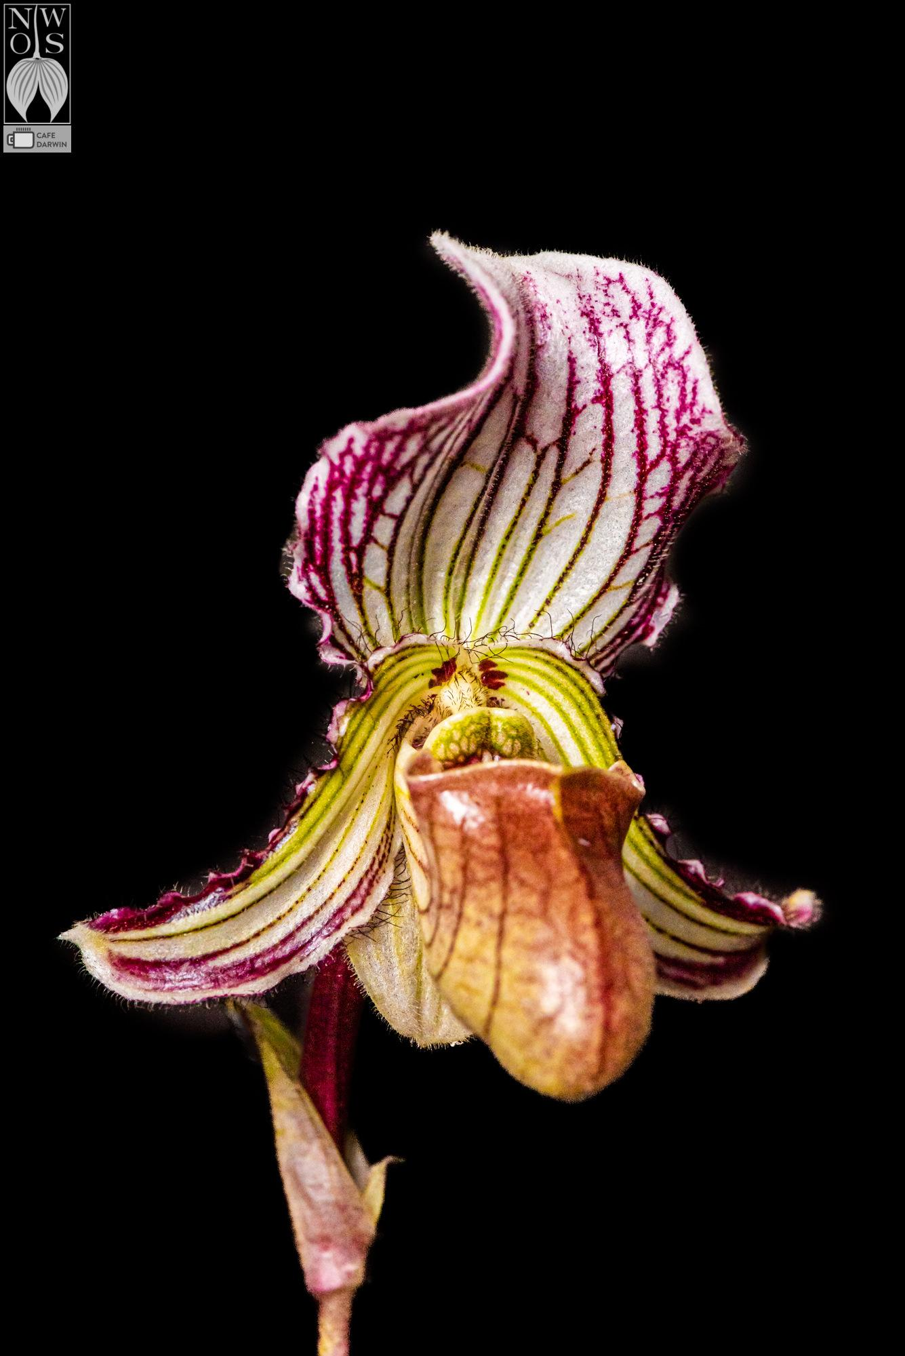
Paphiopedilum fairrieanum - Andy Wright

January 2023 Plant Table Page

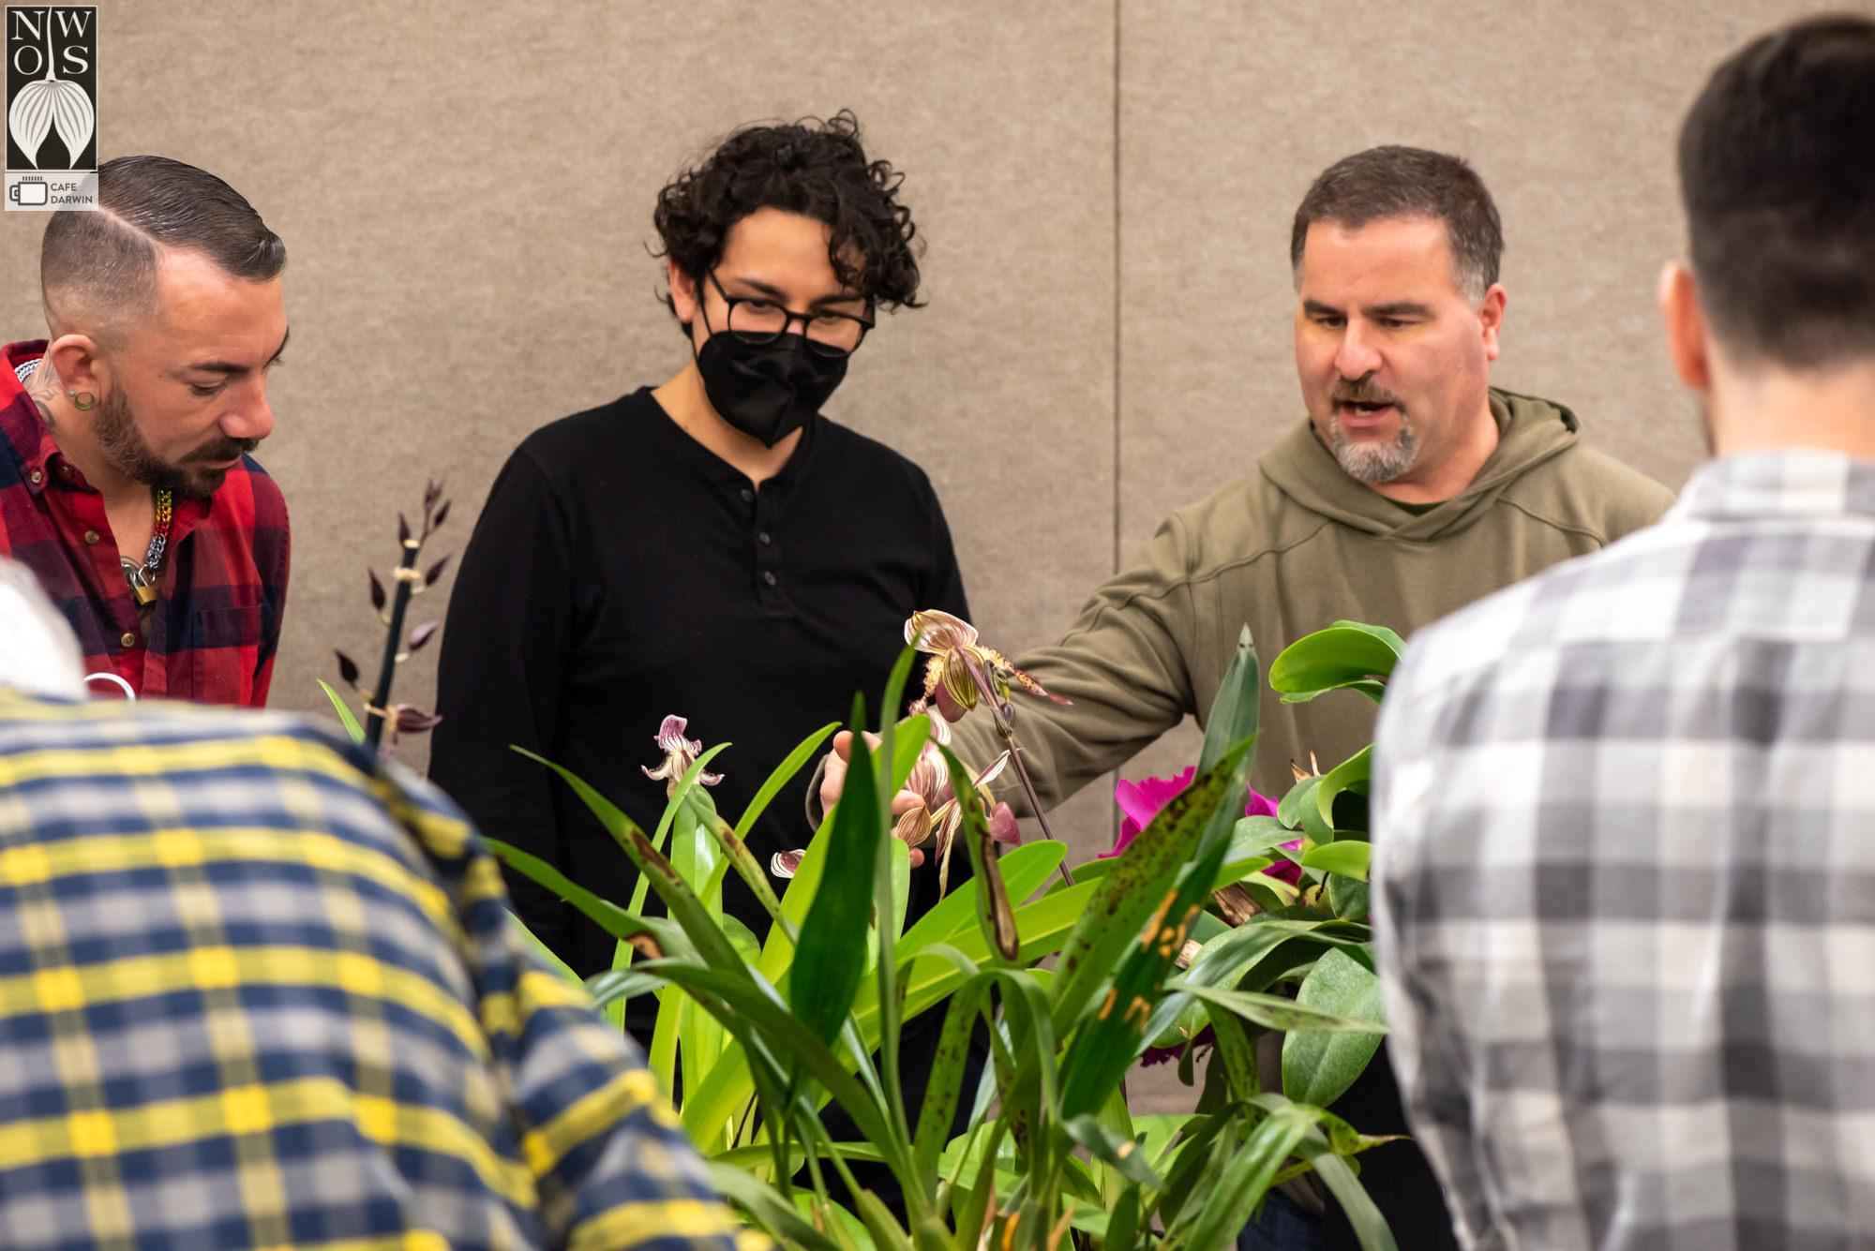
We don’t claim to have the best, but we don’t know where you’ll find better.

The meeting finished with a raffle.
Thank you to everyone that stayed behind and helped us clean up.

Schedule of Upcoming Events
02/25/23 – NWOS Meeting – Annual Auction: This is our annual auction. It starts early with our preview party, nibbles, and bubbly, and ends up with tables and tables of plants for you to bid on. Many of these plants are hard to find and are rarely available outside of private collections.

This will be held at Shoreline Community College, building 9000 from 1:00 PM to 4:30 PM. Please note the change of location,date and time.

03/13/23 – NWOS meeting – Annual Culture Clinic: This is our annual clinic where you can bring your questions, your problem plants, and whatever is ailing something in your collection and the members that have experience with that plant or problem will answer your questions.

04/10/23 – NWOS meeting – Speaker: Jurahame Leyva, “Current Trends in Paphiopedilum Maudiae Breeding” Jurahame will be talking to us about the new trends in this easy-to-grow plant with its showy leaves and long-lasting flowers. It’s a rewarding plant for both novices and experts alike

05/08/23 – NWOS meeting – Speaker: Ron Parsons, “The Genus Dendrobium”

06/12/23 – NWOS meeting – June Food Truck Social: This is our annual social just before we take our summer break. We have a food truck outside and plants inside. We also announce the Gary Baker Service Award at this meeting.

09/11/23 – NWOS meeting – Speaker: Kelly McKracken, “Fragrant Miniatures” The most common question we get asked about plants is “is it fragrant?”; Many orchid growers select their plants based on whether the plant is fragrant. For those of you who grow in limited space, but still love a nose full of floral fragrance, this is the talk for you.

10/09/23 – NWOS meeting – Speaker: Andrew McGinnis, Growing Orchids in Grow Tents, Advanced Indoor Growing.

11/13/23 – NWOS meeting – Speaker: Alan Koch, “A New Look at Intergeneric Phalaenopsis” Phalaenopsis have been enjoyed by novice growers for the ease of growth and long-lasting flowers. Intergeneric Phalaenopsis hybrids are easier to grow, maintain long-lasting flowers, and often bloom more often than a normal Phalaenopsis. Another benefit from this line of breeding has been the creation of many fragrant hybrids. The bright colors, fragrant flowers, and smaller hardier plants make this an interesting direction in orchids.

12/11/23 – NWOS meeting – Holiday Food Truck Social, introduction of new Officers, NWOS Annual Meeting report, Schoenfeld and Northen Orchid Awards, and Holiday Plant gifts.

Reminder for Officers & Board Members
The next board meeting is Wednesday, February 1st which will be at 6 p.m. and hosted over ZOOM. Check your email for the Zoom registration link and agenda. Future meetings are tentatively scheduled for March 7, May 2, September 5, and November 7th

NWOS Website Links

- Main website: Http://www.nwos.org
- Events Calendar: http://www.nwos.org/events
- Membership (including renewals): https://nwos.org/Membership/
- Newsletter - Current Issues: https://nwos.org/newsletters/
- Newsletter - Archived Issues: http://newsletter.nwos.org
- Show Information: https://nwos.org/nwos-fall-show/
- Facebook: http://www.facebook.com/nworchidsociety
- Instagram: https://www.instagram.com/nworchidsociety/
- Twitter: https://twitter.com/nworchidsociety

Special Announcements

Orchid Digest Corporation May 2023 Orchid Tour - France
The Orchid Digest Corporation is conducting a May 2023 Orchid Tour to Provence and Rhône-Alpes, France.

This is an opportunity for a unique, eleven-day orchid and cultural safari through two of France's iconic regions during the peak blooming period.

Trip Details
Registration

©2023 Northwest Orchid Society - All Rights Reserved

The opinions and recommendations published herein are those of the authors. The Northwest Orchid Society (NWOS) disclaims responsibility for any losses or damages that may be attributed to the use or misuse of any material or any opinion published in these articles and on the website. This website and the photographs, articles, and content are protected by copyright and no part of them may be reproduced or re-used without the permission of the author.

The Special Announcements (SA) section is provided as a courtesy to the readers of this newsletter for events that may be of general interest to the readers. The NWOS (1) makes no promises, warranties, or representations as to SA, including its completeness, accuracy, availability, timeliness, propriety, security, or reliability; (2) provides SA on an "AS IS" and "AS AVAILABLE" basis and any risk of using SA is assumed by you.

