Northwest
Orchid News
December 2022
Volume 75, Issue 11

- About the December Meeting
- This is Our Holiday Meeting
- Volunteer Opportunities
- 2023 NW Flower & Garden Festival
- Plant Table
- Sales Table
- Raffle Table
- NWOS Library
- Report From The November Meeting
- Schedule of Upcoming Events
- Reminder for Officers & Board Members
- NWOS/Amazon Shopping Link
- NWOS Website Links
- Special Announcements

About the December Meeting
December 12, 2022 7 PM
University of Washington Center for Urban Horticulture
3501 NE 41st Street, Seattle, WA 98105

Hybrid Meeting, In person and via Zoom Zoom Registration

The Zoom segment will be brief, reminding online NWOS members they need to send in arrangements to reserve their holiday plants now if they have not already done so. We will see them in the New Year.
This is Our Holiday Meeting
Holiday Foodtruck Social, Holiday Plant Giveaway, Annual Report, Introduction of new Officers, Orchid Trophy Competitions, and Voting on new Bylaws

This year will be a no-host catered event by the El Gran Taco.

Happy Holidays! It's once again time to put our growing skills to the test. Please join your fellow NWOS members in our friendly annual competition. We have two trophies to award, the Schoenfeld Trophy as well as the Rebecca T. Northen Miniature Orchid Trophy. This is also the time of the year for Holiday Plants, each person who is a full-fledged member, whether they paid for a single, dual, or youth membership. Everyone is entitled and encouraged to participate in winning one or both of these trophies. All you have to do is bring in one blooming plant for each competition. Let's make this a robust and lively competition. Bring your blooms whether you think they'll win or not. After all, we LOVE to see lots of orchids. If you’re not the competitive sort we will be having a Plant Table to display your lovely plants.

The Schoenfeld Trophy is awarded to the best-blooming plant of any size.

The Rebecca T. Northen Miniature Orchid Trophy is awarded to the best blooming plant that is 6 inches or less in height, excluding the bloom spike which can extend beyond the 6" limit for the foliage.
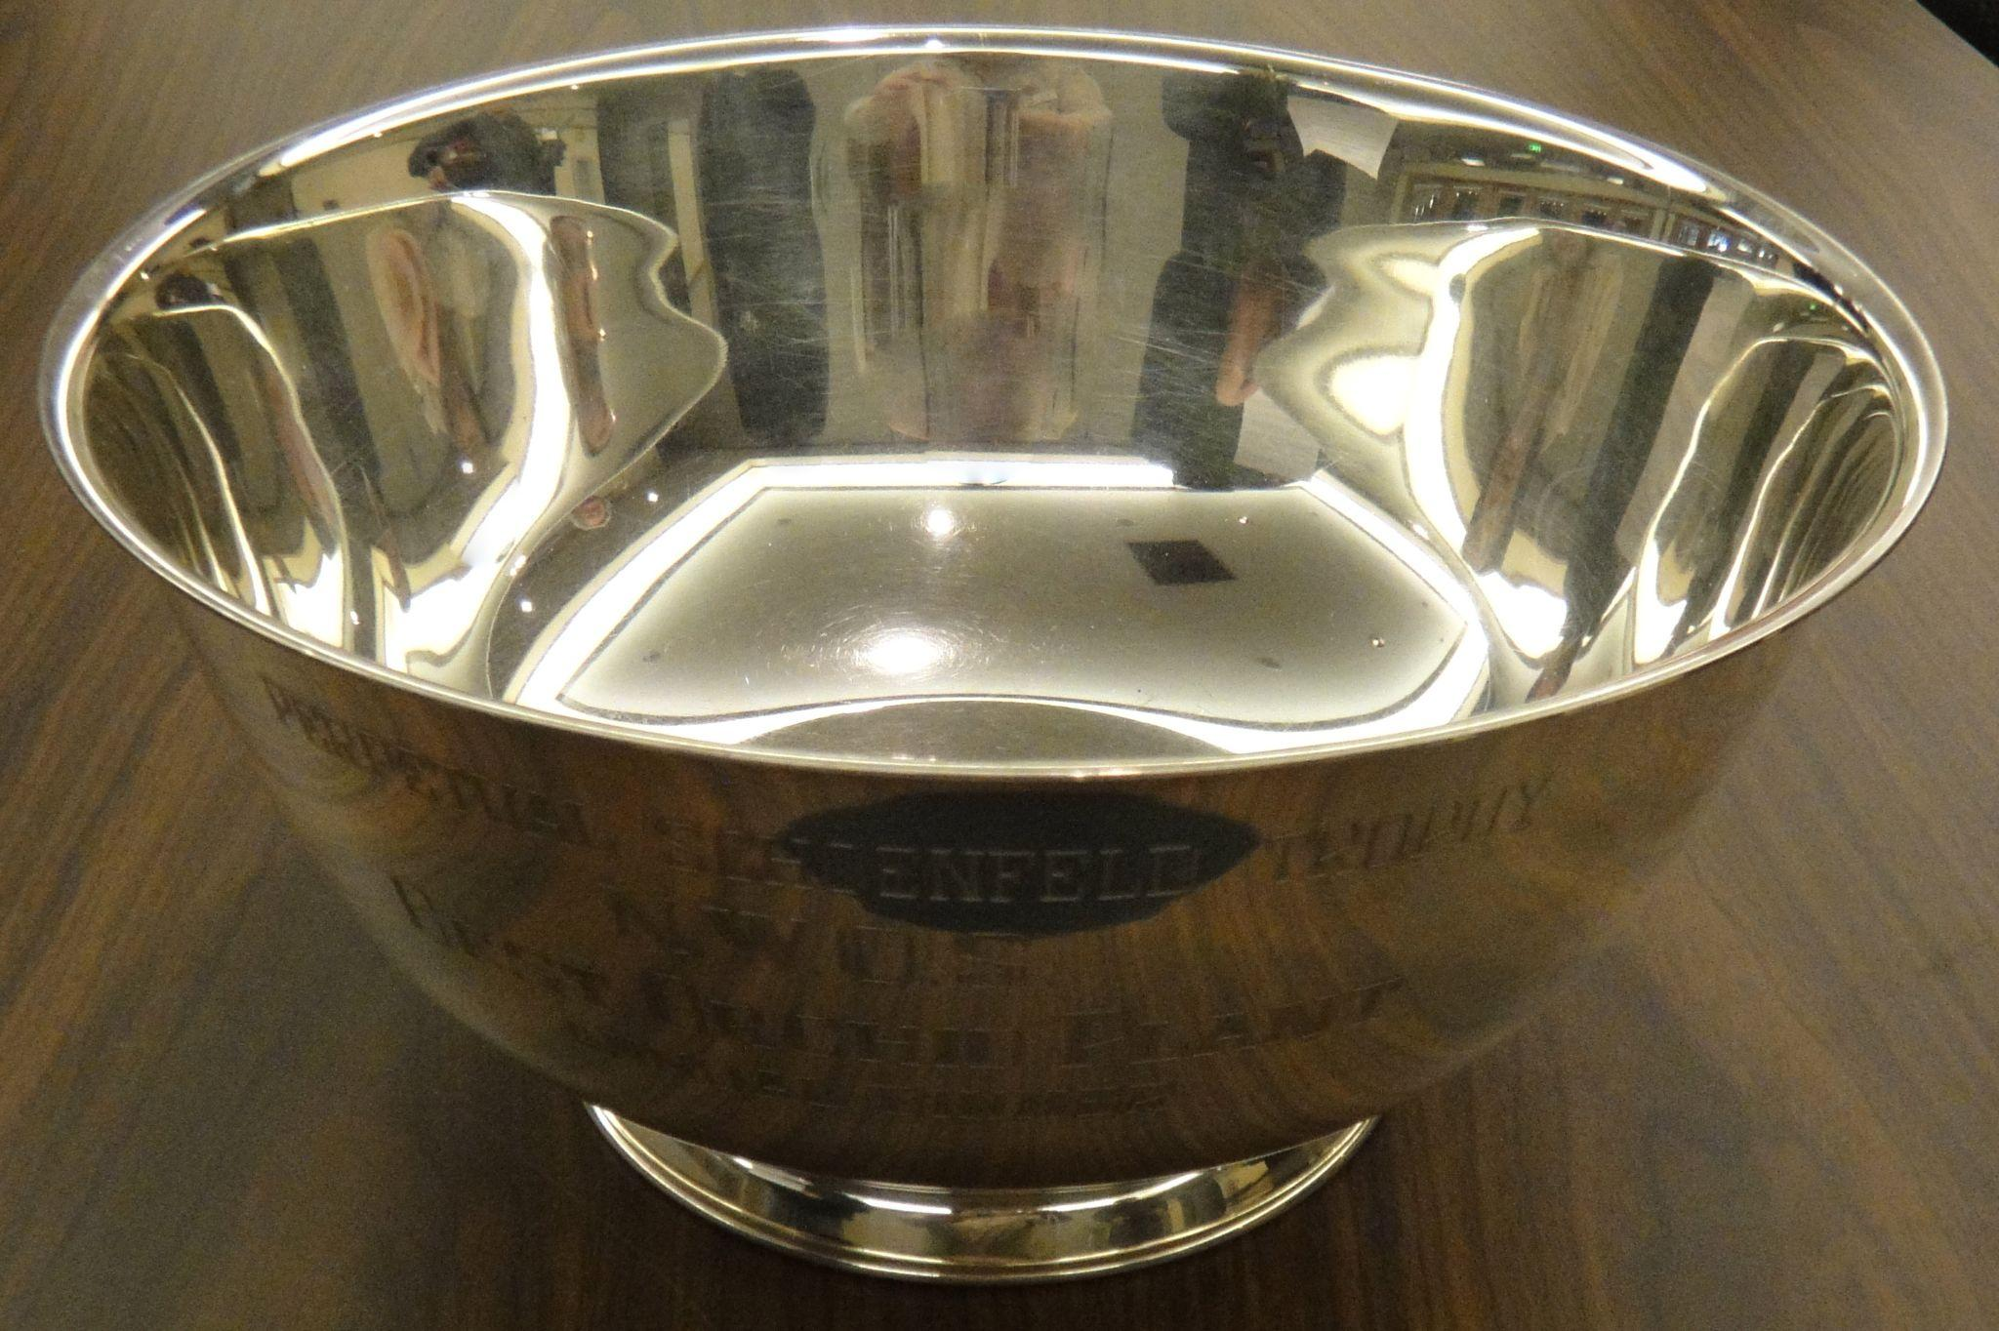 | 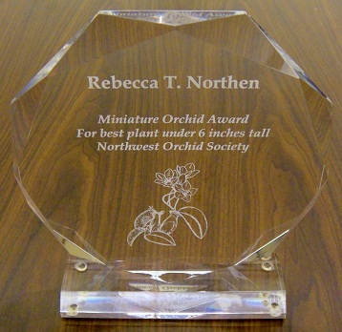
Schoenfeld Trophy Rebecca Northen Trophy

Everyone at the Holiday Party will cast a vote for each trophy. What do we mean by 'best-blooming plant'? That's completely up to you, the voter, to decide what 'Best' means to you. The winner will keep the trophy until the December 2023 meeting.

We will be voting on the new slate of officers and board members and then welcome them on board and thank those retiring.

We will also be voting on new ByLaw changes.

This is also our annual meeting and we will have brief reports from our officers and committee chairs.

This year at our annual Holiday Social we will continue our annual tradition of gift plants. The gift plants are quality plants purchased specially for this event. Each member whose dues were paid by Nov. 11 will be able to select a plant that is suitable to their growing conditions. You do not have to attend in order to receive your plant. To be clear, each person is a full-fledged member whether they joined as a single, dual, or youth member, and will receive one free plant as a gift from the society.

If you are not able to attend and would like to receive your plant you have two options.

- Pick up your plant from a North or South End location by the next meeting, plants not picked up by then will become raffle plants at the next meeting.
  - The North End location is located in Shorline
  - The South End location is located in Normandy Park
- Pay to have your plants shipped to you. This will cost about $12-$13 per plant including a heatpak.
- You will need to make arrangements prior to the meeting. Please email Robert Culver at vp1st@nwos.org.

Display Table:
Unlike previous years we will have a display table. Unlike our standard Display Table, we will not have a discussion of the Display Table plants. We will still have them labeled and photographed and shown on the website as well as in the January Newsletter, but, the focus of this meeting will be our Trophy Tables. You will be encouraged to talk to members about their plants.

Sales Table:
No sales table this month, but extra holiday plants will be available to purchase after the members have all received theirs.

Raffle:
No raffle this month.

NWOS Library:
No Library this month.

Volunteer Opportunities

- Joe Grienauer is heading up the 2023 Northwest Flower and Garden show this year. Joe has his own sales booth to run as well as our show to manage. He is going to need help from willing society members to help make this happen. The opportunities available are discussed in the 2023 NW Flower & Garden Festival Section

2023 NW Flower & Garden Festival

The 2023 NW Flower and Garden Festival is fast approaching. We are in need of YOU to help us build our 875 sq ft orchid garden.
I have broken out each day into 3-hour shifts to make things easier. Feel free to sign up for one or more shifts as your time allows.
If you would like to sign-up, please send an email to FGS@NWOS.ORG with your requested shift(s) and contact information.

“Setup” work passes – for those of you who sign up to help us build or teardown the garden, you can obtain a “Workpass” from the WSCC door guards as you enter the Show floor (4th floor) Convention Center. The same goes if you enter via the Hand-Carried Freight elevator entrance in the Main parking garage between Pike and Seneca streets.
“Show” wristbands – for those of you who sign up to work a shift during the Show (Feb 15- 19), your color-coded wristbands (unique for each day) will be available at the Will-Call window on the 4th floor. From the Pike Street entrance, follow the escalator signs up to the 4th floor Atrium, turn left to see the “Will-Call” window. Just give your Name and “NWOS” to get your envelope. Your envelope will contain all of the wristbands needed to enter each day that you signed up to work.
So, make sure you sign up!

Below are the days and shifts that need a few more helpers. The minimum age allowed on the floor during Setup and Teardown is 16 and no pets.
Moss Collection: Location – Grantham’s in Lake Forest Park
Thursday, February 9– We need at least 5 people for this event. A small group of us will meet at the Granthams’ for breakfast. From there we will carpool to a property owned by the Granthams’ out near Monroe. Moss will be collected in sheets from the ground, from fallen tree trunks, and from tree limbs. Moss will be placed in plastic tubs and loaded into Joff’s van.
After collecting for about 3 hours or until the van is full, we will meet for a late lunch at a local Mexican or Thai restaurant in downtown Monroe, and then head back home. The moss will be used as ground cover and to hide orchid/plant pot rims in the garden.
- 9 am to 3 pm
Garden Build: Location – Washington State Convention Center
Saturday, February 11– This is “heavy lifting” day. Bring gloves and dress in layers. Our first setup day consists of measuring out the garden’s perimeter walls, placing the stone benches, and erecting the mountain of wood pallets and pre-built wood superstructure. Large irregular slate pieces will be affixed to the wood superstructure with 3-inch-long screws through large metal washers along the slate edges to hold the pieces in place. If you have a portable electric drill with a torx head for driving the screws, we could use you and your drill today. Also, people with rakes or shovels are welcome. Anyone willing to show will be put to work. We will have Horticulture students again helping us from Lake Washington Technical College.
Stones, that are already on pallets, will be set within the garden area with the help of a forklift. While that is taking place, a low wall of granite “tumbled cobble” bricks will be set along the garden’s perimeter. This wall will only be 3-bricks tall (about 18 -inches), so it will be built quickly given enough helpers. A dry creek bed of oval stones will be laid near the base of the mountain. Then the entire garden will be filled with sawdust.
- 9 am to 7 pm
Sunday, February 12 – Your orchids must arrive today. Your orchids will be grouped by flower color, groupings will be labeled with orchid type and name, and then stored on temporary staging and shelving that will surround the garden. Some larger orchids may be placed today, but most will get placed within the garden on Monday.
Foliage plants from the Woodland Park Zoo arrive at 11 am. Foliage plants are grouped and placed at various locations within the garden, and then “planted” within the garden’s sawdust.
- 9 am to 6 pm
Monday, February 13 – “The Grind”
Orchids — Volunteer Park and UW Botany – arrive today.
Orchids are grouped by color, arranged to look like a giant plant, and placed within the garden with the top 1-inch of each pot showing. Moss sheets will be placed around the plants and over the pots to help “hide” those tops. Technically, we can’t have any pots showing unless they are ceramic and part of the garden. So, the moss will help us in that regard.
Orchids will be placed on the mountain and draped or hung along the rock wall. Some trailing foliage plants will be placed here as well.
LED ground lights and spots will be placed around and throughout the garden to highlight specific plants and structures.
Foliage plants need to be watered and the bricks of our perimeter walls lightly sprayed with water to clean away dirt and debris.
- 9 am to 12 am
Tuesday, February 14 – This is “finishing touches” day. Moss is placed to hide any exposed pots and rims, plant signs are adjusted to face the viewing Public, and the foliage is cleaned up for judging.
- 7 am to 12 pm
Festival Shifts
- If you have a name badge, please try to wear it. If you don’t, you can request one from Robert Culver.
- We will have NWOS aprons for you to wear.
- We will have a postcard about the NWOS for you to hand out to people.
Wednesday, February 15 – This first day is usually the busiest with Day 4 (Saturday) being the second busiest. Volunteers will help answer common orchid questions, and ask people not to sit on the wall, not to step into the garden, and not touch the orchid flowers. There will be small signs informing viewers of these points around the garden wall, but some people need to be reminded.
You may also be asked to give a “hint” as to where our “Treasure Hunt” item is hidden – in every garden, an item is hidden for children (of all ages) to locate and note on a form. The completed form can be exchanged for a 4-inch blooming plant at the entry to the Skybridge. This treasure hunt helps engage young ones supposedly while their families admire the gardens.
If you are asked a question, you don’t know how to answer, there will be other members present each shift you can point to for help.
Volunteering during the Festival is also a fantastic way to see the rest of the show and visit the orchid vendors. You may do this after or before your shift. There may also be periodic breaks during your shift if enough people sign up to help.
- 12 pm to 8 pm
Thursday, February 16 – Foot traffic will start out busy in the morning and will slow down towards the afternoon. In years past, Thu and Fri have had many school and tour groups viewing the Festival.
- 9 am to 8 pm
Friday, February 17 – Like Thursday, foot traffic will be heaviest in the morning and tapering towards the early afternoon. Then a surge of people around 5 pm onward due to the lower ticket price.
- 12 pm to 8 pm

Saturday, February 18 – This is probably the second busiest day next to Wednesday, especially if the weather outside is sunny. Foot traffic will slow down around 3 pm.
- 12 pm to 8 pm
Sunday, February 19 – This is the final day and foot traffic starts out slow and gradually builds toward the show’s end. The bargain hunters appear hoping for special pricing deals in the Plant Marketplace. Don’t be surprised if you are asked “what plants we will be throwing away” at the Festival’s end. The answer is “none”. All orchids are owned by our members and the foliage belongs to the Zoo.
- 12 pm to 6 pm
Teardown
Sunday, February 19 –
All orchids are removed from the garden. The plants are grouped by their owner and placed into owner-marked boxes and trays. Hopefully, each owner marked “each of their plant’s pots (boxes and trays too) with their name or initials on blue painters’ tape” before the start. Each plant is checked against the “list the owner made previously” to verify the correct plant is going home with its proper owner.
Plant owners take their charges home, or have previously made arrangements with others tearing down to transport their plants to the February General Meeting on Monday Feb 20. (IF the NWOS Board voted to move the meeting, that is.)
Moss is removed and bagged. Foliage plants and the bagged moss are moved to their “staging area” for later pick-up on Monday by the Zoo. Plants from Volunteer Park and UW Botany are set aside in their “staging area” for pick up on Monday. Wood pallets for the stone bricks are unearthed and the stone bricks can be cleaned of debris stacked on their pallets.
- 6 pm to 9 pm
Monday, February 20 –
Volunteer Park and UW Botany pick up their plants in the morning. The Zoo retrieves their foliage plants as well.
Slate pieces are removed from the mountain’s superstructure and placed on their pallets. Again, members with cordless drills with a torx head are most welcome. Any remaining wall bricks are cleaned of debris and placed on their pallets. The garden area is cleaned up of debris. Trucks are loaded with the garden’s superstructure, or the debris taken to the dumpsters on the Loading Dock.
In years past, we have finished dismantling and loading all vehicles, as well as cleaning up our space by 2 or 3 pm. Hopefully, we will do that again, with enough helpers.
- 9 am to 6pm
NOTE: The orchids purchased by the society will be at the March 13 Meeting to help the Society recoup its costs and be available during the auction.
* Orchid Vendors *
There are two orchid vendors plying their wares at the NW Flower & Garden Festival this year — Emerald City Orchids (Booth 2228) and Andy’s Orchids (Booth 2134). Both of these vendors are found in the “Plant Marketplace” area directly ahead as you exit the Skybridge. Just look for the “Orchids” banner hanging nearby.
Sign Up to Help
As you can see, there are many tasks where we need helpers like YOU to build our garden, staff it during the Festival, and even help dismantle it. We can use help from all of you.
Sign-up sheets can be found at the December and January General Meeting. You may also sign up by sending an email to FGS@NWOS.ORG with your name, contact information, and requested work shifts. Someone will get back to you quickly.
Any questions, talk to Joe, Ben, Joff, or Robert at the Meeting or send us an email at FGS@NWOS.ORG.

Report From The November Meeting

Steve Dorsey, President, began our meeting by introducing our speaker Peter T. Lin who spoke to us on Neofinetia and its hybrids. Before Peter began his presentation. Steve had Robert Culver speak about the new Plant Table Tag System. This system is being put in place to help both our photographer Sean Hoyt prepare the photographs for our gallery and to allow each of us to identify the plants more easily when we are walking about the Plant Table.

Steve then had Joe Grienauer come up and speak about the 2023 Flower and Garden Festival. Joe spoke about what we will be building this coming year and the need for help. (See above for more information about the 2023 Flower and Garden Festival.)

Peter T. Lin then spoke to us about Neofinetia and its hybrids. Peter covered the history of Neofinetia with its long history in Japan and the current judging system in place there. Unlike here, Neofeinetias are judged not for their flowers but primarily for the shape of the plant, the color of the root tips, how they are potted on mounds of moss, and the containers they are potted in. He showed the great variety of forms that the plants come in as well as the forms that the flowers come in.

Peter talked about the natural environment of these plants, and in one dramatic picture showed the limbs of a Ginko enrobed in white from Neofentias covering the branches of the tree. Peter covered the culture of Neofentias while covering their natural environment. These plants are very temperature tolerant and adapt well to home living.

He then covered the hybrids that are being made with Neofinetia. There are many delightful hybrids being made with genera such as Vanda, Rhynchostylis, Aerides, Phalaenopsis, and Renethara. These plants will make an excellent addition to a collection for anyone growing in the home or an intermediate to warm greenhouse.

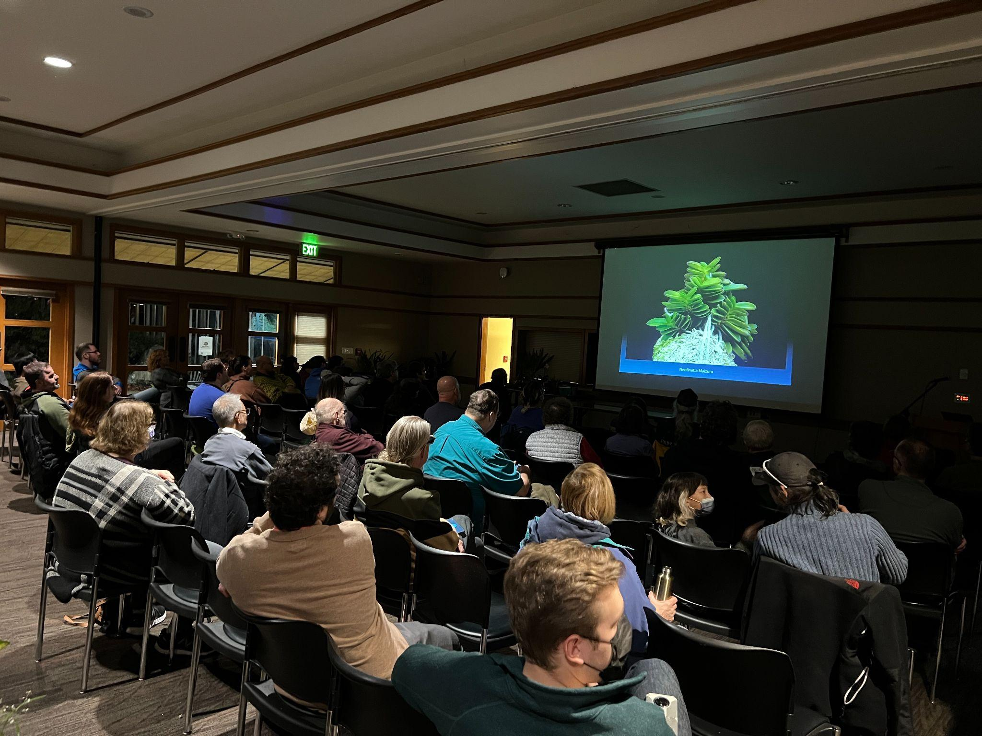
One of the many forms of Neofentia falcata

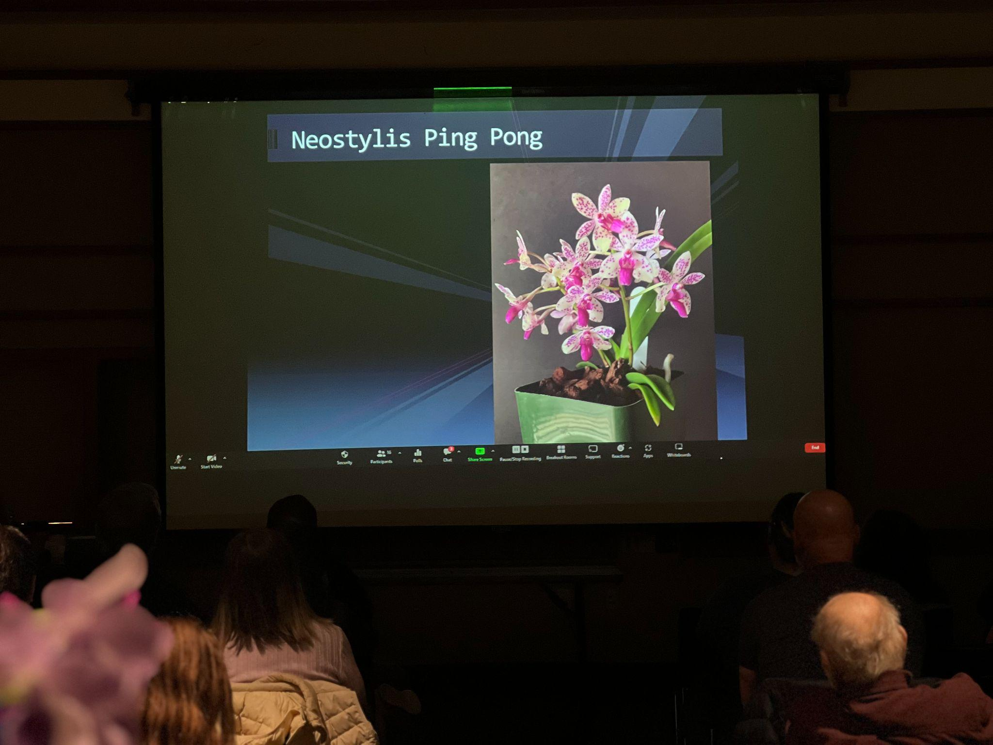
One of the many attractive hybrids available, Neosylis Ping Pong

As a reminder, Peter’s talk is available for members to view in the member's section of the website till June of 2023.

We then took a break and moved onto our Plant Table where Andy Wright covered the plants that were brought in. As we have moved into the winter plants have begun to flower after maturing their summer and fall growths. Sean Hoyt assisted with photography and video.

These are several selected images from the November meeting. To see the rest of the photos of November's Plant Table, please follow the link to go to the online gallery for both photos and a video of the Plant Table.

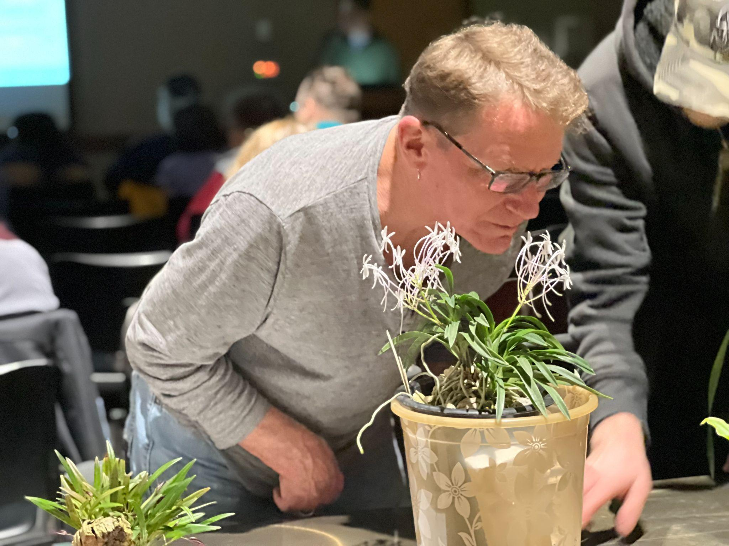
Bill Leicht inspecting a magnificent Neofentia grown by Minh Au.

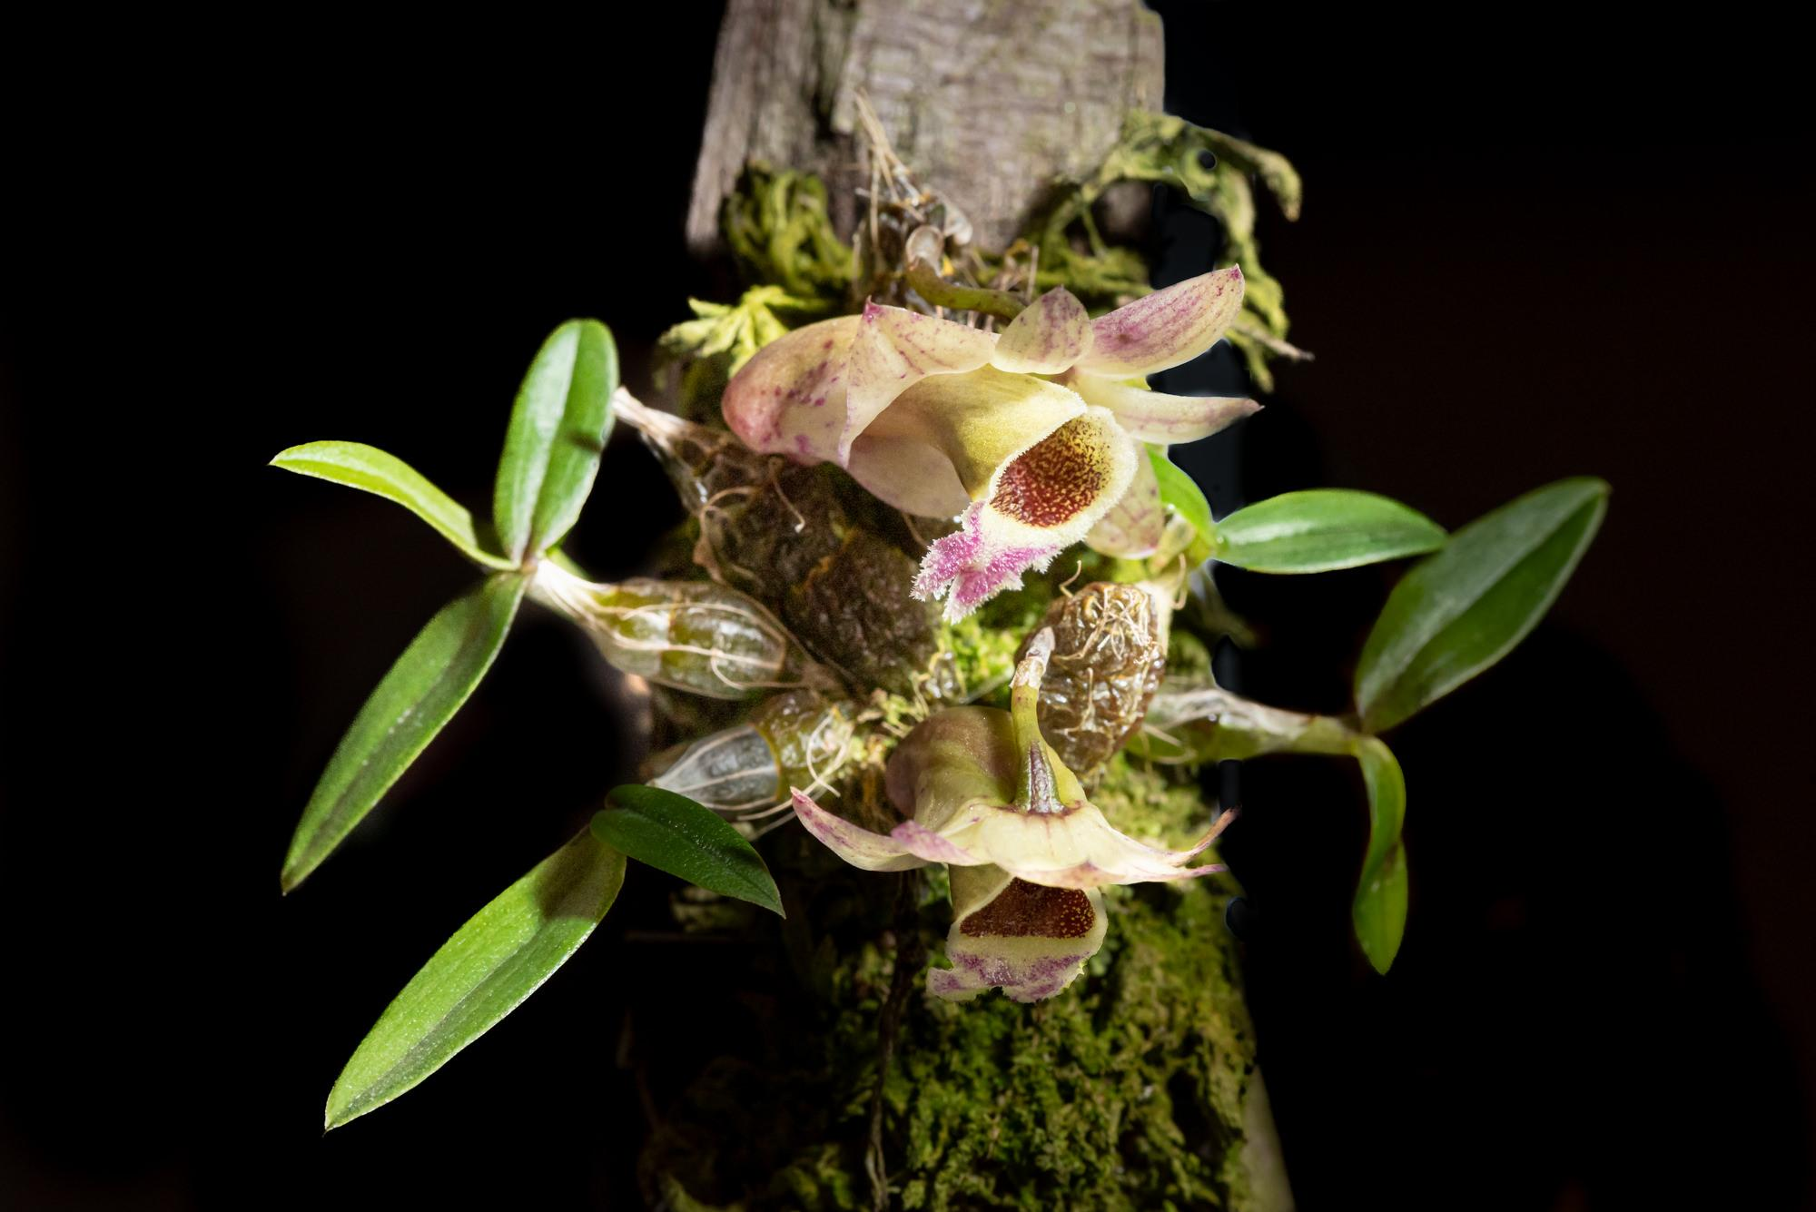
Dendrobium hekousnse grown by Julian Banbury
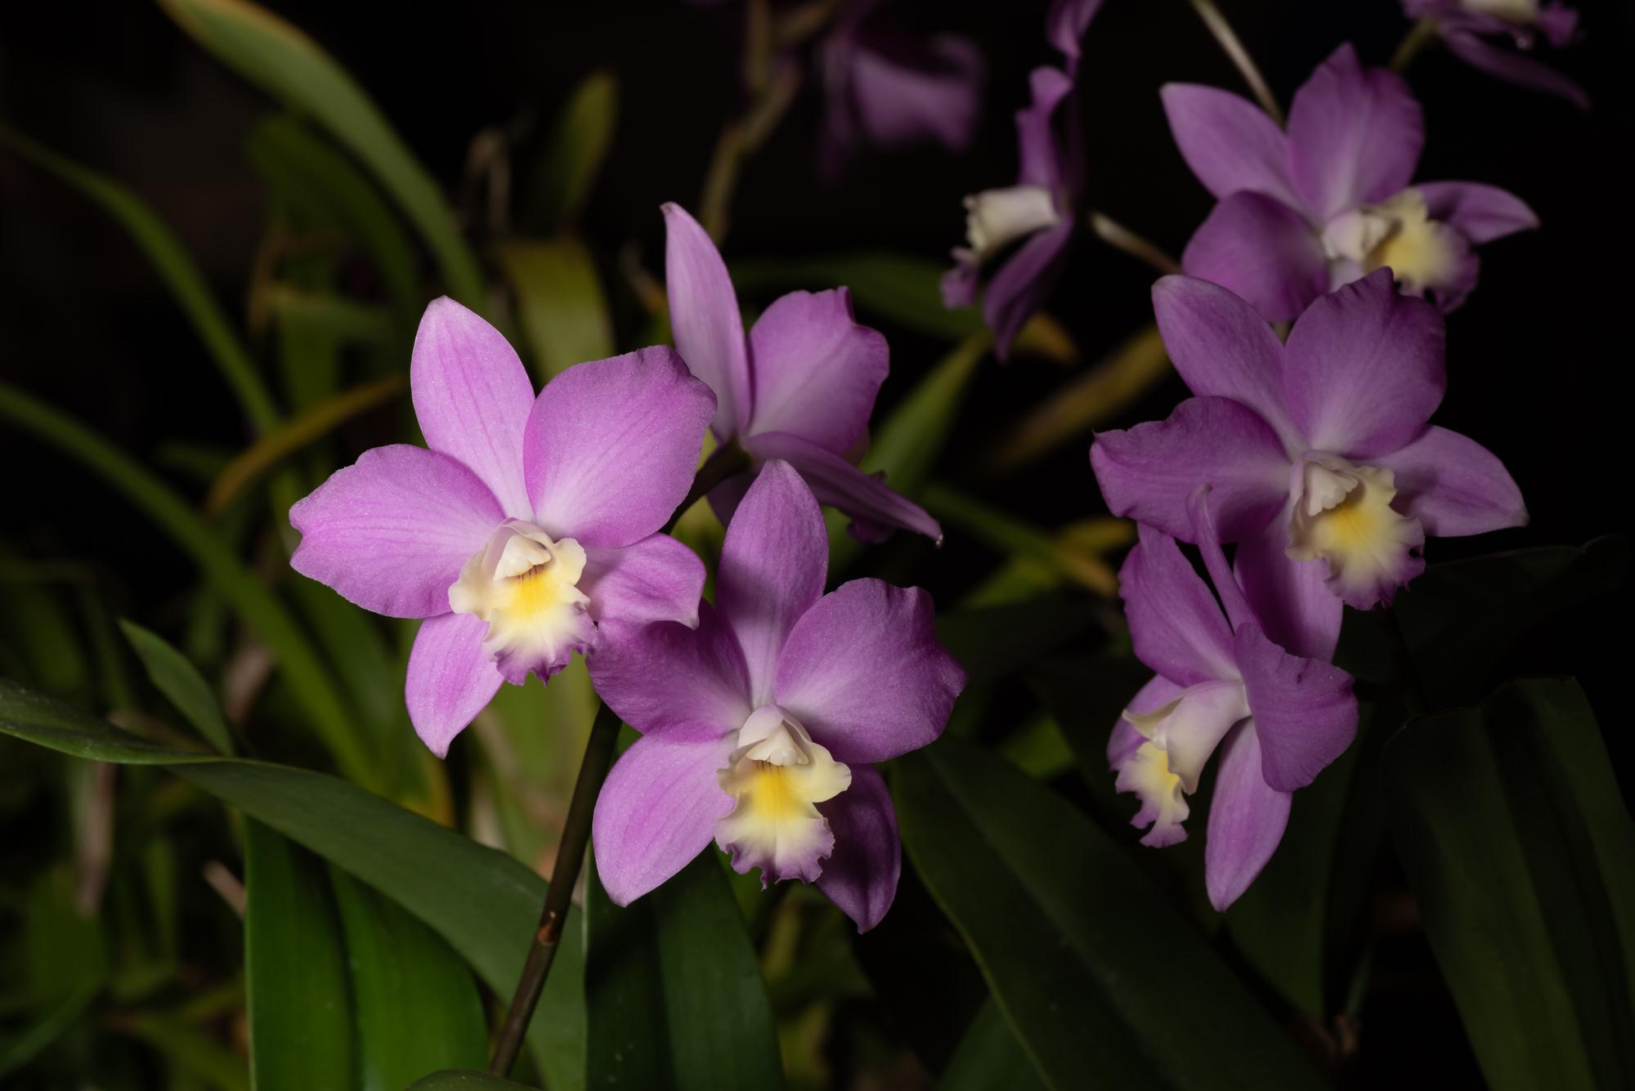
Laeliocatanthe Rosemarie grown by Steve Mongivin
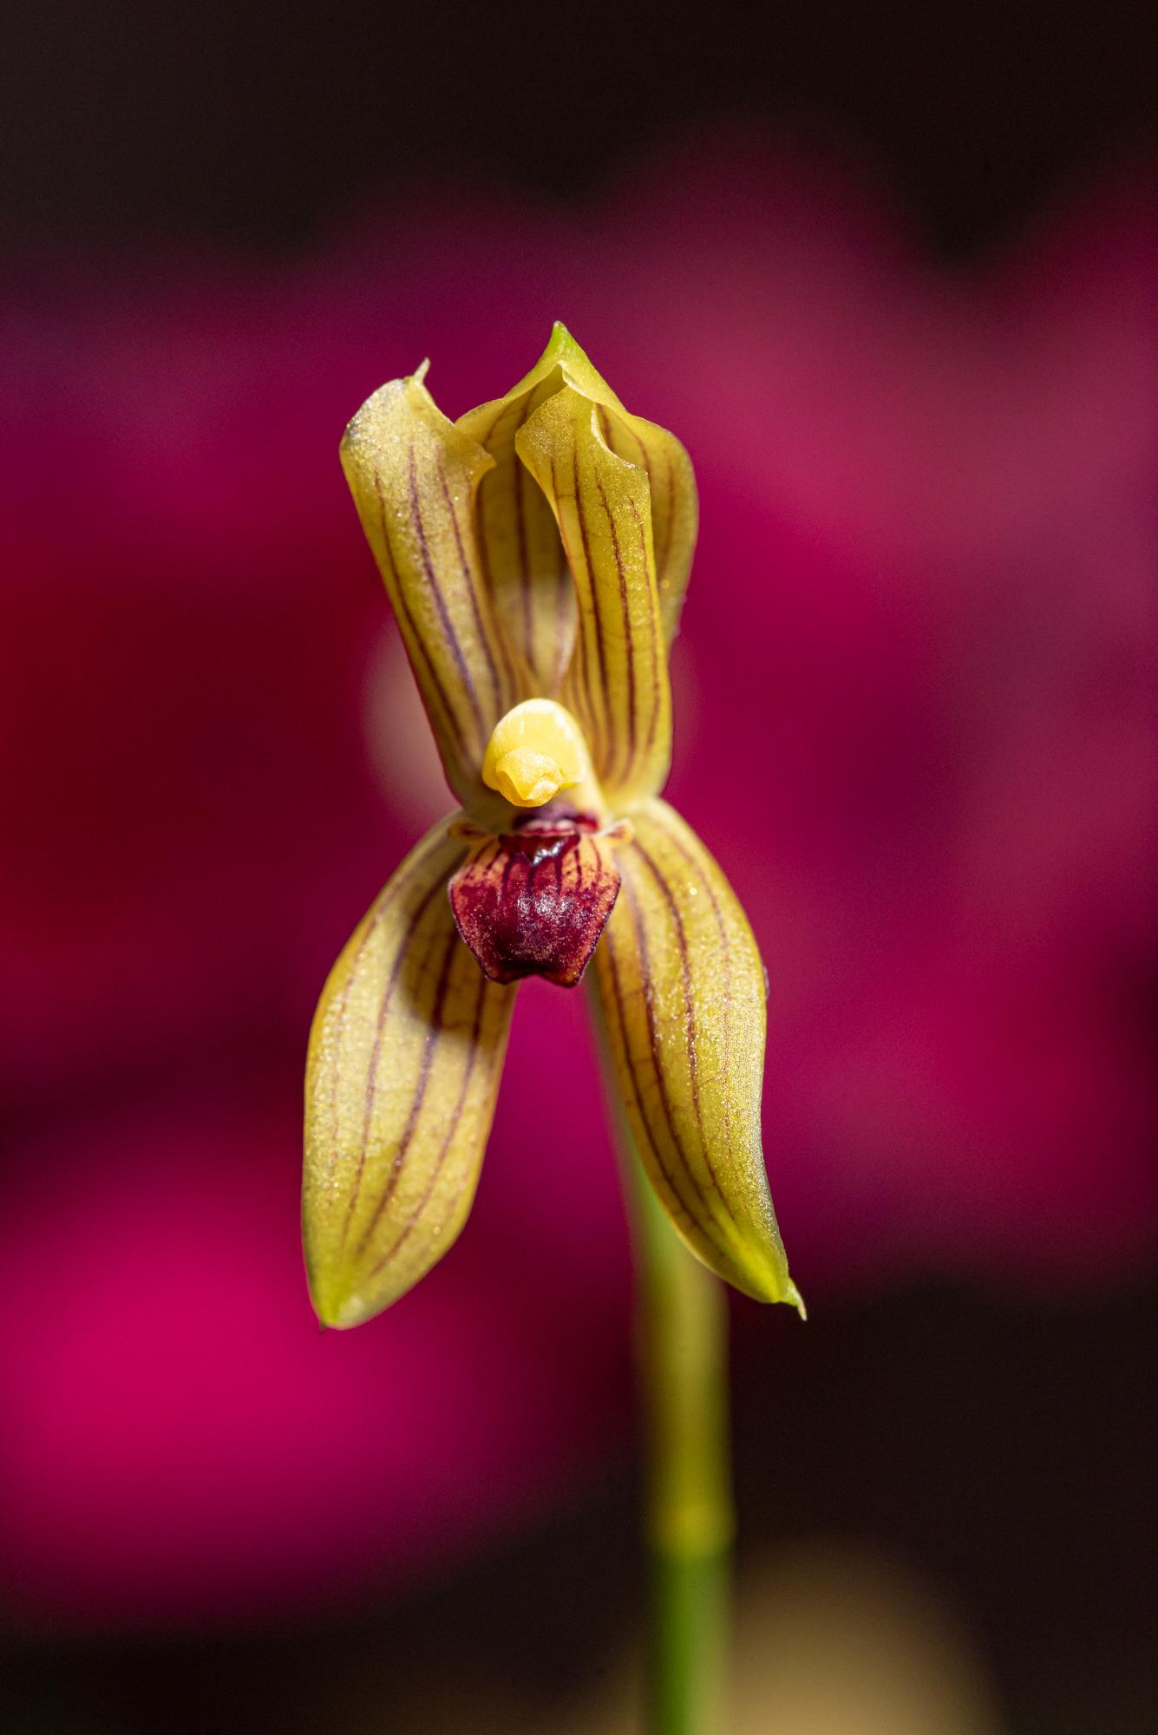
Mormolyca ringens grown by The Granthams

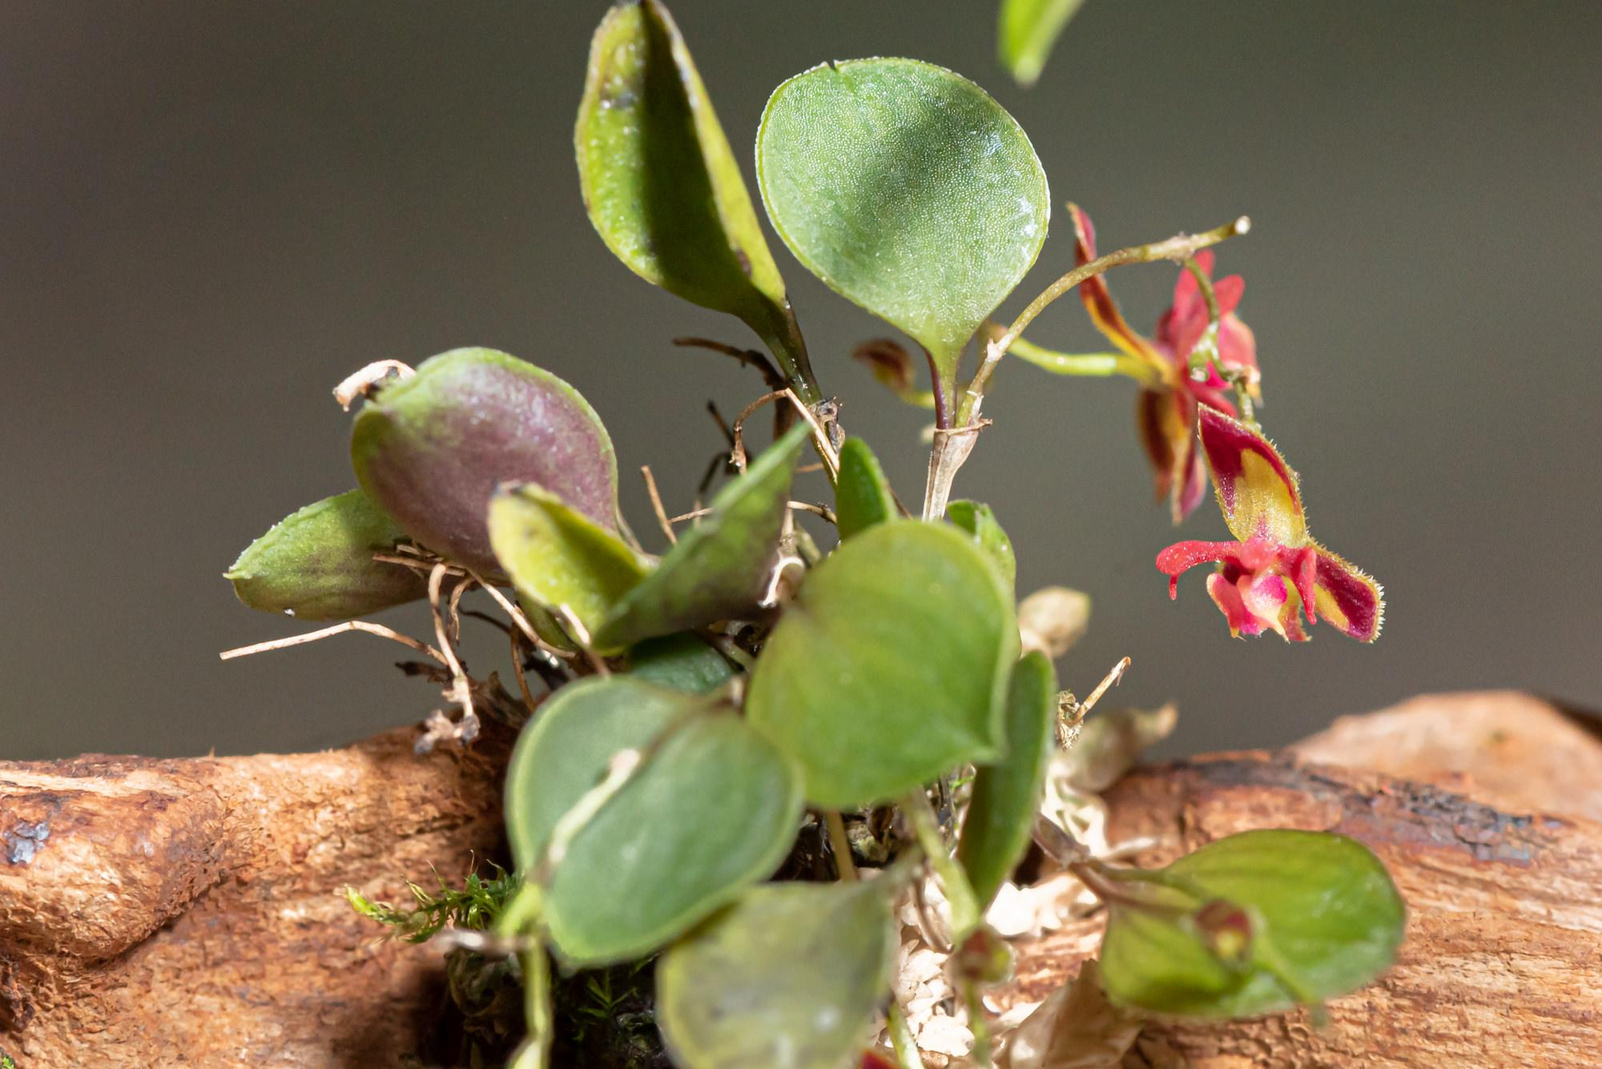
Pleuro. lepanthes grown by Heather Harrigton

Steve continued with the remainder of NWOS business, thanking the currently serving officers and Board members for their service. He read out the proposed slate as presented by the nominating committee. The slate was:
Officers, one-year term expiring Dec. 31 2023:
- President - Robert Culver
- 1st VP - Joseph Grienauer
- 2nd VP - Ben Johnson
- Treasurer - Bill Leicht
- Secretary - Sean Hoyt
Director positions, two-year term expiring Dec. 31, 2024:
- Diane Drisch
- Heather Harrington
- Yoshi Nagamatsu

The above slate of Officers and Directors will be voted on by the membership at the December 12th meeting. In addition to the above slate, the following Directors will continue to serve the remainder of their two-year term expiring Dec. 31, 2023:

- Brad Collins
- Pat Gossler
- Peter Maunsell
- Lori Lederman
- Andy Wright

- Past President - Steve Dorsey

Steve then read the proposed changes to the ByLaws, which were published in the November Newsletter.

George Grantham spoke briefly about the bark order and what a success it was this year. Steve thanked George for arranging it again for the club again this year.

We then moved on to our raffle. Joff Morgan called the numbers with Violet Nagamatsu assisting.
Joe Grienauer brought in a selection of Neofentias that were on the sale table. Hopefully, many of you took the opportunity to pick one up.

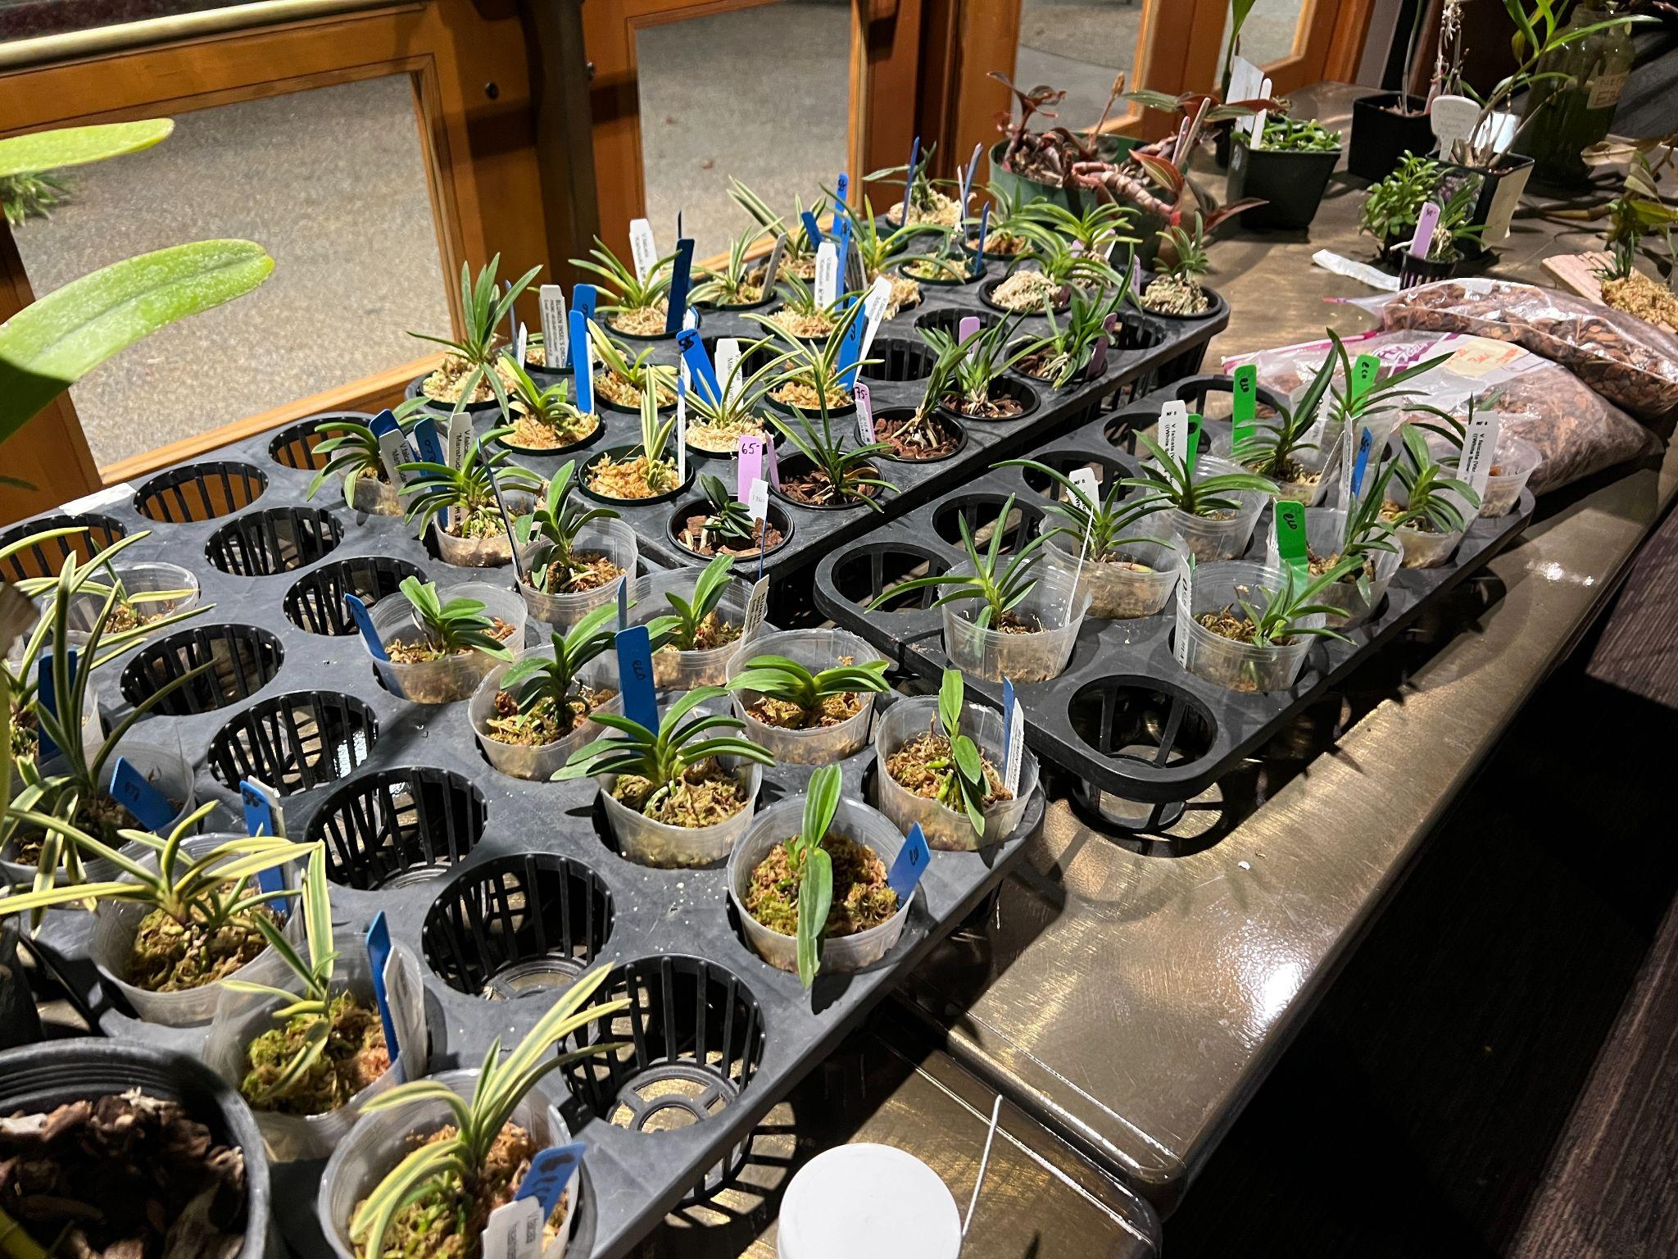
Varieties of Neofentias on the Sale Table

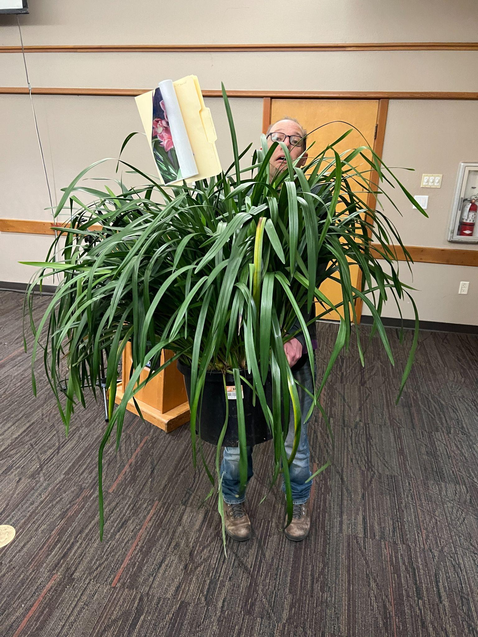
Joe going home with Cousin Itt.

Schedule of Upcoming Events

12/12/22 – NWOS meeting – Holiday Food Truck Social, introduction of new Officers, NWOS Annual Meeting report, Schoenfeld and Northen Orchid Awards, and Holiday Plant gifts.

01/09/23 – NWOS meeting – Speaker: Tennis Maynard, "Trichopilias" Tennis will be speaking to us about this beautiful, yet underrepresented genus in many of our collections.

02/13/23 – NWOS meeting – Annual Culture Clinic: This is our annual clinic when you can bring your questions, your problem plants and whatever is ailing something in your collection and the members that have experience with that plant or problem will answer your questions.

03/13/23 – NWOS Meeting – Annual Auction: This is our annual auction. It starts early with our preview party, nibbles, and bubbly, and ends up with tables and tables of plants for you to bid on. Many of these plants are hard to find and are rarely available outside of private collections.

04/10/23 – NWOS meeting – Speaker: Jurahame Leyva, “Current Trends in Paphiopedilum Maudiae Breeding” Jurahame will be talking to us about the new trends in this easy-to-grow plant with its showy leaves and long-lasting flowers. It’s a rewarding plant for both novices and experts alike.

05/08/23 – NWOS meeting – Speaker: Ron Parsons, “The Genus Dendrobium”

06/12/23 – NWOS meeting – June Food Truck Social: This is our annual social just before we take our summer break. We have a food truck outside and plants inside. We also announce the Gary Baker Service Award at this meeting.

09/11/23 – NWOS meeting – Speaker: Kelly McKracken, “Fragrant Miniatures” The most common question we get asked about plants is “is it fragrant?”; Many orchid growers select their plants based on whether the plant is fragrant. For those of you who grow in limited space, but still love a nose full of floral fragrance, this is the talk for you.

10/09/23 – NWOS meeting – Speaker: Andrew McGinnis, Growing Orchids in Grow Tents, Advanced Indoor Growing.

11/13/23 – NWOS meeting – Speaker: Alan Koch, “A New Look at Intergeneric Phalaenopsis” Phalaenopsis have been enjoyed by novice growers for the ease of growth and long lasting flowers. Intergeneric Phalaenopsis hybrids are easier to grow, maintain the long lasting flowers and often bloom more often than a normal Phalaenopsis. Another benefit from this line of breeding has been the creation of many fragrant hybrids. The bright colors, fragrant flowers and smaller hardier plants make this an interesting direction in orchids.

12/11/23 – NWOS meeting – Holiday Food Truck Social, introduction of new Officers, NWOS Annual Meeting report, Schoenfeld and Northen Orchid Awards, and Holiday Plant gifts.

Reminder for Officers & Board Members

The next board meeting is January 3rd which will be a transitional meeting consisting of both outgoing and incoming Officers and Board members. Meet at 7 p.m. at a location to be determined.

Shopping on Amazon? Use this link to earn $$ for the NWOS

If you go to https://smile.amazon.com and sign in to your account, you'll be given information about supporting various non-profits. You can type in "Northwest Orchid Society" and it will then send .5% of your purchase price to the organization.

It's really easy, but you have to remember to go in through the 'smile' subdomain when you place the order, otherwise it will go through as a regular order.

NWOS Website Links

- Main website: Http://www.nwos.org
- Events Calendar: http://www.nwos.org/events
- Membership (including renewals): https://nwos.org/Membership/
- Newsletter - Current Issues: https://nwos.org/newsletters/
- Newsletter - Archived Issues: http://newsletter.nwos.org
- Show Information: https://nwos.org/nwos-fall-show/
- Facebook: http://www.facebook.com/nworchidsociety
- Instagram: https://www.instagram.com/nworchidsociety/
- Twitter: https://twitter.com/nworchidsociety

Special Announcements

Ecuagenera will be having a pop-up January 14/15 at Emerald City Orchids.
Joe has the full details on his Facebook Page.
The last day to pre-order is December 26. If you have questions, talk to Joe.

©2022 Northwest Orchid Society - All Rights Reserved

The opinions and recommendations published herein are those of the authors. The Northwest Orchid Society (NWOS) disclaims responsibility for any losses or damages that may be attributed to the use or misuse of any material or any opinion published in these articles and on the website. This website and the photographs, articles and content are protected by copyright and no part of them may be reproduced or re-used without the permission of the author.

The Special Announcements (SA) section is provided as a courtesy to the readers of this newsletter for events that may be of general interest to the readers. The NWOS (1) makes no promises, warranties, or representations as to SA, including its completeness, accuracy, availability, timeliness, propriety, security, or reliability; (2) provides SA on an "AS IS" and "AS AVAILABLE" basis and any risk of using SA is assumed by you.

