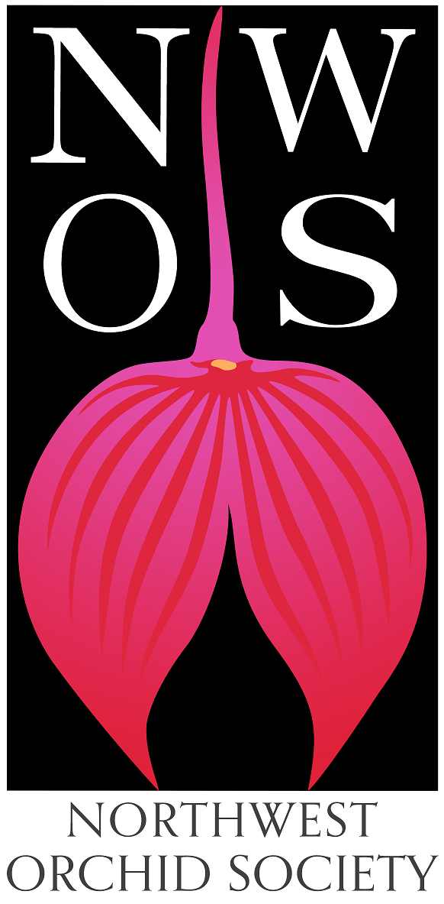
Northwest
Orchid News
December 2021
Volume 74, Issue 9

- About the December Meeting
- This is Our Holiday Meeting
- Speaker: Piper McCullough, “Scholarship Recipient”
- Speaker: David Edgley, “Novelty Phalaenopsis”
- Plant Table
- Sales Table
- Raffle Table
- NWOS Library
- Volunteer Positions
- News From The American Orchid Society
- Report From The November Meeting
- Schedule of Upcoming Events
- Reminder for Officers & Board Members
- NWOS/Amazon Shopping Link
- NWOS Website Links

About the December Meeting
December 9, 2021 7 PM
University of Washington Center for Urban Horticulture
3501 NE 41st Street, Seattle, WA 98105

Hybrid Meeting, In person and via Zoom Zoom Registration

We will be meeting in person for the foreseeable future. The Covid protocol for the meetings will be shared monthly for attendees and is available at our web site located here: Covid Response – Northwest Orchid Society (nwos.org)

This is Our Holiday Meeting
Holiday ‘Notluck Snacks’, Speakers: David Edgley & Piper McCullough, Holiday Plant Giveaway, Annual Report,Introduction of new Officers, and Orchid Trophy Competitions

This Month’s Speakers

Speaker: Piper McCullough, “Scholarship Recipient”
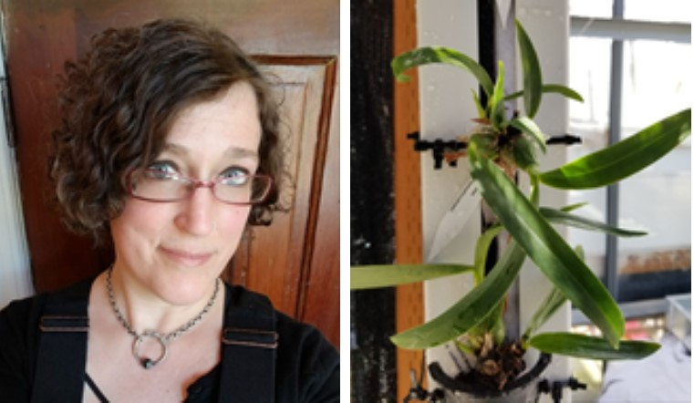
Piper McCullough is a student in the Sustainable Agriculture program at Skagit Valley College, located in Mount Vernon, WA. Her future goals include earning a Bachelor’s Degree in Environmental Conservation, and starting a career in Permaculture Consultation.

She chose to include Hydroponics as part of her study focus, in order to contribute to the progression of alternate methods of plant management. In a world where our soils are being depleted at an alarming rate, it is increasingly important to support systems which offer potential to slow destructive results, from conventional management practices. Hydroponics have shown great promise and have already been successfully integrated into large scale plant production in Iceland. There have also been advances in hydroponic integration in Africa, where much of the land is challenging, if not impossible to manage. Hydroponics offer new solutions towards keeping the future of plant management sustainable.

The research being done by Piper, for the Northwest Orchid Society, investigates whether a variety of orchid species would thrive on a hydroponic farm wall system. Three orchid species are being studied: B. nodosa x C. guttata alba, L. purpurata var. flammea (dark) x self, E. cordigera x Psh. prismatocarpa. These are split into four substrate groups; a sphagnum moss control group, a bark mix control group, a full-sun farm wall group, and a shaded farm wall group. The shade intends to mimic the orchid’s natural epiphytic canopy habitat.

Speaker: David Edgley, “Novelty Phalaenopsis”
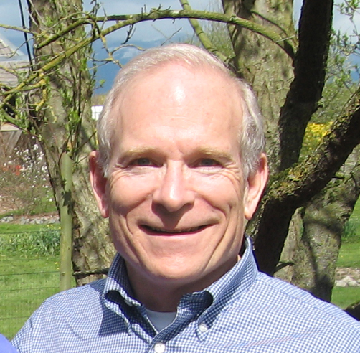
David has been growing Phalaenopsis for decades, introduced to them as a teenager living on a Navy base in the Philippines. A hobby grower, David has been active in local societies and shows, spreading the good news about Phalaenopsis. In his small and rather crowded (10'x12') greenhouse in the Pacific Northwest, David grows hundreds of orchids, primarily Phalaenopsis. In addition, David has made several of his own crosses. He is an accredited American Orchid Society judge, member of the board of trustees of the AOS, serves on various AOS committees, and is treasurer of the International Phalaenopsis Alliance (IPA).

Happy Holidays! It's once again time to put our growing skills to the test. Please join your fellow NWOS members in our friendly annual competition. We have two trophies to award, the Schoenfeld Trophy as well as the Rebecca T. Northen Miniature Orchid Trophy. Each person is a full-fledged member, whether they paid for a single, dual or youth membership. So each person is entitled and encouraged to participate in winning one or both of these trophies. All you have to do is bring in one blooming plant for each competition.

Let's make this a strong, lively competition. Bring your blooms whether you think they'll win or not. After all, we LOVE to see lots of orchids.

The Schoenfeld Trophy is awarded to the best blooming plant of any size.

The Rebecca T. Northen Miniature Orchid Trophy is awarded to the best blooming plant that is 6 inches or less in height, excluding the bloom spike which can extend beyond the 6" limit for the foliage.
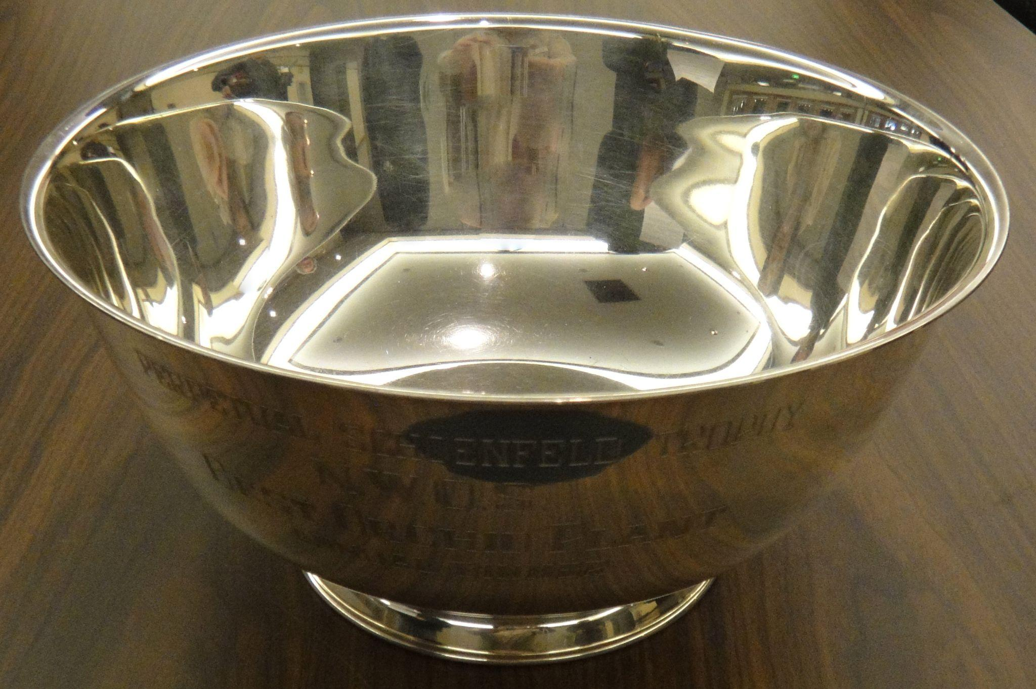 | 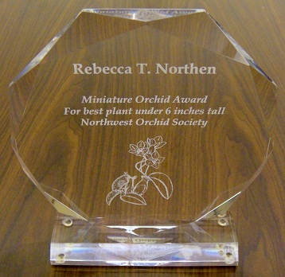
Schoenfeld Trophy Rebecca Northen Trophy

Everyone at the Holiday Party will cast a vote for each trophy. What do we mean by 'best blooming plant'? That's completely up to you, the voter, to decide what 'Best' means to you. The winner will keep the trophy until the December 2022 meeting.

We will welcome our new officers and board members and thank those who are retiring.

This is also our annual meeting and we will have brief reports from our officers and committee chairs.

This year at our annual Holiday Potluck Party we will continue our annual tradition of gift plants. These are quality plants purchased specially for this event. Each member who's dues were paid by Nov. 11 will be able to select a plant that is suitable to their growing conditions. You must attend in order to receive your plant. To be clear, each person is a full-fledged member whether they joined as a single, dual or youth membership and will receive one free plant as a gift from the society.

There are makeup plants for those that attended last year’s Zoom meeting.

Due to COVID restrictions we are unable to have our traditional potluck dinner this year. However, snacks and drinks will be provided.

Display Table:
No display table this month, but bring in your best plants to compete for one or both trophies.

Sales Table:
No sales table this month, but extra holiday plants will be available to purchase after the members have all received theirs.

Raffle:
No raffle this month.

NWOS Library:
No Library this month.

Volunteer Opportunities

There are lots of choices for participating and helping our society utilizing different skills, interests and available time.

- Volunteers are needed for our show at the NW Flower and Garden Festival in early February. We will have sign-up sheets so you can choose the time and tasks that work the best for your skills and availability. You can also contact the Festival committee: Gordon Cromwell, Joe Grienauer or Joff Morgan.

- Do you enjoy taking photos? We could use someone to take pictures of our monthly meeting plants along with their information forms to identify the plant and the grower.

- Volunteers are needed to help Kathy on the Scholarship committee this coming year.

Report From The November Meeting

Joe Grienauer, President, began our meeting by thanking the currently serving officers and Board members for their service. He read out the proposed slate as presented by the nominating committee. The slate had two vacancies. He then called for two additional nominations or volunteers. The final slate was:
Officers, one-year term expiring Dec. 31 2022:
- President - Steve Dorsey
- 1st VP - Robert Culver
- 2nd VP - Ben Johnson
- Treasurer - Bill Leicht
- Secretary - Mike Cory
Director positions, two-year term expiring Dec. 31, 2023:
- Brad Collins
- Pat Gossler
- Lori Lederman
- Peter Maunsell
- Andy Wright

Joe called for the vote and the slate was approved unanimously by a verbal vote of all the members present.
In addition to the above slate, the following Directors will continue to serve the remainder of their two-year term expiring Dec. 31, 2022:
- Tom Bell-Games
- Diane Drisch
- Thuan Nguyen
- Michael Pearson
- OPEN position

- Past President - Joe Grienauer

Joe reviewed the need for volunteers to help with the Raffle and to serve on the Scholarship committee. He asked for people to return any outstanding Library books. We then had a report by Joff and Gordon about the upcoming NWF&G Festival that will be held February 9-13, 2022

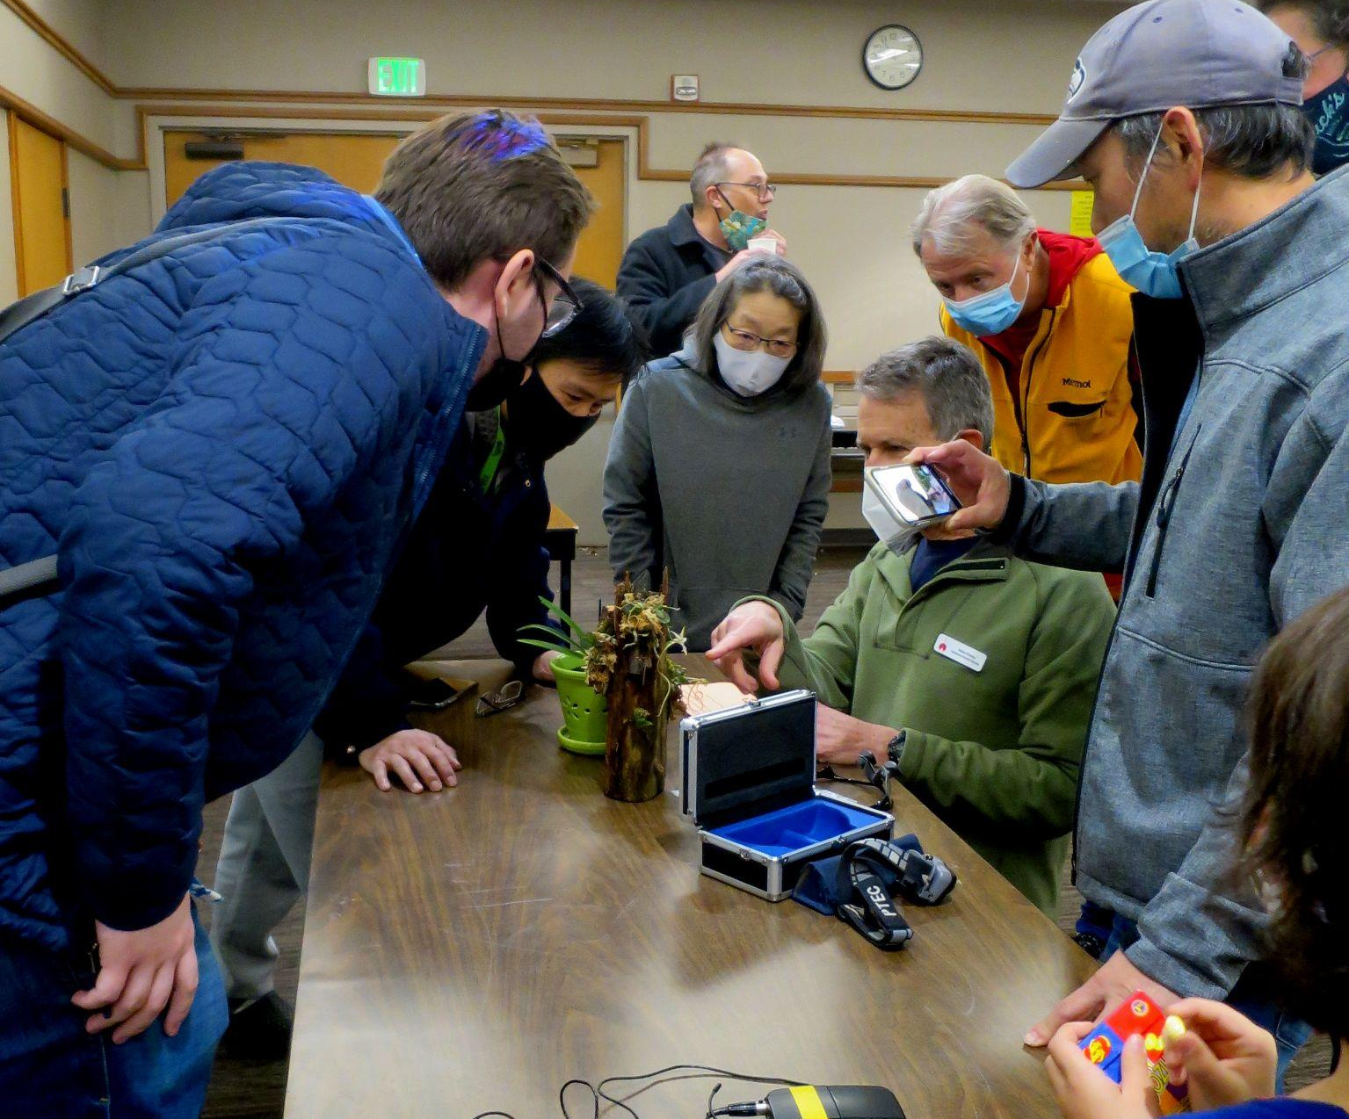
Our main program was a virtual talk via Zoom by Ron Parsons on the “Rarities and Oddities of the Orchid World”. Ron proceeded to show a marvelous array of amazing blooms. He began with the terrestrials like Habenaria medusa. He included species from around the world. There were bee orchids, sun orchids, beard orchids, hammer orchids and lady slippers. The monopodial group had ghost orchids & spider orchids to name just a few. The list was amazingly long with images of these special flowers, some of which are very rare. It was a treat to see the incredible variety of flower forms and colors exhibited across the world of orchids.

Andy Wright reviewed the plant table. Steve Dorsey gave an Orchid Basics talk about the changing light conditions as we go into our winter low light season. Steve also pollinated a flower which drew an enthusiastic group to watch the process
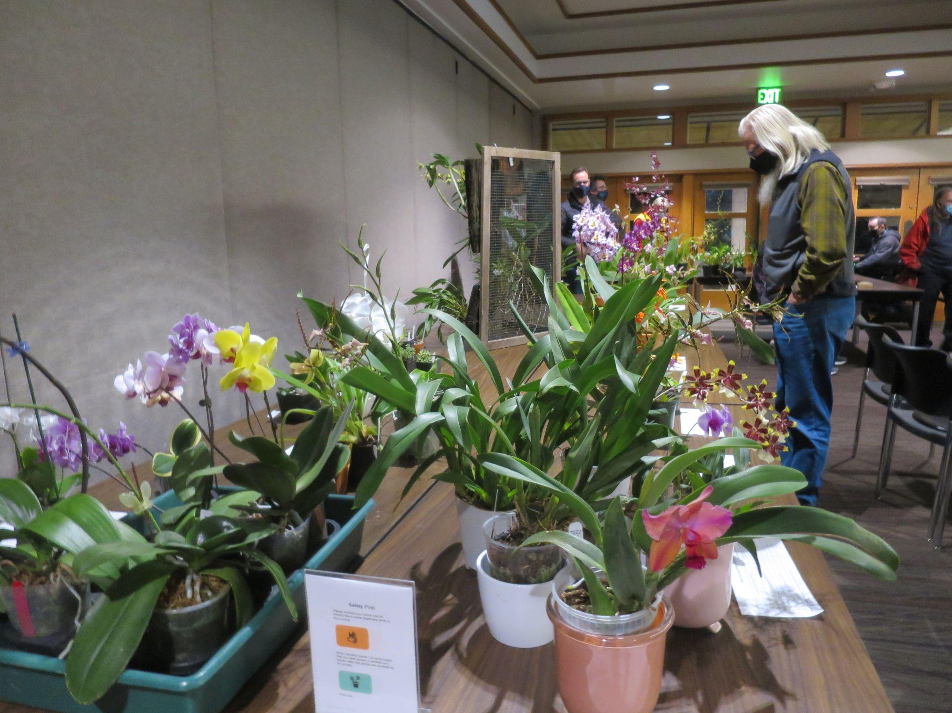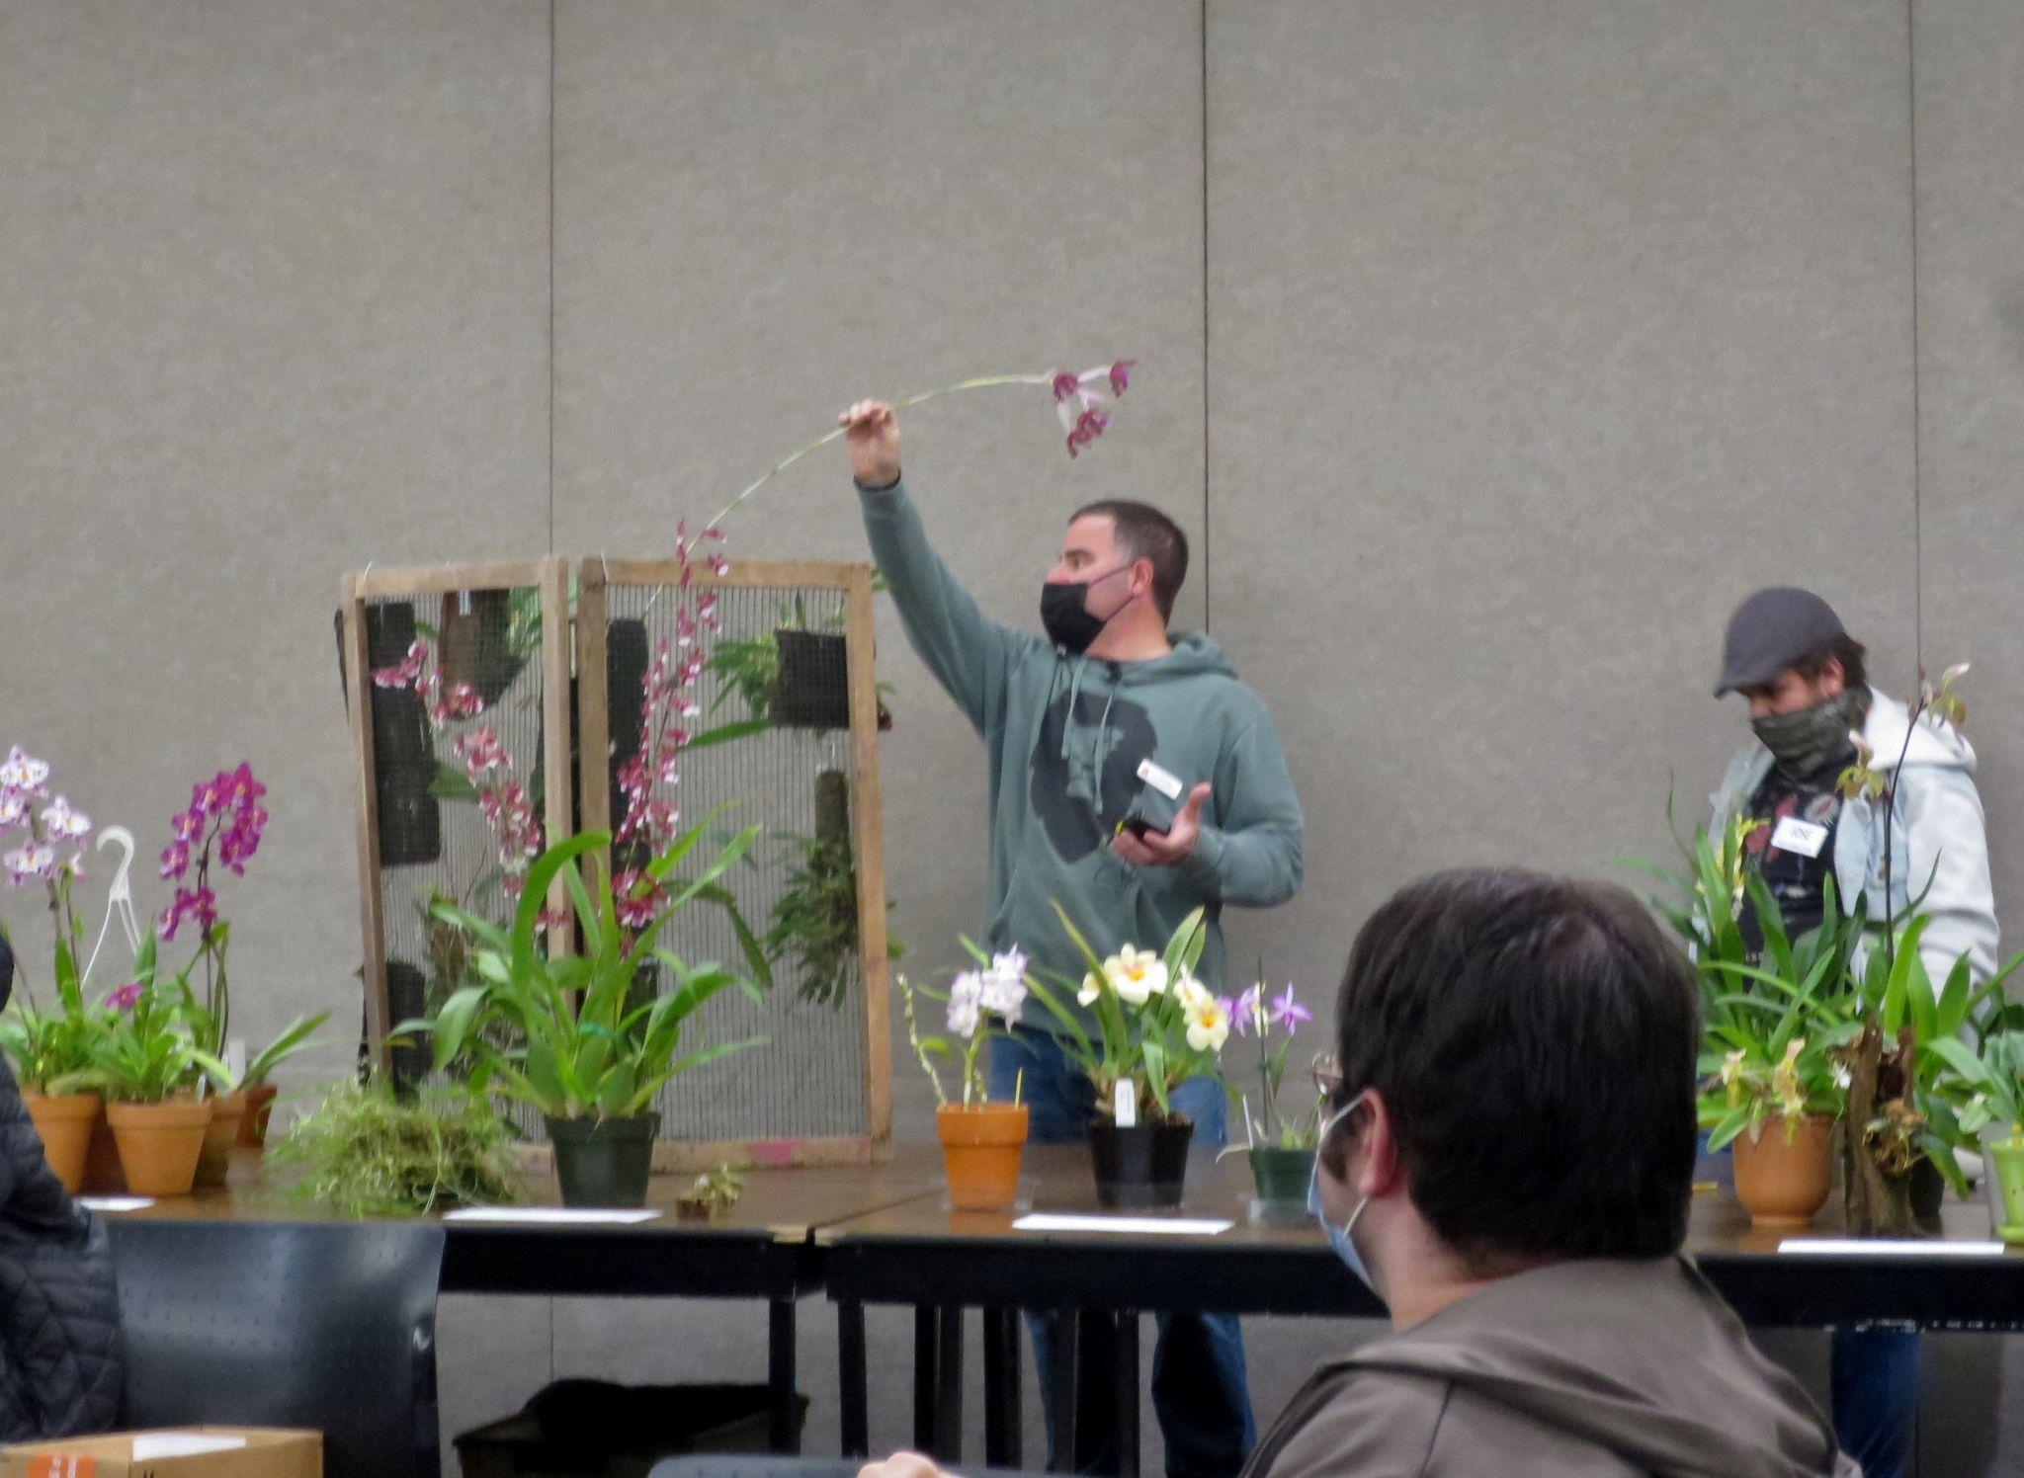

These are several selected images from the November meeting. To see the rest of the photos of November's plant table, please follow the link to go to the online gallery.

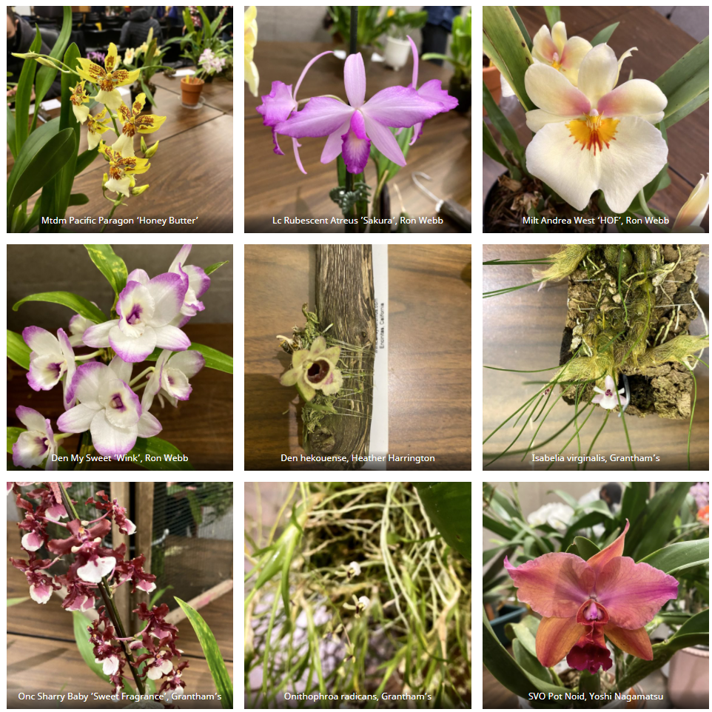

Schedule of Upcoming Events

12/13/21 – NWOS meeting – Speaker: David Edgley, “Novelty Phalaenopsis Breeding”, Scholarship Recipient Report, introduction of new Officers, NWOS Annual Meeting report, Schoenfeld and Northen Orchid Awards, and Holiday Plant gifts. Unfortunately we will not be able to have our traditional Holiday Potluck dinner this year.

01/10/22 – NWOS meeting - Speaker: Theresa Hill, “Paph charlesworthii a Giant Among Miniatures”

02/14/22 – NWOS meeting - Culture Seminar & Sale

03/14/22 – NWOS meeting - Spring Auction

04/11/22 – NWOS meeting - Speaker: Kelly McKracken, “Artificial Lighting”

05/09/22 – NWOS meeting - Speaker: Tyler Albrecht, “An Exploration of the Fluffy and Puffy Parvisepalum Pahiopedilums”

06/13/22 - NWOS meeting - June potluck, Gary Baker Service Award, etc.

09/12/22 - NWOS meeting - Speaker: Tom Ethridge, “Odontoglossums Then and Now, Has Anything Changed?”

Reminder for Officers & Board Members

The first board meeting for the 2022 membership year will be held at 7 p.m. on Tuesday 1/6/22, It will be a transitional meeting consisting of both former and incoming Officers and Board members at a location to be determined. The schedule for the remaining board meetings for this membership year is: 3/8/22, 5/3/22, 7/??/22, 9/6/22, 11/8/22.

Shopping on Amazon? Use this link to earn $$ for the NWOS

If you go to https://smile.amazon.com and sign in to your account, you'll be given information about supporting various non-profits. You can type in "Northwest Orchid Society" and it will then send .5% of your purchase price to the organization.

It's really easy, but you have to remember to go in through the 'smile' subdomain when you place the order, otherwise it will go through as a regular order.

NWOS Website Links

- Main website: Http://www.nwos.org
- Events Calendar: http://www.nwos.org/events
- Membership (including renewals): https://nwos.org/Membership/
- Newsletter - Current Issues: https://nwos.org/newsletters/
- Newsletter - Archived Issues: http://newsletter.nwos.org
- Show Information: http://nwos.orchid-society.net/ShowTime/Show2021/Show.html
- Facebook: http://www.facebook.com/nworchidsociety
- Instagram: https://www.instagram.com/nworchidsociety/
- Twitter: https://twitter.com/nworchidsociety

©2021 Northwest Orchid Society - All Rights Reserved

The opinions and recommendations published herein are those of the authors. The Northwest Orchid Society disclaims responsibility for any losses or damages that may be attributed to the use or misuse of any material or any opinion published in these articles and on the website. This website and the photographs, articles and content are protected by copyright and no part of them may be reproduced or re-used without the permission of the author.

