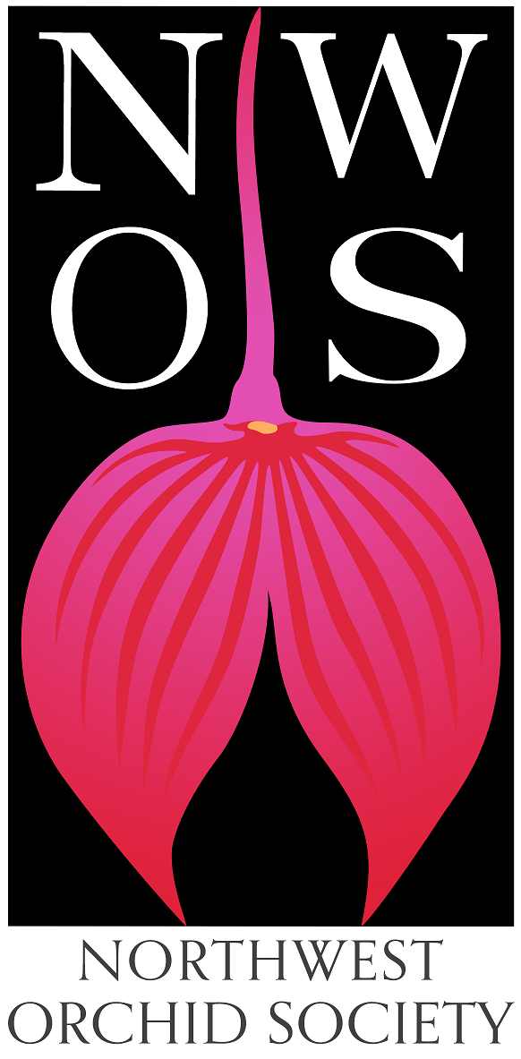
Northwest
Orchid News
April 2022
Volume 75, Issue 4

- About the April Meeting
- Speaker: Kelly McCracken, “Artificial Lighting”
- Speaker’s Dinner
- Plant Table
- Sales Table
- Raffle Table
- NWOS Library
- Spokane Orchid Society Show April 9-10
- Report From The March Auction
- NWOS Potting Clinic
- Gary Baker Service Award
- The World’s Favorite Fragrance
- Growing Odontoglossums
- Meeting Recordings
- News from the AOS
- Schedule of Upcoming Events
- Reminder for Officers & Board Members
- NWOS/Amazon Shopping Link
- NWOS Website Links

About the April Meeting
April 11, 2022 7 PM
University of Washington Center for Urban Horticulture
3501 NE 41st Street, Seattle, WA 98105
Hybrid Meeting, In person and via Zoom Zoom Registration
Doors open at 6:00 PM
Zoom Stream starts at 6:30 PM

We will be meeting in-person for the foreseeable future. The UW no longer has any Covid restrictions in place.

Speaker: Kelly McCracken, “Artificial Lighting”

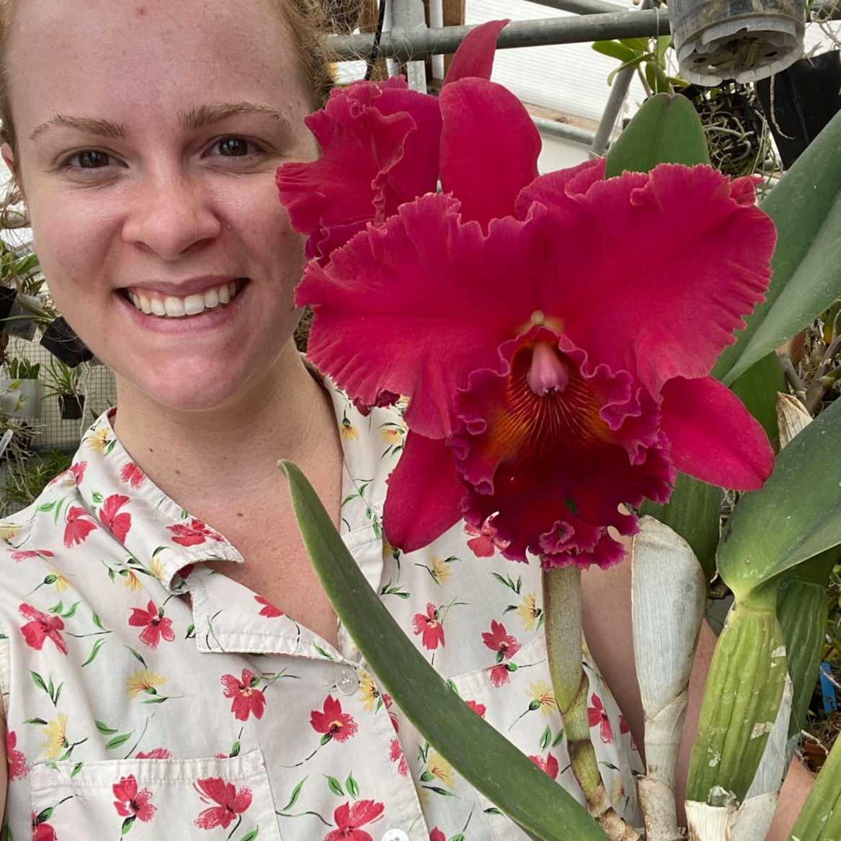
Kelly McCracken, owner of High Desert Orchids started as an avid hobbyist, and like many of you, couldn’t stop buying plants. Quickly one greenhouse became two, and now she grows plants in a unique 3,000 sq ft high-bay industrial warehouse space all under artificial lights. Kelly specializes in miniature plants, with a particular affection for miniature Cattleyas , Angraecoids, Jewel Orchids, and Dendrobiums.

Kelly will be speaking to us about artificial lighting. Many of us have discovered that as our hobby grows sometimes we run out of window spaces, or we don’t have a good window to begin with. Artificial lighting can provide our plants with the light they need to thrive. Many growers have discovered the opportunities that the recent drop in price and increase in availability of LED lights has provided. But there is relatively little information about how much artificial light orchids need and what kinds of lights are best. This talk will go over the unique HDO grow space, which is entirely under LED lights, how we set it up, the lights we use, and some tips we have discovered while growing a commercial sized grow space all under artificial light.

Speaker’s Dinner

We will be having a no-host Speaker’s dinner with Kelly, anyone is welcome to come and join us and meet with Kelly before the meeting.

You will need to send your intent to join us for the dinner to Robert Culver by 10:00 AM Monday 04/11/2022.

We will need to be at the restaurant at 4:30 in order to have a table by 5:00 to be done eating by 6:00.
We will be meeting at: Dim Tai Fung - U-Village

Plant Table

We will be having an in-person plant table this month. For your convenience, you can print out a Plant Table Information Form ahead of time. Click for your version of choice: PDF WORD Excel

Diane has taken pictures of the plant table for many years and has requested that someone else take up the torch. We appreciate everything that she has done. For those who aren’t able to attend, please do keep sending your pictures, we will be including them in our online gallery and in next month’s newsletter. Please send them to photos@nwos.org.

Sales Table

Members may bring up to 10 plants to sell. Include an extra tag with your name and the price in the plant.

Raffle Table
The raffle will be held as usual. Win a new orchid for your collection while supporting the Scholarship Fund. If you have any extra Orchids, please consider donating them to the raffle.

NWOS Library

If you'd like to check out a book or tape from our Library, please contact our Librarian Joe Grienauer a minimum of 2 weeks before the next meeting. Besides email, you can give Joe your request at any meeting. For a list of library items please click here NWOS Library.

Spokane Orchid Society Show April 9-10
The NWOS has entered a display at The Spokane Orchid Society Show. Ben Johnson and George and Cyliva Grantham drove plants over for the society. Additionally, Thuan Nguyen collected plants in the south end. Joe Greinauer is also over there as Emerald City Orchids. We will get a full report from the show for the next newsletter. We have a quick peek behind the scenes to hold us over till then.
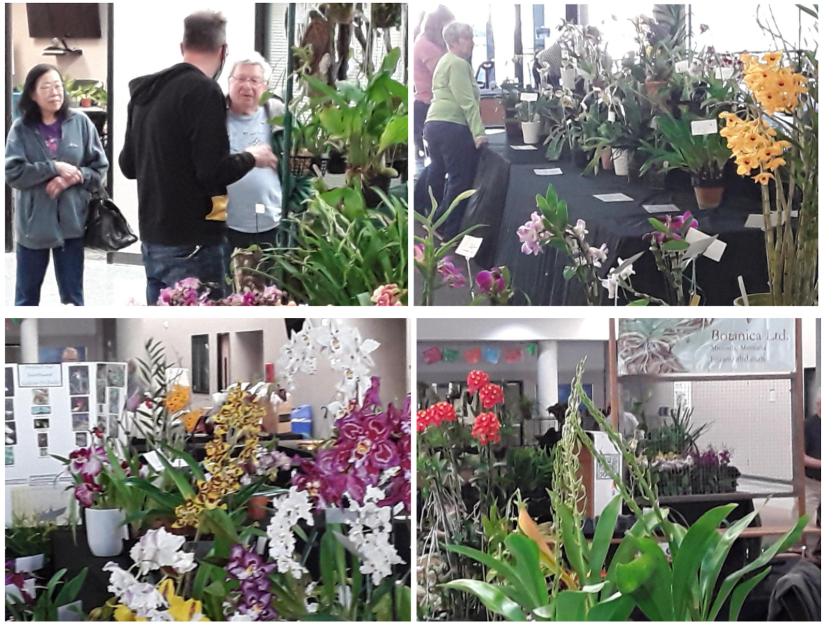

Report From The March Auction

We first want to thank everyone that brought in plants for the auction and for the plant donations. Additionally, a warm thank you to Kelly and Peter Maunsell for supplying us with the food and beverage for the Preview Party.

Steve Dorsey opened the meeting and led us quickly into the auction. There wasn’t a moment to spare either, because there was table after table of plants for the lucky people in attendance to bid on.

We welcomed back Mike Pearson and Joe Grienauer as our auctioneers for the evening. They kept the evening lively with information about the plants, jokes to amuse us and an urgency to keep up the bid.

Our helpers for the evening were Violet Nagamatsu, Yoshi Nagamatsu’s daughter and George Grantham. Other key helpers who helped record the bids, ring up the sales and worked on our computer hookups and links were Lillian Otani, Pat Gossler, Bill Leicht, Alan LaMont, Abigail Chang, Lori Lederman and Robert Culver.

The sales this year from the auction were $3940.
The Society was able to net the following from the sales.

Fund | Sales
Zoo | $1,178
General | $1,189
Scholarship | $ 39
Library | $ 155
UW Greenhouse | $ 16
Total | $2,557

For members there is a “highlights reel” that runs about 15 minutes in the member’s content section of the website. It captures some of the more myrthful or educational moments of the evening.

Here’s some photos from the Auction
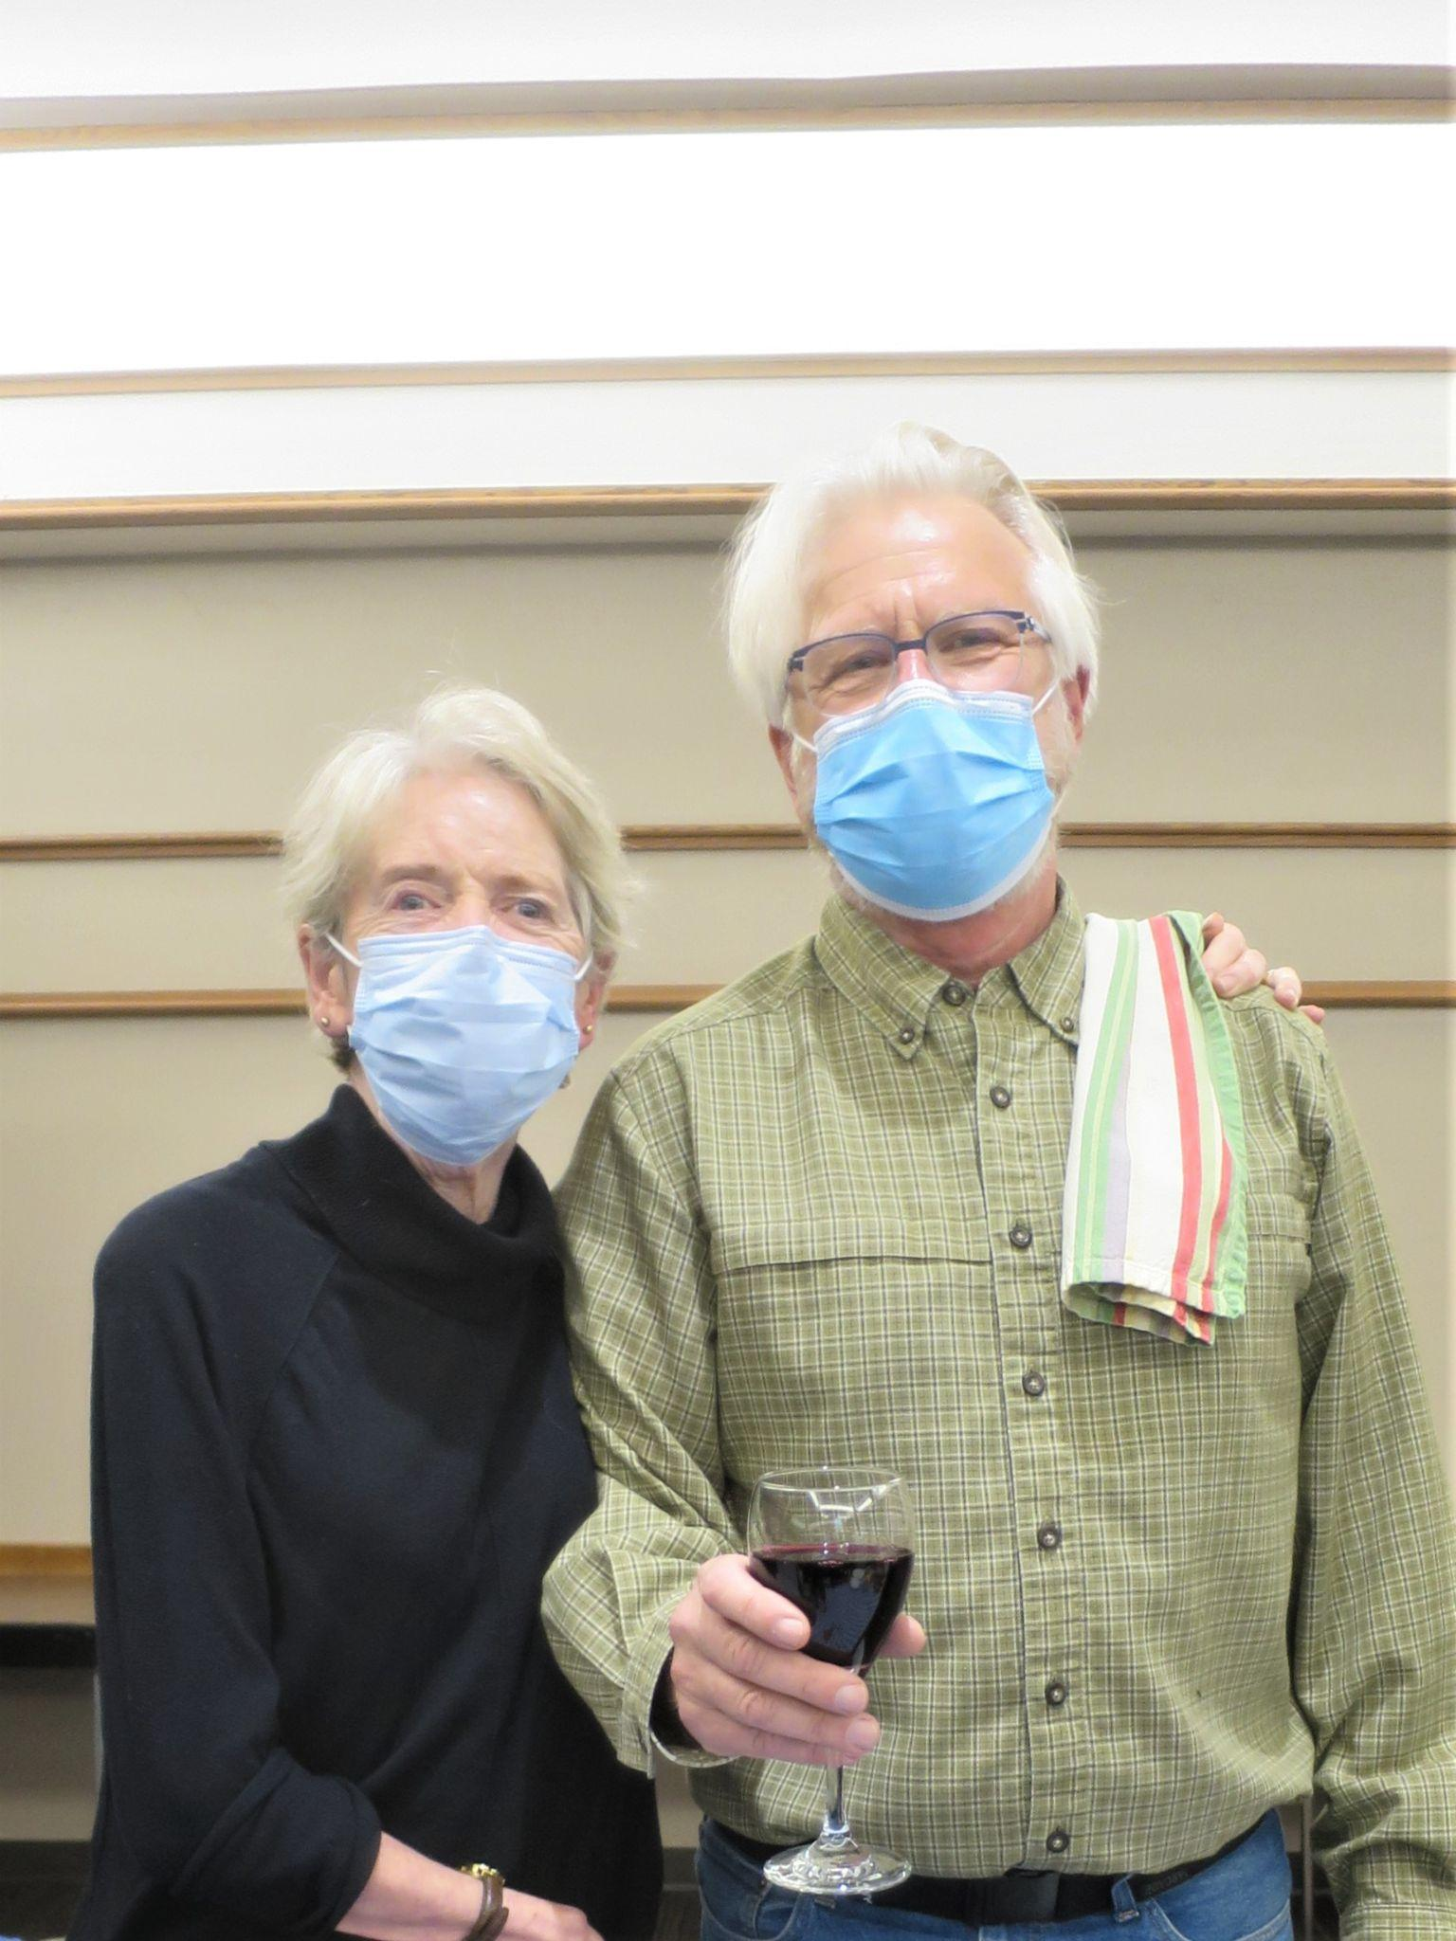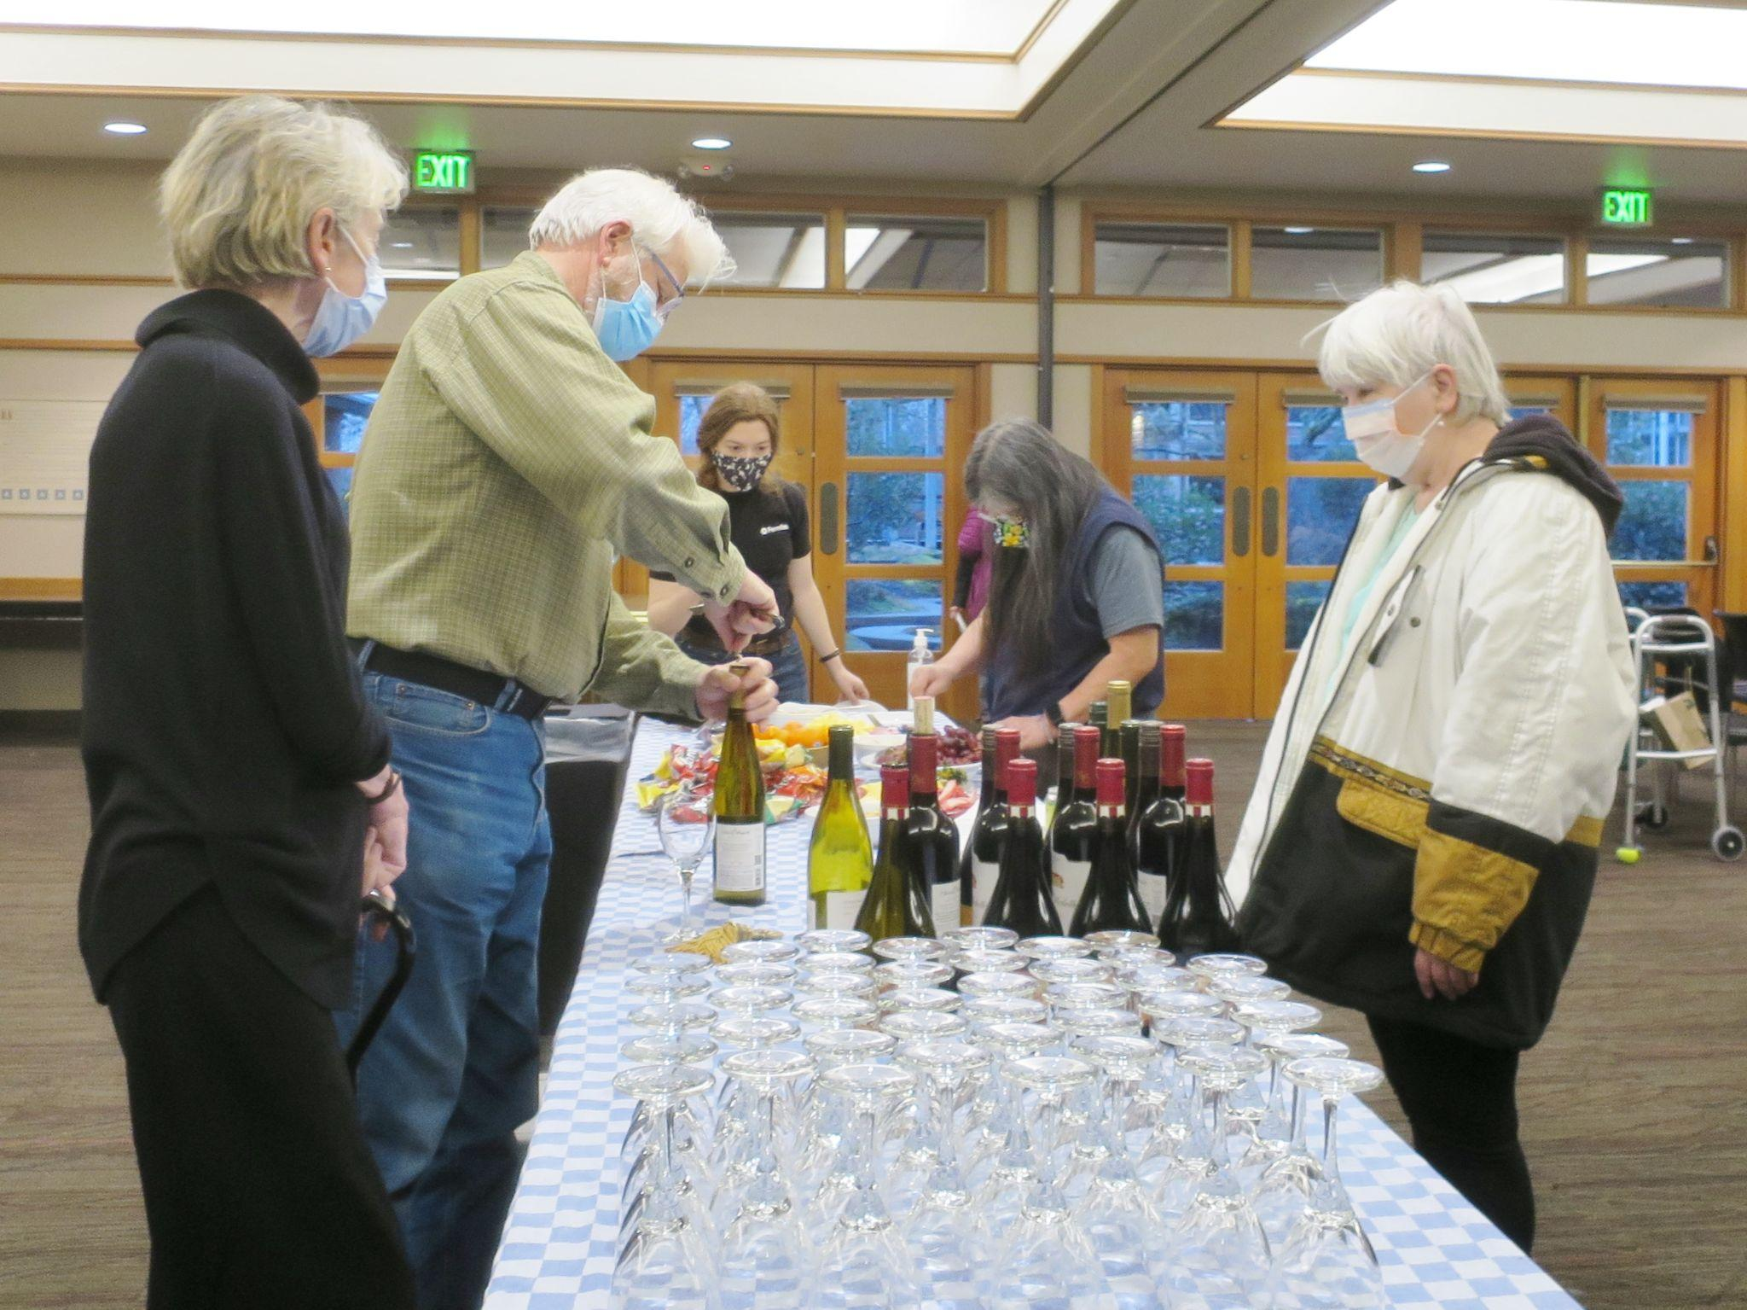
Kelly & Peter Maunsell Preview Party
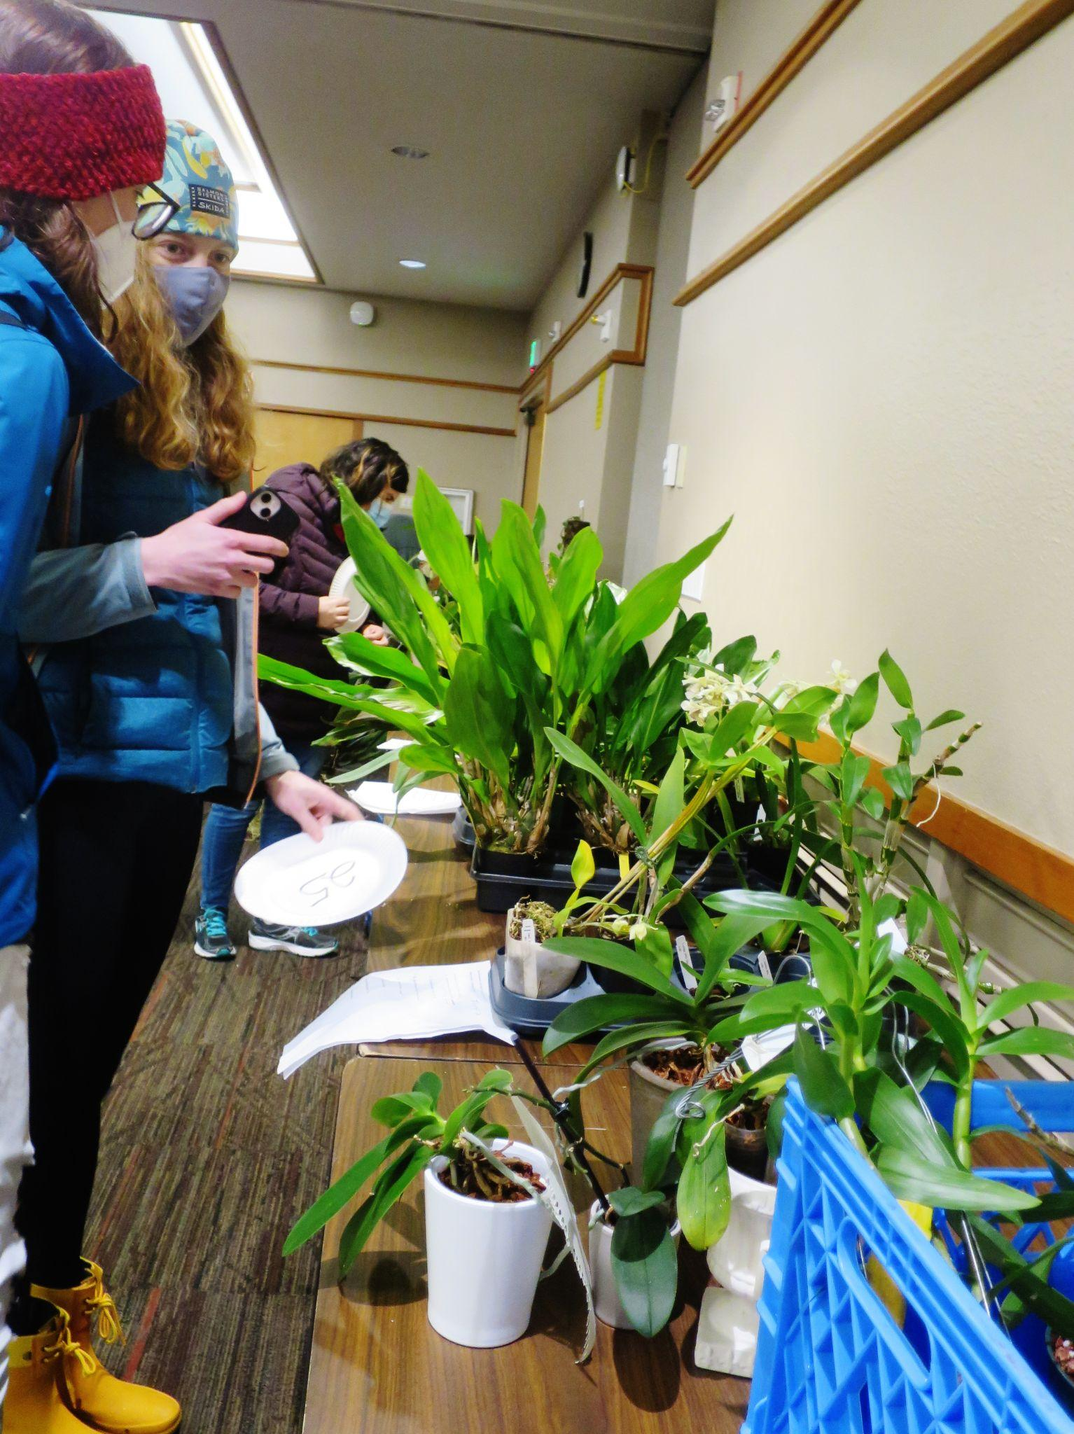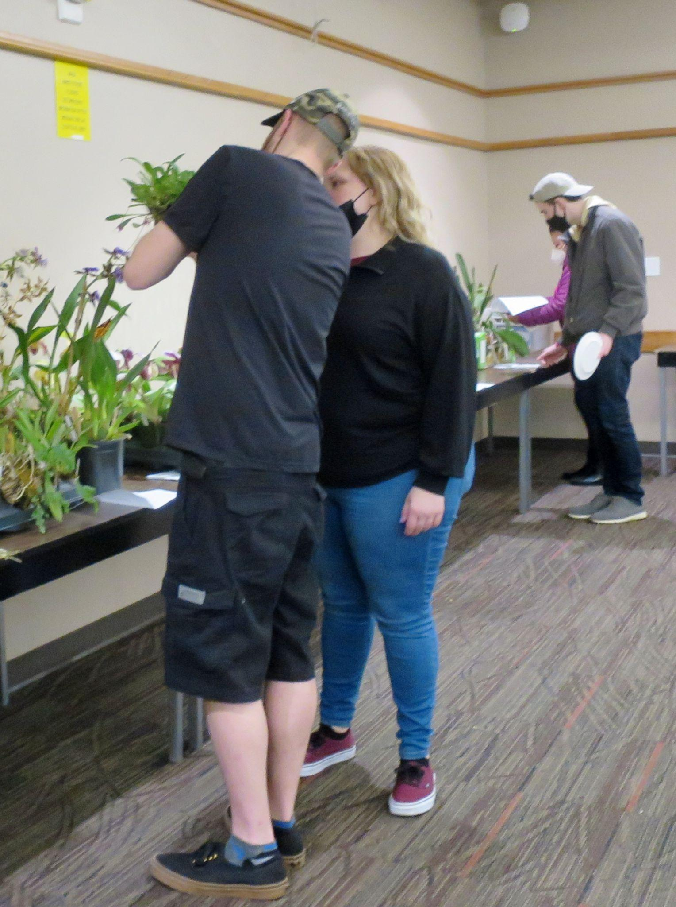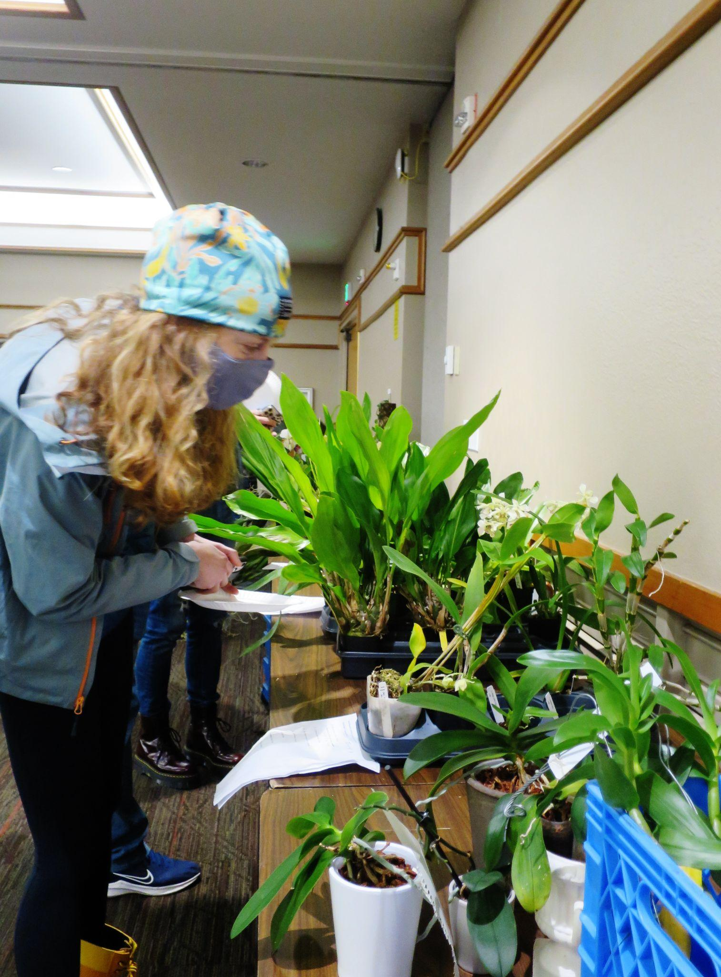
Checking the plants Do you like this one? Which one do I want?
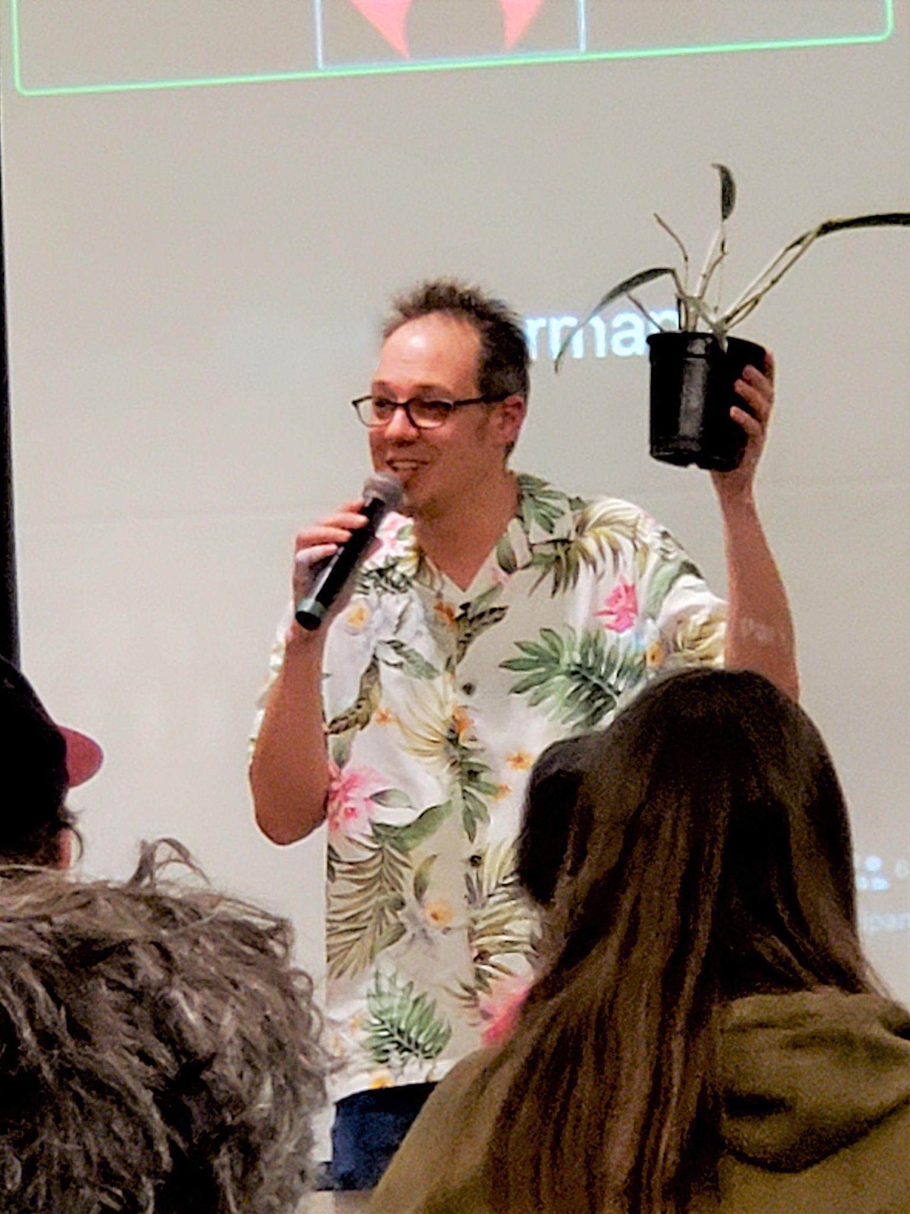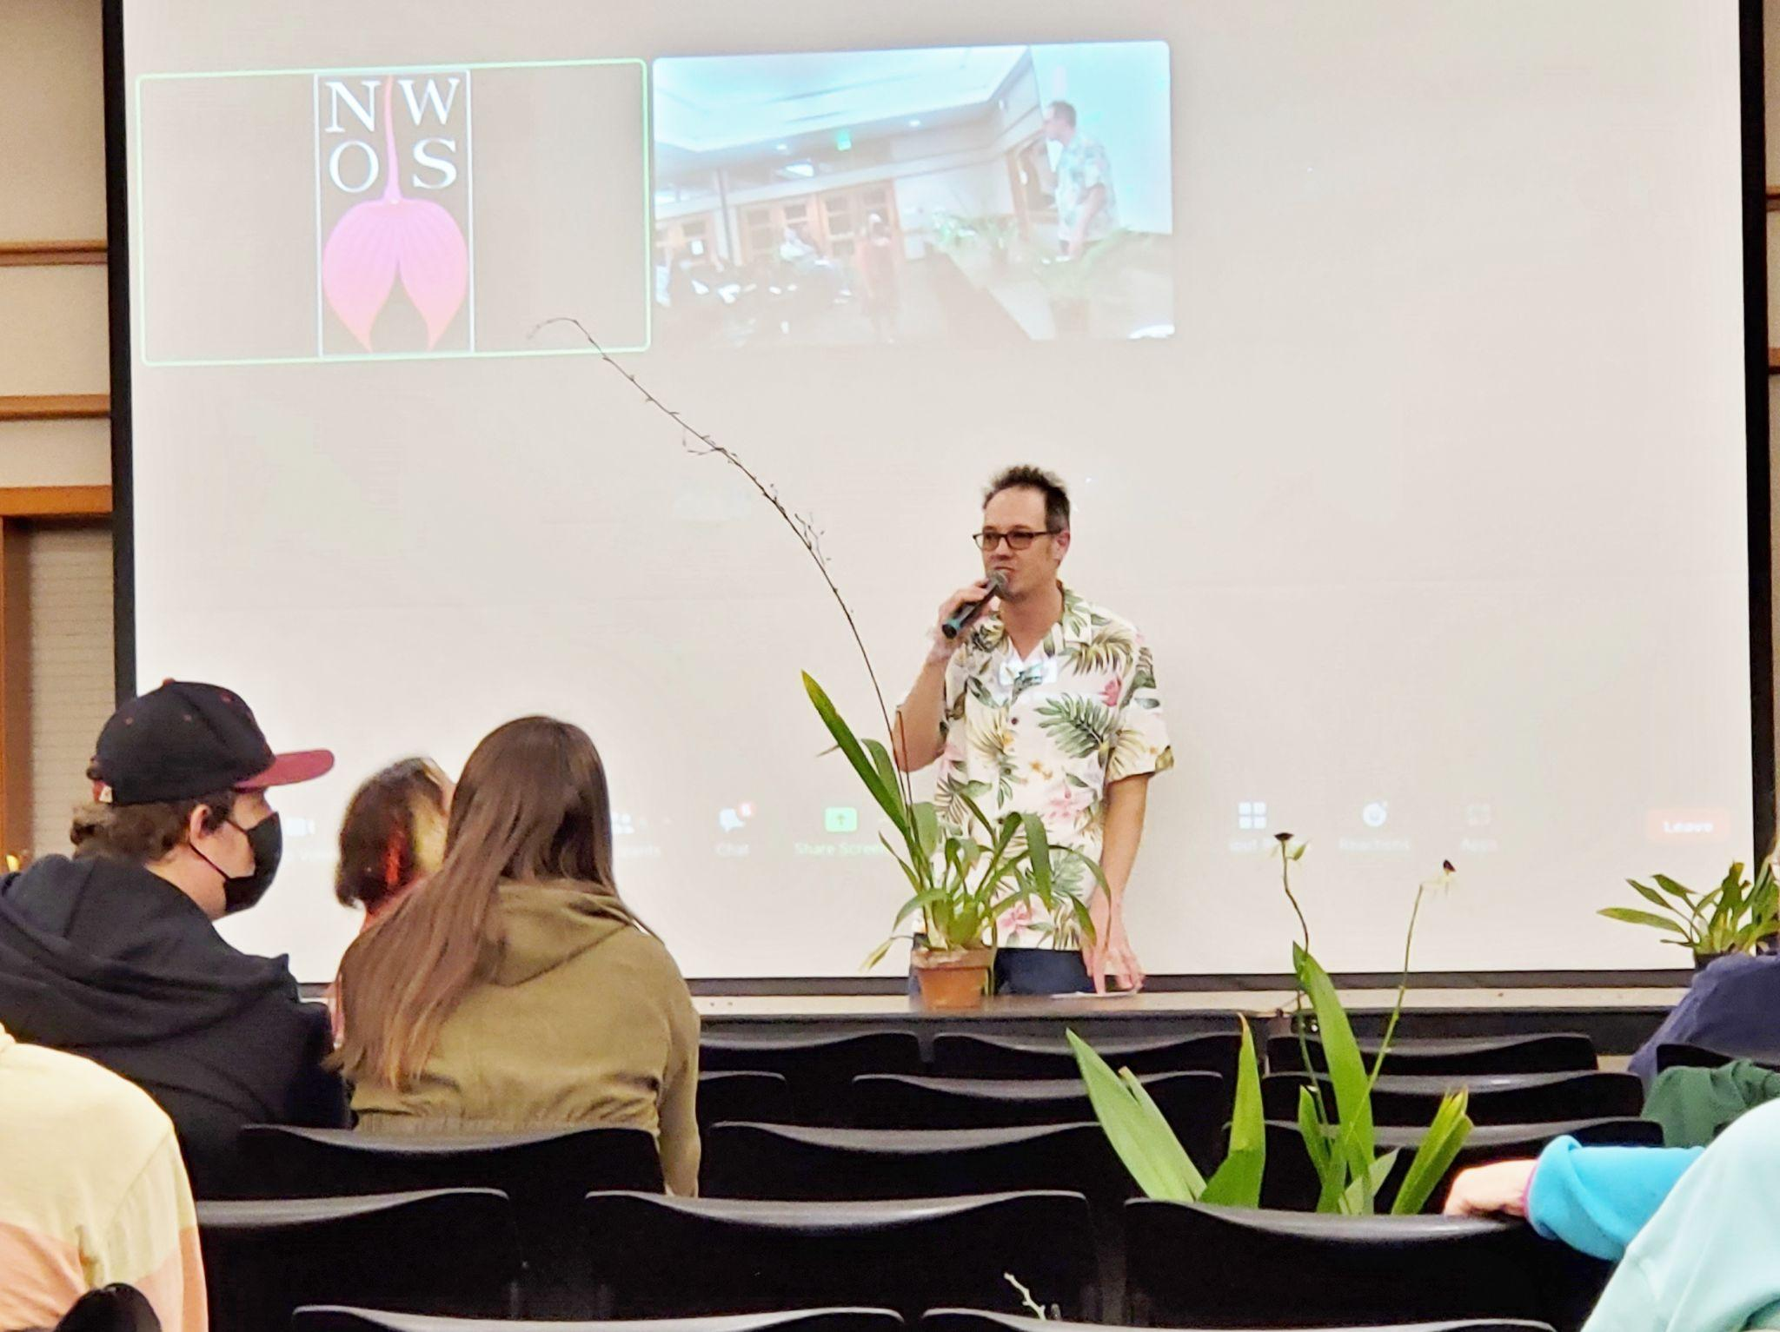
Auctioneer Joe That’s a really long spike!
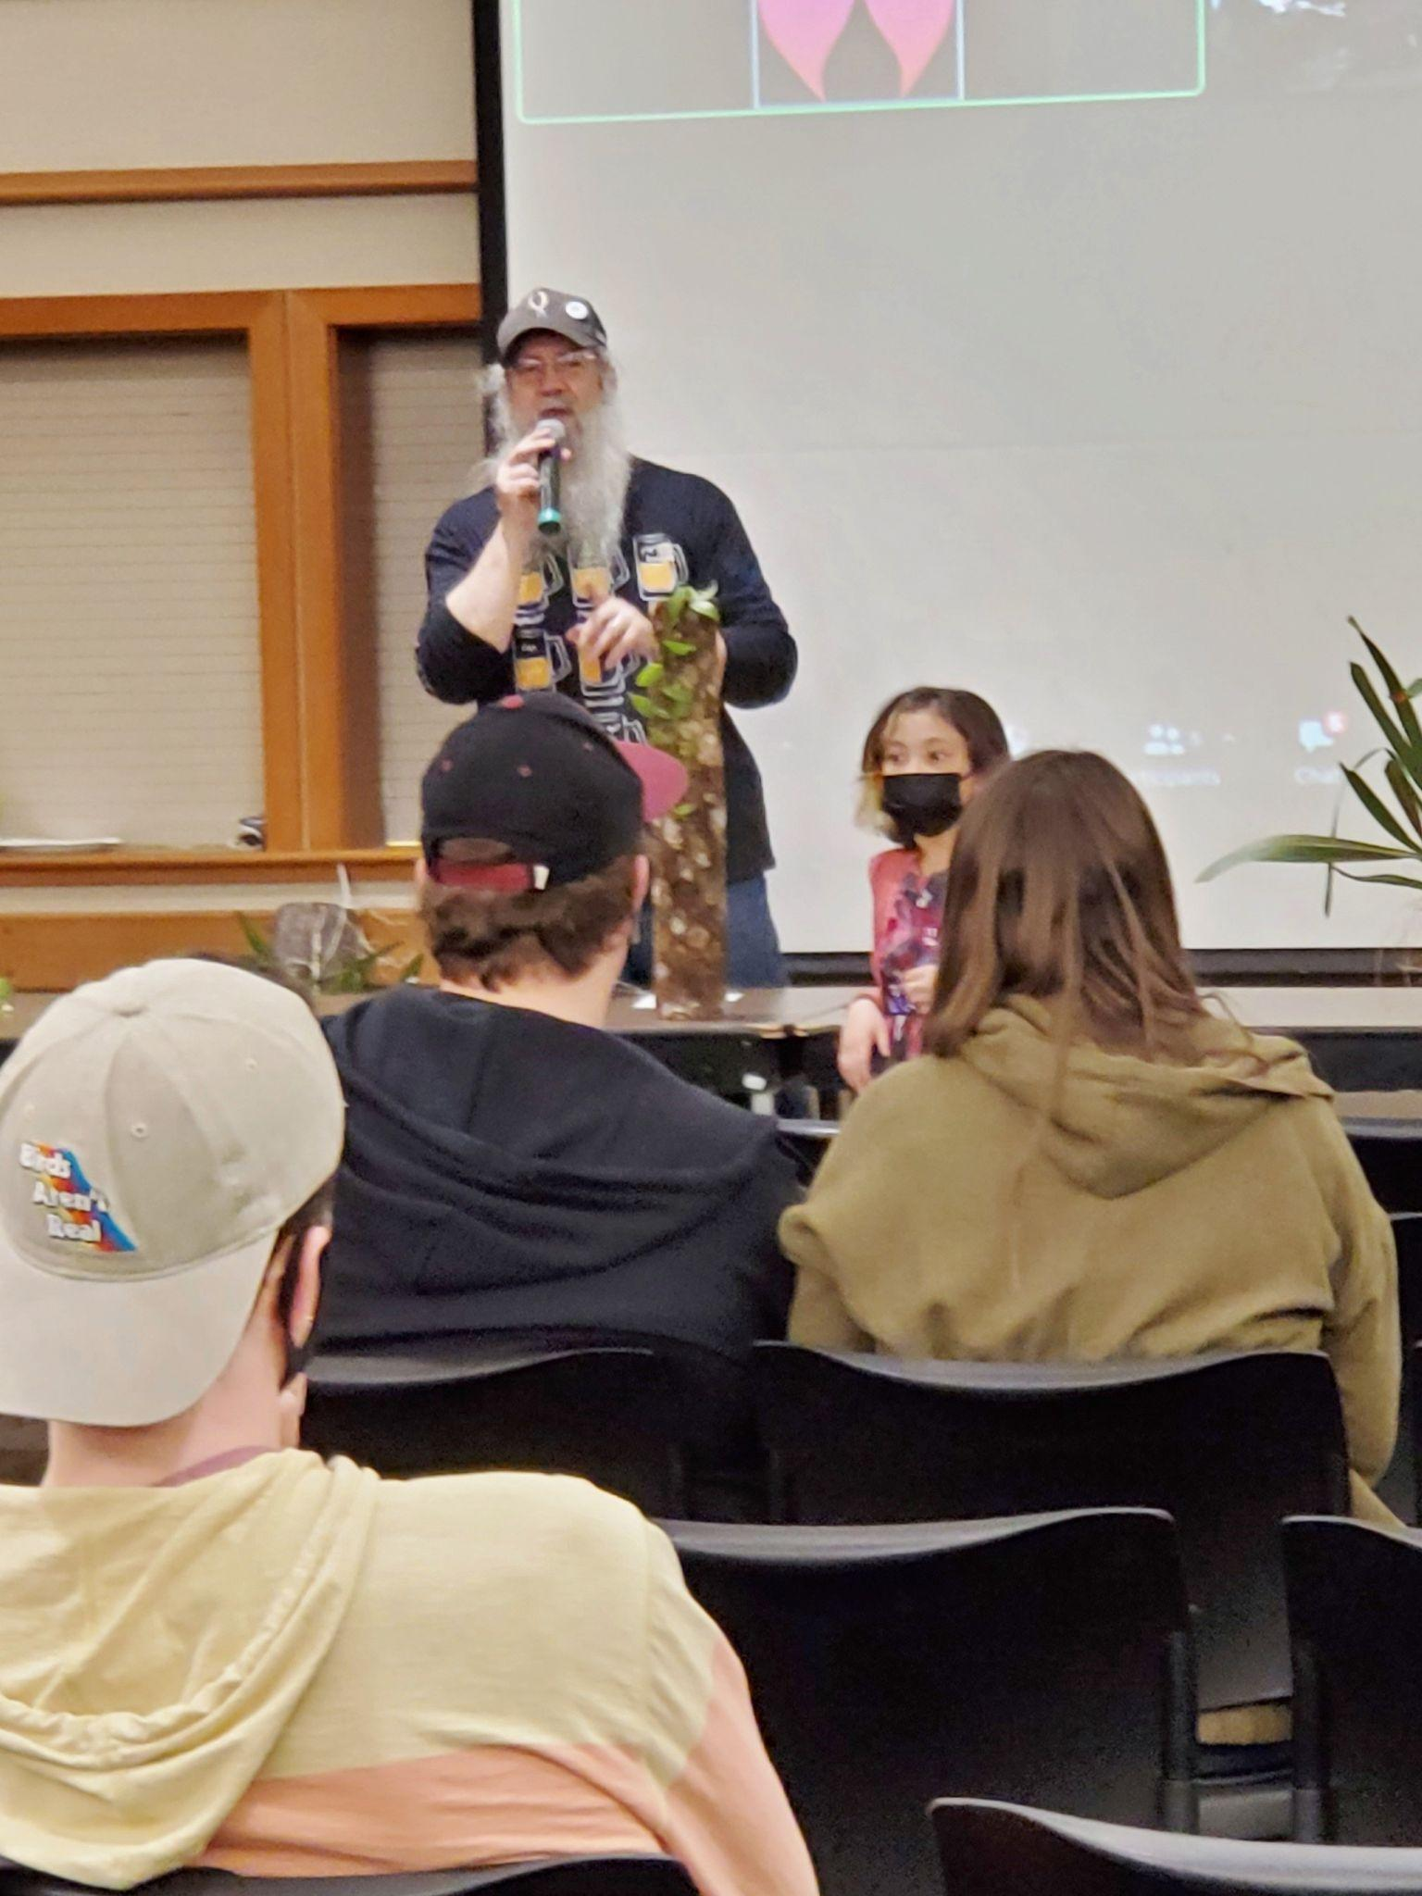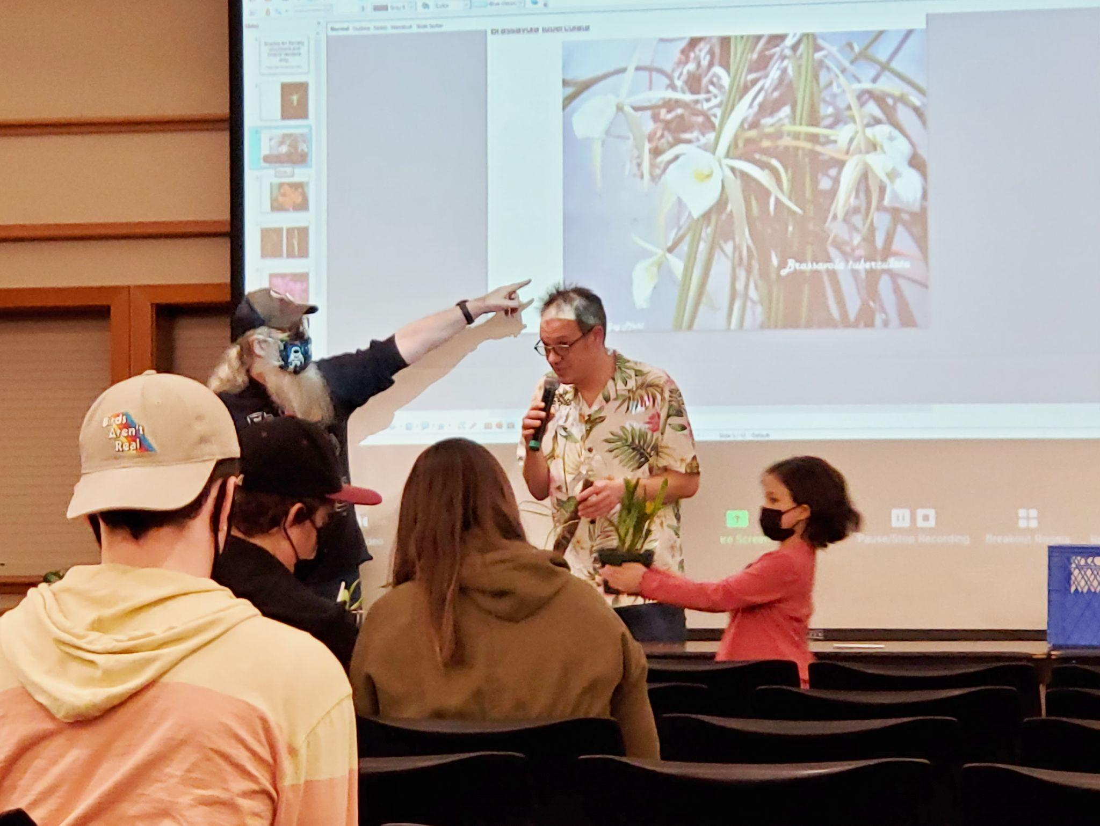
Auctioneer Mike Mike, Joe and Violet
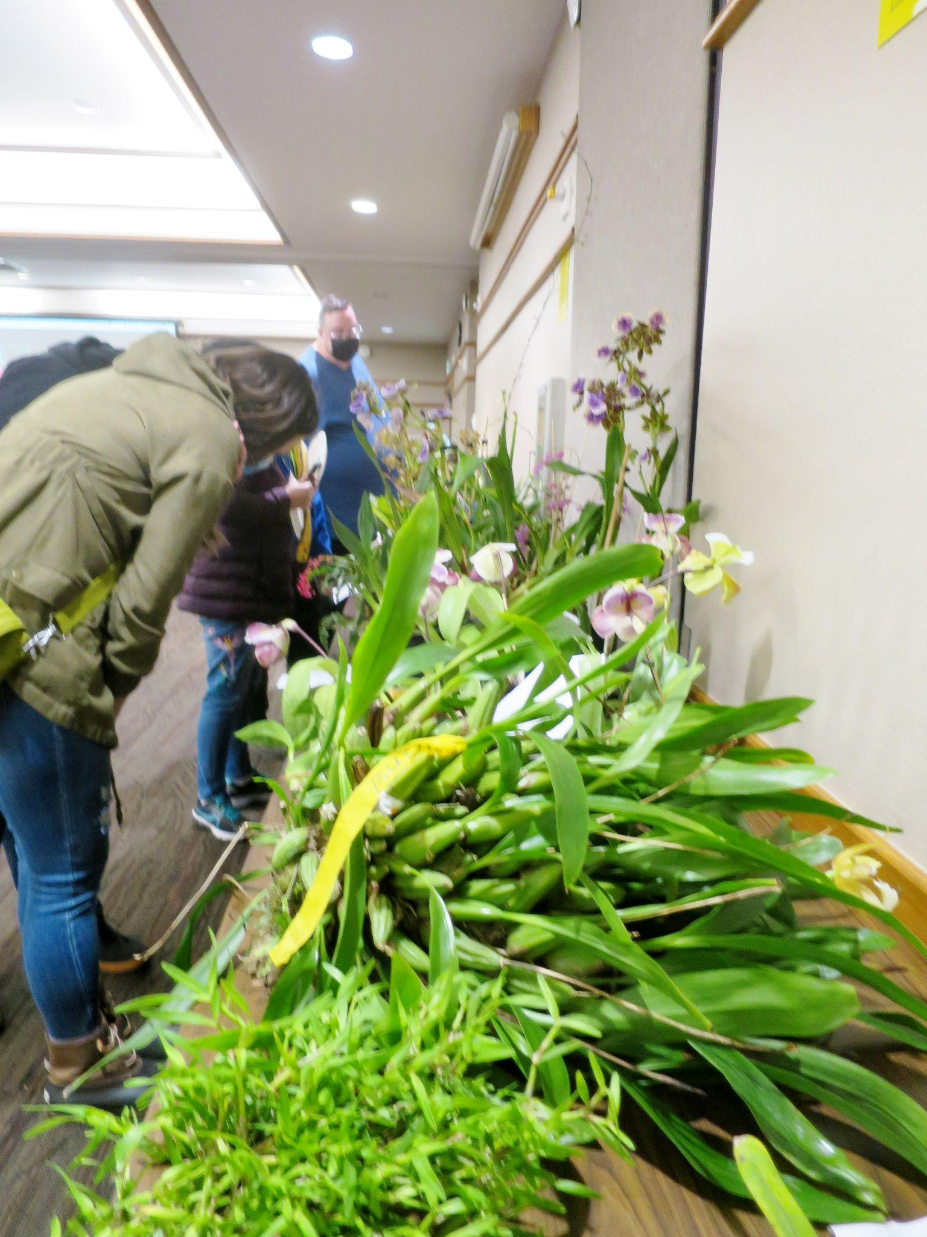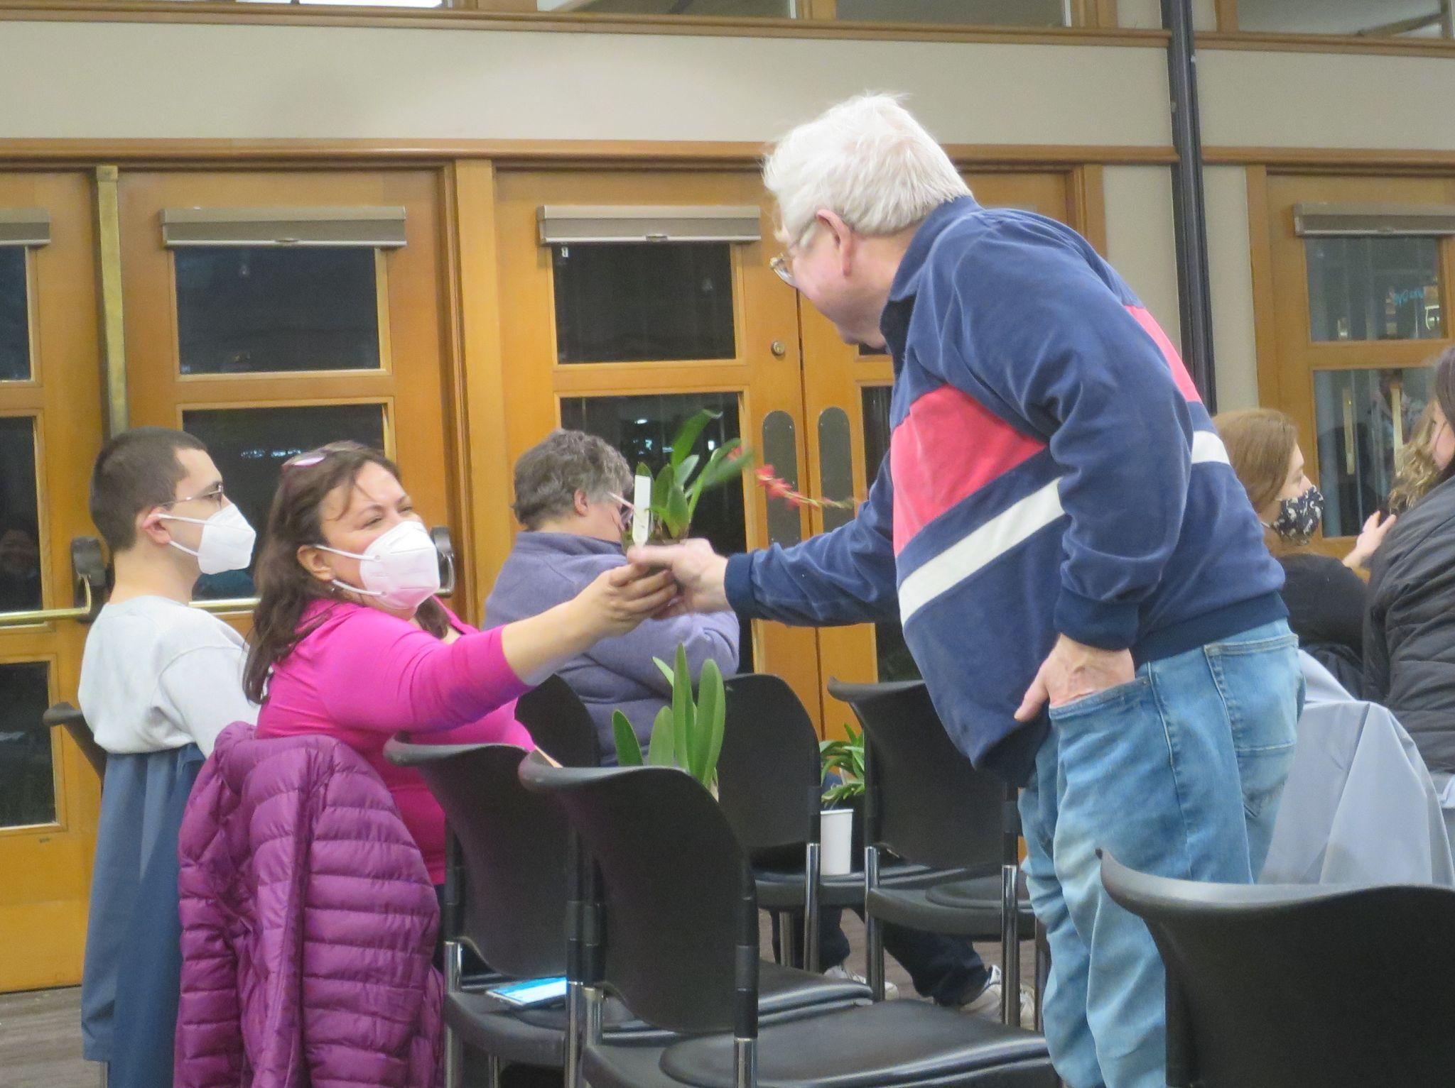
some huge plants were donated George offers a closer view
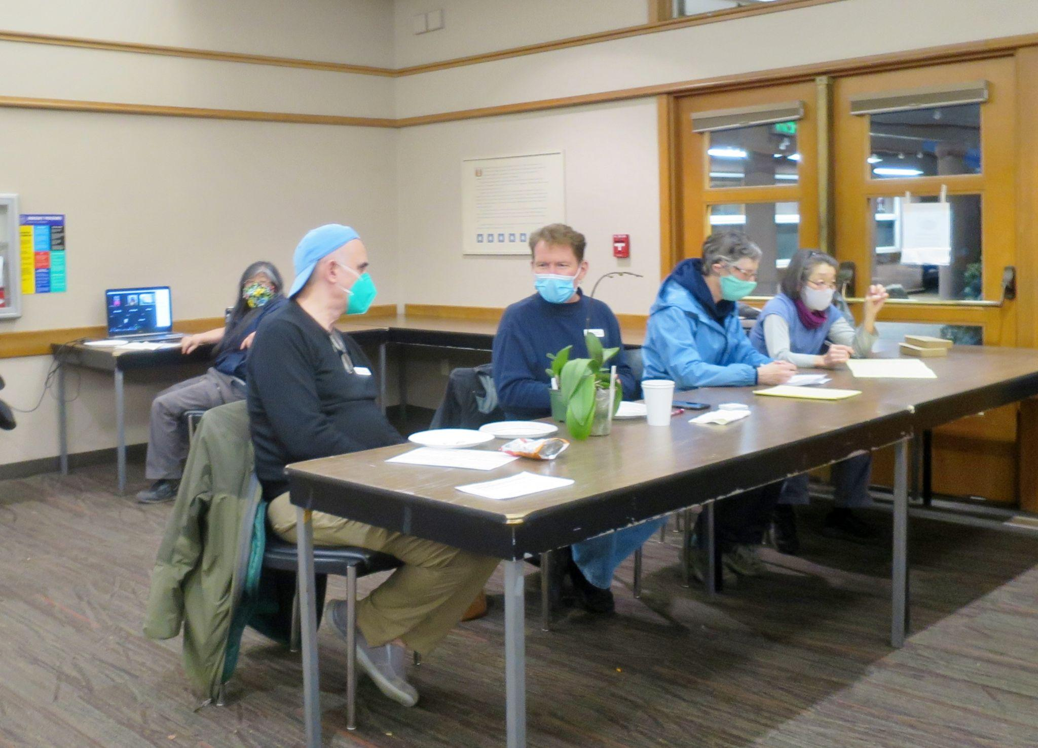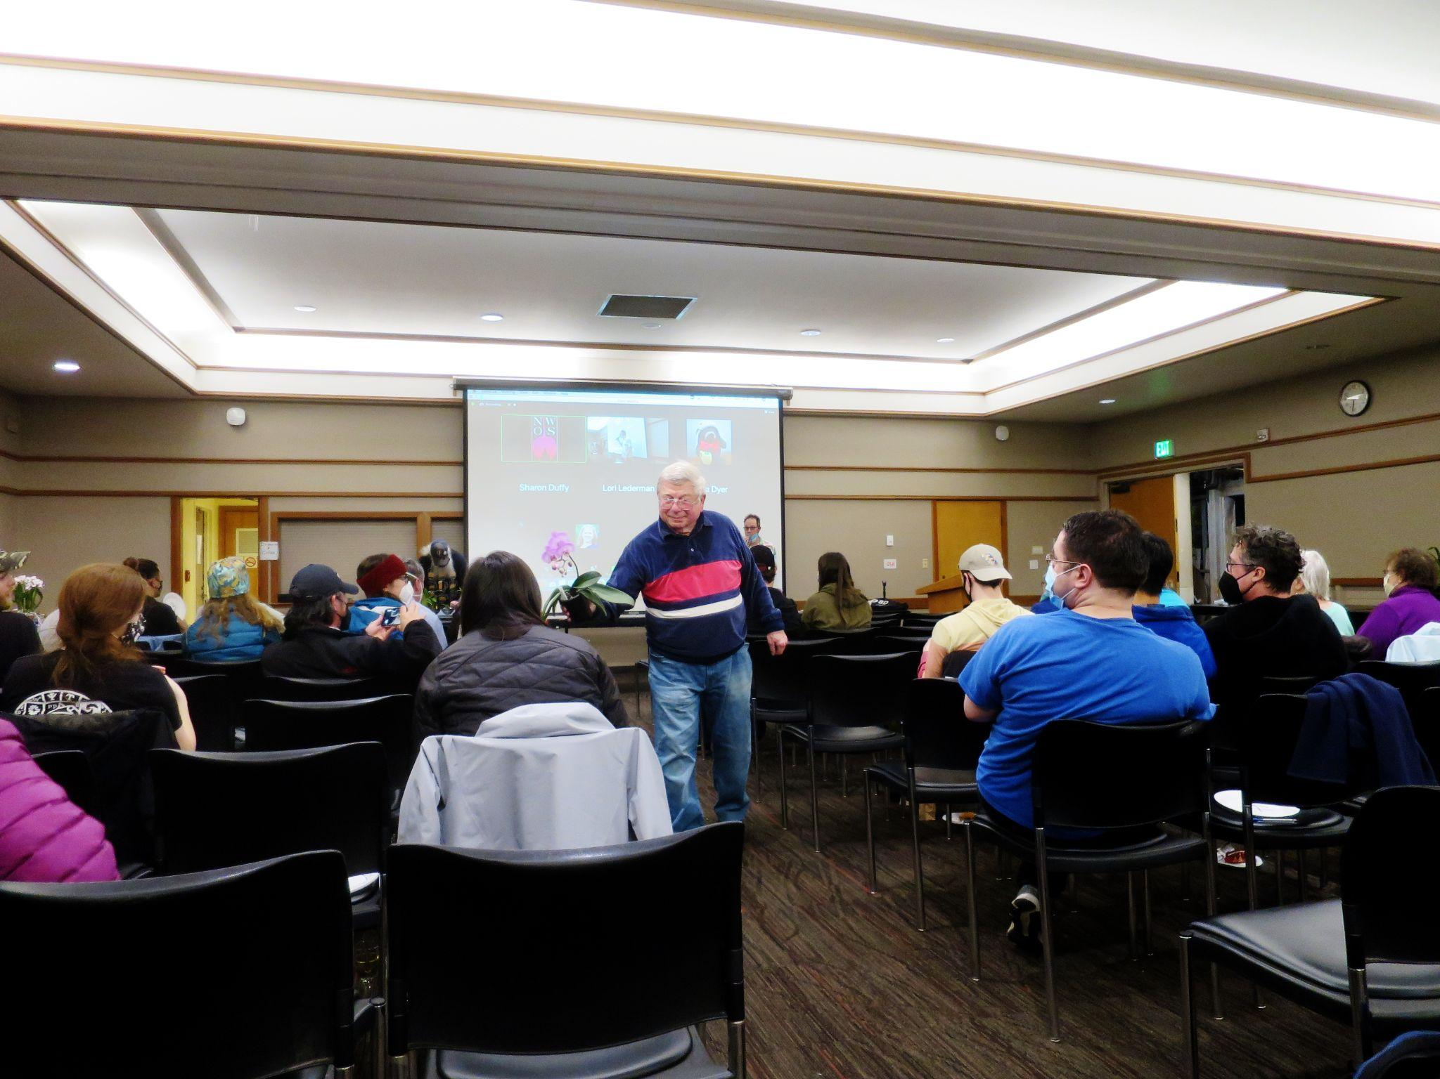
Hard working volunteers George shows us the plants up for bid
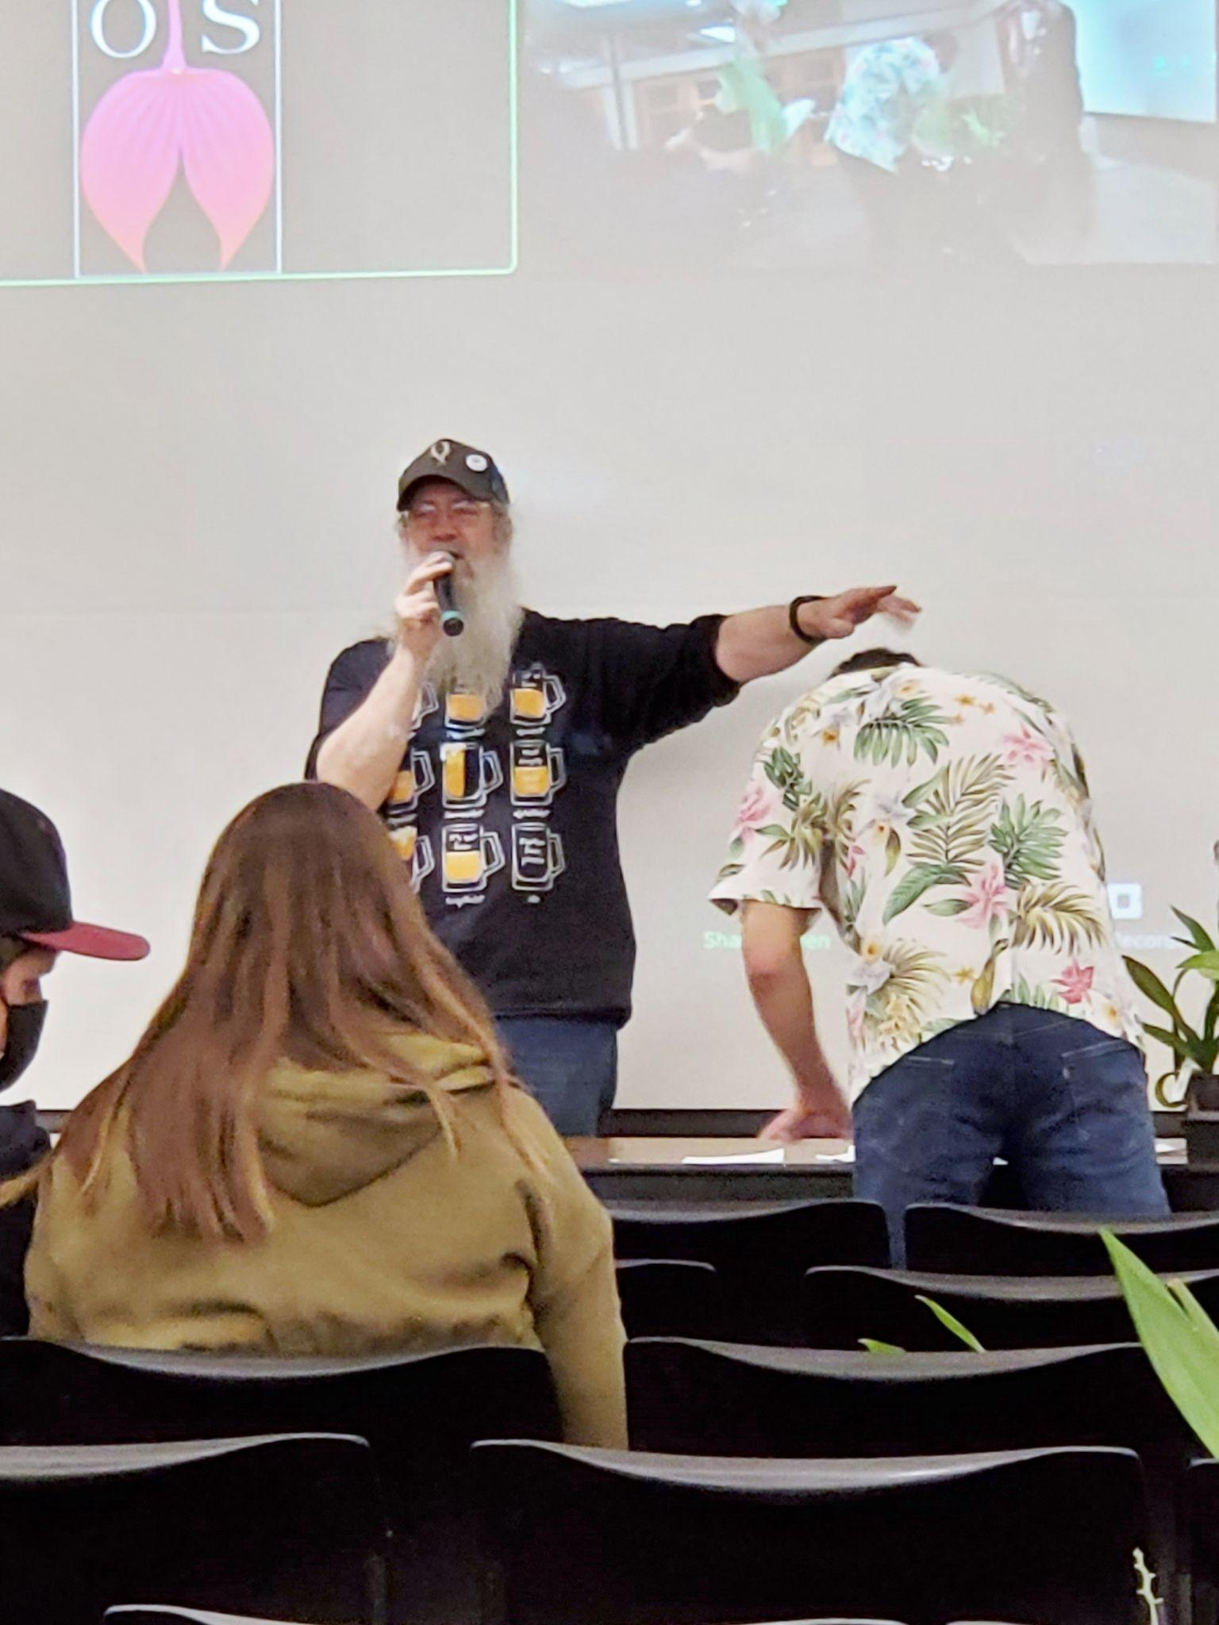

And finally: “Who wants to bid on this fine fellow?”

NWOS Potting Clinic

The NWOS held a potting clinic on March 19th at a facility associated with the Volunteer Park Conservatory.

The Potting Clinic was very well attended with 24 attendees, 9 of whom we welcomed as new members into the Society.

The potting clinic was staffed by 6-8 NWOS volunteers (in no particular order), Dev White, Bill Leicht, Mike Pearson, Abigail Chang, Lillian Otani, Joff Morgan, and members that should be mentioned but will have to forgive us for not doing so.

Deb White started the clinic by speaking about the basics of orchid potting and giving a demonstration to the attendees.

After the introduction the clinic broke into small groups and people began their repotting efforts. Most attendees brought three plants to the clinic.

As this was such a successful clinic we are in the planning stages for an additional potting clinic this year. Keep your eyes tuned for updates about this and other educational opportunities throughout the year.

Gary Baker Service Award

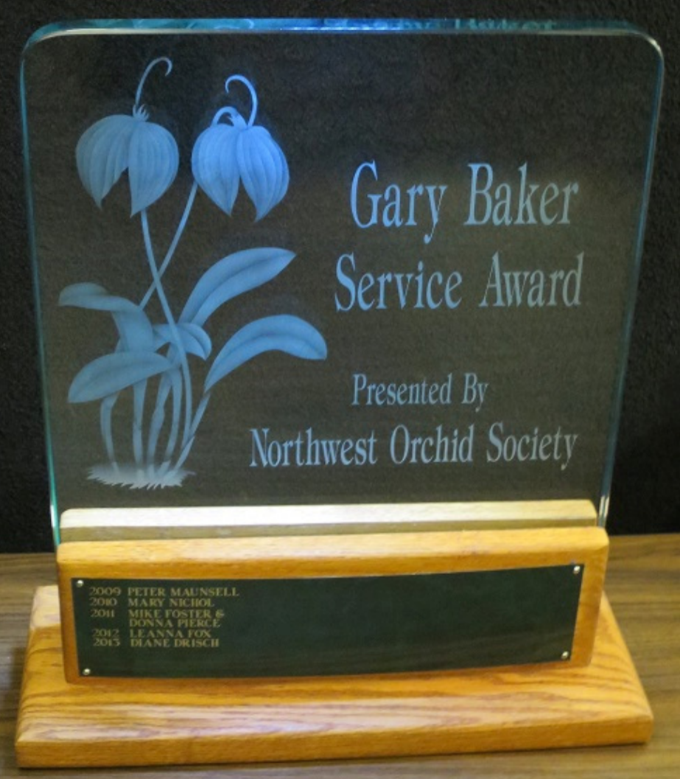
Gary Baker was a long term member of the Northwest Orchid Society. As with another member of our society, Rebeca Northen, Gary has contributed significantly to the orchid world. Gary was a hybridizer with the Beall Orchid Company for decades where he produced many famous crosses, some of which are foundations of orchids still in production today. Later in life he would open a nursery in Woodinville that many of us visited, Baker and Chantry.

There are six hybrids named after Gary, and a Miltoniopsis hybrid with a clone named after Gary.

This award is given annually to the person who has contributed the most to the overall goals of the society in the prior year. The recipient is selected by the board from nominations made by the general membership. Honorees are presented with a crystal perpetual trophy engraved with their name.

Some of the past recipients.

- 2017 - Andy Wright
- 2018 - Alba Dennis
- 2019 - Deb White

At this time the society solicits nominations from the general membership. If you have someone that you would like to nominate for service during the past year, please fill out one of the following forms and return it to Ben Johnson via email.

Gary Baker Service Award - Nomination Form - Word
Gary Baker Service Award - Nomination Form - PDF

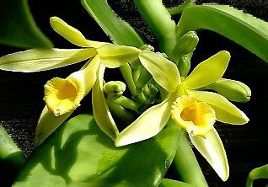
The World’s Favorite Fragrance Is … An Orchid
Apparently across all cultures, continents and economic conditions one scent is the universal favorite, vanillin one of the main scent and flavor components in Vanilla. Let’s hear it for the mighty orchid and grab ourselves another scoop of Vanilla ice cream!
Science Alert Article
Current Biology Study

Growing Odontoglossums
Some of you may have seen the large display of Odontoglossums and Odontiodas in our display at the Northwest Flower and Garden Festival. These genera were once very popular, but like trends that can come and go these genera have fallen out of favor with large commercial producers of orchids.
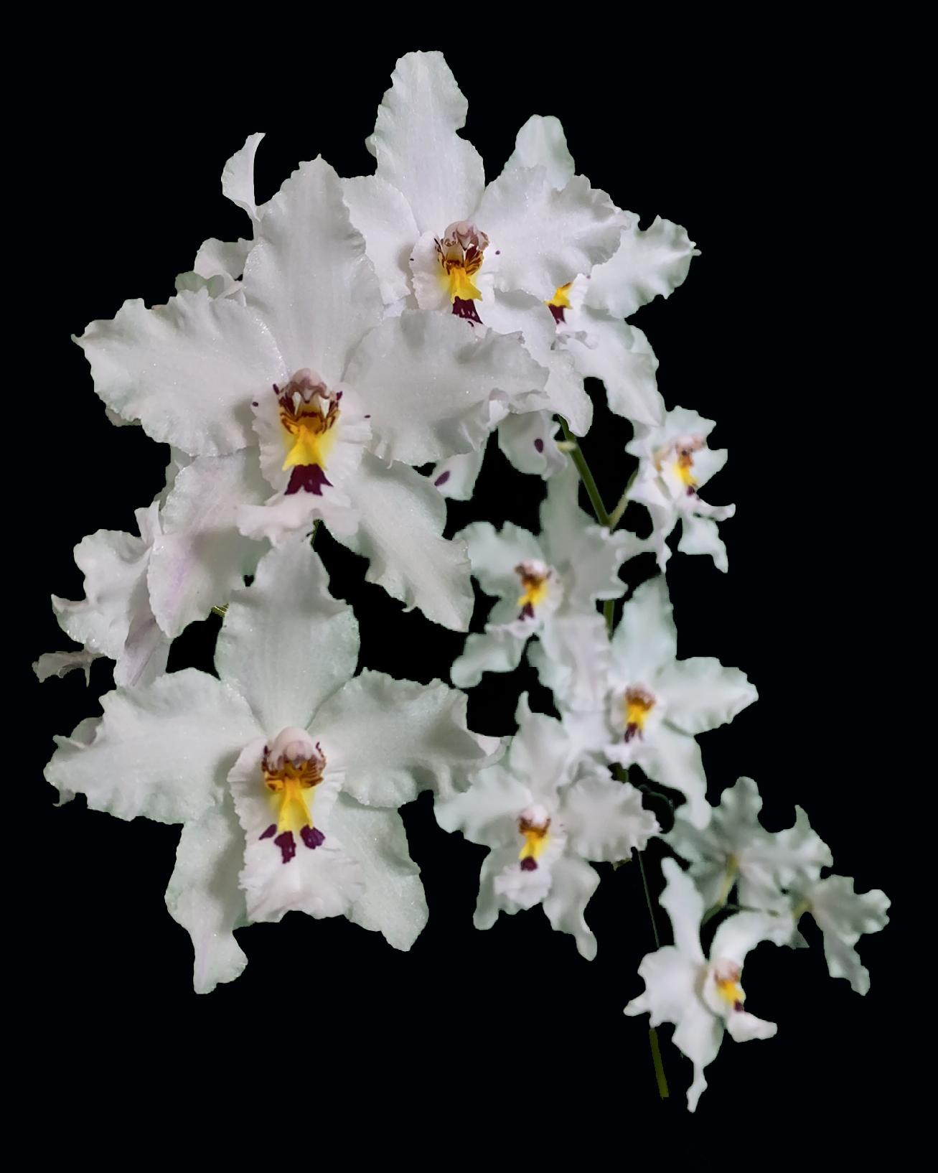
Fortunately for us living here in the lovely cool (generally!) Pacific Northwest, these can be grown without too much difficulty. Many times people will grow them in a shaded greenhouse with an evaporative cooler. However, hobbyists can be quite successful in growing them under lights, usually in a cool basement.
Odontoglossum nobile is found in the cloud forests in certain regions of Colombia between 2000 and 2400 meters. This small or medium sized plant is foundational to many of the complex Odontoglossum based hybrids. This species brings a paper whiteness to its hybrids that is often missing from the more common Odontoglossum crispum.
Odm nobile (‘Keith Andrew’ x alba)

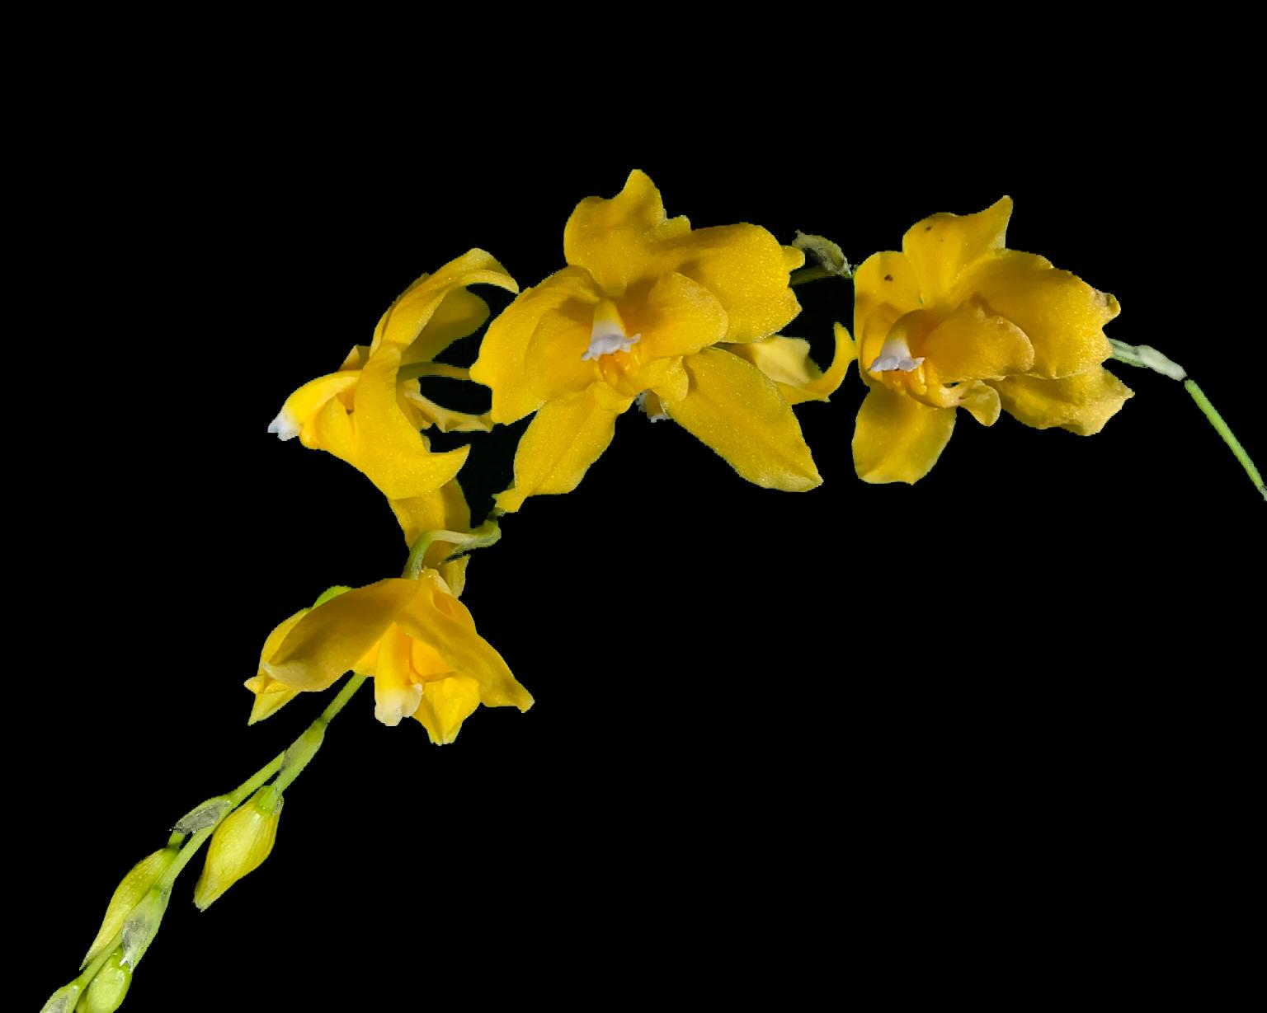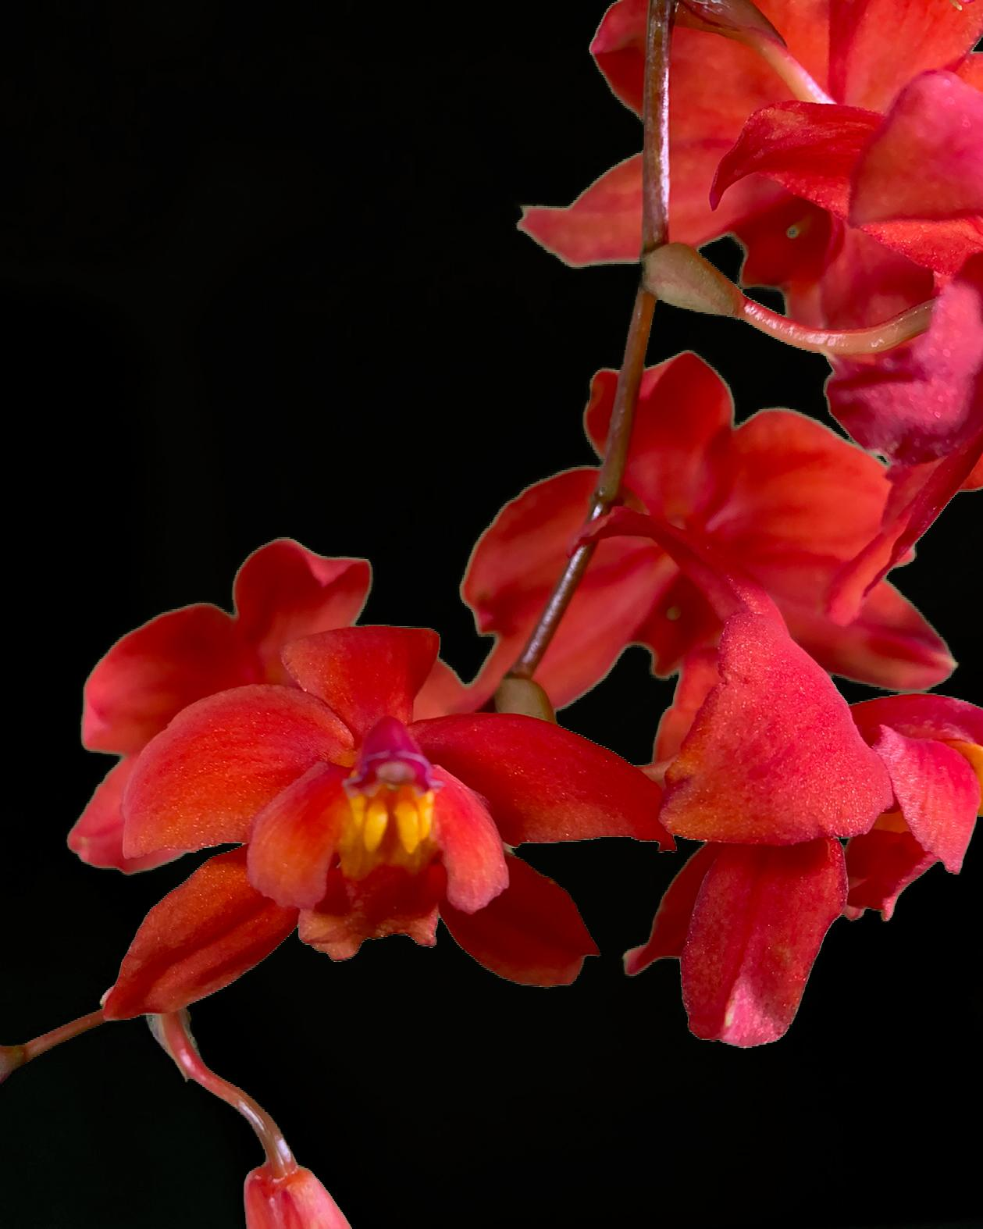
Cda noezliana flava ‘J&L’s Gold’ Cda noezliana ‘Geyserland’ 4N
Cochlioda noezliana is a small to medium cool growing species from Bolivia and Peru. This small to medium sized species is the entire reason that there are the flamboyant red, pink and purple Odontiodas today. It comes in both the standard red or orange form as well as a xanthic flava form. It is also interesting to note that when touring some of the older botanic gardens sometimes the only Odotoglossums they are able to maintain are the solid red Odontioda hybrids.
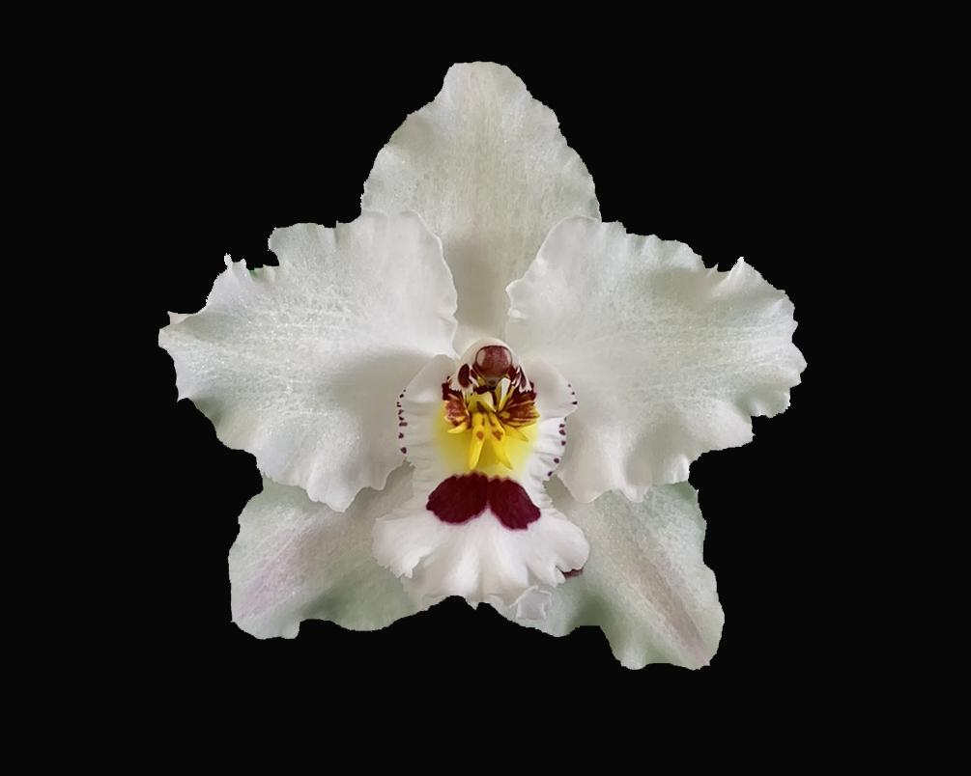 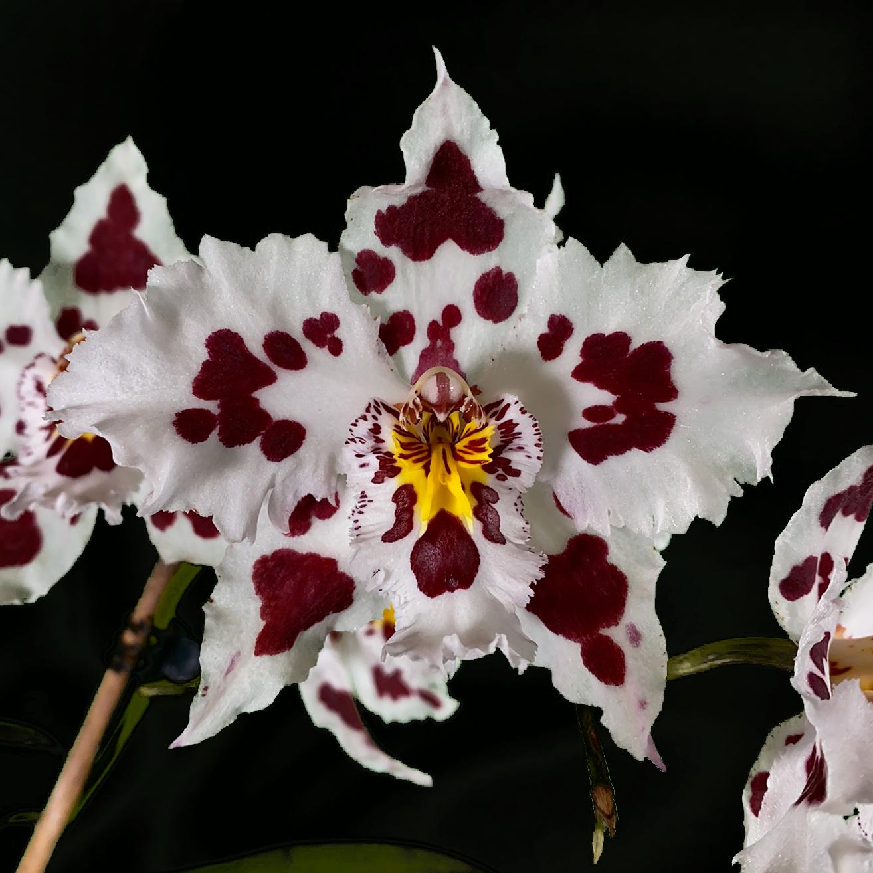
Oda Betty Whiteout ‘Lipstick’ Odm Nicky Nikcy ‘Nova’
Here are two examples of ‘classic’ Odontoglossums. The first one is actually an Odontioda, which means there is a Cochlioda somewhere in the parentage. Despite that it looks for all intents and purposes like an improved version of Odm nobile. The second one being a heavily patterned white is a classic Odontoglossum crispum type hybrid with frilly ‘crisped’ edges and dark highly contrasting patterns.
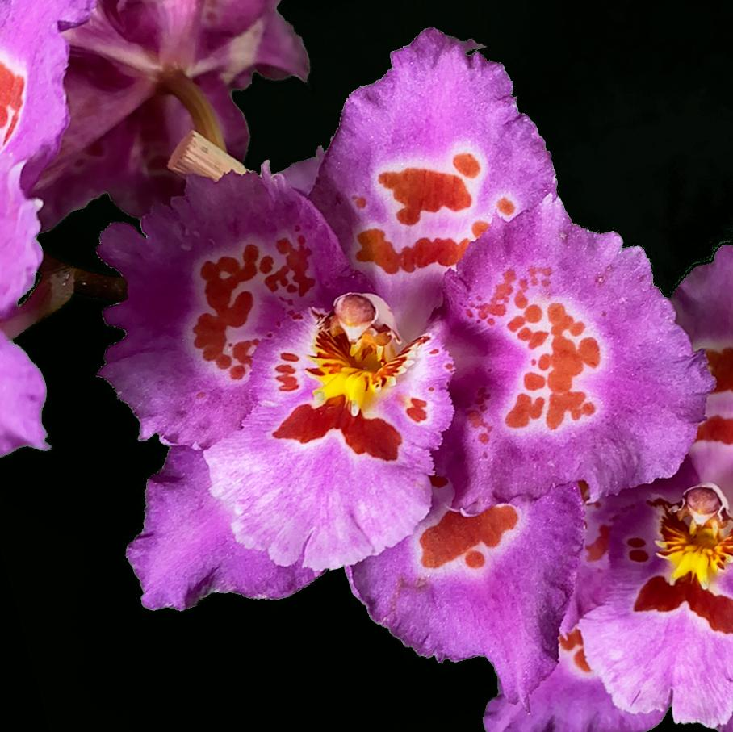 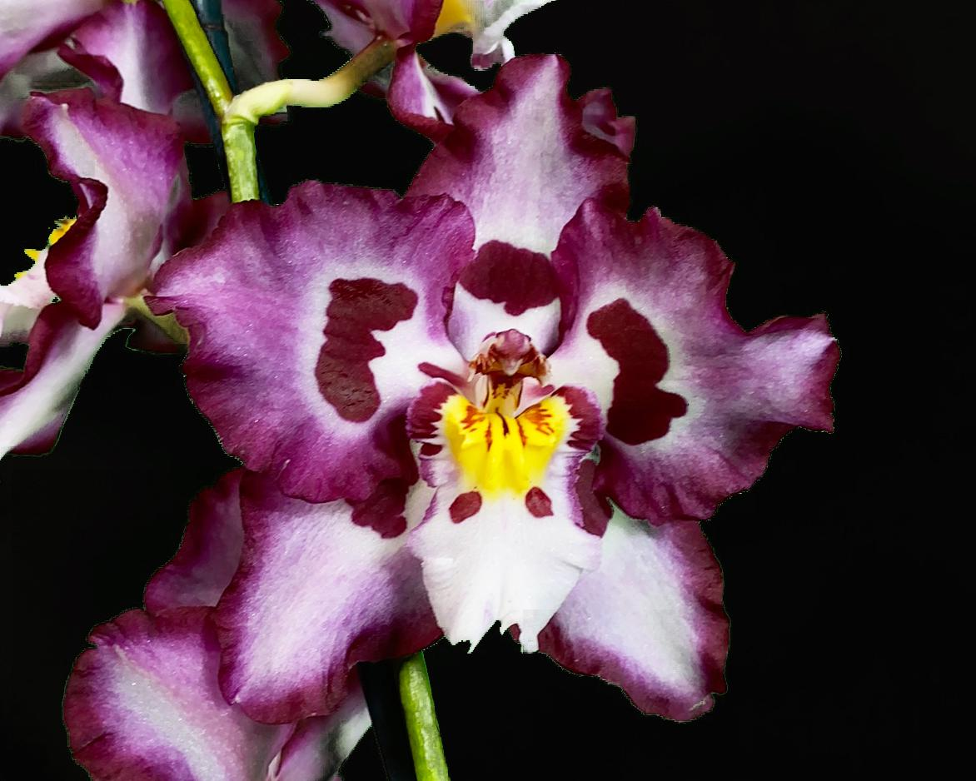
Oda Florence Stirling ‘Perfection’ Oda Saint Wood ‘Hawk Hill’
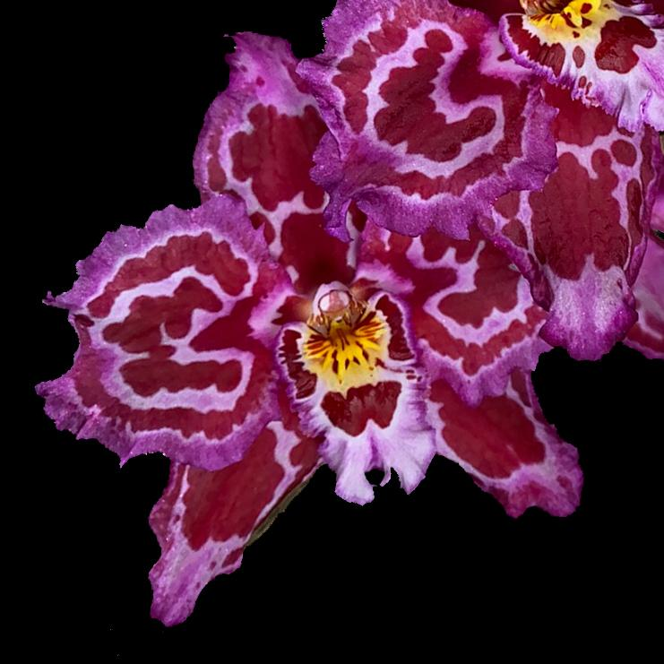
Odontiodas may very well be the flamenco dancers of the orchid world. They are most certainly not timid or shy with their colors and patterns. They will be one of the first things you see when you walk into a room when they are in bloom, they are the opposite of the quiet elegance of their Odontoglossum sisters. However they are grown just the same.

Oda Opal Etheridge ‘Hawk Hill’

The last grex is named for the mother of our September speaker, Tom Etheridge, he will be speaking on advances and trends in the breeding of Odontoglossums it will be an interesting program.
South America is the natural habitat for Odontoglossums where they grow in an area approximately 15 degrees either side of the Equator high in the Andes mountains at elevations between about 1,500 - 3,800 meters (5,000 ft and 12,500 ft). For most species night time temperatures are as low as 50° Fahrenheit with constant high humidity, plentiful rainfall and heavy mists which help to compensate for higher temperatures during the daytime which reach the mid 70°F. Cool damp nights are essential for good growth. One size certainly does not fit all because many modern hybrids combine parents from related warmer growing genera, so it is useful to understand parentage before generalizing.
Light - In their natural habitat Odontoglossums grow in filtered light beneath overhanging vegetation so although they need good light, they do not need direct sun. In fact, leaves burn easily so a balance of good general light is needed to stimulate growth and initiate flowering. Plants should be shaded during the Summer season while they are growing strongly then the light increases towards Autumn/Winter when pseudobulbs complete growth and ripen.
Here in Seattle I grow under 60% Aluminet shade cloth with some additional shade compound applied to the sides and ends of my greenhouse. I'm growing under these conditions year round.
Temperature - A good diurnal fluctuation in temperature mimics their natural habitat improving plant vigor and extending flower life. 50-55°F is ideal for nights but the plants need an increase of +/- 20°F during Spring/Summer days which can reduce to just an additional +/-10°F during Autumn/Winter days.
The plants can tolerate a few days of heat stress in the 90-100°F temperatures, it is essential that the leaves be kept misted and that the night temperatures drop at least 20°F-35°F at night during these periods.
Watering - While Odontoglossums do not require a formal dry season, they need less water during Winter months. Composts should never dry completely so watering will depend upon individual conditions, probably every 5-7 days during Spring/Summer reducing to every 7-10 days in Autumn/Winter when reduced light and less warmth slow their growth. A buoyant humid atmosphere is needed (60%) throughout the year with an ideal minimum of 50%. Overhead misting is beneficial particularly in the evening and early morning during Summer months to mirror the natural cloud mist cycle. Care should be taken to maintain humidity during colder months when heaters can dry the atmosphere.
During our cold somber winters I go as long as 14-21 days without water if it has been particularly cold. As with all orchids the most important thing to grow on these plants is their roots. If their roots rot off you will spend the next year regrowing roots and re-establishing the plants.
Fertilizer - Orchids generally are light feeding plants but as Odontoglossums grow throughout the year a constant supply of weak nutrients is beneficial. Every grower will have their own regimen for feeding, but the principle of a “growth” formula (e.g. N20:P5:K15) during Spring/Summer followed in Autumn/Winter by a “flower promoting” formula (e.g. N15:P5:K20) works well. Feed is administered to roots through the watering system although an occasional folia feed can be a beneficial tonic.
I feed mine with Peter’s 15:5:15 Cal Mag. I supplement with some ‘additional’ organic cal-mag which seems to be necessary with the Seattle water that I’m on. Additionally, I use a bit of humic acid and a small amount of Aquatrols wetting agent.
Air movement - Odontoglossums and their hybrids need constant air movement reflecting the freshness of their natural habitat. These plants will not thrive in stale or stagnant air so throughput of as much fresh air as possible is essential for successful culture - continuously operating fans are very beneficial.
Potting - The ideal time to pot Odontoglossums is while new growths are still quite small, about 3 inches high, when young roots are still emerging. This usually occurs in early Spring or early Autumn. Odontoglossums like to be snug in their pots so never over pot, just leaving enough room for a maximum of the next two growths is sufficient. Make sure the compost is free draining, will retain moisture without being wet and also allows air to reach the roots.
For the ‘standard’ type Odontoglossum I pot in Fernwood tree fern fiber. For the harryanum series I use coarse bark and perlite mixed.
If you would like to know more about my experience or have questions about these plants feel free to ask me at the meetings or send me an email at robert.a.culver@gmail.com.
We have a book in our library that you can check out and find out more about the species titled ‘The Odontoglossum Story’. You can ask Joe Grienauer.
Additionally, the Odontoglossum Alliance has current and back issues of their journal online on their website.

Meeting Recordings
The NWOS now has most of our general meetings going back to 2020 and the past few board meetings recorded and available in the “member content” area of the website.
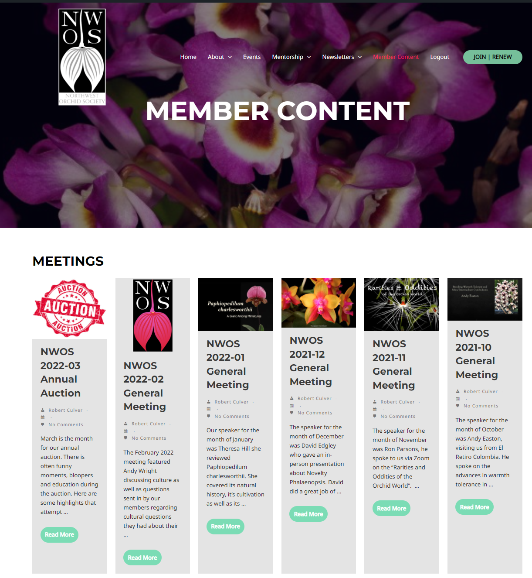
If you were unable to attend a past meeting and are curious about it please hop over and take a look. Some of these will start to be taken down after six months and some a year based on agreements we have with the speakers.
If you have questions about your member access on the website please mail webmaster@nwos.org.
If you have questions about your membership status please email Mike Cory.
If you would like to become a member or renew your membership just hop over to the NWOS membership page.
News from the AOS
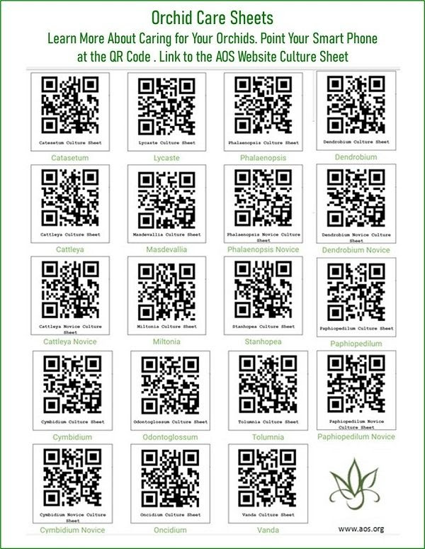
Share the care. On the AOS website these are called Culture Sheets. If you are new to orchids, need a refresher, or are adopting a genus unfamiliar to your collection, this is where you need to go to get the basics. New genera have recently been added and a print version is available, accessible through the AOS website.

Webinars offer new material each month and recorded sessions allow you to search a multitude of topics to view on your personal schedule. The popular monthly Greenhouse Chats are open to everyone. AOS membership is not required. However, if you are an AOS member there are many more webinars available to view.

The AOS website has a wealth of knowledge about orchids for the novice and expert alike. Take some time to browse around to learn more about your hobby. There’s a lot to see and learn including culture, history, awards, pests/problems and of course photos of gorgeous orchid flowers.

Schedule of Upcoming Events

4/9-10/22 - Spokane Orchid Society Show
04/11/22 – NWOS meeting – Speaker: Kelly McKracken, “Artificial Lighting”
05/09/22 – NWOS meeting – Speaker: Bill Goldner, PhD from Woodstream Orchids, “New Looks for Miniature Phragmipedium Hybrids and Other New Lines of Breeding.”
06/13/22 – NWOS meeting – June Potluck: The June Potluck is the last meeting before our summer break. Enjoy socializing during dinner. This is also the meeting where we present the Gary Baker service award.
8/ xx /22 - NWOS Summer Picnic: The NWOS will have a summer picnic for its members. Check back soon for the date.
09/12/22 – NWOS meeting – Speaker: Tom Ethridge, “Odontoglossums Then and Now, Has Anything Changed?”
09/30/22 – NWOS Annual show SETUP at the Volunteer Park Conservatory.
10/01-10/02/22 – NWOS Annual SHOW AND SALE at the Volunteer Park Conservatory.
10/10/22 - NWOS meeting – Speaker: Tyler Albrecht, “An Exploration of the Fluffy and Puffy Parvisepalum Paphiopedilums”
11/14/22 - NWOS meeting – Speaker: Peter Lin, “Neofinetia and Its Hybrids”
12/12/22 – NWOS meeting – Speaker:TBA , introduction of new Officers, NWOS Annual Meeting report, Schoenfeld and Northen Orchid Awards, and Holiday Gift Plants.

Reminder for Officers & Board Members

The next board meeting is Tuesday, May 3rd which will be at 7 p.m. and hosted over Zoom. Check your email for the Zoom registration link and agenda. Future meetings are tentatively scheduled for September 6, and November 8th

A brief NWOS Board meeting will be held after the April Members’ meeting on April 11, 2022, please wait around.

Shopping on Amazon? Use this link to earn $$ for the NWOS

If you go to https://smile.amazon.com and sign in to your account, you'll be given information about supporting various non-profits. You can type in "Northwest Orchid Society" and it will then send .5% of your purchase price to the organization.

It's really easy, but you have to remember to go in through the 'smile' subdomain when you place the order, otherwise it will go through as a regular order.

NWOS Website Links

- Main website: Http://www.nwos.org
- Events Calendar: http://www.nwos.org/events
- Membership (including renewals): https://nwos.org/Membership/
- Newsletter - Current Issues: https://nwos.org/newsletters/
- Newsletter - Archived Issues: http://newsletter.nwos.org
- Show Information: https://newsletter.nwos.org/ShowTime/Index.hml
- Facebook: http://www.facebook.com/nworchidsociety
- Instagram: https://www.instagram.com/nworchidsociety/
- Twitter: https://twitter.com/nworchidsociety

©2022 Northwest Orchid Society - All Rights Reserved

The opinions and recommendations published herein are those of the authors. The Northwest Orchid Society disclaims responsibility for any losses or damages that may be attributed to the use or misuse of any material or any opinion published in these articles and on the website. This website and the photographs, articles and content are protected by copyright and no part of them may be reproduced or re-used without the permission of the author.

