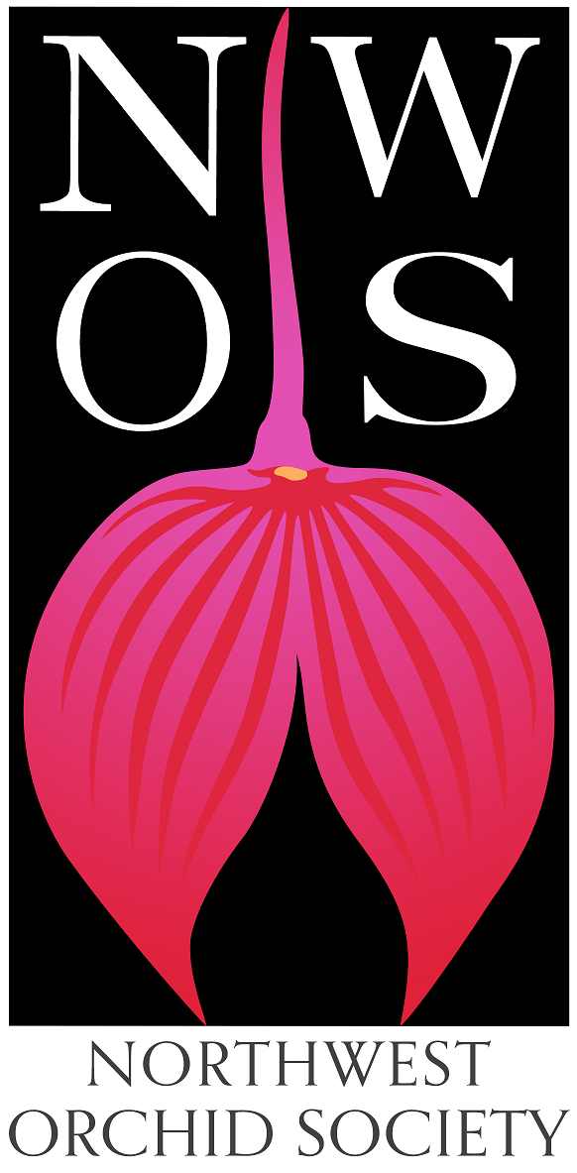
Northwest
Orchid News
Summer 2021
Volume 74, Issue 6

- About the September Meeting
- Speaker: Robert M. Hamilton “The Orchid Craze”
- Plant Table
- Sales Table
- Raffle Table
- NWOS Library
- NWOS at WA State Fair
- Fall Show and Sale at the Volunteer Park Conservatory
- Volunteer Positions
- 2021 Summer Picnic
- Spider Mite Control
- News From The American Orchid Society
- Report From the June Meeting
- Schedule of Upcoming Events
- Holiday Plants
- Reminder for Officers & Board Members
- NWOS/Amazon Shopping Link
- NWOS Website Links

About the September Meeting
September 13, 2021 7 PM
University of Washington Center for Urban Horticulture
3501 NE 41st Street, Seattle, WA 98105

Hybrid Meeting, In person and via Zoom Zoom Registration

We will be meeting in person for the foreseeable future. The Covid protocol for the meetings will be shared monthly for attendees and is available at our web site located here: Covid Response – Northwest Orchid Society (nwos.org)

Speaker: Robert M. Hamilton “The Orchid Craze”
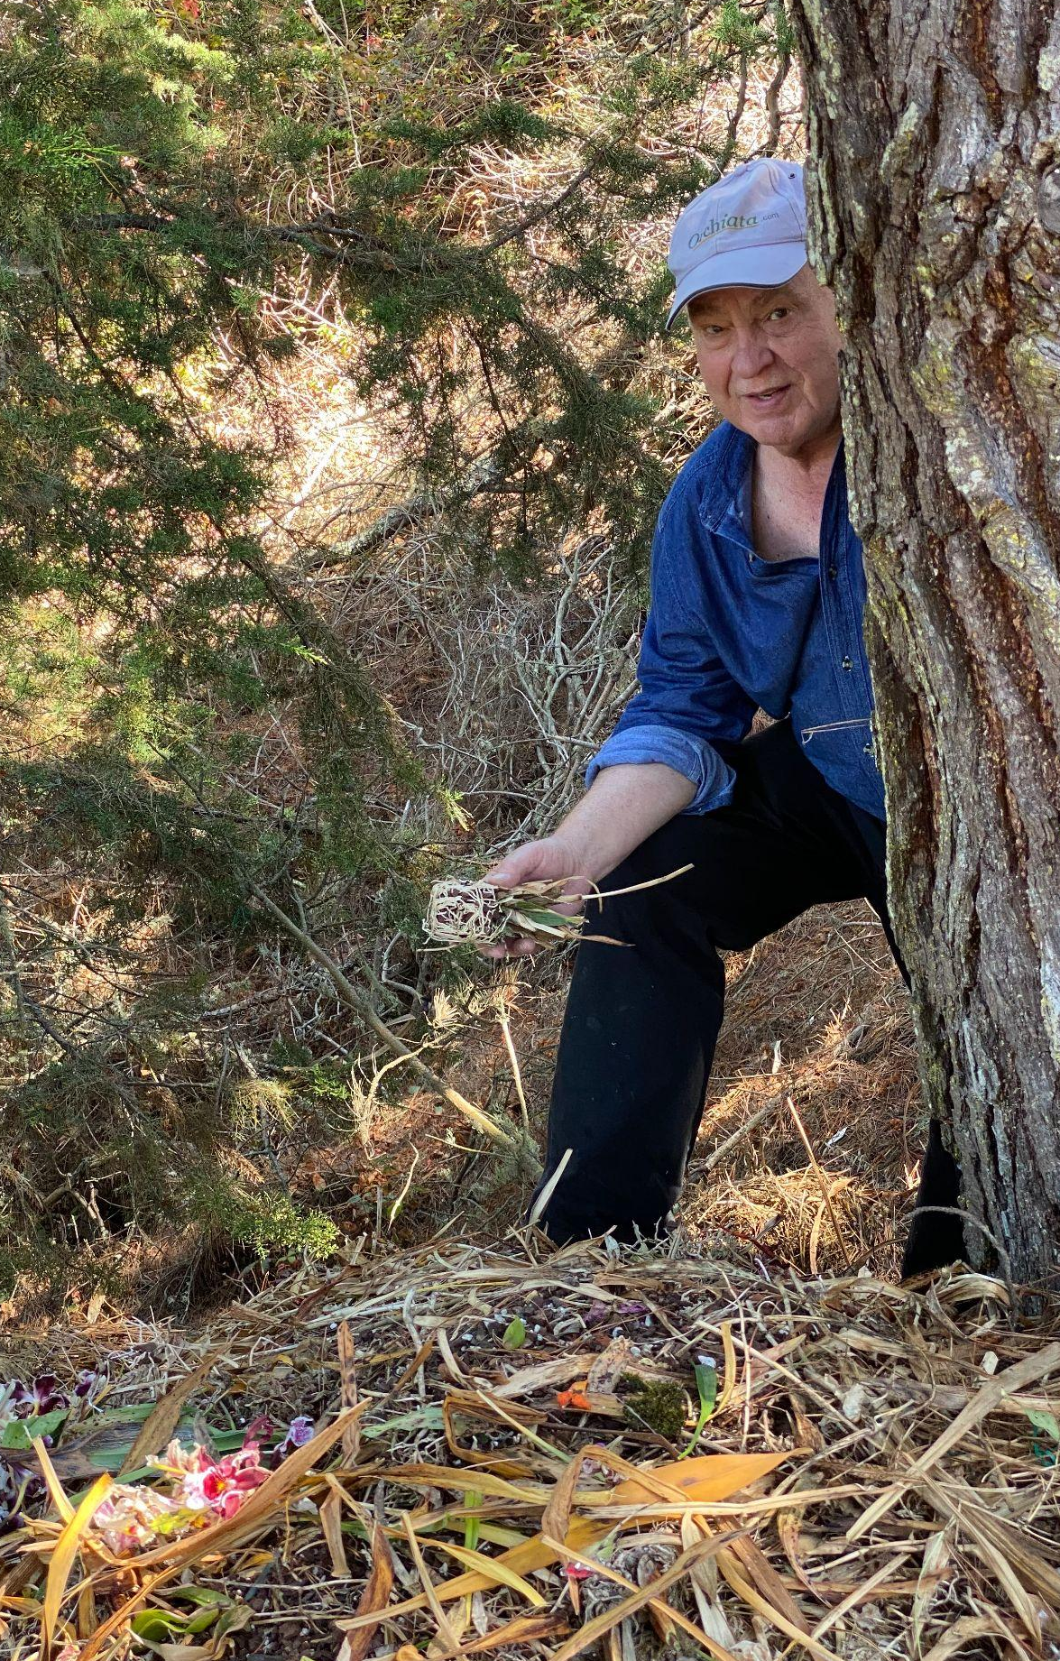
I will be speaking to your society about ‘The Orchid Craze’, It’s Origin and Future Explorations and discoveries in the 19th Century dramatically shifted human consciousness from beliefs based mostly on faith to more objective-based understandings. Exciting new revelations galvanized society. My talk attempts to encapsulate and share some of the ideas, including 19th Century science that resulted in the Victorian and subsequent orchid craze.

I was born in Berkeley, California in 1946 to native parents and educated in the Berkeley School System. I gave up studies in physics to pursue a career as a scientific glassblower specializing in the fabrication of experimental electron tubes, lasers and optics, eventually becoming UC Berkeley’s Principal Scientific Glassblower. As a glassblower I had the privilege of fabricating equipment for three separate Nobel laureates.

A shift in research priorities for my employer, UC Berkeley’s Department of Electrical Engineering & Computer Sciences led me to becoming part of the design team for a shared semiconductor research facility, the UC Berkeley Microlab and later Equipment and Facilities manager for its successor the UCB Marvell Nanofabrication Laboratory, which serves the research needs more than 500 researchers in all branches of science.

My interest in orchids began in 1976 when my partner, John Leathers and I purchased our first home which came with a solarium. We soon filled with plants including orchids. Our first orchid plant came from a UC Berkeley Botanic Garden plant sale, Stanhopea warscewicziana which, after blooming we affectionately named “the dead chicken orchid” because of its rather gross, pendant flower spike. Since then, John has gone on to become the leading hybridizer for Dracula and Masdevallia while I have specialized in Odontoglossum and its intergenerics; we are strictly “cool” growers. John and I have trekked the forests of Mexico, Central America, and the Andes. During one such trek we discovered Pleurothallis teaguei. In addition to propagating species and making hybrids we do our own lab work and freely share laboratory techniques.

John is the recipient of The American Orchid Society, 2015 AOS Hybridizer's Award and me, its President’s Award, granted to an individual who has made an outstanding contribution to the AOS. Besides orchids, my interests include classical piano studies, art and amateur astronomy.

1st VP Note: Bob will be bringing plants from his private collection, one of the premier Odontoglossum collections. There will also be plants from his partner John Leathers, one of the premier Masdevallia and Dracula collections.

Plant Table

We will be having an in person plant table this month. For your convenience, you can print out a Plant Table Information Form ahead of time. Click for your version of choice: PDF WORD Excel

Diane has taken pictures of the plant table for many years and has requested that someone else take up the torch. We appreciate everything that she has done. For those who aren’t able to attend, please do keep sending your pictures, we will be including them in our online gallery and in next month’s newsletter. Please send them to photos@nwos.org.

Here is a sample of some plants which will be added into next month’s gallery since they were part of the summer flowering season.

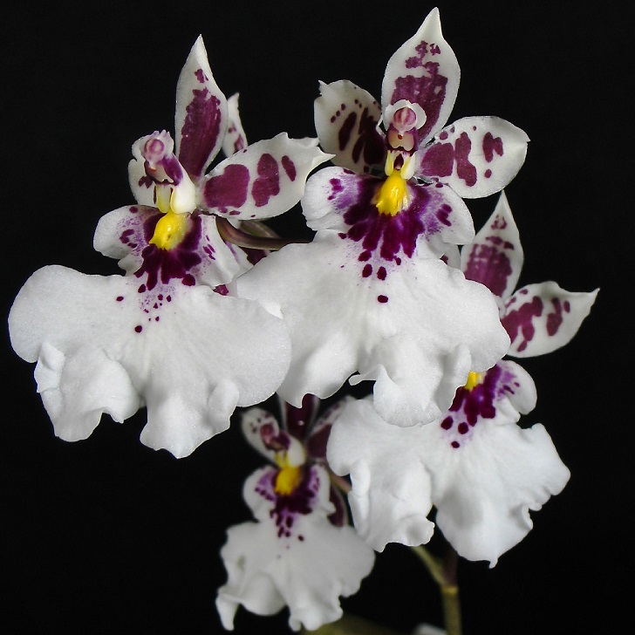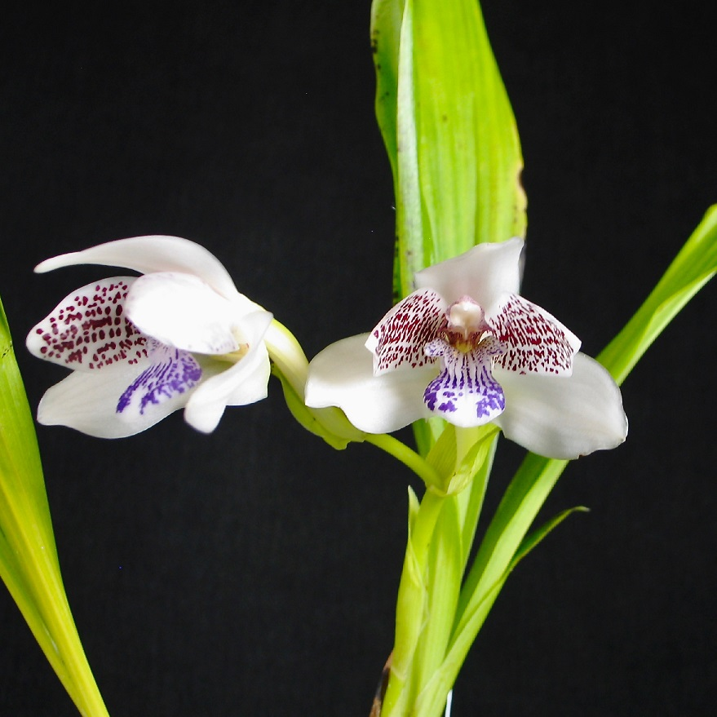
Caucaea phalaenopsis Pabstia jugosa

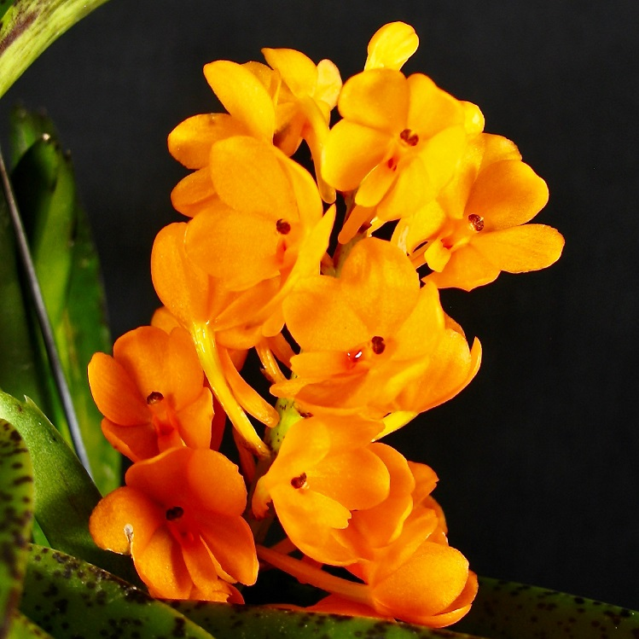 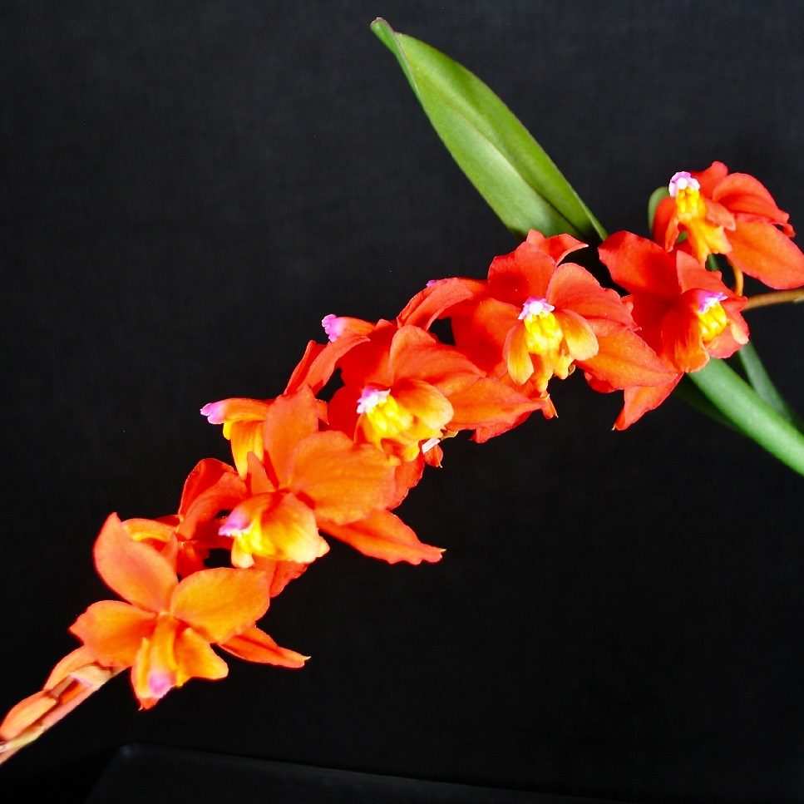
Ascocentrum miniatum Cochlioda noezliana ‘Tetra’
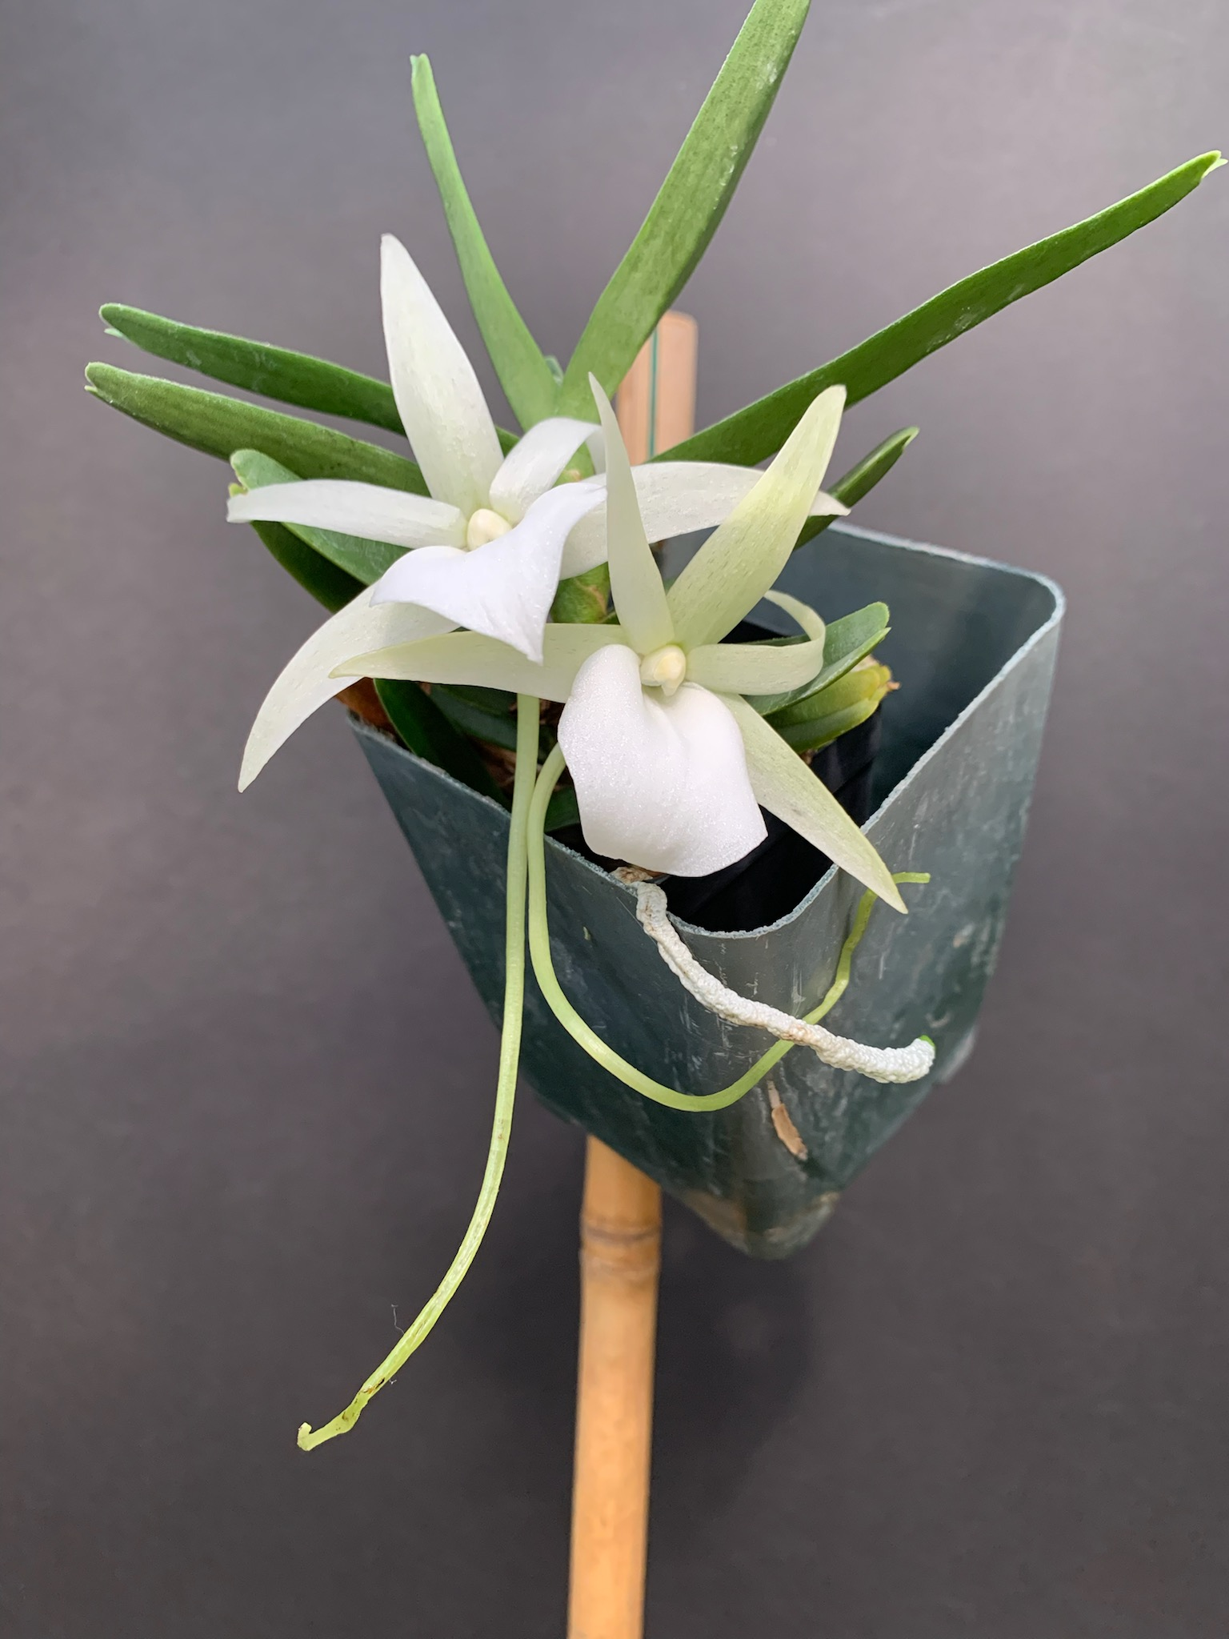 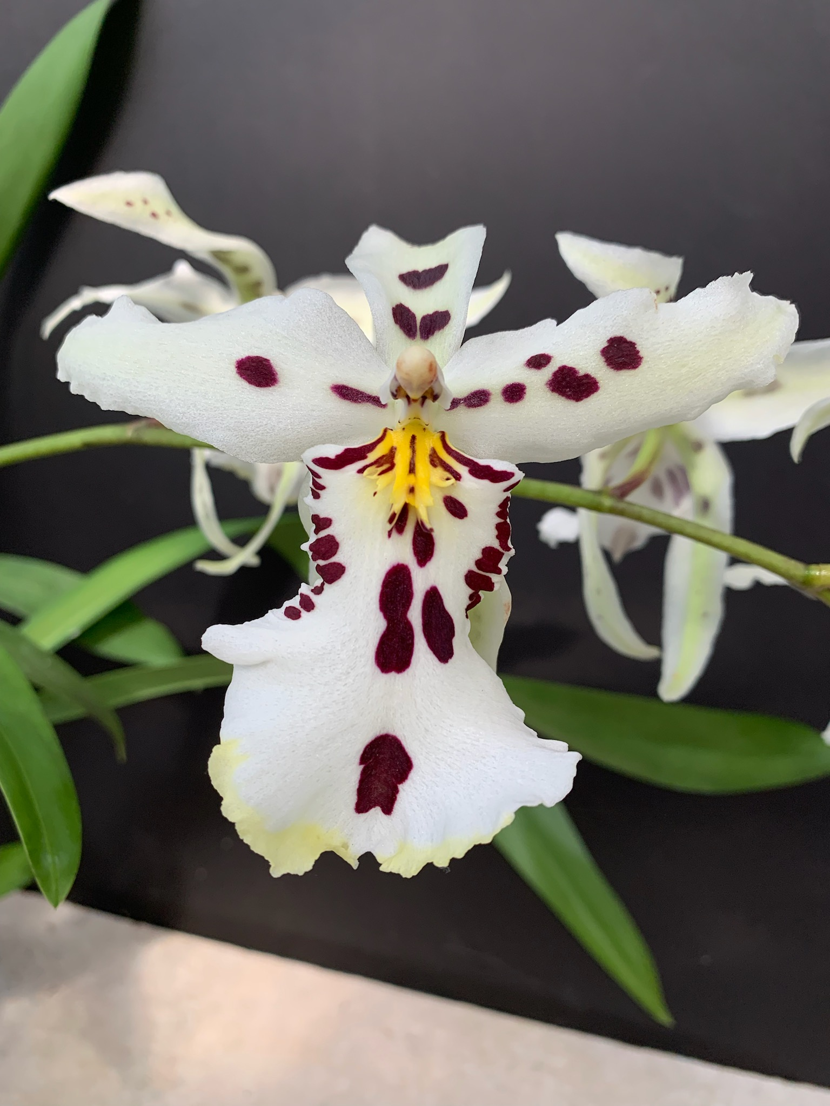
Angcm. didieri, Gordon Cromwell Beallara Snowblind ‘Sweet Spots’, Gordon Cromwell

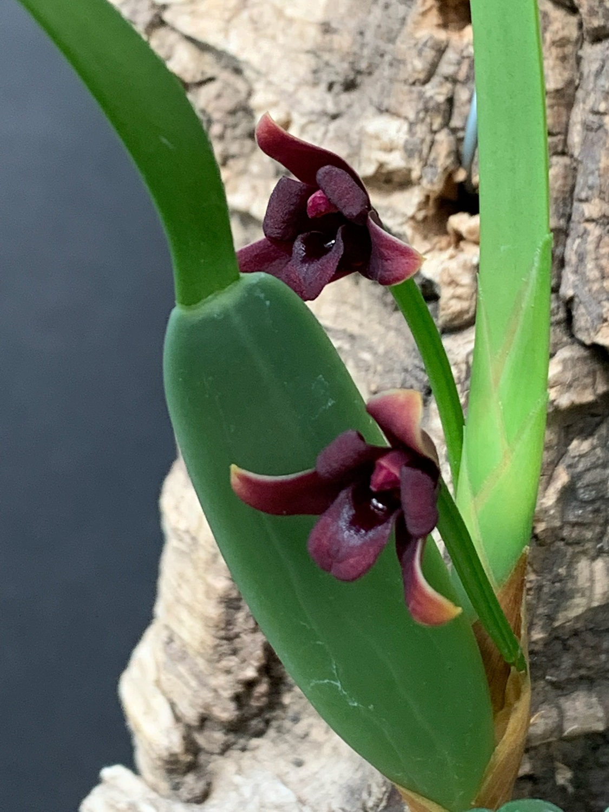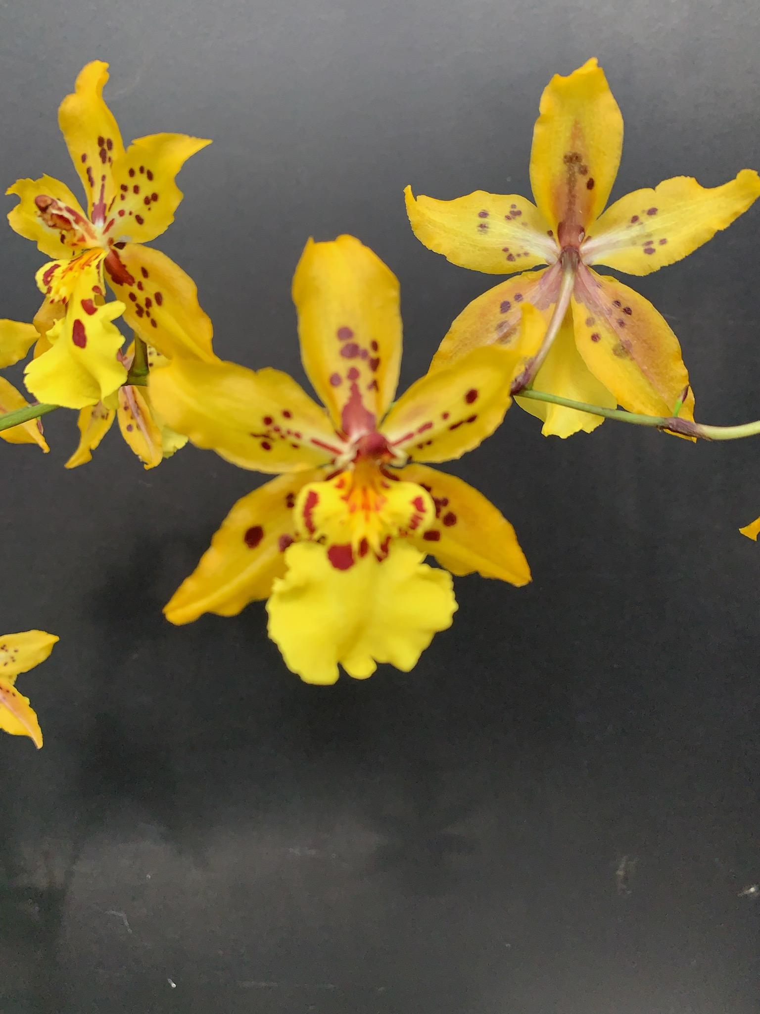
Maxillaria variabilis (red), Gordon Cromwell Odcdm. ‘Tiger Crow’, Gordon Cromwell

Sales Table

Members may bring up to 10 plants to sell. Include an extra tag with your name and the price in the plant.

Raffle Table

The raffle will be held as usual. Win a new orchid for your collection while supporting the Scholarship Fund. If you have any extra Orchids, please consider donating them to the raffle.

NWOS Library

If you'd like to check out a book or tape from our Library, please contact our Librarian Joe Grienauer a minimum of 2 weeks before the next meeting. Besides email, you can give Joe your request at any meeting. For a list of library items please click here NWOS Library.

NWOS at WA State Fair
Display Your Orchids at The Fair!
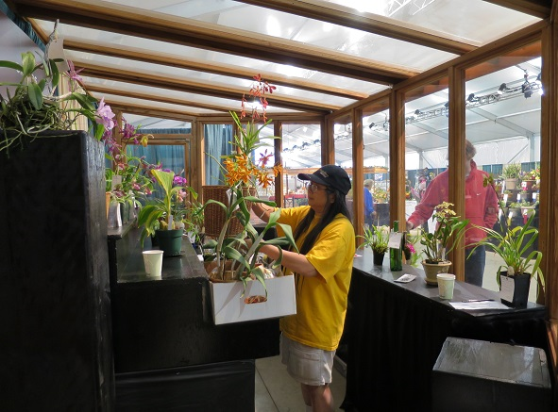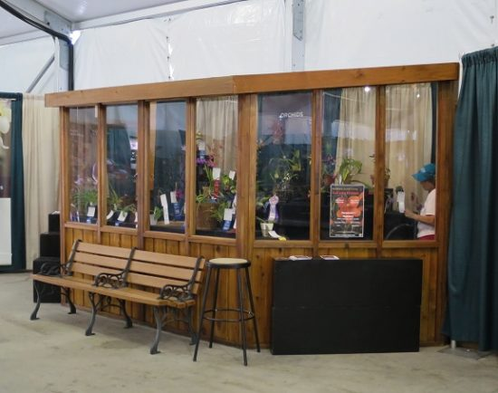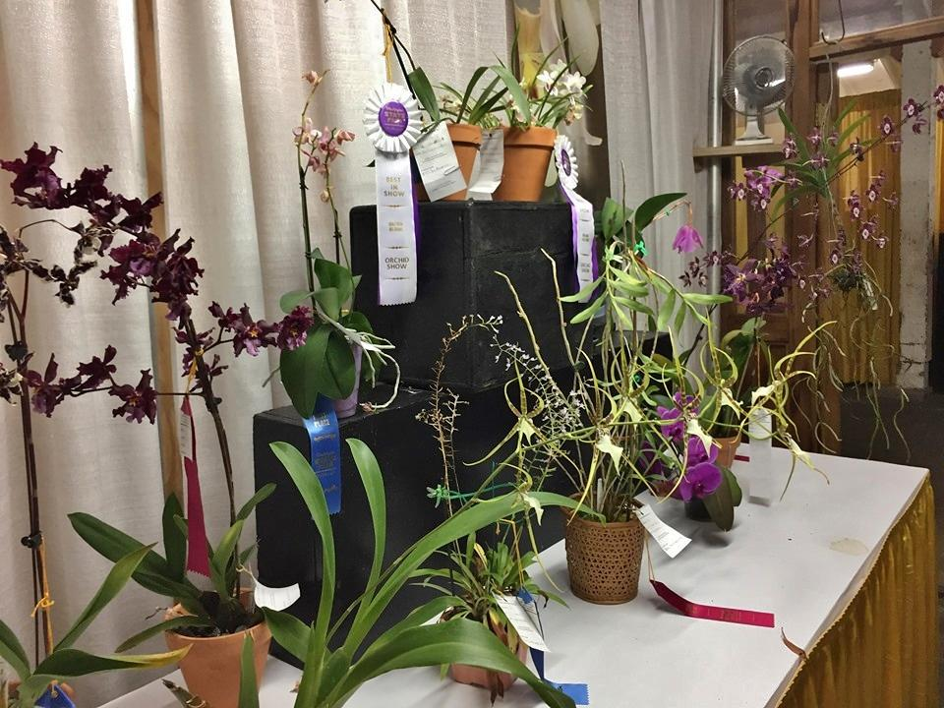Abby Setting Up Display Display Area Back Table Display
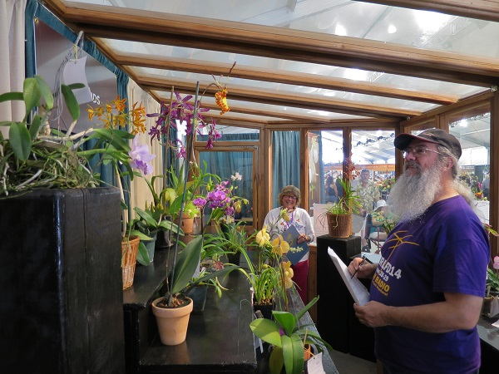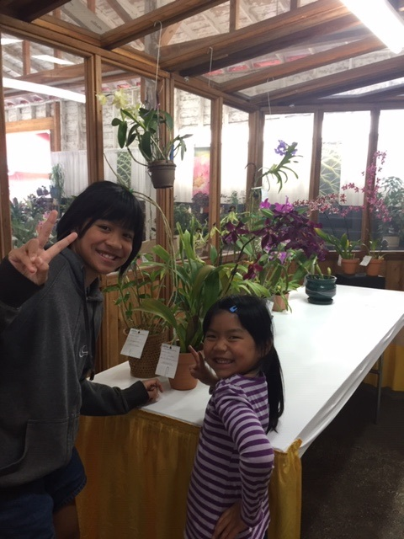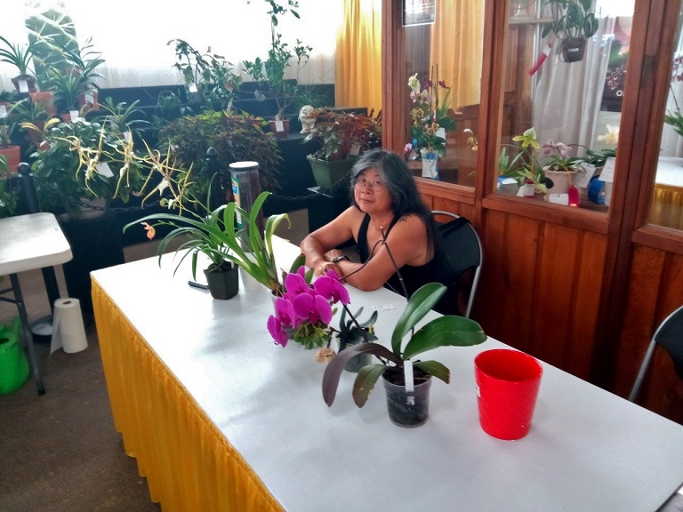
Susy Hunt and Mike Pearson Thuan’s Happy Kids Abby Discussing Orchids
The 2021 Washington State Fair will once again be taking place in Puyallup from September 3rd through the 26th (The Fair will be closed on Tuesdays and also on September 8). The Northwest Orchid Society has been invited to display our orchids in the Floral building (open to ALL, not just NWOS members!). This is an amazing way to introduce people to orchids, possibly take home some cash prizes, and participate in the Fair.
There will be 2 separate orchid shows, with each being judged separately. If you enter plants in the first show you may keep them displayed for the second show, but you will have to get them entered again through the registration process. The orchids are displayed in an enclosed area, and The Fair staff cares for them for the duration of the shows. The public does not have any physical access to the plants.
Cash prizes are awarded in each class for 1st place ($8.00) and 2nd Place ($6.00), with additional awards for Best In Show Orchid Bloom ($10.00) and Best In Show Orchid Culture ($10.00). Just as a side note, there aren’t usually a large number of plants in the show, so the chances of getting a cash prize are pretty good!
You can bring your plants directly to Barn J under Barns and Arenas on the Washington State Fair grounds map. Mobile App
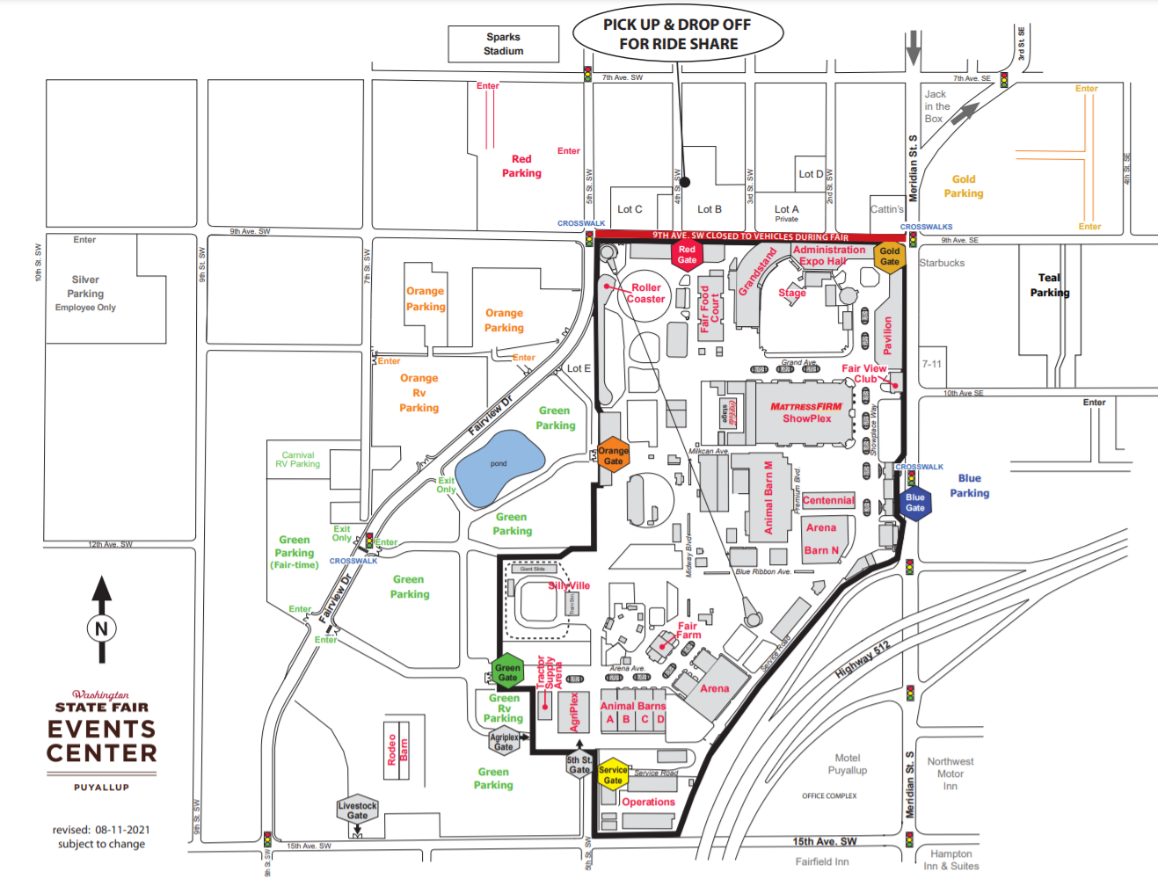
Early dropoff times for orchid plant entries for the 1st Orchid show is Friday, September 3, from 6:00 AM until 8:45 AM. You may also drop plants off on the day of the show judging, Saturday, September 4 from 6:00 AM until 8:45 AM.
Early dropoff times for orchid plant entries for the 2nd Orchid show is Friday, September 17 from 6:00 AM until 8:45 AM. Plants may also be dropped off on the day of the show judging, Saturday, September 18 from 6:00 AM until 8:45 AM.
For your convenience, we have two volunteers who will bring your plants to the Fair this year. Contact Thuan Nguyen or George Grantham. They will be spearheading this again, and will be making arrangements to get your plants to the show and properly entered.
Many thanks to them for once again taking on this task!
Here is the information from the Washington State Fair on Floral entries. There is a calendar on page 2, exhibitor instructions on Page 4, and also some special instructions for registration and entry to the fairgrounds if you want to bring your own plants on the day of the show.
https://www.datocms-assets.com/6258/1627487542-wsf21floralpbook.pdf
Orchid Show classes and prizes are on Page 19 of the Floral Book.
If any NWOS members wish to attend The Fair and volunteer to sit at the exhibit and chat with people about orchids, we are able to get a limited number of Exhibitor and parking passes. Come on out, talk about orchids to fairgoers for a while, and spend the day enjoying The Fair! If you want to attend please let us know the days and times you would like to volunteer, and we’ll find a way to get the passes to you. You may contact us through the main NWOS email account: nwos@nwos.org
Hope to see you and some of your wonderful blooming orchids at The Fair and spend the day enjoying The Fair for FREE!
Mike Pearson

Fall Show and Sale at the Volunteer Park Conservatory
October 2nd and 3rd (setup on the 1st)

If all goes well, we are on our way to holding our first show in two years (yes, the date was October 2019). It will be at the Volunteer Park Conservatory, occupying the Seasonal House and the greenhouse in the back for sales. This year we are also planning on holding AOS judging, so be ready to bring out your best, and wow everyone.

We hope to have all of the vendors who helped us out before, with maybe a little extra surprise. Of course, member sales will be there for those who participate and volunteer.

Now, to pull this off, we need volunteers, volunteers, volunteers. Here's a list of the times and jobs that you can sign up for. Please take a moment and pick a time to come out and support your society. Send an email to the Show Committee (mailto:ShowRegistration@nwos.org) with your preferred date/shift/job

Signups will also be at the picnic and the September meeting. If possible, it would be appreciated if you could bring a writing utensil, to avoid excessive handling of shared pens or pencils.

Date | shift time | job
October 1st (Friday) | 10:00am-6:00pm | Setup
October 2nd (Saturday) | 8:00am  10:00am - 1:00pm  1:00pm - 4:00pm | Ribbon Judging  cashier/greeter/potting clinic/floater  cashier/greeter/potting clinic/floater
October 3rd (Sunday) | 10:00am - 1:00pm  1:00pm - 4:00pm  4:00pm - 6:00pm | cashier/greeter/potting clinic/floater  cashier/greeter/potting clinic/floater  breakdown

- Setup: Set up tables in the Show area, according to the provided layout. Help members, vendors and visiting societies put in their displays. In the sales area, we will be moving greenhouse benches into position, then helping vendors bring in their materials and plants. For the society, there will be the member sales table, books and other NWOS items for sale, instructional materials, and membership applications to be displayed.
- Cashier: Work at cash registers for the Society sales area. Responsible for checking customer plants, entering prices into the cash register, and taking cash, check, or credit card payments. Should be familiar with these tasks, but there will be someone on hand to help train.
- Greeter/Host: Greet visitors as they enter the Show area. Guide them to the displays and sales areas, let them know where they can get information, books, potting materials, and point them to the potting clinic. The seminar schedule will be there, too. Direct them to the sales area in the back greenhouse. Also responsible for light security duty - discourage people from wandering into the display area with sales plants, or from handling the plants.
- Potting Clinic: The potting clinic will be open during all hours of the show, although there may not be much business at times. Repot plants, show visitors the basics, and let them try their hand. Solicit a donation for each plant repotted, as they are used to fund scholarships.
- Floater: help out with the other jobs, as needed. Give volunteers a break. Ask vendors in the Society sales area if they need a break.
- Breakdown: After the show closes, help vendors and societies break down their displays and sales areas, pack their plants and get them to their vehicles. We need to get everything back into the condition we found it on Friday.
- Ribbon Judging: A fun and educational experience. Show your expertise, or just have a good time letting everyone know what you like best about Orchids.

All of this information and more will be available on our webpage at : 2021 Fall Show and Sale

Abigail Chang, Show Committee Co-chair

Holiday Plants

Just a reminder members can be eligible for two holiday plants this year.

Members who attended last year’s Zoom meeting can get a plant, and people who are paid members by the end of the 11/8 meeting can also get a plant by attending the December meeting.

Check with Mike Cory if you have questions about your membership status.

Volunteer Opportunities

There are lots of choices for participating and helping our society utilizing different skills, interests and available time.

--Volunteers are needed for our show in October. Please see the article above for a vast array of choices.

--Our treasurer, Chris, is looking for someone to help out with light duty as a “junior treasurer”.

--Do you enjoy taking photos? We could use someone to take pictures of our monthly meeting plants along with their information forms to identify the plant and the grower.

--We also need people for multiple positions associated with orchid donations and our raffles. You can volunteer for more than one position.
- Respond to offers of donations - usually by email thanking donors and getting contact and plant information. Averages 6-8 times a year. Arrange for a plant pickup volunteer to follow up.
- Several people who can pick up plants and bring them to the next meeting. Perhaps someone for the northside, southside, eastside, etc. Donated plants just need minimal care until the next meeting and don’t need to be commingled with your collection.
- Manage the raffle at the meeting by calling out the winners.

2021 Summer Picnic
This year's Summer picnic was a lovely first for our group. A first because it was the first time we met in person since February of 2020.
Hosted by NWOS president, Joe Grienauer, we gathered in several areas outside. It included a tent in the side yard and tables and chairs in the backyard. Our sumptuous potluck fare was laid out inside in the kitchen. There was plenty for everyone, with a wonderful choice of dishes, both sweet and savory. There was even some homemade brew.
Luckily the warm weather was nice and not too hot. Members mingled around getting reacquainted and sharing stories of our time apart.
There were plants for sale from Yoshi. But there were also a lot of lovely orchids donated so that others could take one or two to try their hand at growing them. A special thanks to Joff for his extreme generosity. Joff also brought quite a few cymbidiums donated from the Woodland Park Zoo collection to share with us. I hope he found a home for those really big ones!
Several new members joined us, and it was nice getting to know them. So, all in all, it was a very nice afternoon spent reconnecting friends and fellow orchid lovers.
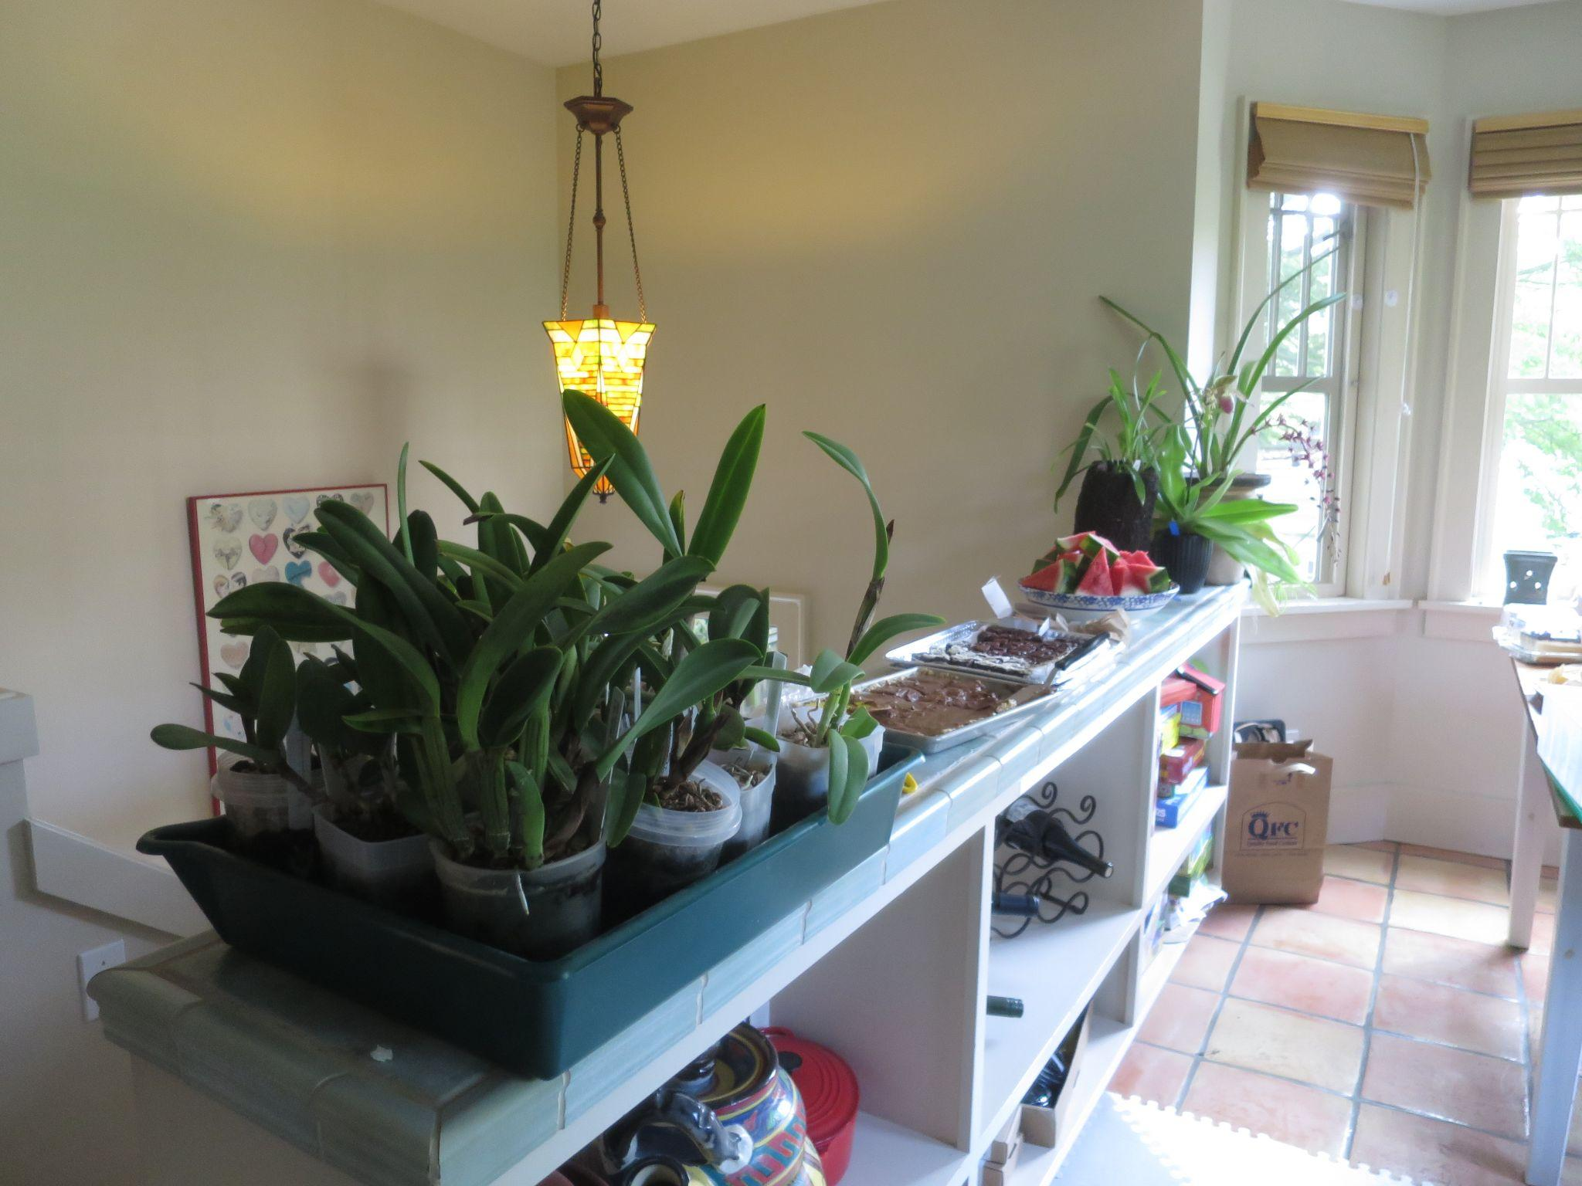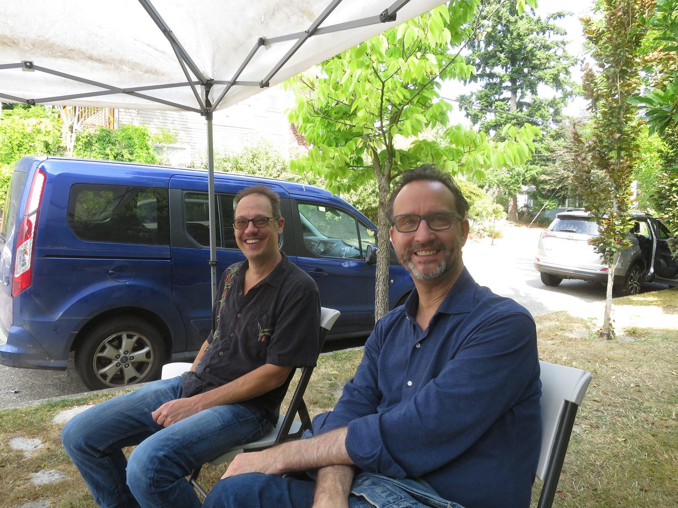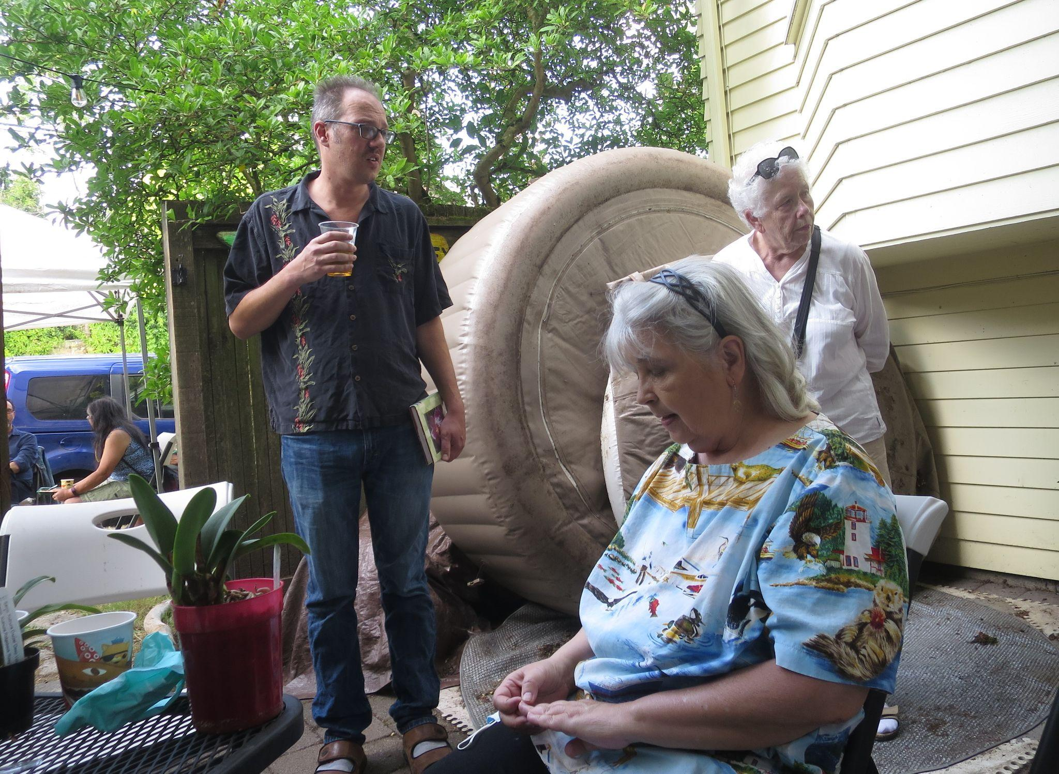Free Plants and Dessert Joe and Robert Joe, Deb and Kathy
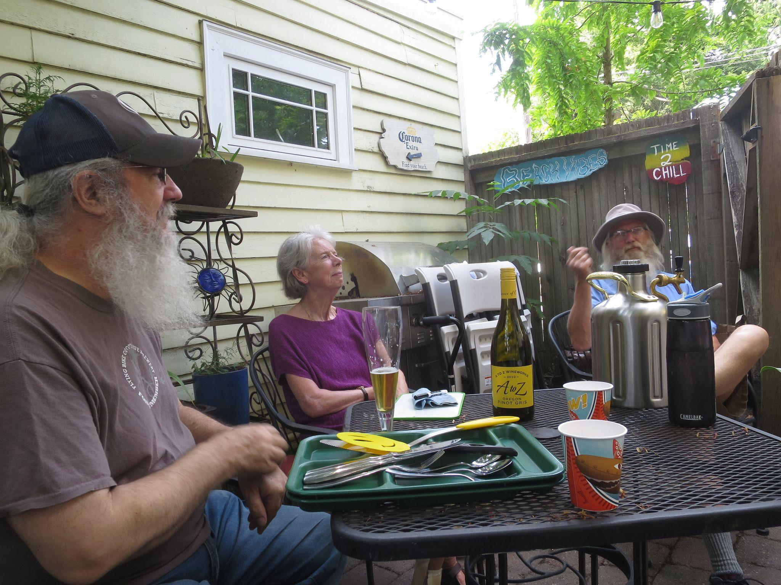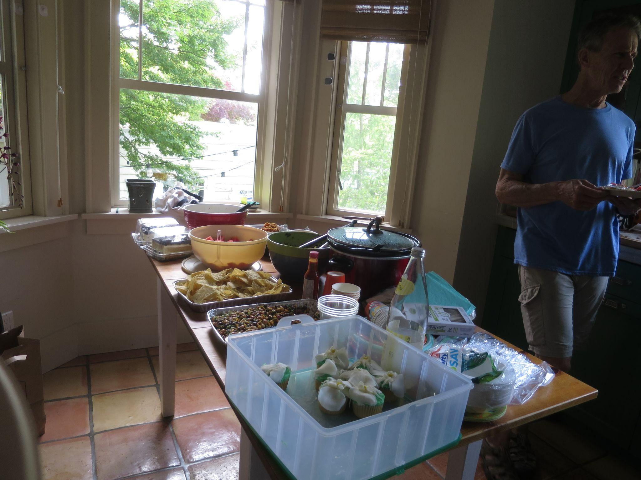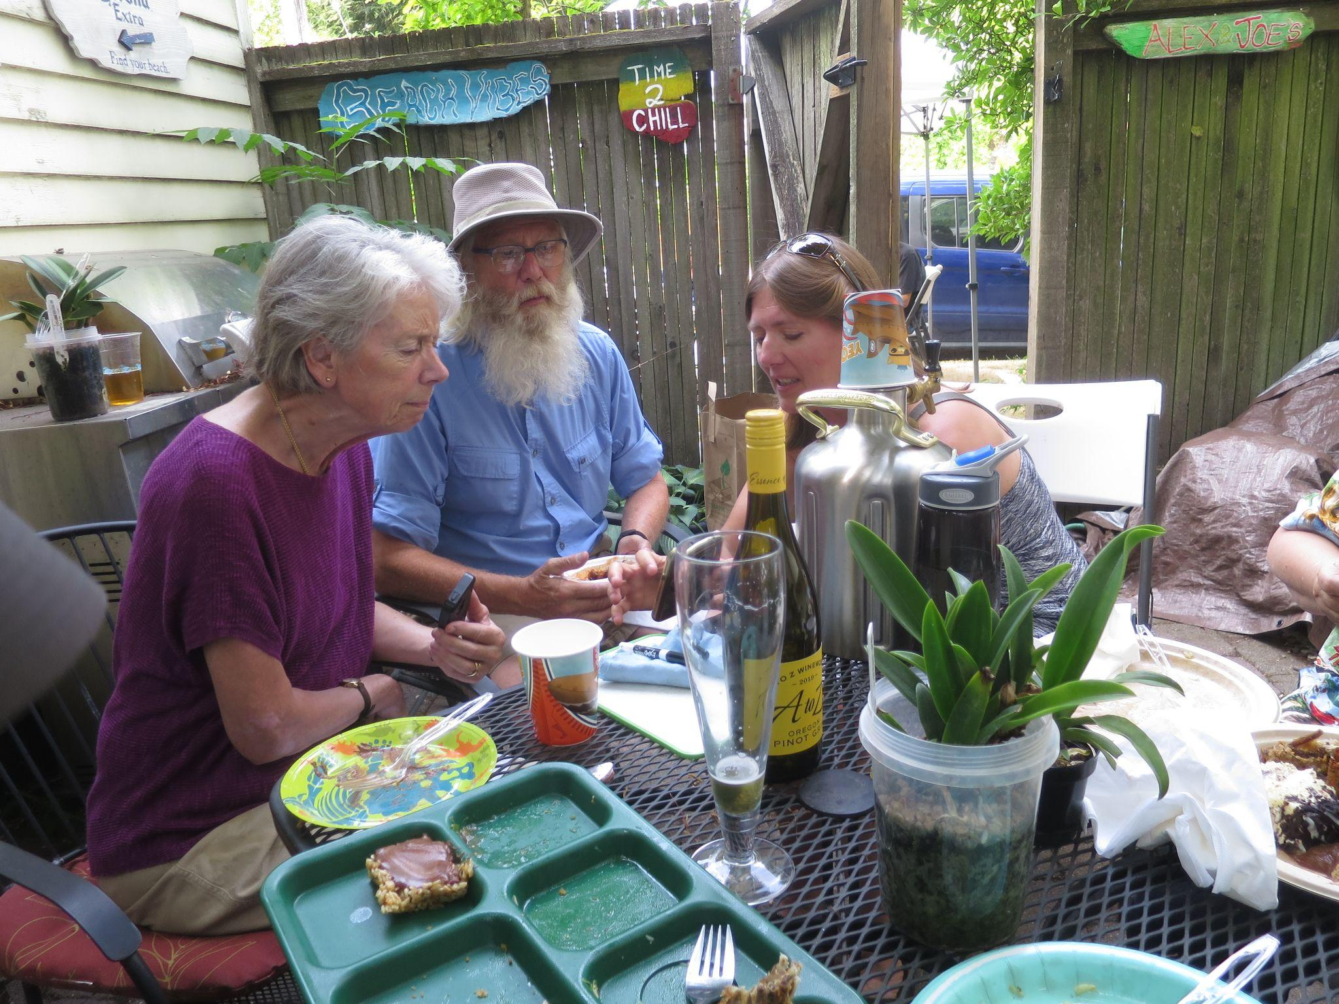
Mike, Kelley and Peter Potluck Spread Kelley, Peter and Lori
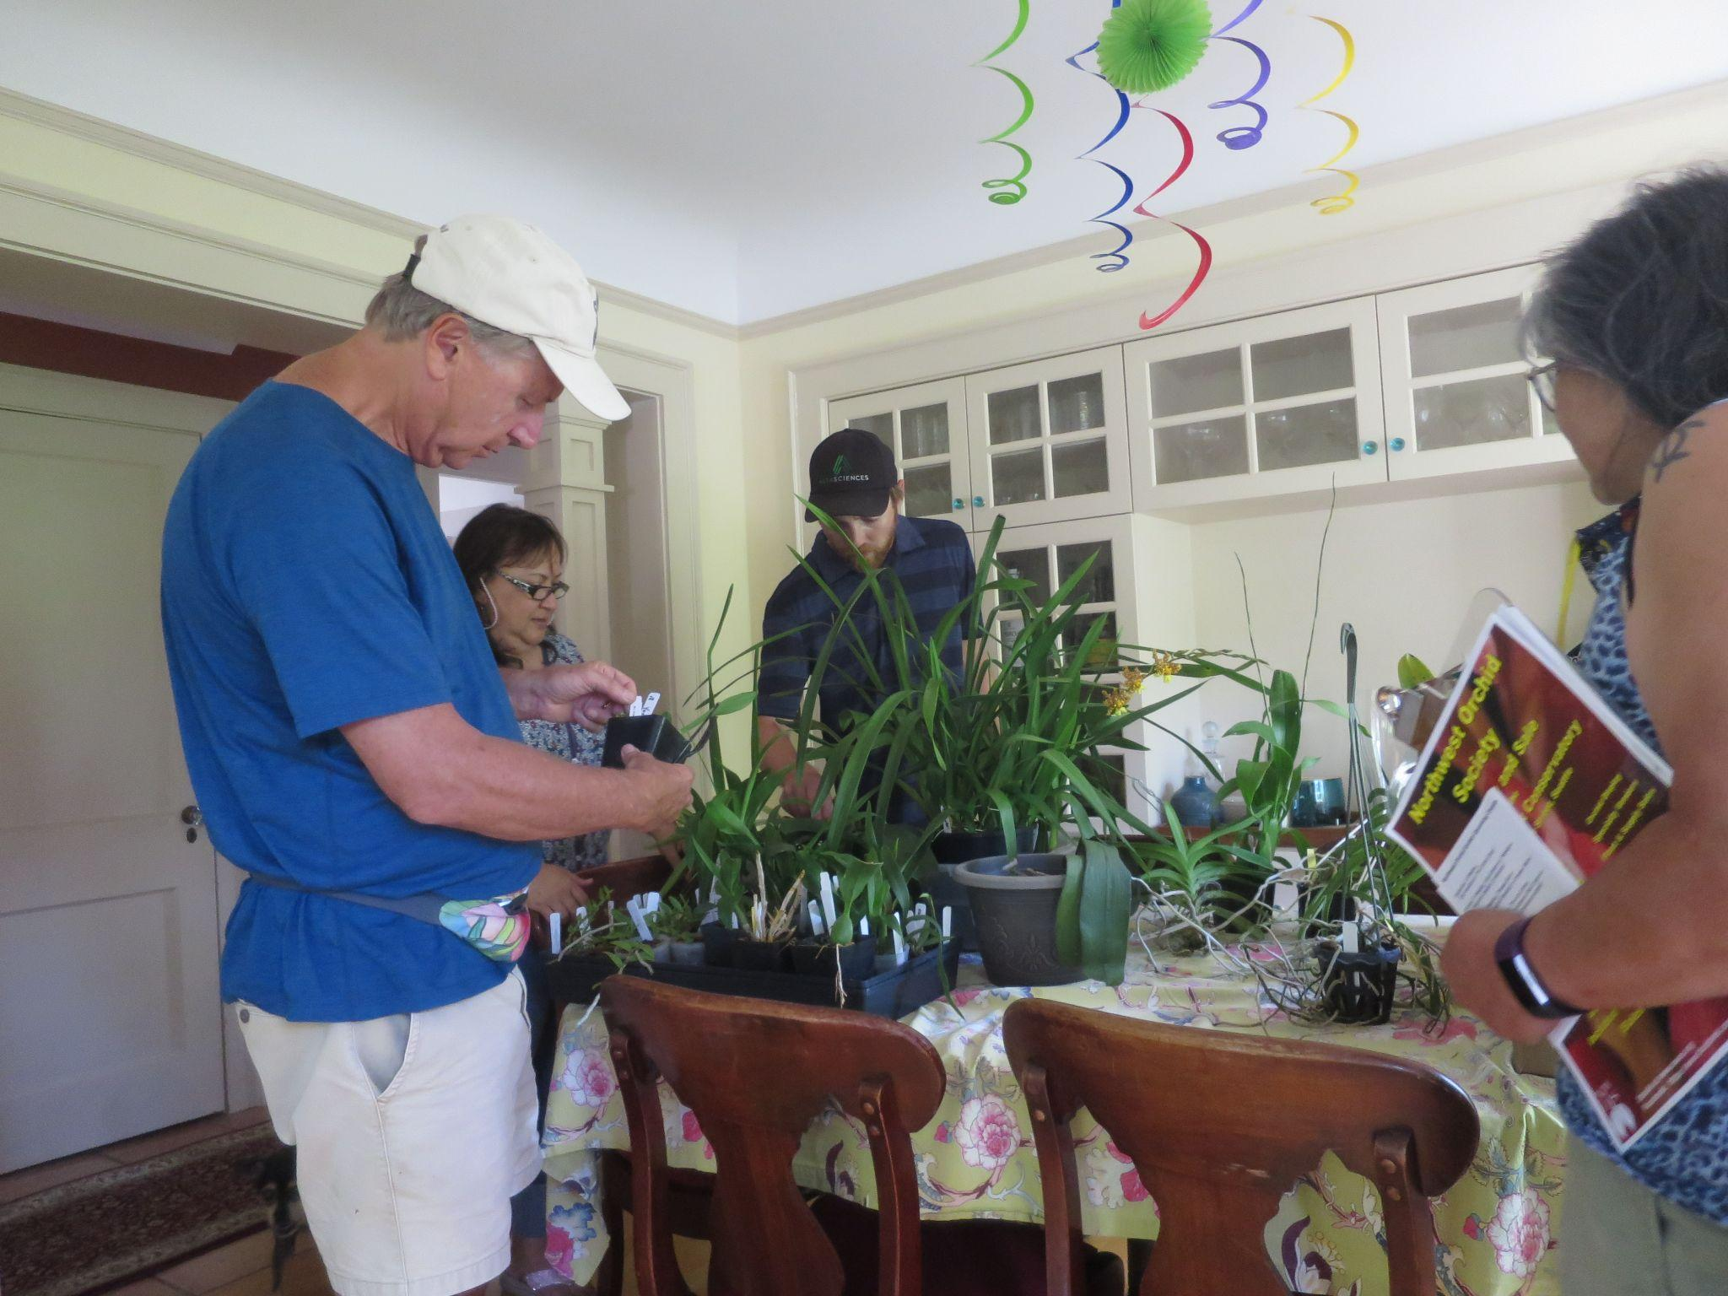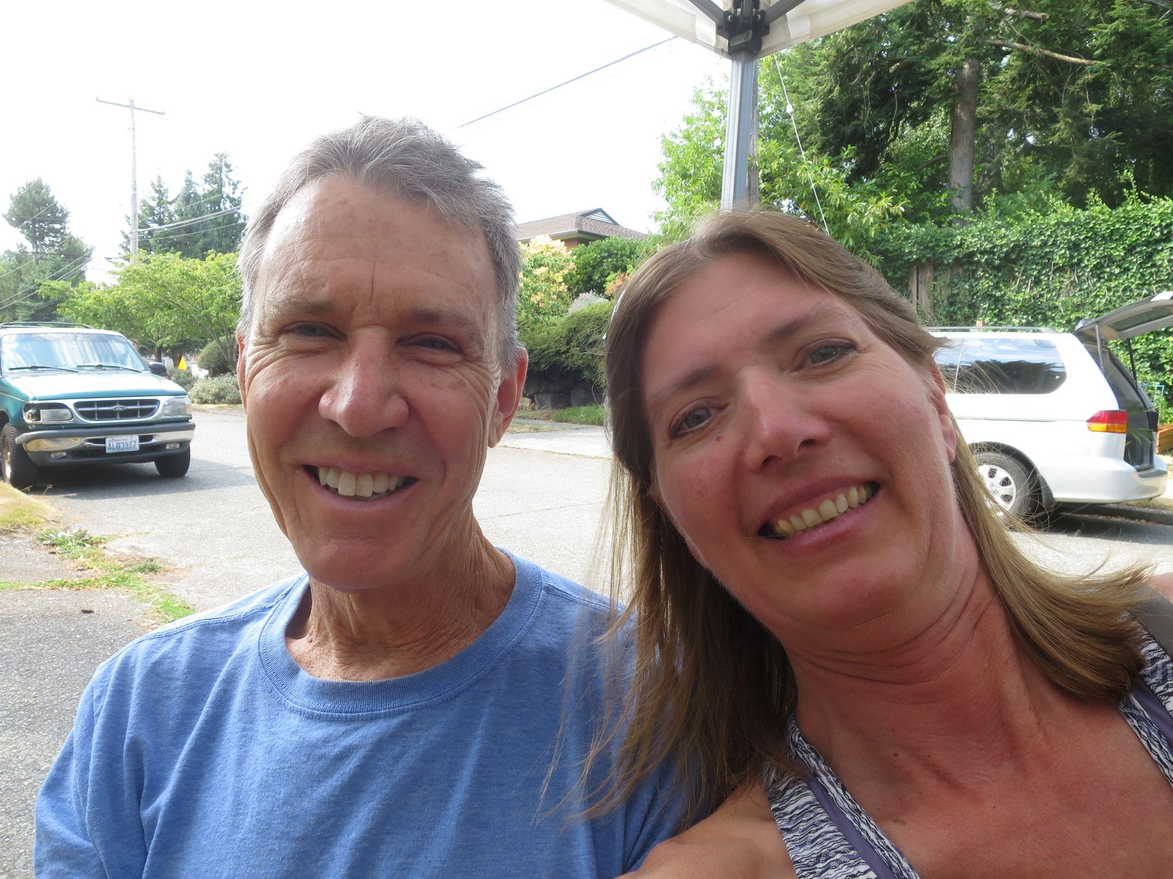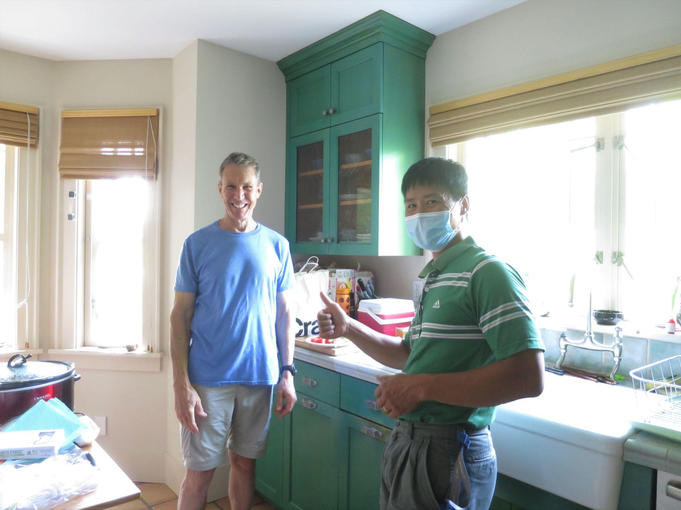
Plants for Sale and Free Steve and Lori Steve and Thuan
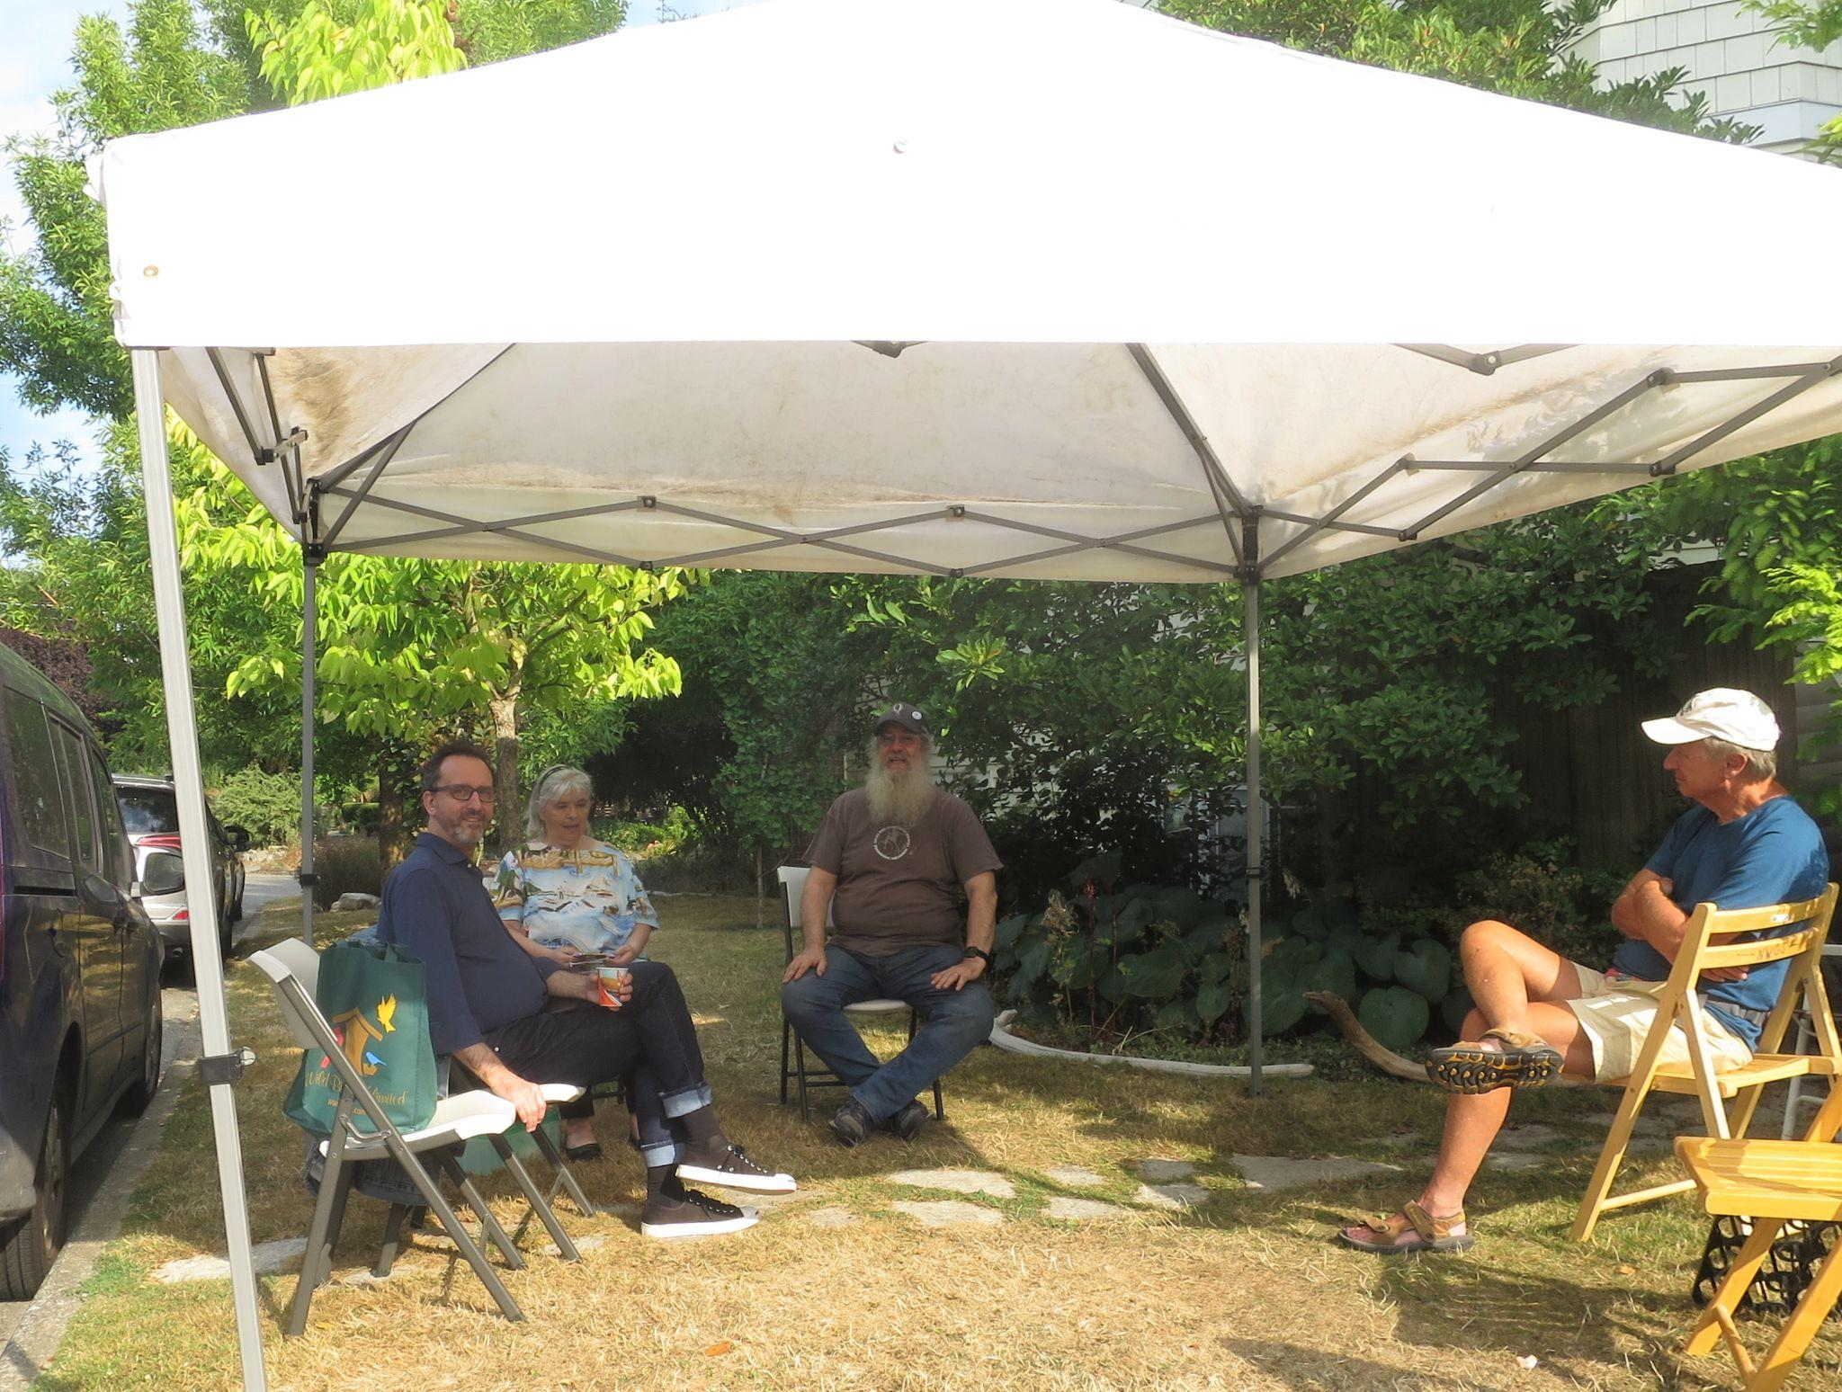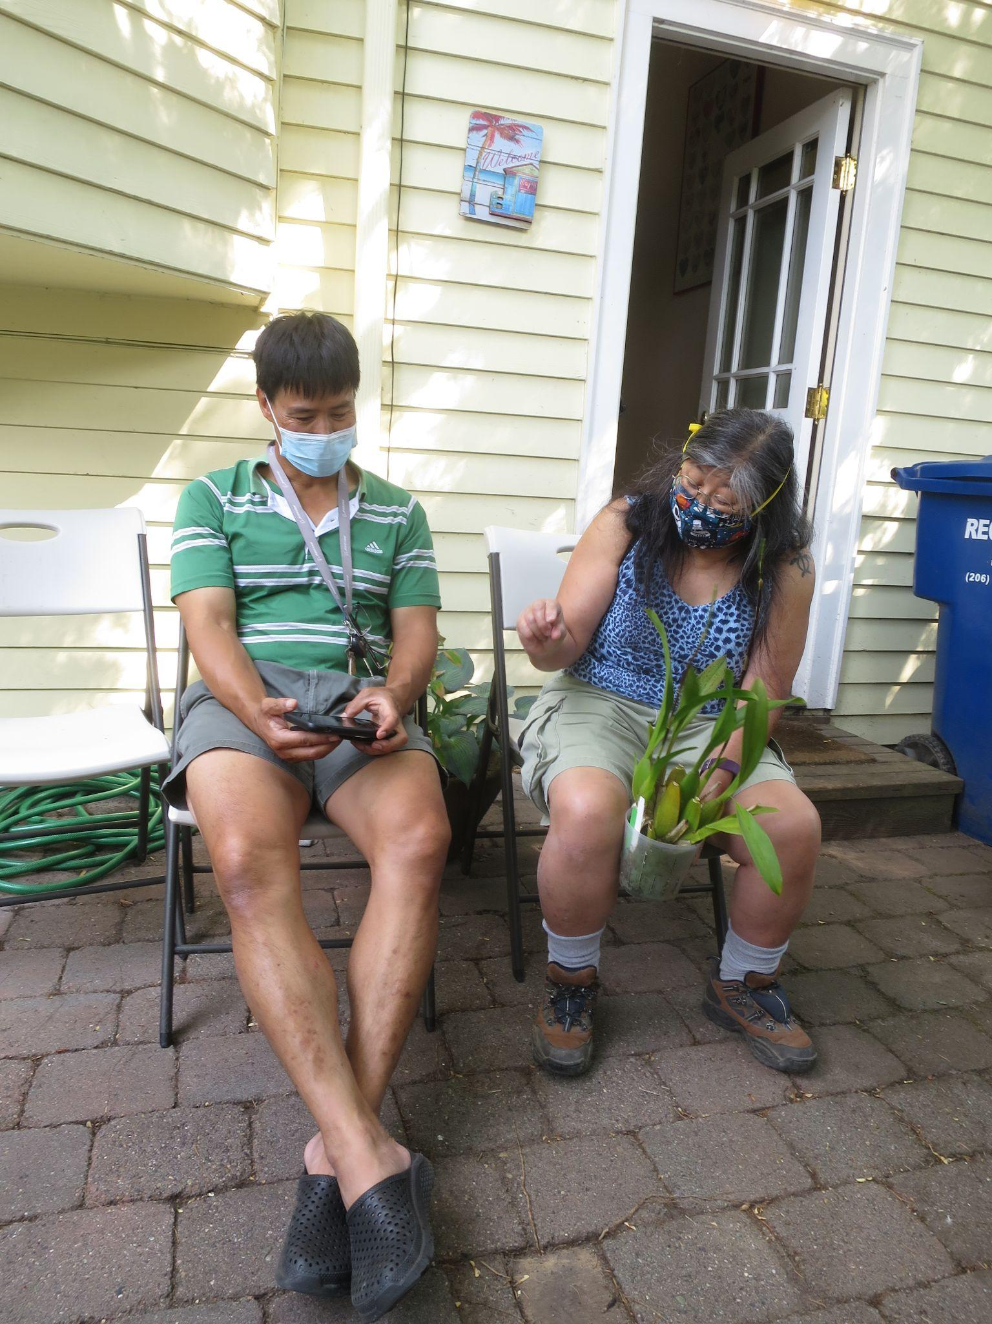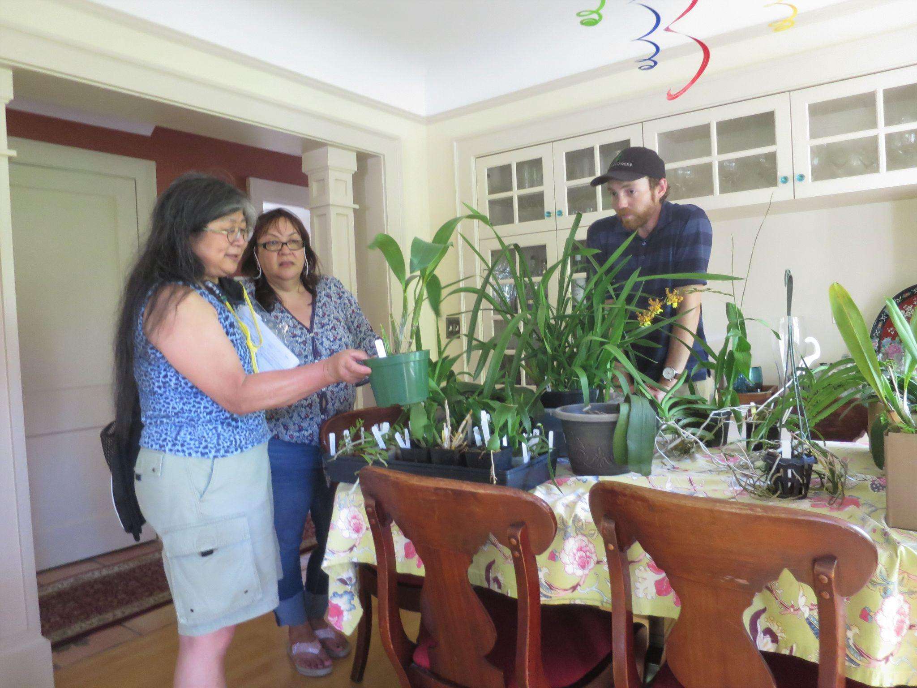
Under the Big Top Thuan and Abby Which One to Buy

Spider Mite Control

They are ubiquitous. They float on air currents and move readily between all kinds of plants including orchids. Sometimes we are tipped off to their presence by webs. Other times we see damage on leaves.

We call them spider mites but those found on our orchids may well be other mite genera. They breed prolifically in warm weather and low humidity. They are also tiny, some as small as one fiftieth of an inch.

Our veteran orchid grower and member Kathy Murray has written another one of her excellent articles, this time focusing on Spider Mites. To read the entire article and learn more about their lives and how to control them, visit: https://nwos.org/spider-mite-control/

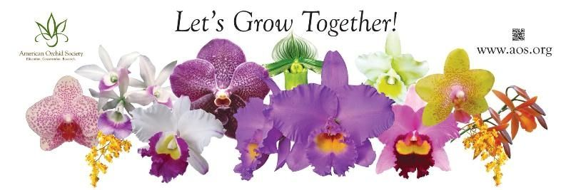
News From The American Orchid Society

The American Orchid Society has recently introduced a marketplace, called ‘Orchid Marketplace™’. There are numerous orchid vendors and orchid supply vendors listed in the marketplace. Our own Ellen Covey has already listed Olympic Orchids there.

Report From The June Meeting
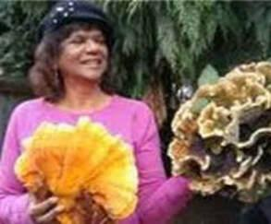
The speaker for the June meeting was our own member Dr. Jairul Rahaman. She spoke about the symbiotic relationship between fungi and orchids. She took us on a trip from her native Guyana where she discovered and grew to love orchids to her interest in fungi and her interest in how fungi interact with the natural world and they are responsible for nurture of our own favorite plants.

For June we still had a virtual plant table, these are a selection of the selected images from the June meeting. Please follow the above link to go to the online gallery.
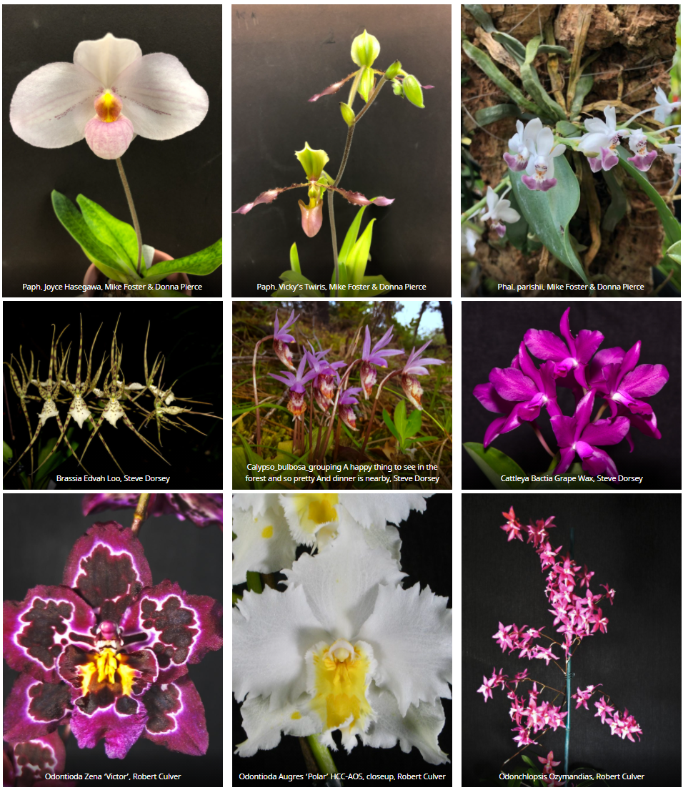

Schedule of Upcoming Events

09/13/21 – NWOS meeting – Speaker: Bob Hamilton, “The Orchid Craze”

10/2&3/21 - NWOS Fall Show and Sale at Volunteer Park Conservatory: 2021 Fall Show

10/11/21 – NWOS meeting – Speaker: Andy Easton, tentatively “Warmth-tolerant Miniature and Intermediate Cymbidiums”

11/08/21 – NWOS meeting – Speaker: Theresa Hill, “Complex Paphiopedilum Breeding”

12/13/21 – NWOS meeting – Speaker: David Edgley, “Novelty Phalaenopsis Breeding”, Scholarship Recipient Report, Holiday Potluck, Introduction of new Officers, NWOS Annual Meeting report, Schoenfeld and Northen Orchid Awards, and Holiday Plant gifts.

Reminder for Officers & Board Members

The schedule for the remaining board meetings for this membership year is: 9/7/21, 11/2/21. The 9/7/21 board meeting will be held via zoom. The board meetings will tentatively be held in person again starting with the November meeting. Meet at 7 p.m. at Mike & Sheila Cory's house unless notified that it's been moved elsewhere.

Shopping on Amazon? Use this link to earn $$ for the NWOS

If you go to https://smile.amazon.com and sign in to your account, you'll be given information about supporting various non-profits. You can type in "Northwest Orchid Society" and it will then send .5% of your purchase price to the organization.

It's really easy, but you have to remember to go in through the 'smile' subdomain when you place the order, otherwise it will go through as a regular order.

NWOS Website Links

- Main website: Http://www.nwos.org
- Events Calendar: http://www.nwos.org/events
- Membership (including renewals): https://nwos.org/Membership/
- Newsletter - Current Issues: https://nwos.org/newsletters/
- Newsletter - Archived Issues: http://newsletter.nwos.org
- Show Information: http://nwos.orchid-society.net/ShowTime/Show2021/Show.html
- Facebook: http://www.facebook.com/nworchidsociety
- Instagram: https://www.instagram.com/nworchidsociety/
- Twitter: https://twitter.com/nworchidsociety

Special Announcements

No Special Announcements this month.

Special Announcements can be deleted if none exist.- dd

©2021 Northwest Orchid Society - All Rights Reserved

The opinions and recommendations published herein are those of the authors. The Northwest Orchid Society disclaims responsibility for any losses or damages that may be attributed to the use or misuse of any material or any opinion published in these articles and on the website. This website and the photographs, articles and content are protected by copyright and no part of them may be reproduced or re-used without the permission of the author.

