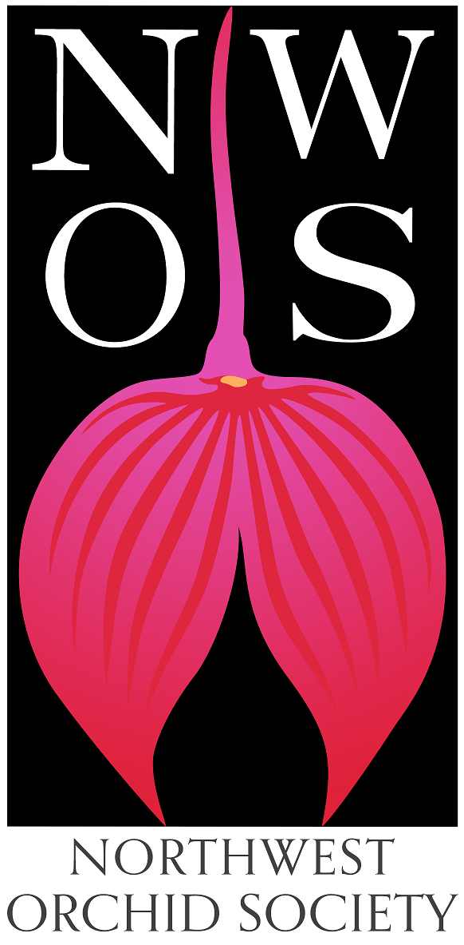
Northwest
Orchid News
September 2023
Volume 76, Issues 7

- About the September Meeting
- Speaker: Kelly McCracken, “Fragrant Miniatures”
- Plant Table
- Sales Table
- Raffle Table
- NWOS Library
- Volunteers Needed For The Nominating Committee
- 2023 NWOS Show and Sale at Volunteer Park Conservatory
- 2024 NWOS Indoor Plant Festival
- 2024 NW Flower & Garden Festival
- Report From the August Picnic
- Membership System
- The Orchid Mart
- Local Judging
- Schedule of Upcoming Events
- Reminder for Officers & Board Members
- NWOS Website Links

About the September Meeting
September 11, 2023 6:30 PM
University of Washington Center for Urban Horticulture
3501 NE 41st Street, Seattle, WA 98105
Hybrid Meeting, In person and via Zoom Zoom Registration

Speaker: Kelly McCracken, “Fragrant Miniatures”
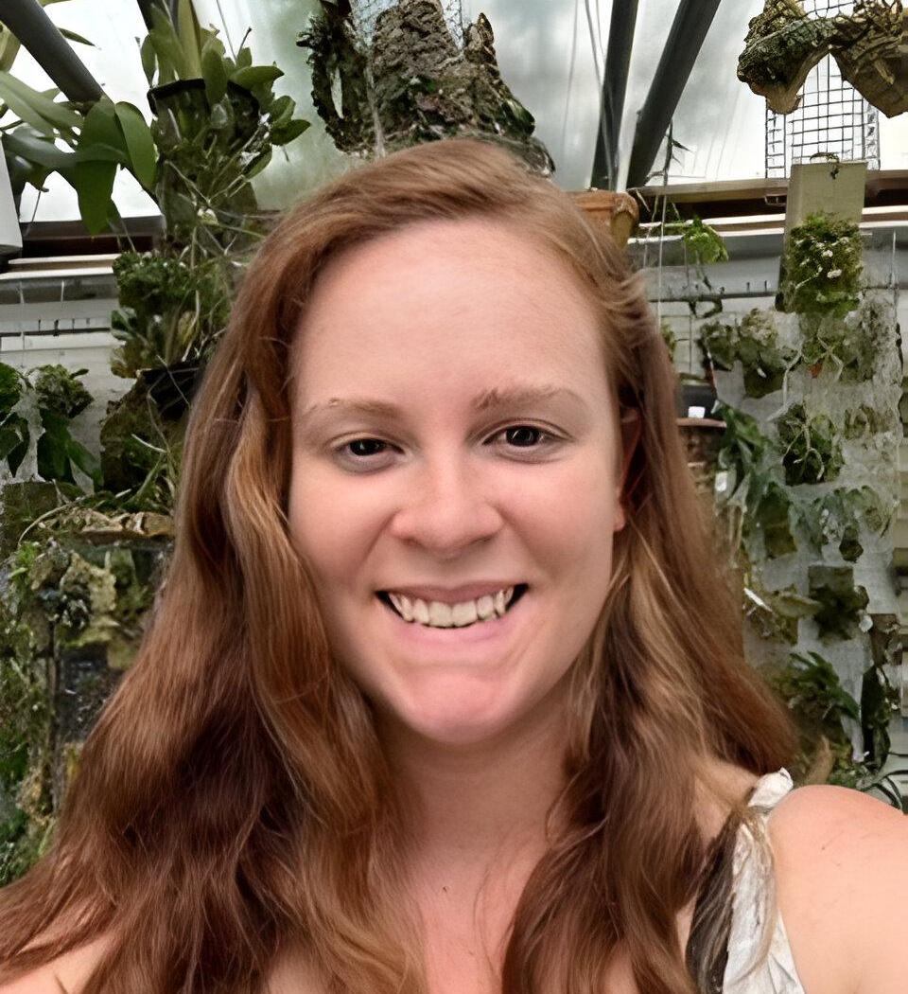
Kelly McCracken is an avid orchid hobbyist and breeder. She enjoys growing miniature specimen plants with a particular affection for Dendrobium, Angraecoids, and Sophronitis. She is currently working as US representative of Tropical Exotique, a Thailand based orchid company.

Kelly’s topic is “Fragrant Miniatures”, The most common question she gets asked about plants is “is it fragrant?” Many orchid growers select their plants based on whether the plant is fragrant. For those of you who grow in limited space, but still love a nose full of floral fragrance, this is the talk for you. Kelly will go over several dozen fragrant species that will stay small (6” and smaller) and their culture. She will also describe their unique fragrances.

Plant Table

We will be having an in-person plant table this month. For your convenience, you can print out a Plant Table Information Form ahead of time. Click for your version of choice: PDF or DOCX file?

For those who aren’t able to attend in person, please do keep sending your pictures, we will be including them in our online gallery and in next month’s newsletter. Please send them to photos@nwos.org.

Sales Table

Members may bring up to 10 plants to sell. Include an extra tag with your name and the price in the plant.

Raffle Table

The raffle will be held as usual. Win a new orchid for your collection while supporting the Scholarship Fund. If you have any extra Orchids, please consider donating them to the raffle.

NWOS Library

If you'd like to check out a book or tape from our Library, please contact our Librarian Joe Grienauer a minimum of 2 weeks before the next meeting. Besides email, you can give Joe your request at any meeting. For a list of library items please click here NWOS Library.

Volunteers Needed For The Nominating Committee
It’s the time of the year for nominating new officers and board members. We need two volunteers from our membership to be on a Nominating Committee with one board member. Thanks to the two members that will volunteer for this position.

Please send your interest in participating to Robert Culver.

2023 NWOS Show and Sale at Volunteer Park Conservatory
Oct 7-8 with setup on Friday Oct. 1st

This year’s Show Chairperson is Ben Johnson. He will be presenting information about our upcoming Show and Sale at our Sept.11th meeting. He’ll also have sign-up sheets so that we can volunteer for a variety of shifts and positions.

The Setup date for the show is Friday Oct. 6th. The dates of our show are Saturday Oct. 7th - Sunday Oct. 8th.

We need your plants, well groomed and ready for display.

For more information regarding the fall show please visit the Fall Show Page.

This has always been a fun activity for our whole society. You can participate in many ways. Help create the displays, be a greeter during the show, help out in the sales area, the potting table, and many other activities that make our show a success. There’s something for everyone.

If you have questions, contact Ben at showchair@nwos.org

2024 NWOS Indoor Plant Festival

The Indoor Plant Festival continues to attract new vendors and excitement from plant club in the region. Ben Johnson is the Chairperson for the working group.

The Setup date for the festival is Friday March the 1st. The dates for the show are Satruday March 2nd - Sunday March 3rd.

Ben will be providing you more information. There will be a preview night, the night of the 1st. We currently have thirteen (13) vendors and seven (7) societies participating at the festival.
This is going to be a great event, as far as we can tell this is the only event focusing on indoor plants geared towards plant enthusiast in North America
For more information please visit the Indoor Plant Festival Page.

If you have questions, contact Ben at showchair@nwos.org

2024 NW Flower & Garden Festival

The NWOS will again be putting in a display at the 2024 NW Flower & Garden Festival. This year the NWOS is partnering with Emerald City Orchids for the display.

Nora Hightower has volunteered to be the Coordination Chair for the NWOS this year. She will be collecting the names of the voluneeteers and scheduling them for their shifts.

Nora will have signup sheets over the next few meetings to collect volunteers.

If you have questions you may contact Nora at norateamhightower@gmail.com

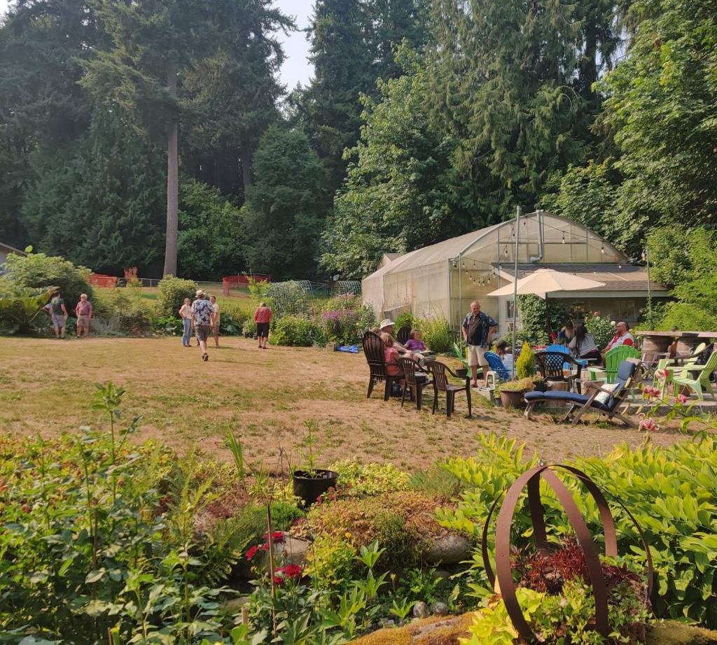
Report From The August Picnic

The August member's picnic was held on Saturday, August 6th at the home of Andy Wright.
Andy and his family set a lovely table for their guests. There was a wide array of mains, sides, desserts, and beverages. There were about twenty people that attended the picnic, including members and their families.
Along with having time to leisurely socialize in this lovely setting it was a wonderful treat to be able to talk with Andy about the plants in his greenhouse. There were orchids and nepenthes everywhere you looked. It was truly a site to behold.
A number of members brought plants to give away, these were in the potting area of Andy’s greenhouse, we are glad these went to new homes. Unfortunately, there was a misunderstanding and a few plants went missing from Andy’s greenhouse, these were not for members to take home. Please see Andy and he will provide you with invoices for these plants.
See the gallery on the NWOS Website.

Membership System

The membership system is online. Memberships will be managed through our new system. The biggest change between the old and new system is your membership will run from year to year from when you sign up rather than from January to December. You will be alerted via email when your membership is about to expire.

The Orchid Mart

As a new service for our members, the NWOS has introduced ‘The Orchid Mart’. This is a free listing service for any member to post items for sale, trade, or rehoming.

While only members can submit items for free, anyone can browse. The NWOS does not manage sales, these will be managed by each member.

The submission does not allow for complex listings. If you are a non-member or are a member that would like to have a complex listing those can be built, but there will be a fee.

To access the site, it is directly under the Home section of the NWOS page.

The Orchid Mart
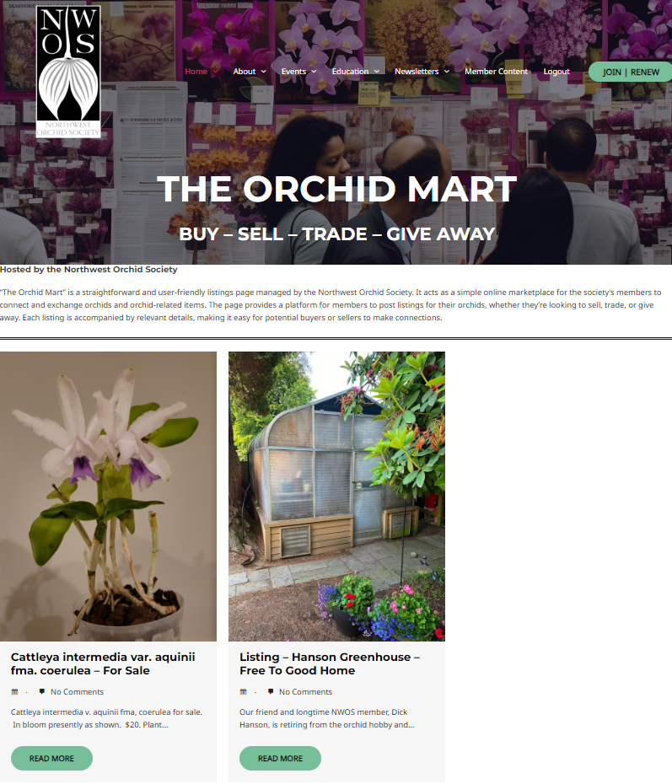

Local Judging

Adapted from William Jansen of the PNW Regional Judging Center.
Please come join us a future Monthly PNWJC judging Sunday (see dates below). We are also looking for societies to have fall shows, but no shows are currently scheduled for the remainder of 2023.
- September 3, 2023 Monthly AOS Judging 1 PM at Keizer Community Center.
- October 1, 2023 Monthly AOS Judging 1 PM at Keizer Community Center.
- October 7, 2023 Show Judging 10 AM at Volunteer Park Conservatory.
- November 5, 2023 Monthly AOS Judging 1 PM at Keizer Community Center.
- December 3, 2023 Monthly AOS Judging 1 PM at Keizer Community Center.
Sunday June 4, 2023 Monthly AOS Judging
Monthly judging June 4, 2023 continued with five (5) great and unusual plants displayed and all were reviewed for judging. There were two (2) awards granted; a CCE/AOS to a stupendous Masdevallia with over 100 flowers and a CBR/AOS award which is provisional pending confirmation by the Species Identification Task Force (SITF). One plant Epidendrum sophronitoides could not be judged because the species was not correct. We had eight (8) judges comprising two (2) judging team.
Photos copyright Ross Leach
- Masdevallia notosiberica ‘Cosmos’ CCE/AOS 91 points, exhibited by Terry Thompson.
- Maxillaria funicaulis CBR/AOS, provisional upon taxonomic verification by SITF, exhibited by William G Jasen.
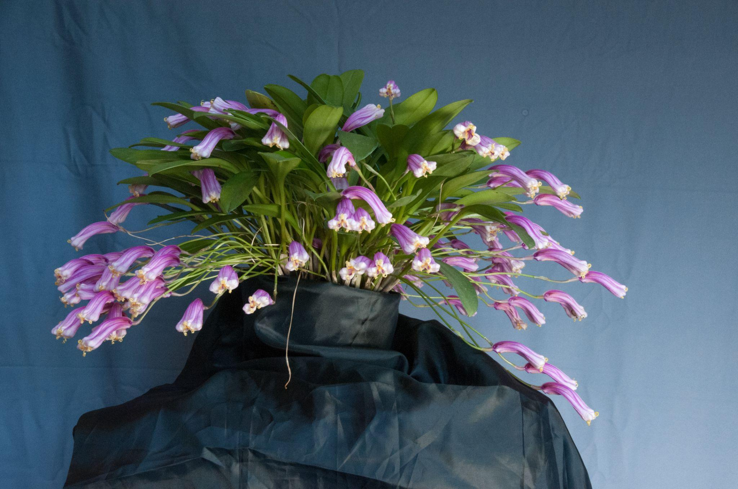
Masdevallia notosiberica ‘Cosmos’ CCE/AOS

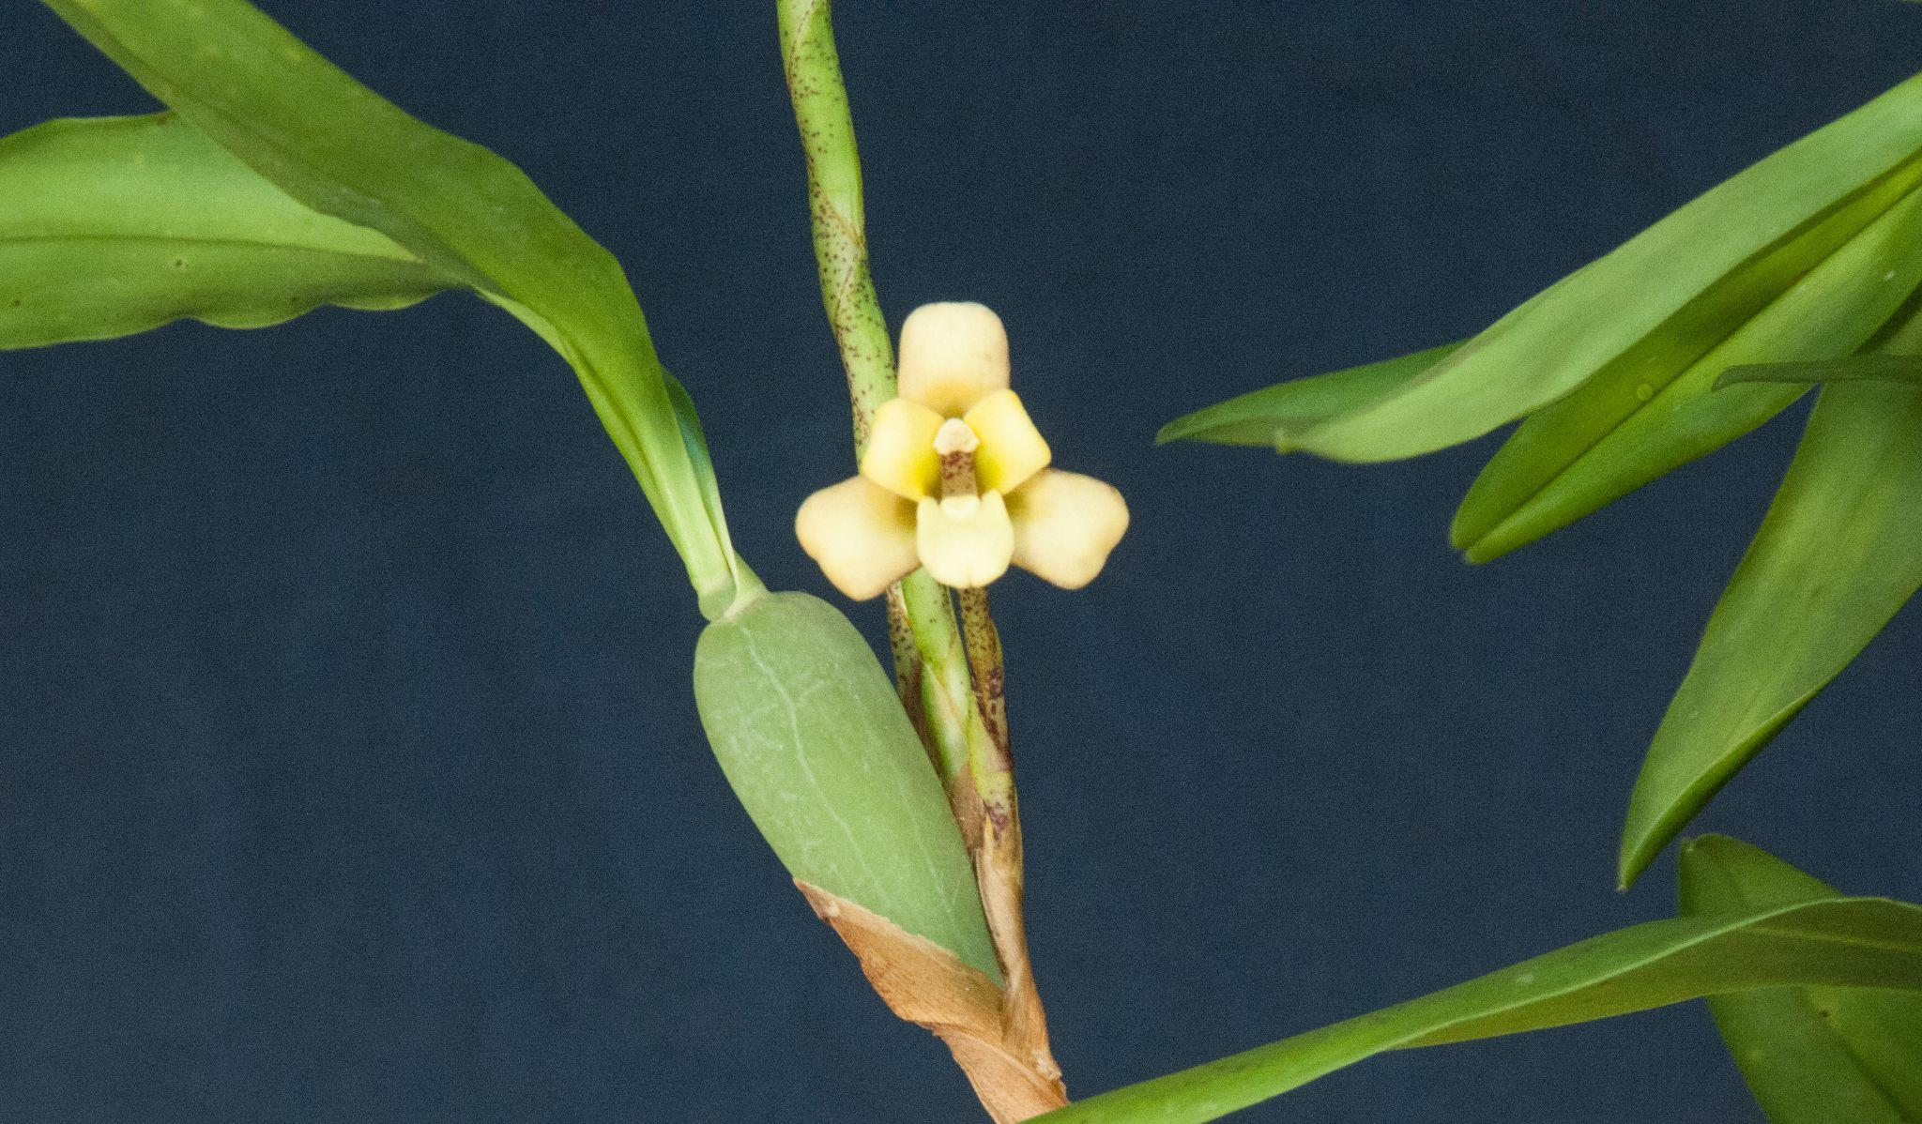
Maxillaria funicaulis CBR/AOS
Sunday July 2, 2023 Monthly AOS Judging Summary
Monthly judging July 2, 2023 continued with eight (8) cool, great and unusual plants displayed and all were reviewed for judging. There were two (2) awards granted; a CHM/AOS to a first bloom seedling for a new Paphiopedilum canhii species; the award is provisional pending confirmation by the Species Identification Task Force (SITF) which has already been confirmed and a HCC/AOS for a cool white Paphiopedilum Nathaniel’s Clarity. One plant Epidendrum oxapamense (purchased as sophronitoides from Peru) could not be judged because a traveling slug had done its damage to the flower. We had nine (9) judges comprising two (2) judging teams.
- Paphiopedilum canhii ‘Beaumont’ CHM/AOS 86 points, exhibited by Chad Lees.
- Paphiopedilum Nathaniel’s Clarity ‘My Pride’ HCC/AOS, exhibited by Janiel Payne.

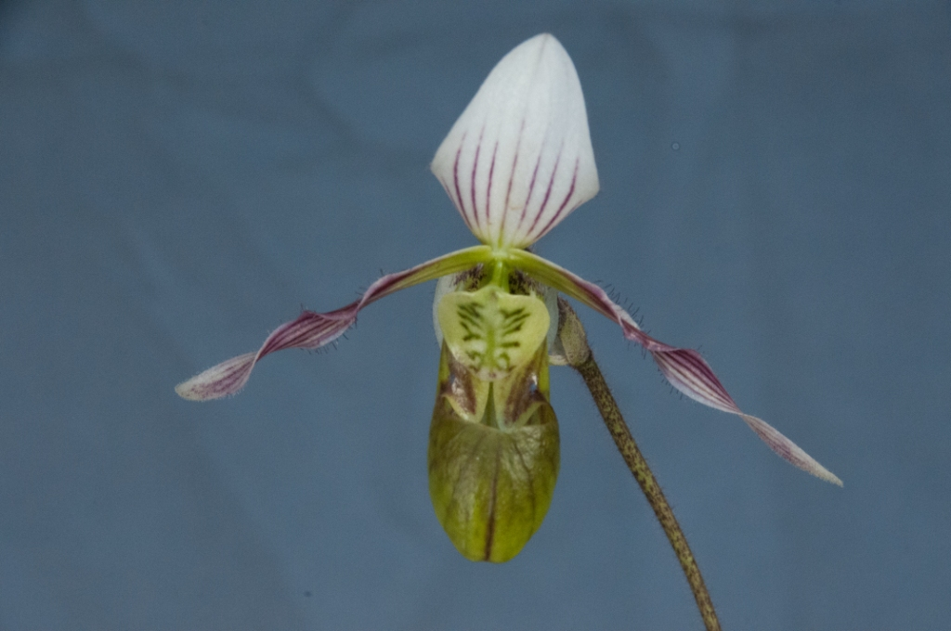
Paphiopedilum canhii ‘Beaumont’ CHM/AOS
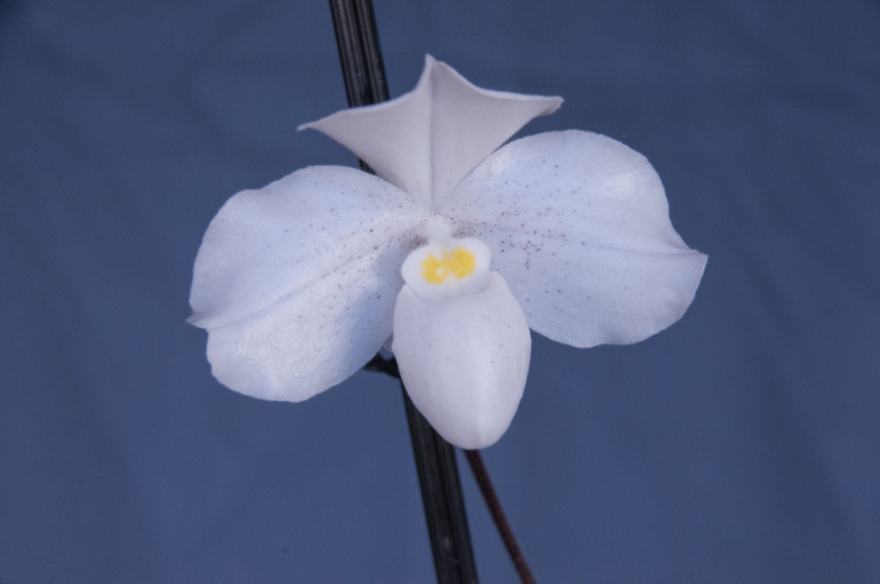
Paphiopedilum Nathaniel’s Clarity ‘My Pride’ HCC/AOS

Sunday August 6, 2023 Monthly AOS Judging Summary
Monthly judging August 6, 2023 had four (4) plants displayed and all were reviewed for judging. There were three (3) awards granted; a CHM/AOS to a seldom cultivated terrestrial Spiranthes; the award is provisional pending confirmation by the Species Identification Task Force (SITF) which has been confirmed. An AM/AOS for a difficult plant to get open flowers to judging as the Sobralia flowers last only 1 day. Another challenging plant to get to judging, a Stanhopea was awarded an HCC/AOS. We had six (6) judges forming one (1) judging team. Ross Leach provided the attached excellent quality photography. The displayed plants and awards are summarized below:

- Stanhopea Elizabeth Grace Jasen ‘Amanda’ HCC/AOS 79 points, exhibited by Gerald N. Swett
- Spiranthes romanzoffiana ‘Old Orchard’ CHM/AOS 86 points, exhibited by Tom Valente.
- Sobralia Nick Rogers ‘Emilia’, AM/AOS 80 points, exhibited by William G Jasen.
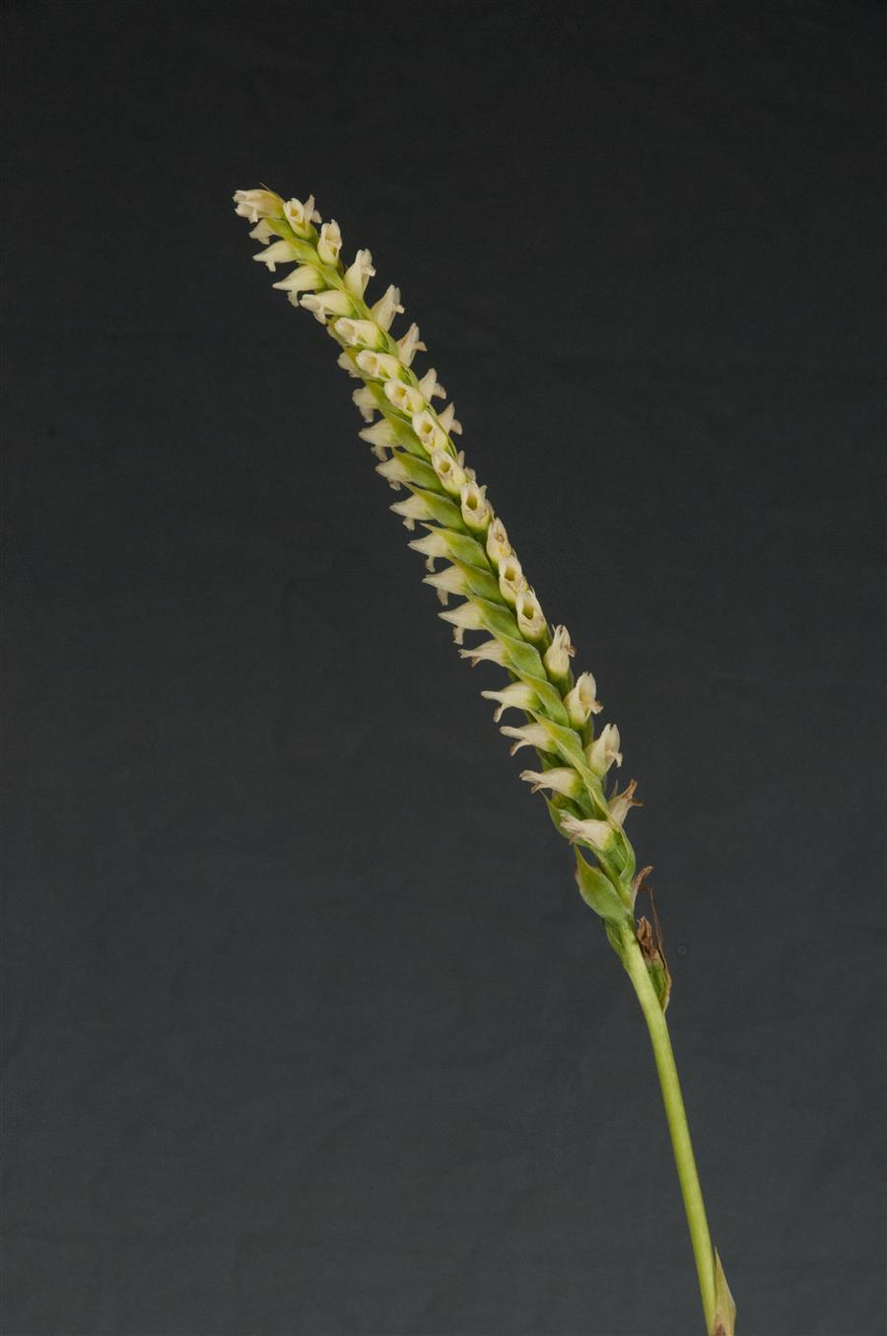
Spiranthes romanzoffiana ‘Old Orchard’
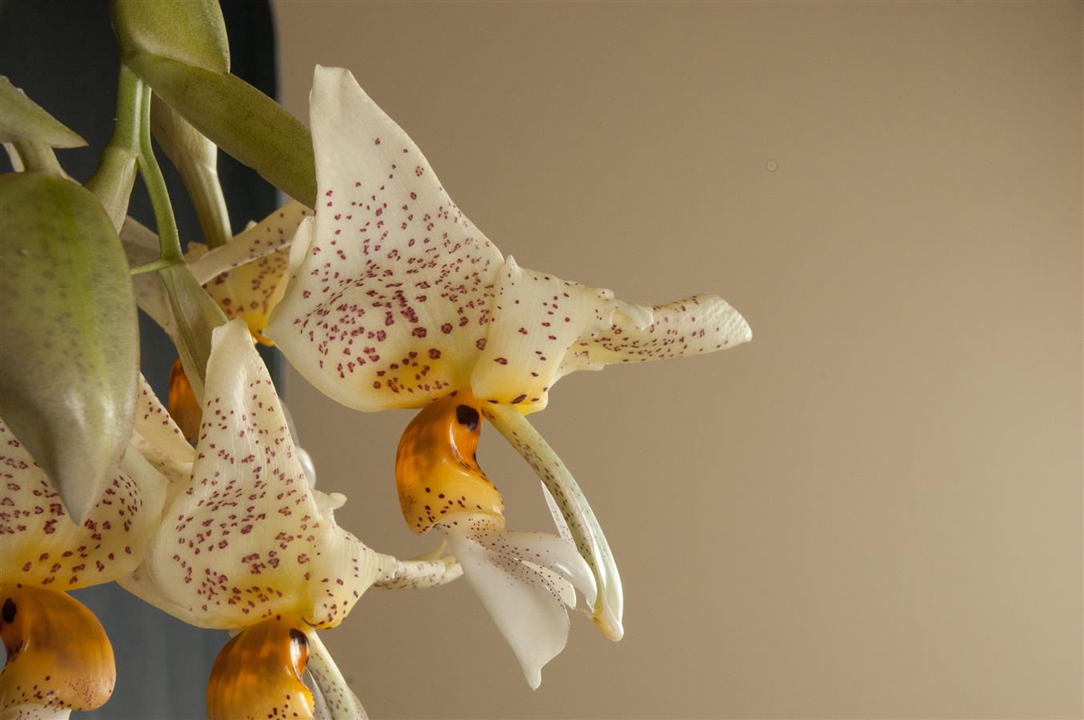
Stanhopea Elizabeth Grace Jasen ‘Amanda’
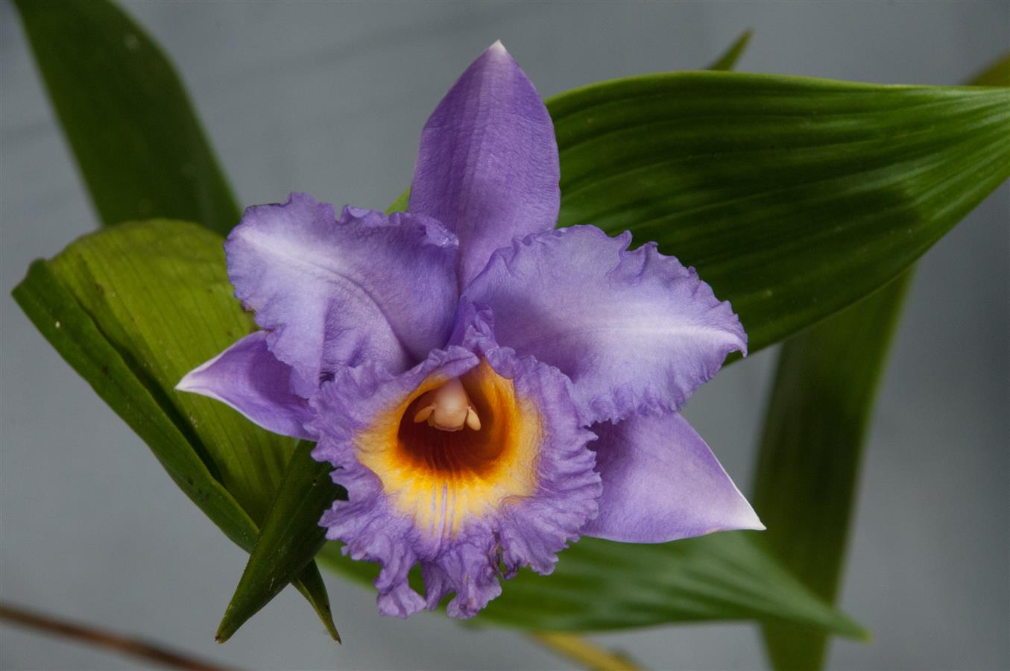
Sobralia Nick Rogers ‘Emilia’

Schedule of Upcoming Events

09/11/23 – NWOS meeting – Speaker: Kelly McKracken, “Fragrant Miniatures” The most common question we get asked about plants is “is it fragrant?”; Many orchid growers select their plants based on whether the plant is fragrant. For those of you who grow in limited space, but still love a nose full of floral fragrance, this is the talk for you.

10/06-08/23 - NWOS Fall Show & Sale - Volunteer Park Conservatory. Details are to be posted on the Events page of the website.

10/09/23 – NWOS meeting – Speaker: Andrew McGinnis, Growing Orchids in Grow Tents, Advanced Indoor Growing.

11/13/23 – NWOS meeting – Speaker: Alan Koch, “A New Look at Intergeneric Phalaenopsis”, Phalaenopsis have been enjoyed by novice growers for the ease of growth and long-lasting flowers. Intergeneric Phalaenopsis hybrids are easier to grow, maintain long-lasting flowers, and often bloom more often than a normal Phalaenopsis. Another benefit from this line of breeding has been the creation of many fragrant hybrids. The bright colors, fragrant flowers, and smaller hardier plants make this an interesting direction in orchids.

12/11/23 – NWOS meeting – Holiday Food Truck Social, introducing new Officers, NWOS Annual Meeting report, Schoenfeld and Northen Orchid Awards, and Holiday Plant gifts.

Reminder for Officers & Board Members

Future meetings are tentatively scheduled for September 5, and November 7th.

NWOS Website Links

- Main website: Http://www.nwos.org
- Events Calendar: http://www.nwos.org/events
- Membership (including renewals): https://nwos.org/Membership/
- Newsletter - Current Issues: https://nwos.org/newsletters/
- Newsletter - Archived Issues: http://newsletter.nwos.org
- Show Information: https://nwos.org/nwos-fall-show/
- Facebook: http://www.facebook.com/nworchidsociety
- Instagram: https://www.instagram.com/nworchidsociety/
- Twitter: https://twitter.com/nworchidsociety

©2023 Northwest Orchid Society - All Rights Reserved unless the copyright is held by other rights holders.

The opinions and recommendations published herein are those of the authors. The Northwest Orchid Society (NWOS) disclaims responsibility for any losses or damages that may be attributed to the use or misuse of any material or any opinion published in these articles and on the website. This website and the photographs, articles, and content are protected by copyright and no part of them may be reproduced or re-used without the permission of the author.

The Special Announcements (SA) section is provided as a courtesy to the readers of this newsletter for events that may be of general interest to the readers. The NWOS (1) makes no promises, warranties, or representations as to SA, including its completeness, accuracy, availability, timeliness, propriety, security, or reliability; (2) provides SA on an "AS IS" and "AS AVAILABLE" basis and any risk of using SA is assumed by you.

