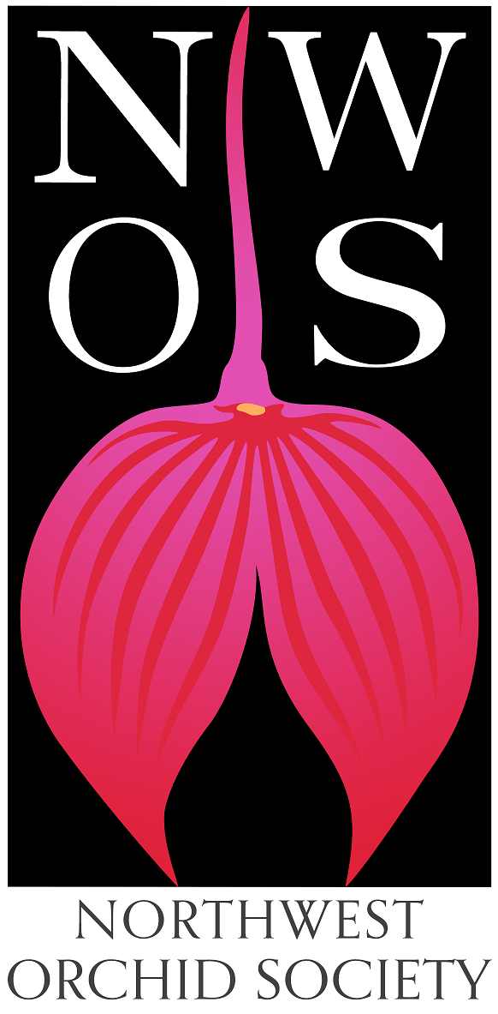
Northwest
Orchid News
September 2022
Volume 75, Issue 8

- About the September Meeting
- Speaker: Tom Etheridge, “Odontoglossums Then and Now, Has Anything Changed?”
- Plant Table
- Sales Table
- Raffle Table
- NWOS Library
- Volunteers Needed For The Nominating Committee
- Volunteers Needed for the Washington State Fair!
- NWOS will be showing at the Oregon Orchid Society Show
- 2022 NWOS Show and Sale at Volunteer Park Conservatory
- Proposed Changes to NWOS Bylaws
- News from the AOS
- Reprint: Homemade Racks for Hanging and Mounted Plants
- Changes at The Royal Horticultural Society
- Changes at The World Orchid Conference Trust
- Report From the August Picnic
- Schedule of Upcoming Events
- Reminder for Officers & Board Members
- NWOS/Amazon Shopping Link
- NWOS Website Links
- Special Announcements

About the September Meeting
September 12, 2022 6:30 PM
University of Washington Center for Urban Horticulture
3501 NE 41st Street, Seattle, WA 98105
Hybrid Meeting, In person and via Zoom Zoom Registration

Speaker: Tom Etheridge, “Odontoglossums Then and Now, Has Anything Changed?”
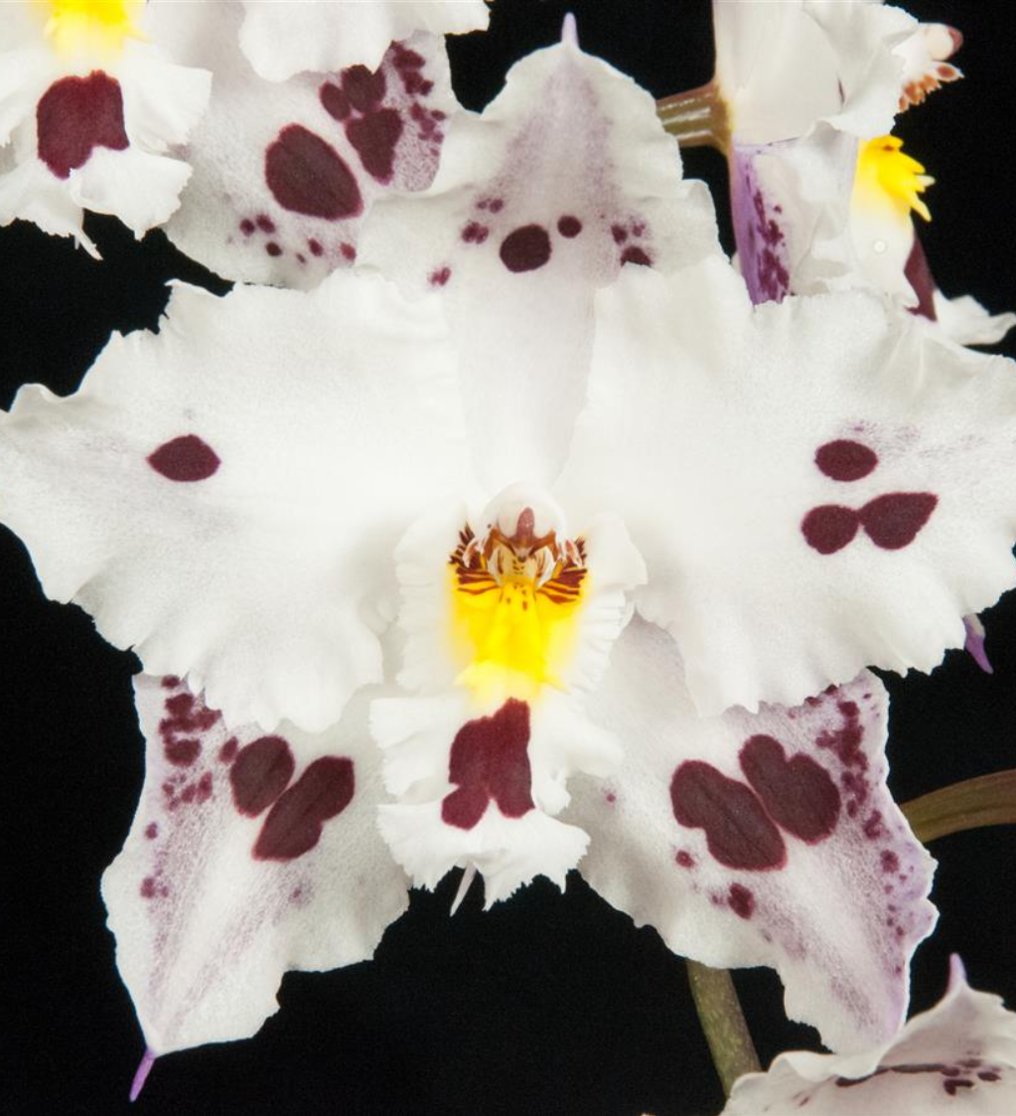
Tom Etheridge has been growing orchids for about 45 years, having first started out with Vandas and Cattleyas while growing up in Florida. Since the mid-1990s he has lived in Oregon where he now specializes in orchids that thrive in the cool Pacific Northwest - Odontoglossums, Masdevallias, and Draculas. He is an Accredited Judge in, and chair of, the Pacific Northwest Judging Center and is a past Vice-President and Board Member of the AOS. Professionally, he holds a PhD in chemistry and retired last year from a 25+ year career at HP where he was the company's Carbon Footprint Program Manager.

Plant Table

We will be having an in person plant table this month. For your convenience, you can print out a Plant Table Information Form ahead of time. Click for your version of choice: PDF WORD Excel

For those who aren’t able to attend in person, please do keep sending your pictures, we will be including them in our online gallery and in next month’s newsletter. Please send them to photos@nwos.org.

Sales Table

Members may bring up to 10 plants to sell. Include an extra tag with your name and the price in the plant.

Raffle Table

The raffle will be held as usual. Win a new orchid for your collection while supporting the Scholarship Fund. If you have any extra Orchids, please consider donating them to the raffle.

NWOS Library

If you'd like to check out a book or tape from our Library, please contact our Librarian Joe Grienauer a minimum of 2 weeks before the next meeting. Besides email, you can give Joe your request at any meeting. For a list of library items please click here NWOS Library.

Volunteers Needed For The Nominating Committee
It’s the time of the year for nominating new officers and board members. We need two volunteers from our membership to be on a Nominating Committee with one board member. Thanks to the two members that will volunteer for this position.

Please send your interest in participating to Steve Dorsey.

Volunteers Needed for the Washington State Fair!

The Washington State Fair in Puyallup is coming up soon! The Fair runs from September 2-25, and there are two separate Orchid Competition/Displays that run about 2 weeks each. For the past several years the Northwest Orchid Society has had a large presence - we’ve supplied most of the plants in the display, and also had some members staffing an info table to answer questions from the public about orchids and to publicize our meetings, speakers, and any upcoming shows. (Several of the folks that came to our show at the Conservatory (and shopped for orchids) found out about it at The Fair.) As a side benefit, these floral competitions have cash prizes for 1st place ($8.00) and 2nd place ($6.00), as well as cash for Best in Show for Culture and Best in Show for Blooms ($10.00 each, plus a rosette ribbon), and several of our members have done very well over the past few year! Without the participation of the Northwest Orchid Society the orchid display at our State Fair would be extremely small; with our participation they fill the display pretty well and create a nice visual enticement for people to get involved.

The NWOS did not participate in the first show and there were only two plants entered in the display. We’re hoping to make a better showing in the second half of the exhibit.

Thuan Nguyen who had taken on this task for the past several years is traveling internationally this year. We need someone to take on the task of collecting and entering plants for the display that Thuan had done so admirably in the past.

You will be allowed to drive on the fairgrounds to the Building (vehicles must leave the fairgrounds at 8:45, before the fair opens for the day).

Entries for the second show can be dropped off at the Fair September 16th or 17th, 6:00-8:45 AM.

We are also hoping to get some people to sign up to sit at the info table at the orchid display for a couple of hours. As an additional benefit, doing this will get you FREE entry to The Fair! The Fair supplies our volunteers with Exhibitor Entry Passes (which lets you into the fairgrounds before The Fair opens) and FREE parking passes for the main parking lots.

This is always a fun event! We usually have cultural information from the American Orchid Society and some handout flyers listing our meetings, shows, and events. Extensive orchid knowledge is NOT required - most of the questions we tend to get are about reblooming phalaenopsis obtained from big box stores, or how many ice cubes they should use for watering (yes, really).

Here’s the information for the Floral competitions, with a section on pre-registration, prizes, etc.

https://www.datocms-assets.com/6258/1654608819-wsf22_floral.pdf

Please consider assisting your Northwest Orchid Society in maintaining our presence and good relationship with The Fair.

Please contact Mike Pearson.

Thanks!
Mike Pearson, NWOS Board Member

NWOS will be showing at the Oregon Orchid Society Show

We are excited to announce that NWOS will be sending an exhibit to the Show and Sale in Portland in late September.
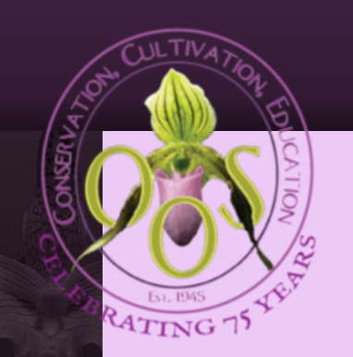
OOS Show and Sale Website
September 24th and 25th
10a - 5p both days
Aquinas Hall, 340 NE Clackamas St, Portland, OR 97232

Setup on Friday the 23rd at a TBD time.
We will need your blooming orchids to help make a wonderful display. We are looking for volunteers to receive plants just prior to the show so they can be brought down to Portland.

2022 NWOS Show and Sale at Volunteer Park Conservatory
Oct 1-2 with setup on Friday Sept. 30th

This year’s Show Chairperson is Abigail Chang. She will be presenting information about our upcoming Show and Sale at our Sept. 12th meeting. She’ll also have sign-up sheets so that we can volunteer for a variety of shifts and positions.

The Setup date for the show is Friday Sept. 30th. The dates of our show are Saturday Oct. 1st - Sunday Oct. 2nd.

We need your plants, well groomed and ready for display.

This has always been a fun activity for our whole society. You can participate in many ways. Help create the displays, be a greeter during the show, help out in the sales area, the potting table, and many other activities that make our show a success. There’s something for everyone.

Members can sign up at NWOS 2022 Fall Show Website.
We also welcome our guests and you can volunteer at the meeting.

Alternately and if you have questions, contact Abigail at showchair@nwos.org

Proposed Changes to NWOS Bylaws
Page 1, Article I, Section 2 – Regular Membership.

“The members of the Society shall consist of persons who have applied for membership in writing and who have paid one year's dues in advance in accordance with Article VII (Dues). That will be deleted and changed to:

“The members of the Society shall consist of persons who have paid one year's dues in advance in accordance with Article VII (Dues).”

Page 2, Article II – Officers, Section 5 – Secretary

“Prior to the end of the term of membership, the Secretary shall bill the members for their dues by the mailing of statements.”

This statement will be removed.

“The Secretary shall give the notice of all meetings in accordance
with these Bylaws and shall give notice to each person of that
person’s election to office or membership in the Society.”

Notice of all meetings are given in the newsletter and webpage.
This statement shall be removed.

Page 2, Article II – Officers, Section 5 – Secretary

“Prior to the end of the term of membership, the Secretary shall bill the members for their dues by the mailing of statements.”

This statement will be removed.

“The Secretary shall give the notice of all meetings in accordance
with these Bylaws and shall give notice to each person of that
person’s election to office or membership in the Society.”

Notice of all meetings are given in the newsletter and webpage.
This statement shall be removed.

Page 3, Article III, Section 5- Committees and Appointments,
Audit committee.

“....close of the fiscal year ending June 30.”

This will be changed to “...close of the fiscal year ending
December 31.” This was changed at a prior board meeting, but
not revised in the bylaws. The two should match.

Members can access the current version of the Bylaws by logging in to the Member Content Area of the NWOS website.

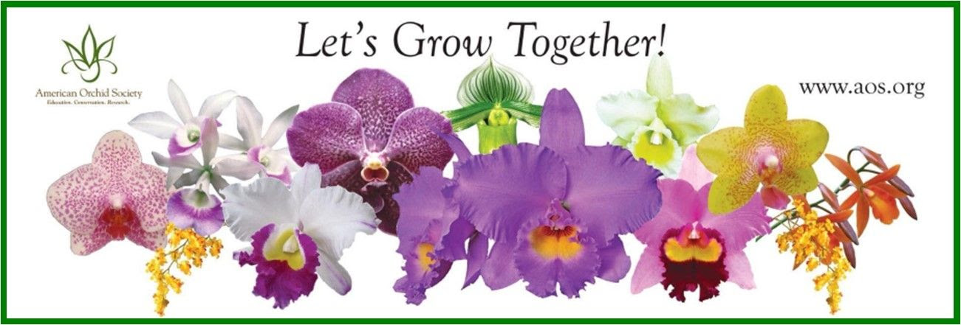
News from the AOS

AOS Webinars – A Wealth of Orchid Information
Barb Schmidt, Chair – Education Committee

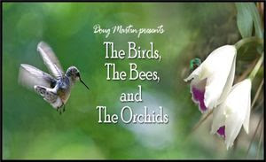
When was the last time you watched an AOS webinar? One of the premier benefits of being an AOS member or an Affiliated Society is access to the amazing and diverse amount of orchid information that is available on our website. With almost 250 recorded webinars, there is something to interest everyone.

Our webinar program began in 2008 and includes information on orchid genera, orchid travel spots, fun facts about orchids, orchid culture, orchid science, and Greenhouse Chats. We are always looking for ideas for new webinars or speakers for our webinars. Travelogs of orchid hot spots and programs on culture are a big hit!
Cheryl Erins (cerins@aos.org) is responsible for any of the non-judging, recorded webinars. Societies can access as well by sending Sandra Svoboda an email sltsvoboda@gmail.com. They are always looking for new ideas; or better yet, new people to create a webinar. Webinars are actually very easy to create. All you need is a great, original idea and a 45-minute Power Point that you narrate. Ideas for webinars can be submitted to Cheryl at the above email. If your proposal is accepted, you will be contacted with further information on how to proceed.
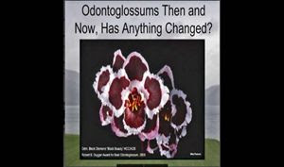
In early 2021, the AOS Judging Committee started posting webinars to help educate the judging community specifically on topics relevant to judging and to educate AOS members on what AOS judging is, what is required of judges and what they look for. The judging webinar program also aids centers and judges in meeting required, yearly education hours. Experts on genera or breeding lines as well as judges of any level are encouraged to submit ideas for judging webinars they would like to present or programs they have seen to Jean Allen-Ikeson (jean.ikeson@gmail.com), National Education Coordinator for Judging. Please submit ideas for approval before submitting a program.
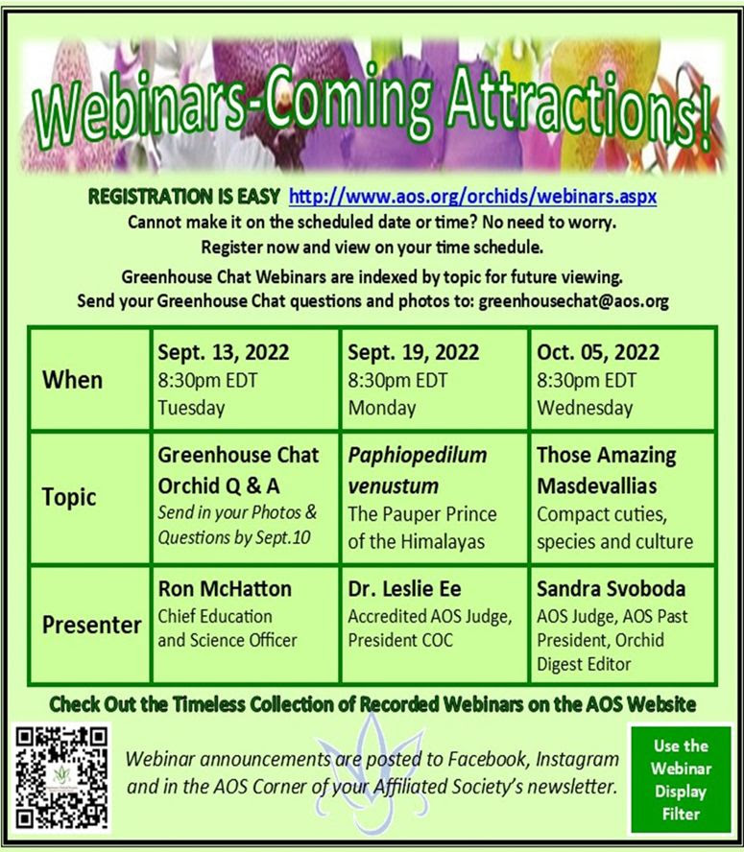

GREAT Ideas
Reprint: Homemade Racks for Hanging and Mounted Plants
By Jean Allen-Ikeson
Photographer: Annette Bagby

ORCHIDS, Bulletin of the American Orchid Society
June 2018 Vol 87 Number 6

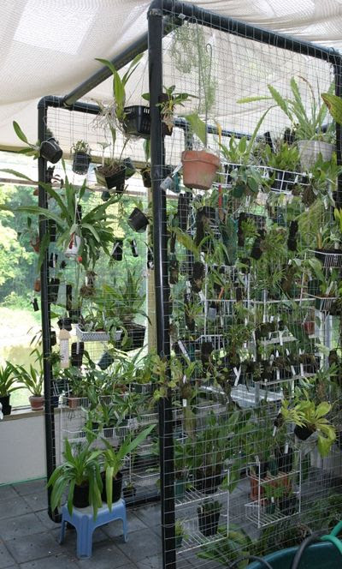
If you grow mounted plants and you have a lot of them, you need a good “vertical bench” on which to hang them. Such racks can be built out of wire mesh and plastic pipe, can consist of just a coil of rabbit cage wire standing on end on a bench or hung by chains from the ceiling, or can be fashioned from one of those discarded wrought iron porch supports that were once so popular on 1950s ranch style homes but now have been relegated to the greenhouse. Vertical benches have the advantage of taking up a small footprint of valuable floor space while providing a home for a large number of mounted plants. Even a little wire mesh tied to the end of a light stand expands the space when you are growing under lights.

Most farm-supply stores and many building centers carry wire mesh that can be used. Chicken wire is probably too lightweight except for the lightest mounts. Mesh with 1-inch (2.5-cm) spacing works well. Plumbing pipe may be purchased in building centers in reasonable lengths. Copy this page with the accompanying photo and take it to the store and tell them, “I want something like this.” You will also need plastic ties such as those used by electricians or heavier single-strand wire to tie the wire mesh to the plumbing pipe.

The best rack I have ever seen was built by Annette Bagby (a retired AOS judge) and her architect husband Jim, who live in Milton, Ontario. The rack was built to house her collection of pleurothallids and other smaller mounted plants in their sunroom greenhouse. Note that the support cross bars may also accommodate hanging baskets for such things as vandaceous orchids. This rack is between 5 and 6 feet (1.5–1.8 m) tall. Such racks are easy to move, sturdy and do not rot. Unless you make the rack wide enough to keep from tipping as in the photo, it might be a good idea to anchor it with a couple of light chains to hooks in the ceiling

Changes at The Royal Horticultural Society

There is unfortunate news from the Royal Horticultural Society in The UK. The December 2022 issue will be the last issue of The Orchid Review as a quarterly journal.

It is currently the world's oldest existing periodical devoted to orchids and each issue features articles by internationally acclaimed experts on subjects such as cultivation, in-depth plant profiles, historical investigation, orchid exploration and all the latest from the world of orchid growing and showing.

The Orchid Review was founded by Robert Allen Rolfe who single-handedly produced and edited 28 volumes. The first monthly issue appeared on January 1st 1893. Rolfe worked in the orchid herbarium at Royal Botanic Gardens, Kew but there was no mention in the periodical of his position there and his name never appeared on the title page. The journal was devoted to orchid cultivation and the increasingly important hybridisation of orchids.
There is a plan for an annual year book with the same title.

The RHS also intends to continue publishing the lists of new hybrids but as an annual booklet.

Shubert’s toast at a wake for Beethoven, “Here’s to the one who has died and the one who’s next”.

Changes at The World Orchid Conference Trust

The WOC has been reorganized as a 501(c)(3) charitable non-profit in the state of Florida. This is its second reincorporation. The past few years have been hard for the WOC shows and for planning for the next ones. They are amazing events, if you have the opportunity to go to one it is an unforgettable experience.

To learn more about the WOC you can visit their website:

Report From The August Picnic

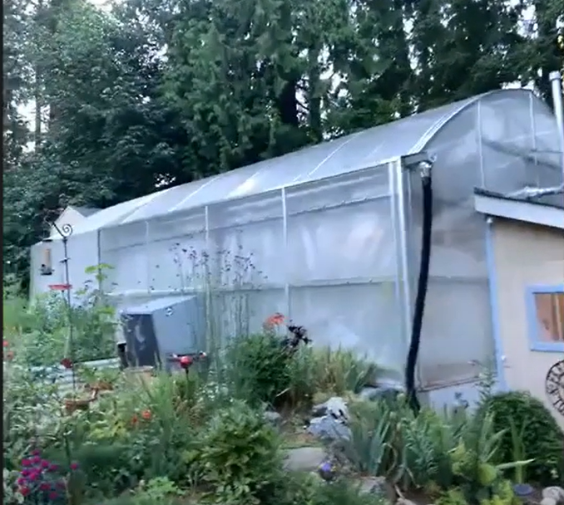
The August member's picnic was held on Saturday, August 13th at the home of Andy Wright.
Andy and his family set a lovely table for their guests. There was a wide array of mains, sides, desserts, and beverages. There were about twenty people that attended the picnic, including members and their families.
Along with having time to leisurely socialize in this lovely setting it was a wonderful treat to be able to talk with Andy about the plants in his greenhouse. There were orchids and nepenthes everywhere you looked. It was truly a site to behold.

Schedule of Upcoming Events

09/12/22 - NWOS meeting - Speaker: Tom Etheridge, “Odontoglossums Then and Now, Has Anything Changed?”

09/24/22-09/25/22 - Oregon Orchid Society Show.

09/30/22 – NWOS Annual show SETUP at the Volunteer Park Conservatory.
10/01/22-10/02/22 – NWOS Annual SHOW AND SALE at the Volunteer Park Conservatory
10/10/22 – NWOS meeting – Speaker: Tyler Albrecht, “Parvisepalum Paphiopedilum” Tyler spoke to us about Dendrobium kingianum and its hybrids last year. This year he is back to talk to us about the wonderful parvisepalum subgenus of Paphiopedilum.

11/14/22 – NWOS meeting – Speaker: Peter Lin, “Neofinetia falcata and its Hybrids”

12/12/22 – NWOS meeting – Scholarship Recipient Report, introduction of new Officers, NWOS Annual Meeting report, Schoenfeld and Northen Orchid Awards, and Holiday Plant gifts.

01/09/23 – NWOS meeting – Speaker: Tennis Maynard, "Trichophilias" Tennis will be speaking to us about this beautiful, yet underrepresented genus in many of our collections.

02/13/23 – NWOS meeting – Annual Culture Clinic: This is our annual clinic when you can bring your questions, your problem plants and whatever is ailing something in your collection and the members that have experience with that plant or problem will answer your questions.

03/13/23 – NWOS Meeting – Annual Auction: This is our annual auction. It starts early with our preview party, nibbles, and bubbly, and ends up with tables and tables of plants for you to bid on. Many of these plants are hard to find and are rarely available outside of private collections.

04/10/23 – NWOS meeting – Speaker: Andew McGinnis, Growing Orchids in Grow Tents, Advanced Indoor Growing.

05/08/23 – NWOS meeting – Speaker: TBA

06/12/23 – NWOS meeting – June Food Truck Social: This is our annual social just before we take our summer break. We have a food truck outside and plants inside. We also announce the Gary Baker Service Award at this meeting.

09/11/23 – NWOS meeting – Speaker: Kelly McKracken, “Fragrant Miniatures” The most common question we get asked about plants is “is it fragrant?”; Many orchid growers select their plants based on whether the plant is fragrant. For those of you who grow in limited space, but still love a nose full of floral fragrance, this is the talk for you.

10/09/23 – NWOS meeting – Speaker: TBA

11/13/23 – NWOS meeting – Speaker: Alan Koch, “A New Look at Intergeneric Phalaenopsis” Phalaenopsis have been enjoyed by novice growers for the ease of growth and long lasting flowers. Intergeneric Phalaenopsis hybrids are easier to grow, maintain the long lasting flowers and often bloom more often than a normal Phalaenopsis. Another benefit from this line of breeding has been the creation of many fragrant hybrids. The bright colors, fragrant flowers and smaller hardier plants make this an interesting direction in orchids.

12/11/23 – NWOS meeting – Scholarship Recipient Report, introduction of new Officers, NWOS Annual Meeting report, Schoenfeld and Northen Orchid Awards, and Holiday Plant gifts.

Reminder for Officers & Board Members

Future meetings are scheduled for September 6, and November 8th.via Zoom.

Shopping on Amazon? Use this link to earn $$ for the NWOS

If you go to https://smile.amazon.com and sign in to your account, you'll be given information about supporting various non-profits. You can type in "Northwest Orchid Society" and it will then send .5% of your purchase price to the organization.

It's really easy, but you have to remember to go in through the 'smile' subdomain when you place the order, otherwise it will go through as a regular order.

NWOS Website Links

- Main website: Http://www.nwos.org
- Events Calendar: http://www.nwos.org/events
- Membership (including renewals): https://nwos.org/Membership/
- Newsletter - Current Issues: https://nwos.org/newsletters/
- Newsletter - Archived Issues: http://newsletter.nwos.org
- Show Information: https://nwos.org/nwos-fall-show/
- Facebook: http://www.facebook.com/nworchidsociety
- Instagram: https://www.instagram.com/nworchidsociety/
- Twitter: https://twitter.com/nworchidsociety

Special Announcements

A small orchid business in Lynnwood is looking for a part-time person to help with packing orders for shipment and some basic plant care. Ideally, you should have your own transportation. Contact Ellen at 206-229-7919 or e-mail olympicorchids@gmail.com.

©2022 Northwest Orchid Society - All Rights Reserved

The opinions and recommendations published herein are those of the authors. The Northwest Orchid Society (NWOS) disclaims responsibility for any losses or damages that may be attributed to the use or misuse of any material or any opinion published in these articles and on the website. This website and the photographs, articles and content are protected by copyright and no part of them may be reproduced or re-used without the permission of the author.

The Special Announcements (SA) section is provided as a courtesy to the readers of this newsletter for events which may be of general interest to the readers. The NWOS (1) makes no promises, warranties, or representations as to SA, including its completeness, accuracy, availability, timeliness, propriety, security or reliability; (2) provide SA on an "AS IS" and "AS AVAILABLE" basis and any risk of using SA is assumed by you.

