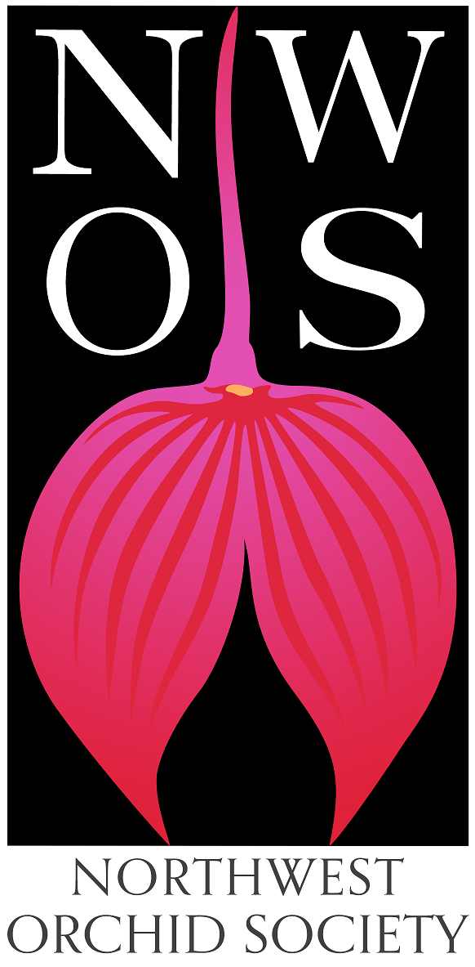
Northwest
Orchid News
October 2023
Volume 76, Issue 8

- About the October Meeting
- Andrew McGinnis, "Exploring Indoor Growing"
- Plant Table
- Sales Table
- Raffle Table
- NWOS Library
- Report from the Nominating Committee
- Holiday Plants
- NWOS Fall Show and Sale
- 2024 NW Flower & Garden Festival
- 2024 NWOS Indoor Plant Festival
- Report From The September Meeting
- Local Judging
- Schedule of Upcoming Events
- Reminder for Officers & Board Members
- NWOS Website Links
- Special Announcements

About the October Meeting
October 9, 2023 7 PM
University of Washington Center for Urban Horticulture
3501 NE 41st Street, Seattle, WA 98105
Hybrid Meeting, In person and via Zoom Zoom Registration

Speaker: Andrew McGinnis, “Exploring Indoor Growing: Grow Tents, Terrariums, Cases, & More”.

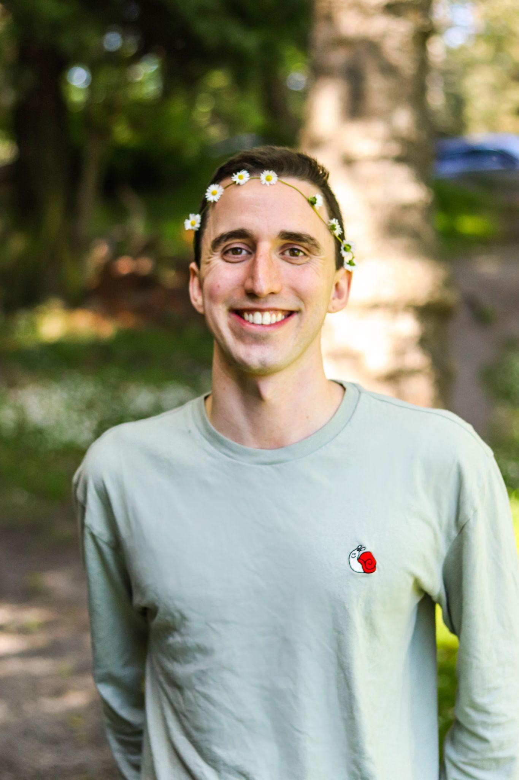
Andrew is an orchid hobbyist and former horticulturist with a degree in ecology, evolution, and conservation biology from the University of Washington. He has been a member of the NWOS since 2018 and grows a variety of orchid genera in grow tents and racks in his Seattle apartment, favoring minis. Aside from growing orchids, he also makes ceramic orchid mounts and pottery, and grows ferns, tropical Ericaceae like Vireya rhododendrons, carnivorous plants, bromeliads, gesneriads, bonsai, kusamono, and more. He has been sharing photos of his plant collection and pottery on Instagram since 2018 under the handle @Urban_Epiphyte.
Andrew will be covering design considerations, setup, and maintenance for indoor grow spaces that solve common problems that indoor growers encounter, with a focus on grow tents as a base example. Regardless of where you are at in your orchid growing journey, you will leave this talk with ideas for how to successfully expand the breadth of plants you can grow indoors, display them in a more aesthetic way, or optimize your maintenance routine using cultural principals and technology that you can adapt to your unique situation.

Plant Table

We will be having an in-person plant table this month. For your convenience, you can print out a Plant Table Information Form ahead of time. Click for your version of choice: PDF or DOCX file?

For those who aren’t able to attend in person, please do keep sending your pictures, we will be including them in our online gallery and in next month’s newsletter. Please send them to photos@nwos.org.

Sales Table

Members may bring up to 10 plants to sell. Include an extra tag with your name and the price in the plant.

Raffle Table

The raffle will be held as usual. Win a new orchid for your collection while supporting the Scholarship Fund. If you have any extra Orchids, please consider donating them to the raffle.

NWOS Library

If you'd like to check out a book or tape from our Library, please contact our Librarian Joe Grienauer a minimum of 2 weeks before the next meeting. Besides email, you can give Joe your request at any meeting. For a list of library items please click here NWOS Library.

Report from the Nominating Committee
The Nominating Committee is currently composed of Joff Morgan.
Here is the currently proposed Slate of NWOS Officers:
Officers, one-year term ending Dec 31, 2024:
President - open
1st VP (Education) - open
2nd VP (Shows) - Ben Johnson
Treasurer - open
Secretary - open

Director positions, two-year term ending Dec 31, 2025:
- Tom Bell-Games
- Peter Maunsell (returning)
- Nora Hightower
- Ryan Russell
- Andy Wright (returning)

The above slate of Officers and Directors will be voted on by the membership at the Nov 13th meeting. In addition to the above slate, the following Directors will continue to serve the remainder of their two-year term expiring Dec 31, 2024:

- Diane Drisch
- Heather Harrington
- Yoshi Nagamatsu

Past President - Robert Culver

Respectfully submitted,
~ Joff Morgan
NWOS Nominating Committee

We are still searching for members to step forward and fill the following open positions:

President - this person will preside at the meetings of the Society and the
Directors. They will have general supervision over the affairs of the Society.
They will also make a report at the Annual Meeting in December with the help of
the other Officers and Committee Chairs. The President also signs written
documents and contracts along with the Secretary.

1st VP (Education) - schedules the monthly general meeting with the UW CUH, arranges for A/V equipment, ensures it is working, and maintains Society laptop for Zoom meetings, manages the monthly meetings and speakers, arranges speaker transport and lodging (or host member) for out-of-town speakers, oversees the Christmas plant event.

2nd VP (Shows) - helps setup our local fall Show display, organizes the collection of plants, transports, and sets up orchid displays at out-of-town shows. Currently, NWOS attends shows in Mt Vernon and Spokane, both in the Spring.

Treasurer - manages Society accounting records using QuickBooks, makes budgets, deposits, pays invoices and quarterly / annual taxes, licenses, and manages Society accounts.

Secretary - keeps a written record of Officer meetings and manages the membership list. Signs written documents and contracts along with the President.

Director - no experience is necessary. But we really prefer people who will actively participate! This includes a willingness to freely express your opinion to various presented issues and proposals. This is a good position to learn the inner workings of the Society and help with its direction. There are 6 Board meetings each year and one of them is a potluck dinner. This is a two-year term expiring Dec. 31, 2025.

If you would like to be considered for one of the "open" positions or have
questions, please contact any of the Nominating Committee members below. Or
just send an email to nwos@nwos.org and it will be routed to the appropriate
people.

Holiday Plants

This is a heads up to our members as to how we are executing the Holiday Plant Gift this season. Members of the NWOS who are paid in full as of midnight Nov. 14th and attend the December meeting will receive a free orchid as a way of saying thank you from the NWOS for being a loyal, supporting member.

PLEASE ensure you have paid your dues NO LATER THAN NOV. 14TH! Anyone paid later than that will sadly miss a plant.

Go to NWOS.org and Register/Login. If your membership isn’t up to date, you can renew there. If your membership isn’t available you can click on the Join|Renew and join.

If you believe there are issues with your membership reach out to Sean Hoyt.

NWOS Fall Show and Sale

The NWOS will be having it’s annual fall show and sale on the 7th and 8th of October. Setup is on the afternoon of the 6th.
There are trophies being awarded this year with either a $50 cash prize ($100 for best in show) or two tickets ($100 cash value) to the preview night to the Indoor Plant Festival (this includes a weekend pass to the festival as well).
We have a potting clinic booth and local vendors selling plants at the show as well.
Members are also able to sell plants at the show for a 20% donation on each sales and you must also volunteer for a shift at the show.
Complete details can be found at the NWOS Fall Show Page.

2024 NW Flower & Garden Festival

The NWOS will again be putting in a display at the 2024 NW Flower & Garden Festival. This year the NWOS is partnering with Emerald City Orchids for the display.

Nora Hightower has volunteered to be the Coordination Chair for the NWOS this year. She will be collecting the names of the voluneeteers and scheduling them for their shifts.

Nora will have signup sheets over the next few meetings to collect volunteers.

If you have questions you may contact Nora at norateamhightower@gmail.com

2024 NWOS Indoor Plant Festival

The Indoor Plant Festival continues to attract new vendors and excitement from plant club in the region. Ben Johnson is the Chairperson for the working group.

The Setup date for the festival is Friday March the 1st. The dates for the show are Satruday March 2nd - Sunday March 3rd.

Ben will be providing you more information. There will be a preview night, the night of the 1st. We currently have thirteen (13) vendors and seven (7) societies participating at the festival.
This is going to be a great event, as far as we can tell this is the only event focusing on indoor plants geared towards plant enthusiast in North America
For more information please visit the Indoor Plant Festival Page.

If you have questions, contact Ben at showchair@nwos.org

Report From The September Meeting
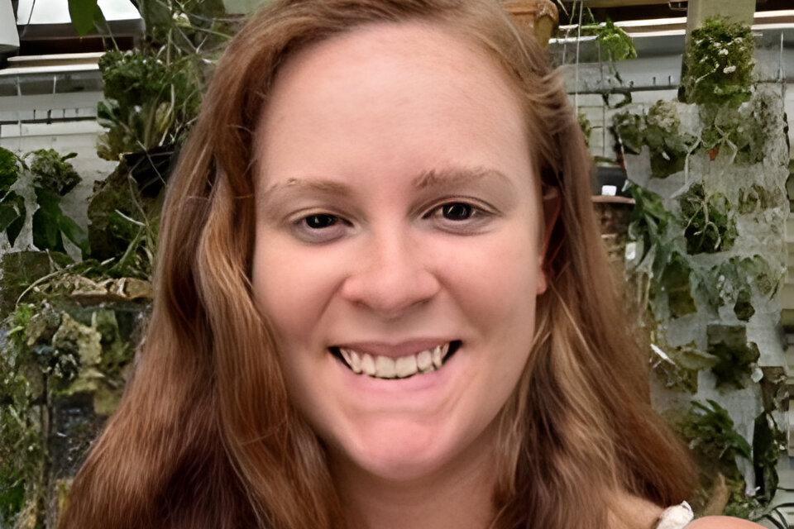
.
Joe Grienauer opened the meeting in lieu of president Robert Culver who was unable to attend, thank you Joe.

Sean Hoyt Introduced the new membership system, which is now live and allows members to manage their own memberships as they see fit.

The Orchid Mart was introduced. It is a online system where members can post items for sale, trade, or gifting. Anyone has access to browse this system.

Ben Johnson brought us up to speed on all the events that have been happening including the upcoming fall show and spring show. Nora Hightower updated us on the progress for the upcoming Flower and Garden Festival.

Joe was presented with the engraved Gary Baker Service award for the service that he has consistently shown to The Society.

Joff Morgan started the annual appeal for the nominating committee. This year there are many open positions, which means there are many new opportunities for people to step up and volunteer for the society.

Our speaker was Kelly McCracken, she spoke to us last year about artificial lighting and this year she was back speaking to us about fragrant minature orchids. Many of us grow in confined indoor spaces, so again, it was great to have a topic that spoke to those of us that have the limitations of an indoor space.

Joe Grienauer reviewed the plant table with assistance by Sean Hoyt.

These are several selected images from the September meeting. To see the rest of the photos of September's plant table, please follow the link to go to the online gallery.
Photography by Julian Branbury

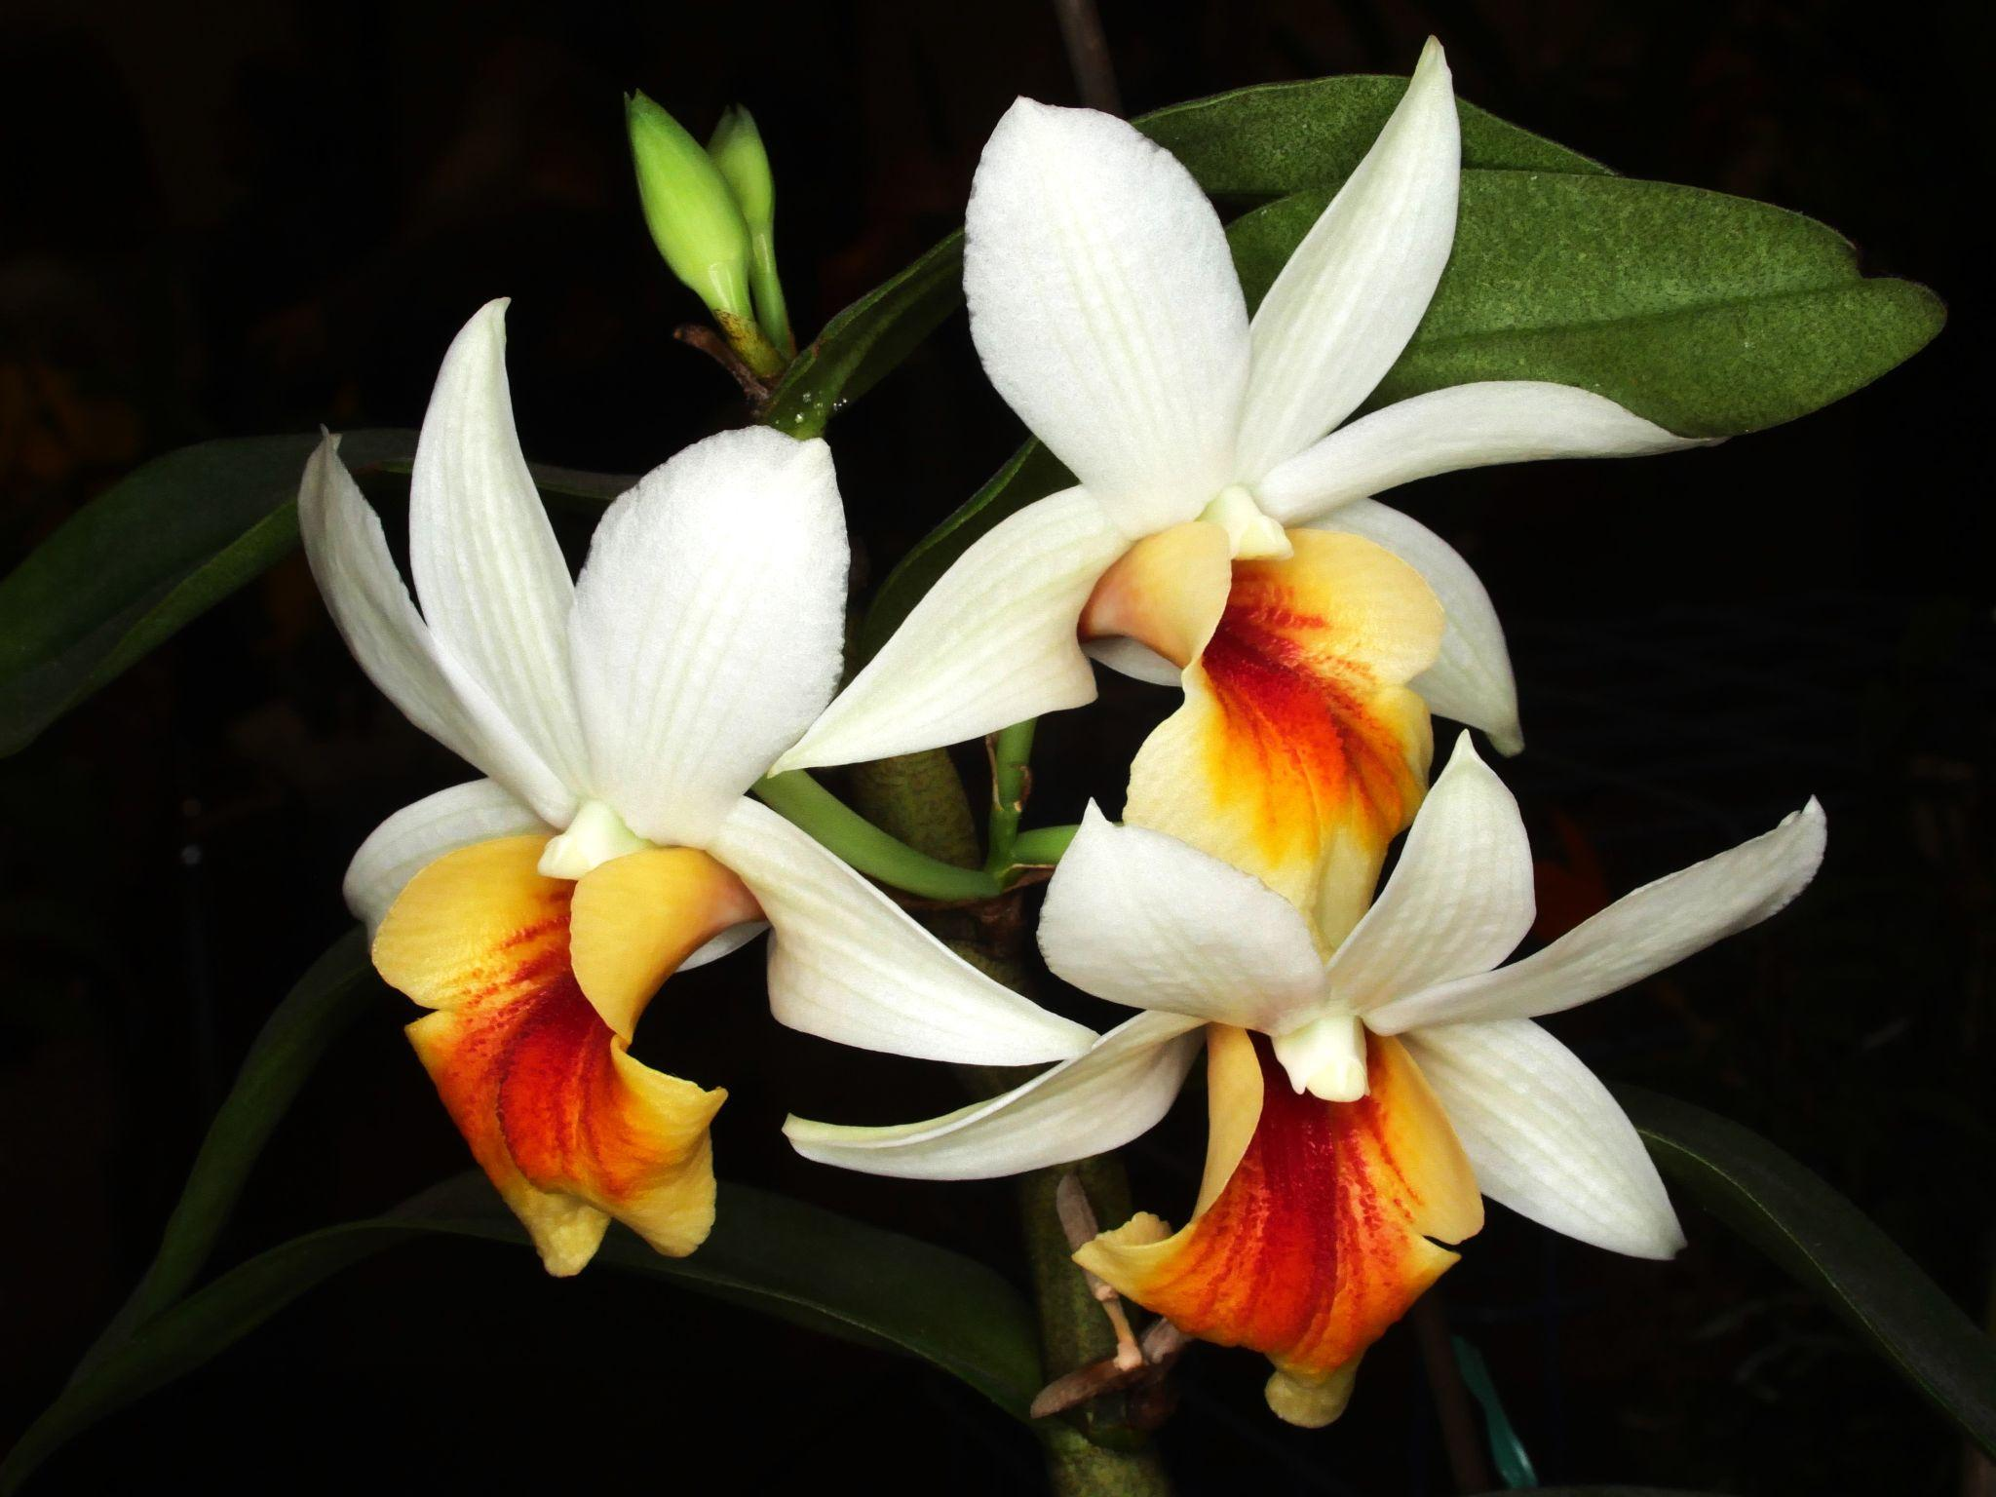

Dendrobium Christy Dawn

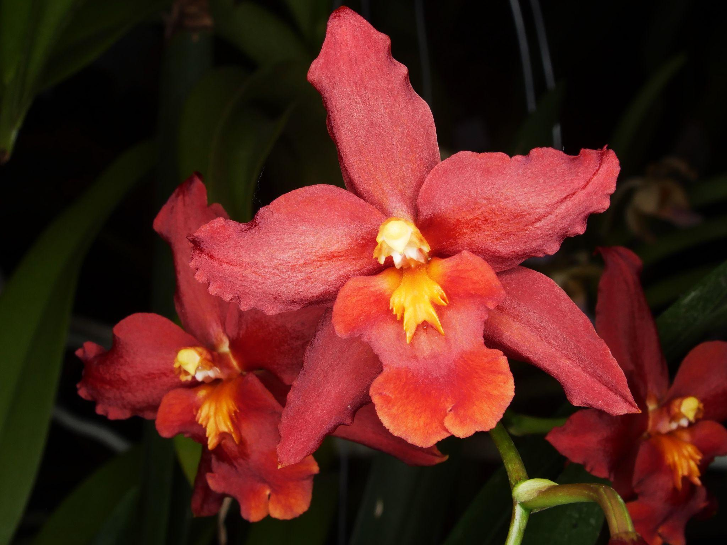
Wilsonara Space Mine 'Red Rendezvous'
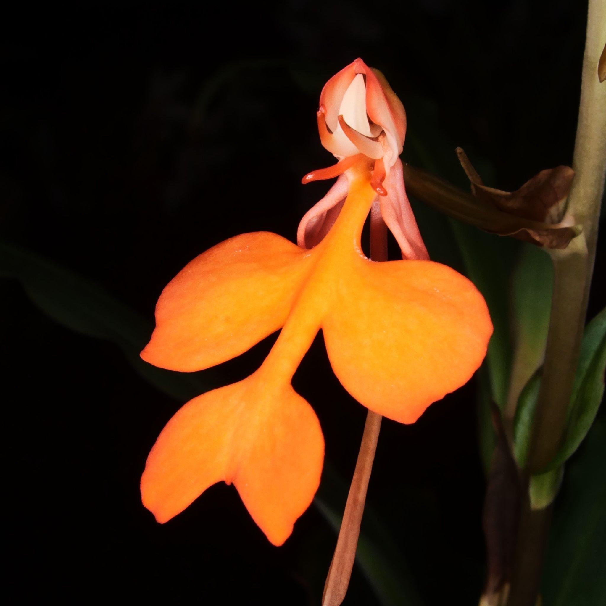
Habenaria rhodocheila 'Orange'

The meeting ended with a raffle using our new raffle system of selecting the plants you place your raffle entries against. The feedback has been positive on this new system.

Local Judging

Adapted from William Jansen of the PNW Regional Judging Center.
Please come join us a future Monthly PNWJC judging Sunday (see dates below). We are also looking for societies to have fall shows, but no shows are currently scheduled for the remainder of 2023.
- October 7, 2023 Show Judging 10 AM at Volunteer Park Conservatory.
- November 5, 2023 Monthly AOS Judging 1 PM at Keizer Community Center.
- December 3, 2023 Monthly AOS Judging 1 PM at Keizer Community Center.
Sunday September 3, 2023 Monthly AOS Judging Summary
Monthly judging September 3, 2023 had us unintentionally locked out of the Keizer Community Center so judging was held outside under the Gazebo. It was just a bit windy but still a beautiful day. We had eight (8) plants displayed and all were reviewed for judging. There was one (1) award granted; an AM/AOS to a very cool Proslia hybrid. We had seven (7) judges and one (1) student forming two (2) judging teams. Ross Leach provided the attached excellent quality photography. The displayed plants and awards are summarized below:
- Proslia Spots ‘CMSgt Joe Arel’, AM/AOS 81 points, exhibited by Mark Arel.

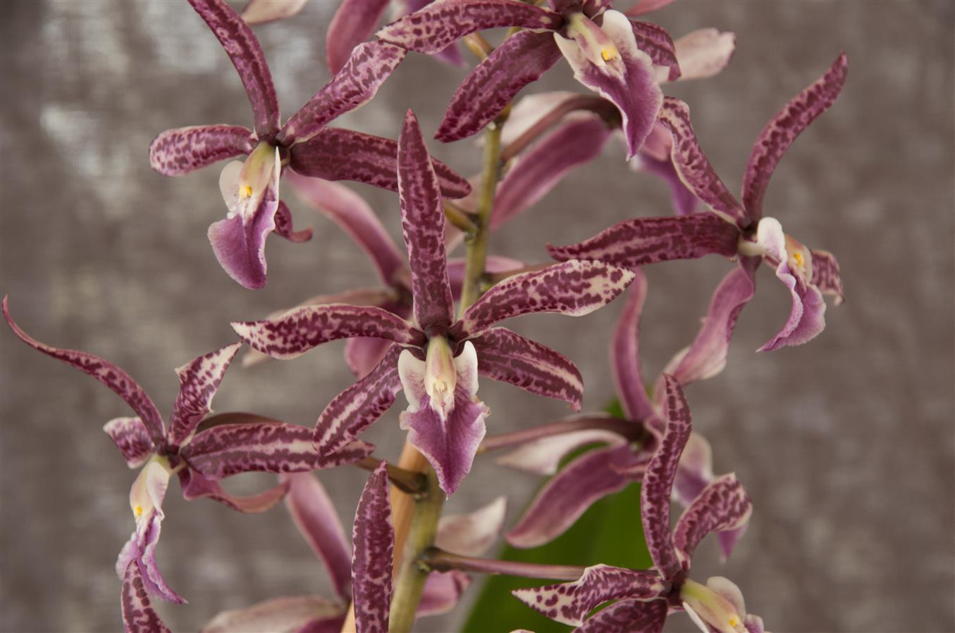
Proslia Spots ‘CMSgt Joe Arel’

Schedule of Upcoming Events

10/06-08/23 - NWOS Fall Show & Sale - Volunteer Park Conservatory. Details are to be posted on the Events page of the website.

10/09/23 – NWOS meeting – Speaker: Andrew McGinnis, Growing Orchids in Grow Tents, Advanced Indoor Growing.

11/13/23 – NWOS meeting – Speaker: Alan Koch, “A New Look at Intergeneric Phalaenopsis”, Phalaenopsis have been enjoyed by novice growers for the ease of growth and long-lasting flowers. Intergeneric Phalaenopsis hybrids are easier to grow, maintain long-lasting flowers, and often bloom more often than a normal Phalaenopsis. Another benefit from this line of breeding has been the creation of many fragrant hybrids. The bright colors, fragrant flowers, and smaller hardier plants make this an interesting direction in orchids.

12/11/23 – NWOS meeting – Holiday Food Truck Social, introducing new Officers, NWOS Annual Meeting report, Schoenfeld and Northen Orchid Awards, and Holiday Plant gifts.

Reminder for Officers & Board Members

Future meetings are tentatively scheduled for November 7th.

NWOS Website Links

- Main website: Http://www.nwos.org
- Events Calendar: http://www.nwos.org/events
- Membership (including renewals): https://nwos.org/Membership/
- Newsletter - Current Issues: https://nwos.org/newsletters/
- Newsletter - Archived Issues: http://newsletter.nwos.org
- Show Information: https://nwos.org/nwos-fall-show/
- Facebook: http://www.facebook.com/nworchidsociety
- Instagram: https://www.instagram.com/nworchidsociety/
- Twitter: https://twitter.com/nworchidsociety

Special Announcements

Emerald City Pop-Up Weekend

Emerald City will be hosting a number of vendors over 27th - 29th. Ecuagenera, Wilson’s Orchids, A.G.E. Tropicals, Orchids by the Lake.
For more information visit ECO.

November Ecuagenera Tour

Joe is leading a 10-day guided tour of Ecuador starting on November 24, beginning at Uzhupud Gardens and including exclusive access to Ecuagenera facilities with special plant purchase offers. The tour costs $175-$200/night, covering meals, accommodations, and transport, with inquiries directed to info@emeraldcityorchids.com referencing "Emerald City Orchids November Tour".

For more information visit ECO.

©2023 Northwest Orchid Society - All Rights Reserved unless the copyright is held by other rights holders.

The opinions and recommendations published herein are those of the authors. The Northwest Orchid Society (NWOS) disclaims responsibility for any losses or damages that may be attributed to the use or misuse of any material or any opinion published in these articles and on the website. This website and the photographs, articles, and content are protected by copyright and no part of them may be reproduced or re-used without the permission of the author.

The Special Announcements (SA) section is provided as a courtesy to the readers of this newsletter for events that may be of general interest to the readers. The NWOS (1) makes no promises, warranties, or representations as to SA, including its completeness, accuracy, availability, timeliness, propriety, security, or reliability; (2) provides SA on an "AS IS" and "AS AVAILABLE" basis and any risk of using SA is assumed by you.

