Northwest
Orchid News
November 2021
Volume 74, Issue 8

- About the September Meeting
- Speaker: Ron Parsons, “Rarities And Oddities Of The Orchid World”
- Plant Table
- Sales Table
- Raffle Table
- NWOS Library
- Report from the Nominating Committee
- Holiday Plants
- Volunteer Positions
- Help Needed for NWOS Scholarship Criteria Review
- 2022 NW Flower & Garden Festival
- DIY LED Lights for Orchid Growing
- How and when Do I Water My Orchid?
- Native Orchid Conference on Olympic Peninsula, June 2022
- Report From The October Meeting
- Schedule of Upcoming Events
- Reminder for Officers & Board Members
- NWOS/Amazon Shopping Link
- NWOS Website Links

About the November Meeting
November 8, 2021 7 PM
University of Washington Center for Urban Horticulture
3501 NE 41st Street, Seattle, WA 98105
Hybrid Meeting, In person and via Zoom Zoom Registration

We will be meeting in person for the foreseeable future. The Covid protocol for the meetings will be shared monthly for attendees and is available at our web site located here: Covid Response – Northwest Orchid Society (nwos.org)

Speaker: Ron Parsons, “Rarities And Oddities Of The Orchid World”
Ron Parsons has been growing orchids for more than 45 years, and has been interested in the species for most of that time. He loves to photograph orchids and other flowers whenever he can, and does so as often as possible. Ron has more than 90,000 digital images, most of which are of orchids, and still retains a slide library that exceeds 100,000 botanical images.

He has given more than 500 talks on various botanical topics, and has more than 6500 published photos. Ron has co-authored four books on botanical subjects, all with Mary E. Gerritsen.

The first two, published by Timber Press, are Masdevallias, Gems of the Orchid World and Calochortus, Mariposa Lilies and their Relatives. Their third book, a two-volume set, A Compendium of Miniature Orchid Species was published by Redfern Natural History Productions in January 2014. In 2019 The American Orchid Society Guide to Orchids and their Culture was released, and is on its third printing. They have recently completed a fifth book, a much-revised second edition of A Compendium of Miniature Orchids Species. It is now in four volumes with 3100 photos (1800 of those are new), including those of more than 500 species not in the first edition. The set is being released late this summer, 2021.

For this talk Ron will be joining us via Zoom. This talk features some of the strangest and rarest plants in the orchid family, and includes both terrestrial and epiphytic species. The majority of terrestrial orchids are not in cultivation, and many of those shown were photographed in nature. Most of the epiphytic species presented are in cultivation, and though some may be relatively common, others are not, but hopefully all will inspire a little awe.

Plant Table

We will be having an in person plant table this month. For your convenience, you can print out a Plant Table Information Form ahead of time. Click for your version of choice: PDF WORD Excel

Diane has taken pictures of the plant table for many years and has requested that someone else take up the torch. We appreciate everything that she has done. For those who aren’t able to attend, please do keep sending your pictures, we will be including them in our online gallery and in next month’s newsletter. Please send them to photos@nwos.org.

Sales Table

Members may bring up to 10 plants to sell. Include an extra tag with your name and the price in the plant.

Raffle Table

The raffle will be held as usual. Win a new orchid for your collection while supporting the Scholarship Fund. If you have any extra Orchids, please consider donating them to the raffle.

NWOS Library

If you'd like to check out a book or tape from our Library, please contact our Librarian Joe Grienauer a minimum of 2 weeks before the next meeting. Besides email, you can give Joe your request at any meeting. For a list of library items please click here NWOS Library.

Report from the Nominating Committee
Here is the currently proposed Slate of NWOS Officers:
Officers, one-year term expiring Dec. 31 2022:
President - Steve Dorsey
1st VP - Robert Culver
2nd VP - OPEN
Treasurer - Chris Peterson or Bill Leicht
Secretary - Mike Cory
Director positions, two-year term expiring Dec. 31, 2023:
- Pat Gossler
- Peter Maunsell
- Lori Lederman
- 2 OPEN spots if Bill Leicht is voted in as Treasurer
The above slate of Officers and Directors will be voted on by the membership at the November 8th meeting. In addition to the above slate, the following Directors will continue to serve the remainder of their two-year term expiring Dec. 31, 2022:
- Tom Bell-Games
- Diane Drisch
- Ben Johnson
- Thuan Nguyen
- Michael Pearson

Past President - Joe Grienauer

We are still searching for members to step forward and fill the following open positions:
2nd VP - this person will be in charge of our participating in out-of-town Shows. Presently for the 2022 year that will be Spokane and Mt Baker orchid societies. Tri-Cities is a possibility as well. The 2nd VP will arrange for plants to be picked up from gathering points around the city, transport to the out-of-town Show, set up the display, register plants, note the ribbons and awards given to member plants, dismantle and return plants to their gathering points. You will need to make a report for the Newsletter afterwards. You may ask others to help or go in your place if you're unable to attend a particular show. This position is a one-year term expiring Dec 2022.

Director - there are two or three open positions. No experience is necessary. But we really prefer people who will actively participate! This includes a willingness to freely express your opinion to various presented issues and proposals. This is a good position to learn the inner workings of the Society and help with its direction. There are 6 Board meetings each year and one of them is a potluck dinner. This is a two-year term expiring Dec. 31, 2023.

If you would like to be considered for one of these "open" positions or have questions, please contact any of the Nominating Committee members below. Or just send an email to nwos@nwos.org and it will be routed to the appropriate people.

Respectfully submitted, ~ Susan Burgess, Joff Morgan, Deborra White
NWOS Nomination Committee

Holiday Plants

Just a reminder members can be eligible for two holiday plants this year. Members who attended last year’s Zoom meeting can get a plant, and people who are paid members by the end of the 11/8 meeting can also get a plant by attending the December meeting.

Check with Mike Cory if you have questions about your membership status.
Volunteer Opportunities

There are lots of choices for participating and helping our society utilizing different skills, interests and available time.

--Do you enjoy taking photos? We could use someone to take pictures of our monthly meeting plants along with their information forms to identify the plant and the grower.
--We also need people for multiple positions associated with orchid donations and our raffles. You can volunteer for more than one position.

- Mike Cory has volunteered to respond to offers of donations - usually by email thanking donors and getting contact and plant information. Averages 6-8 times a year. Arrange for a plant pickup volunteer to follow up. He will need to be supported by:
- Several people who can pick up plants and bring them to the next meeting. Perhaps someone for the northside, southside, eastside, etc. Donated plants just need minimal care until the next meeting and don’t need to be commingled with your collection.
- Manage the raffle at the meeting by calling out the winners.

Help Needed for NWOS Scholarship Criteria Review

For decades the NWOS has offered scholarships for orchid research to students at 2- and 4-year institutions in Washington, Oregon, and Idaho. There have been several problems: few applicants, research proposals not acceptable to the NWOS board, and failure by students to complete projects.

The Board has authorized me to form a committee to review the process and criteria with a 1 January 2022 deadline. If you’d like to be part of the committee (likely working remotely), let me know and I will email you more information.
Kathy Murray, NWOS Scholarship Chair, Riverhaven203@gmail.com

2022 NW Flower & Garden Festival

Our next big event is the 2022 NW Flower & Garden Festival. We are designing a walk-through garden space complete with a Victorian style glass greenhouse in the center.

Gordon Cromwell, Joe Grienauer, Robert Culver and I are working out the various details.

The Festival opens February 9 and runs through February 13.
Current Garden Layout

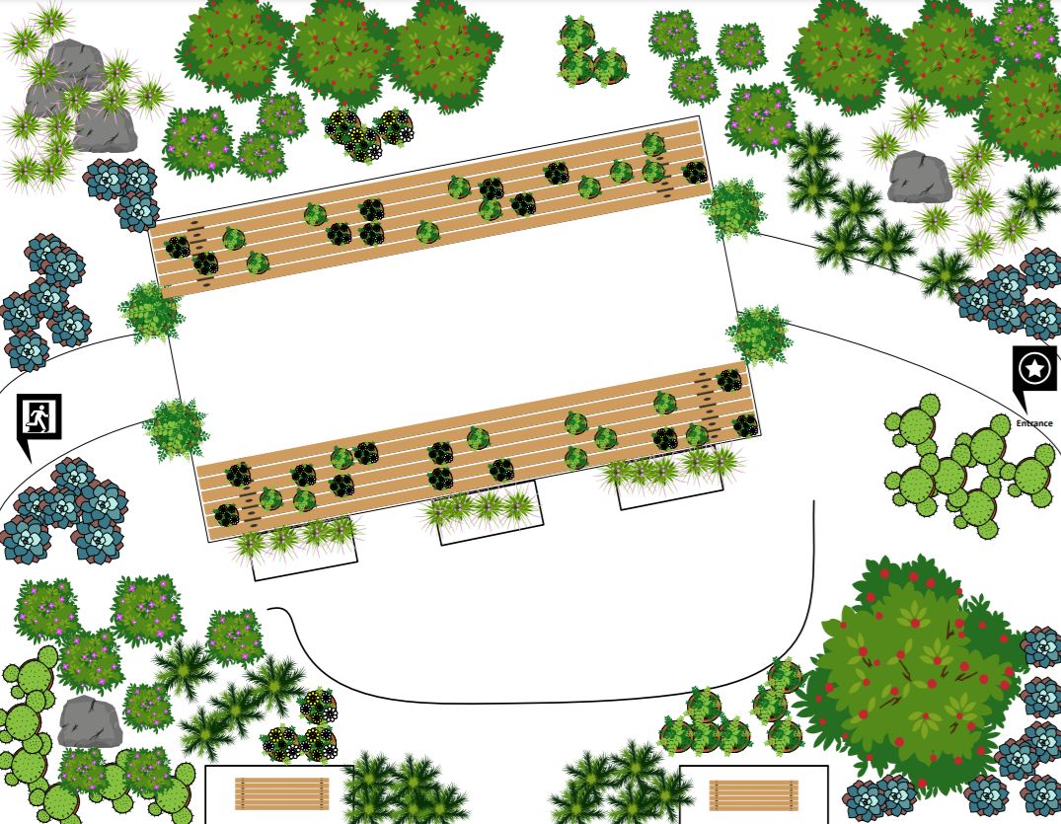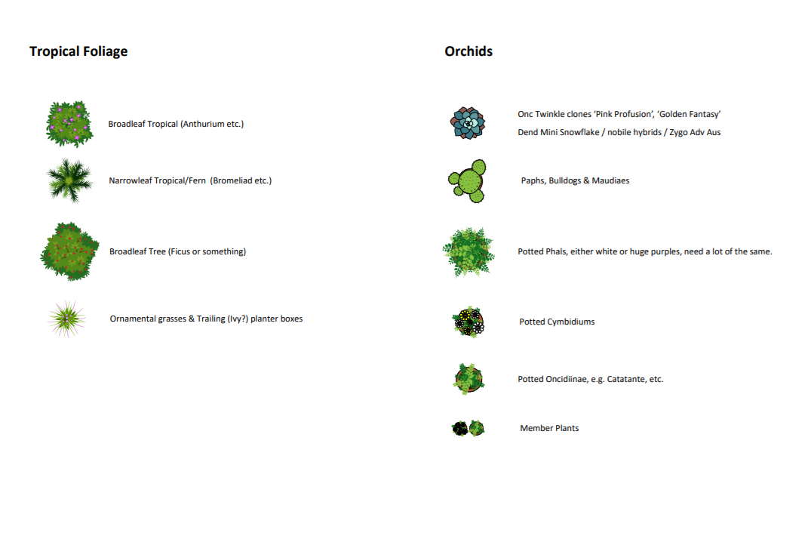
We will need volunteers to help us build, staff, and dismantle the garden. In addition, we will need YOUR ORCHIDS to be the "stars of the Festival" within the garden and greenhouse.

If you'd like to see additional information about our garden design or festival information, visit the "Events" page of our website or go to https://nwos.org/nw-flower-garden-festival/.

Sign-up sheets will be at the November meeting. Any questions, please contact me.

~ Joff Morgan

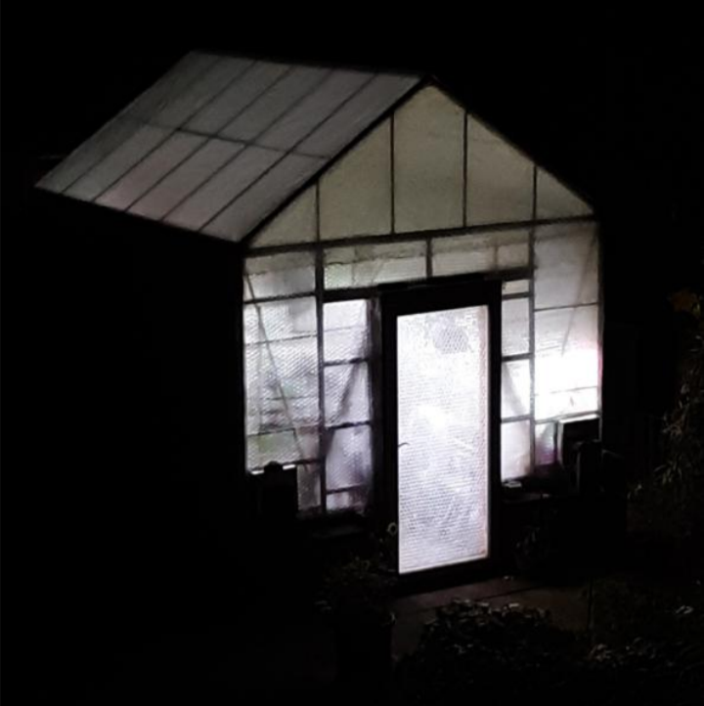
DIY LED Lights for Orchid Growing
By Steve Dorsey, Stevertd2010@gmail.com
It’s November in the Pacific Northwest and the darkness that we used to call daylight is fast approaching. The rain festival has started and the gray days are the norm. And it all happened so quickly.

But we don’t have to sit in the dark. Many of you already use lights if you are growing full time indoors. If you have a greenhouse or grow with a window nearby, you have some light all year. However there isn’t enough light on a typical day to keep your plants robust and as healthy as they can be during the winter. You should consider supplementing the light needs to make up for the lack of intensity and day length of our northern skies.
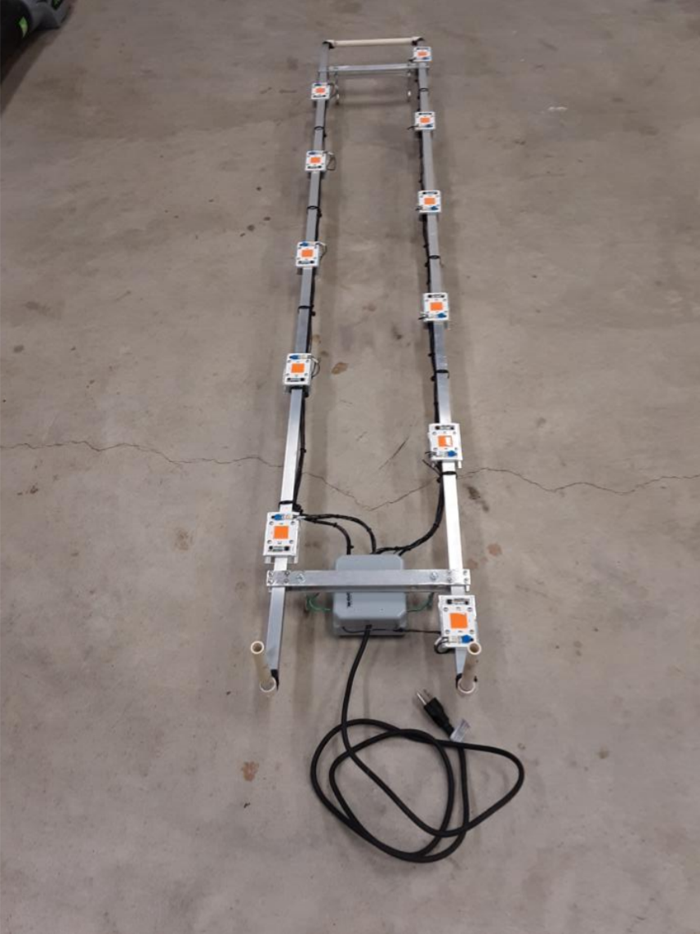
For those wishing to expand their lighting set up, and not finding a configuration that fits their layout, you might wish to consider making your own LED light system. I will cover all the basics, but understand there are details omitted. If you wish to know more, please feel free to contact me for further information.
Let’s start out with the finished product. This one has 11 lights on it. We will be using an LED light called a chip on board (COB). Each COB has its own built in circuit so that all is needed is to provide normal house current to make it work. All are mounted on square aluminum to provide cooling.

This is a close up of the COB that will provide light from the LEDs on it.
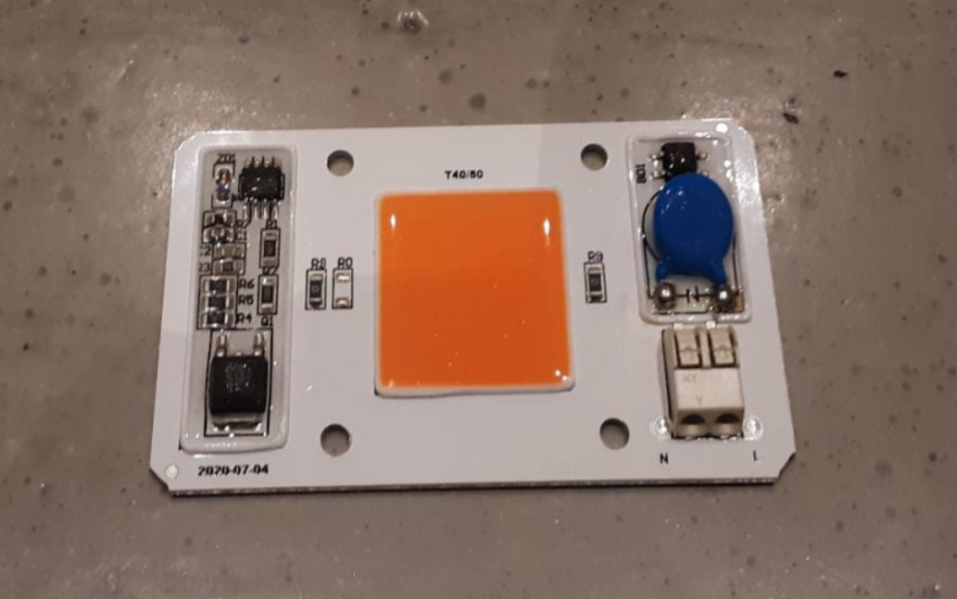
I started with straps that will be used to mount some eyelets to hang this system. I used 1 inch aluminum cut to length and drilled holes for all the mounting screws.
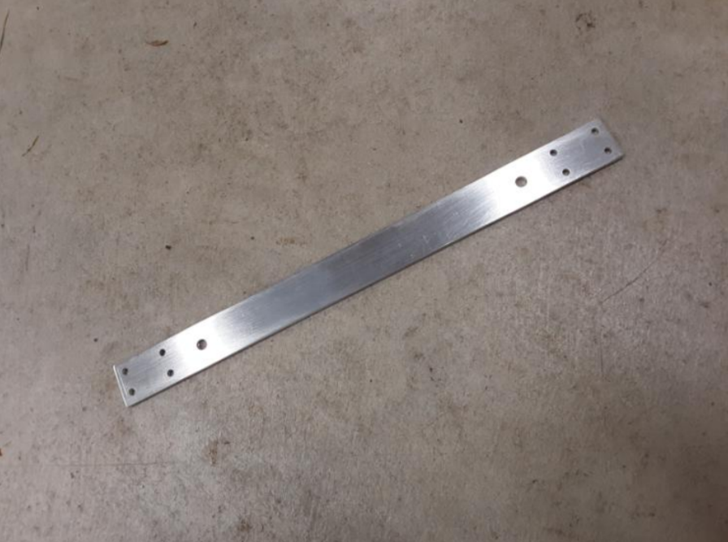

These are then mounted to the square aluminum pieces with screws and the eyelets are attached also.
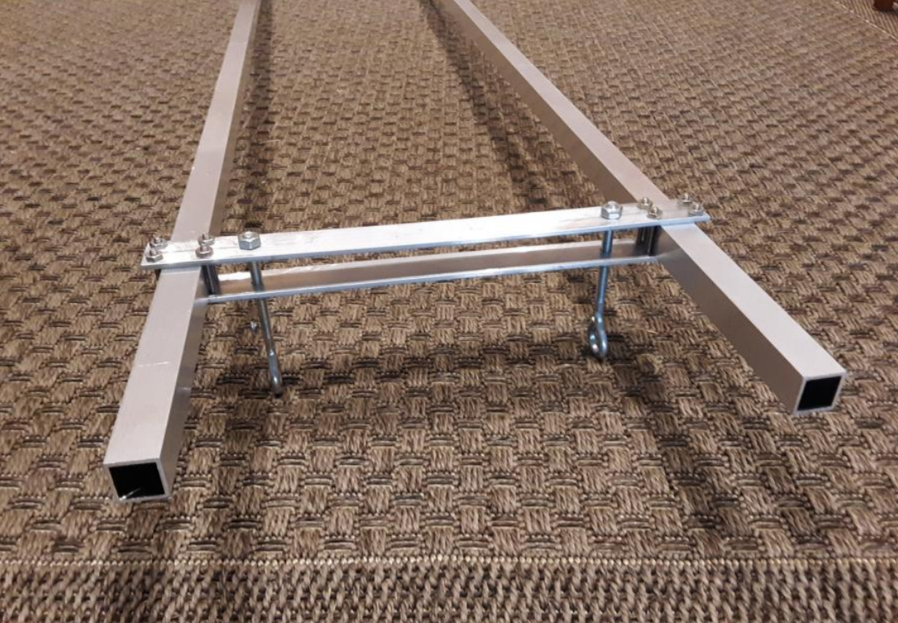
To be able to run water through the tubes, I used plastic fittings from a typical home improvement store. The size is perfect for sliding into the square holes. As it is literally a round peg in a square hole, you can use common silicone gasket/sealer to close the holes around the fittings. On one end it will be a 90 degree for the tubing to connect and the other simply connects from one tube to the other.
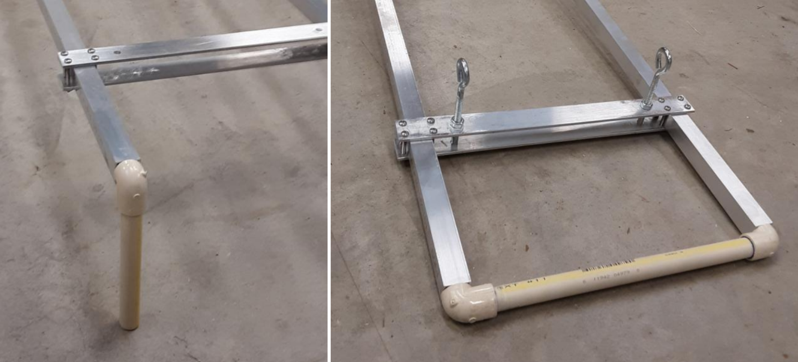
Now we need some mounting plates for the COBs. I cut these from 2” wide aluminum straps and drilled the holes for mounting.
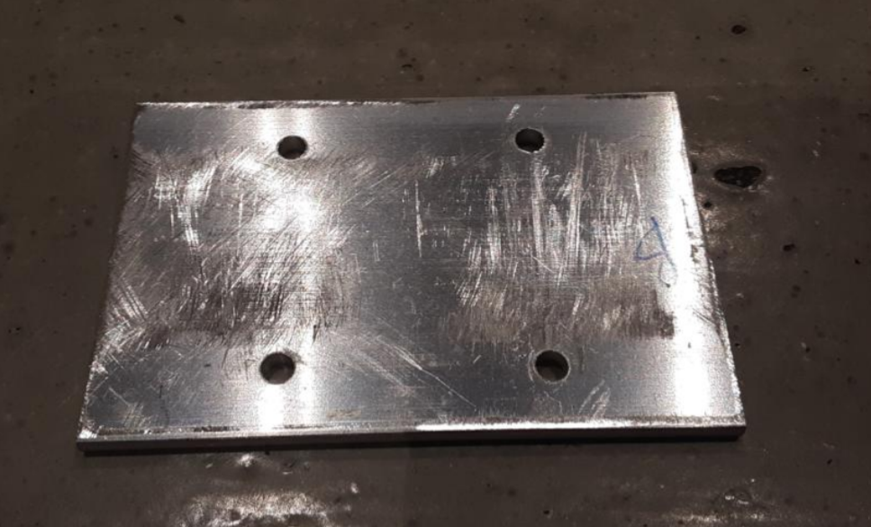
These will be used to put the COBs onto the square tubes. They are basically sandwiched together as shown.
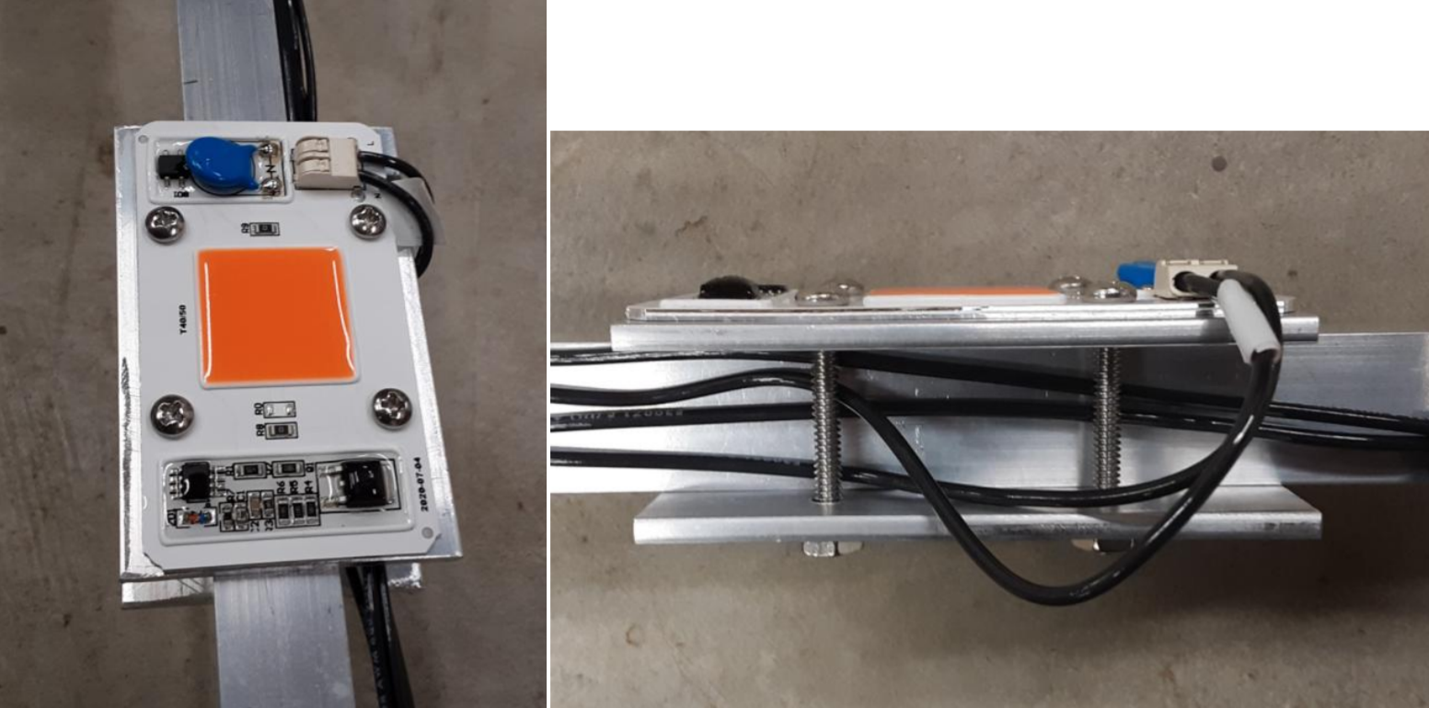
After mounting the LED s the way you want, then it’s just a matter of connecting the wires to each. This is a nice design on these at it is simply pushing the wire into the white connector. All of these go to a waterproof box (gray) that has screw on terminal connectors in it.
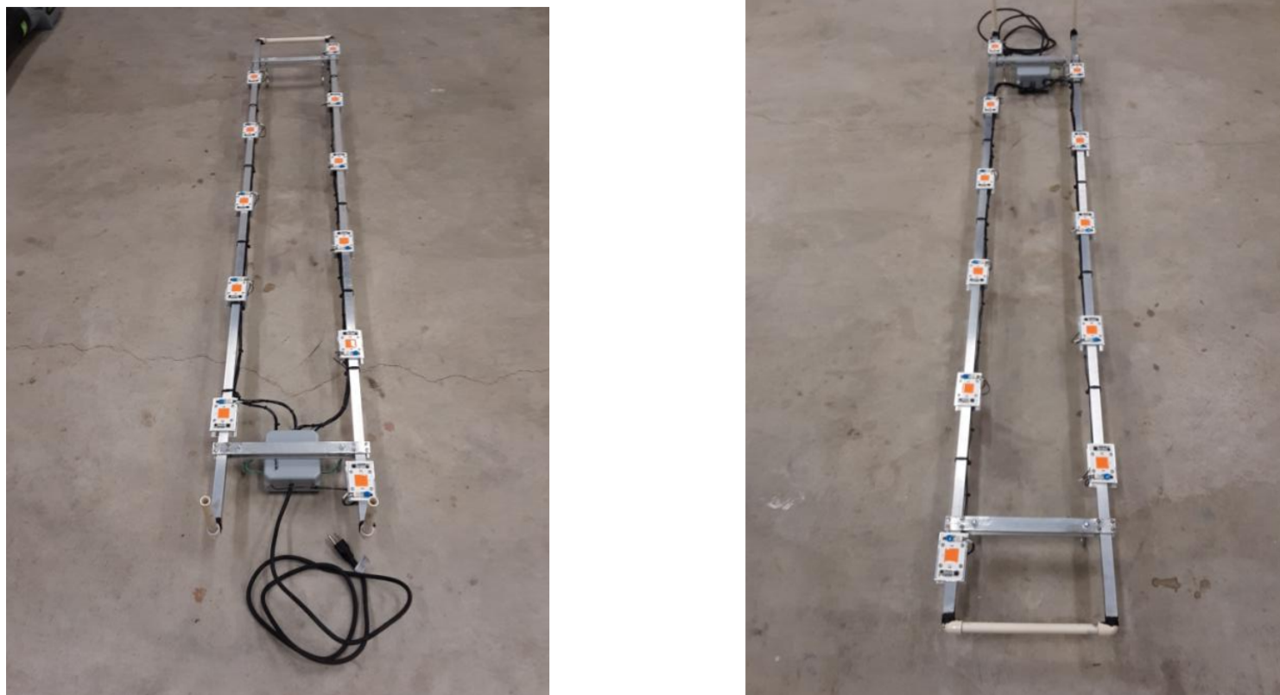
It looks like a lot of wiring, but it is just a simple 4” plastic electrical box with a couple of terminals that you can purchase cheaply online. Just screw on each wire. There is a fuse for additional protection and I am assuming this will be plugged into a GFCI outlet designed to protect things plugged into an outdoor plug.
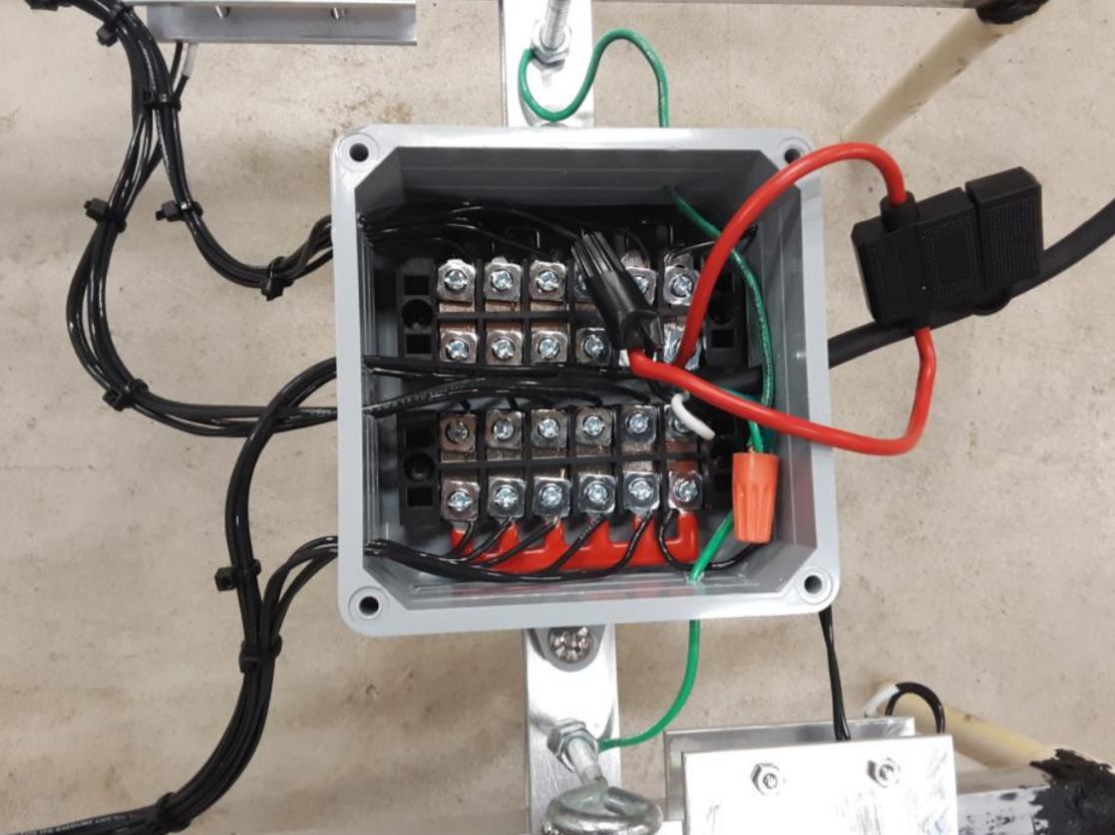
My next step was to test the unit. The yellow top storage container is to hold the water for the cooling. The plastic tubing runs from the bin to the light setup. There is a simple hydroponic pump in the container to pump the water up to the lights and then it comes back down to the container
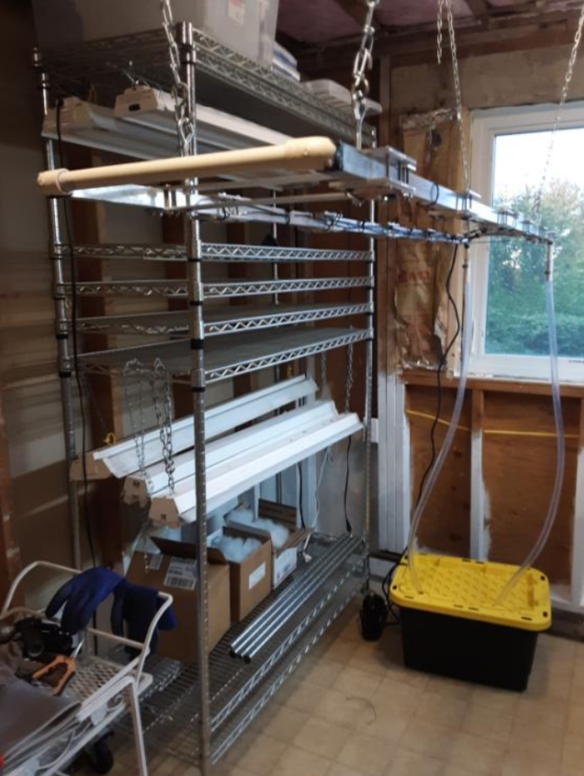
This unit was built for a friend and was designed to fit the space and plants in his growing area. It can be built in many configurations as a person wishes to have. It can be used indoors or outdoors in a greenhouse setting. This unit was about 500 watts and cost about $150 to build.
As I said previously, I have omitted several details, but wished to pique someone’s interest on what can be done if you wished to improve the health and growth of your orchids during our seasonal sunshine doldrums. I can say that without a doubt, adding lights for this part of the year has made a significant improvement of my plants and definitely the amount of blooms on many of my orchids.
So there you have it. A DIY system of LED lighting for your growing area.

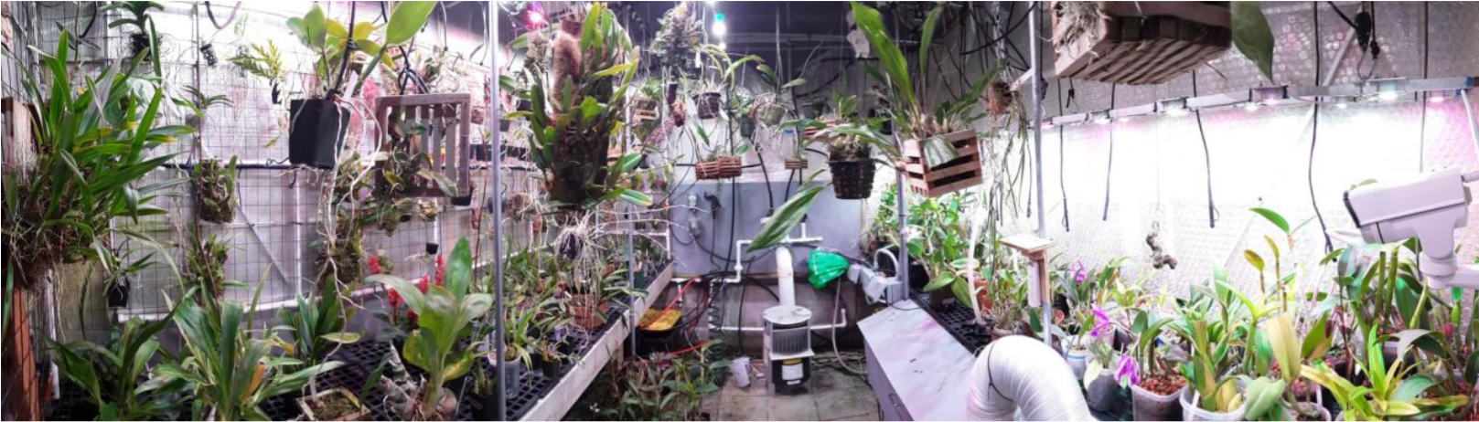

How and when Do I Water My Orchid?

By Steve Dorsey, Stevertd2010@gmail.com
It seems like such a simple question. Yet more orchids are killed by improper watering than any other reason. If you research your particular orchid online, you may find a variety of answers to that question. Why is this so?
WHEN? Most of the orchids that are grown are epiphytes. They don’t dry out and wilt immediately like the annual bedding plants will. The roots have a spongy layer on them that absorbs and holds water on the roots and the leaves have a stronger structure preventing collapse in drier periods. It’s all about understanding the drying cycle needed for epiphytes. Some orchids have large storage vessels which are named pseudobulbs and others none, so another factor of when to water. If kept wet and if they are submerged in media, they can rot easily. And depending on the orchid and its natural habitat, this cycle of drying can vary depending on the time of year. The more active the growth of the plant is, the higher the need for water. Winter time usually has slower growth, so you must allow for longer periods of drying for most plants due to the cooler temps and less sunlight. Plants like Phaleanopsis and Vandas don’t have pseudobulbs, and grow all year, so they may need more watering whereas Cattleyas do better even drier in winter as they slow down and have reserves to handle that.

One of the factors of the root wetness is media Media varies quite a bit. There is no perfect media or mix. You have to learn what works in your environment and find what you like to grow in. Indoor growers might need media that retains water longer than greenhouse growers with higher humidity. You will have to adjust to the media and needs of each plant.

Below are before and after watering images. On the left are healthy green tips of the roots and the root surfaces are a light gray. On the right the roots have turned green after watering. If the roots remain brown and don’t change color, they are not absorbing the water and are possibly dead roots or have significant rot.

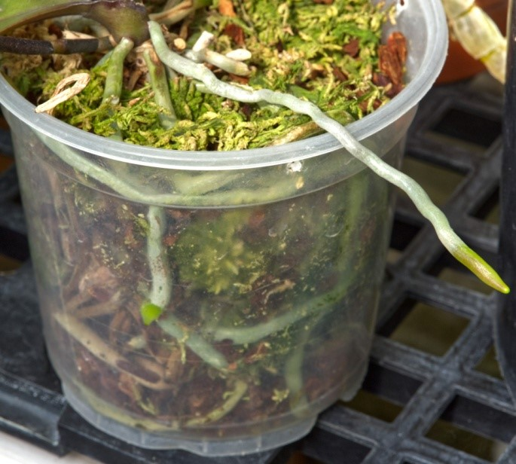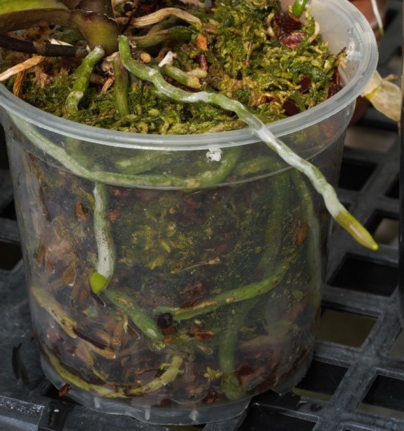
Age of the media will also affect how long you can go between watering. As it breaks down, it will stay wet for a longer time. The amount of drainage in the pot and size of drainage holes can slow or speed down the time. Sphagnum moss can retain water for a longer time than bark. Having clear pots as shown above are a good way to visually tell about how dry the plant is. You can also gauge by the weight of the plant when first watered and after it dries. If you have a wooden dowel or skewer, place it deep into the pot and look at how wet it is. Sometimes if the plant has been in the media for a long time, removing and inspecting the roots can provide a lot of information about the health of the roots and the status of the media. You might be surprised at what you learn and also discover many plants that need to be repotted.

It is usually best to water in the morning as this allows time for the plant to dry on the leaves which, especially during the winter months, reduces the risk of infection or fungus. Again, the amount of time between watering depends on the media, how it is grown – mounted, basket, in a pot, and the humidity of the environment. Indoors with the heat on dries it out quicker.
HOW? I often am asked if orchids should be soaked in water or water poured in them. As the media ages, more material accumulates in the media including the salts from fertilizers applied. It is very important to thoroughly flush out the debris and salts at least once a month to remove these. Soaking doesn’t do this, so a good amount of water flowed through the media is best. Mounted plants don’t have this issue as much, but a good rinse helps them also.

Avoid wetting the leaves as much as possible during cooler times and on overcast days. The plants can’t absorb the water as well and extended times of wetness on the leaves and crevices will leave them more susceptible to disease. Air movement really helps with this. Fans are great if possible.

As the seasons vary, so does the need for watering. When in doubt, try less water with greater times between watering when cooler and darker times. When the plant is growing rapidly with warmer temps and brighter conditions, they will be able to use more frequent watering. Some plants require a rest period of no water, so it is best to do some research and learn of your plant’s needs.

It’s a process of learning and feedback from your plants. Enjoy the journey and happy growing.
Native Orchid Conference on Olympic Peninsula, June 2022

The Native Orchid Conference, an organization with members in the US and Canada, will host a four-day symposium on the Olympic Peninsula, June 24–27, 2022. There will be two days of field trips and two days of talks. This is a great opportunity to learn about Washington’s native orchids. For details see Symposium | Native Orchid Conference | Native Orchids. Registration is limited to 100.

The NOC fosters the study, conservation, and enjoyment of native orchids of the United States and Canada. Anyone interested in wild orchids can join.

After the Olympic Peninsula conference was twice postponed because of the pandemic, the NOC began monthly Zoom meetings on native orchid topics. The most recent was on orchid conservation in Illinois. Another that I found of particular interest was orchids of Newfoundland. Details on these presentations are on the NOC web site.

Kathy Murray

Report From The October Meeting

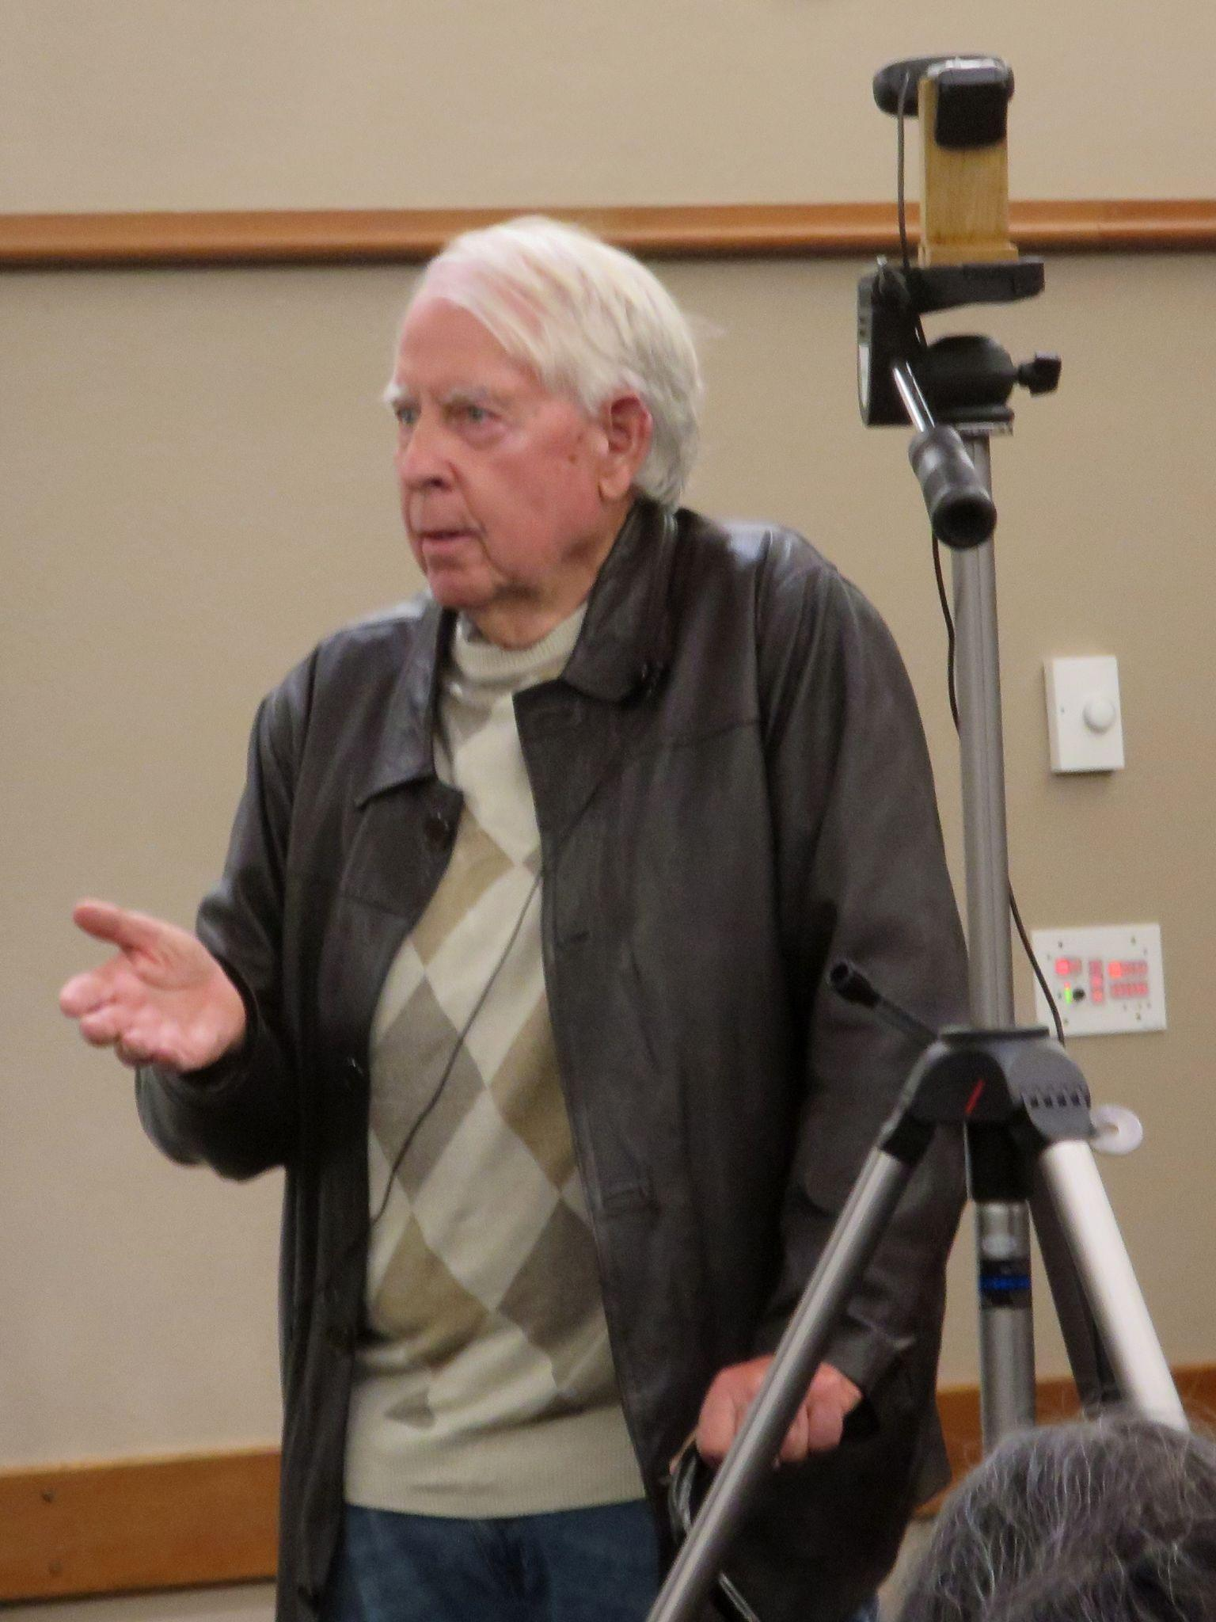
President Joe Grienauer opened the meeting by welcoming folks who were joining us for the first time. George Grantham gave an update on our recent show and sale at the Volunteer Park Conservatory. Gordon Cromwell updated us about the upcoming NW Flower & Garden Festival and our plans for a garden which will include a real greenhouse. Thuan Nguyen reviewed how the exhibits turned out at the recent Washington State Fair. He handed out ribbons to many participants who won not just ribbons, but cash prizes for their blooming plants. Joe presented the report from the Nominating Committee and member Joff added additional information about the slate of Officers and Directors.
We then had our main presentation by Andy Easton on the topic of Warmth Tolerant Cymbidiums. He showed many small Cymbidiums and included some of the important species like ensifolium, madidum, parishii, aloifolium and so on. He then included a number of the medium growing hybrids. Andy also spoke about the timing of blooming for various seasonal considerations such as Christmas and Mother’s Day.

After his talk, Andy took many questions from the audience. He also generously donated many cymbidium plants to our raffle table which made it quite special.
Andy is also a frequent contributor to the Odontoglossum Alliance. You can read his contributions in their online journal here: Odontoglossum Alliance

Steve Dorsey stepped up as our Orchid Basics speaker. His topic “I’ve got this new plant. Now what do I do?” addressed many of the concerns people have after acquiring plants at our big sale as well as our two recent bountiful raffle tables. He reviewed how to inspect your plant for pests, physical damage and root condition. He also covered repotting with clean techniques and tools, using disinfectant, fungicides and pesticides as appropriate. It was a very practical and thorough guide.

Ben Johnson reviewed the plant table.

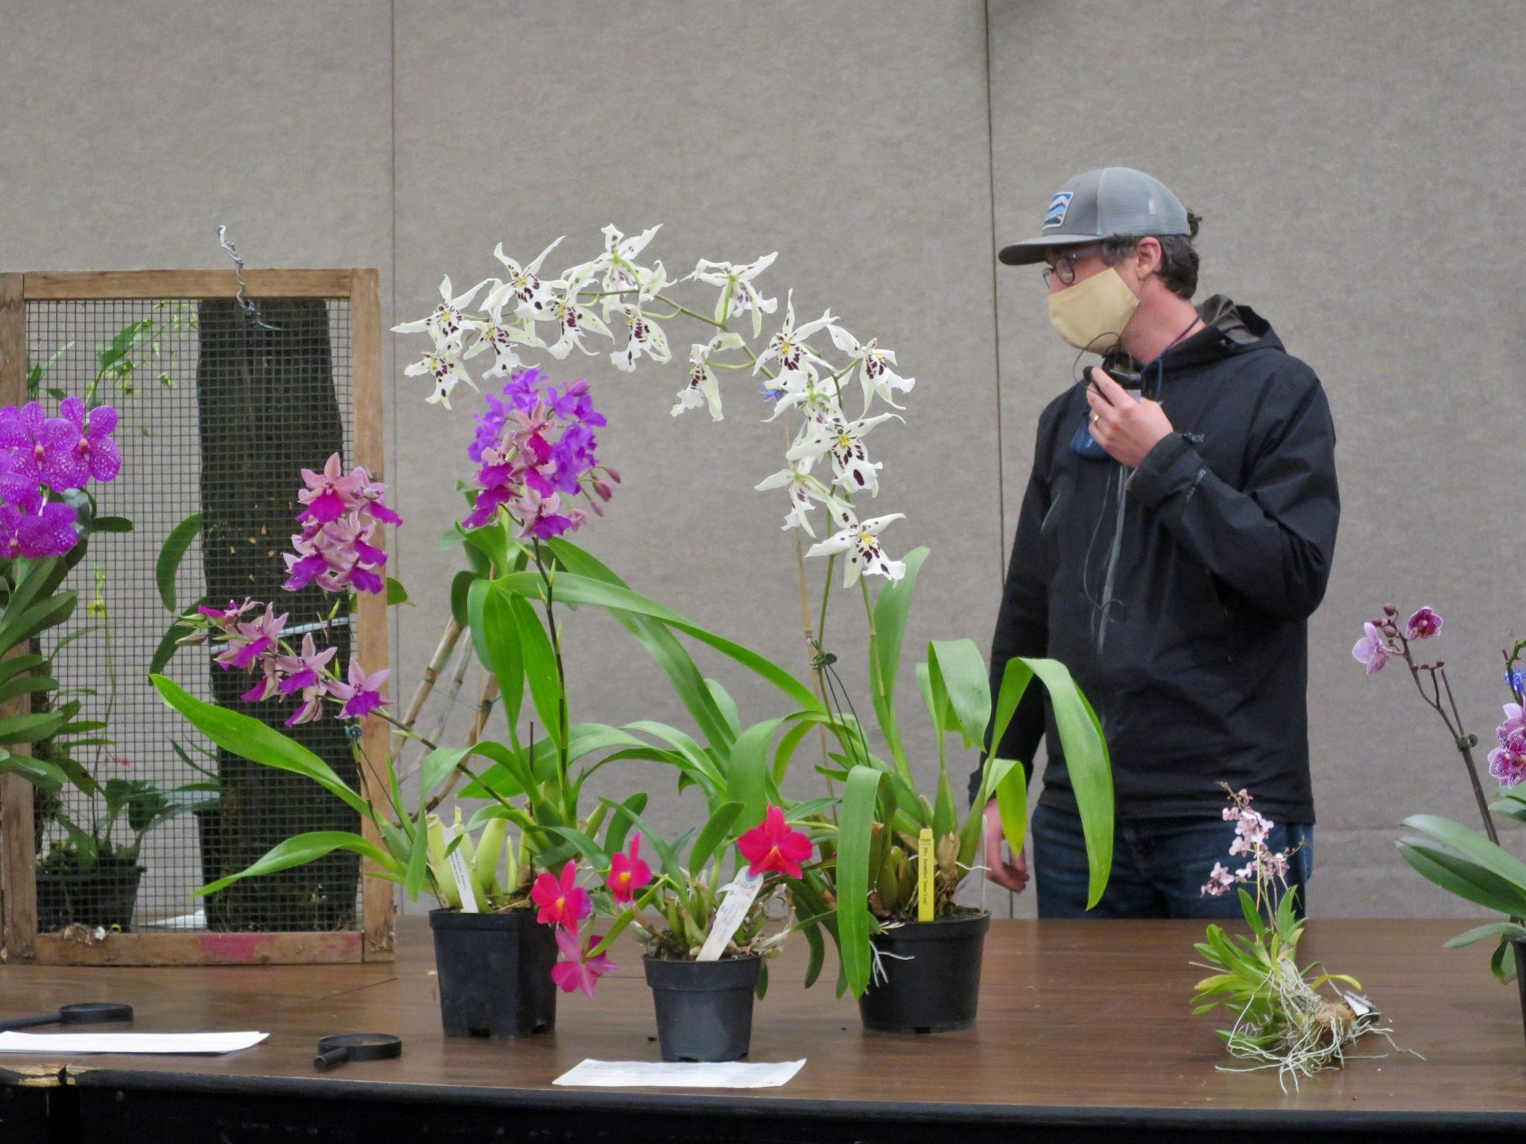

To top off the evening, Joff recruited a special presenter to help him with our Raffle. Violet, who is Yoshi Nagamatsu’s daughter, did a wonderful job of picking and calling out the winner’s of our raffle.
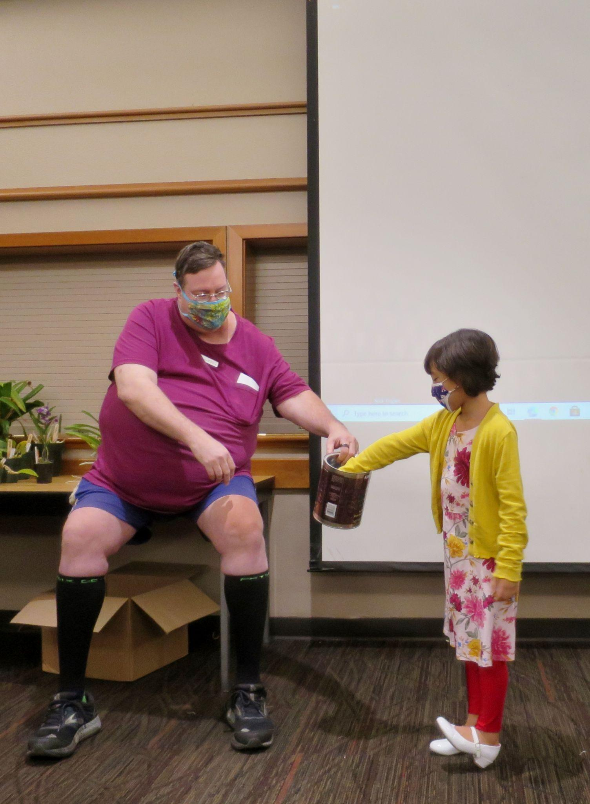
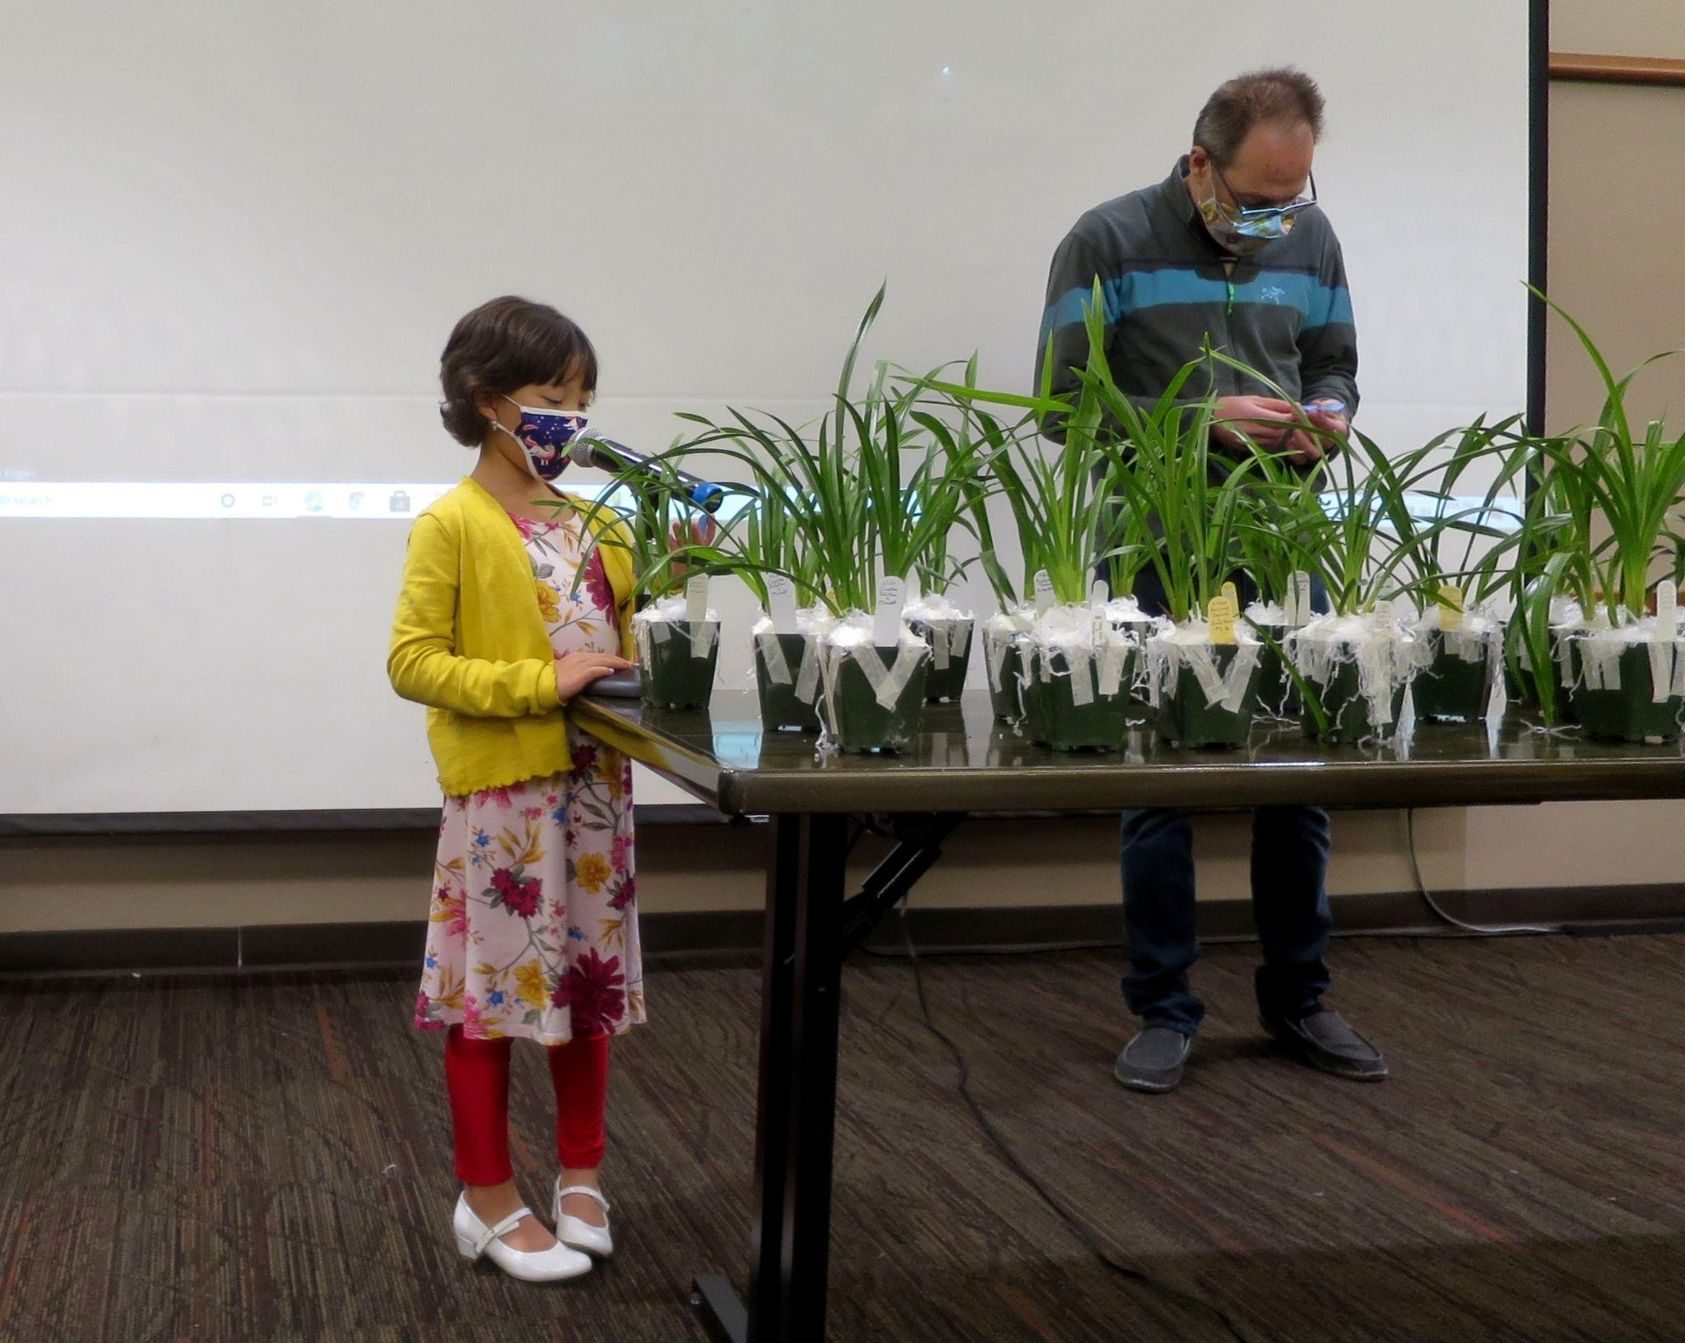

These are several selected images from the October meeting. To see the rest of the photos of October's plant table, please follow the link to go to the online gallery.

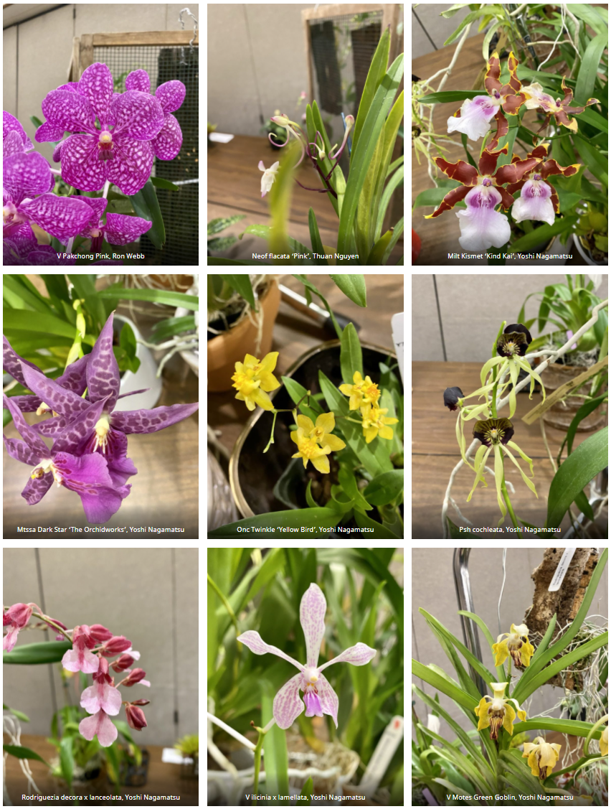

Schedule of Upcoming Events

11/8/21 - NWOS meeting - Speaker: Ron Parsons, “Rarities And Oddities Of The Orchid World”

12/13/21 – NWOS meeting – Speaker: David Edgley, “Novelty Phalaenopsis Breeding'', Scholarship Recipient Report, introduction of new Officers, NWOS Annual Meeting report, Schoenfeld and Northen Orchid Awards, and Holiday Plant gifts. Unfortunately we will not be able to have our traditional Holiday Potluck dinner this year.

01/10/22 – NWOS meeting - Speaker: Theresa Hill, “Paph charleswothii a Giant Among Miniatures”

02/14/22 – NWOS meeting - Culture Seminar & Sale

03/14/22 – NWOS meeting - Spring Auction

04/11/22 – NWOS meeting - Speaker: Kelly McKracken, “Artificial Lighting”

05/09/22 – NWOS meeting - Speaker: Tyler Albrecht, “An Exploration of the Fluffy and Puffy Parvisepalum Paphiopedilums”

Reminder for Officers & Board Members

The schedule for the remaining board meetings for this membership year is: 11/2/21 at 7 p.m. at Mike & Sheila Cory's house.

The next board meeting is January 6th which will be a transitional meeting consisting of both outgoing and incoming Officers and Board members. Meet at 7 p.m. at a location to be determined.

Shopping on Amazon? Use this link to earn $$ for the NWOS

If you go to https://smile.amazon.com and sign in to your account, you'll be given information about supporting various non-profits. You can type in "Northwest Orchid Society" and it will then send .5% of your purchase price to the organization.

It's really easy, but you have to remember to go in through the 'smile' subdomain when you place the order, otherwise it will go through as a regular order.

NWOS Website Links

- Main website: Http://www.nwos.org
- Events Calendar: http://www.nwos.org/events
- Membership (including renewals): https://nwos.org/Membership/
- Newsletter - Current Issues: https://nwos.org/newsletters/
- Newsletter - Archived Issues: http://newsletter.nwos.org
- Show Information: http://nwos.orchid-society.net/ShowTime/Show2021/Show.html
- Facebook: http://www.facebook.com/nworchidsociety
- Instagram: https://www.instagram.com/nworchidsociety/
- Twitter: https://twitter.com/nworchidsociety

©2021 Northwest Orchid Society - All Rights Reserved

The opinions and recommendations published herein are those of the authors. The Northwest Orchid Society disclaims responsibility for any losses or damages that may be attributed to the use or misuse of any material or any opinion published in these articles and on the website. This website and the photographs, articles and content are protected by copyright and no part of them may be reproduced or re-used without the permission of the author.

