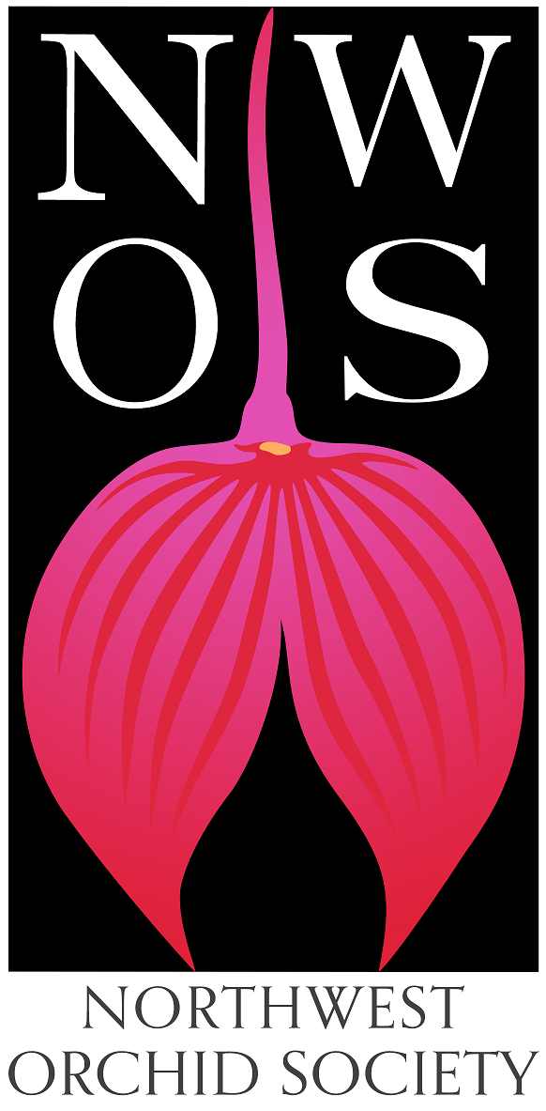
Northwest
Orchid News
May 2023
Volume 76, Issue 5

- About the May Meeting
- Speaker: Ron Parsons, “The Genus Dendrobium"
- Plant Table
- Sales Table
- Raffle Table
- NWOS Library
- June Social
- Potting Clinic - Saturday May 13th, 9 am - 2 pm
- Volunteer Opportunities
- Oregon Orchid Society Show and Sale
- Discover Dazzling Mini Dendrobiums
- Report From The April Meeting
- Local Judging
- Schedule of Upcoming Events
- Reminder for Officers & Board Members
- NWOS Website Links
- Special Announcements

About the May Meeting
May 8, 2023, 7 PM
University of Washington Center for Urban Horticulture
3501 NE 41st Street, Seattle, WA 98105
Hybrid Meeting, In person and via Zoom Zoom Registration
Doors open at 6:00 PM
Zoom Stream starts at 6:30 PM
Meeting starts at 7:00 PM

We will be meeting in person for the foreseeable future.

Speaker: Ron Parsons, “The Genus Dendrobium”
Ron Parsons has been growing orchids for nearly 48 years, and has been interested in the species for most of that time.

He loves to photograph orchids and other flowers whenever he can and does so as often as possible. Ron has more than 90,000 digital images, most of which are of orchids, and still retains a slide library that exceeds 100,000 botanical images.

He has given more than 500 talks on various botanical topics and has nearly 6500 published photos.

Ron has co-authored four books on botanical subjects, all with Mary E. Gerritsen:

- The first two, published by Timber Press, are “Masdevallias, Gems of the Orchid World” and “Calochortus, Mariposa Lilies and their Relatives.”
- Their third book, a two-volume set, “A Compendium of Miniature Orchid Species" was published by Redfern Natural History Productions in January 2014. In 2019
- “The American Orchid Society Guide to Orchids and their Culture” was released and is in its third printing.
- They have recently completed a fifth book, a much-revised second edition of “A Compendium of Miniature Orchids Species.” It is now in four volumes with 3100 photos (1800 of those are new), including those of more than 500 species not in the first edition. The set was released in early October 2021.

Plant Table

We will be having an in-person plant table this month. For your convenience, you can print out a Plant Table Information Form ahead of time. Click for your version of choice: PDF or DOCX file?

For those who aren’t able to attend, please keep sending your pictures, we will include them in our online gallery and in next month’s newsletter. Please send them to photos@nwos.org.

Sales Table

Members may bring up to 10 plants to sell. Include an extra tag with your name and the price in the plant.

Raffle Table

The raffle will be held as usual. Win a new orchid for your collection while supporting the Scholarship Fund. If you have any extra Orchids, please consider donating them to the raffle.

NWOS Library

If you'd like to check out a book or tape from our Library, please contact our Librarian Joe Grienauer a minimum of 2 weeks before the next meeting. Besides email, you can give Joe your request at any meeting. For a list of library items please click here NWOS Library.

June Social

We will be having a food truck provide the food for our June Social again. Details on the food truck are upcoming.

The rest of the activities for the evening will be:
- Socializing!
- Presentation of The Gary Baker Service Award
- Plant Table
- Raffle
- More Socializing!

It will be a fun evening, so be sure to join us.

Potting Clinic - Saturday, May 13th, 9 am - 2 pm

The NWOS held a very successful potting clinic in March. So, we’re going to host another event, this time, in Woodinville. Here are the details:

Sat May 13 from 9 am – 2 pm
Molbak’s Garden + Home
13625 NE 175th St, Woodinville, WA 98072
Join us on the Saturday before Mother's Day between 9 am and 2 pm at Molbaks in Woodinville. They have one of the largest indoor plant selections available in the pacific northwest.
There will be a class available on Orchid basics, as well as a potting clinic where members will be on hand to help you re-pot your plants, talk about potting orchid health and culture, and give you insight as to what your orchid might be telling you.
Admission to the potting event is free to the public. The cost per repot is $5 per plant (limit 3 average-sized orchids), which includes the pot and media and can be applied towards becoming a new member of the Northwest Orchid Society
These clinics have always been popular. Our most experienced members give expert advice on all aspects of repotting your orchids:
- Determine whether and when your orchid needs to be repotted. This can vary by species and time of year.
- Diagnose potting problems, such as root loss and decomposition of potting mixes, over-potting, and under-potting.
- Choosing the right pot type and size.
- What’s the best potting mix for your particular orchid?
- Can it be mounted?
- How your environment and watering habits can affect these choices.
Come with questions, get some answers, and some hands-on experience, with guidance from our volunteer members. Potting media and some pots will be available on-site.
It’s an afternoon of fun and learning, and your orchids will thank you
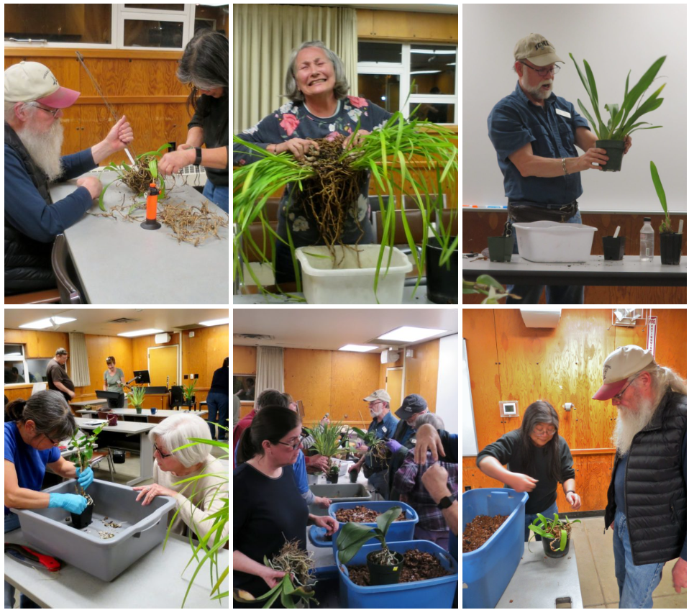

Volunteer Opportunities

We are looking for a couple of volunteers to help with some outreach and multimedia for the society. If you are interested contact Robert Culver.

Membership Committee
Sean Hoyt, our Secretary, is forming a membership committee to study the addition of some additional membership levels to our existing levels. This is in an effort to help promote awareness of our society with businesses and sponsors, etc. If you would be interested in participating in the design of these levels please contact Sean directly at secretary@nwos.org.

Sales and Marketing on Social Media
Currently, Julian Branbury, Ben Johnson, and Robert Culver are managing postings on our social media sites. We are looking for a volunteer that will work with them to coordinate Sales and Marketing targeted postings on Social Media. These will focus on our major events such as our shows and clinics. If you are interested please contact events@nwos.org or speak to Ben or Robert.

Vision 2030 Committee
We are forming a new committee that will meet over the summer to prepare a new vision statement and along with that, a direction for the society as we head into the future. We are asking for a few members to join us in charting this course. Please let us know if you’re interested by sending an email to Robert Culver at robert.c@nwos.org.

Oregon Orchid Society Show and Sale

Ben Johnson took down a display for us to the OOS Show and Sale. George and Cylvia Grantham, as well as Lillian Otani were also down there to help with the display and were a huge help in getting our display installed.

Here are some images from our display and around the show.
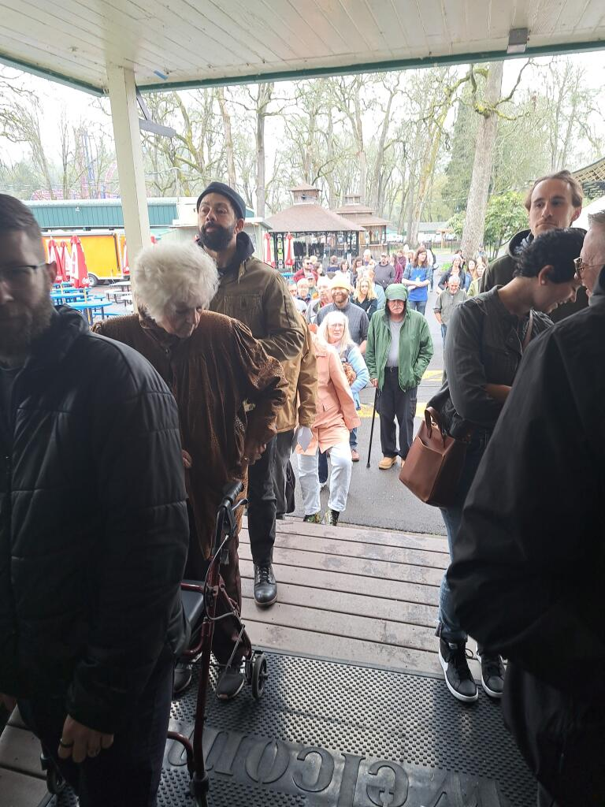
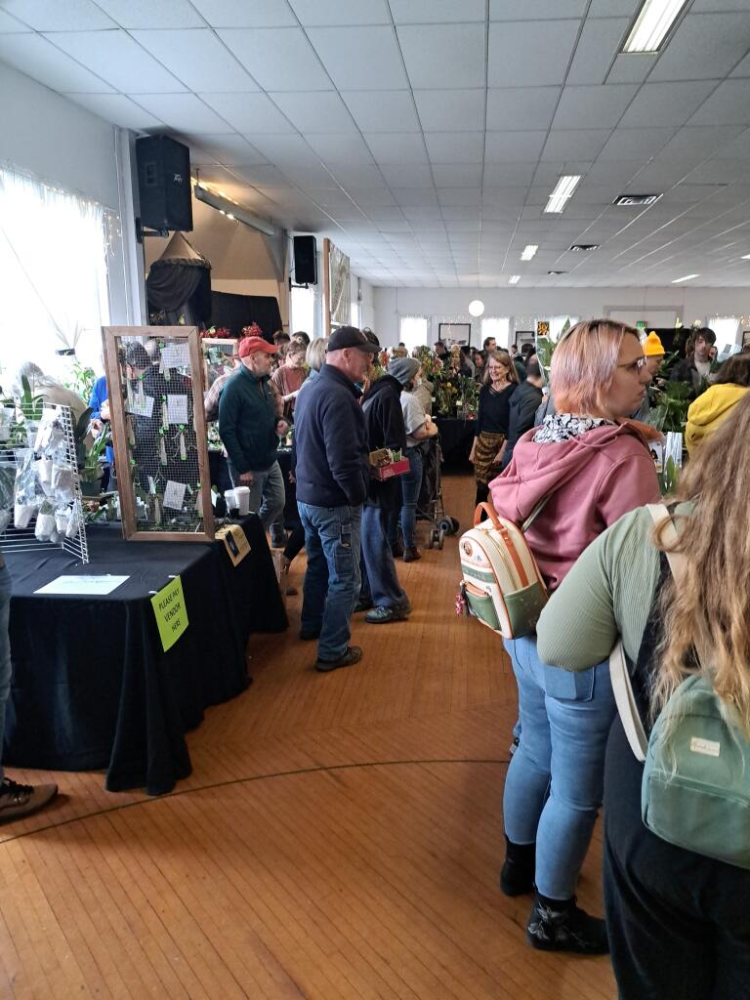

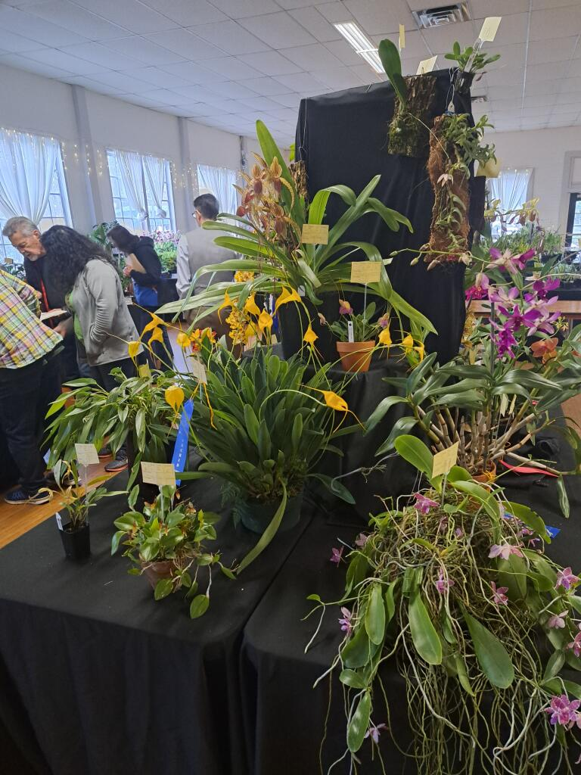
NWOS Display
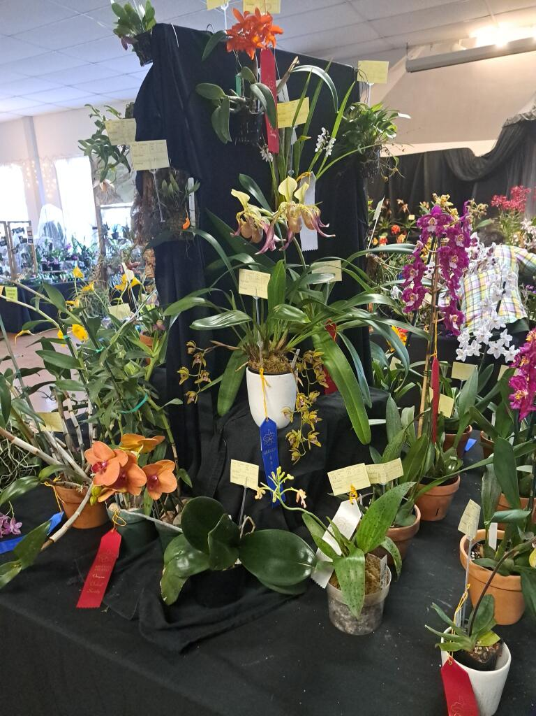
NWOS Display
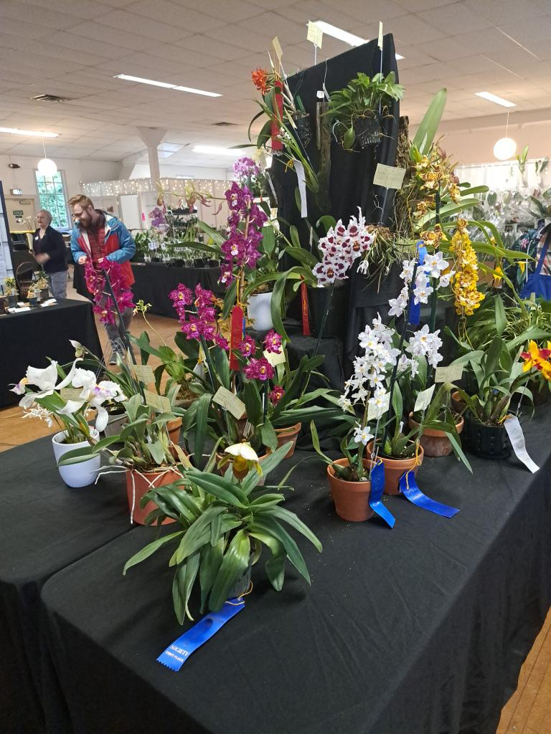
NWOS Display
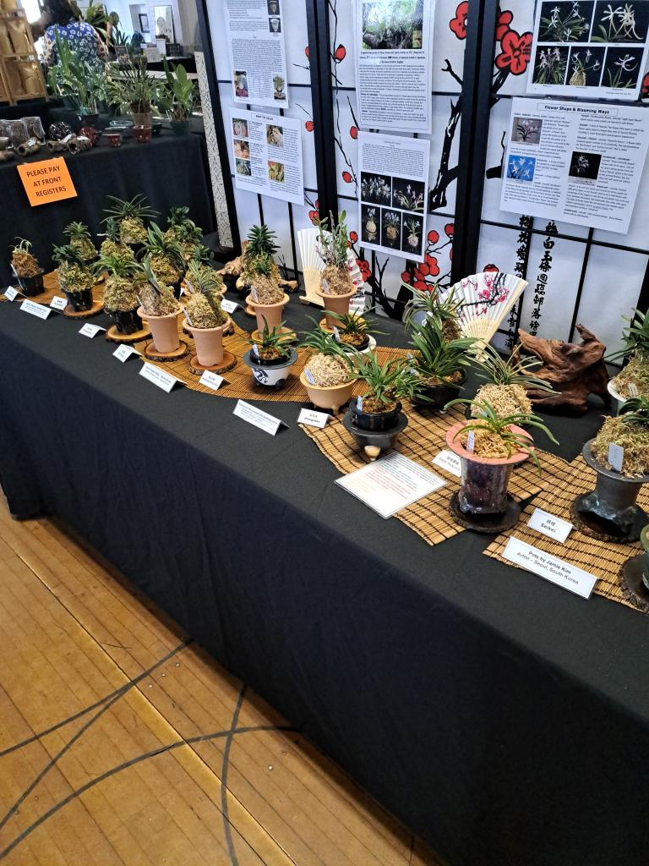
Education Display - Neofinetia falcata
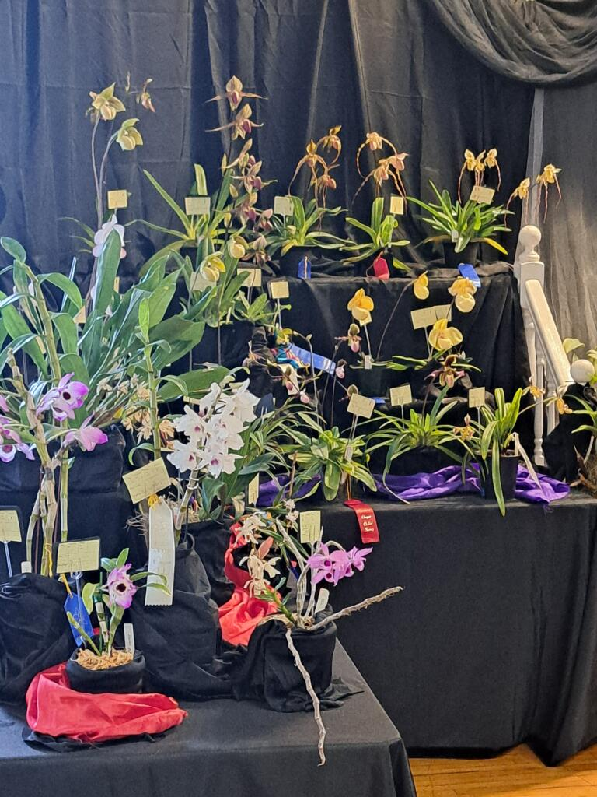
OOS Display
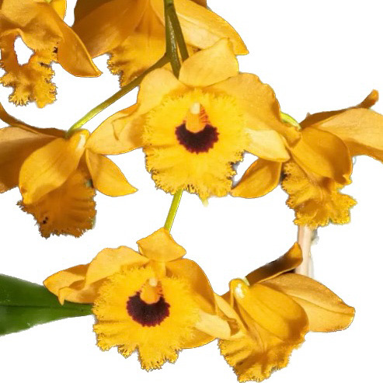
Dedrobium fribriatrum var oculatum

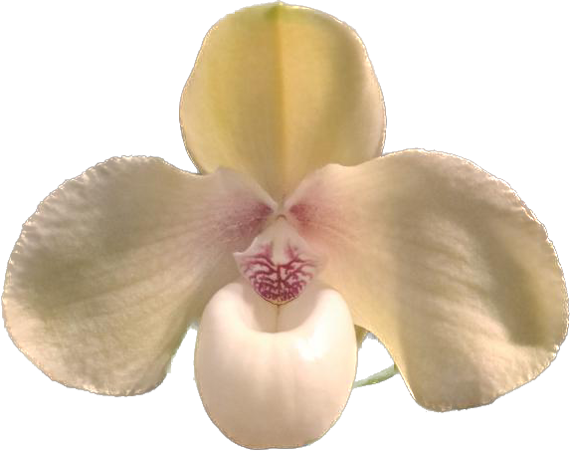
Paph hangianum
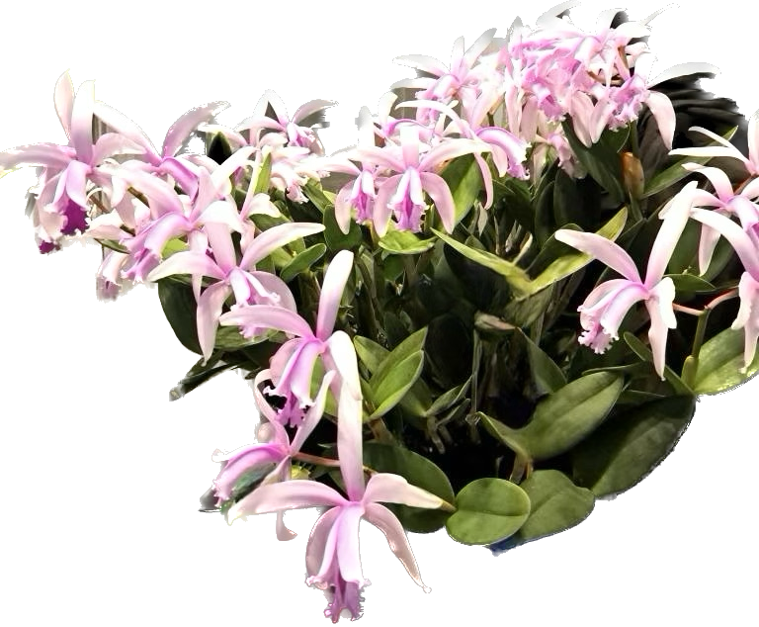
Cattleya intermedia

Discover Dazzling Mini Dendrobiums: A Compact Guide to Growing Petite Orchids in Your Home

As the popularity of orchids in the home has grown, so has the interest in cultivating a diverse range of these beautiful and exotic plants. Orchid enthusiasts are continuously seeking new and intriguing species to add to their collections, and miniature dendrobiums offer a perfect opportunity for those looking to explore the world of orchids in a more compact form.

These smaller orchids can easily be accommodated into the limited spaces of the home, making them an ideal choice for urban dwellers and those with limited growing areas. With a wide variety of species available, dendrobiums can adapt to a range of growing conditions, from warm and tropical to cooler, more temperate environments.

This care sheet offers a small sampling of miniature dendrobium species, grouped by their cultural requirements, to introduce you to the fascinating diversity these plants have to offer and help you successfully grow them in your home.
Here is a list of six miniature dendrobium species that adapt to culture in the home given the right cultural conditions, such as a bright window, an ‘IKEA Cabinet’, or under lights in a cool basement.
- Warm-growing miniature dendrobiums:
  - a. Dendrobium tanii
  - b. Dendrobium unicum
- Intermediate-growing miniature dendrobiums:
  - a. Dendrobium aggregatum (syn. Dendrobium lindleyi)
  - b. Dendrobium christyanum (dwarf type)
- Cool-growing miniature dendrobiums:
  - a. Dendrobium cuthbertsonii
  - b. Dendrobium lichenastrum

Cultural Requirements:
- Light: Bright indirect light (1,500 to 2,500 foot-candles)
- Temperature:
  - Warm-growing - 65°F to 85°F (18°C to 29°C) during the day, with a 10°F (-12°C) drop at night, in the winter allow the plant to cool additionally
  - Intermediate-growing - 55°F to 75°F (13°C to 24°C) during the day, with a 10°F (-12°C) drop at night
  - Cool-growing - 50°F to 70°F (10°C to 21°C) during the day, with a 10°F (-12°C) drop at night
- Watering: Keep the medium evenly moist, allowing it to dry slightly between waterings, some plants require a winter dormancy
- Fertilizing: Apply a balanced orchid fertilizer (20-20-20) every 2-3 weeks during the growing season, reducing it to once a month during winter, some plants require winter dormancy
Keep in mind that specific care requirements may vary slightly depending on the individual species and your local environment. It's essential to monitor your plants and adjust your care regimen as needed.

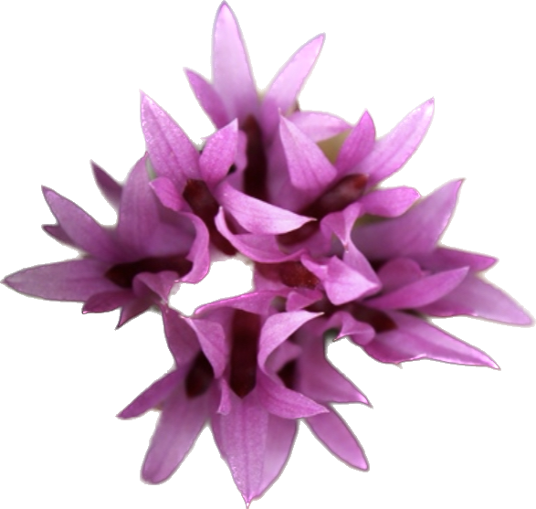
Dendrobium tanii

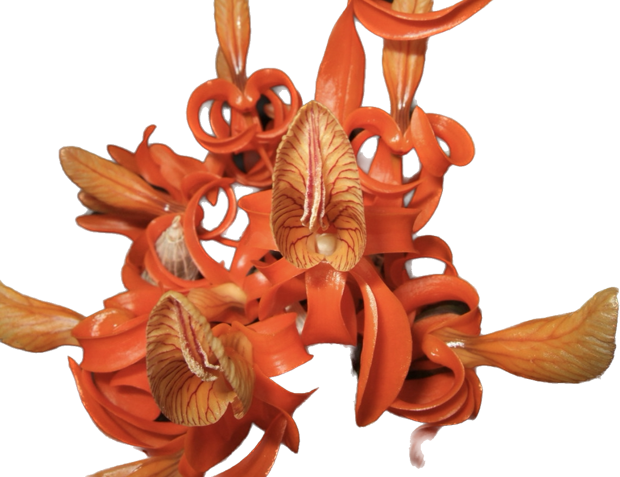
Dendrobium unicum
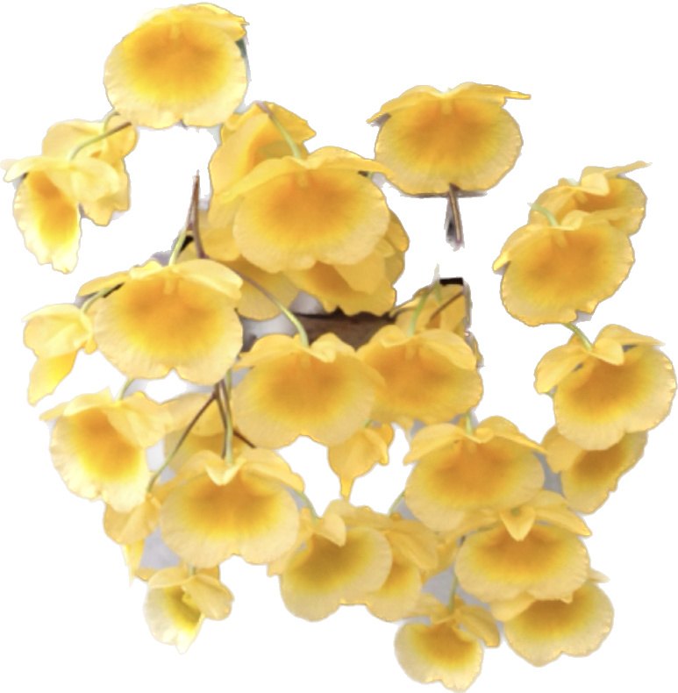
Dendrobium aggregatum
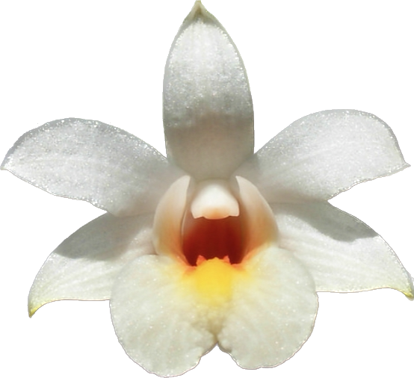
Dendrobium christyanum
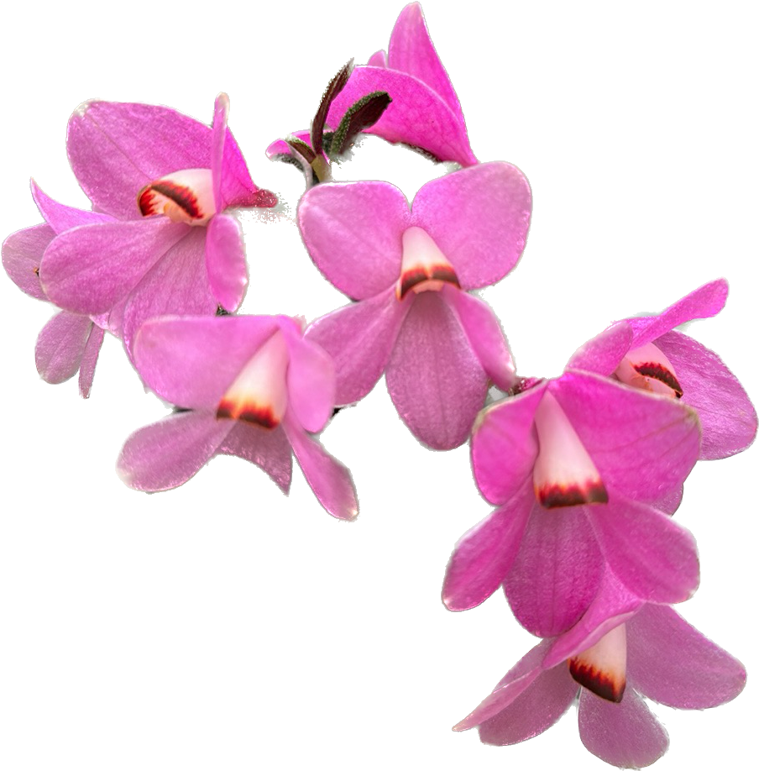
Dendrobium cuthbertsonii
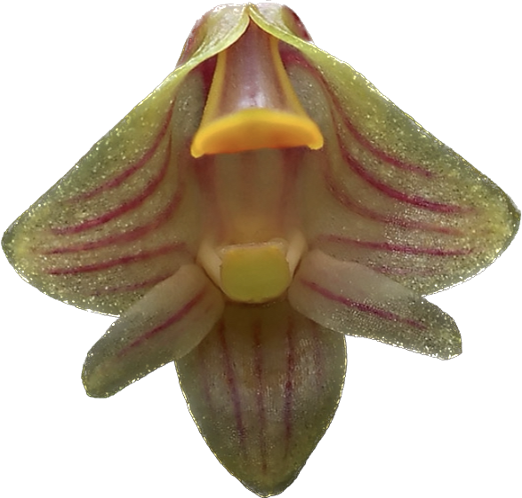
Dendrobium lichenastrum

Report From The April Meeting

Robert Culver opened the April meeting by welcoming everyone. He welcomed the new members and asked for the contact of members that had joined at previous meetings for which we have no contact information.

He then discussed the progress on a new membership system and the intent to have it live by the next meeting. This will allow members to manage their own memberships and will tie all of our various systems together.

Our Events VP, Ben Johson, gave us an update on the Spokane Orchid Society Show that we had recently attended and the upcoming Oregon Orchid Society Show, the Potting Clinic we will be having in May at Molbak’s, our fall show, and the new Indoor Plant Festival to be held next spring at the Lynnwood Events Center.

Our Education VP, Joe Grienauer, talked briefly about the NWOS library and what resources are available to members. He followed up with the Legion of Bloom and answered questions people had about that if they weren’t at the previous meeting or still had unanswered questions.
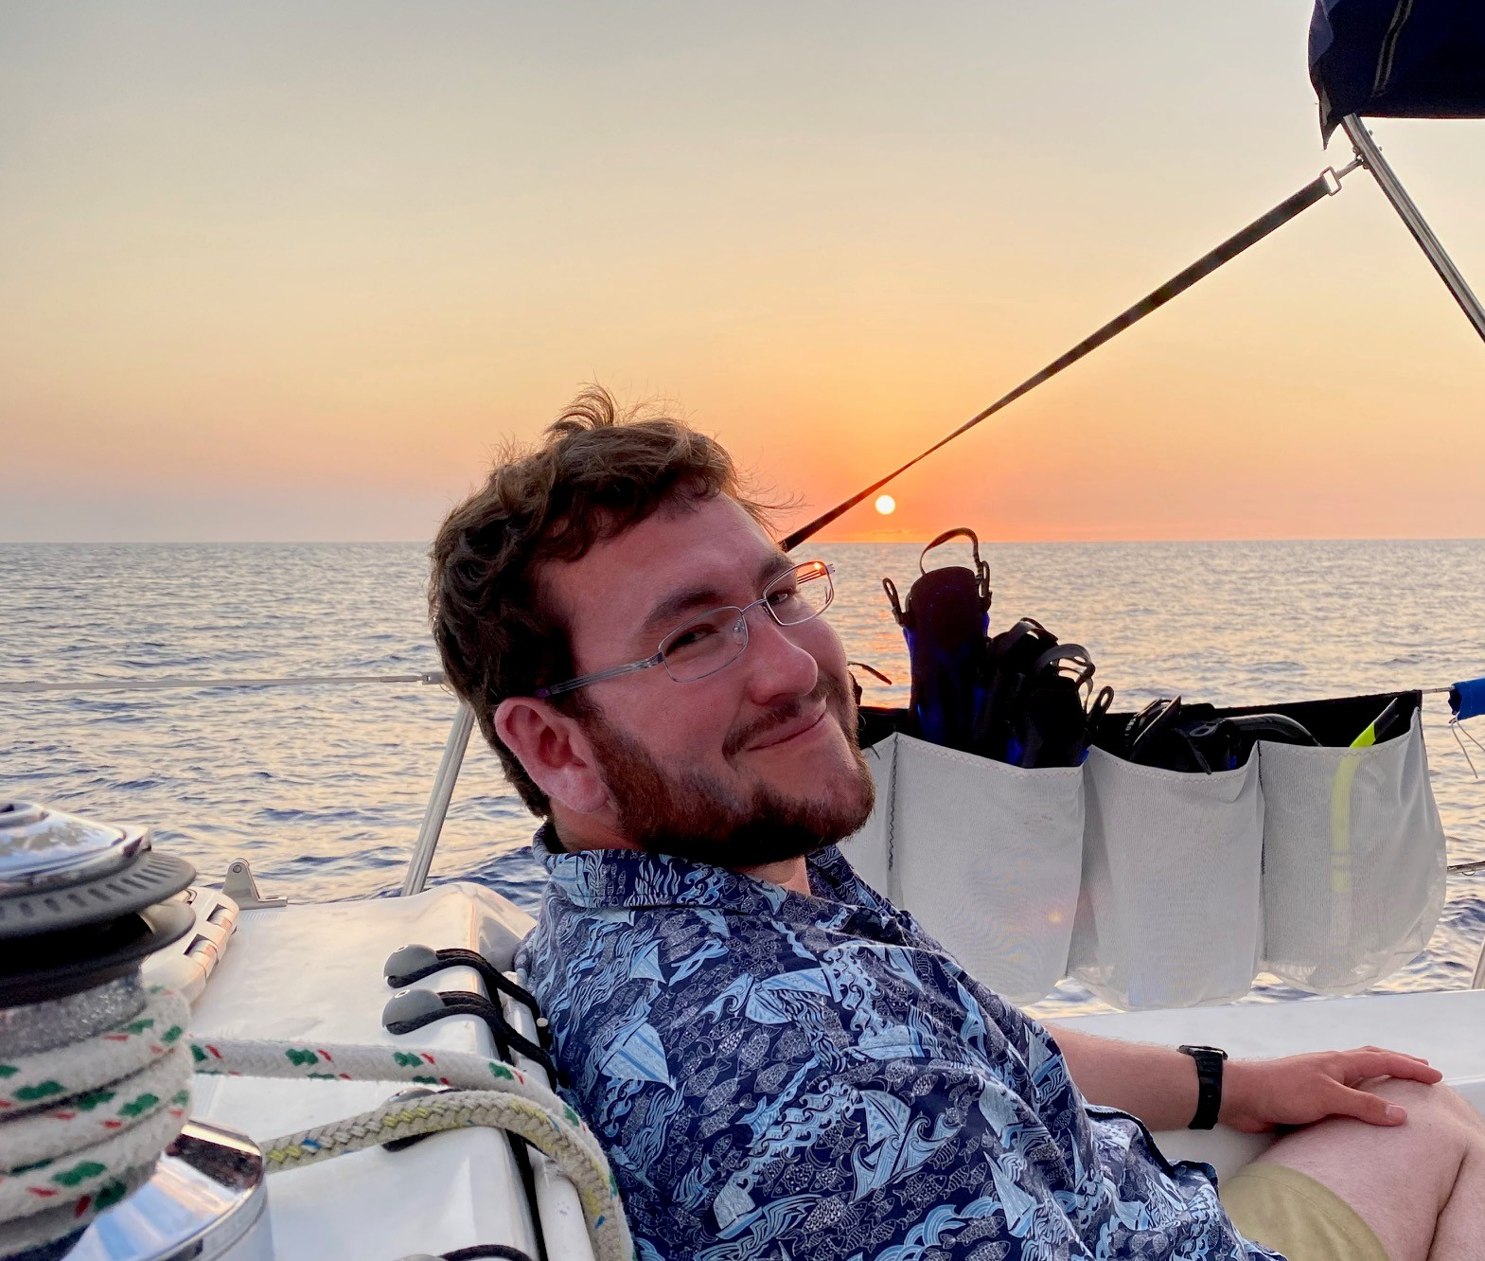
Jurahame Leyva, our speaker for the evening, and owner of The Orchid Fix Nursery Orchids from Hawaii | Wholesale/Retail | The OrchidFix spoke to us about modern trends in Paphiopedilum Maudiae hybrids. He reviewed the key species in this group of hybrids. He also discussed some of the individual plants that were selected during the hybridizing process that have yielded the spectacular results we see today. Many of the wonderful plants we see are a result of the breeding program carried on by Graham Wood at Lehua Orchids. Jurahame showed us many beautiful examples to illustrate the progress made in this group. As he was closing he introduced a number of smaller species and some of the hybrids that were a result of those crosses, showing that the development of this group is far from finished.

We then took a short break and returned to an excellent plant table hosted by this month’s guru Andy Wright assisted by Sean Hoyt and Julian Branbury.

We ended the evening with our raffle table.

Here are some shots from the Plant Table.

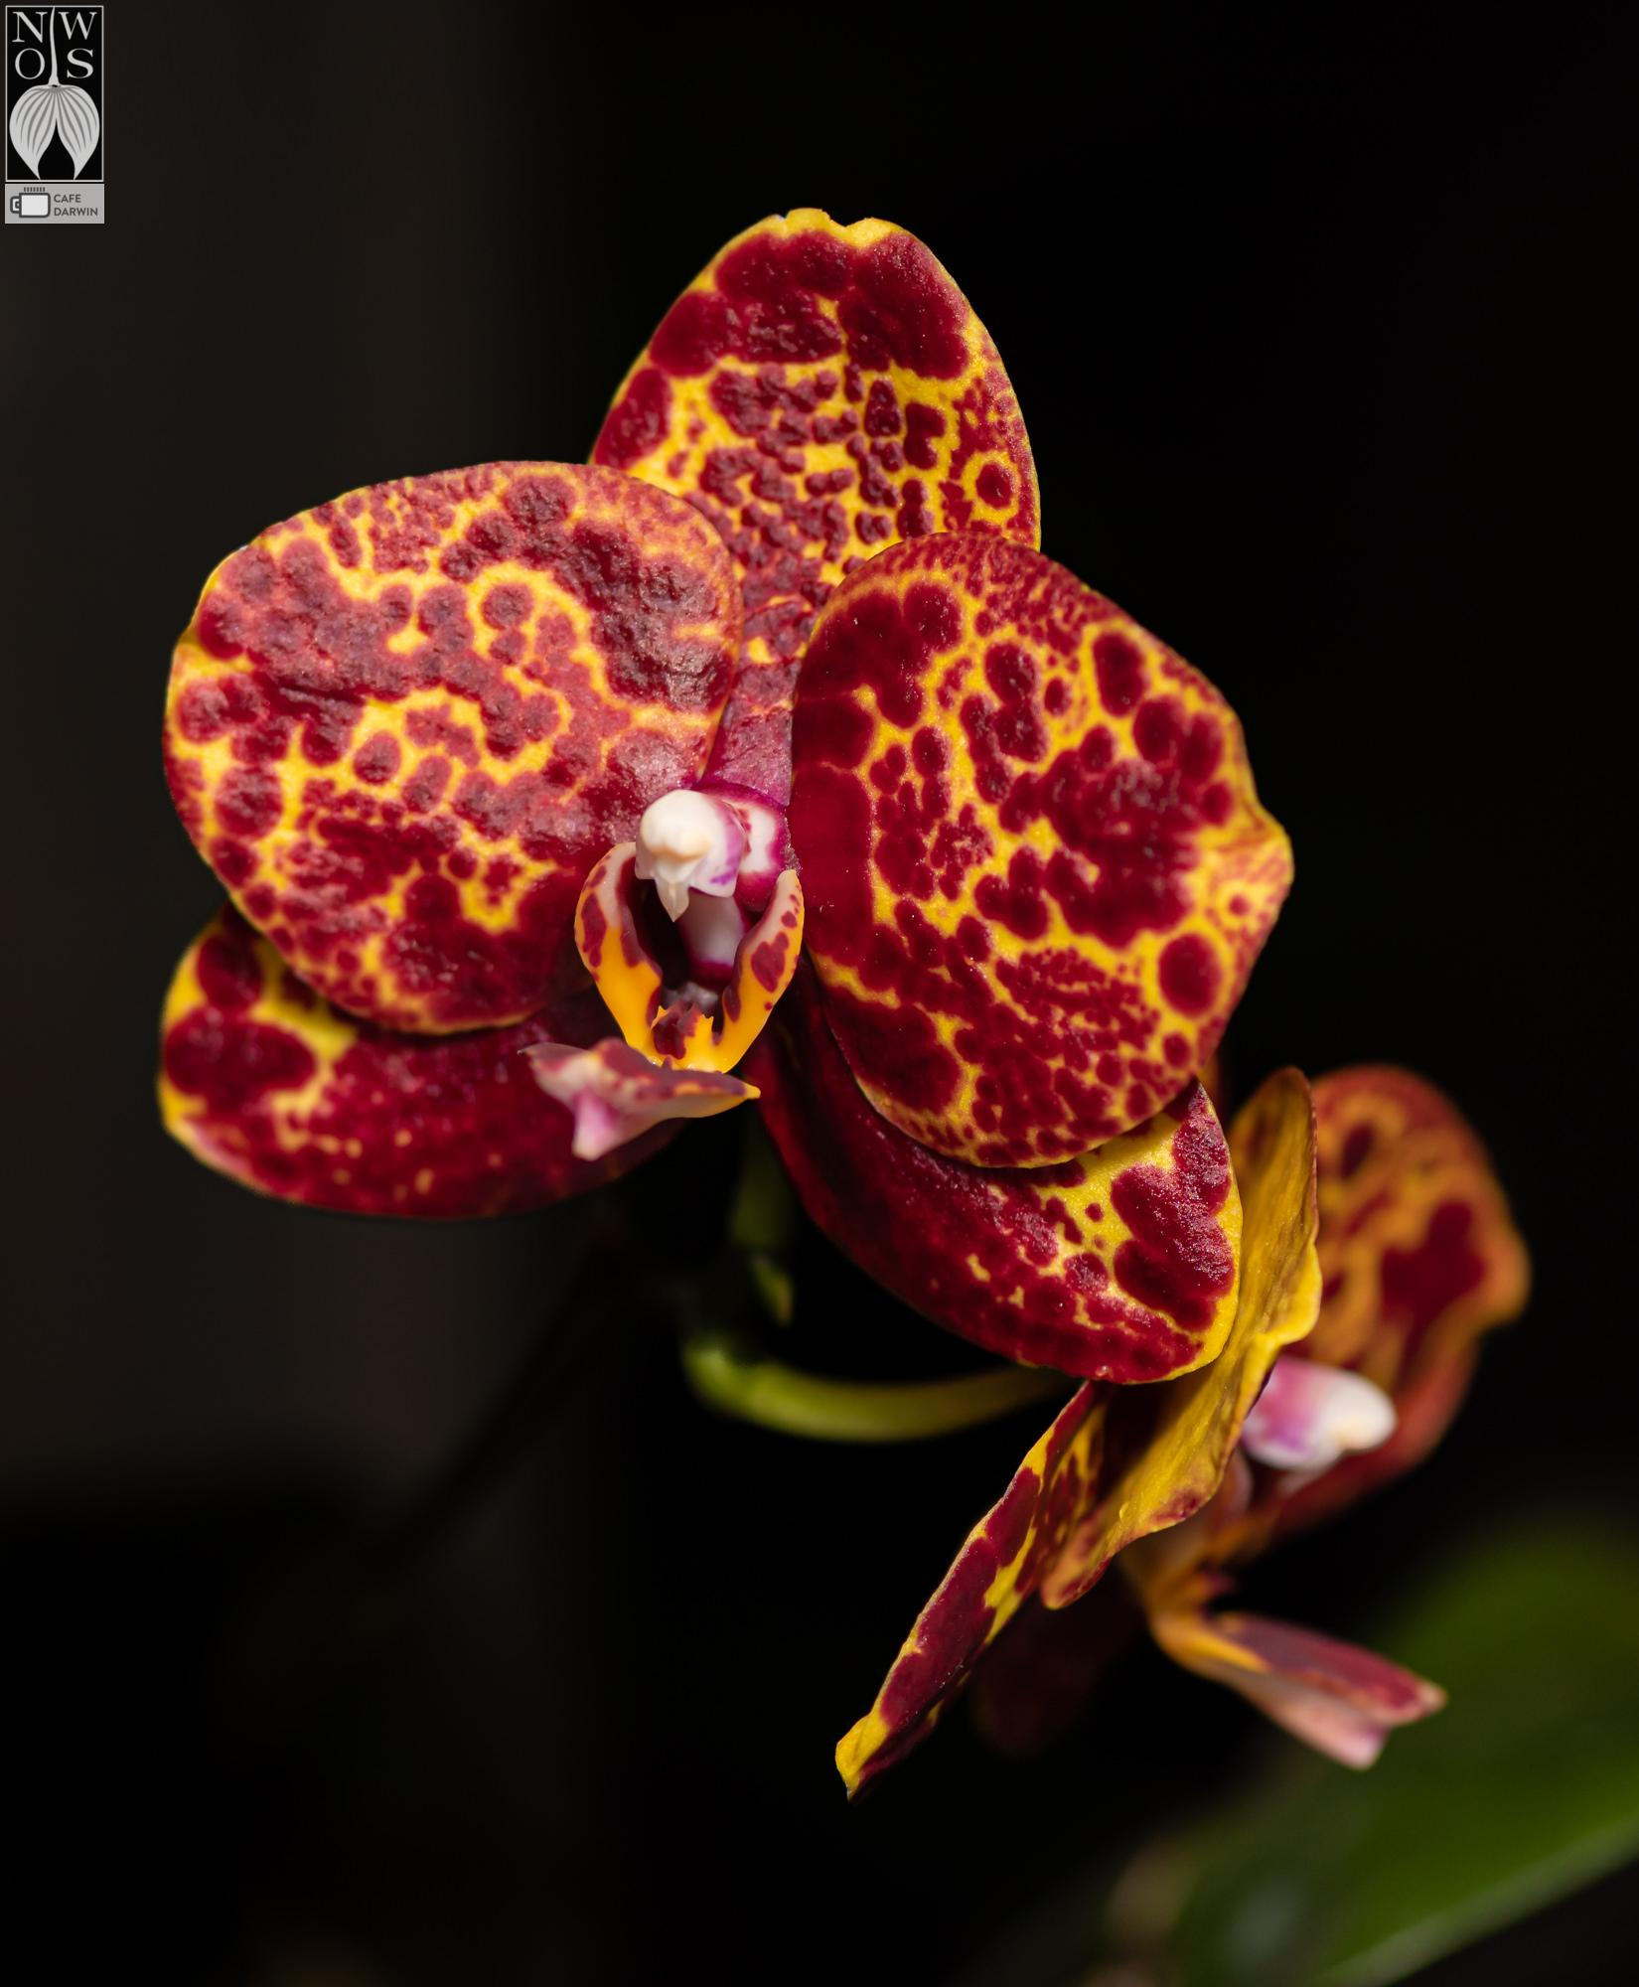
Phal Yaphon ‘Black Snake’ - Drew Rodriquez
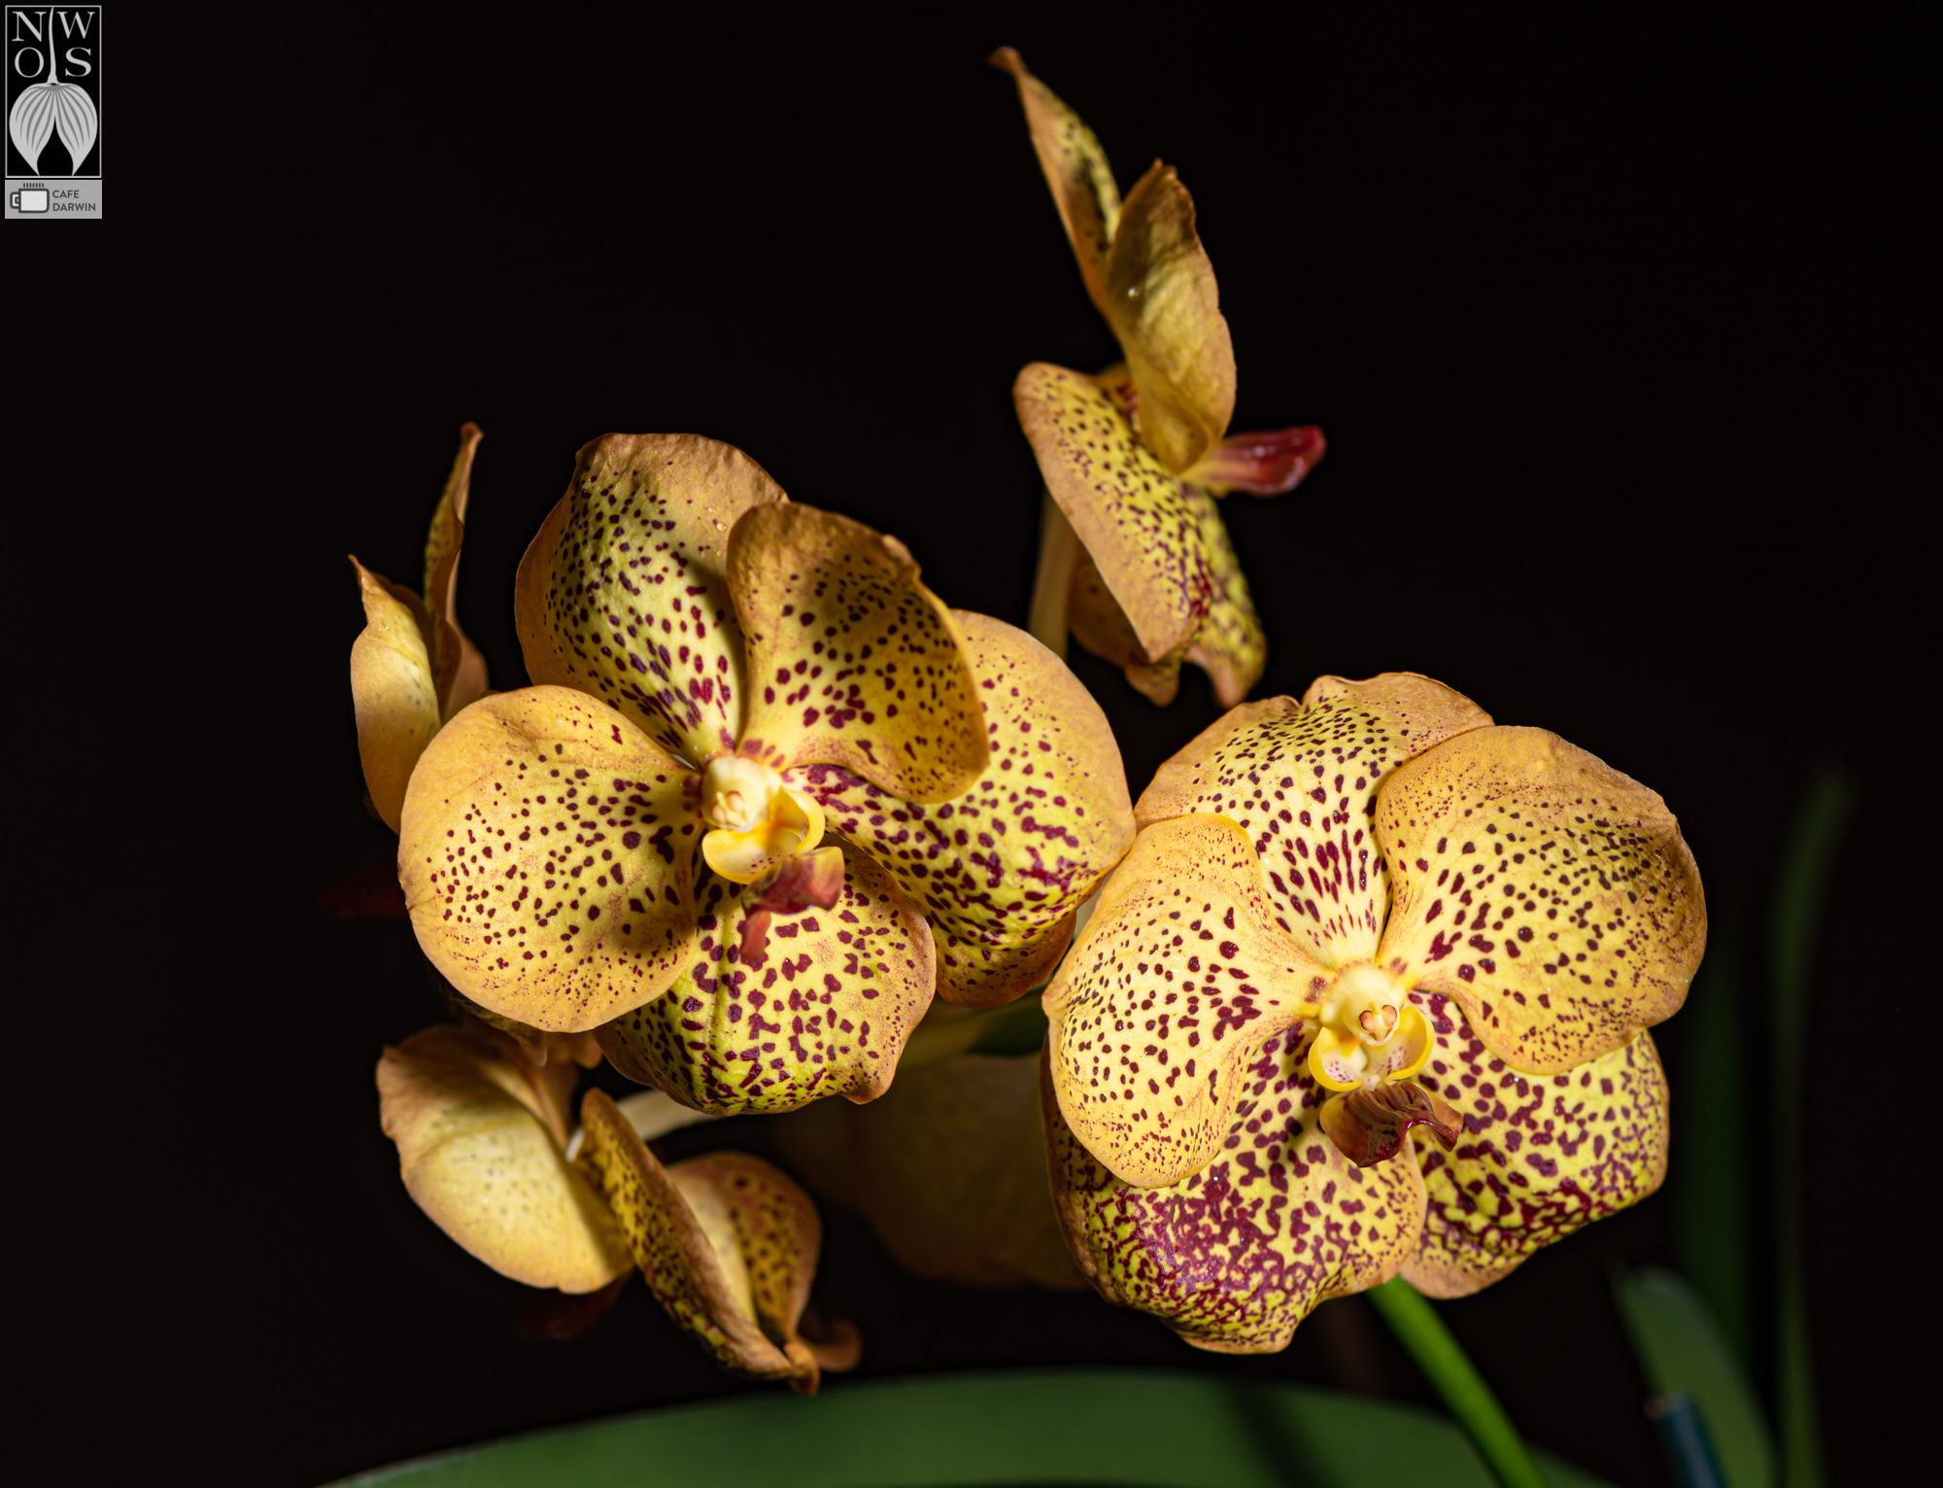
Vanda Sanchai Gold Spot - Ron Webb

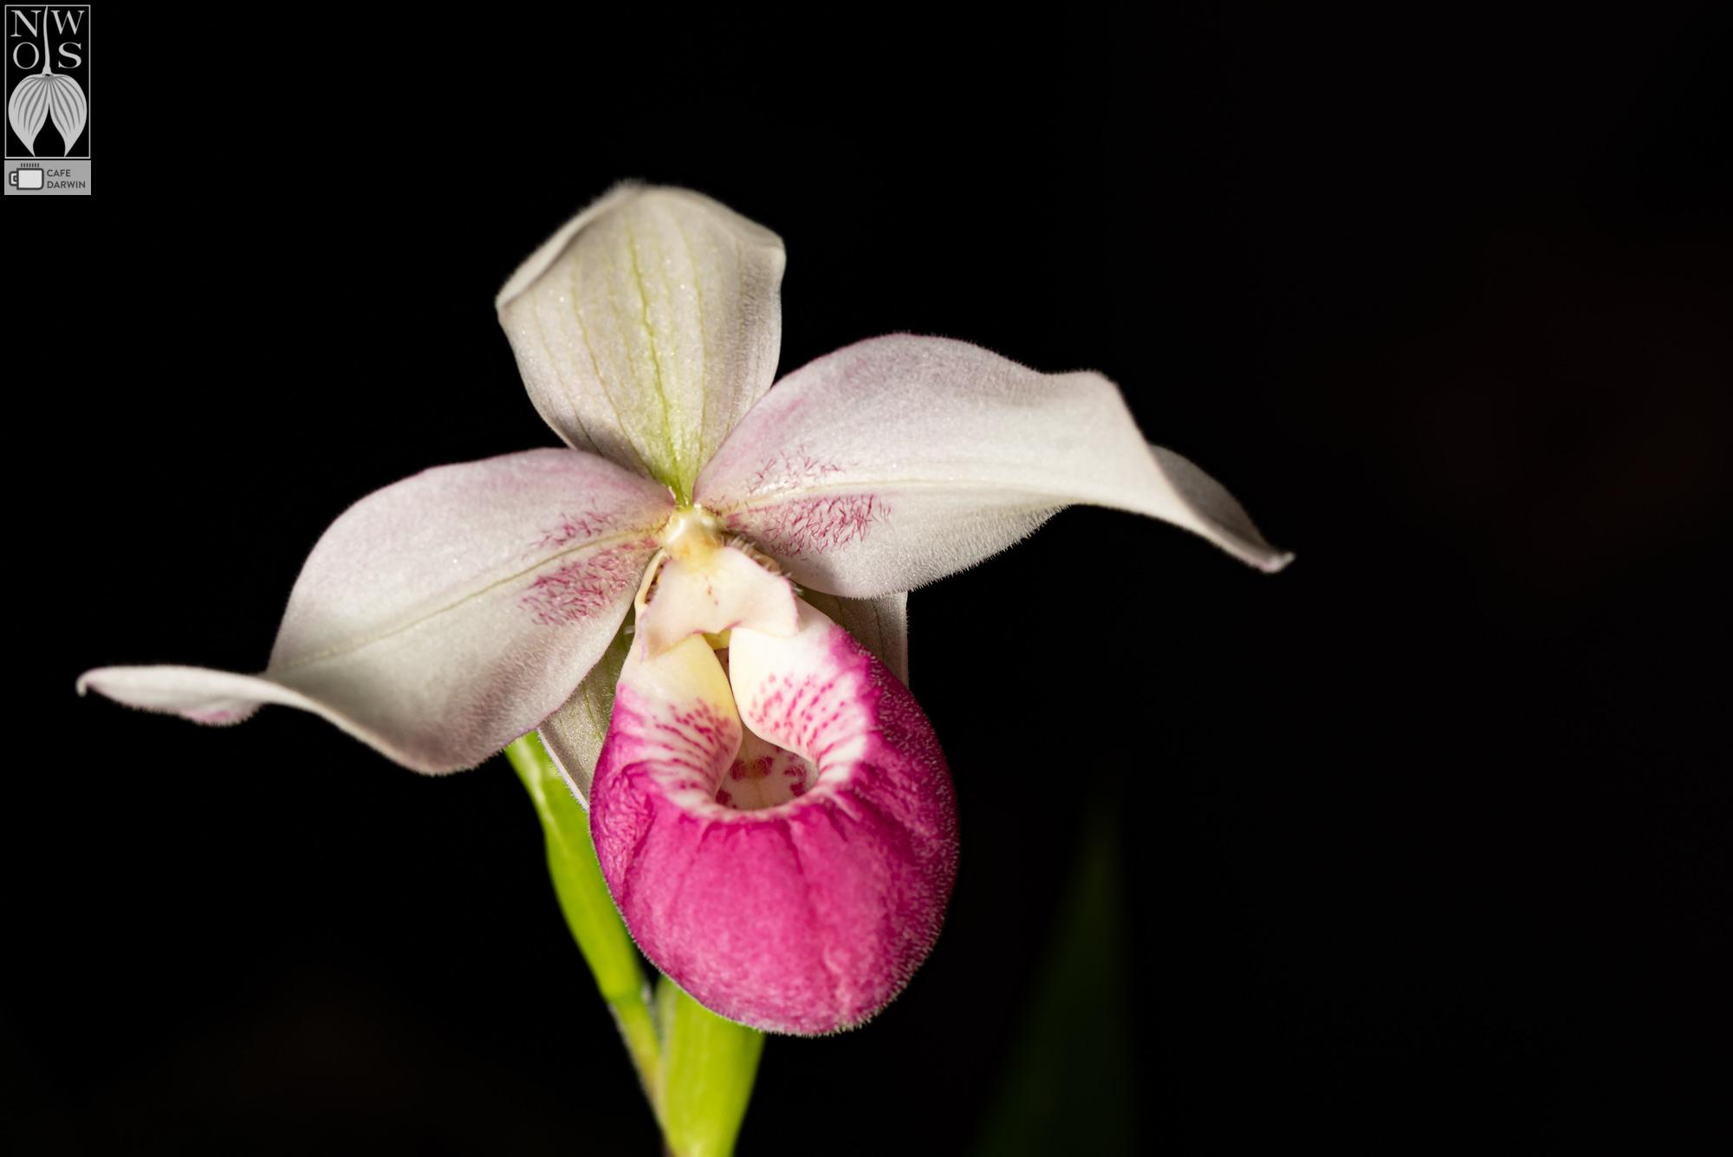
Phrag Cardinale - Mike Foster and Donna Pierce

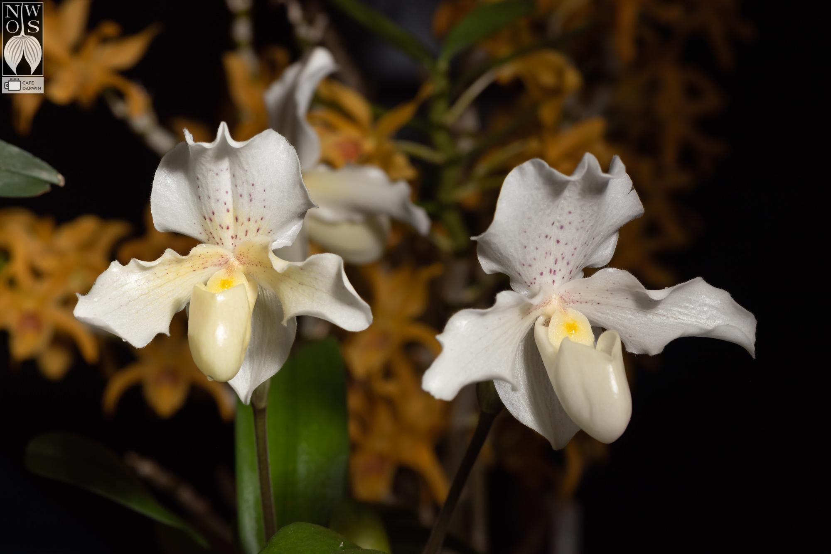
Paph Rosy Dawn ‘Superbum’ - John Gleisner

You can see more photos from the online gallery and the video from the meeting online.

Local Judging

What a wonderful April month for PNWJC AOS judging. We had five judged events in the month of April starting with the Spokane Orchid Society (SOS) show and Cherry City Orchid Society (CCOS) shows on April 1-2, 2023 with judging on Saturday, April 1, 2023. These two events were followed by monthly judging on April 2, 2023, and two other shows.

Adapted from William Jansen of the PNW Regional Judging Center.

Please come join us at a future Monthly PNWJC judging Sunday (see dates below)
- May 6, 2023, PNWJC Business Meeting on Zoom
- May 7, 2023, Monthly AOS Judging 1 PM at Keizer Community Center.
- June 4, 2023, Monthly AOS Judging 1 PM at Keizer Community Center.
- July 2, 2023, Monthly AOS Judging 1 PM at Keizer Community Center.

Spokane Orchid Society (SOS) show

- A beautiful show with 144 plants displayed and eight (8) nominations and five (5) awards granted. We had five (5) judges comprising one (1) judging team. Mike Pearson provided the attached excellent-quality photography. The awarded plants in no particular order:

- Paphiopedilum Fumi’s Delight ‘Carol Rettenmund’ CCE/AOS 91 points, Award #20235464, exhibited by Scott Rettenmound.
- Odontioda Louis Posey ‘South Cove’ HCC/AOS 77 points, Award #20234565, exhibited by Robert Culver.
- Odontioda Eric’s Golden Holiday ‘Hawkhill’ HCC/AOS 76 pts., Award #20235470, exhibited by Robert Culver.
- Dendrobium Blue Seas ‘Twilight’ HCC/AOS 76 pts., Award #20235471, exhibited by Stevie Mussellwhite. This Dendrobium was also awarded the best plant in the SOS show. Stevie is also a new orchid hobbyist and a new AOS member.

Photos copyright Mike Pearson

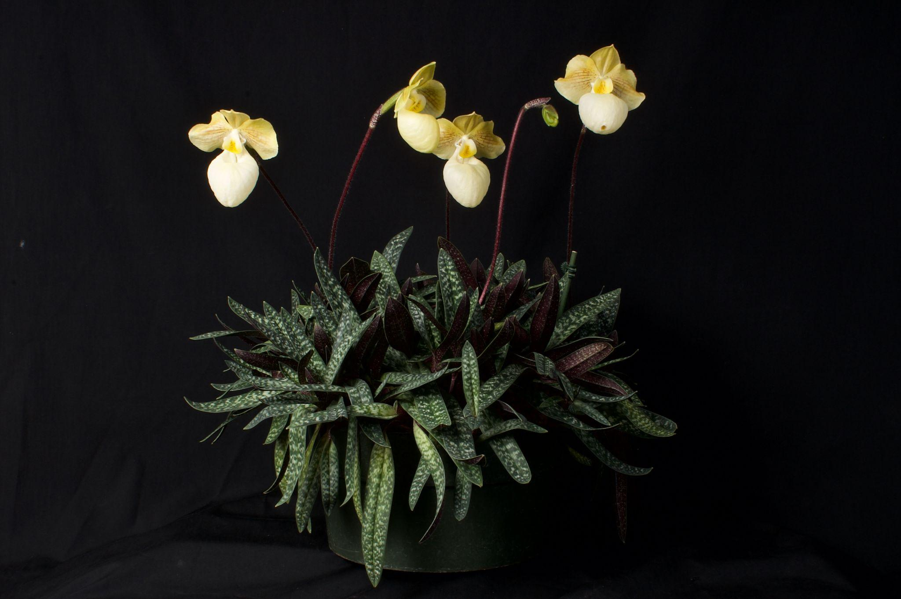
Paphiopedilum Fumi’s Delight ‘Carol Rettenmund’ CCE/AOS 91 points

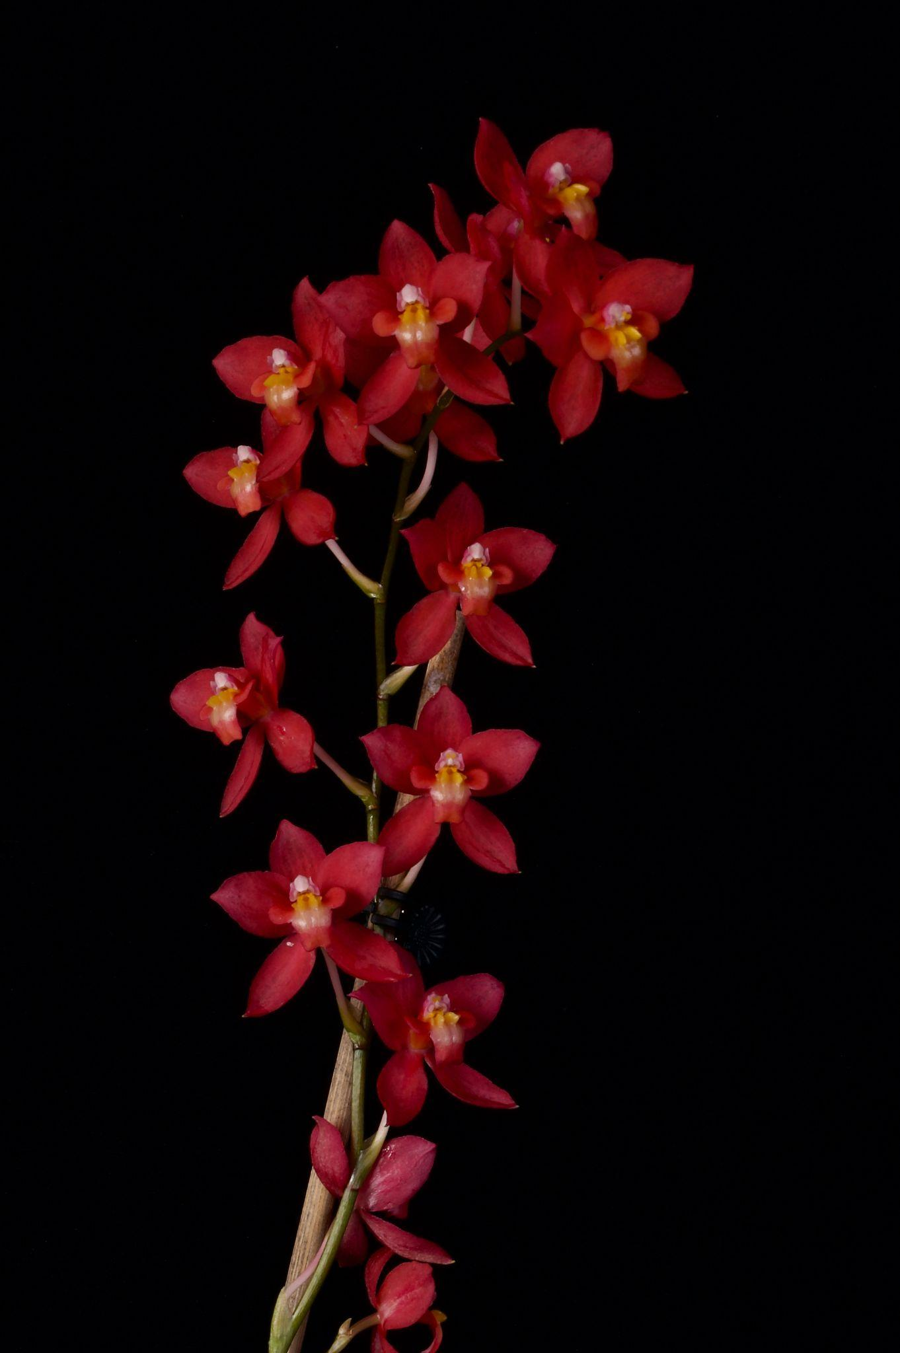
Odontioda Louis Posey ‘South Cove’ HCC/AOS 77 points
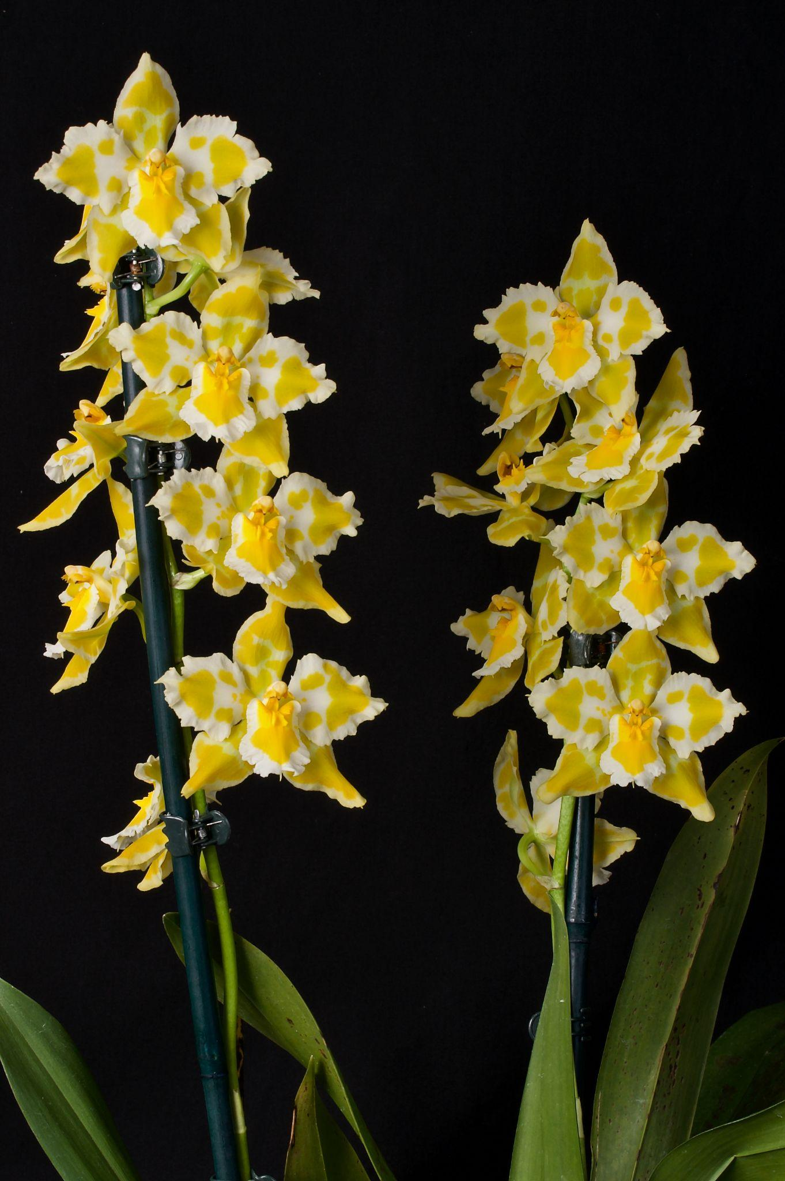
Odontioda Eric’s Golden Holiday ‘Hawkhill’ HCC/AOS 76 pts

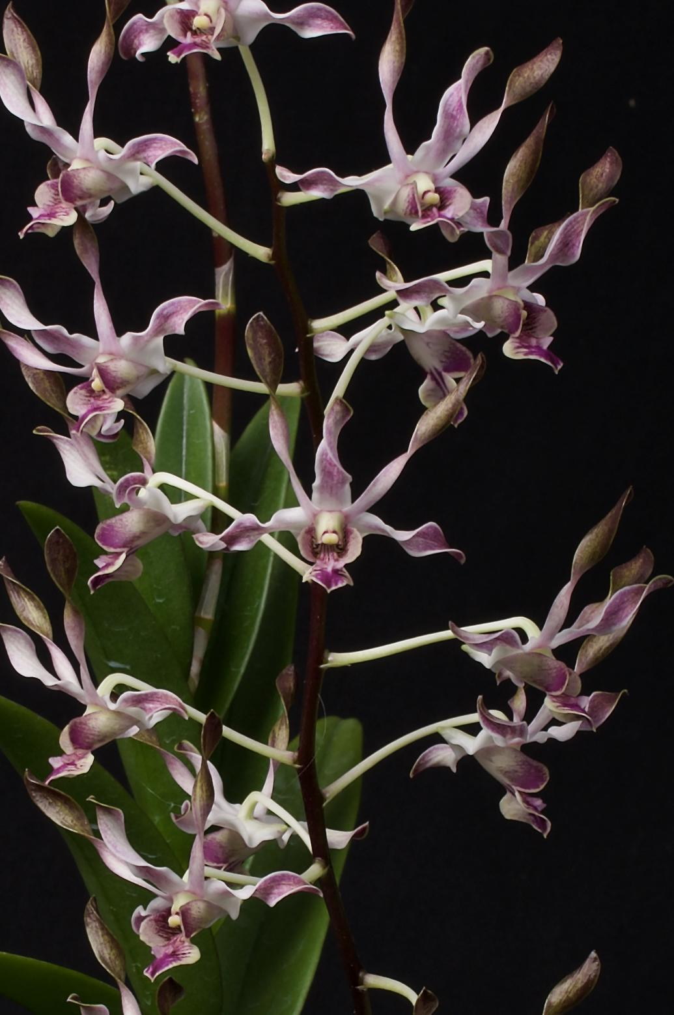
Dendrobium Blue Seas ‘Twilight’ HCC/AOS 76 pts
Cherry City Orchid Society (CCOS) show

A beautiful show with excellent displays and 167 plants exhibited. There were seven (7) nominations and five (5) awards granted. We had eight (8) judges and one student comprising two (2) judging teams. Ross Leach provided the attached excellent-quality photography of the show displays and plants. The awards in no particular order are summarized below:

- AOS Show Trophy (ST) #20235466 and Silver Certificate (SC) #20235467 were Awarded to the Oregon Orchid Society (OOS).
- Cattleya praestans ‘West Coast’ HCC/AOS 79 pts., 20234568, exhibited by Tyler Boddy
- Educational Exhibit Certificate (EEC) #20235469 and Artistic Certificate AC) #20235472, exhibited by Cherry City Orchid Society (CCOS).

Photos copyright Ross Leach

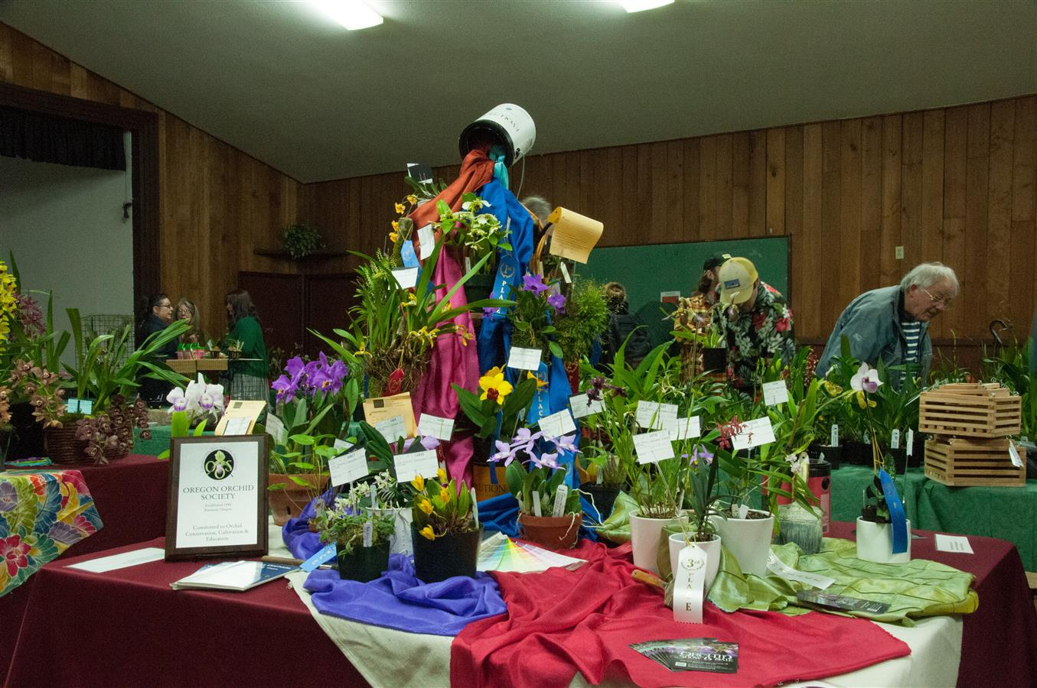
AOS Show Trophy (ST) #20235466
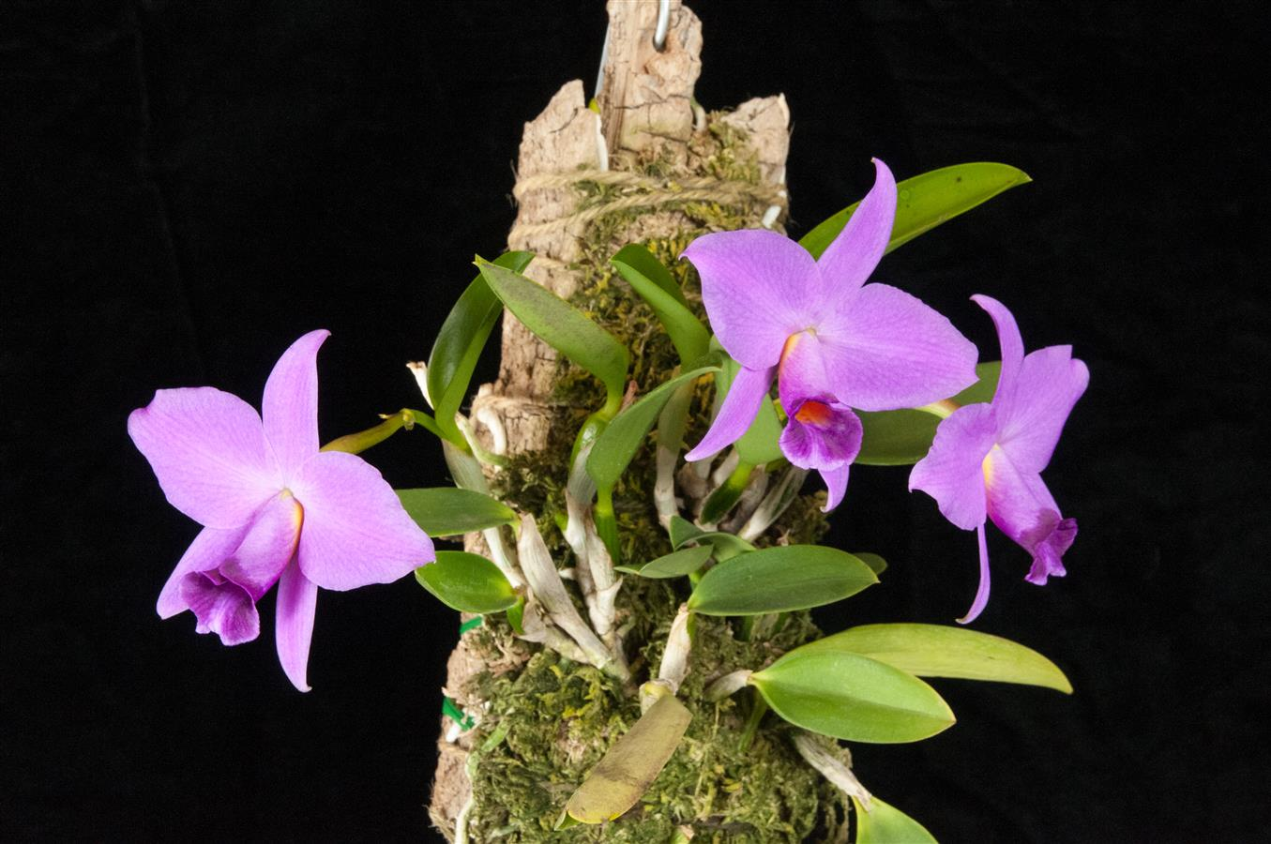
Cattleya praestans ‘West Coast’ HCC/AOS 79 pts

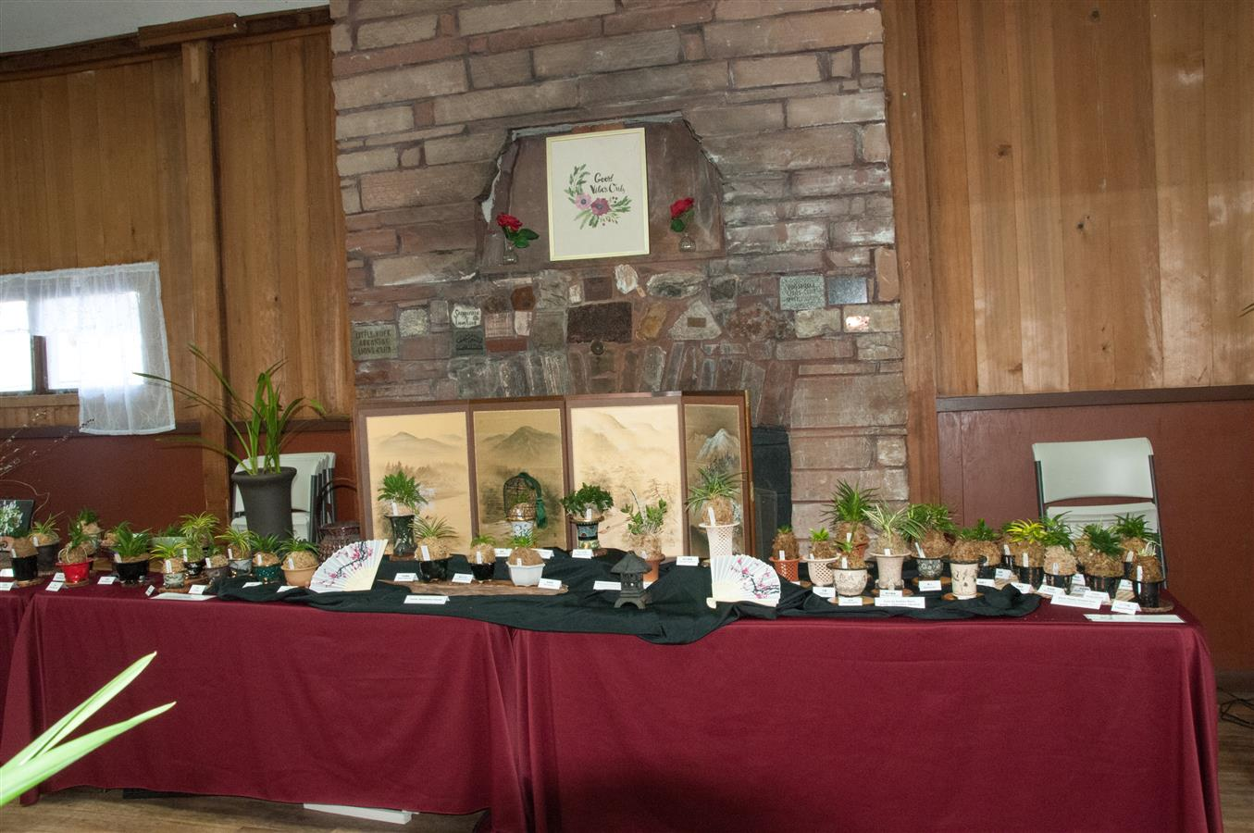
Educational Exhibit Certificate (EEC)
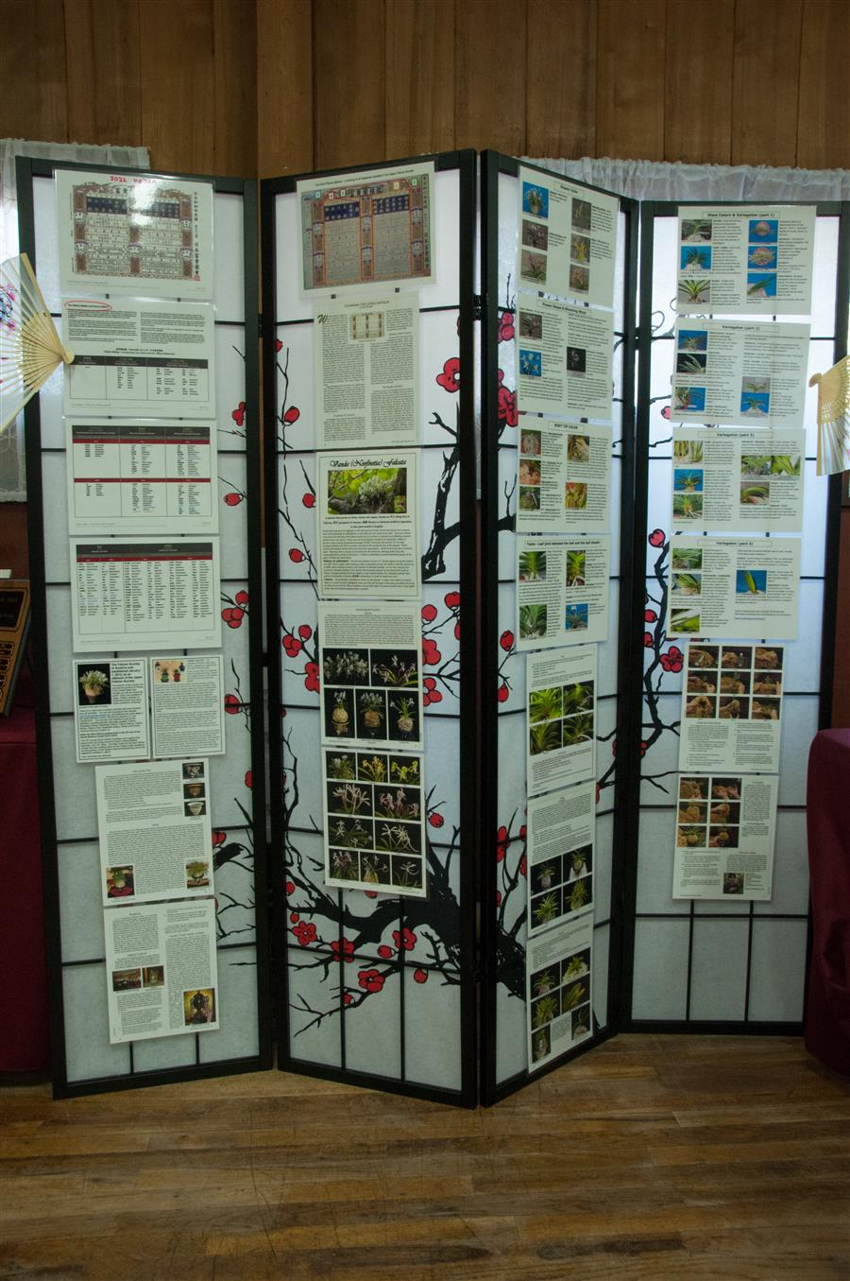
Educational Exhibit Certificate (EEC)

Sunday April 2, 2023 Monthly AOS Judging

Monthly judging April 2, 2023 continued with eight (8) plants displayed and five (5) nominations, and four (4) awards granted. We had nine (9) judges and one student comprising two (2) judging teams. Ross Leach provided the attached excellent-quality photography. The displayed plants and awards in no particular order:

- Paphiopedilum Helen’s Gold ‘Rite of Spring’ FCC/AOS 90 points, Award #20235474, exhibited by Theresa Hill.
- Paphiopedilum Greyjoy ‘Pyke’ HCC/AOS 75 points, Award #20235476, exhibited by Theresa Hill.
- Paphiopedilum Golden Palace ‘Midas Touch’ HCC/AOS 76 points, Award #20235475, exhibited by Theresa Hill.
- Paphiopedilum Lola Bird, exhibited by Theresa Hill.
- Lepanthes Terpsichore, exhibited by Tom Etheridge
- Masdevallia wurdackii, exhibited by Tom Etheridge
- Odontioda Barossa Valley ‘Keizer’ HCC/AOS 78 points, Award #20234573, exhibited by Tom Etheridge.
- Cattleya trianae coerulea ‘Thales Shun’, exhibited by Kaiju Lyu.

Photos copyright Ross Leach

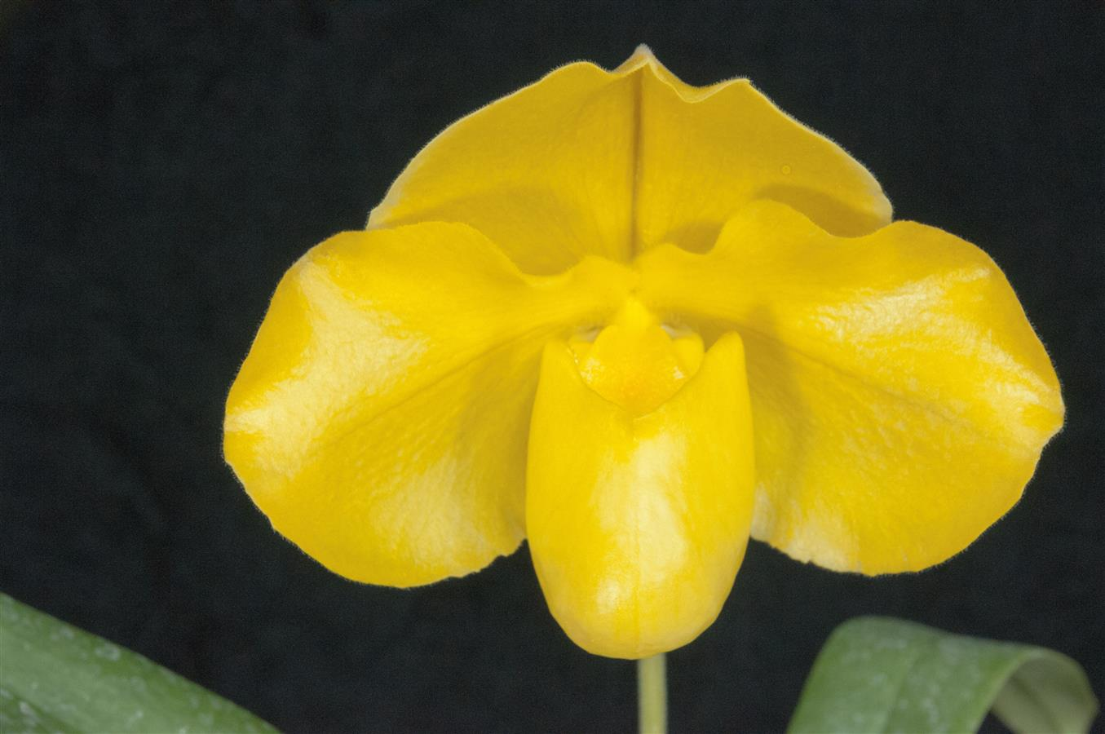
Paphiopedilum Helen’s Gold ‘Rite of Spring’ FCC/AOS
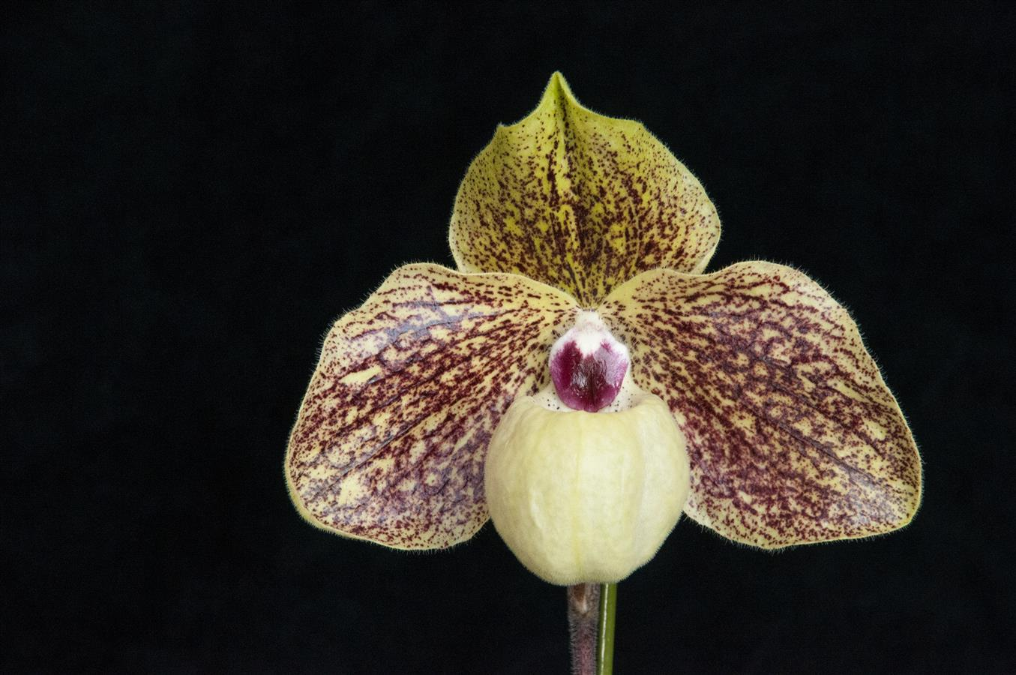
Paphiopedilum Greyjoy ‘Pyke’ HCC/AOS
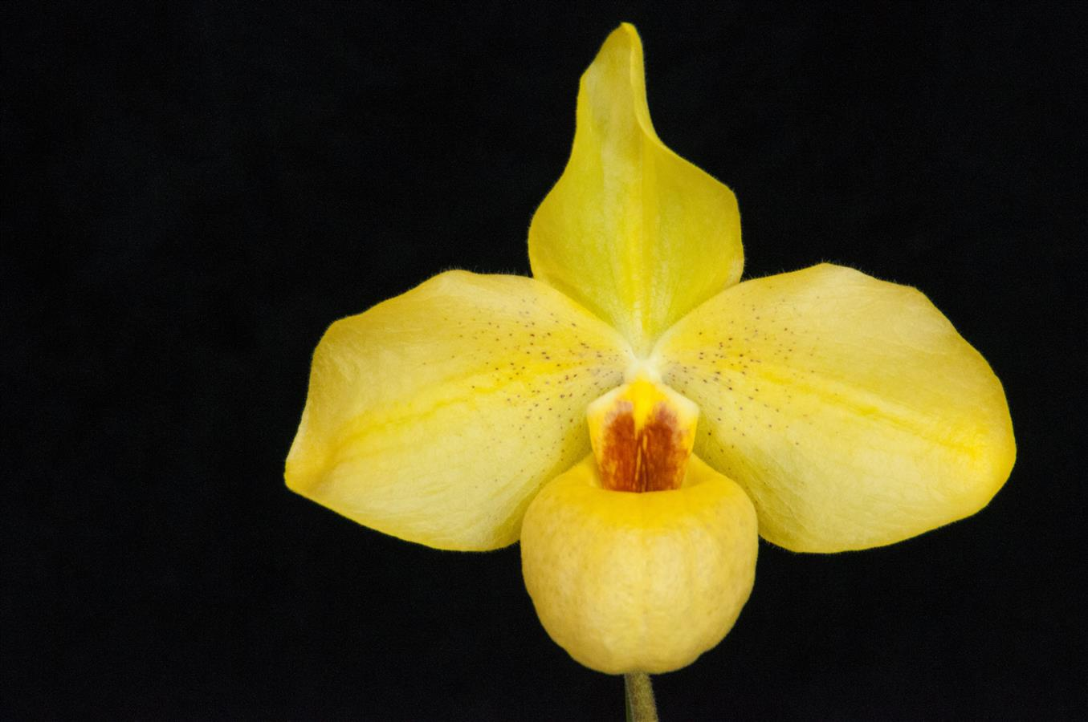
Paphiopedilum Golden Palace ‘Midas Touch’ HCC/AOS
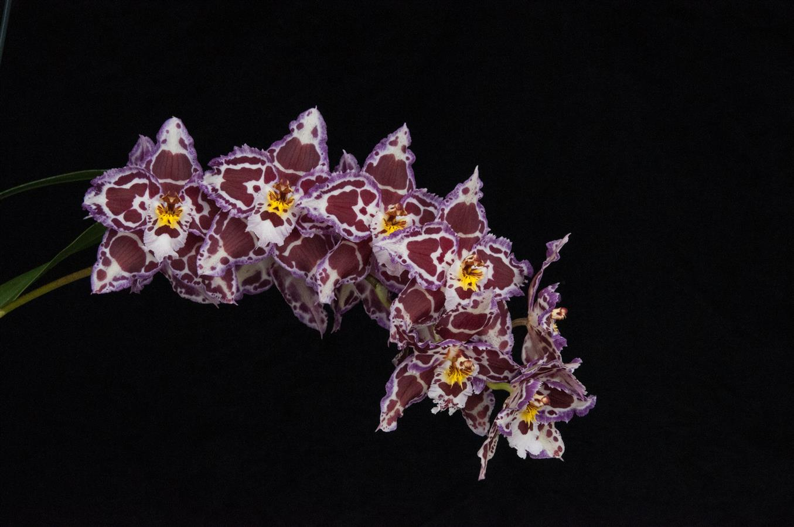
Odontioda Barossa Valley ‘Keizer’ HCC/AOS

Oregon Orchid Society (OOS) show

The Oregon Orchid Society had a beautiful show with 177 plants exhibited. Judging was on April 22 and there were twelve (12) nominations and three (3) awards granted. We had eight (8) judges and one student comprising two (2) judging teams. Tim Morton provided the attached excellent-quality photography of the plants. The awards in no particular order are summarized below:

- Odontoglossum Teresa Heinz Kerry ‘SO Striking’ HCC/AOS 77 points, Award #20235479, exhibited by Robert Culver.
- Laeliocattleya Novissima ‘Charles Bierer’ AM/AOS 83 points, Award #20235481, exhibited by Alex Juergens.
- Odontoglossum Elegans (1879) ‘Mary’s Peak’ HCC/AOS 75 points, Award #20234580, exhibited by Tom Etheridge.

Photos copyright Tim Morton

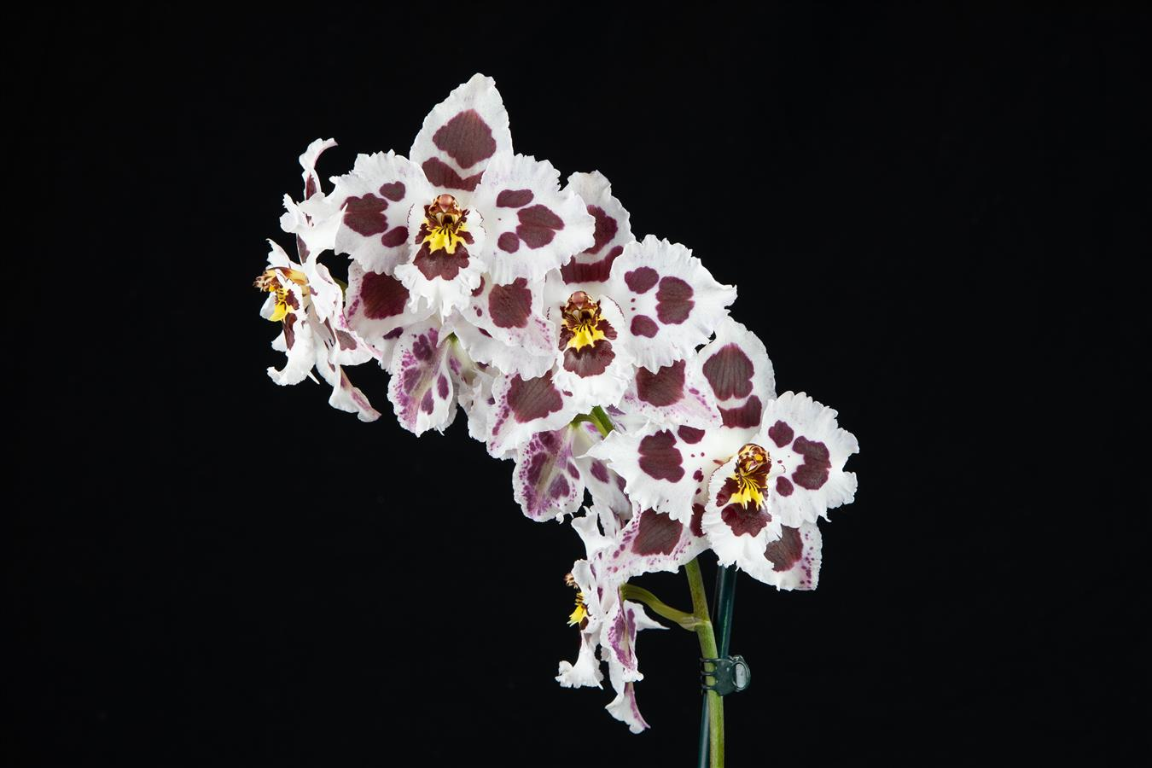
Odontoglossum Teresa Heinz Kerry ‘SO Striking’ HCC/AOS
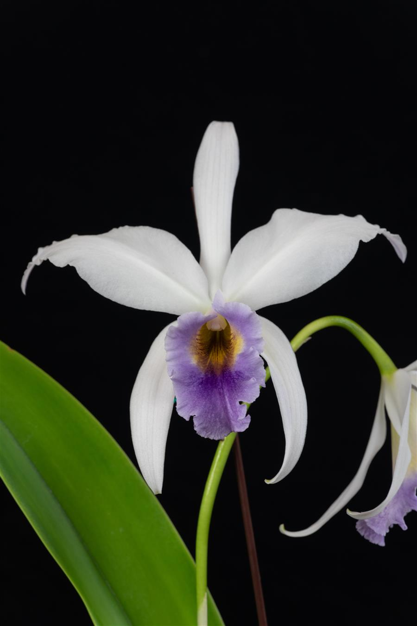
Laeliocattleya Novissima ‘Charles Bierer’ AM/AOS
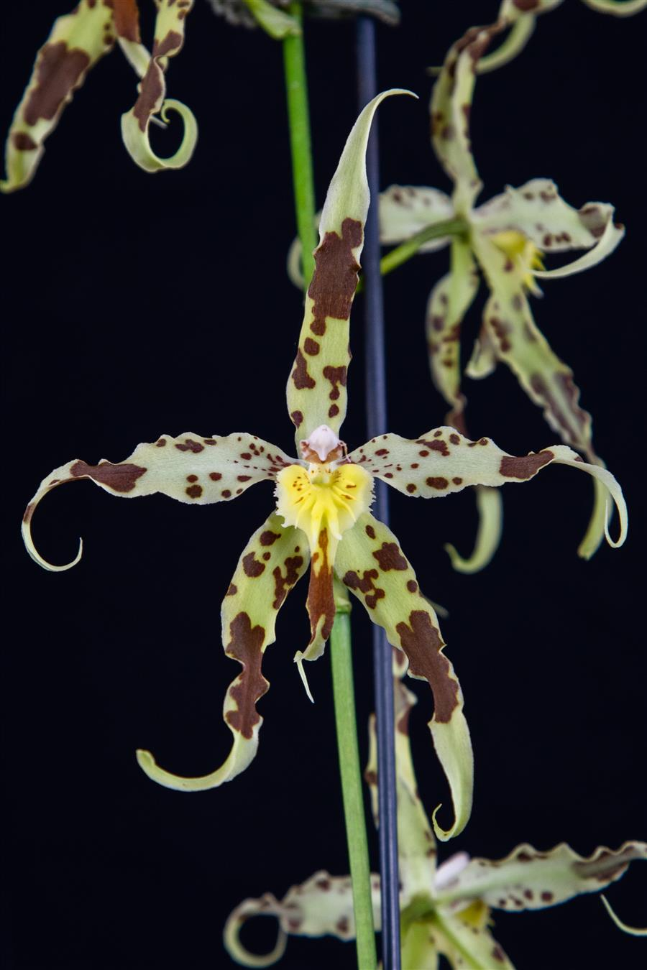
Odontoglossum Elegans (1879) ‘Mary’s Peak’ HCC/AOS

Schedule of Upcoming Events

05/08/23 – NWOS meeting – Speaker: Ron Parsons, “The Genus Dendrobium”

05/13/23 - Potting Clinic - at Molbak’s Nursery in Woodinville, 9 am to 2 pm

06/12/23 – NWOS meeting – June Food Truck Social: This is our annual social just before we take our summer break. We have a food truck outside and plants inside. We also announce the Gary Baker Service Award at this meeting.

August NWOS Picnic - Time and place to be announced. Stay tuned to the Events page and your email..

09/11/23 – NWOS meeting – Speaker: Kelly McKracken, “Fragrant Miniatures” The most common question we get asked about plants is “is it fragrant?”; Many orchid growers select their plants based on whether the plant is fragrant. For those of you who grow in limited space, but still love a nose full of floral fragrance, this is the talk for you.

10/06-08/23 - NWOS Fall Show & Sale - Volunteer Park Conservatory. Details are to be posted on the Events page of the website.

10/09/23 – NWOS meeting – Speaker: Andrew McGinnis, Growing Orchids in Grow Tents, Advanced Indoor Growing.

11/13/23 – NWOS meeting – Speaker: Alan Koch, “A New Look at Intergeneric Phalaenopsis”, Phalaenopsis have been enjoyed by novice growers for the ease of growth and long-lasting flowers. Intergeneric Phalaenopsis hybrids are easier to grow, maintain long-lasting flowers, and often bloom more often than a normal Phalaenopsis. Another benefit from this line of breeding has been the creation of many fragrant hybrids. The bright colors, fragrant flowers, and smaller hardier plants make this an interesting direction in orchids.

12/11/23 – NWOS meeting – Holiday Food Truck Social, introducing new Officers, NWOS Annual Meeting report, Schoenfeld and Northen Orchid Awards, and Holiday Plant gifts.

Reminder for Officers & Board Members

The next board meeting is Tuesday, May 2nd which will be at 7 p.m. and hosted over ZOOM. Check your email for the Zoom registration link and agenda. Future meetings are tentatively scheduled for September 5, and November 7th.

NWOS Website Links

- Main website: Http://www.nwos.org
- Events Calendar: http://www.nwos.org/events
- Membership (including renewals): https://nwos.org/Membership/
- Newsletter - Current Issues: https://nwos.org/newsletters/
- Newsletter - Archived Issues: http://newsletter.nwos.org
- Show Information: https://nwos.org/nwos-fall-show/
- Facebook: http://www.facebook.com/nworchidsociety
- Instagram: https://www.instagram.com/nworchidsociety/
- Twitter: https://twitter.com/nworchidsociety

Special Announcements

Olympic Orchids
Looking for a part-time employee to help with a small orchid business. You would be processing orders, potting plants, and doing basic orchid care. Some knowledge of orchids would be good, but you can learn as you work. You should have your own transportation. If interested, contact Ellen Covey at info@olympicorchids.com.

Emerald City Orchids Spring Pop-Up With Ecuagenera and Andy’s Orchids Along with Local Vendors

Saturday, May 28th through Monday, May 29th
Friday Night Preview Party May 26th

ECO is excited to announce that their next Open House and Pop-Up will take place at Emerald City Orchids on May 27-29, with an exclusive Friday night preview party on the 26th. It'll be a 4-day event throughout the entire Memorial Day weekend, and they can't wait to knock your socks off with the biggest selection of plants they’ve ever had.

Check out all the details on the ECO Website: ECO Spring Pop-Up

At the Emerald City Orchids greenhouses
4734 S. Tacoma Way
Tacoma, WA 98409

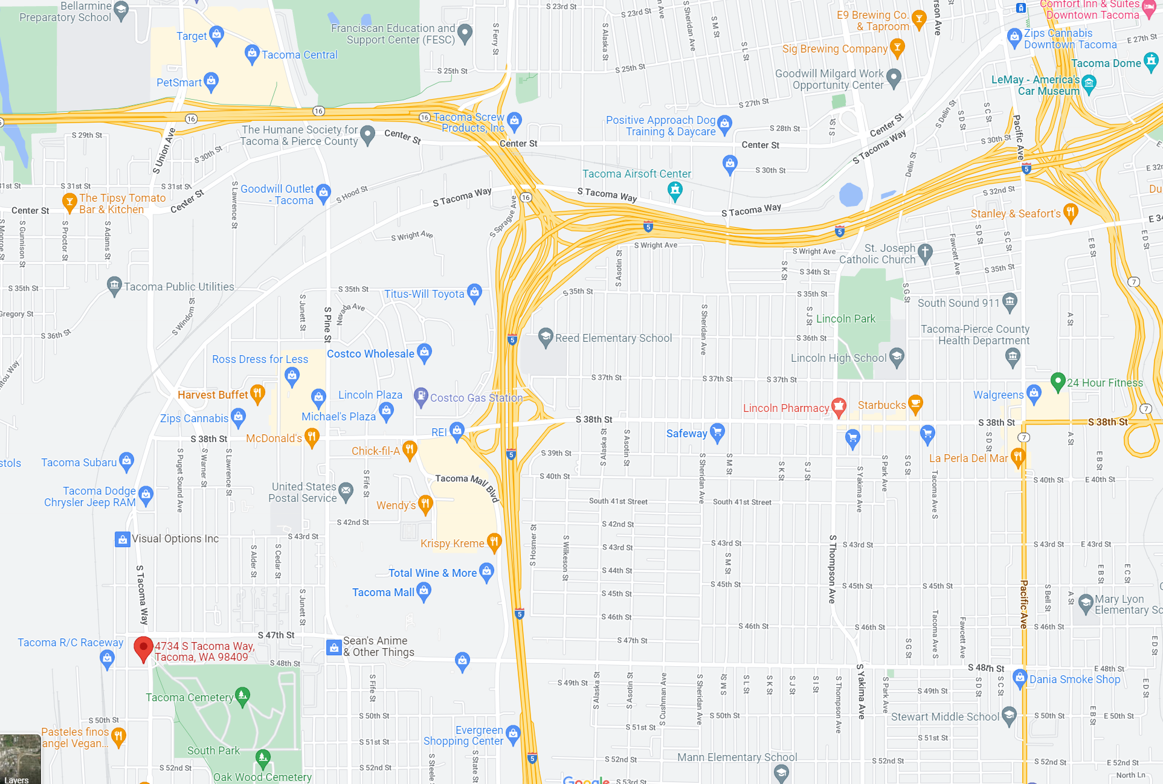

©2023 Northwest Orchid Society - All Rights Reserved unless the copyright is held by other rights holders.

The opinions and recommendations published herein are those of the authors. The Northwest Orchid Society (NWOS) disclaims responsibility for any losses or damages that may be attributed to the use or misuse of any material or any opinion published in these articles and on the website. This website and the photographs, articles, and content are protected by copyright and no part of them may be reproduced or re-used without the permission of the author.

The Special Announcements (SA) section is provided as a courtesy to the readers of this newsletter for events that may be of general interest to the readers. The NWOS (1) makes no promises, warranties, or representations as to SA, including its completeness, accuracy, availability, timeliness, propriety, security, or reliability; (2) provides SA on an "AS IS" and "AS AVAILABLE" basis and any risk of using SA is assumed by you.

