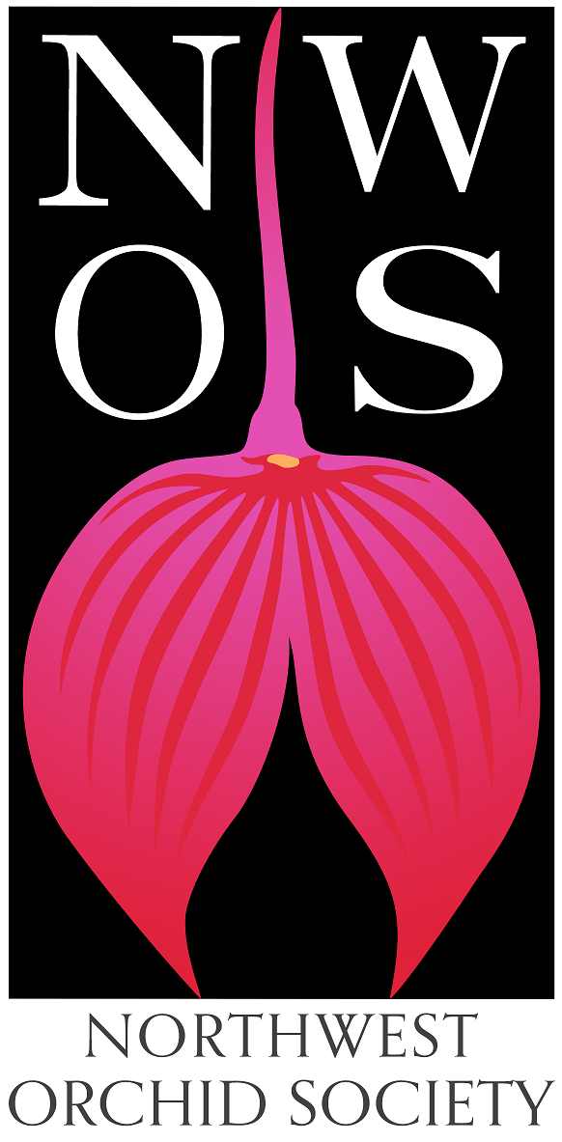
Northwest
Orchid News
May 2022
Volume 75, Issue 5

- About the May Meeting
- Speaker: Bill Goldner, PhD, “New Looks for Miniature…
- Plant Table
- Sales Table
- Raffle Table
- NWOS Library
- June Social
- Potting Clinic - Saturday May 7th, 11 am - 2 pm
- Proposed Changes to NWOS Bylaws
- Membership Renewal Reminder
- Volunteer Positions
- Before Instagram, Before Pinterest, Before Facebook, Before The Internet
- Plant Table Format
- Native Orchid Conference on Olympic Peninsula, June 2022
- Report From The April Meeting
- Schedule of Upcoming Events
- Reminder for Officers & Board Members
- NWOS/Amazon Shopping Link
- NWOS Website Links
- Special Announcements - Open (Green)House at Emerald City Orchids

About the May Meeting
May 9, 2022 7 PM
University of Washington Center for Urban Horticulture
3501 NE 41st Street, Seattle, WA 98105
Hybrid Meeting, In person and via Zoom Zoom Registration

We will be meeting in person for the foreseeable future.

Speaker: Bill Goldner, PhD, “New Looks for Miniature Phragmipedium Hybrids and Other New Lines of Breeding.”
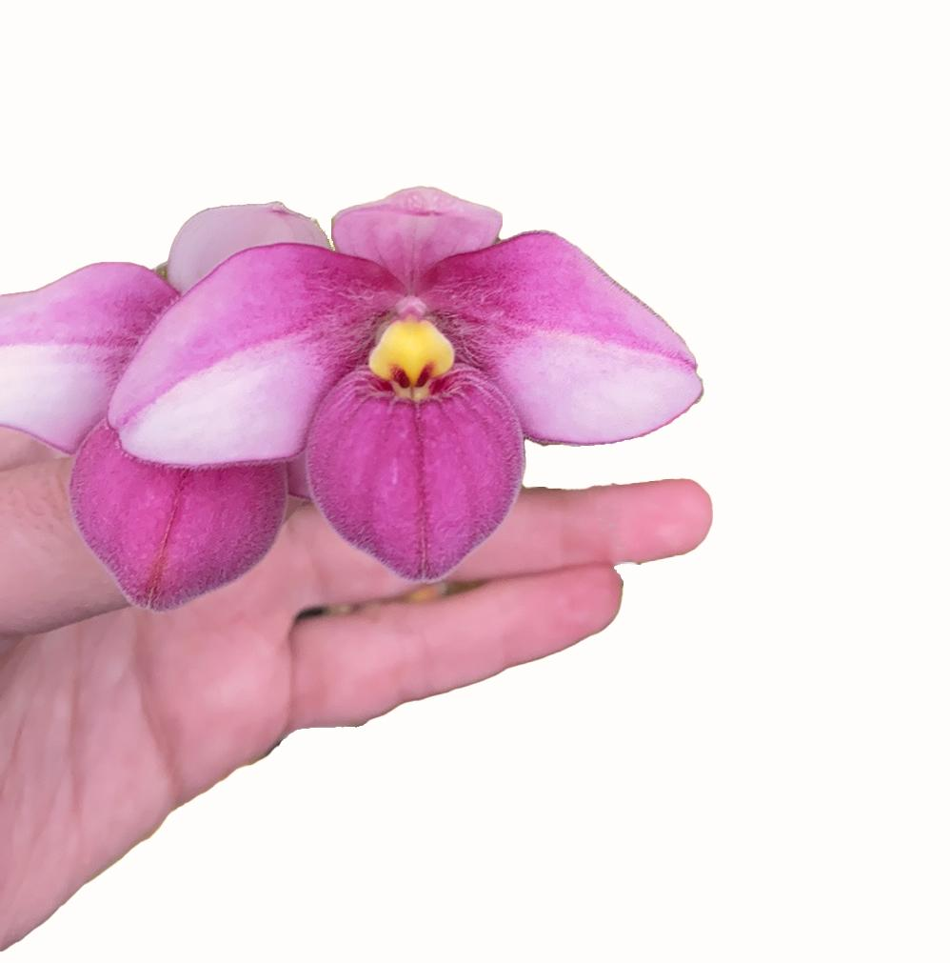

Dr. Bill Goldner is best known in the orchid world as the owner of Woodstream Orchids with his wife Lynn Evans-Goldner.

A life-long outdoorsman, Bill’s current mid-life crisis is fly fishing for trout, steelhead, and salmon, a passion he shares with Lynn and their son Zane. Many of the hybrid and cultivar names registered and used by Woodstream Orchids are names of the many places they have fished.

Now Zane (age 12) is part of the pack which includes golden retrievers Luna and Leo. In fact, at age four Zane and Bill started a jungle cactus and succulent business for Zane. Zane’s Orchid Companion Plants now grows over one hundred species of epiphytic cactus (or soft cactus as Zane calls them). He propagates the cacti from seed and cuttings.

Woodstream Orchids (WSO) is a leading hybridizer and producer of Phragmipediums, Paphiopedilum species, and Epidendrums. They are well known for their innovative miniature Phrag hybrids. They are currently upping their game to include white and yellow Phrag hybrids.

Please email Bill for updated lists of Phrags, Paphs, and Epis.

Plant Table

We will be having an in person plant table this month. For your convenience, you can print out a Plant Table Information Form ahead of time. Click for your version of choice: PDF WORD Excel

Diane has taken pictures of the plant table for many years and has requested that someone else take up the torch. We appreciate everything that she has done. For those who aren’t able to attend, please do keep sending your pictures, we will be including them in our online gallery and in next month’s newsletter. Please send them to photos@nwos.org.

If you won’t be able to make it to the meeting but would like your plants to be included in the online gallery for the month, please do send the images of your plants along with their names to photos@nwos.org.

Sales Table

Members may bring up to 10 plants to sell. Include an extra tag with your name and the price in the plant.

Raffle Table

The raffle will be held as usual. Win a new orchid for your collection while supporting the Scholarship Fund. If you have any extra Orchids, please consider donating them to the raffle.

NWOS Library

If you'd like to check out a book or tape from our Library, please contact our Librarian Joe Grienauer a minimum of 2 weeks before the next meeting. Besides email, you can give Joe your request at any meeting. For a list of library items please click here NWOS Library.

June Social

Historically our June meeting has been a potluck affair. Everyone brings in their favorite dishes, and we get to sit and dine and socialize before heading into the long lazy days of summer.

Because of updated policies we will no longer be able to share home cooked dishes with each other. We are as disappointed as you. However, we thought we would share what we will be doing instead in advance.

We have invited the El Gran Taco food truck to provide food for the social. Everyone will be responsible for paying for their own food and beverages. Generally a meal will cost about $12.

There are vegetarian, vegan and gluten free options.

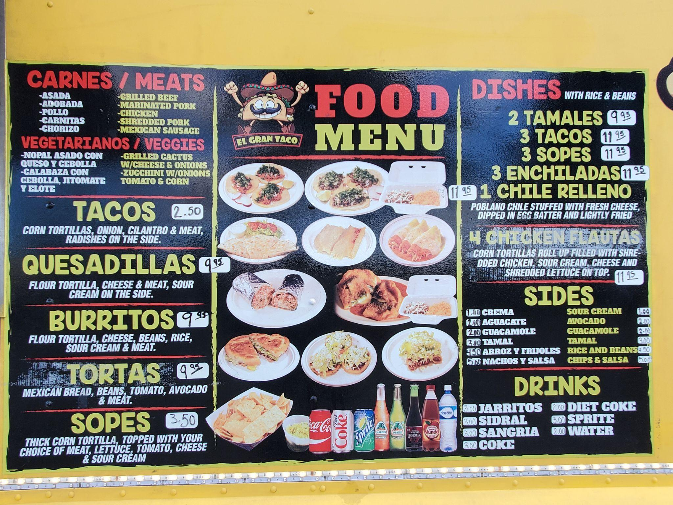

The rest of the activities for the evening will be:
- Socializing!
- Presentation of The Gary Baker Service Award
- Plant Table
- Raffle
- More Socializing!

It will be a fun evening, so be sure to join us.

Potting Clinic - Saturday May 7th, 11 am - 2 pm

The NWOS held a very successful potting clinic in March. So we’re going to host another event, this time right next to where we have our monthly meetings at the Center for Urban Horticulture. Here are the details:

Sat May 7 from 11 am – 2 pm
3501 NE 41st St, Seattle, WA 98105
Bring up to three average sized orchids to the Potting Clinic held in the Douglas Classroom at the UW Center For Urban Horticulture.
The Douglass Classroom is below the main parking lot next to the greenhouses.
Admission is Free for NWOS members and $15 for non-members, which can be applied towards becoming a member.
These clinics have always been popular. Our most experienced members give expert advice on all aspects of repotting your orchids:
- Determining whether and when your orchid needs to be repotted. This can vary by species and time of year.
- Diagnosing potting problems, such as root loss and decomposition of potting mixes, over-potting and under-potting.
- Choosing the right pot type and size.
- What’s the best potting mix for your particular orchid?
- Can it be mounted?
- How your environment and watering habits can affect these choices.
Come with questions, get some answers. Bring up to three plants. Then add some hands-on experience, with guidance from our volunteer members. Potting media and some pots will be available on site.
It’s an afternoon of fun and learning, and your orchids will thank you.

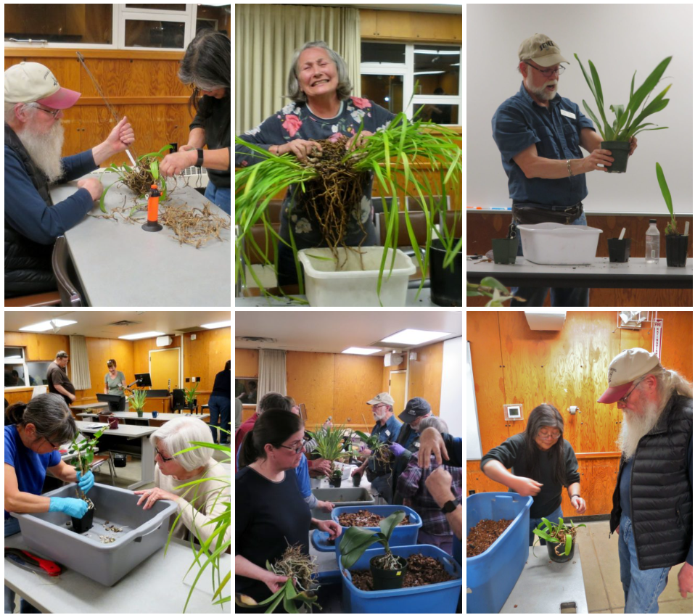

Proposed Changes to NWOS bylaws

Page 1, Article I, Section 2 – Regular Membership.
“The members of the Society shall consist of persons who have applied for membership in writing and who have paid one year's dues in advance in accordance with Article VII (Dues).

That will be deleted and changed to:
“The members of the Society shall consist of persons who have paid one year's dues in advance in accordance with Article VII (Dues).”

Page 2, Article II – Officers, Section 5 – Secretary
“Prior to the end of the term of membership, the Secretary shall bill the members for their dues by the mailing of statements.”

This statement will be removed.

“The Secretary shall give the notice of all meetings in accordance with these Bylaws and shall give notice to each person of that person’s election to office or membership in the Society.”

Notice of all meetings are given in the newsletter and webpage. This statement shall be removed.

Page 3, Article III, Section 5- Committees and Appointments, Audit committee.
“….close of the fiscal year ending June 30.”
This will be changed to “…close of the fiscal year ending December 31.” This was changed at a prior board meeting, but not revised in the bylaws. The two should match.

The above proposed changes are posted in writing in accordance with Article VIII, Section 4 - Amendment Procedure.

Membership Renewal Reminder

It's time to renew your NWOS membership for 2022. Our membership period now goes by calendar year (Jan. 1 to Dec. 31). You can pay at most meetings by cash, check, or debit/credit card. Click HERE to pay online using Paypal on our Membership page.

You may also mail a check (payable to NWOS) to PO Box 51021, Seattle, WA 98115-1021. New members may wish to complete the Membership Form and send it to the address above.

Dues are $30 for one person or $40 for two people at the same address. We also have a Youth membership of $15 for one person aged 22 or under. Dues are kept low to encourage membership but they cover only a small portion of the society's expenses.

Each single, dual and youth membership person will be considered an individual full-fledged member entitled to all privileges and benefits of the society (Members-only area of the website, voting, Holiday gift plants, sell plants at meetings/shows/auction, members-only summer BBQ, etc.).

Please contact Mike Cory for questions about your dues.

Volunteer Opportunities

We are looking for a couple of volunteers to help with some outreach and multimedia for the society. If you are interested contact Robert Culver.

- We are looking for someone(s) that will help with multimedia for the society. These will be used on the society’s website, and in its social media outreach. These are some of the things we are looking for help with.
  - Fun images of people during the meeting.
  - Images of plants from the plant table (and their names!)
  - Video of the plant table presentation.
- We need someone to help us with our social media presence.
  - Facebook, Instagram, Twitter
  - Coordinate campaigns across the platforms using Hootsuite
  - Help setup campaigns on Mailchimp

Before Instagram, Before Pinterest, Before Facebook, Before The Internet

Today we have so many sources of information to call upon to arouse our curiosity, stoke our desires and satiate our appetites. It's easy to forget what it was like just a few short years ago. Many of us would eagerly await the latest publication of a journal or society bulletin. We would carefully scan through the latest catalogs from the myriad of orchid vendors throughout the country and across the globe hoping to catch the latest rage in hybridizing fashion or snatch that prized species. Some of us even ran up eye watering long distance bills trying to track down a mythical plant that no one seemed to have.

But how did it all start? One of our recent speakers, Bob Hamiton, spoke to us about the Victorian Orchid Craze, the discovery of the natural world and how that led to the hobby we have today. (Members with logins to the NWOS website can watch that meeting here: September 2021 Meeting.)

How did the Victorians create that desire? How did they inform? How did they sell? They did it in much the same way we do today, with words and with pictures, only the medium was different.

Part of their marketing was the production of lavish magazines and journals to cater to this Orchidmania. As today we are presented with images and text describing the plants, so too were Victorian consumers. They were enticed by images of plants to attend salons to see a rare plant bloom or attend auctions in hopes of purchasing something rare or better, new.

Some of the more notable journals are The Orchid Album, Lindenia, Reichenbachia, The Botanical Register. It is possible to find originals of these today on eBay or Etsy. The occasional rare book seller will still have the entire set of original bound volumes available for sale (I think I’d rather have a car.) What is remarkable is just how beautiful the species were that were collected from the jungles. It’s easy to see how these plants enchanted a continent 150 to 200 years ago as they do today.

I’ve included some images from these journals for you to enjoy. The society has thought about opening up an online store allowing people to buy NWOS related merchandise. Let us know if you think it would also be an interesting idea to make some of these photos available to put on things like t-shirts, mugs, tote bags, etc.

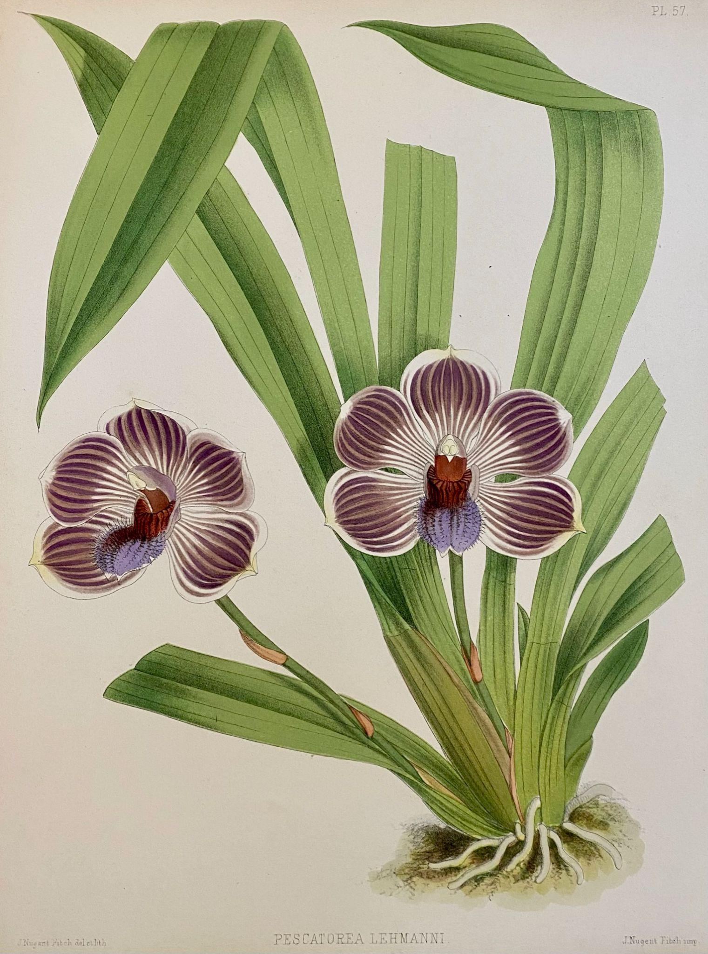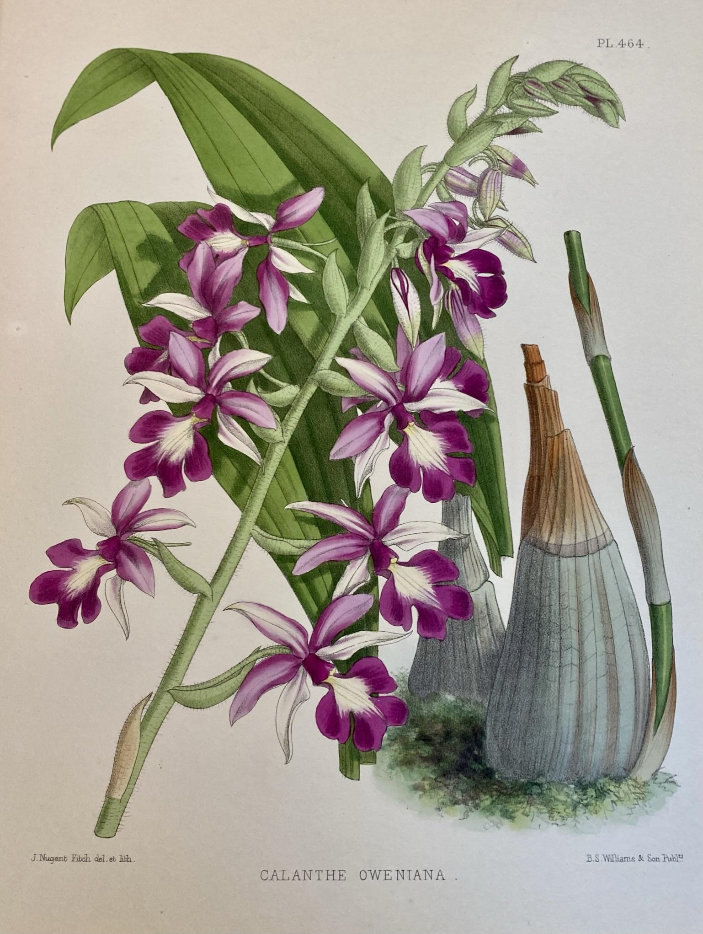
Pescatorea lehmanni Calanthe oweniana
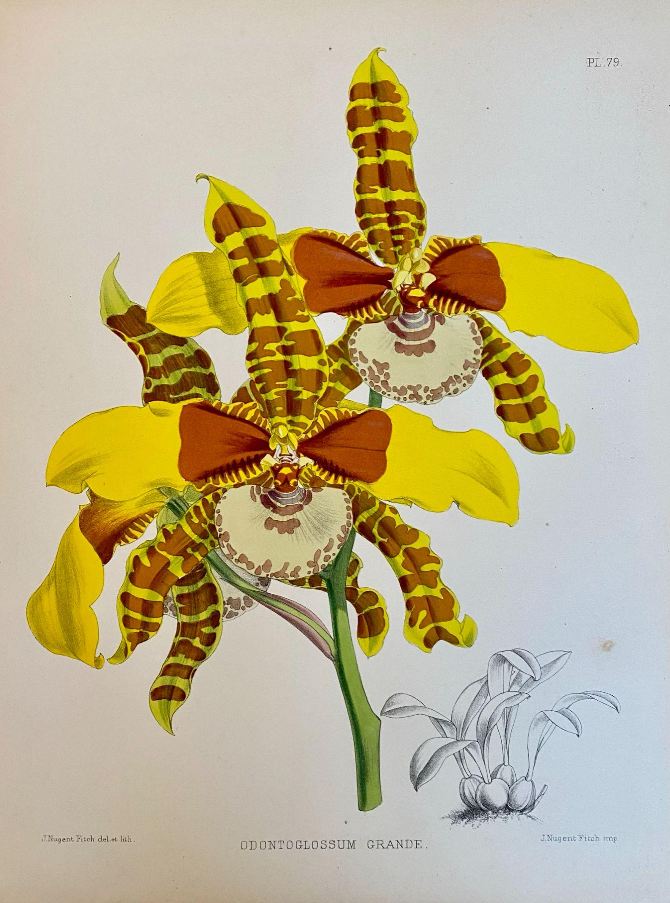 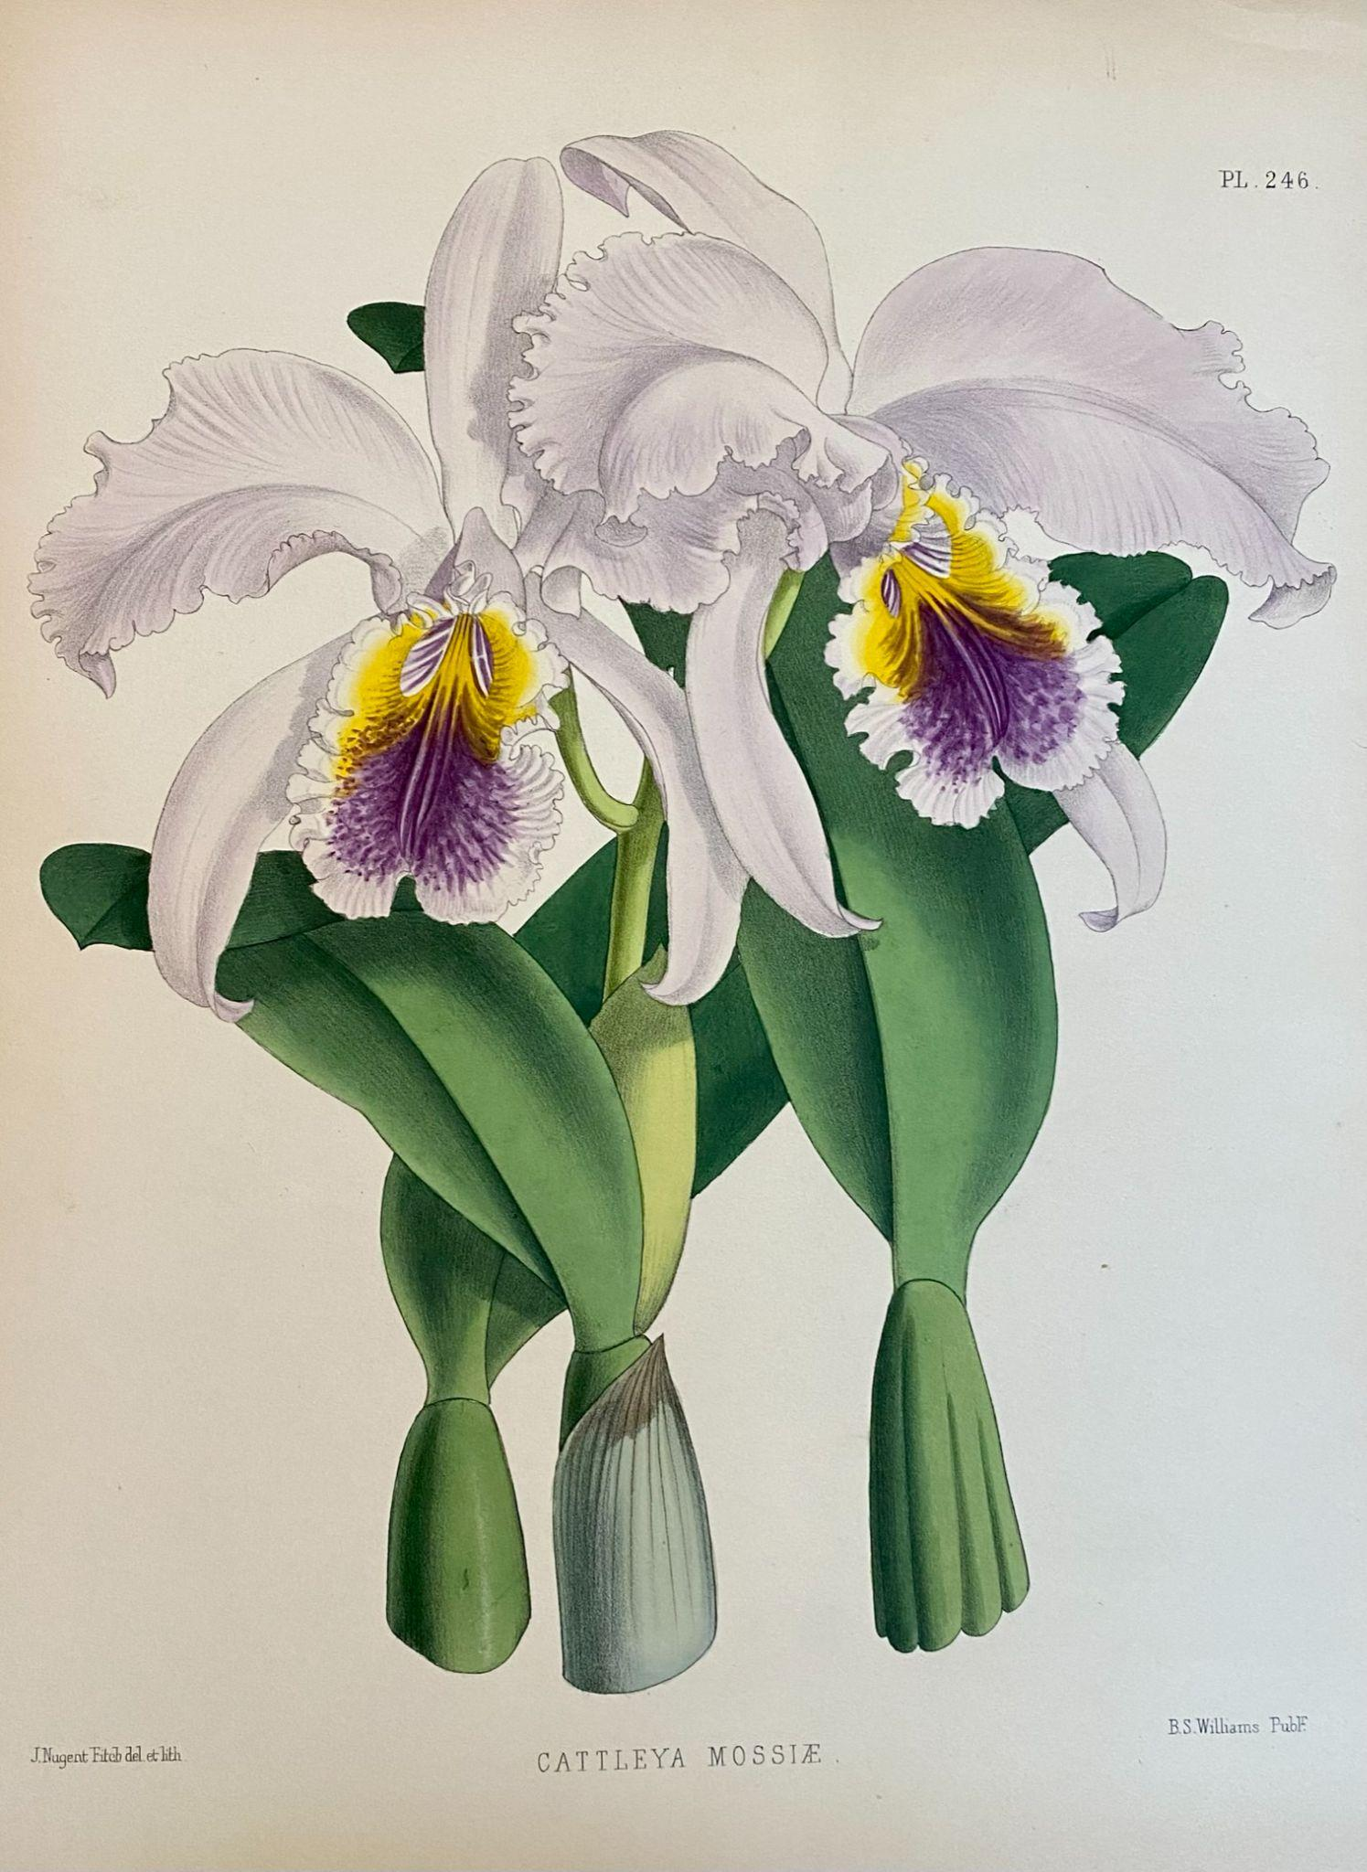
Odontoglossum grande Cattleya mossiae
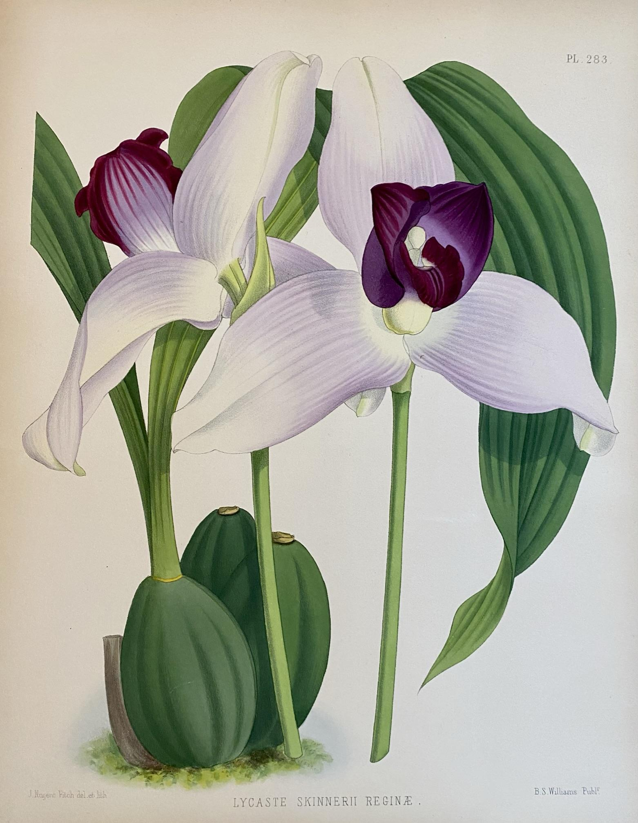 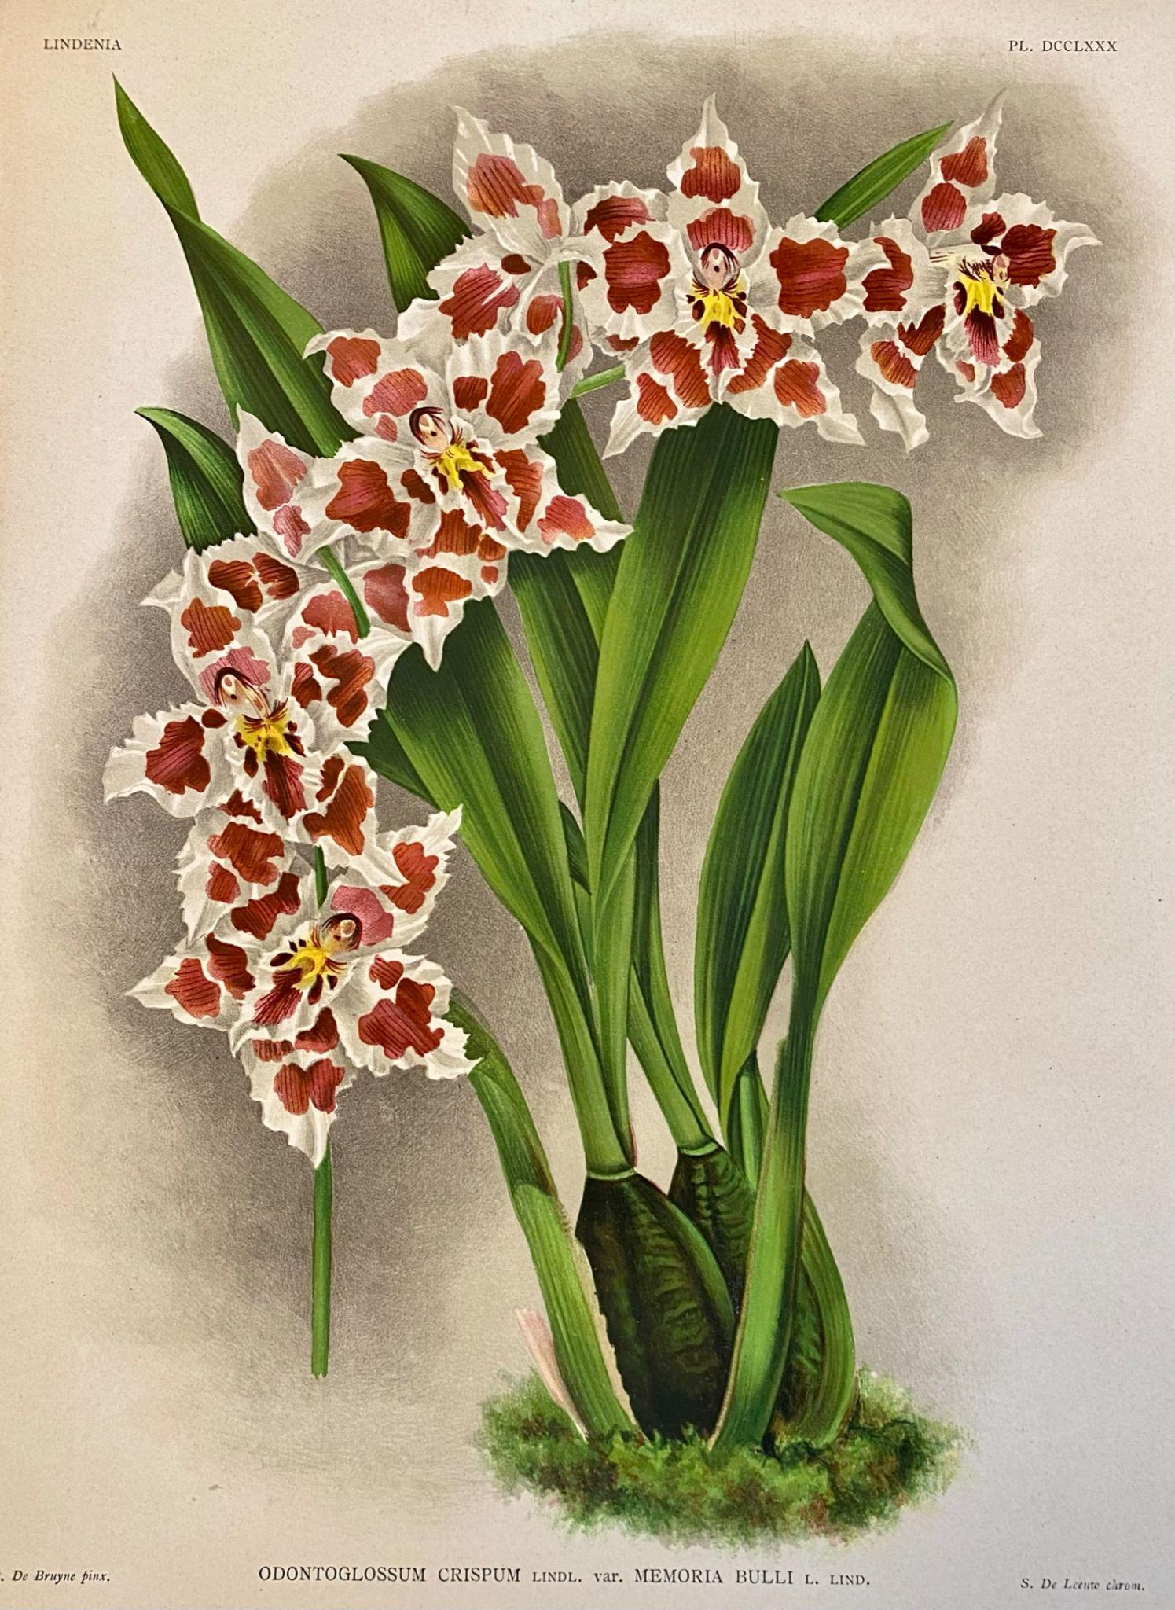
Lycaste skinnerii 'Reginae' Odontoglossum crispum 'Memoria Bulli'
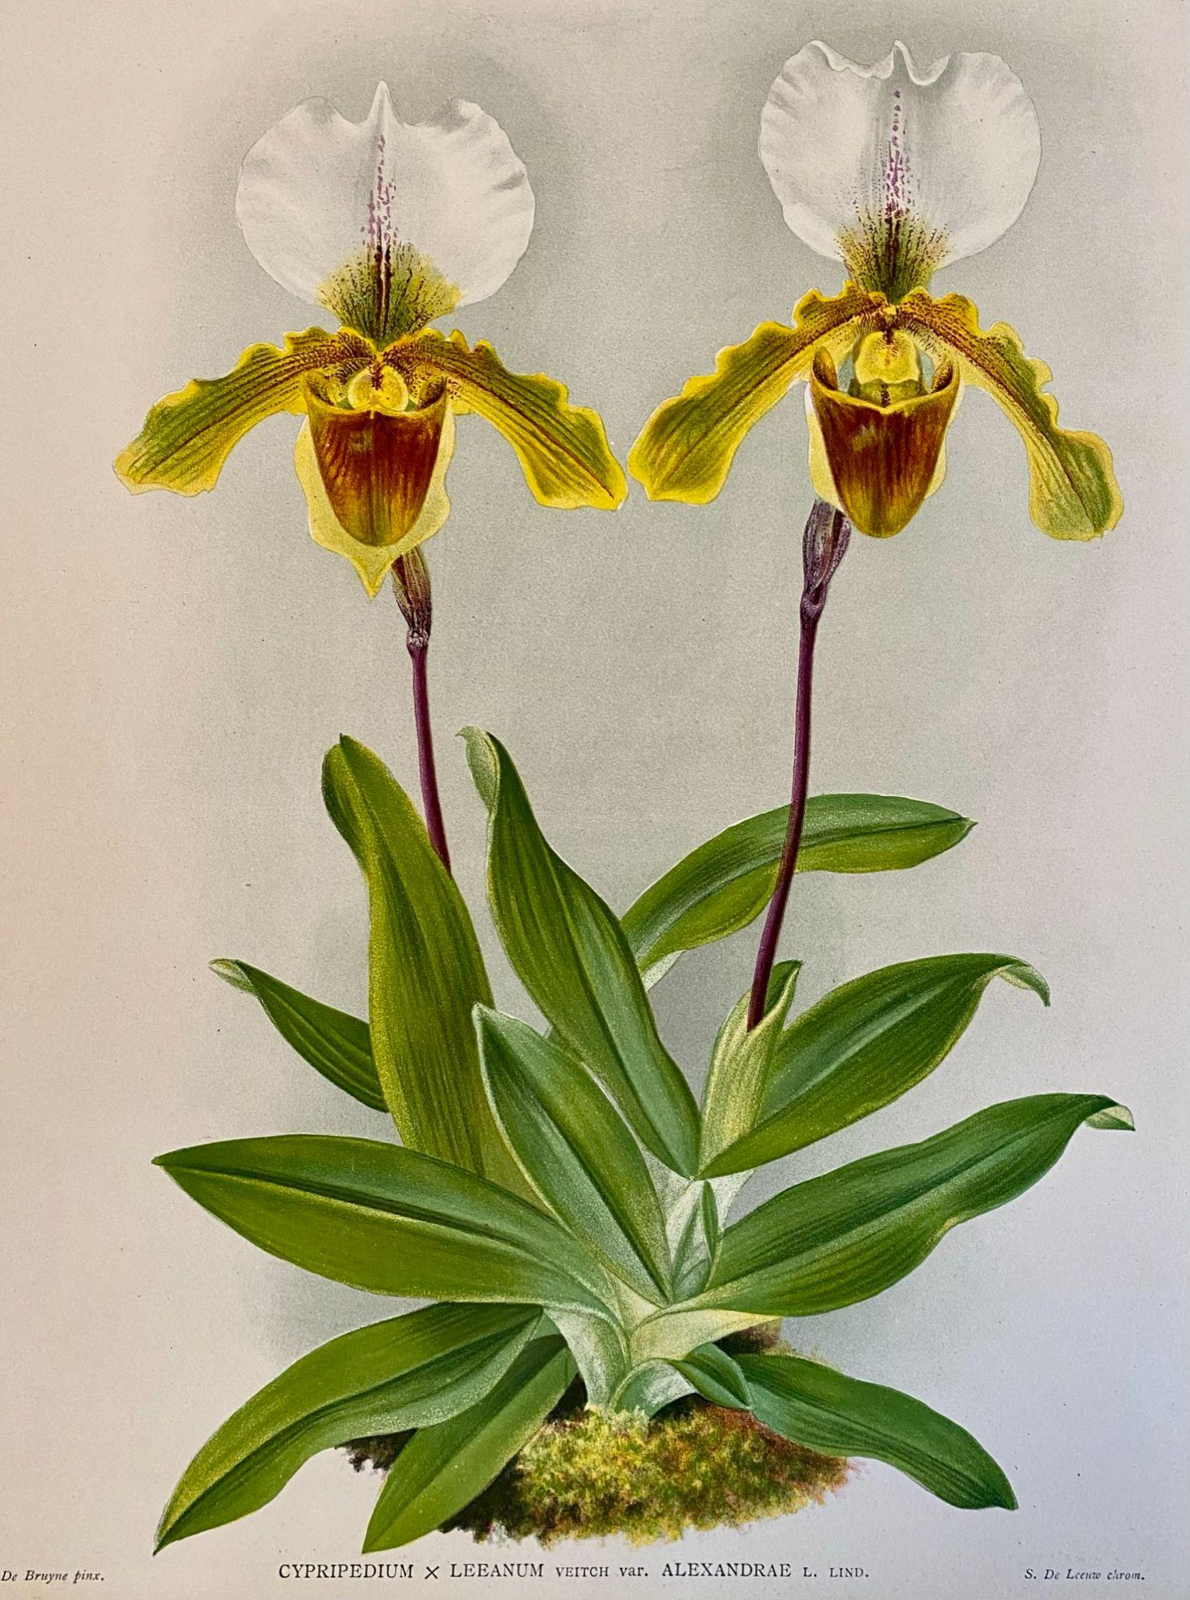 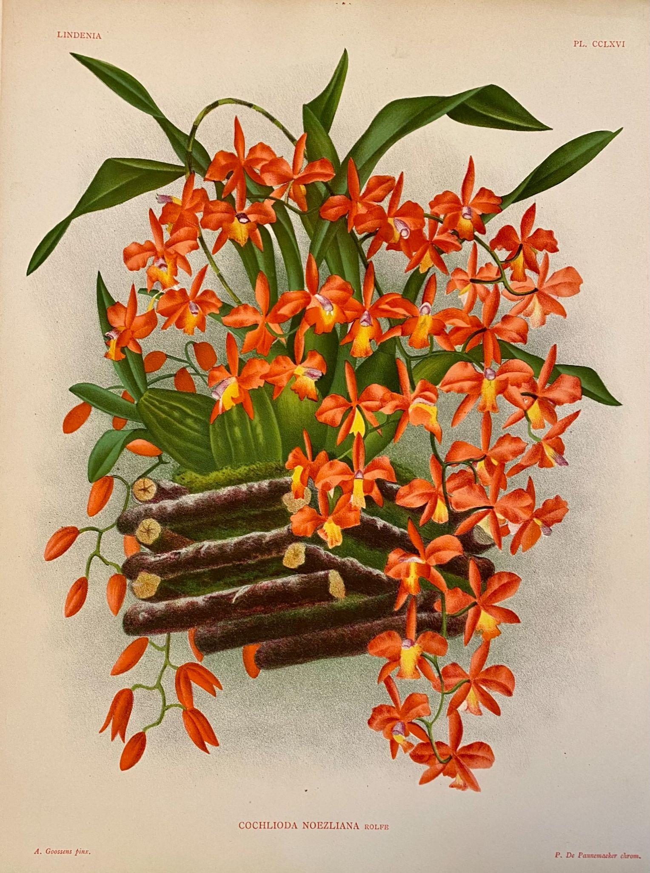
Paphiopedilum Leeanum 'Alexandrae' Cochlioda noezliana
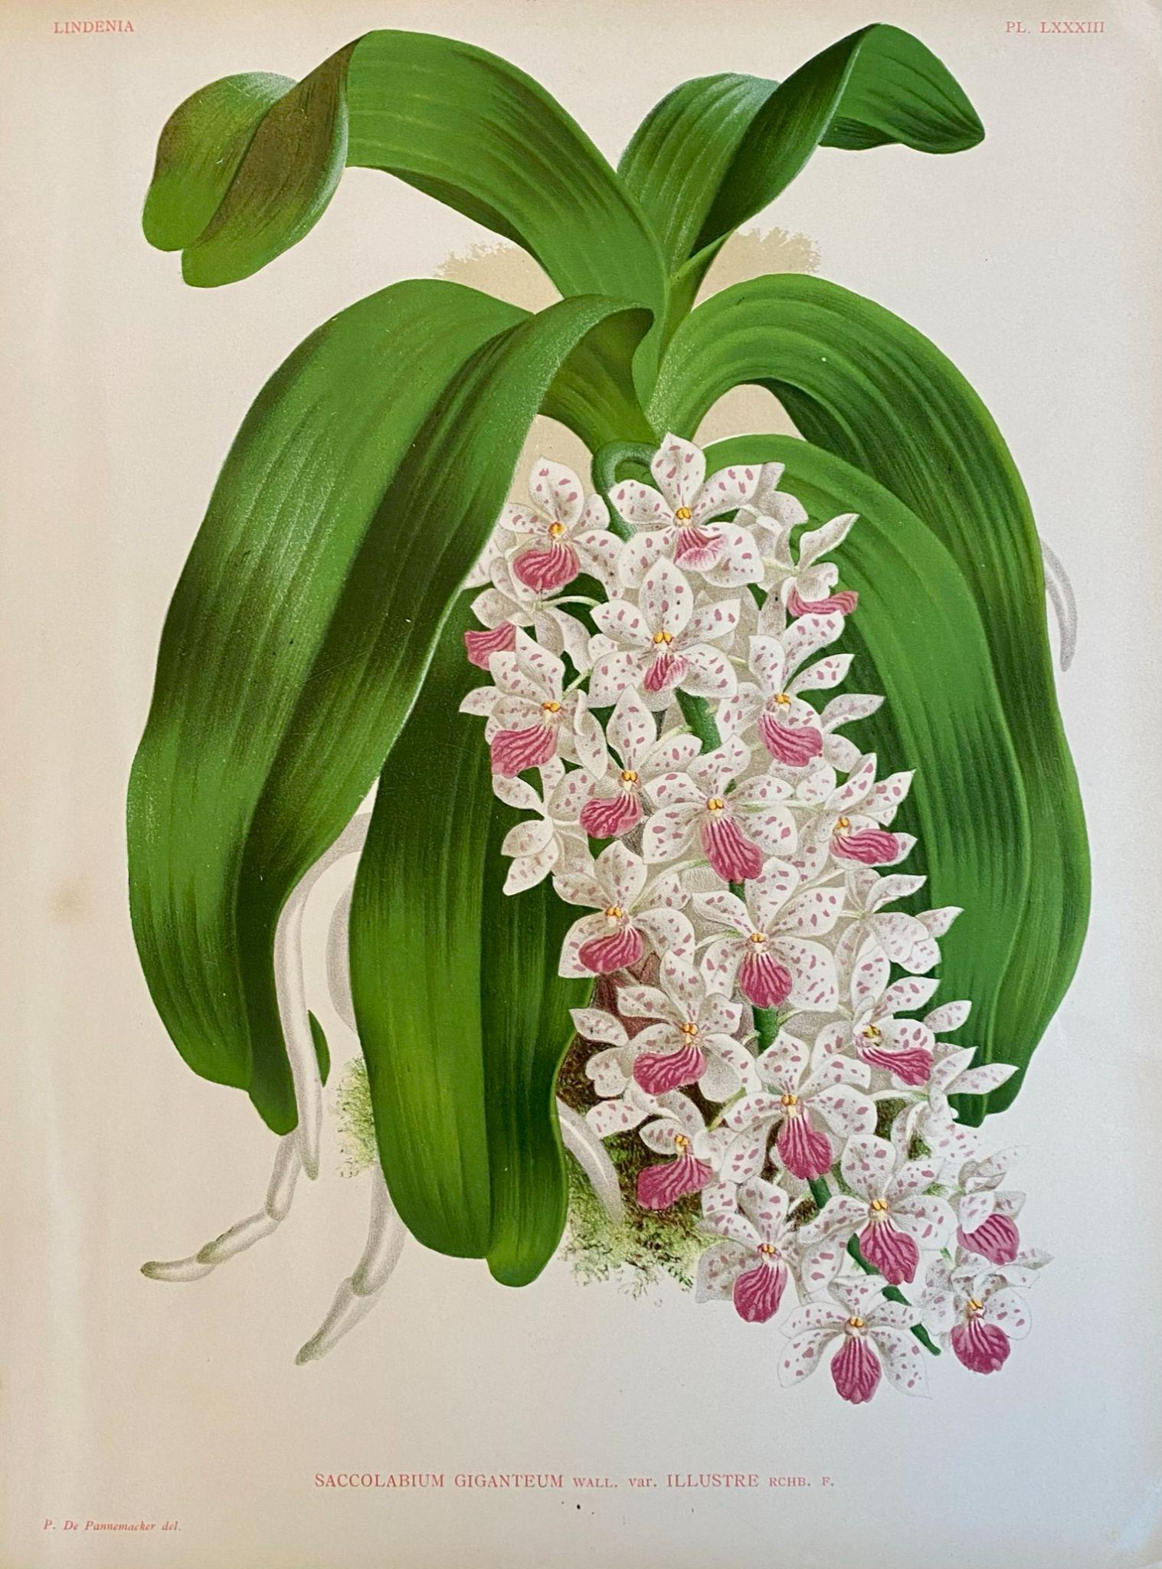 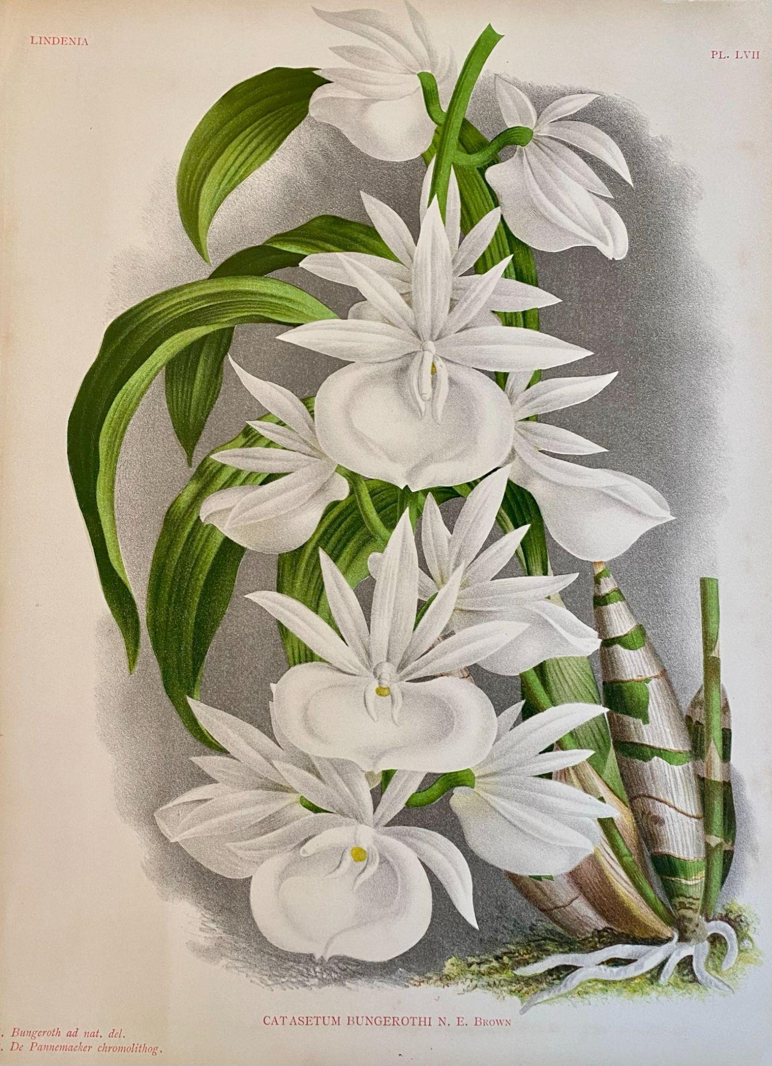
Rhynchostylis gigantea 'Illustre' Catasetum pileatum alba

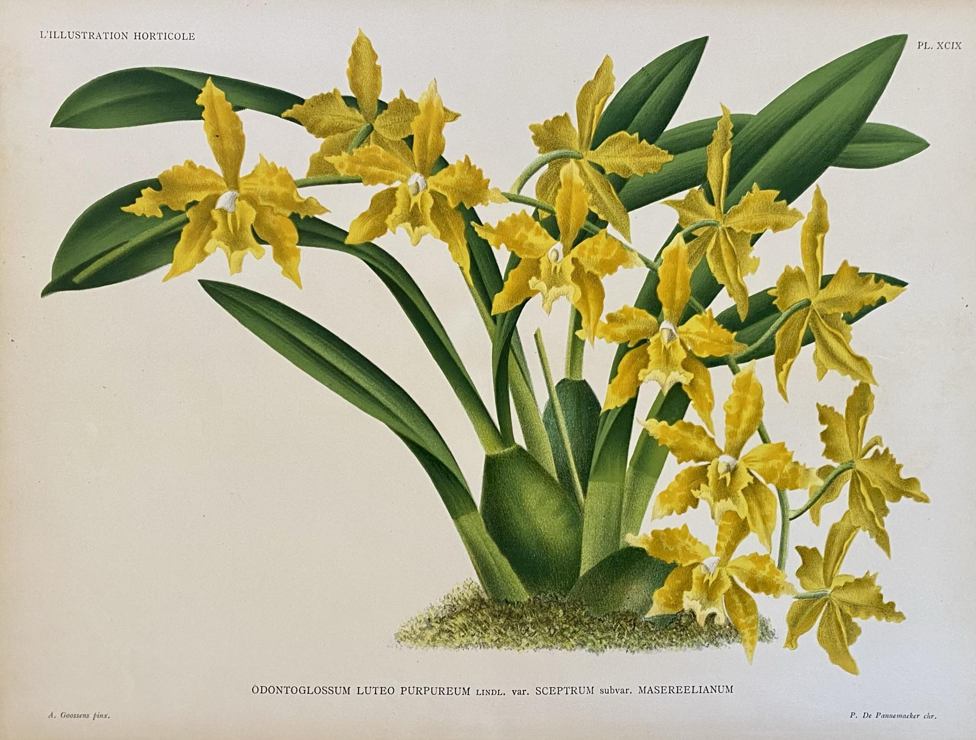
Odontoglossum Luteo-purpureum var. sceptrum 'Masereelianum'
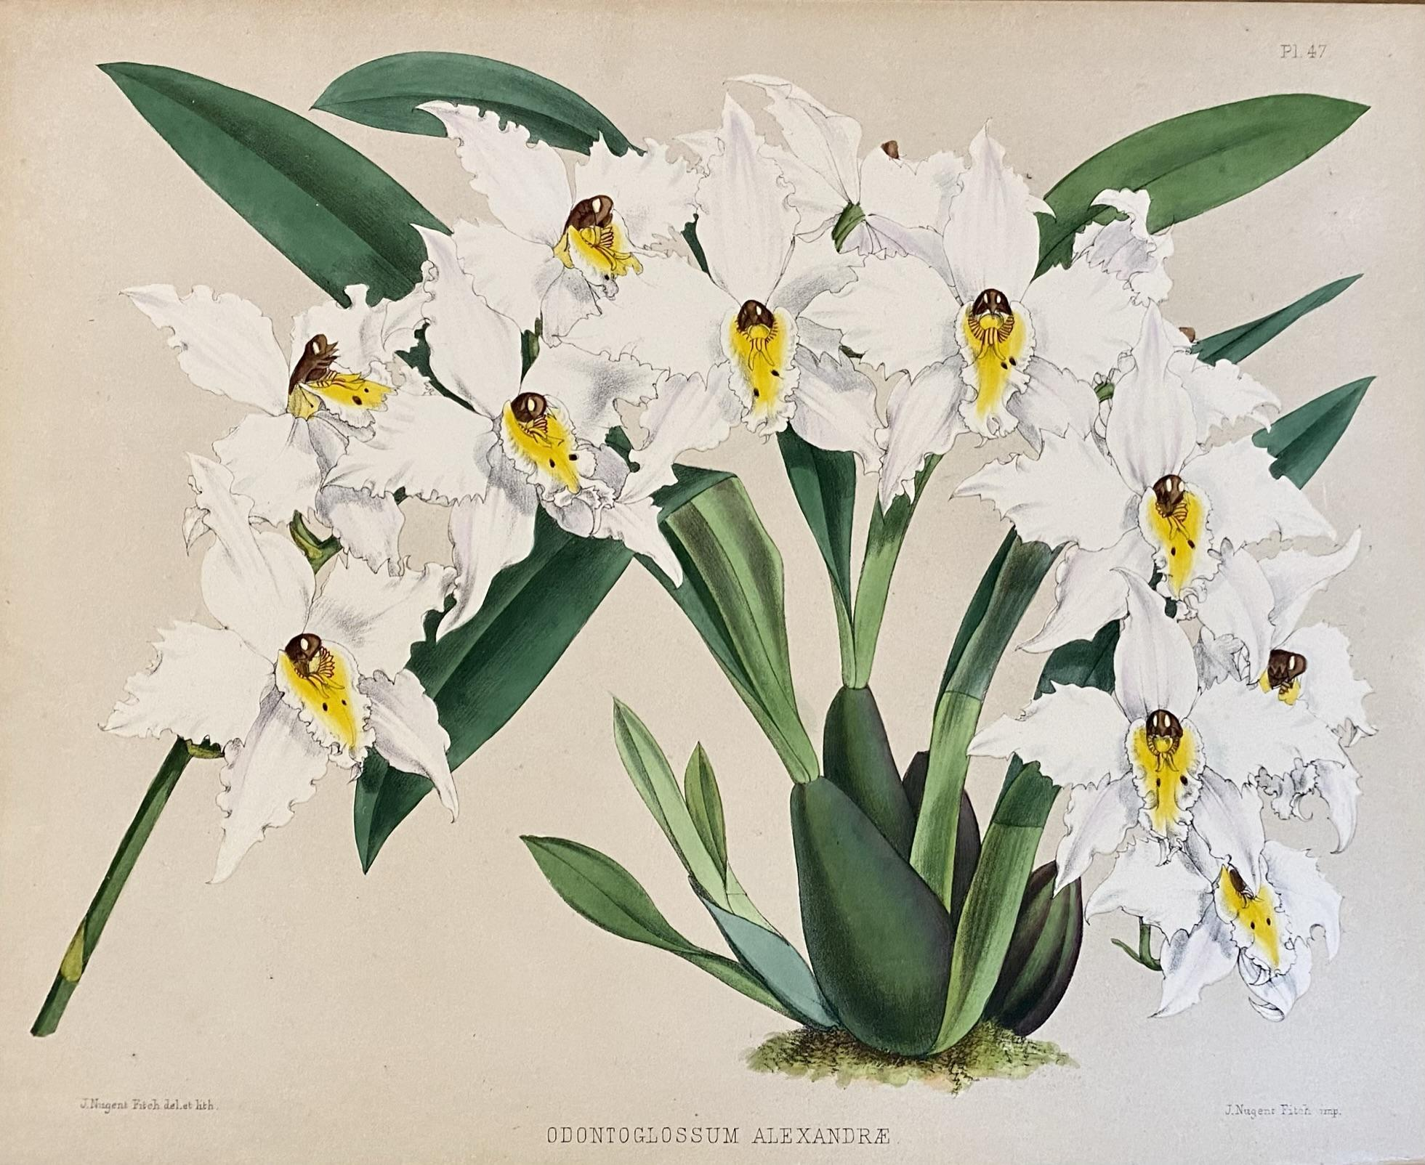
Odontoglossum crispum
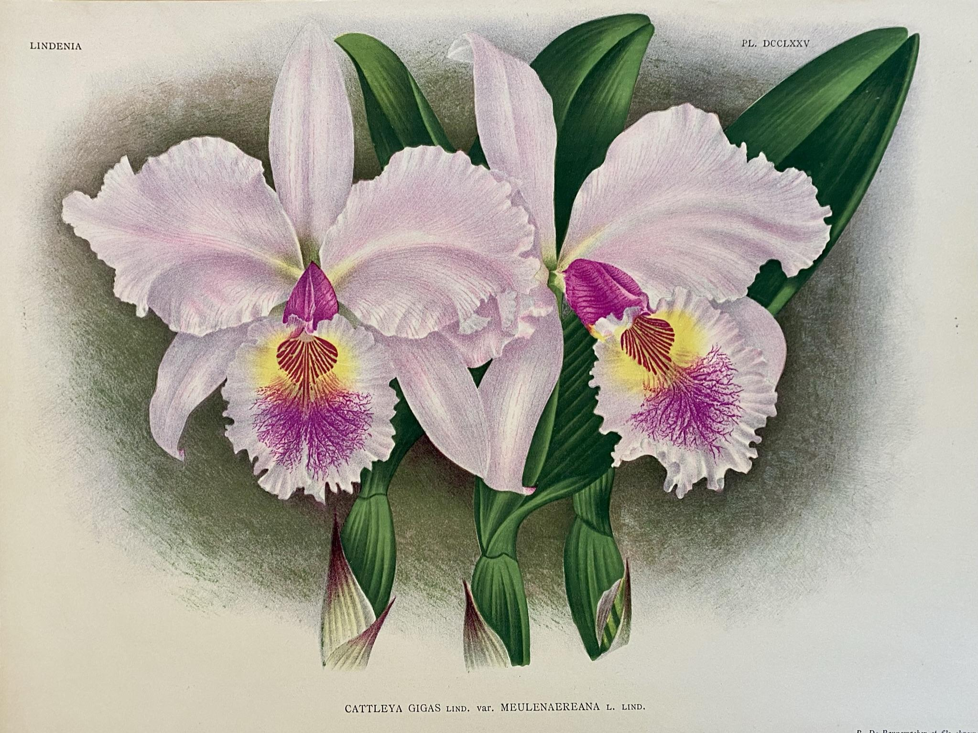
Cattleya gigas 'Meulenaereana'

Plant Table Format

We are currently soliciting ideas for the format for our Plant Table. As mentioned we are going to continue to photograph and start to video the Plant Table as part of our meeting and post it to the website. However, as part of our continuing evolution we would like input on what you would find valuable.

We currently have three ideas for how to manage the Plant Table.

Mini-Presentation (Current Format)
- People bring in their labeled plants and display them their own plants in a group.
- A single person will go around and select a plant or plants from a group and discuss something about that plant further educating the society.
- The owner of the plant will often be asked a question or questions.

Show and Tell
- This is very much like the Mini-Presentation format, however in this case each person bringing in a plant will be asked to come up and talk about a plant that they feel would be of particular interest to the society.

Mini-Show
- People again will label their plants, however they will also register them by ‘class’. These will be things like Cattleya, Paphiopedilum, Phramipedium, Oncidium/Odontoglssum, etc. Hybrids vs Species, etc.
- Each class or group will then be reviewed and discussed and the plants (and their owners) assigned virtual ribbons.
- At the end of the year small awards are given to the top three winners.
Please send your feedback and ideas to Robert Culver.

Native Orchid Conference on Olympic Peninsula, June 2022

The Native Orchid Conference, an organization with members in the US and Canada, will host a four-day symposium on the Olympic Peninsula, June 24–27, 2022. There will be two days of field trips and two days of talks. This is a great opportunity to learn about Washington’s native orchids. For details see Symposium | Native Orchid Conference | Native Orchids. Registration is limited to 100.

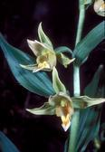
The NOC fosters the study, conservation, and enjoyment of native orchids of the United States and Canada. Anyone interested in wild orchids can join.

After the Olympic Peninsula conference was twice postponed because of the pandemic, the NOC began monthly Zoom meetings on native orchid topics. The most recent was on orchid conservation in Illinois. Another that I found of particular interest was orchids of Newfoundland. Details on these presentations are on the NOC web site.

Kathy Murray

Stream Orchid (Epipactis gigantea)

Report From The April Meeting

President Steve Dorsey opened the meeting by welcoming folks who were joining us for the first time. 2nd Vice President Ben Johnson thanked the members who helped with the past weekend’s show at the Spokane Orchid Society. He also reported on the awards earned by many of our NWOS members. This included George and Cylvia Grantham whose Dendrobium fimbriata var. oculatum won Best in Show. It’s on display on the plant table.

Steve thanked everyone who helped at the recent Potting Clinic which was held at the Volunteer Park Conservatory. Since that one was very successful he then announced that there will be another Potting Clinic on May 7th. This one will be held at the Douglas classroom of the Center for Urban Horticulture on the UW campus. It is adjacent to our regular meeting room below the parking lot next to the greenhouses.

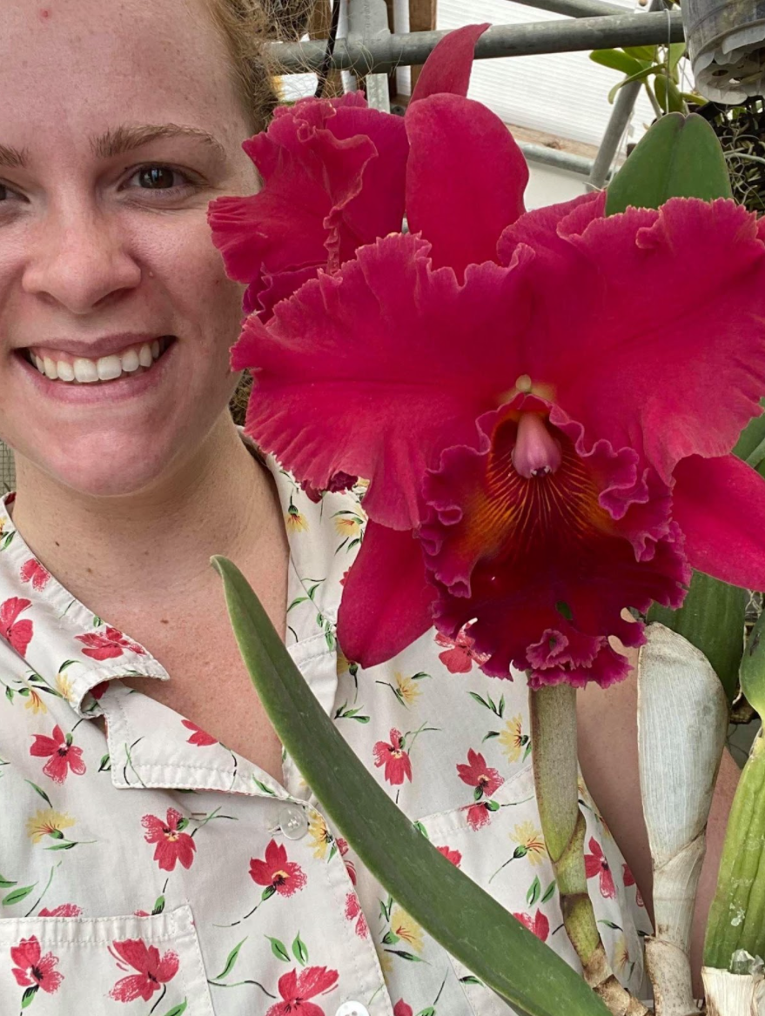
First Vice President Robert Culver introduced our Speaker, Kelly McCracken from High Desert Orchids. Her topic was “Artificial Lighting”. She uses lights in her growing areas. Her talk was very detailed about the various characteristics of light and how plants use all wavelengths of light. She recommended that we purchase horticultural lights that show light levels. There is a recommended light values chart that can be accessed on her website (highdesertorchids.com). Besides talking about how much light plants use, she also discussed what kind of light is best. Kelly introduced us to lighting concepts such as PAR and luminous flux and how our plants are affected. Included was a chart showing fluorescent vs. LED lights. A variety of other topics included bar lights, how light values can vary along the length of the bulbs, how high above the plants that the lights should be placed, the use of reflector and the use of full spectrum lights. Kelly’s talk was very detailed and thorough. Interest from our members was evident by the many questions and discussions at the end of her talk.

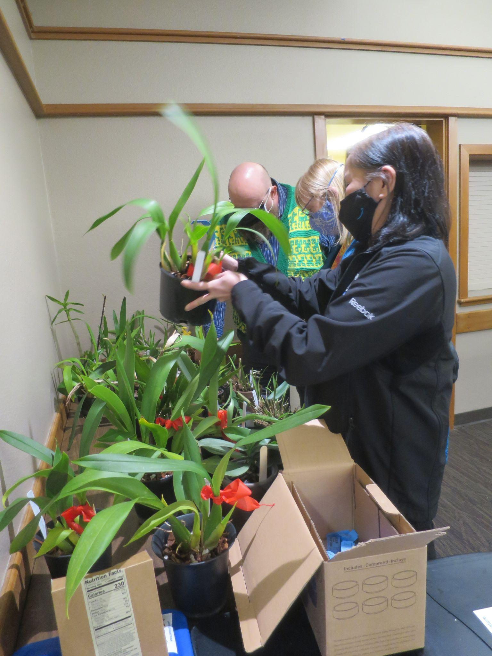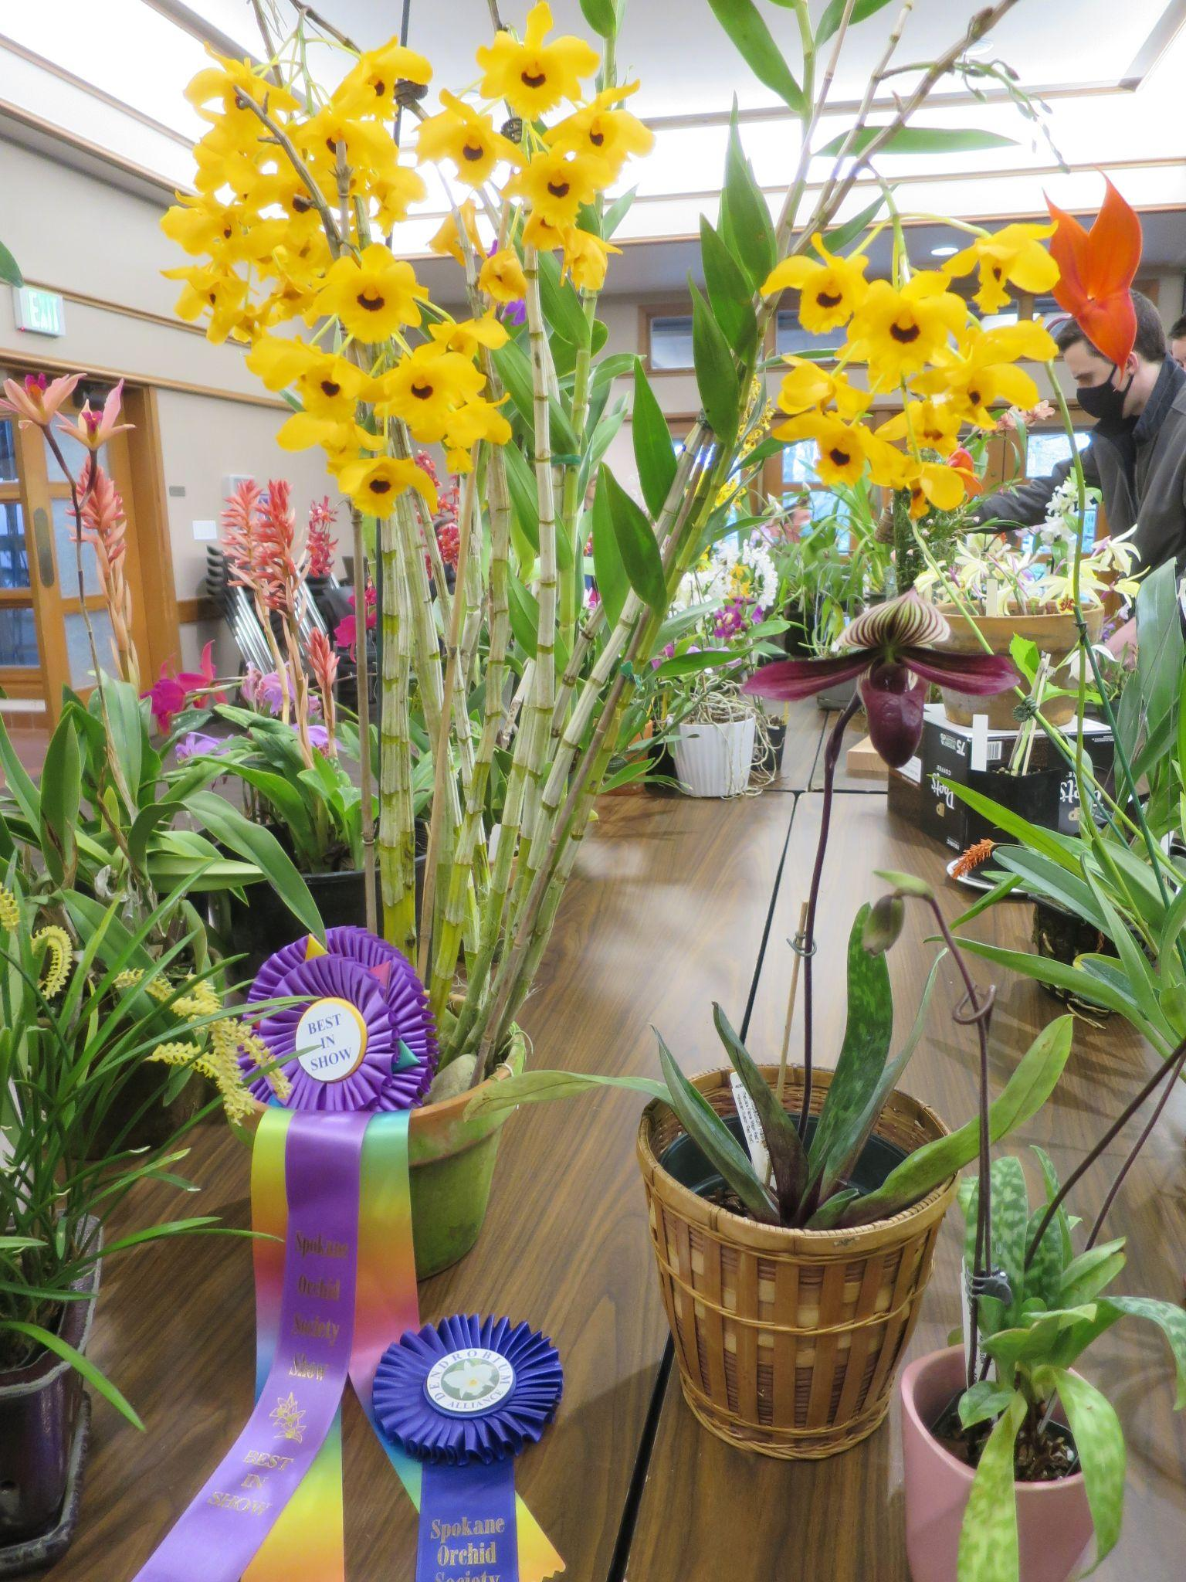
Inspecting the raffle plants Dendrobium is Best in Show at Spokane OS, Grantham
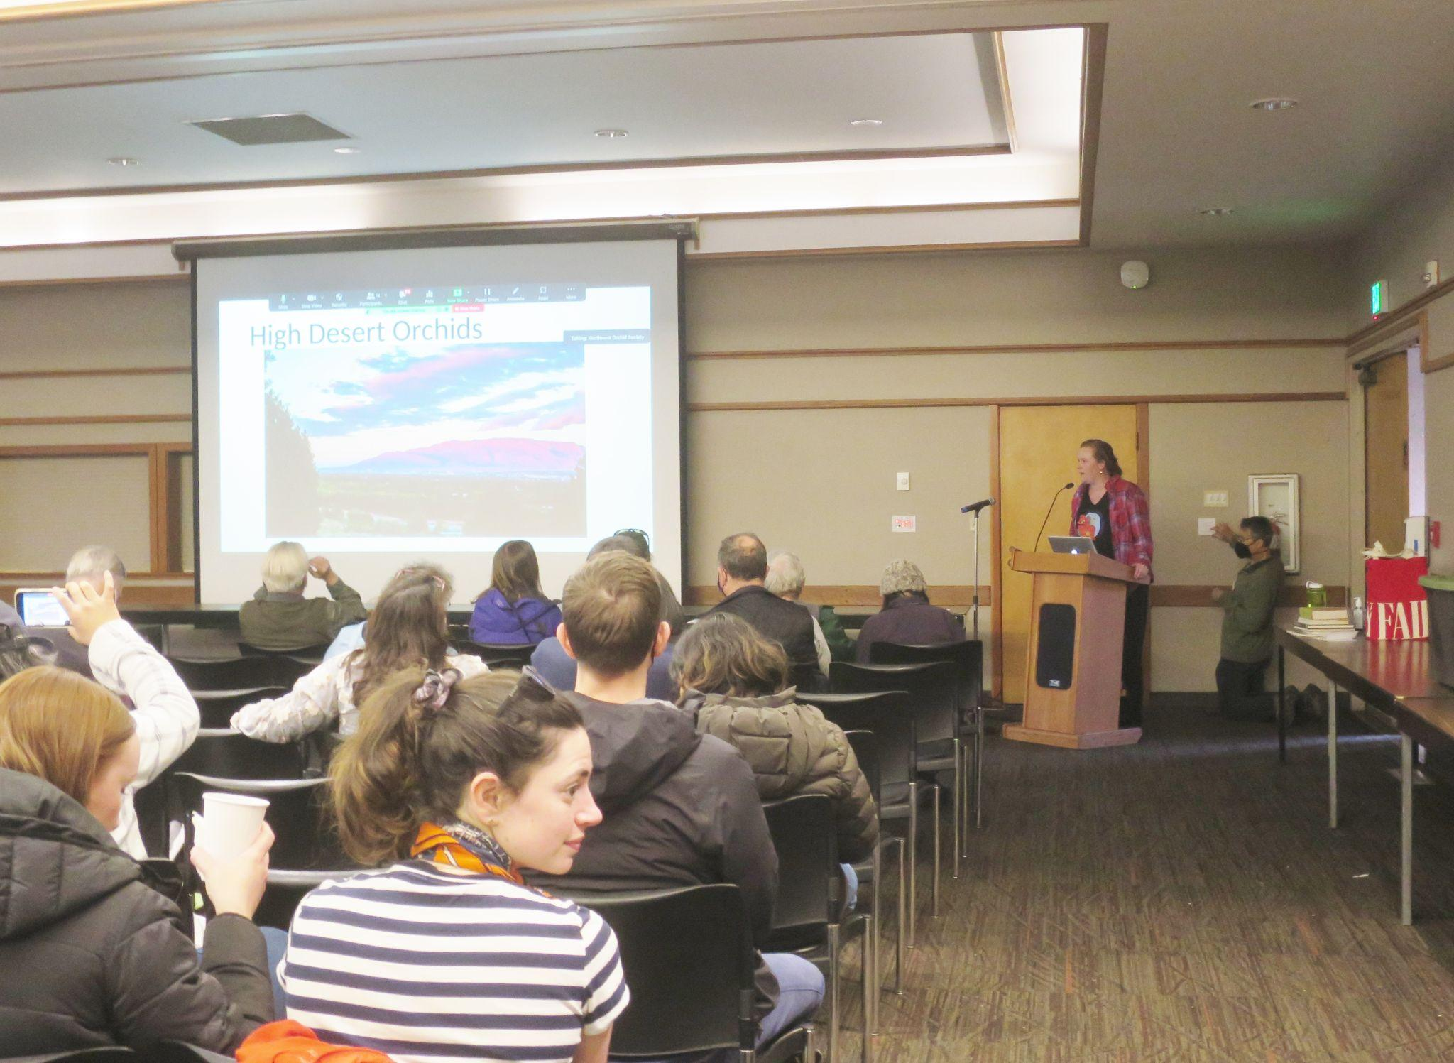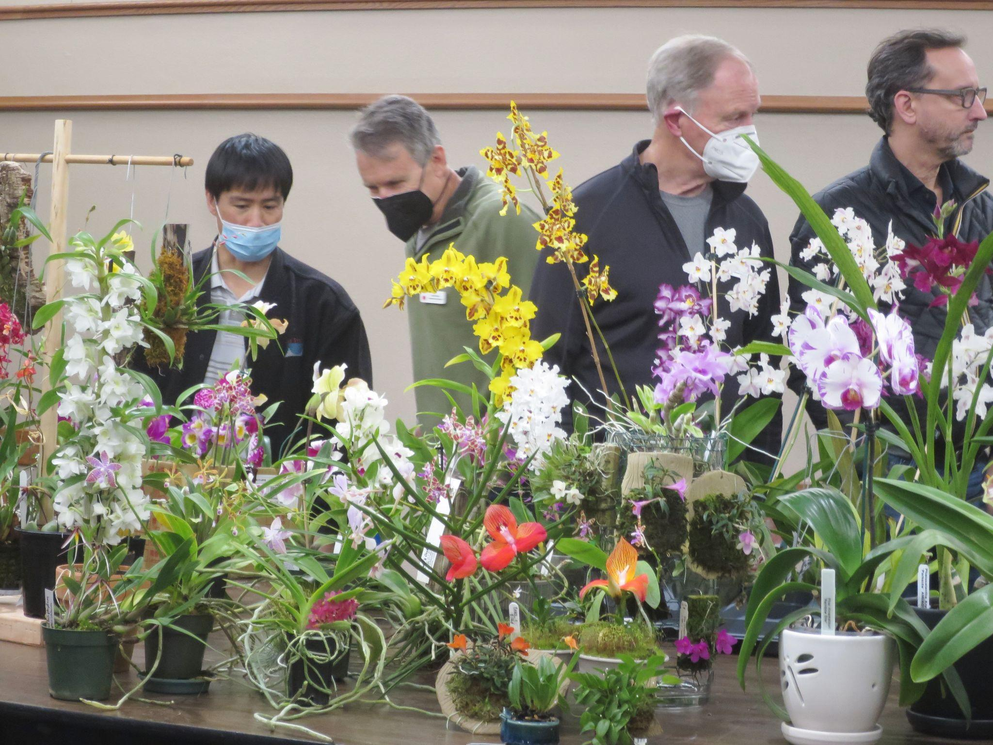
Kelly McCracken speaking to the group Admiring the Plant Table

Kelly mentioned that our plant table was the finest plant table of any society’s she has seen, and there are many fine growers here. You should all be proud of your accomplishment.

Here are several selected photos of April's Plant Table from the online gallery.

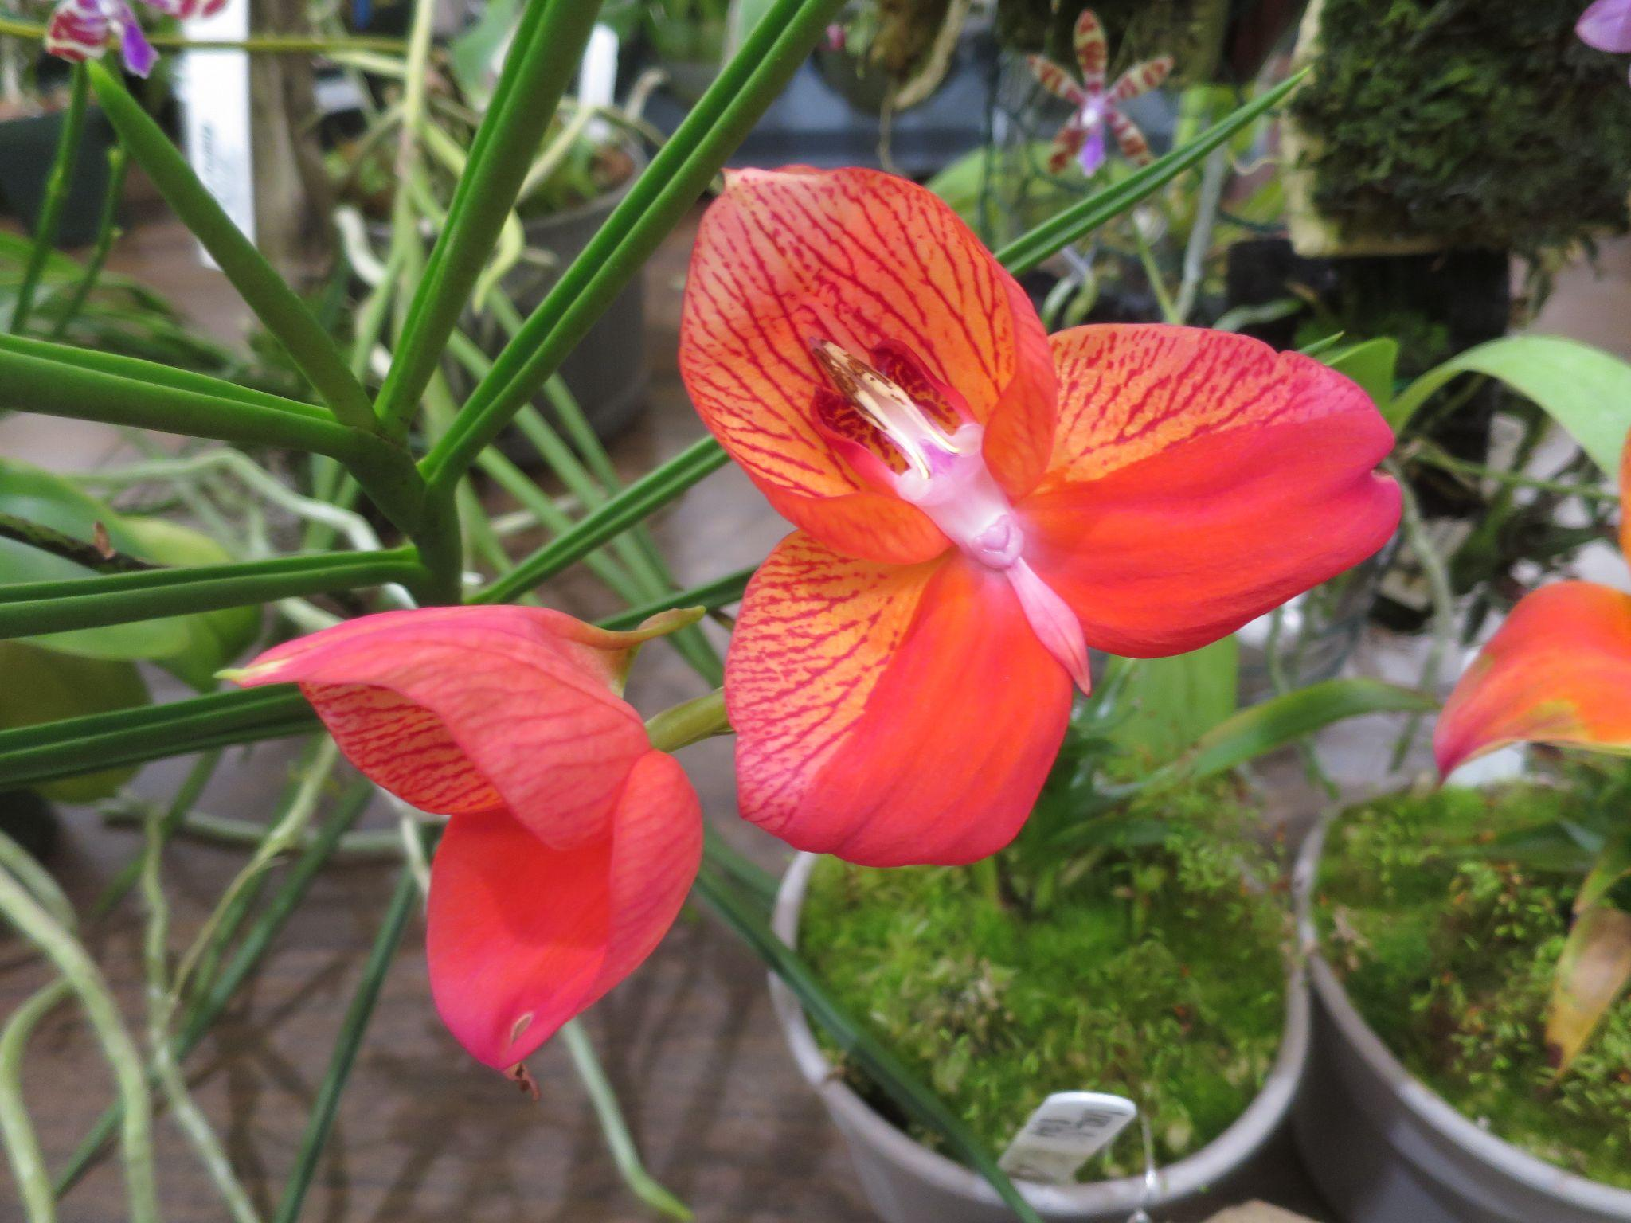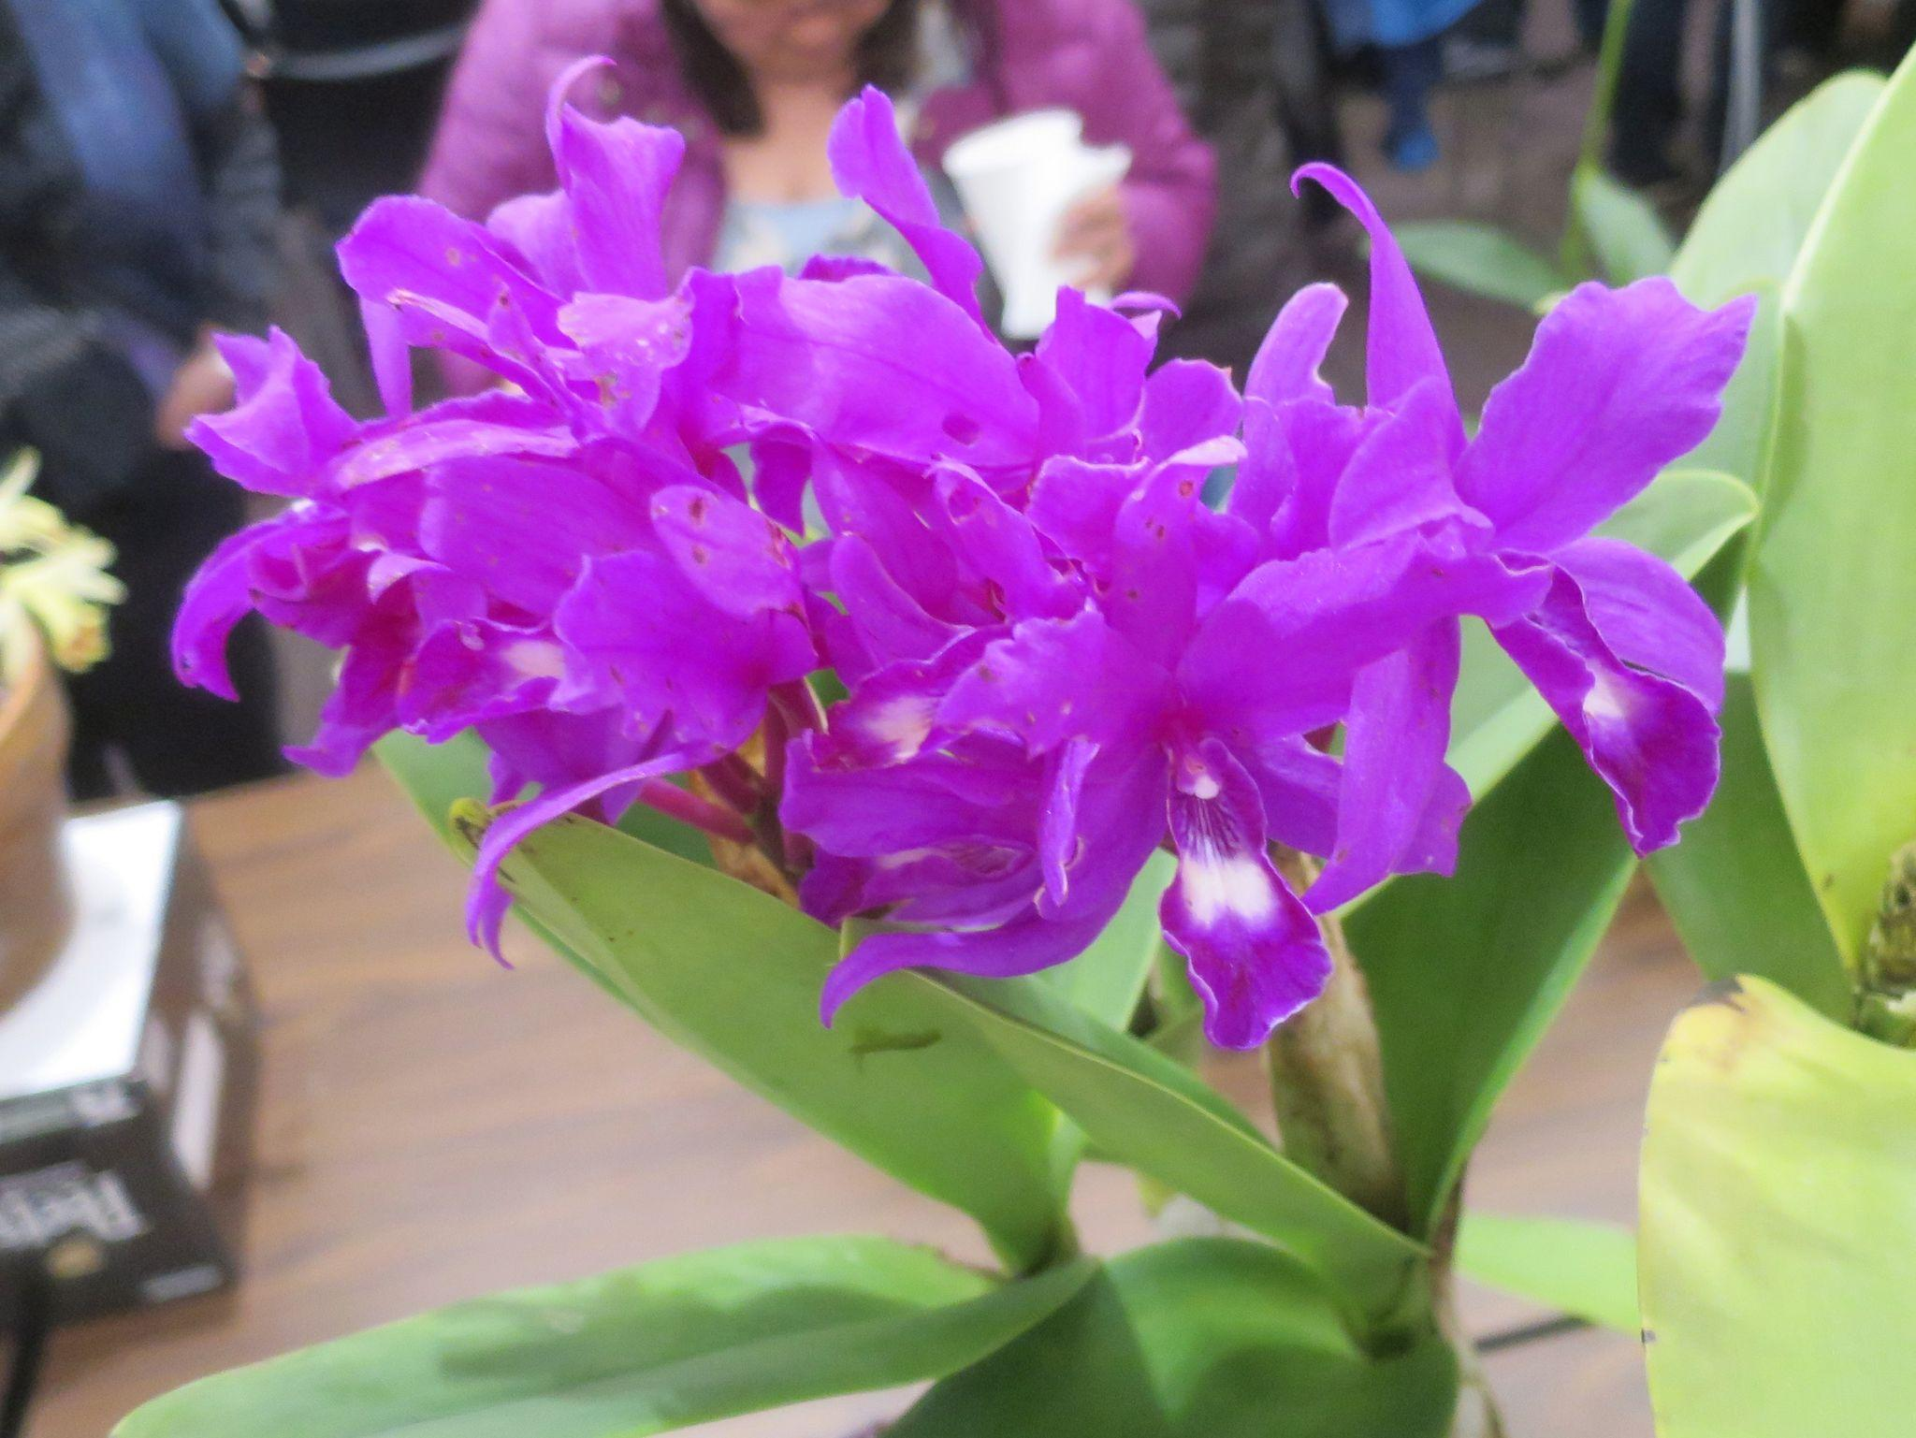
Disa uniflora, Andrew McGinnis Guarianthe Hail Storm ‘Nilene’, George Krasle
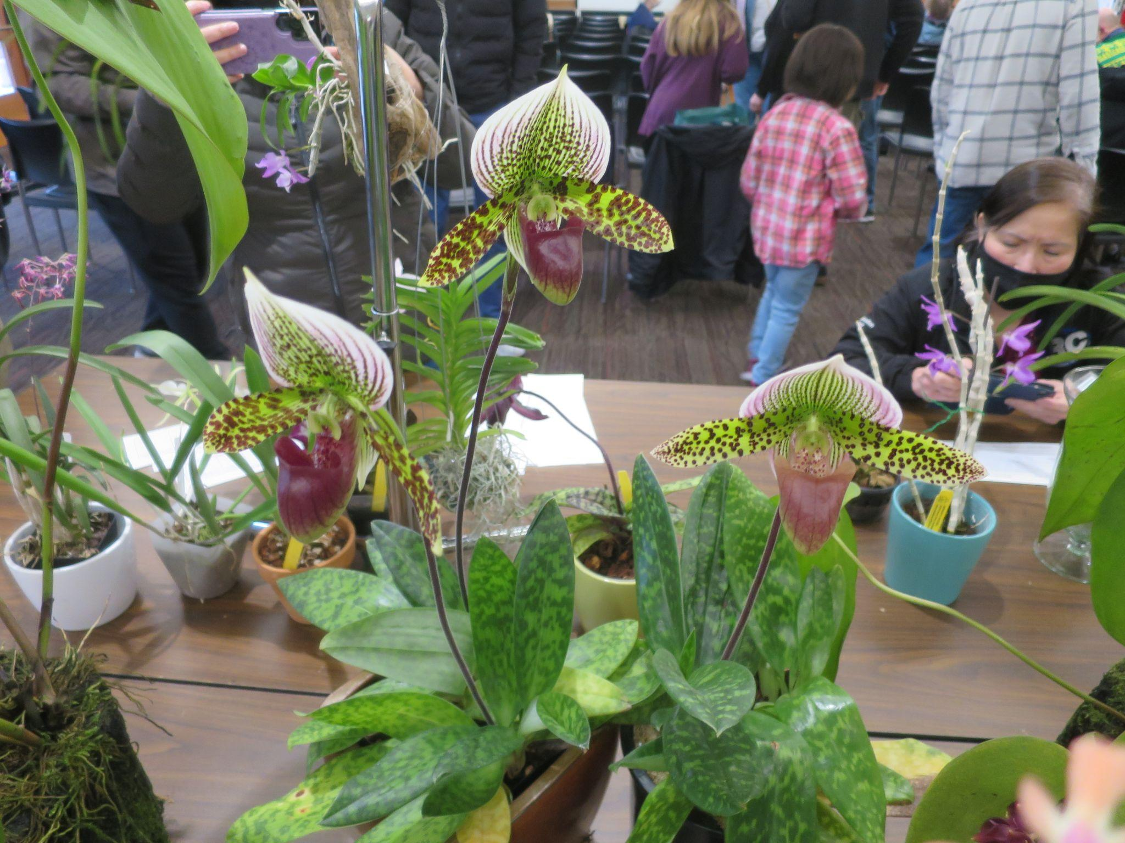 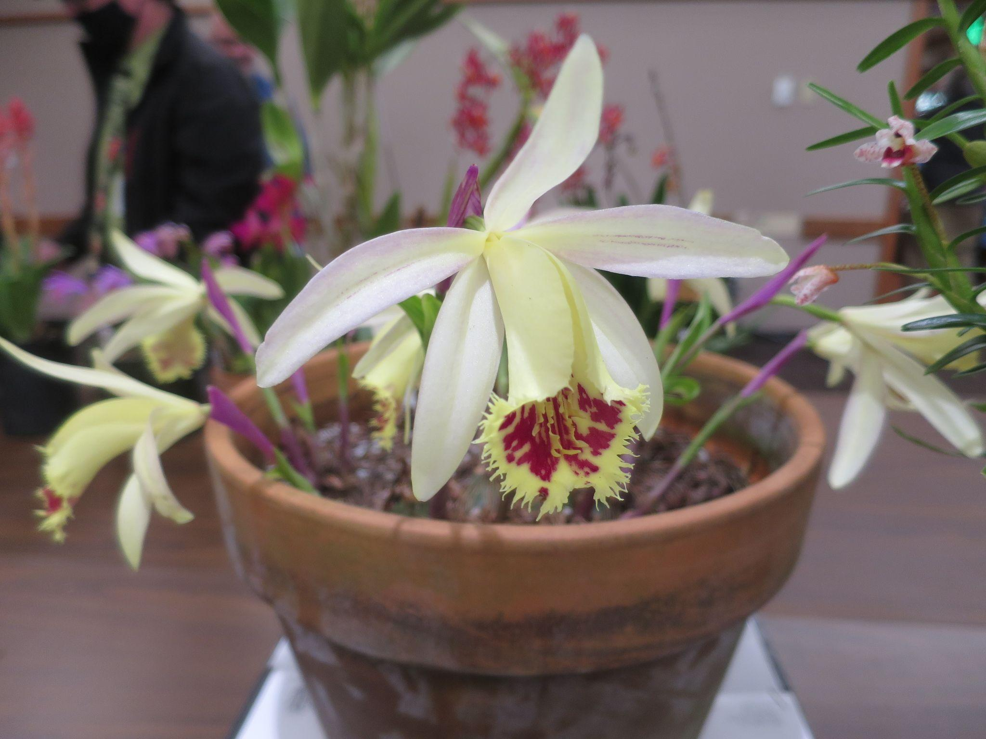Paphiopedilum Hybrid, Andy Wright Pleione confusa 'Golden Gate', Gordon Cromwell

Schedule of Upcoming Events

05/07/22 - Potting Clinic – 11AM to 2PM at the Douglas classroom, CUH (Center for Urban Horticulture), Univ. Washington. See article above.

05/09/22 – NWOS meeting – Speaker: Bill Goldner, PhD from Woodstream Orchids, “New Looks for Miniature Phragmipedium Hybrids and Other New Lines of Breeding.”

06/13/22 – NWOS meeting – June Social: The June Social is the last meeting before our summer break. Enjoy socializing during dinner. This is also the meeting where we present the Gary Baker service award.
8/ xx /22 - NWOS Summer Picnic: The NWOS will have a summer picnic for its members hosted at the home of Andy Wright. Check back soon for the date.
09/12/22 – NWOS meeting – Speaker: Tom Ethridge, “Odontoglossums Then and Now, Has Anything Changed?”
09/30/22 – NWOS Annual show SETUP at the Volunteer Park Conservatory.
10/01-10/02/22 – NWOS Annual SHOW AND SALE at the Volunteer Park Conservatory.
10/10/22 - NWOS meeting – Speaker: Tyler Albrecht, “An Exploration of the Fluffy and Puffy Parvisepalum Paphiopedilums”
11/14/22 - NWOS meeting – Speaker: Peter Lin, “Neofinetia and Its Hybrids”
12/12/22 – NWOS meeting – Speaker:TBA , introduction of new Officers, NWOS Annual Meeting report, Schoenfeld and Northen Orchid Awards, and Holiday Gift Plants.

Reminder for Officers & Board Members

The next board meeting is Sunday, July 10th, the date and time have not yet been determined. Check your email for the Zoom registration link and agenda. Future meetings are tentatively scheduled for September 6, and November 8th
.

Shopping on Amazon? Use this link to earn $$ for the NWOS

If you go to https://smile.amazon.com and sign in to your account, you'll be given information about supporting various non-profits. You can type in "Northwest Orchid Society" and it will then send .5% of your purchase price to the organization.

It's really easy, but you have to remember to go in through the 'smile' subdomain when you place the order, otherwise it will go through as a regular order.

NWOS Website Links

- Main website: Http://www.nwos.org
- Events Calendar: http://www.nwos.org/events
- Membership (including renewals): https://nwos.org/Membership/
- Newsletter - Current Issues: https://nwos.org/newsletters/
- Newsletter - Archived Issues: http://newsletter.nwos.org
- Show Information: http://nwos.orchid-society.net/ShowTime/Show2021/Show.html
- Facebook: http://www.facebook.com/nworchidsociety
- Instagram: https://www.instagram.com/nworchidsociety/
- Twitter: https://twitter.com/nworchidsociety

Special Announcements

Emerald City Orchids Spring Open (Green)House

Saturday May 7th and Sunday May 8th

Emerald City Orchids is having a sales on Mother's Day weekend, including extended hours (open Sunday)

Literally every orchid plant in the inventory will be on sale, with discounts ranging from modest for exclusive collectibles to bonkers for clearance plants. In the past three months, we’ve had shipments of new orchids arrive from Asia, South America, California and Hawaii. Thousands of new orchid plants in hundreds of new varieties of species and hybrids have been added to our already incredible diversity of orchids available.

Hours are extended, and we will be open Mother’s Day Sunday.

Saturday, May 7/8 9 a.m. - 4 p.m.

At the Emerald City Orchids greenhouses
4734 S. Tacoma Way
Tacoma, WA 98409

It’s going to be a lovely weekend. Bring the mothers in your life to let them know how much you appreciate them.

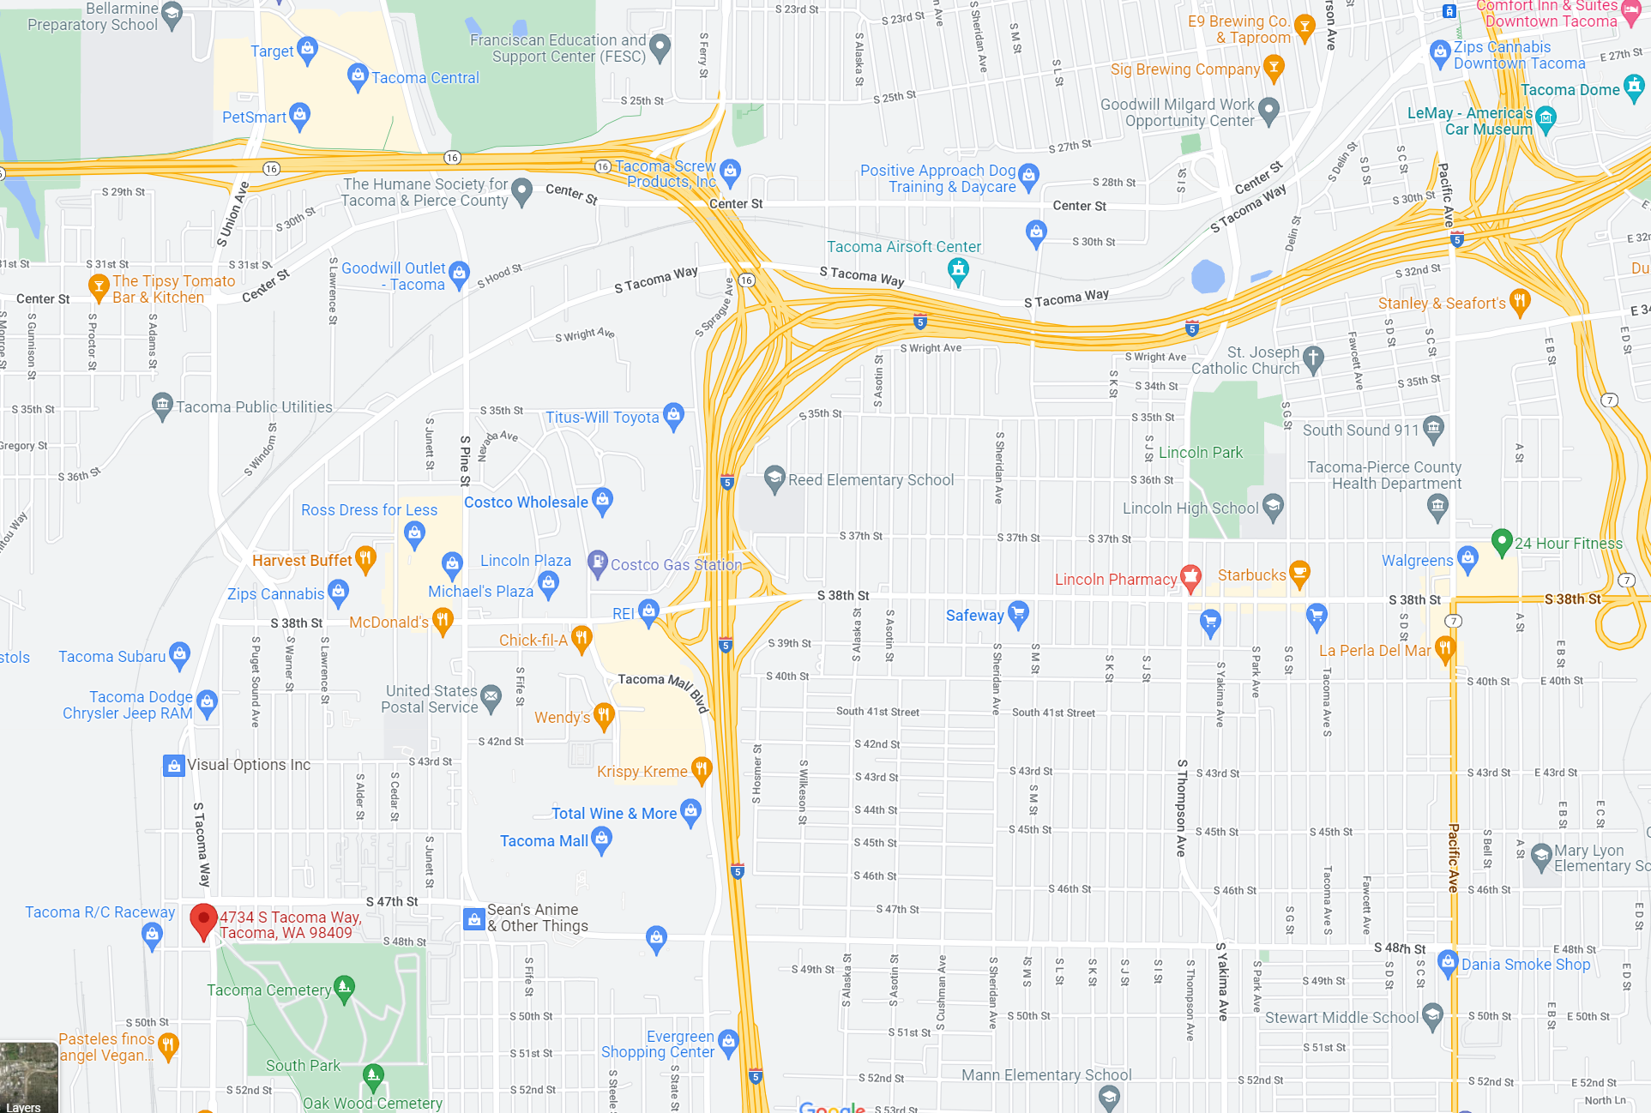

©2022 Northwest Orchid Society - All Rights Reserved

The opinions and recommendations published herein are those of the authors. The Northwest Orchid Society (NWOS) disclaims responsibility for any losses or damages that may be attributed to the use or misuse of any material or any opinion published in these articles and on the website. This website and the photographs, articles and content are protected by copyright and no part of them may be reproduced or re-used without the permission of the author.

The Special Announcements (SA) section is provided as a courtesy to the readers of this newsletter for events which may be of general interest to the readers. The NWOS (1) makes no promises, warranties, or representations as to SA, including its completeness, accuracy, availability, timeliness, propriety, security or reliability; (2) provide SA on an "AS IS" and "AS AVAILABLE" basis and any risk of using SA is assumed by you.

