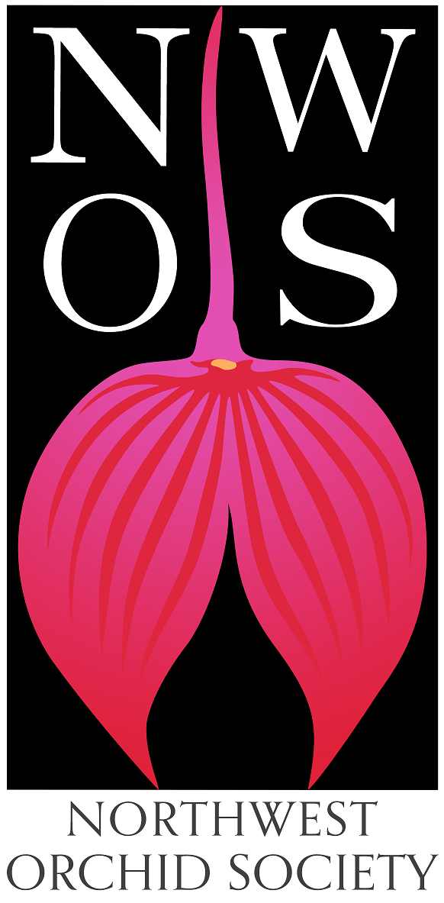
Northwest
Orchid News
June 2023
Volume 76, Issue 6

- About the June Meeting
- Spring Social
- Plant Table
- Sales Table
- Raffle Table
- NWOS Library
- New Events Calendar
- 2023 NWOS Fall Show and Sale
- Volunteer Opportunities
- Summer Your Orchid Outside
- Report From The May Meeting
- Local Judging
- Schedule of Upcoming Events
- Reminder for Officers & Board Members
- NWOS Website Links
- Special Announcements

About the June Meeting
June 12, 2023 7 PM
University of Washington Center for Urban Horticulture
3501 NE 41st Street, Seattle, WA 98105

We will be meeting in person for the foreseeable future.

Spring Social

Come and join us for our last meeting before summer break when we sit down and have a meal together and socialize. Bring your plants for the plant table and see what’s on the sales or raffle table that you want to go home with.
Carver Kitchen, our caterer for the evening, told us to expect about $12-18 + beverage per person. The food truck will be outside at 7:00, so please allow plenty of time to get your food.
This meeting will not be available via Zoom.

Evening Highlights
- Plant Table
- Raffle
- Sales Table
- Gary Baker Service Award
- Society Business

Plant Table

We will be having an in-person plant table this month. For your convenience, you can print out a Plant Table Information Form ahead of time. Click for your version of choice: PDF or DOCX file?

For those who aren’t able to attend, please keep sending your pictures, we will include them in our online gallery and in next month’s newsletter. Please send them to photos@nwos.org.

Sales Table

Members may bring up to 10 plants to sell. Include an extra tag with your name and the price in the plant.

Raffle Table

The raffle will be held as usual. Win a new orchid for your collection while supporting the Scholarship Fund. If you have any extra Orchids, please consider donating them to the raffle.

NWOS Library

If you'd like to check out a book or tape from our Library, please contact our Librarian Joe Grienauer a minimum of 2 weeks before the next meeting. Besides email, you can give Joe your request at any meeting. For a list of library items please click here NWOS Library.

New Events Calendar
The NWOS now has an Events Calendar you can subscribe to and events will be added to your calendar. If you would like them to be added to your calendar so you can be aware of more than just the monthly meetings, this is a great option for you.

You can find the link here: Events Calendar

2023 NWOS Show and Sale at Volunteer Park Conservatory

Ben Jonson is heading up the Fall Show Working Group. We know that many of you will be helping out with our upcoming show. Please raise your hand and let us know so we can create a mailing list.

The dates of our show are Friday Oct. 7th - Sunday Oct. 8th
The NWOS Page can be found here: NWOS Fall Show

Volunteer Opportunities

We are looking for a couple of volunteers to help with some outreach and multimedia for the society. If you are interested contact Robert Culver.

Membership Committee
Sean Hoyt, our Secretary, is forming a membership committee to study adding some additional membership levels to our current levels. This is in an effort to help promote awareness of our society with businesses and sponsors, etc. If you would be interested in participating in the design of these levels please contact Sean directly at secretary@nwos.org.

Sales and Marketing on Social Media
Currently, Julian Branbury, Ben Johnson, and Robert Culver are managing postings on our social media sites. We are looking for a volunteer that will work with them to coordinate Sales and Marketing targeted postings on Social Media. These will focus on our major events such as our shows and clinics. If you are interested please contact events@nwos.org or speak to Ben or Robert.

Vision 2030 Committee
We are forming a new committee that will meet over the summer to prepare a new vision statement and along with that, a direction for the society as we head into the future. We are asking for a few members to join us in charting this course. Please let us know if you’re interested by sending an email to Robert Culver at robert.c@nwos.org.

Summering Your Orchids Outside in the Pacific Northwest
Adapted from advice in an article by Gary Baker published in the AOS ‘Summer Orchid Care Across the USA’.
Hey there, orchid enthusiasts in the Pacific Northwest! With the arrival of the warm season, it's a great idea to let your orchids embrace the outdoors. They'll benefit from the fresh air, increased airflow, and a good dose of sunlight. However, be aware of potential threats such as insects or even curious pets.
Got an apple tree or any other fruit tree in your yard? Perfect! These can be fantastic natural homes for your orchids. Just hang them up there ensuring they're well-positioned to catch the light. Don't have a fruit tree? No problem. You can use a well-lit patio or balcony. Remember to keep them in a spot where they can avoid the harsh midday sun but still get plenty of morning and late afternoon light.
For our Alaska-based orchid aficionados, it's generally better to keep your orchids inside. They'll appreciate a well-lit room with plenty of indirect sunlight.
For those of you based east of the Cascade Mountains, dealing with humidity can be tricky, particularly during those dry, scorching summer days. Any orchid daring enough to face the heat outside must be prepared. You can use a humidity tray, which is basically a tray with pebbles and water. You place your orchid pot on the pebbles, making sure the water level doesn't reach the pot. The water will evaporate and increase humidity around the orchid.
Grouping your orchids together can also help, as they will create a microclimate, naturally increasing humidity. Another helpful tip is to gently mist the leaves with water in the morning. This allows them to dry during the day, reducing the risk of fungal diseases.
Place your cymbidium orchids where they'll get plenty of light, but not so much that they burn. When they're getting just the right amount of light, you'll notice their leaves turning yellowish-green. Let them soak in the outdoors until early autumn, just before the first light frost. By then, they should have started sprouting inflorescences.
Nobile-type dendrobiums are a bit more sun-friendly and would enjoy almost full sun exposure. Just make sure to help them gradually adjust to the higher light levels. These types, along with cymbidiums, love lots of water and fertilizer. However, remember to bring them back inside before the frost hits.
Masdevallias and other pleurothallids are the perfect fit for a shady spot under a tree. On warmer, drier days, make sure they're getting enough humidity. You can do this by misting their leaves if the humidity levels are a bit low.
As for your paphiopedilums, they should be done flowering by now. This is the ideal time to divide and repot them. Try to do this quickly so they can start developing strong new growths in time for the winter flowering season.
Your Miltoniopsis, also known as the pansy orchid, should be finishing up its beautiful spring bloom. Make sure to remove any dried flowers and pick off dead leaves to prevent any bacterial or fungal issues. Don't be surprised if the leaves of these orchids turn a bit pink under strong light – it's perfectly normal and healthy. However, if the pink starts to turn a bit reddish, it might be a sign of too much sun, so you may want to increase the shade a bit.
Odontoglossums, though, can handle a lot of red pigmentation on their leaves without any harm. As the weather starts to get drier, keep an eye out for signs of red spider mite damage, especially on your Miltoniopsis. Look for a silvery sheen on the leaves – that's your cue.
One of the most effective methods to fight off spider mite infestations is to increase the humidity during the day. You can do this by using a humidifier or placing a tray with water near your orchids. Don't forget to pair this with plenty of air movement to prevent any stagnant air or fungal growth. A small fan can help circulate the air, but make sure it's not directly hitting the plants to avoid drying them out.
Your cattleyas and related varieties need enough light to turn their leaves a light, yellowish green. If the leaves are dark green, that's a sign they're not getting enough light.
And hey, while you're spending more time outside, don't forget to take a moment to admire the beauty of summer-flowering orchids. The Brazilian Miltonias, and their relatives in the Oncidium Alliance, are often overlooked but they're absolutely stunning.
Given the longer days and warmer temperatures, many of your orchids will be in a phase of vigorous growth. Make sure they're getting plenty of water and fertilizer to help them develop healthy new pseudobulbs and produce food. Think of it as prepping them for a strong, healthy bloom cycle. This period is crucial for their growth, so make sure they're well cared for!
Ref: Summer Orchid Care Across the USA, June 1993 AOS Bulletin

Report From The May Meeting

NWOS president Robert Culver welcomed new people to our group. We had a brief update on our upcoming membership system. Ben Johnson, our Event’s VP then updated us on the recent and upcoming events. Importantly, we are having two NWOS-sponsored shows this year, the fall show at Volunteer Park and we’re reviving the spring show, which will be held at the Lynnwood Events Center.
We then covered the upcoming summer events and volunteer opportunities available for members of the society.

After that, our speaker Ron Parsons took us on a photo tour of the large and enchanting genus Dendrobium. He covered the broad and diverse species that make up this genus giving us information about their origin, cultivation as well as stunning photography.

Ron then took questions from those gathered at the meeting. And some of us were lucky enough to purchase plants from Ron’s personal collection.

We then took a short break and returned to an excellent plant table hosted by this month’s guru Andy Wright assisted by Sean Hoyt and Julian Branbury.

We ended the evening with our raffle table.

Here are some shots from the Plant Table.

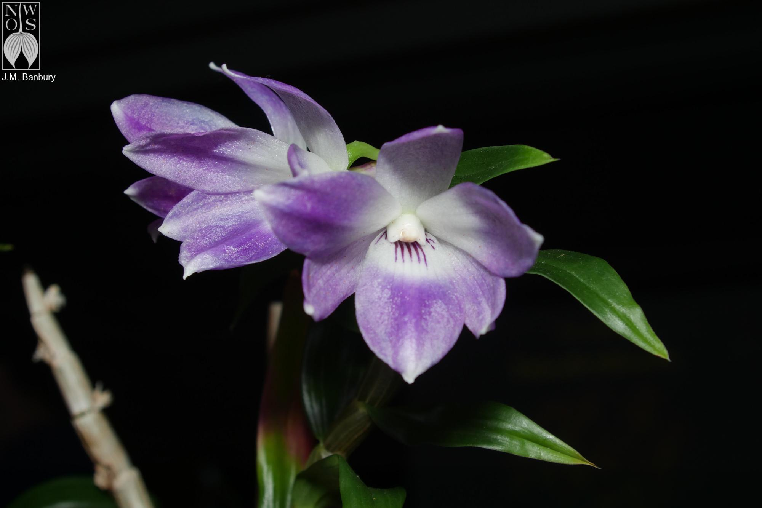
Dendrobium victorina-reginae, Bryan Schultz
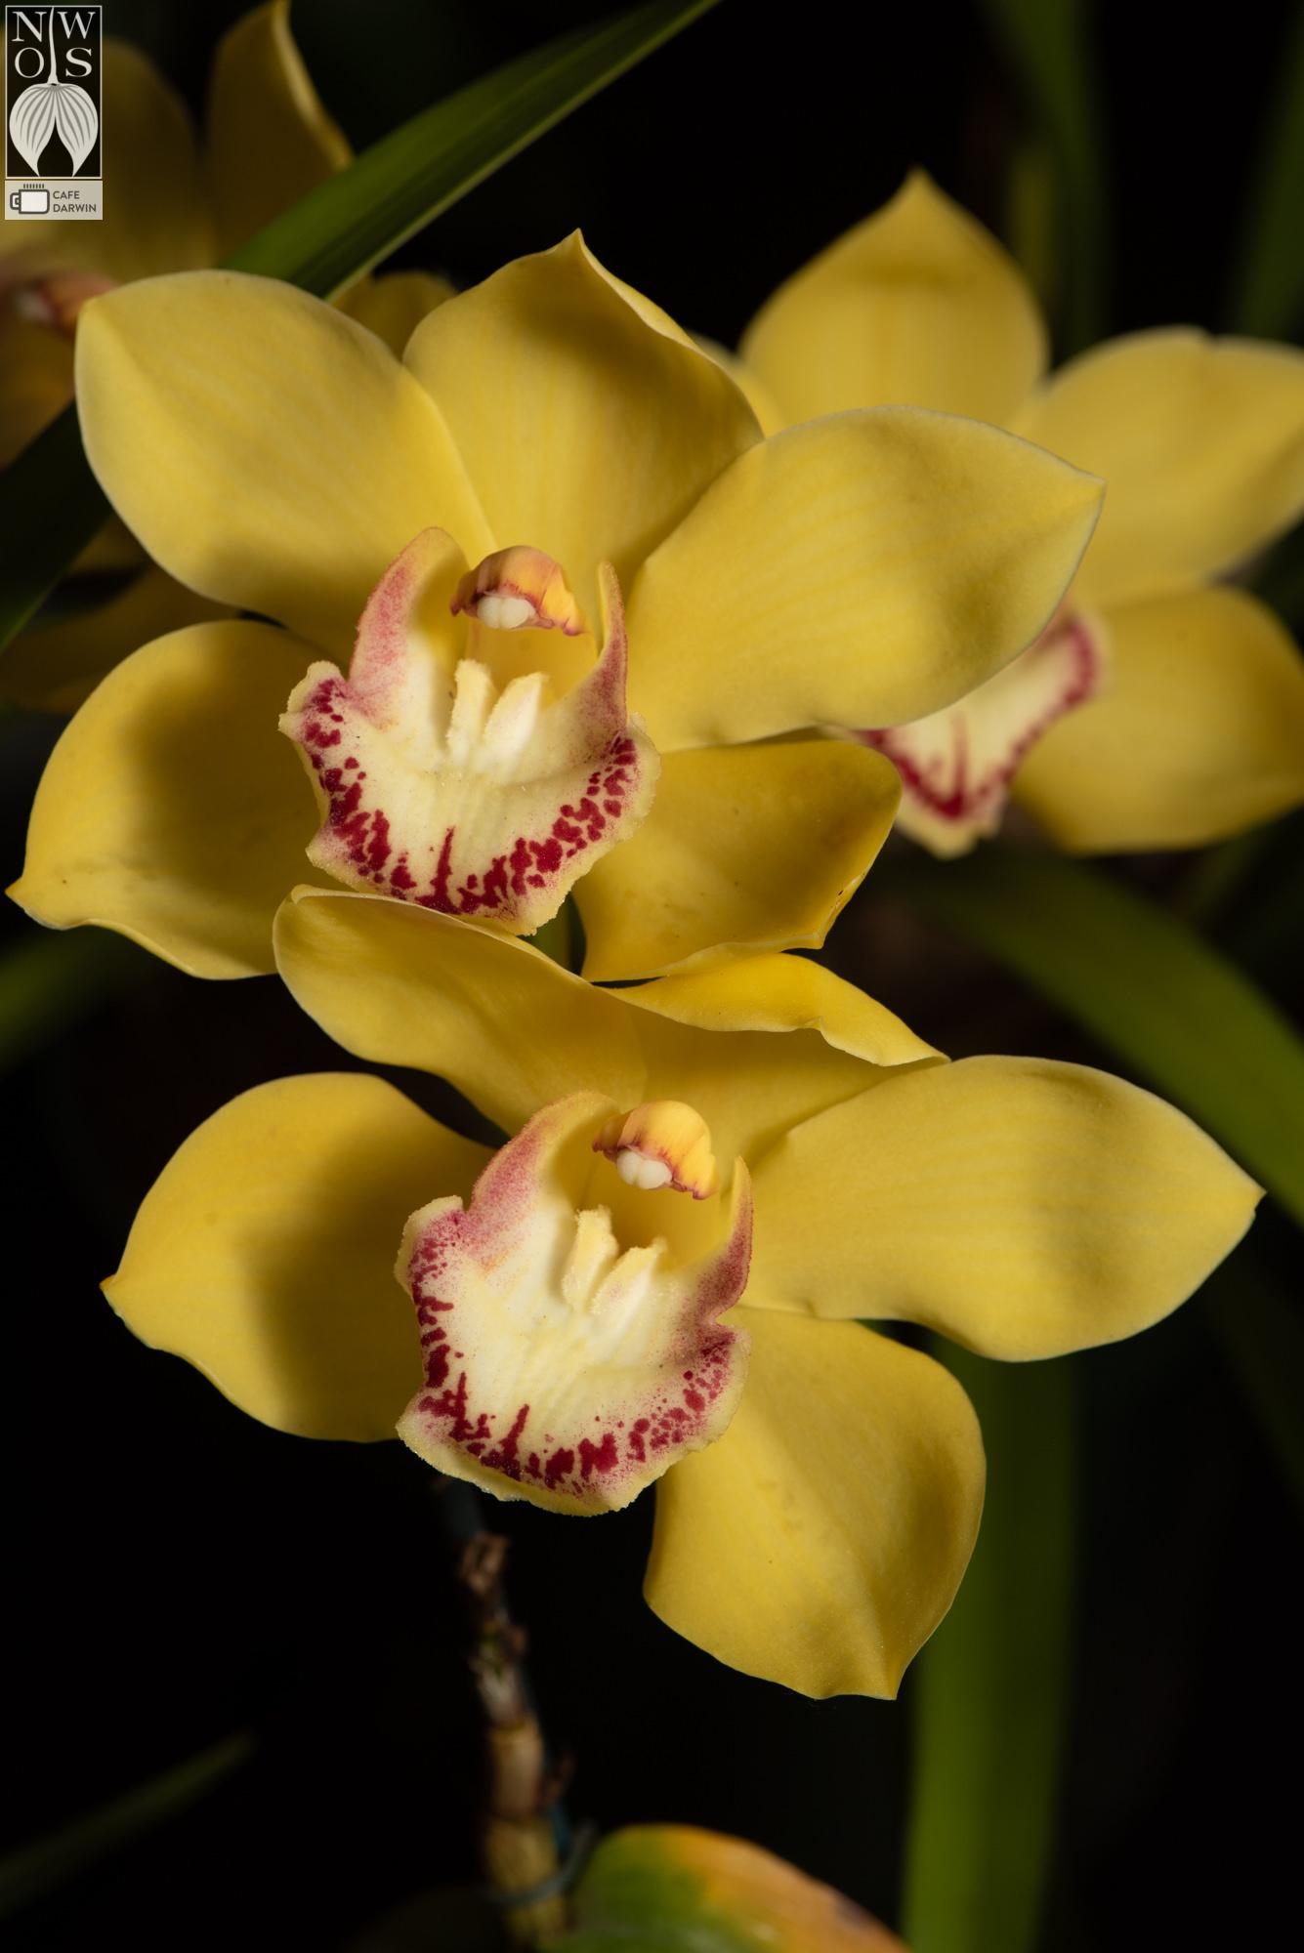

Cym Koren x Via Ambarino, Ron Webb
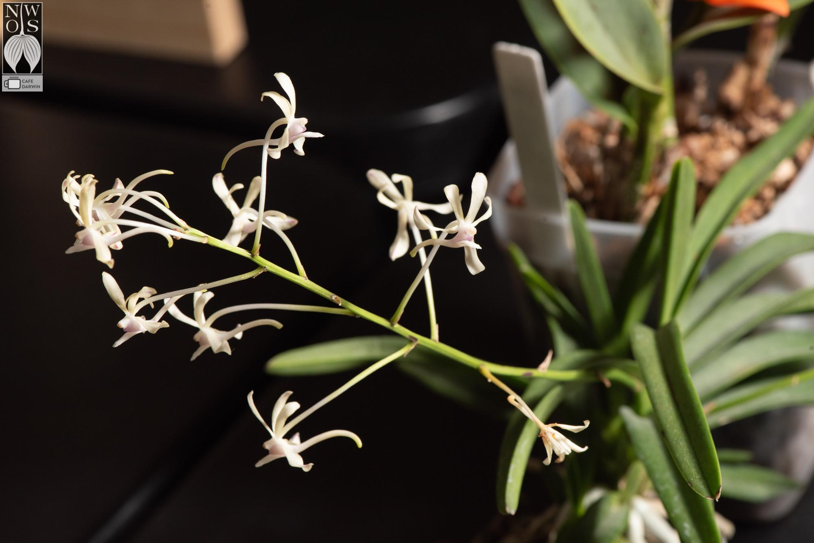

Vanda Lucknow (testacea x falcata), Joff Morgan

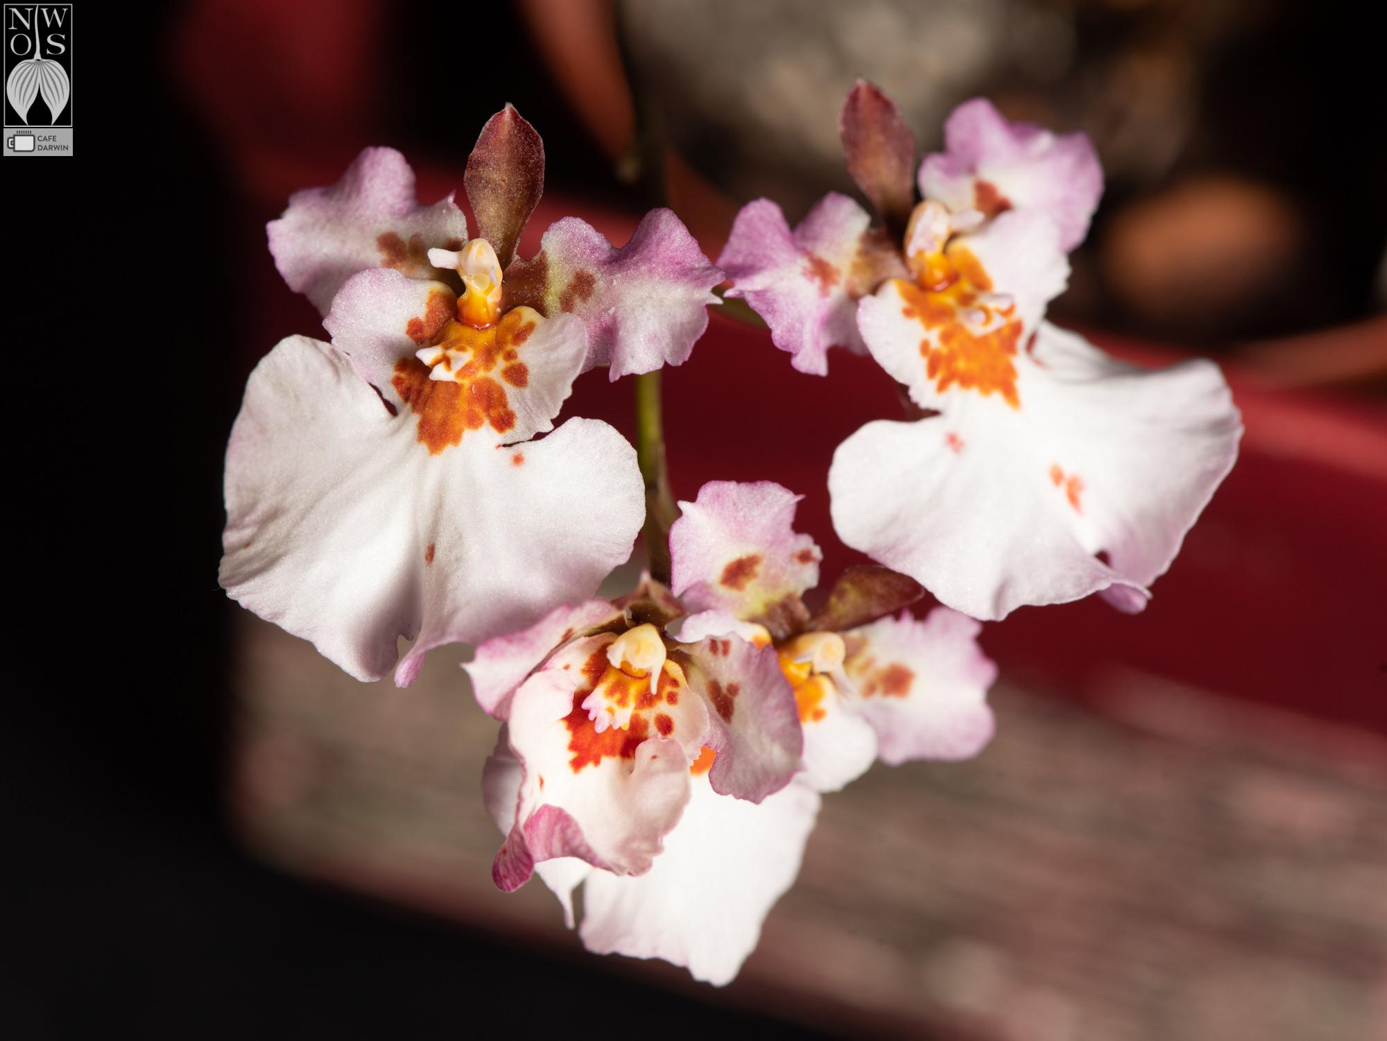

Onc. Krathoomban, Barb Roberts

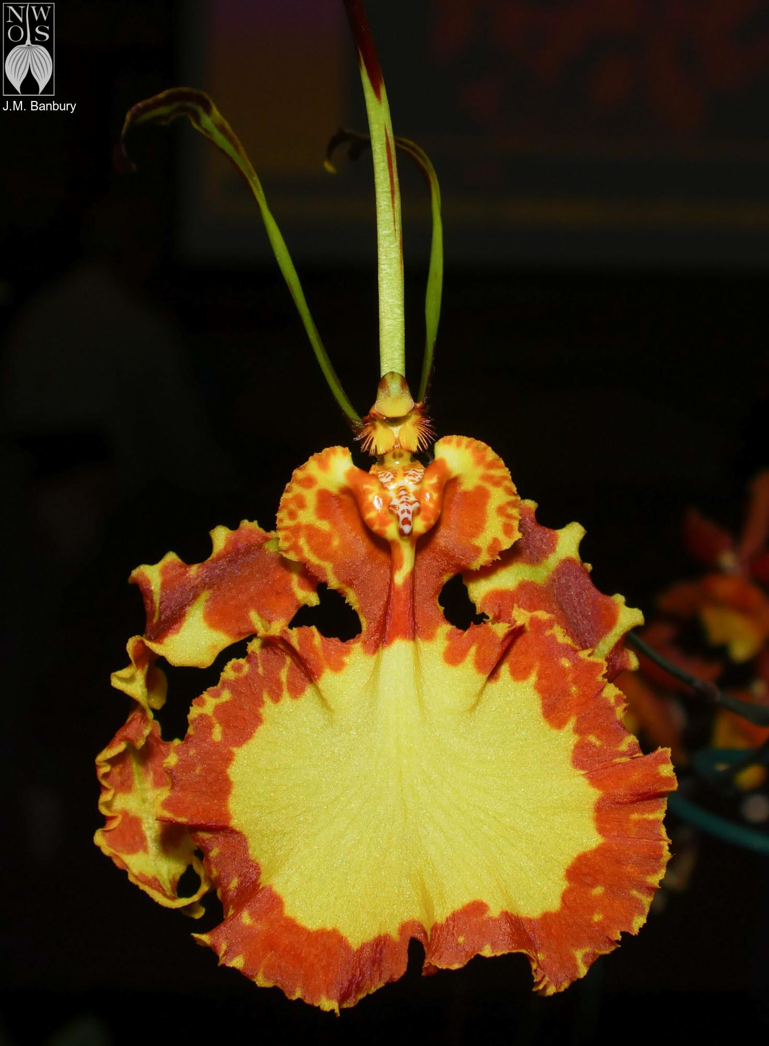

Pyp Mendenhall 'Hildos' FCC-AOS, Phuong-Thi Nguyen
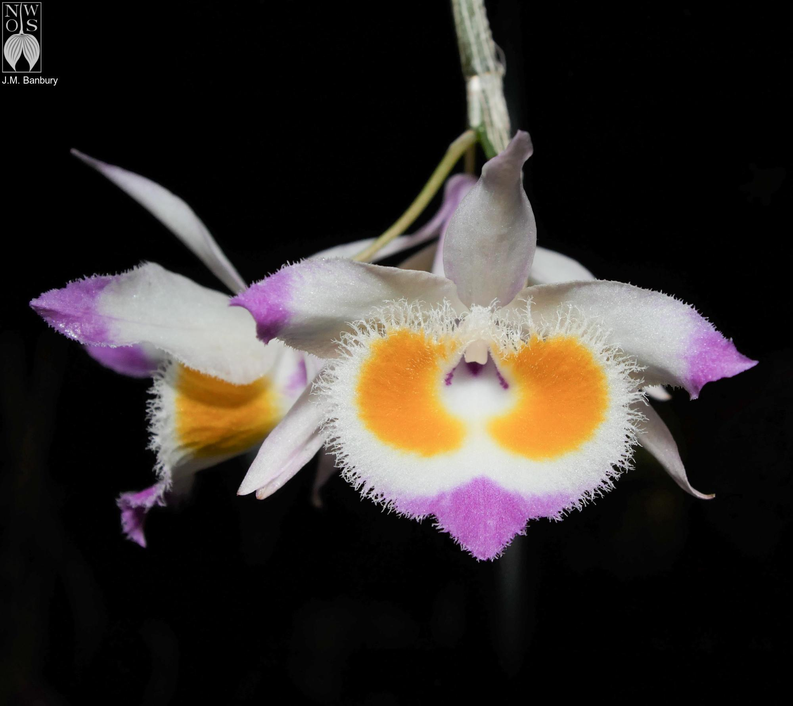

Dendrobium devonianum

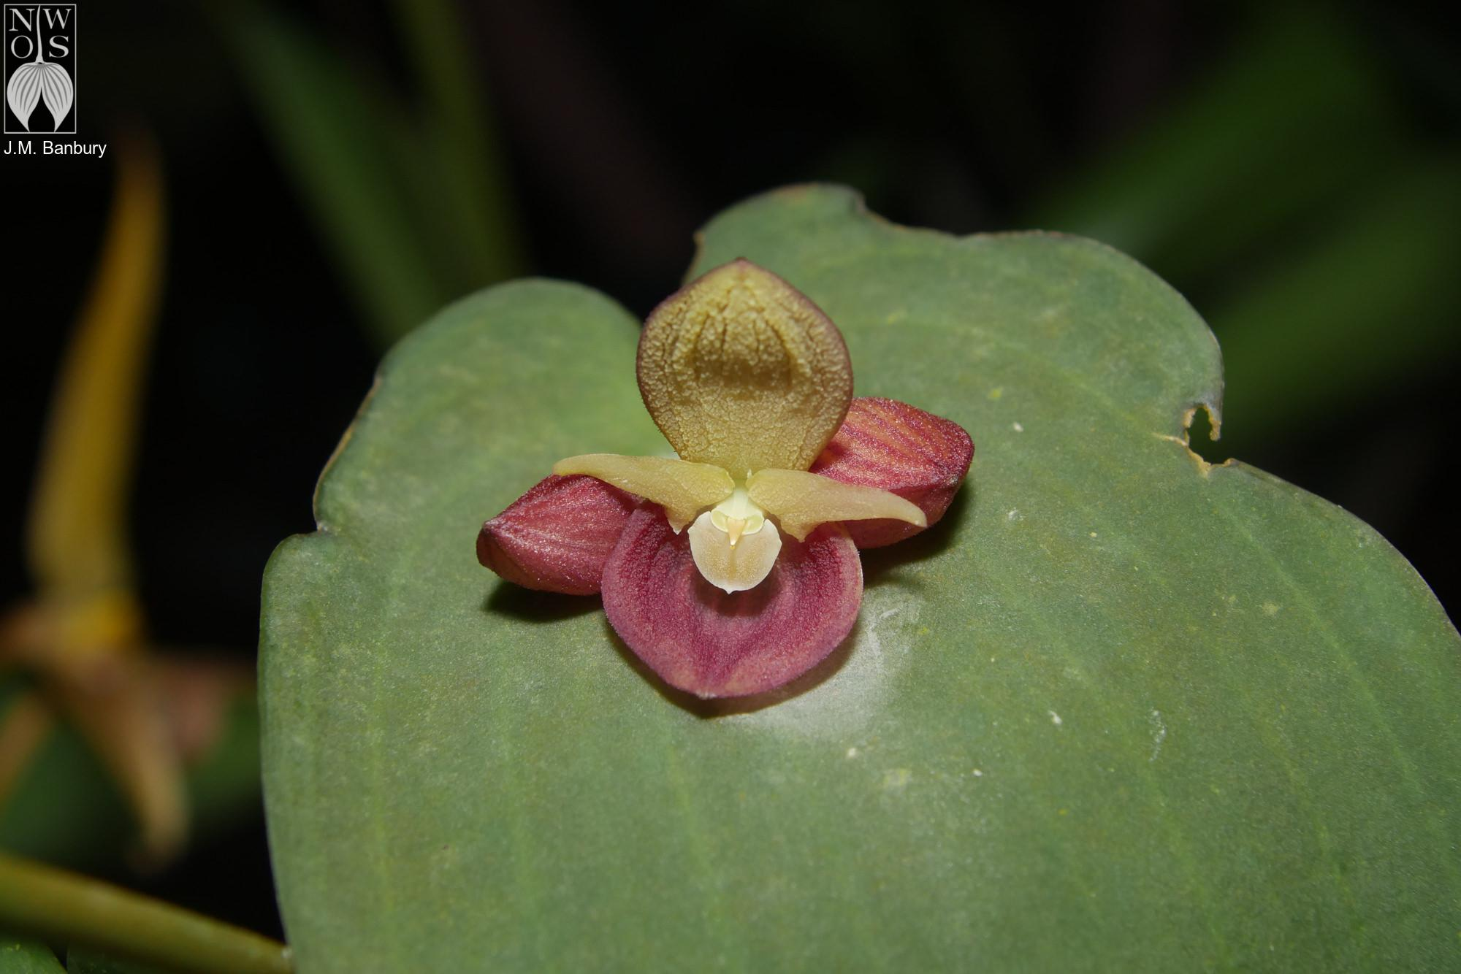

Pleurothallis cyanea, Andy Wright
You can see more photos from the online gallery and the video from the meeting online.

Local Judging

Adapted from William Jansen of the PNW Regional Judging Center.

Please come join us for a future Monthly PNWJC judging Sunday (see dates below). We are also looking for societies to have fall shows, but no shows are scheduled for the remainder of 2023.

- June 4, 2023, Monthly AOS Judging 1 PM at Keizer Community Center.
- July 2, 2023, Monthly AOS Judging 1 PM at Keizer Community Center.
- August 6, 2023, Monthly AOS Judging 1 PM at Keizer Community Center.

Treasure Valley Orchid Society Orchid Show, Boise Idaho

Treasure Valley Orchid Society Orchid Show, Boise Idaho had a beautiful show with around many exceptional plants exhibited. We had a wonderful location at the Hilton Garden Inn Hotel, great attendance from the society and the public, and AOS Judging on April 15. There were four nominations and two awards granted. We had six judges comprising one judging team. Carolyn Watts (with a little assistance from Tim Morton) provided the attached excellent-quality photography of the plants.

- Miltoniopsis Kyle Quintal ‘Mary Turnbow Brooks’ AM/AOS 80 points, exhibited by Janet Crist.
- Paphiopedilum Super Hawaiian ‘Slipper Zone Joyful’ AM/AOS 82 points, exhibited by Graham Wood.

Photos copyright Carolyn Watts
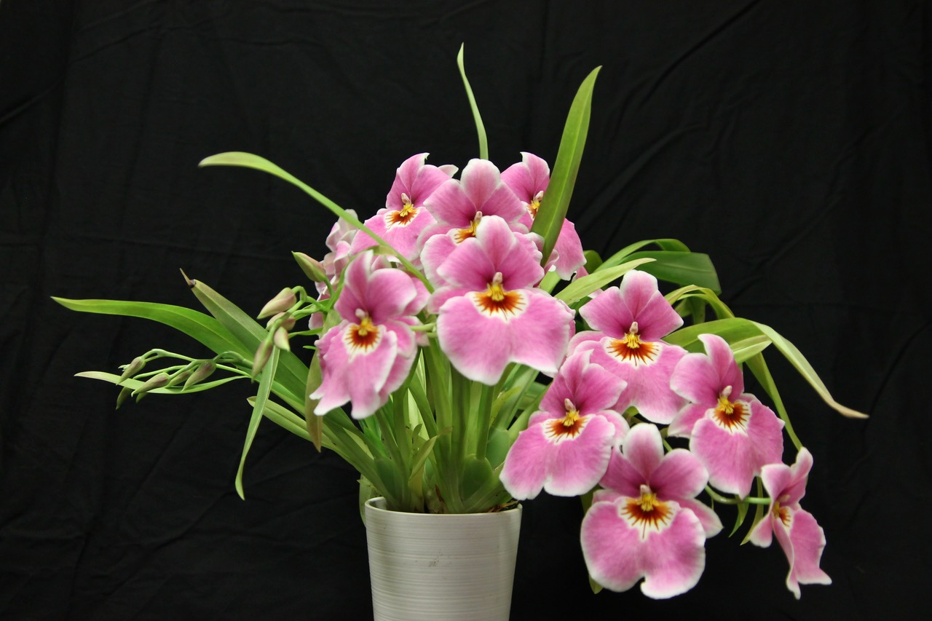
Miltoniopsis Kyle Quintal ‘Mary Turnbow Brooks’ AM/AOS
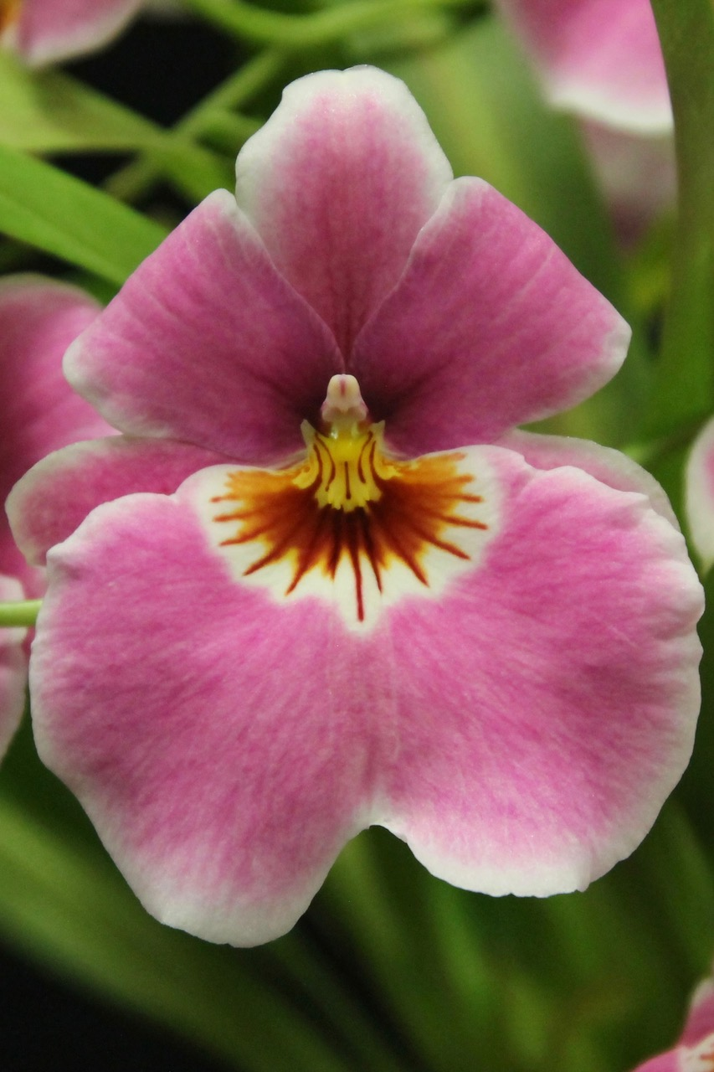
Miltoniopsis Kyle Quintal ‘Mary Turnbow Brooks’ AM/AOS

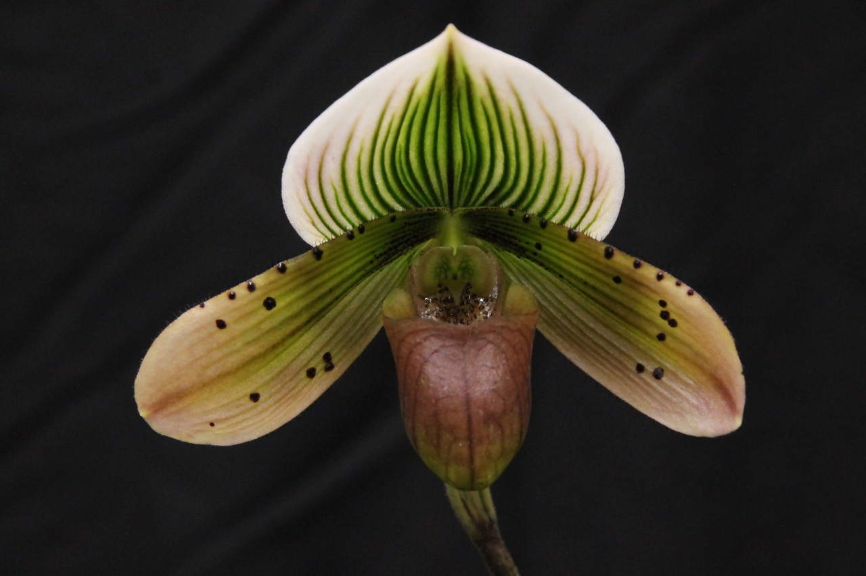
Paphiopedilum Super Hawaiian ‘Slipper Zone Joyful’ AM/AOS

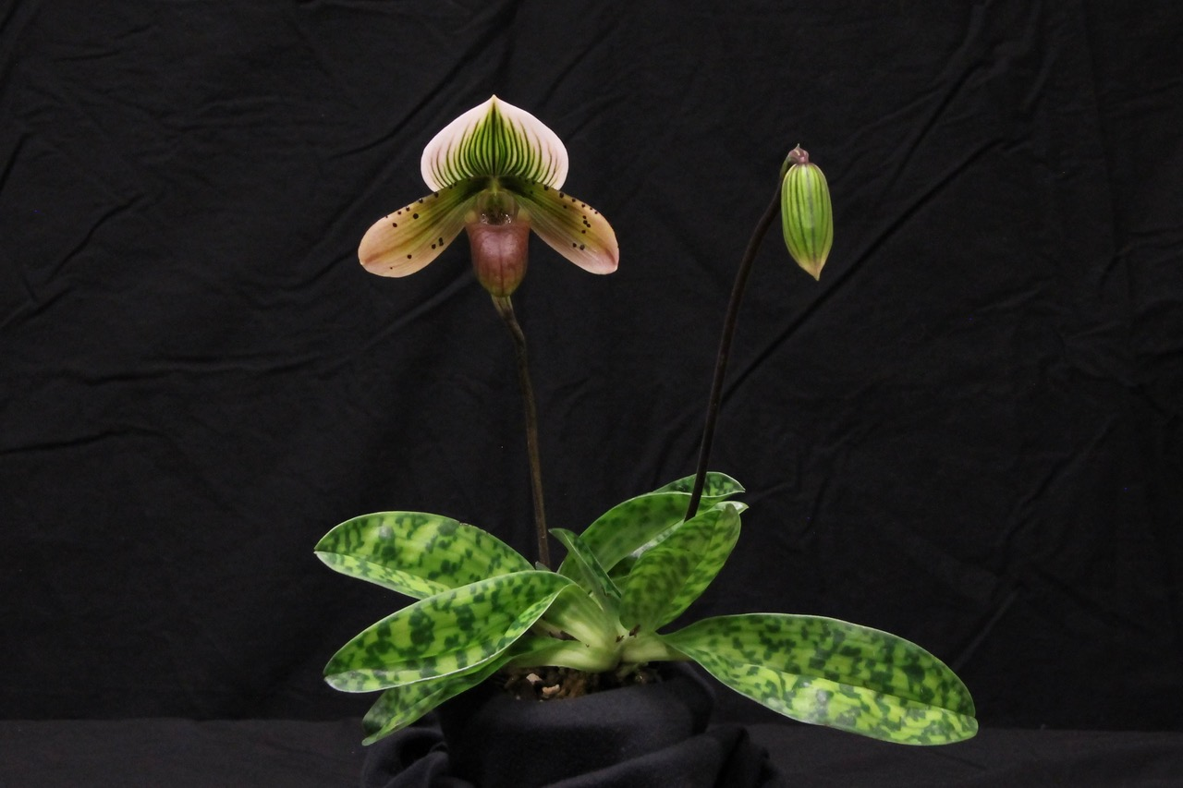
Paphiopedilum Super Hawaiian ‘Slipper Zone Joyful’ AM/AOS
Sunday May 7, 2023 Monthly AOS Judging

After a super fantastic April; WOW what a way to start May!! Monthly judging on May 7, 2023 continued with eight stupendous plants displayed and all reviewed for judging. There were eight awards granted to six plants; two plants received two awards each. We had nine judges comprising two judging team. Ross Leach provided the attached excellent-quality photography. The displayed plants and awards are summarized below along with the April Treasure Valley Show.
- Pleurothallis calceolaris ‘drmorris’ CCM/AOS 88 points, and AM/AOS 82 points, exhibited by David Morris.
- Dracula venefica ‘Which Witch’ AM/AOS 84 points, and CCE/AOS 92 points, exhibited by Tom Etheridge.
- Brassia Mary Traub Levin ’Maku’u’ AM/AOS 80 points, exhibited by Leonard Gines.
- Cyrtochilum serratum ‘Solar Place’ AM/AOS 84 points, exhibited by Tom Etheridge.
- Paphiopedilum hangianum, AM/AOS 87 points, exhibited by Theresa Hill.
- Paphiopedilum Champagne Charlie, ‘Variety Leon’ AM/AOS 85 points, exhibited by Theresa Hill.
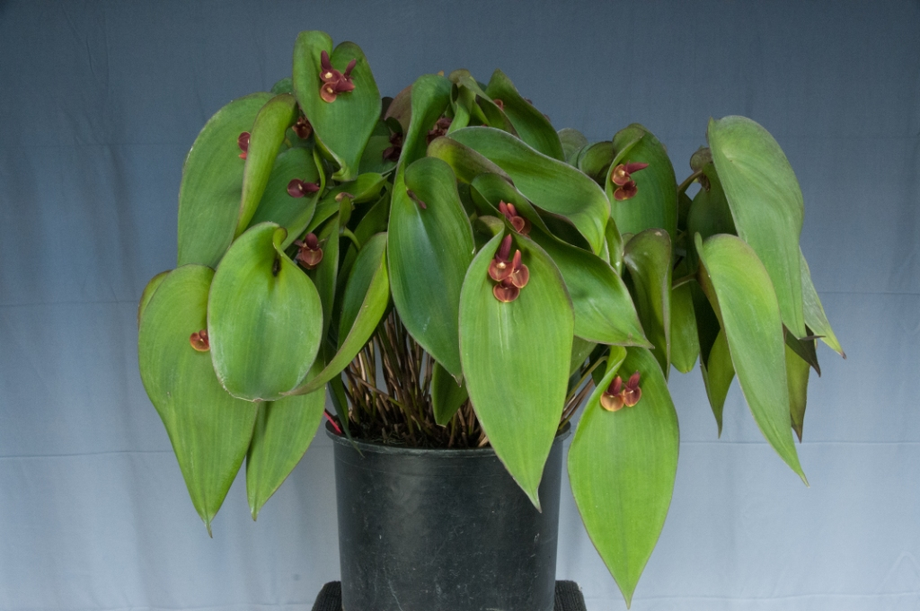
Pleurothallis calceolaris ‘drmorris’ CCM/AOS, AM/AOS

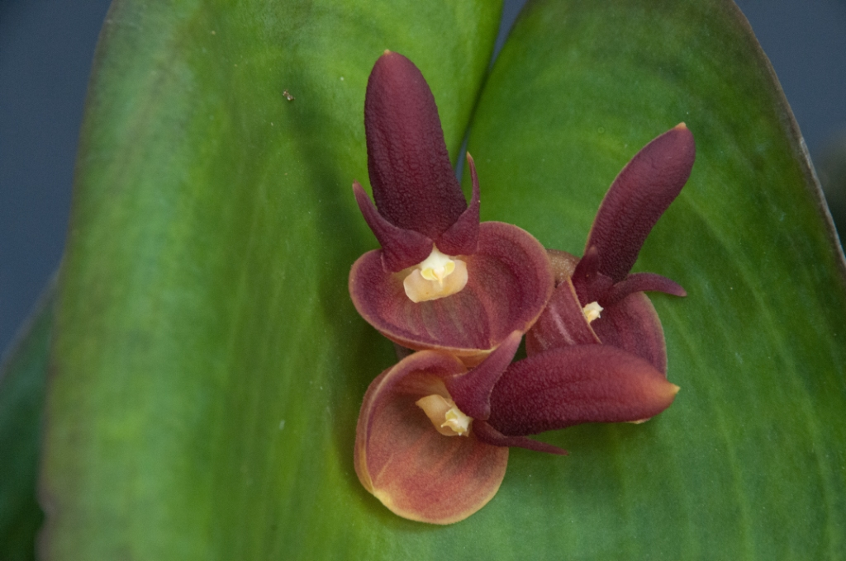
Pleurothallis calceolaris ‘drmorris’ CCM/AOS, AM/AOS
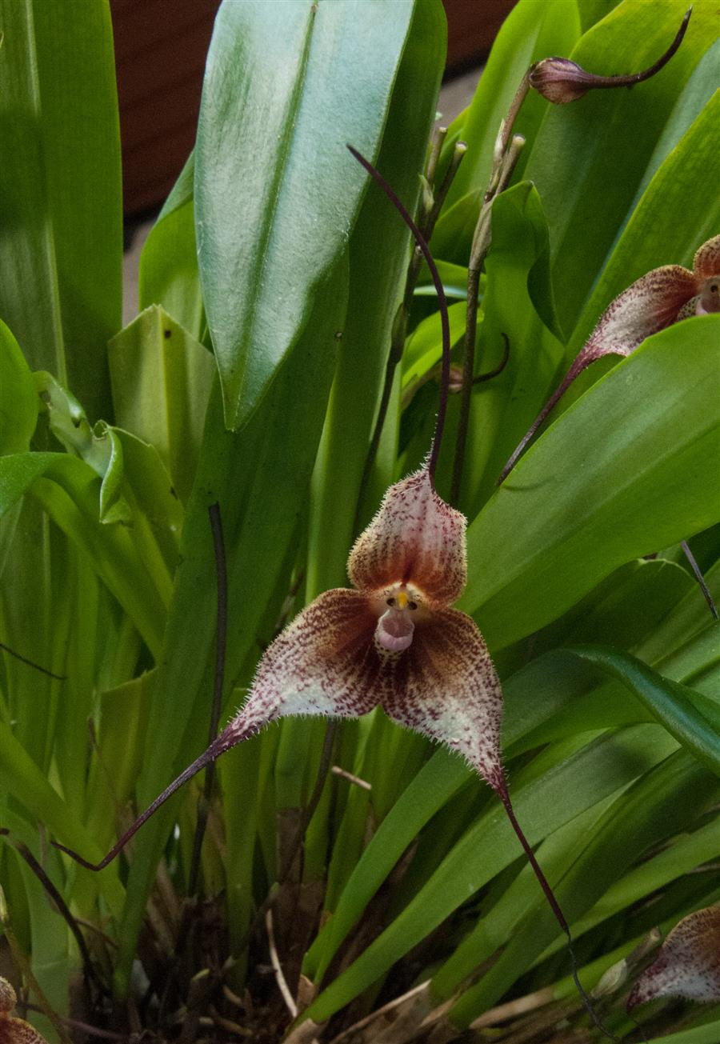
Dracula venefica ‘Which Witch’ AM/AOS, CCE/AOS
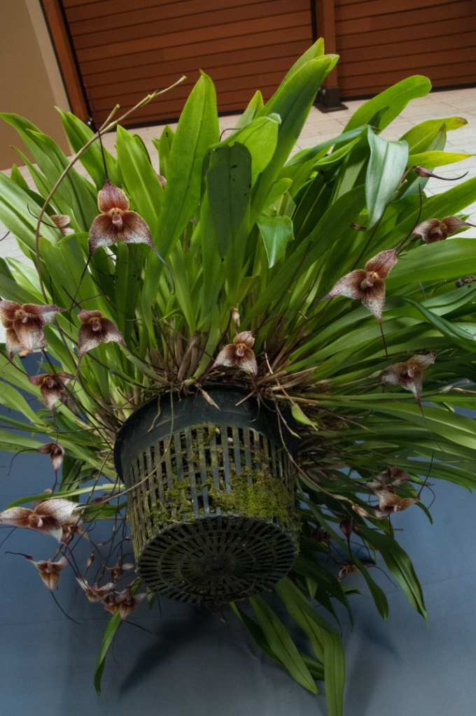
Dracula venefica ‘Which Witch’ AM/AOS, CCE/AOS
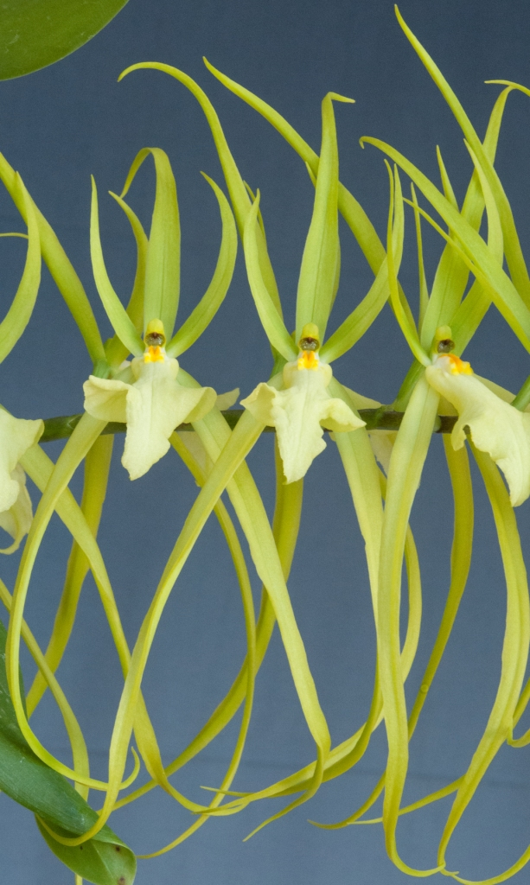
Brassia Mary Traub Levin ’Maku’u’ AM/AOS
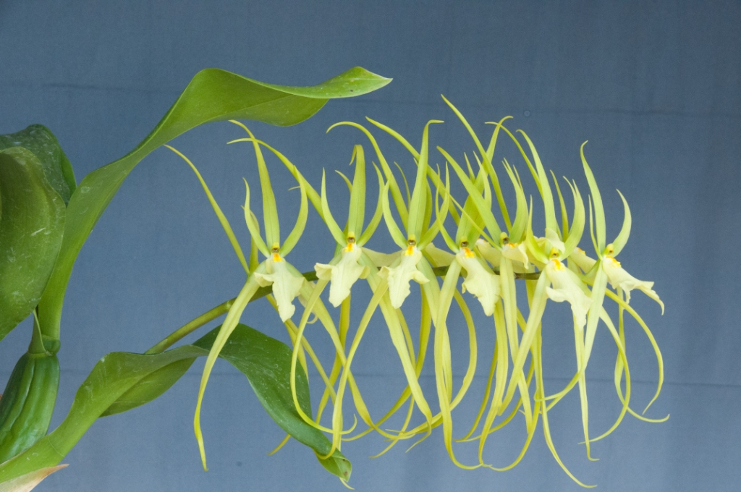
Brassia Mary Traub Levin ’Maku’u’ AM/AOS

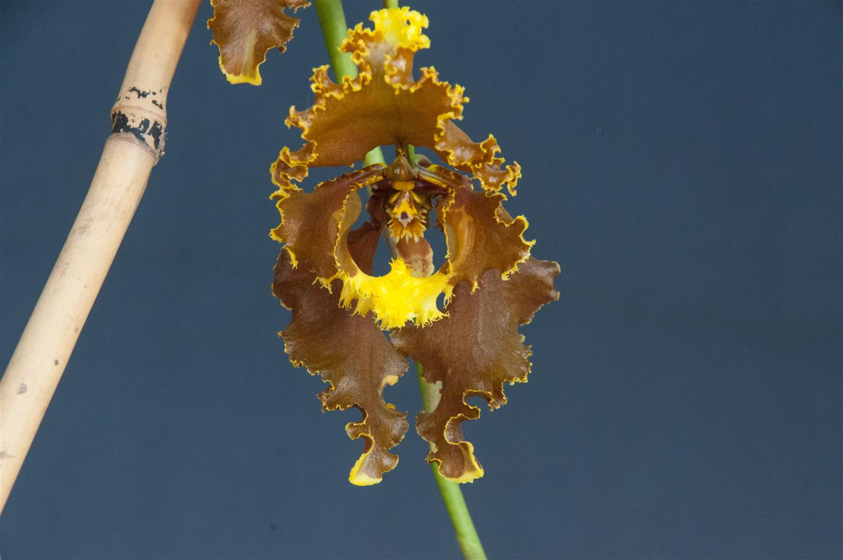
Cyrtochilum serratum ‘Solar Place’ AM/AOS
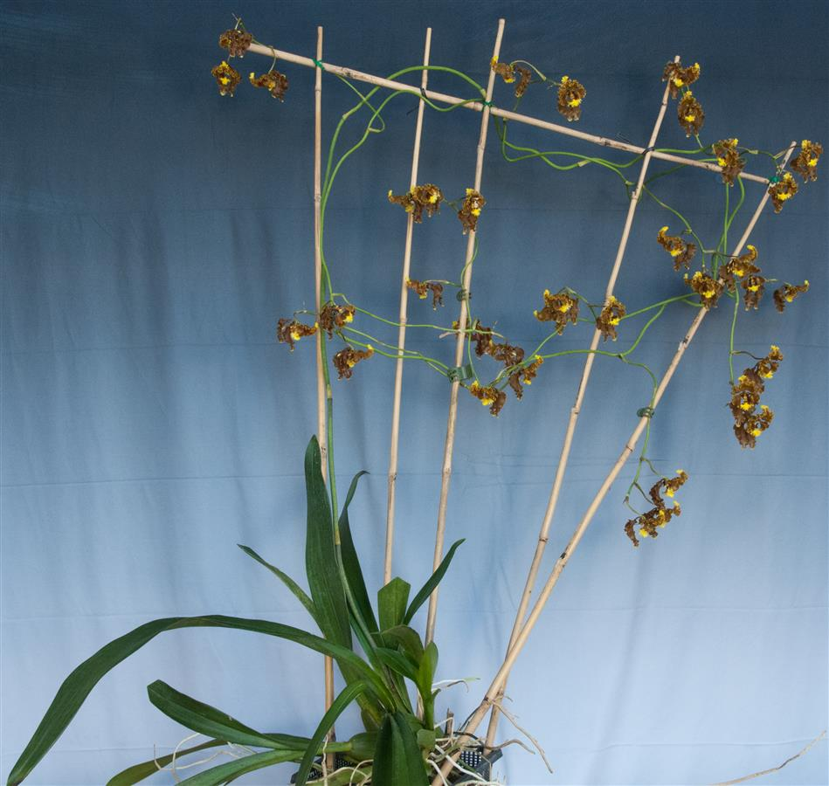
Cyrtochilum serratum ‘Solar Place’ AM/AOS

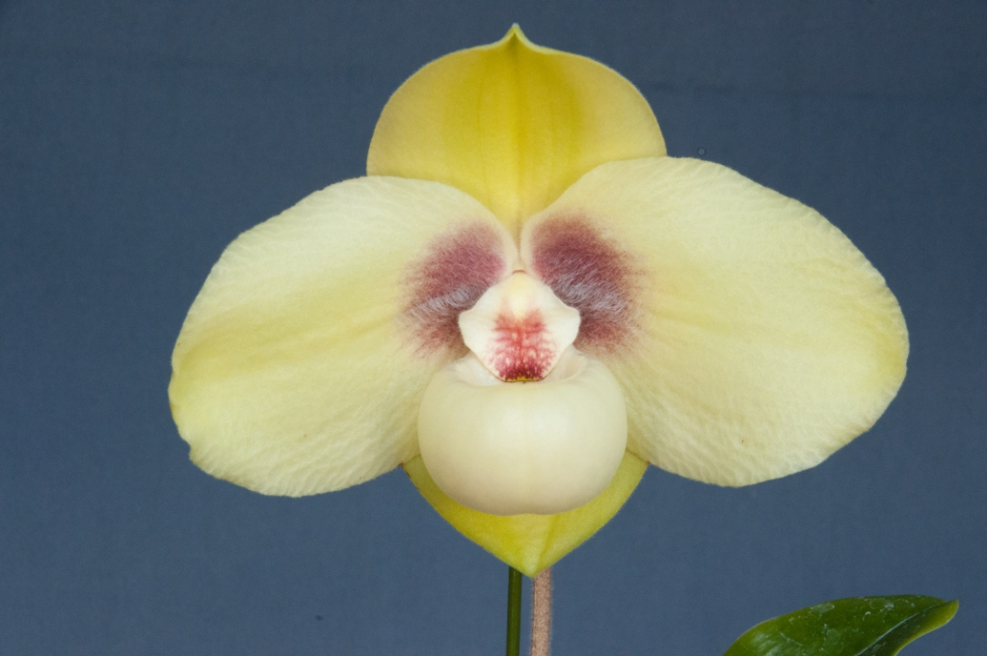
Paphiopedilum hangianum, AM/AOS

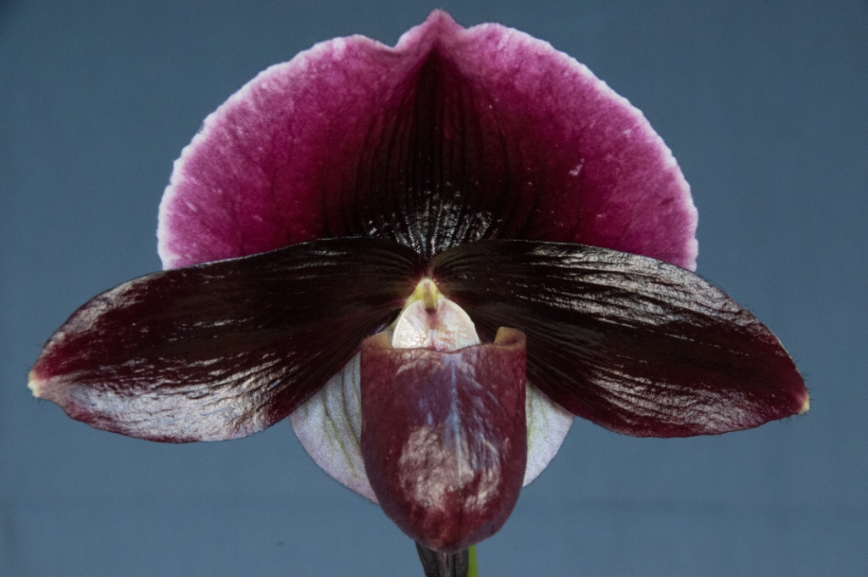
Paphiopedilum Champagne Charlie, ‘Variety Leon’ AM/AOS

Schedule of Upcoming Events

06/12/23 – NWOS meeting – June Food Truck Social: This is our annual social just before we take our summer break. We have a food truck outside and plants inside. We also announce the Gary Baker Service Award at this meeting.

August NWOS Picnic - Time and place to be announced. Stay tuned to the Events page and your email..

09/11/23 – NWOS meeting – Speaker: Kelly McKracken, “Fragrant Miniatures” The most common question we get asked about plants is “is it fragrant?”; Many orchid growers select their plants based on whether the plant is fragrant. For those of you who grow in limited space, but still love a nose full of floral fragrance, this is the talk for you.

10/06-08/23 - NWOS Fall Show & Sale - Volunteer Park Conservatory. Details are to be posted on the Events page of the website.

10/09/23 – NWOS meeting – Speaker: Andrew McGinnis, Growing Orchids in Grow Tents, Advanced Indoor Growing.

11/13/23 – NWOS meeting – Speaker: Alan Koch, “A New Look at Intergeneric Phalaenopsis”, Phalaenopsis have been enjoyed by novice growers for the ease of growth and long-lasting flowers. Intergeneric Phalaenopsis hybrids are easier to grow, maintain long-lasting flowers, and often bloom more often than a normal Phalaenopsis. Another benefit from this line of breeding has been the creation of many fragrant hybrids. The bright colors, fragrant flowers, and smaller hardier plants make this an interesting direction in orchids.

12/11/23 – NWOS meeting – Holiday Food Truck Social, introducing new Officers, NWOS Annual Meeting report, Schoenfeld and Northen Orchid Awards, and Holiday Plant gifts.

Reminder for Officers & Board Members

The next board meeting is Tuesday, May 2nd which will be at 7 p.m. and hosted over ZOOM. Check your email for the Zoom registration link and agenda. Future meetings are tentatively scheduled for September 5, and November 7th.

NWOS Website Links

- Main website: Http://www.nwos.org
- Events Calendar: http://www.nwos.org/events
- Membership (including renewals): https://nwos.org/Membership/
- Newsletter - Current Issues: https://nwos.org/newsletters/
- Newsletter - Archived Issues: http://newsletter.nwos.org
- Show Information: https://nwos.org/nwos-fall-show/
- Facebook: http://www.facebook.com/nworchidsociety
- Instagram: https://www.instagram.com/nworchidsociety/
- Twitter: https://twitter.com/nworchidsociety

Special Announcements

Olympic Orchids
Looking for a part-time employee to help with a small orchid business. You would be processing orders, potting plants, and doing basic orchid care. Some knowledge of orchids would be good, but you can learn as you work. You should have your own transportation. If interested, contact Ellen Covey at info@olympicorchids.com.

©2023 Northwest Orchid Society - All Rights Reserved unless the copyright is held by other rights holders.

The opinions and recommendations published herein are those of the authors. The Northwest Orchid Society (NWOS) disclaims responsibility for any losses or damages that may be attributed to the use or misuse of any material or any opinion published in these articles and on the website. This website and the photographs, articles, and content are protected by copyright and no part of them may be reproduced or re-used without the permission of the author.

The Special Announcements (SA) section is provided as a courtesy to the readers of this newsletter for events that may be of general interest to the readers. The NWOS (1) makes no promises, warranties, or representations as to SA, including its completeness, accuracy, availability, timeliness, propriety, security, or reliability; (2) provides SA on an "AS IS" and "AS AVAILABLE" basis and any risk of using SA is assumed by you.

