Northwest
Orchid News
January 2023
Volume 76, Issue 1

- About the January Meeting
- Speaker: Tennis Maynard, Trichopilias: Underappreciated Gems”
- Plant Table
- Sales Table
- Raffle Table
- NWOS Library
- 2022 NWOS Orchid Show - Show Trophy
- New Year - New Dues
- Volunteer Positions
- NWF&G Festival - Your Orchids Are Needed!
- NWF&G Festival - Helpers Needed
- Schoenfeld and Rebecca T. Northen Trophy - December Competitions
- Report From The December Meeting
- Schedule of Upcoming Events
- Reminder for Officers & Board Members
- Special Announcements
- NWOS/Amazon Shopping Link
- NWOS Website Links

About the January Meeting
January 9, 2023 7 PM
University of Washington Center for Urban Horticulture
3501 NE 41st Street, Seattle, WA 98105
Hybrid Meeting, In person and via Zoom Zoom Registration

Speaker: Tennis Maynard, “Trichopilias: Underappreciated Gems”
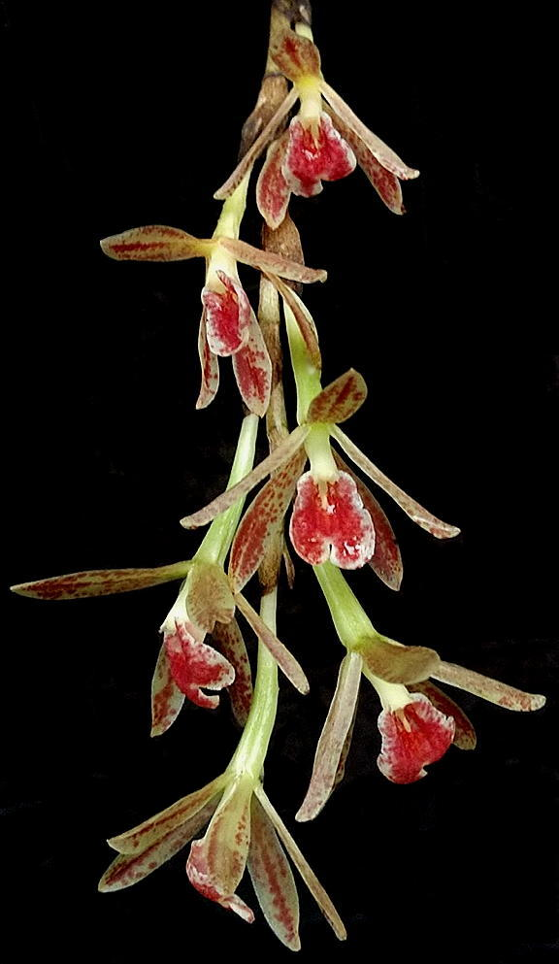
Tennis Maynard has been growing orchids for over 45; he built a greenhouse 15 years ago to house his collection of orchids. In his time growing orchids, he has received ten AOS awards, including three for the genus Trichopilia. Like many of us, Tennis grows a wide variety of genera from warm-growing Vandas to cool-growing Maxillaria including many 'botanicals' such as tonight's topic Trichopilas and even our native Cypripediums.

Plant Table

We will be having an in-person plant table this month. For your convenience, you can print out a Plant Table Information Form ahead of time. Click for your version of choice: PDF WORD

For those who aren’t able to attend, please do keep sending your pictures, we will be including them in our online gallery and in next month’s newsletter. Please send them to photos@nwos.org.

Sales Table

Members may bring up to 10 plants to sell. Include an extra tag with your name and the price in the plant.

Raffle Table

The raffle will be held as usual. Win a new orchid for your collection while supporting the Scholarship Fund. If you have any extra Orchids, please consider donating them to the raffle.

NWOS Library

If you'd like to check out a book or tape from our Library, please contact our Librarian Joe Grienauer a minimum of 2 weeks before the next meeting. Besides email, you can give Joe your request at any meeting. For a list of library items please click here NWOS Library.

2022 NWOS Orchid Show - Show Trophy

While researching awards given at NWOS orchid shows it was discovered that our society received The AOS Show Trophy for our display at our show in October. A huge thank you to everyone that donated their time and shared their plants in creating our display.

We all look forward to Abigail Chang bringing in the trophy to share it with us.
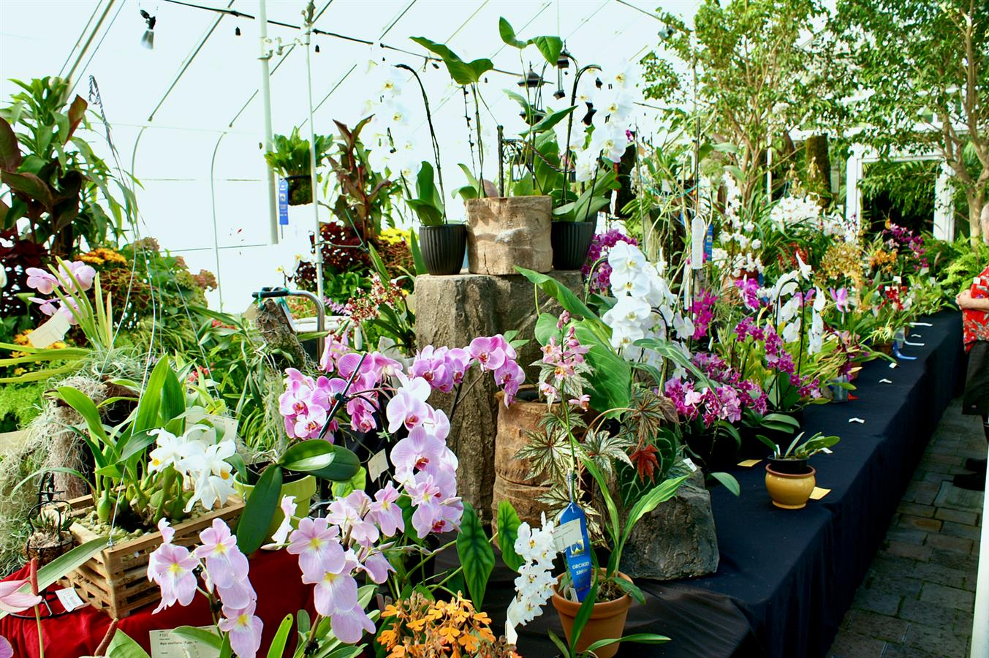
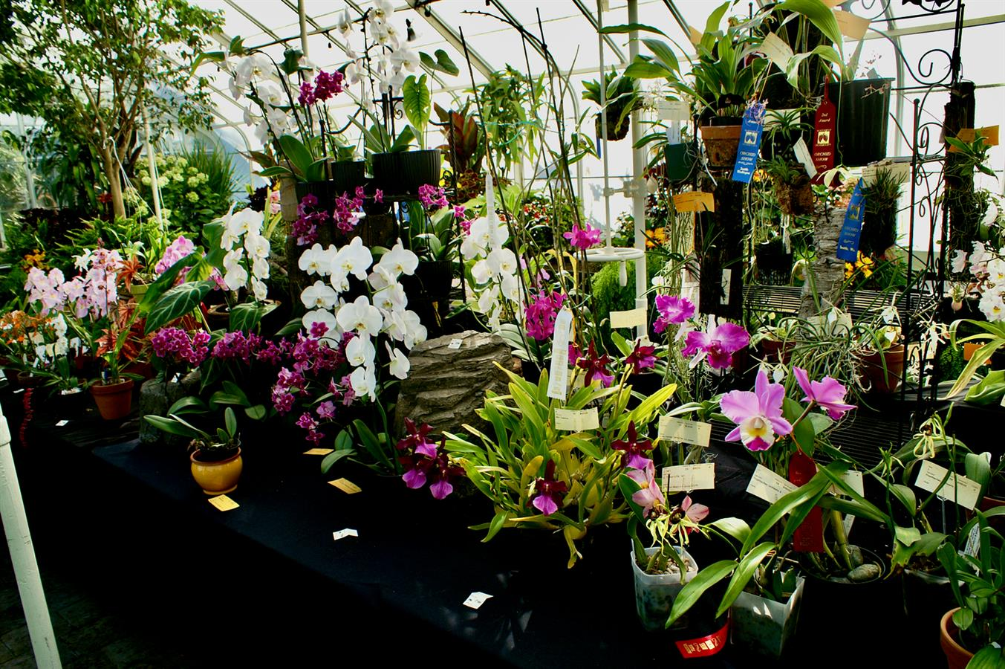

New Year - New Dues

We love seeing all of you here and the energy and excitement you bring to the meetings. Your volunteer support makes all of this possible and we’re grateful for it. Another reality is the cost of running the society and your dues help defray those expenses. It’s time again to renew your dues if you have not already done so. Please take a moment and visit our Join | Renew link and help keep the society running.

Volunteer Opportunities

There are lots of choices for participating and helping our society utilizing different skills, interests, and available time.

– Our next big volunteer event is the 2023 Northwest Flower and Garden Festival. We will need volunteers to help build, staff, and teardown the show. Please signup using the signup sheets or send an email to FGS@NWOS.ORG.

NWF&G Festival - Your Orchids Are Needed!

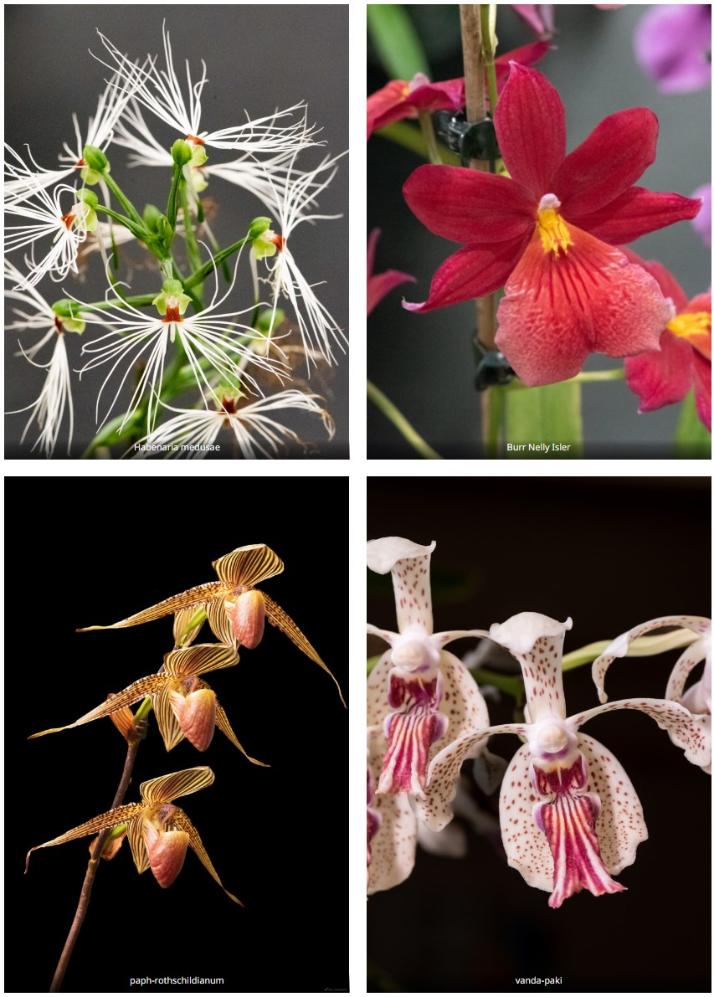
We need your BLOOMING ORCHIDS to help fill out the garden. Any blooming orchid qualifies as long as it is clean, pest and disease free, and the flowers will last for at least one week.
When Can Orchids can arrive:
- 1 pm to 5 pm on Sunday, Feb 12
Bring your orchids on Sunday, there will be plenty of 4-wheeled carts to use at the “Hand Carried Freight” elevator. If you wait until Monday, you will be competing with all of the Marketplace Vendors moving in that day.
There will be a variety of named, blooming Paphiopedilums, Oncidiums, Dendrobiums, and more! All of these orchids will be available for purchase at the March 13 NWOS Auction.
My Orchids Want To Participate, What Do I Need To Do?
1. Write your name or initials on a piece of blue painter’s masking tape (it won’t smudge or come off if it gets wet) or use an address label. Affix the tape or label to each orchid pot. Affix the tape or label to your plant trays and packing boxes too.
2. Print a list of plants with your contact information and the name of each orchid or flower. Please indicate how you will be picking up your plants — either on Sunday, Feb 15 after 6 pm at the WSCC or at the Monday, March 13 meeting at 7 pm.
3. Clean and trim the leaves as needed, check for any visible pests and diseases, and stake the flower spikes if needed to prevent breakage in transport; the usual routine is to prep plants for a show.
4. Package your orchids in a sturdy box or tray. Did you label your box or trays?
How Do I Get There?
See the map on how to get to the Convention Center’s Main Parking Garage. The garage is located underneath the WSCC between Pike and Seneca streets.

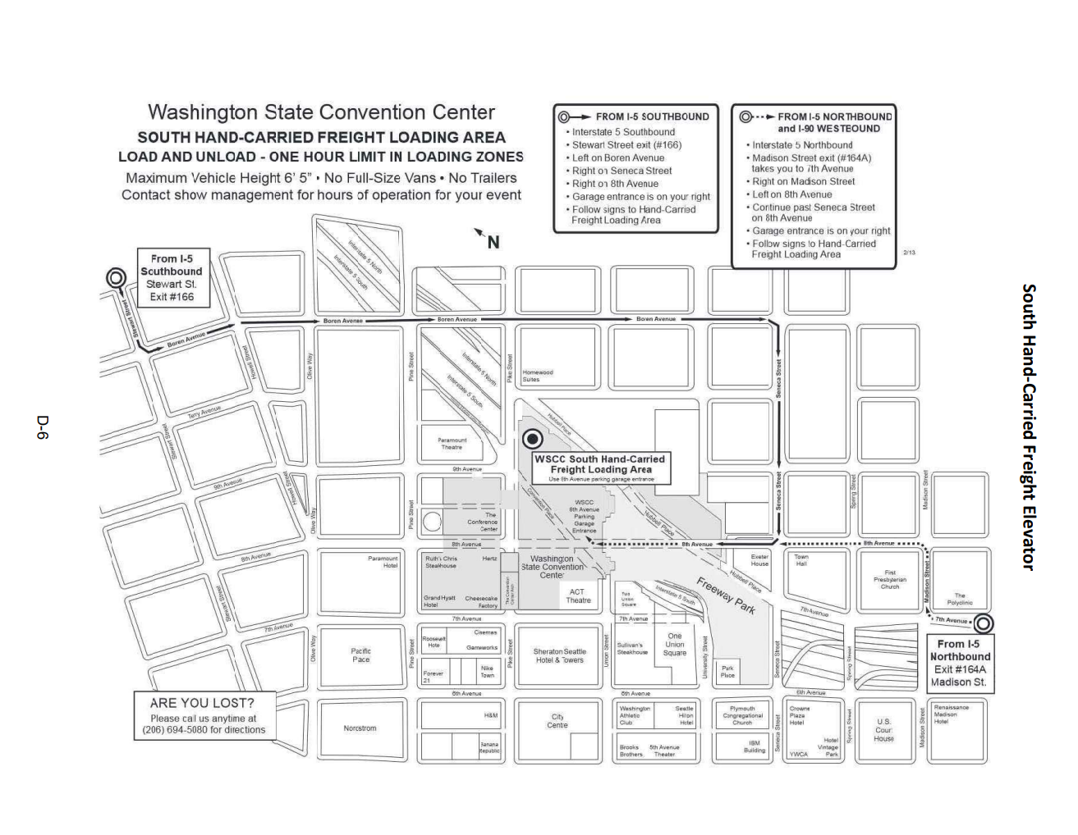
Once inside the garage, follow the signs to the "Hand-Carried Freight" elevator. Take your parking ticket with you, and get it stamped (If you are in and out of the garage within one hour, you don't pay). Pick up a "Work Pass" and put it on your clothing. Ride the elevator to the 4th-floor loading dock.
Walk straight ahead through the clear plastic curtain to the Show floor. Our garden is straight ahead next to the rightmost concrete pillar. See the map if you need help locating us or are entering from the 4th-floor Atrium entrance.

What Day and Time Can I Bring Plants?
- Sunday, Feb 12 from 1 pm to 5 pm

When Can I Get My Plants Back?
You can either pick up your orchids on Sunday, Feb 15 after 6 pm (preferred) or request the plants be delivered to Saturday’s February 25 NWOS Auction at the Shoreline Community College. IF you come on Sunday after 6 pm, you may help us dismantle the garden. We can always use the extra help!
Whichever you choose, be sure to let us know on your list of plants when you deliver them.
Any questions or concerns, email FGS@NWOS.ORG, and we will reply quickly..
~ NWOS Flower and Garden Show

NWF&G Festival - Helpers Needed

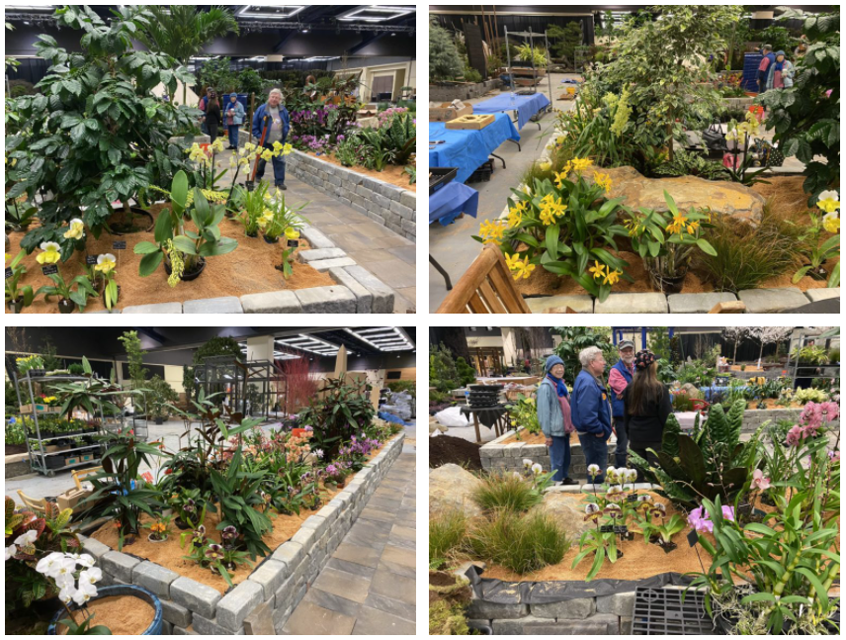
The 2023 NW Flower and Garden Festival is fast approaching. We are in need of YOU to help us build our 875 sq ft orchid garden.
We have broken out each day into 3-hour and 2-hour shifts to make things easier. Feel free to sign up for one or more shifts as your time allows.
If you would like to sign-up, please send an email to FGS@NWOS.ORG with your requested shift(s) and contact information.
"Setup" work passes - for those of you who sign up to help us build or teardown the garden, you can obtain a "Work pass" from the WSCC door guards as you enter the Show floor (4th floor) Convention Center. The same goes if you enter via the Hand-Carried Freight elevator entrance in the Main parking garage off 9th Avenue between Pike and Seneca streets.
"Show" wristbands - for those of you who sign up to work a shift during the Show (Feb 15- 19), your color-coded wristbands (unique for each day) will be available at the Will-Call window on the 4th floor. From the Pike Street entrance, follow the escalator signs up to the 4th-floor Atrium, and turn left to see the "Will-Call" window. Just give your Name and "NWOS" to get your envelope. Your envelope will contain all of the wristbands needed to enter each day that you signed up to work.
So, make sure you sign up!
Below are the days and shifts that need a few more helpers. The minimum age allowed on the floor during Setup and Teardown is 16 and no pets.
Moss Collection: Location - Grantham's in Lake Forest Park
Thursday, February 9 - Five people have signed up for this event, another two will make the collection go that much faster.
A small group of us will meet at the Granthams' for breakfast. From there we will carpool to a property owned by the Granthams out near Monroe. Moss will be collected in sheets from the ground, from fallen tree trunks, and from tree limbs. Moss will be placed in plastic tubs and loaded into Joff's van.
After collecting for about 3 hours or until the van is full, we will meet for a late lunch at a local Mexican or Thai restaurant in downtown Monroe, then head back home. The moss will be used as ground cover and to hide orchid/plant pot rims in the garden.
- 9 am to 3 pm
Garden Build: Location - Washington State Convention Center
Saturday, February 11 - Four people have signed up to help on this day. Ideally, we need 10 people.
This is a "heavy lifting" day. Bring gloves and dress in layers. Our first setup day consists of measuring out the garden's perimeter walls, placing two stone benches, and erecting the mountain of wood pallets and pre-built wood superstructure. Large irregular slate pieces will be affixed to the wood superstructure with 3-inch-long screws through large metal washers along the slate edges to hold the pieces in place. If you have a portable electric drill with a Torx head for driving the screws, we could use you and your drill today. Also, people with buckets, shovels and/or rakes are welcome. Anyone willing to show up will be put to work. We will have Horticulture students again helping us from Lake Washington Technical College.
Stones, that are already on pallets, will be set within the garden area with the help of a forklift. While that is taking place, a low wall of granite "tumbled cobble" bricks (27-pounds each!) will be set along the garden's perimeter. This wall will only be 3 bricks tall (about 18-inches), so it will be built quickly given enough helpers. A dry creek bed of oval stones will be laid near the base of the mountain. Then the entire garden will be filled with sawdust.
- 9 am to 7 pm
Sunday, February 12 - Your orchids must arrive today. Your orchids will be grouped by flower color, and groupings will be labeled with orchid type and name, and then stored on temporary staging that will surround the garden. Most orchids will get placed in the garden on Monday.
Foliage plants from the Woodland Park Zoo arrive at 11 am. Foliage plants are grouped and placed at various locations within the garden, and then "planted" within the garden's sawdust.
Four people have signed up to help this day. We need at least 2 more.
- 9 am to 6 pm
Monday, February 13 - "The Grind"
Orchids -- Volunteer Park and UW Botany - arrive today.
Orchids are grouped by color, arranged to look like a large specimen plant, and placed within the garden with the top 1-inch of each pot showing. Moss sheets will be placed around the plants and over the pots to help "hide" those tops. Technically, we can't have any pots showing as the garden has to look “fully planted and established”: The moss will help us in that regard.
Orchids will be placed on the mountain and draped or hung along the rock wall. Some trailing foliage plants will be placed here as well.
LED ground lights and spots will be placed around and throughout the garden to highlight specific plants and structures.
Foliage plants need to be watered and the bricks of our perimeter walls lightly brushed and sprayed with water to clean away dirt and debris. Got to make this “established” garden look clean and well cared for.
Four people have signed up to help, a few more people would help us greatly. Last year we finished at 9 pm, I am hoping for a similar end time this year.
- 9 am to 12 am
Tuesday, February 14 - This is "finishing touches" day. Moss is placed to hide any exposed pots and rims, plant signs are adjusted to face the viewing Public, and the foliage is cleaned up for judging. The garden has to be complete and everyone off the floor by Noon.
Three people have signed up to help, two more helpers would be awesome.
- 7 am to 12 pm
Festival Shifts
If you have a name badge, please try to wear it. If you don't, you can request one from Robert Culver.
We will have NWOS aprons for you to wear.
We will have a postcard about the NWOS for you to hand out to people.
Wednesday, February 15 - This first day is usually the busiest with Day 4 (Saturday) being the second busiest. Volunteers will help answer common orchid questions and ask people not to sit on the wall, not step into the garden, and not to touch the orchid flowers. There will be small signs informing viewers of these points around the garden wall, but some people need to be reminded.
You may also be asked to give a "hint" as to where our "Treasure Hunt" item is hidden - in every garden, an item is hidden for children (of all ages) to locate and note on a form. The completed form can be exchanged for a 4-inch blooming plant at the entry to the Skybridge. This treasure hunt helps engage young ones supposedly while their families admire the gardens.
If you are asked a question, you don't know how to answer, there will be other members present each shift you can point to for help.
Volunteering during the Festival is also a fantastic way to see the rest of the show and visit the two orchid vendors in the “Plant Marketplace” - Andy’s Orchids and Emerald City Orchids. You may do this after or before your shift. There may also be periodic breaks during your shift if enough people sign up to help. Hint, hint.
These shifts need two people each: 9 am to 12 pm and 6 pm to 8 pm. All other shifts have been filled.
- 9 am to 8 pm
Thursday, February 16 - Foot traffic will start out busy in the morning and will slow down towards the afternoon. In years past, Thu and Fri have had many school and tour groups viewing the Festival.
These shifts need two people each: 12 pm to 3 pm, 3 pm to 6 pm, 6 pm to 8 pm.
- 9 am to 8 pm
Friday, February 17 - Like Thursday, foot traffic will be heaviest in the morning and tapering towards the early afternoon. Then a surge of people around 5 pm onward due to the lower ticket price.
These shifts each need one more person: 9 am to 12 pm and 6 pm to 8 pm.
- 9 am to 8 pm
Saturday, February 18 - This is probably the second busiest day next to Wednesday, especially if the weather outside is sunny. Foot traffic will slow down around 4 pm.
These shifts need two people each: 12 pm to 3 pm, 3 pm to 6 pm, 6 pm to 8 pm.
- 9 am to 8 pm
Sunday, February 19 - This is the final day and foot traffic starts out slow and gradually builds toward the show's end. The bargain hunters appear hoping for special pricing deals in the Plant Marketplace. Don't be surprised if you are asked "what plants we will be throwing away" at the Festival's end. The answer is "none". All orchids are owned by our members and the foliage belongs to the Zoo.
All shifts are filled with at least two people except for teardown.
- 9 am to 6 pm
Teardown
Sunday, February 19 - This shift begins at 6 pm just as the Show closes. Four people have signed up to help. To ensure things go quickly though we need 10 people.
All orchids are removed from the garden. The plants are grouped by their owner and placed into owner-marked boxes and trays. Hopefully, each owner marked "each of their plant's pots (boxes and trays too) with their name or initials on blue painters' tape" before the start. Each plant is checked against the "list the owner made previously" to verify the correct plant is going home with its proper owner.
Plant owners take their charges home, or have previously made arrangements with others tearing down to transport their plants to the February General Meeting / Auction on Saturday, Feb 25 at Shoreline Community College.
Moss is removed and bagged. Foliage plants and the bagged moss are moved to their "staging area" for later pick-up on Monday by the Zoo. Plants from Volunteer Park and UW Botany are set aside in their "staging area" for pick up on Monday. Wood pallets for the stone bricks are unearthed and the bricks are cleaned of debris as they are stacked on their pallets.
- 6 pm to 9 pm
Monday, February 20 -
Volunteer Park and UW Botany pick up their plants in the morning. The Zoo retrieves its foliage plants and bags of moss around 11 am.
Slate pieces are removed from the mountain's superstructure and placed on their pallets. Again, members with cordless drills with a Torx head are most welcome. Any remaining wall bricks are cleaned of debris and placed on their pallets. The garden area is cleaned up of debris. Trucks are loaded with the garden's superstructure, or the debris are taken to the dumpsters on the Loading Dock.
In years past, we have finished dismantling and loading all vehicles, as well as cleaning up our garden space by 3 pm. Hopefully, we will do that again, with enough help.
- 9 am to 6 pm
NOTE: The orchids purchased by the society will be at the February 25 Meeting to help the Society recoup its costs and be available during the auction.
~ NWOS Flower and Garden Show

Schoenfeld and Rebecca T. Northen Trophies - December Competitions

At our December meeting we brought in our best-blooming orchid to participate in our friendly annual competitions. Two trophies were awarded by a vote of all the people attending.

The Schoenfeld Trophy is awarded to the best-blooming plant of any size.

The Rebecca T. Northen Miniature Orchid Trophy is awarded to the best blooming plant that is 6 inches or less in height, excluding the bloom spike which can extend beyond the 6" limit for the foliage.
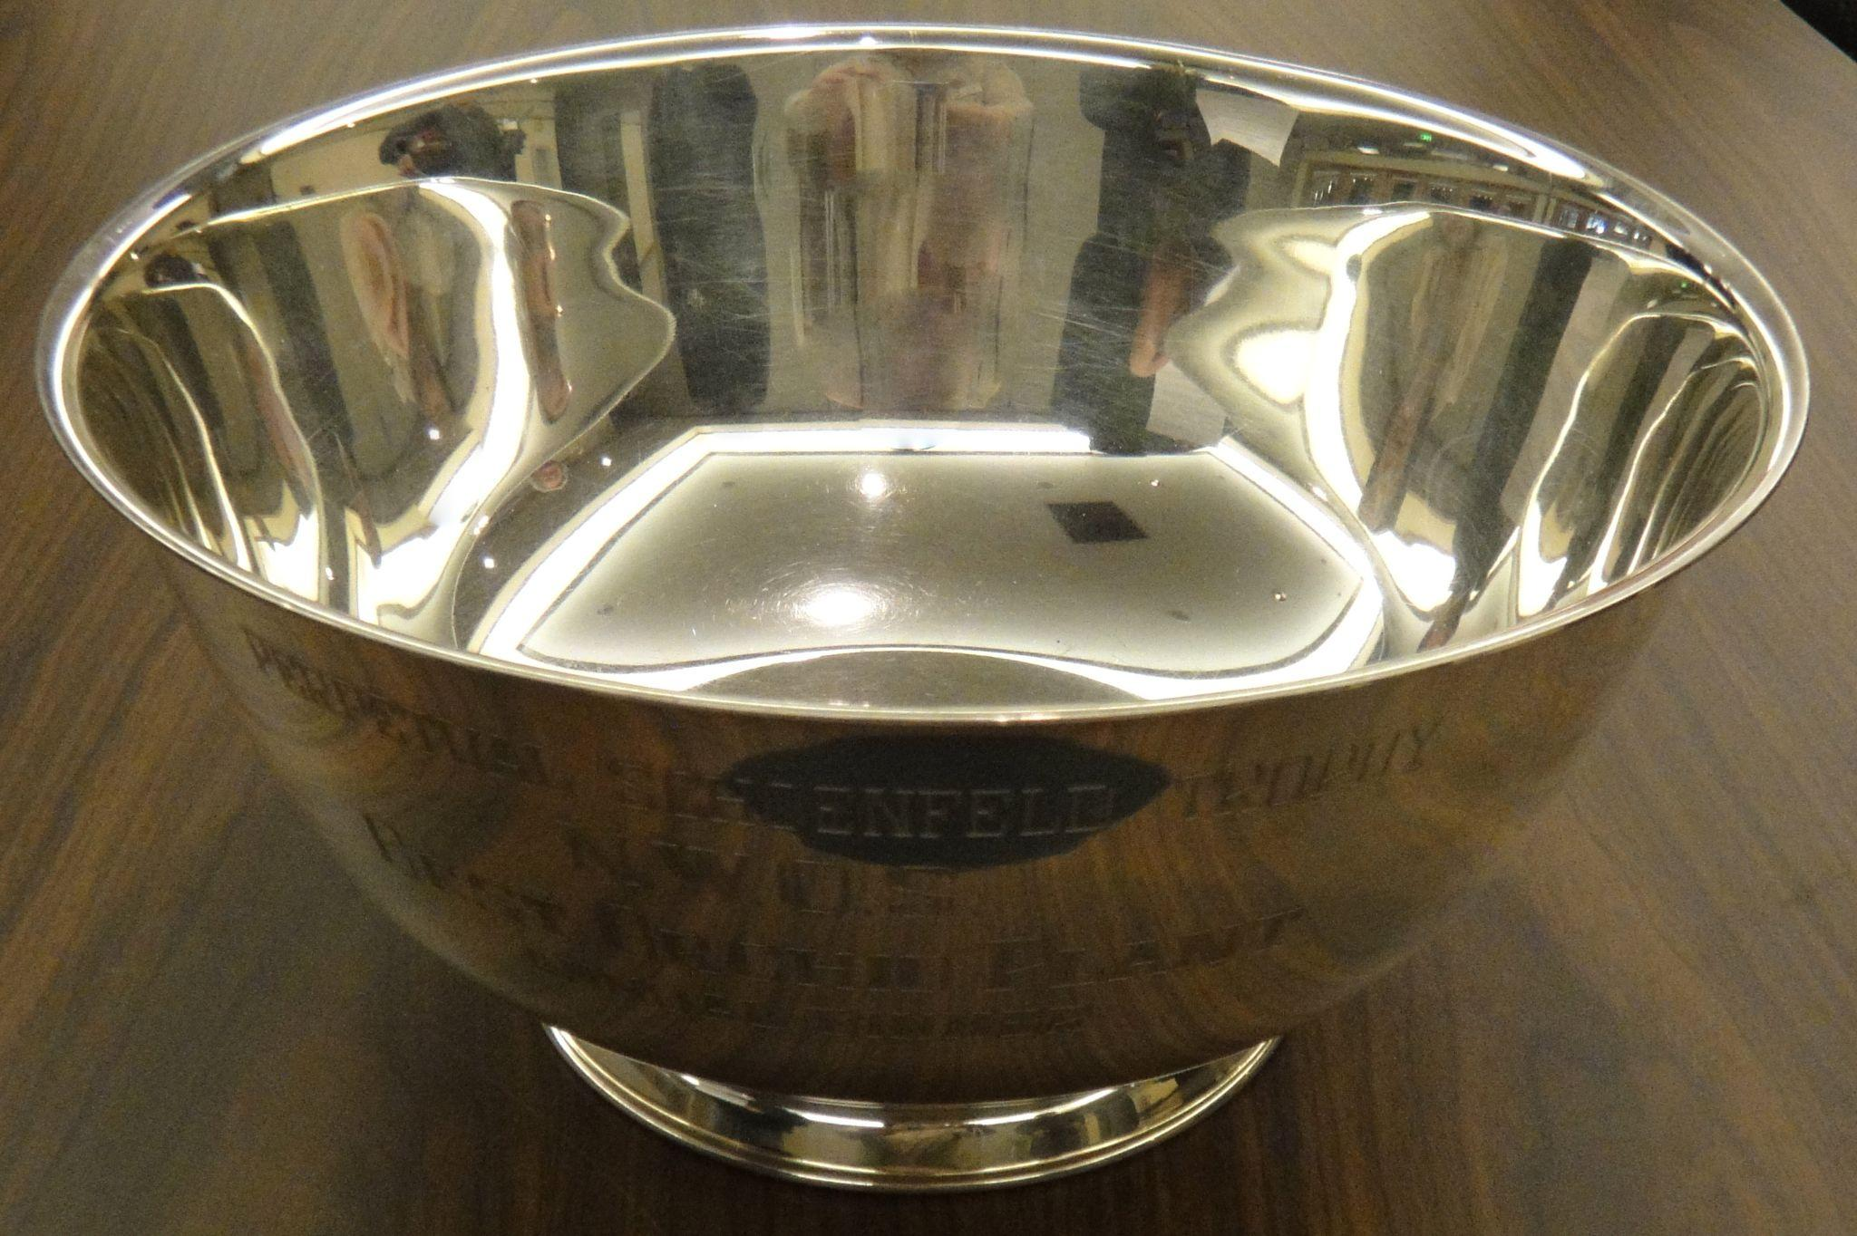 | 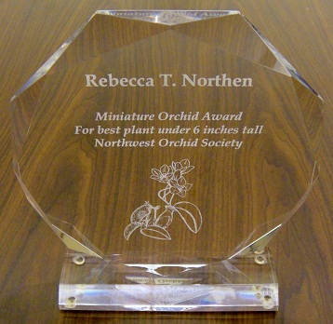
Schoenfeld Trophy Rebecca Northen Trophy

Here is a recap of our most recent competitions.
First, we have the contestants for the Schoenfeld Trophy:
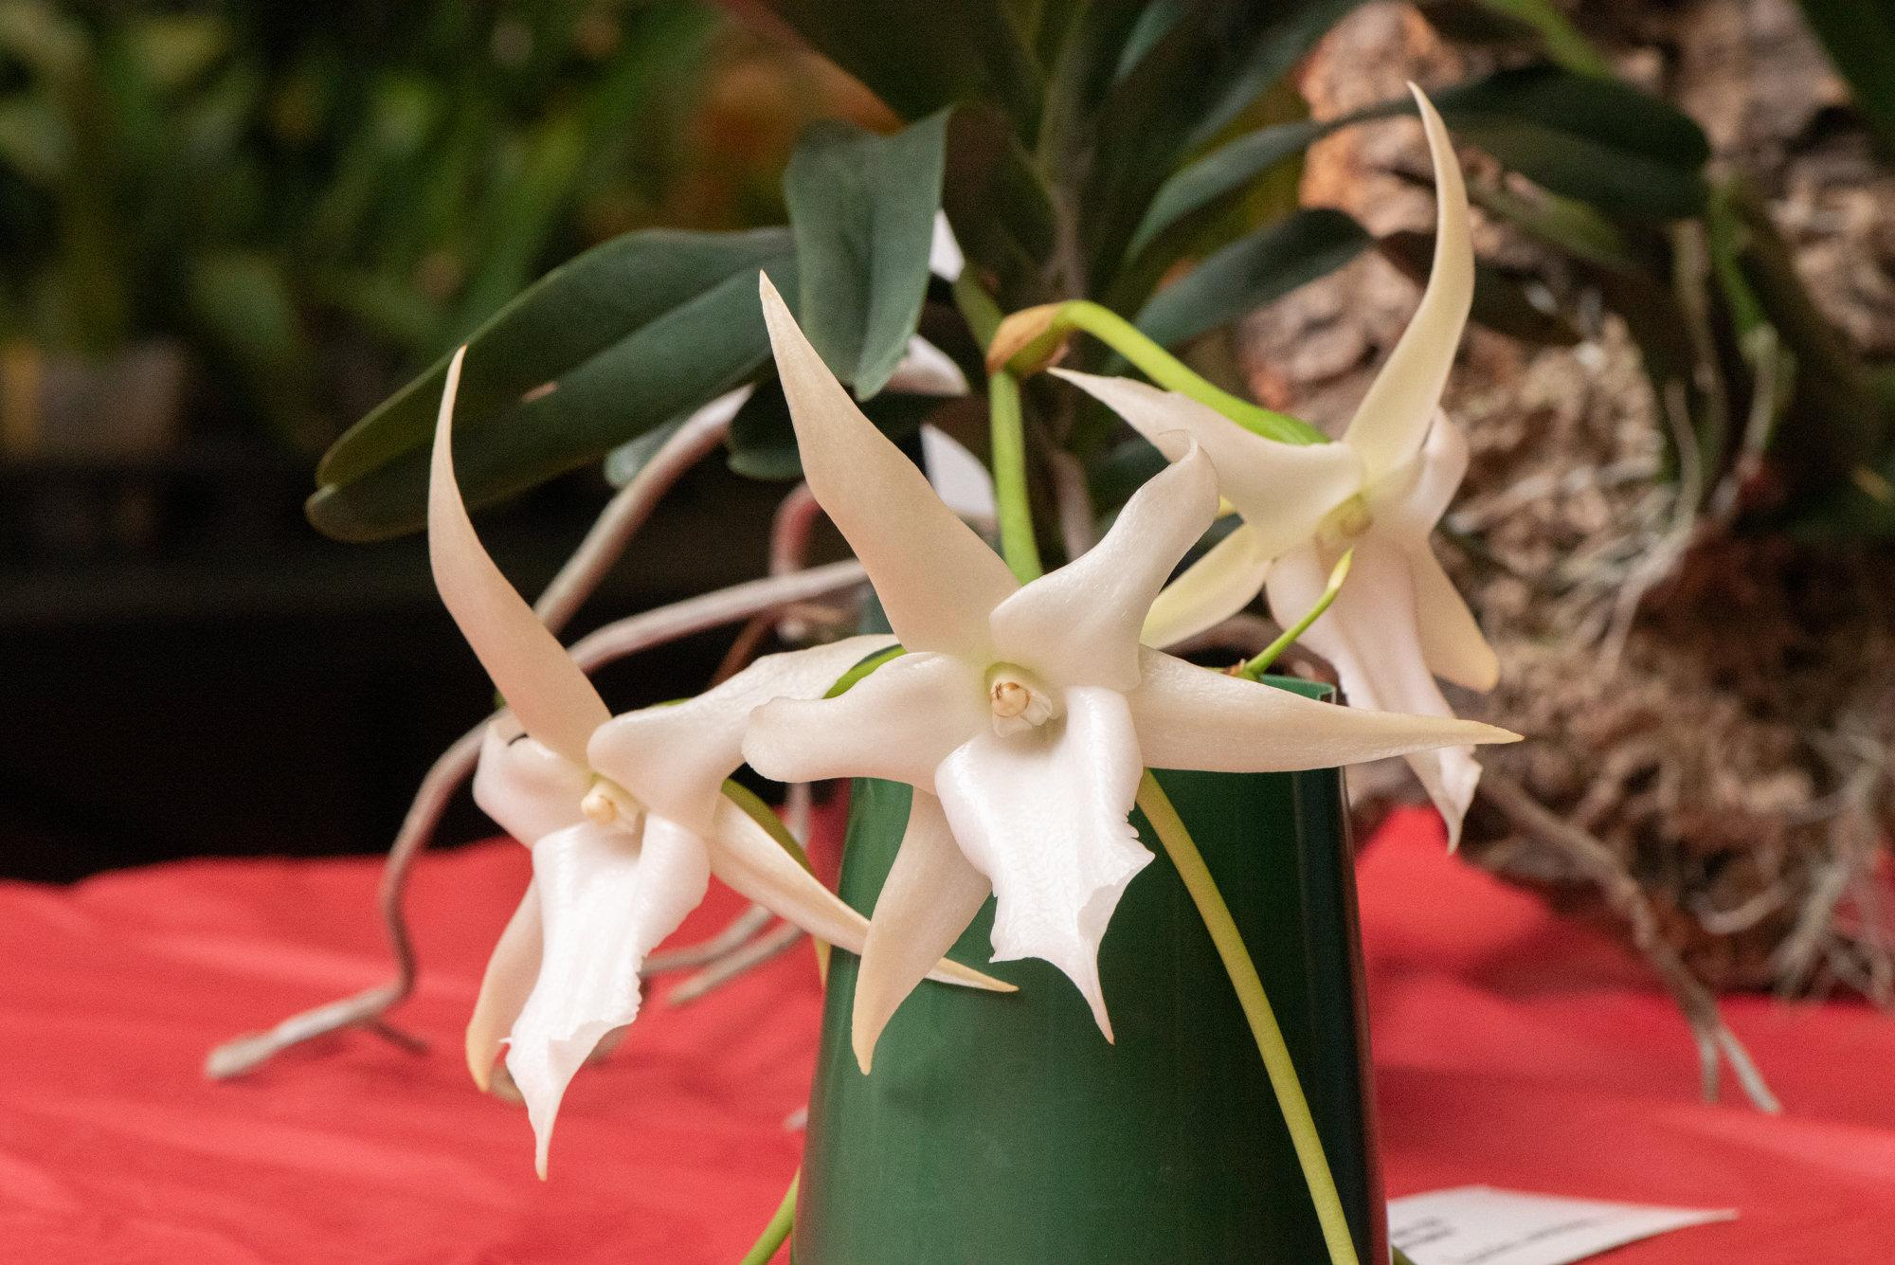
Angraecum sesquipedale
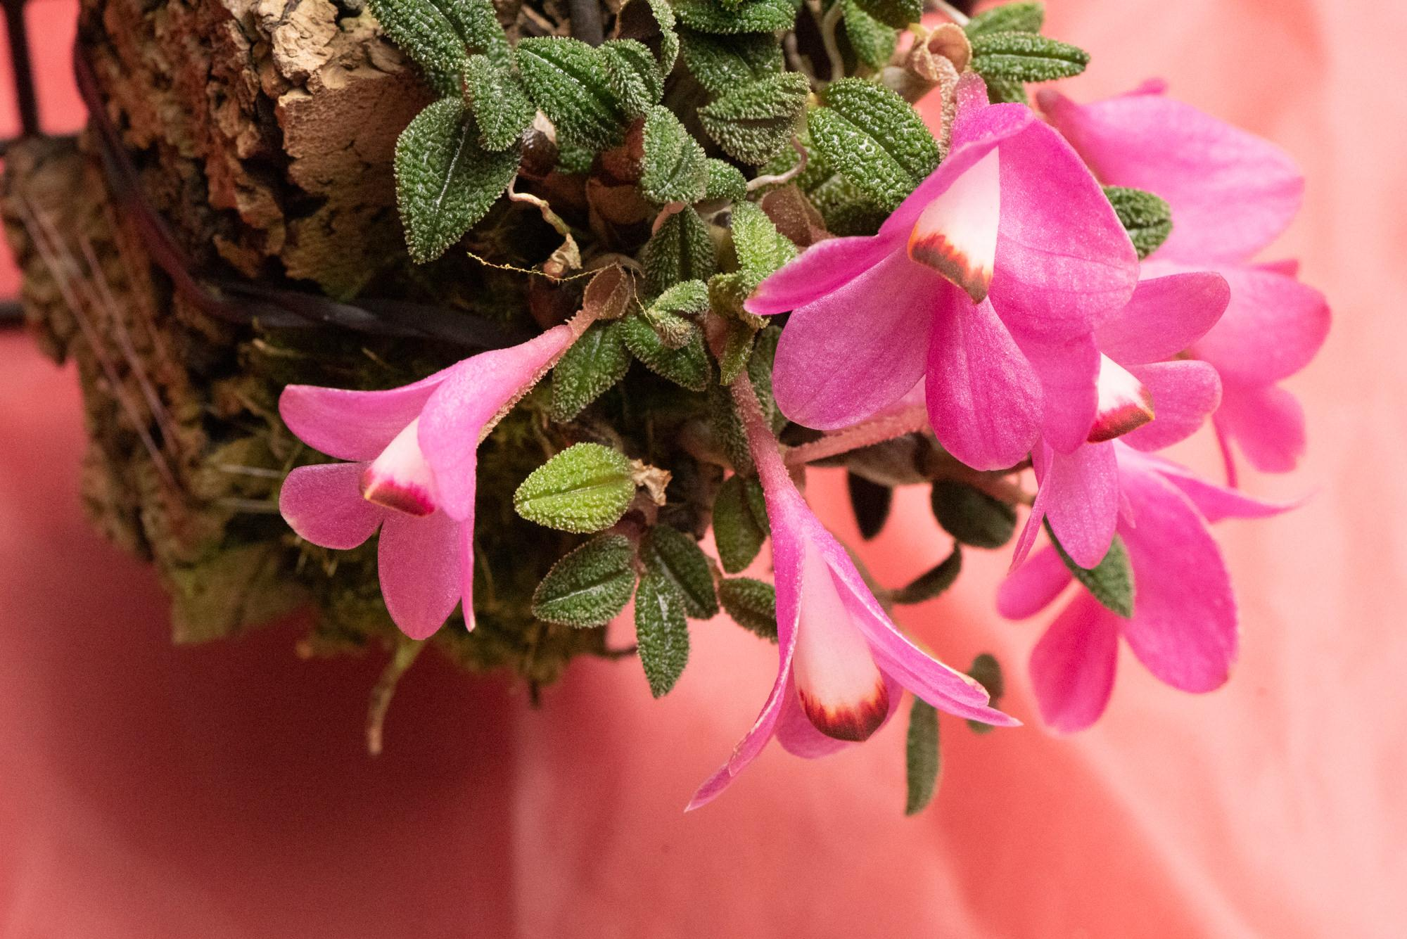
Dend. cuthbertsonii
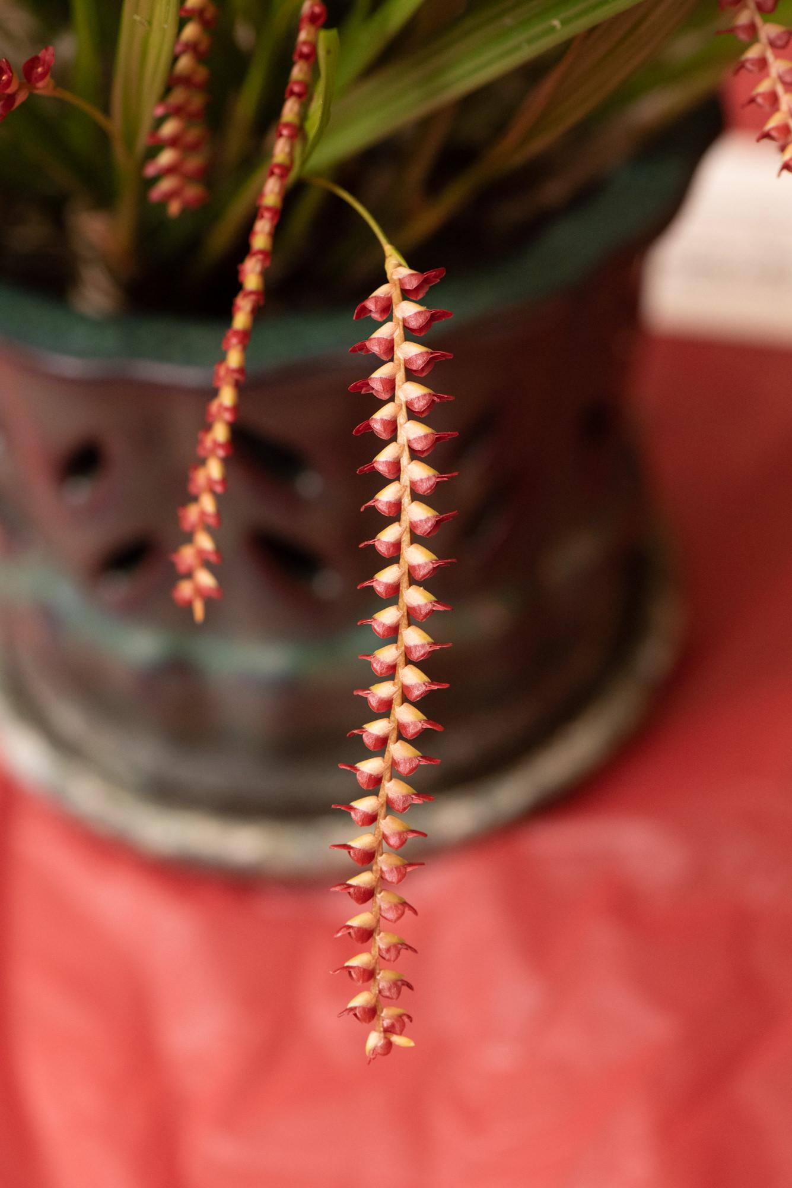
Dendrochilum saccolabium
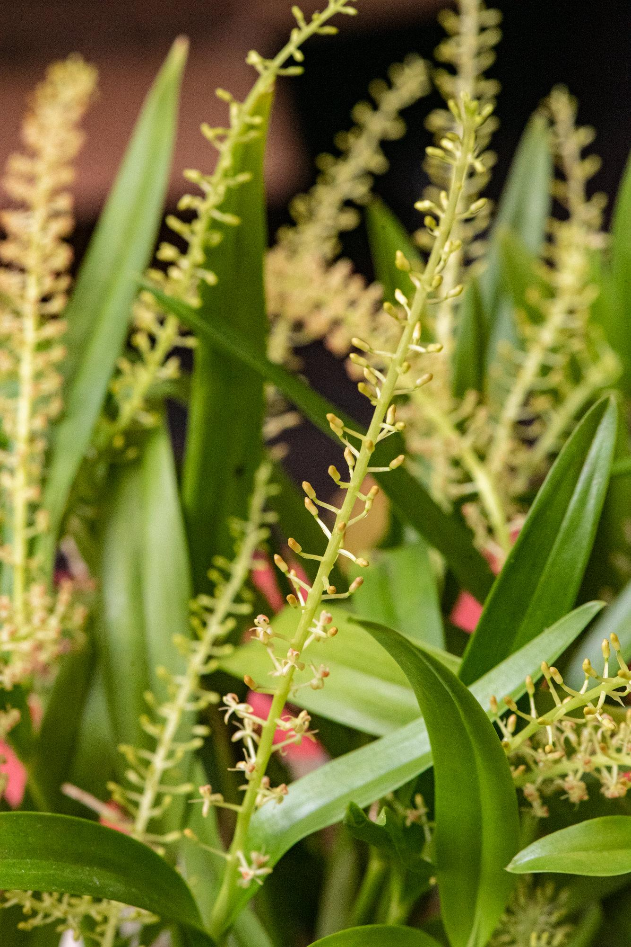
Liparis condylobulbon

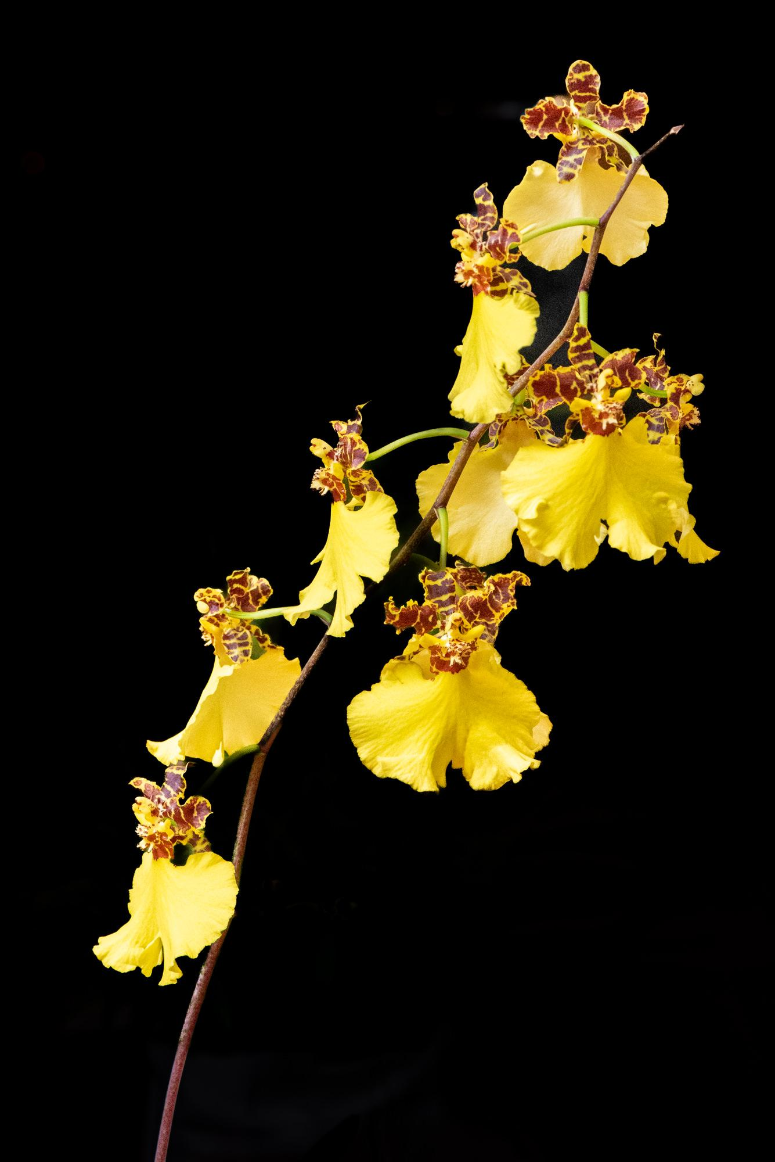
Onc. Jiuhbao Gold

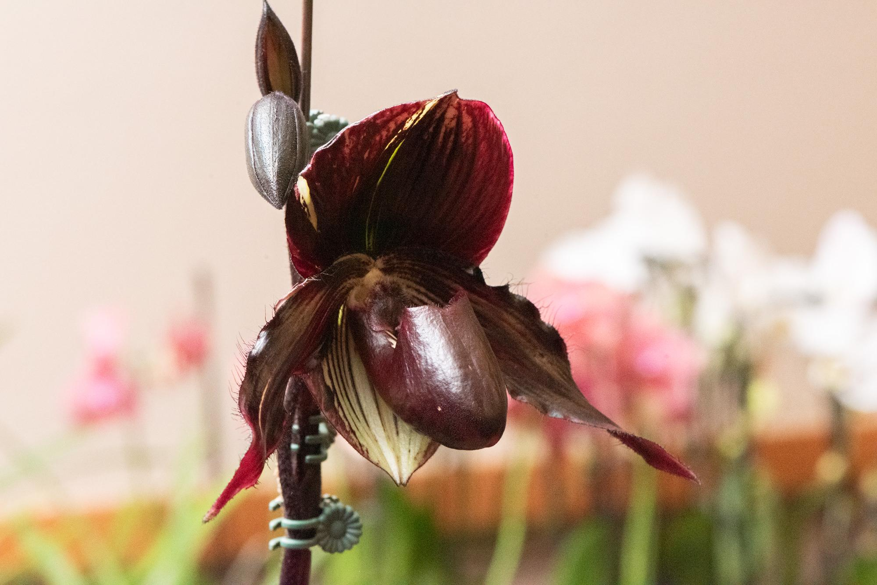
Paph Midnight Child 'Blackout'

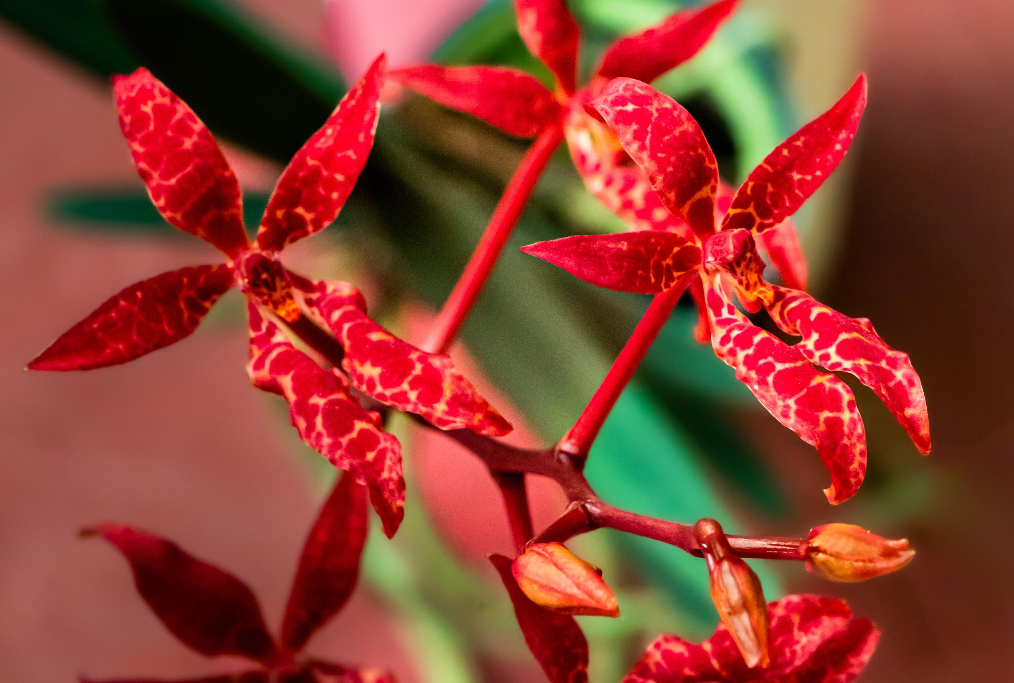
Renanthera bella

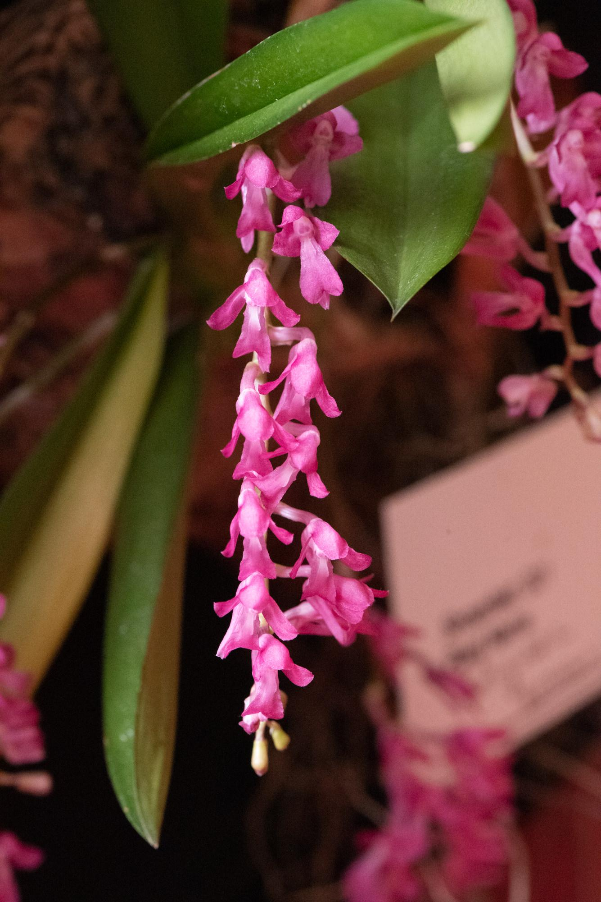
Rodriguezia batemanii
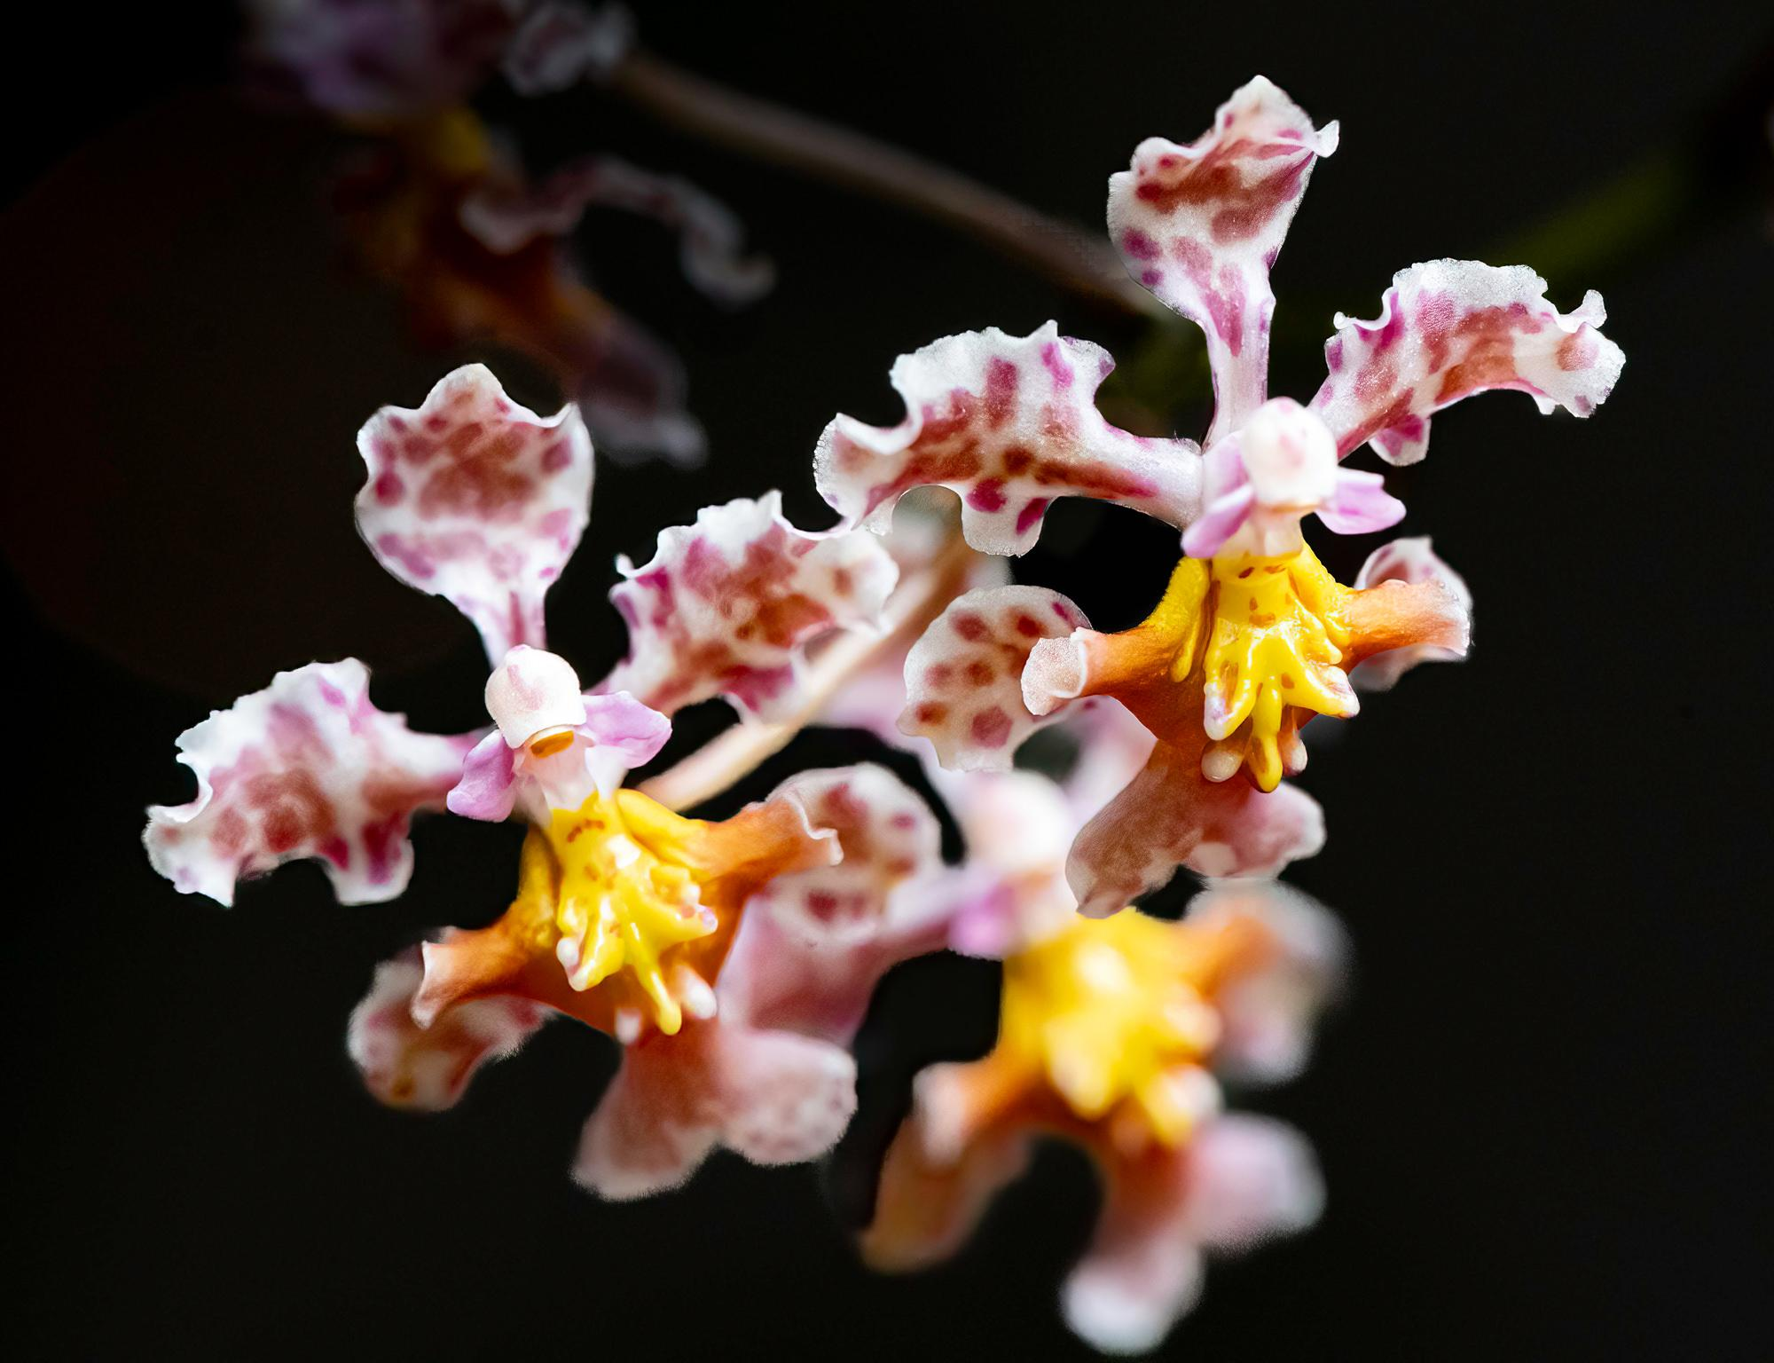
Trichocentrum Oestedii

And the winner is:

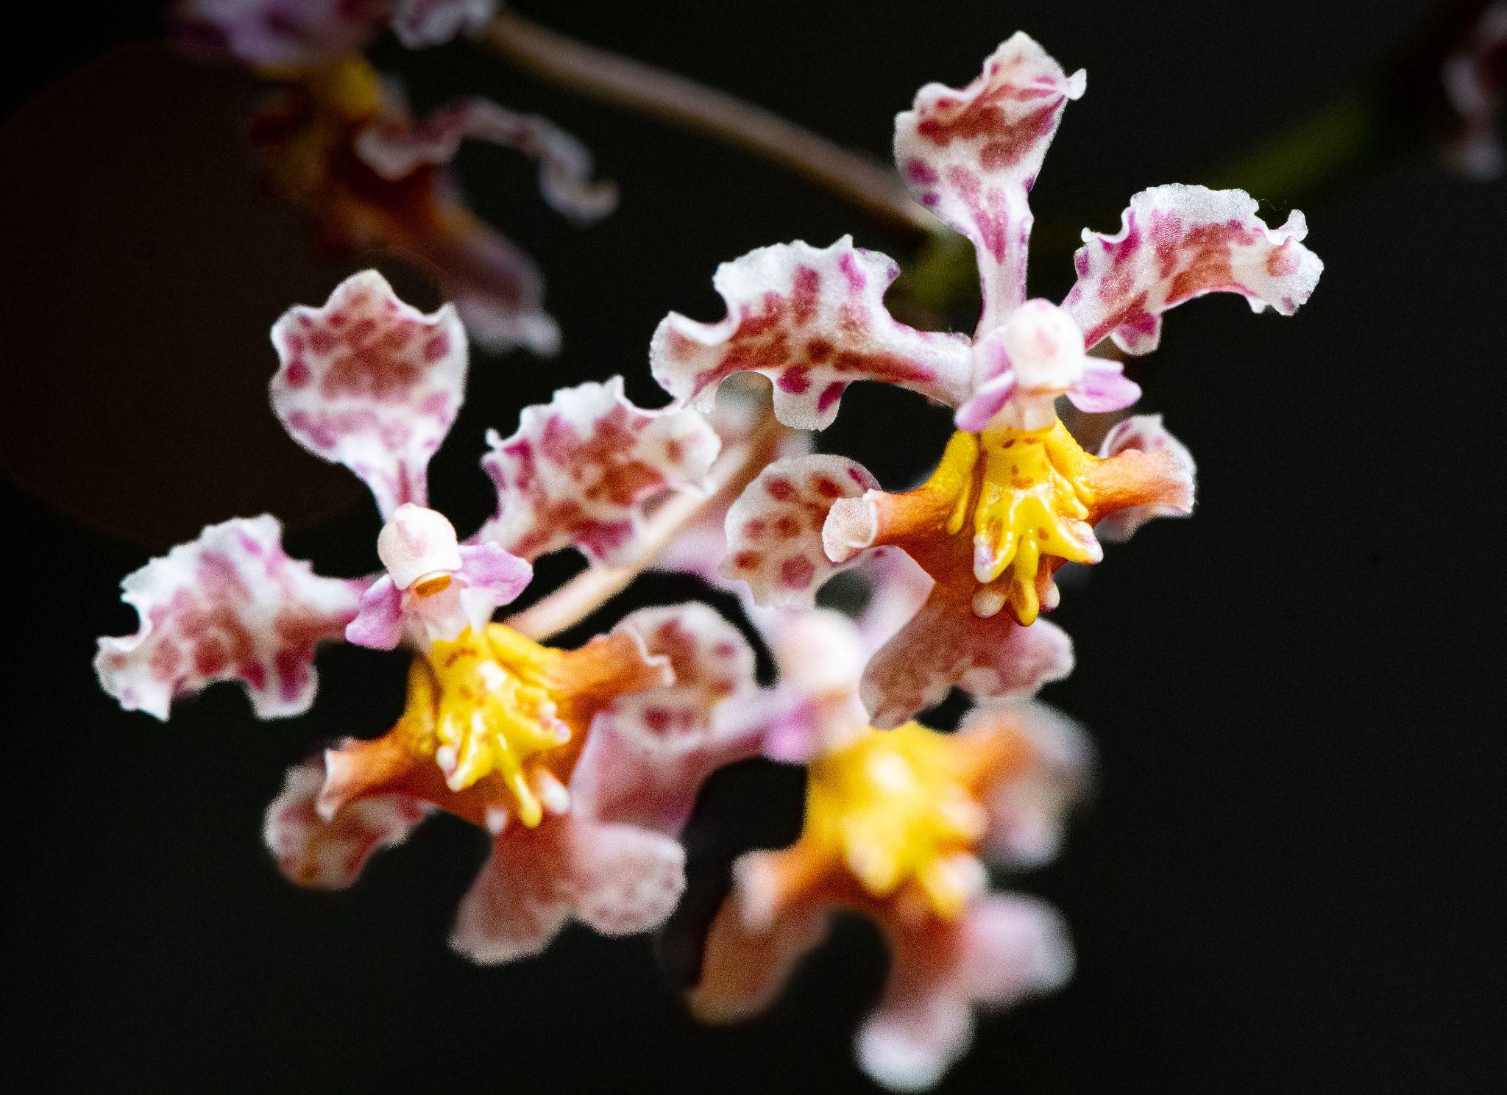
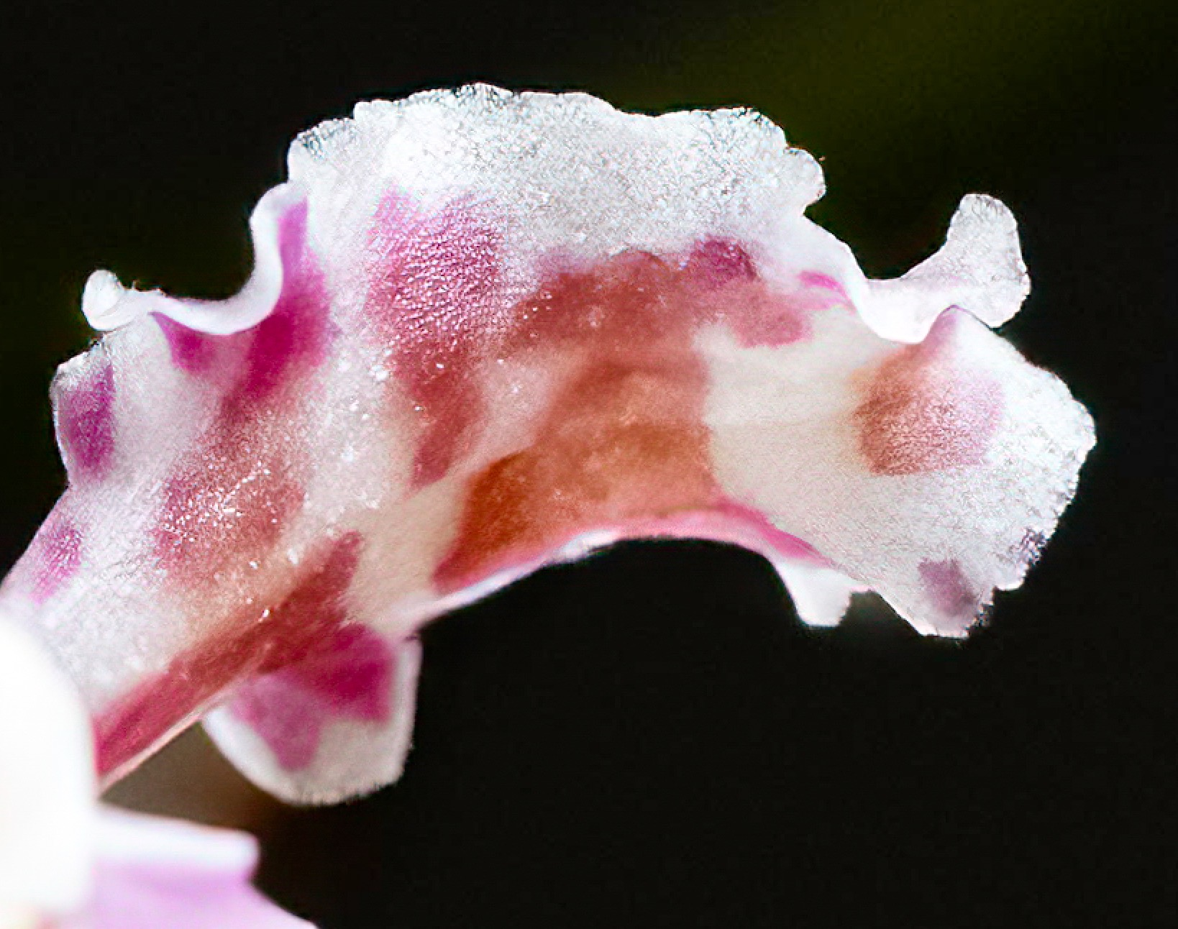

Caryle Harper with Trichocentrum oerstedii

Next, we have the contestants for the Northen trophy:
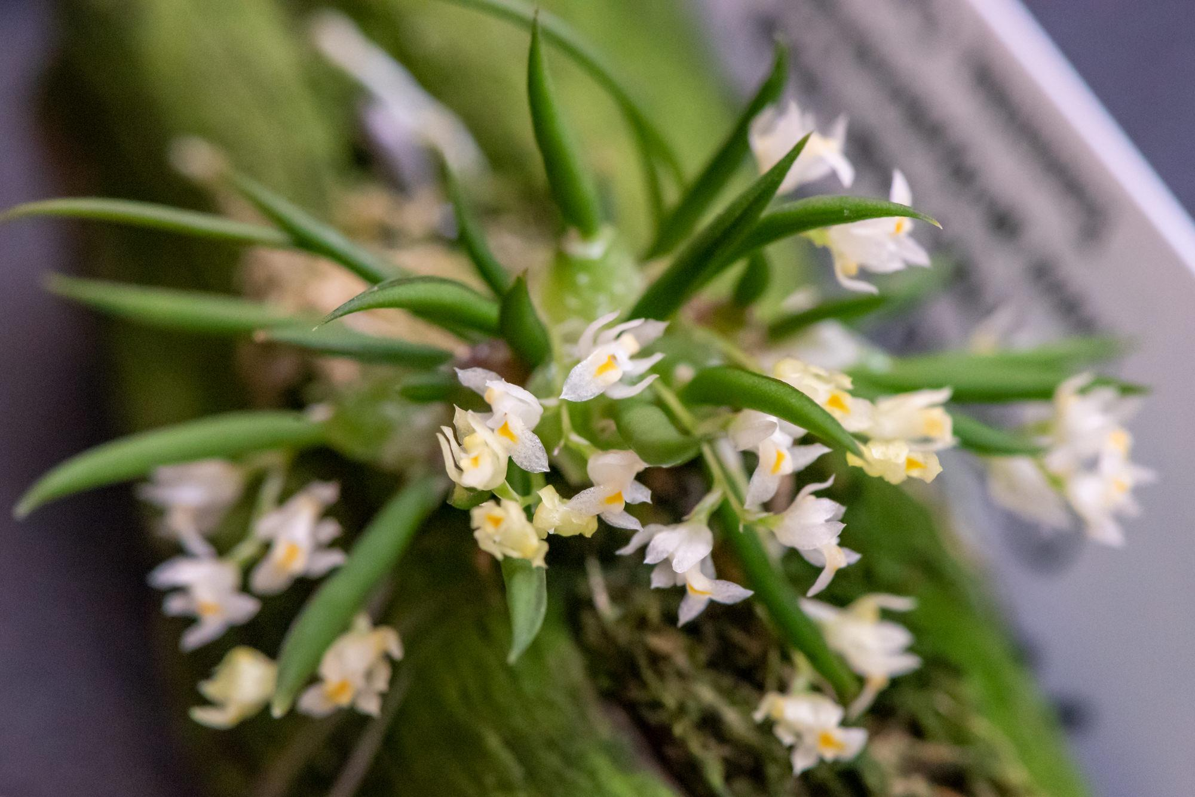
Capanemia micromera

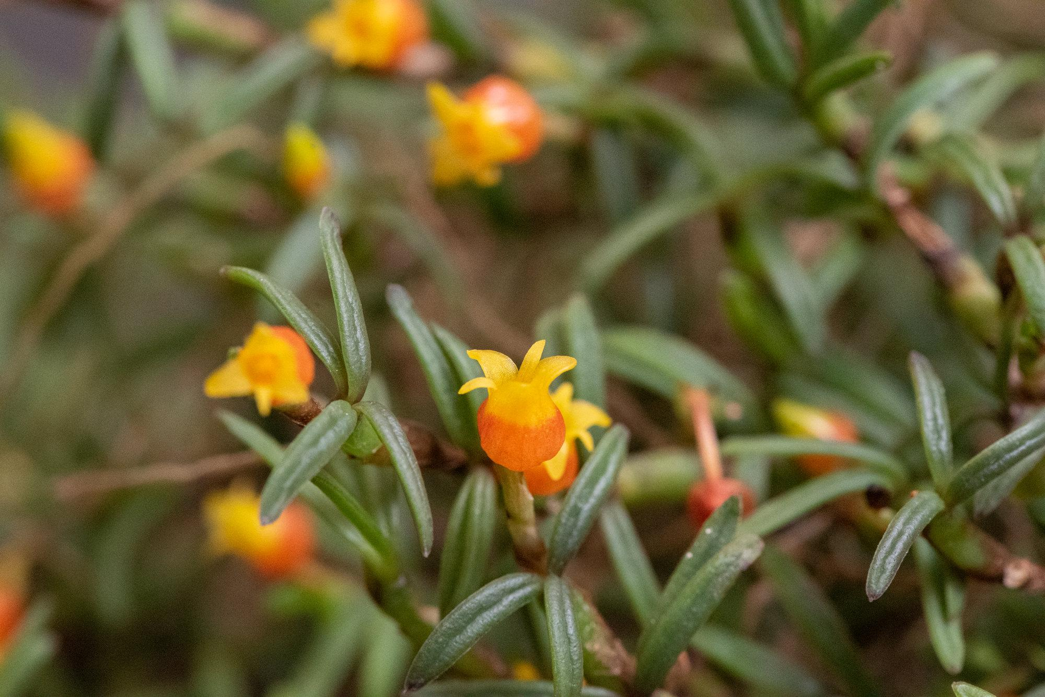
Mediocalar decoratum
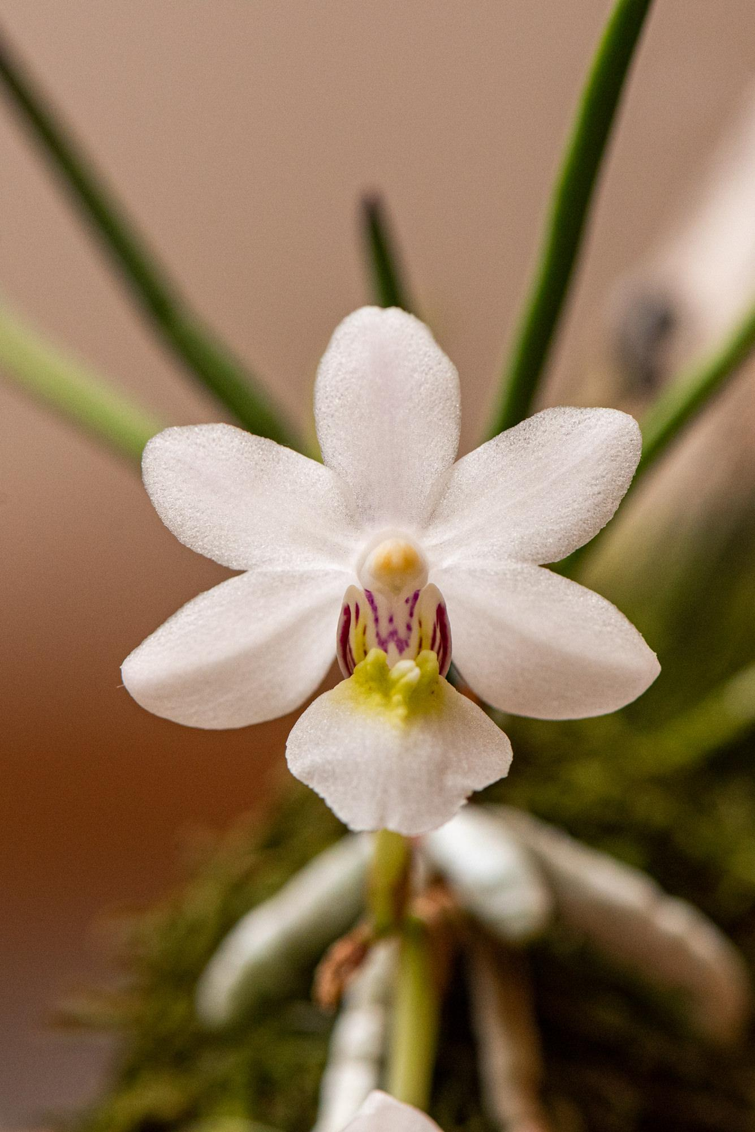
Holcoglossum rupeste
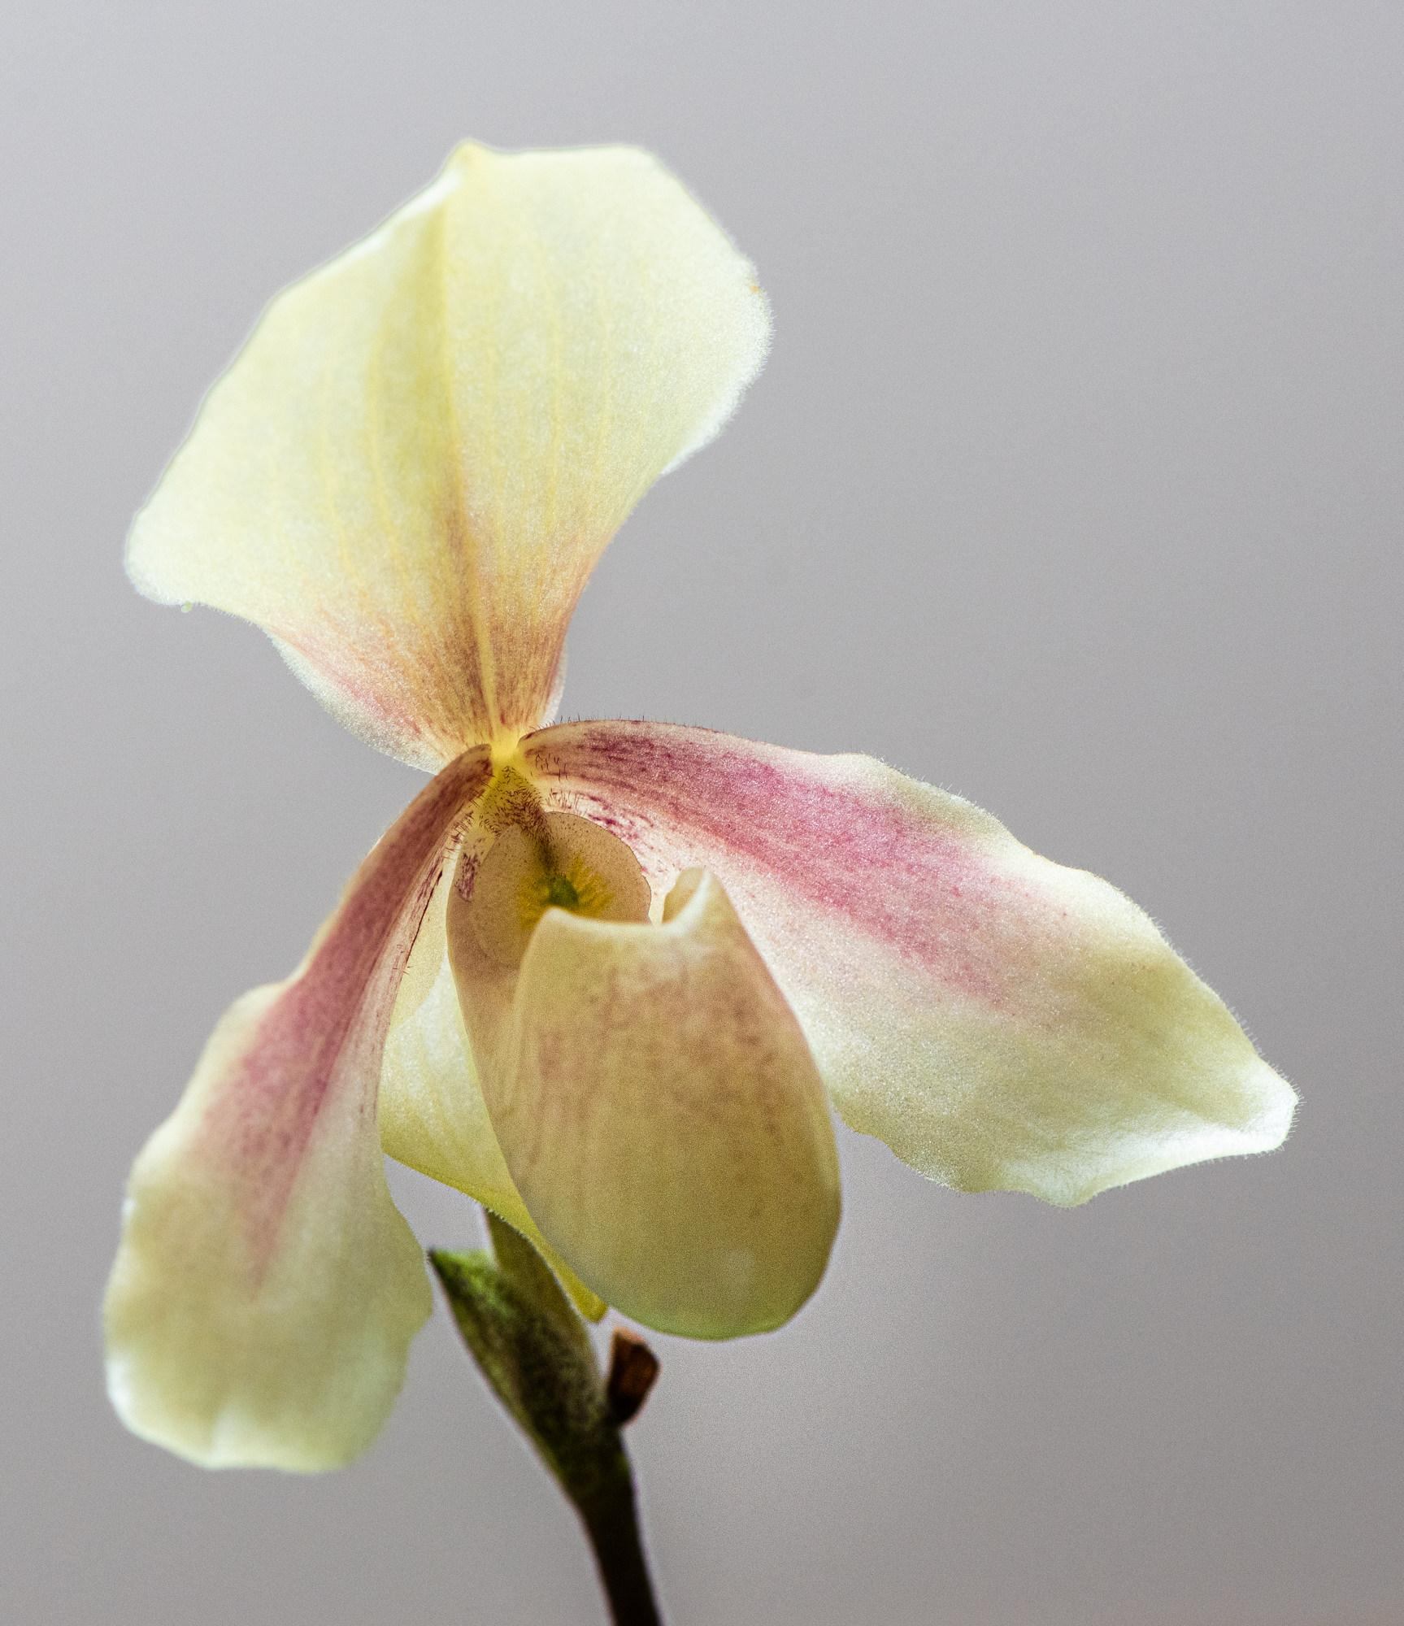
Paph. Helenae x Godfroyae
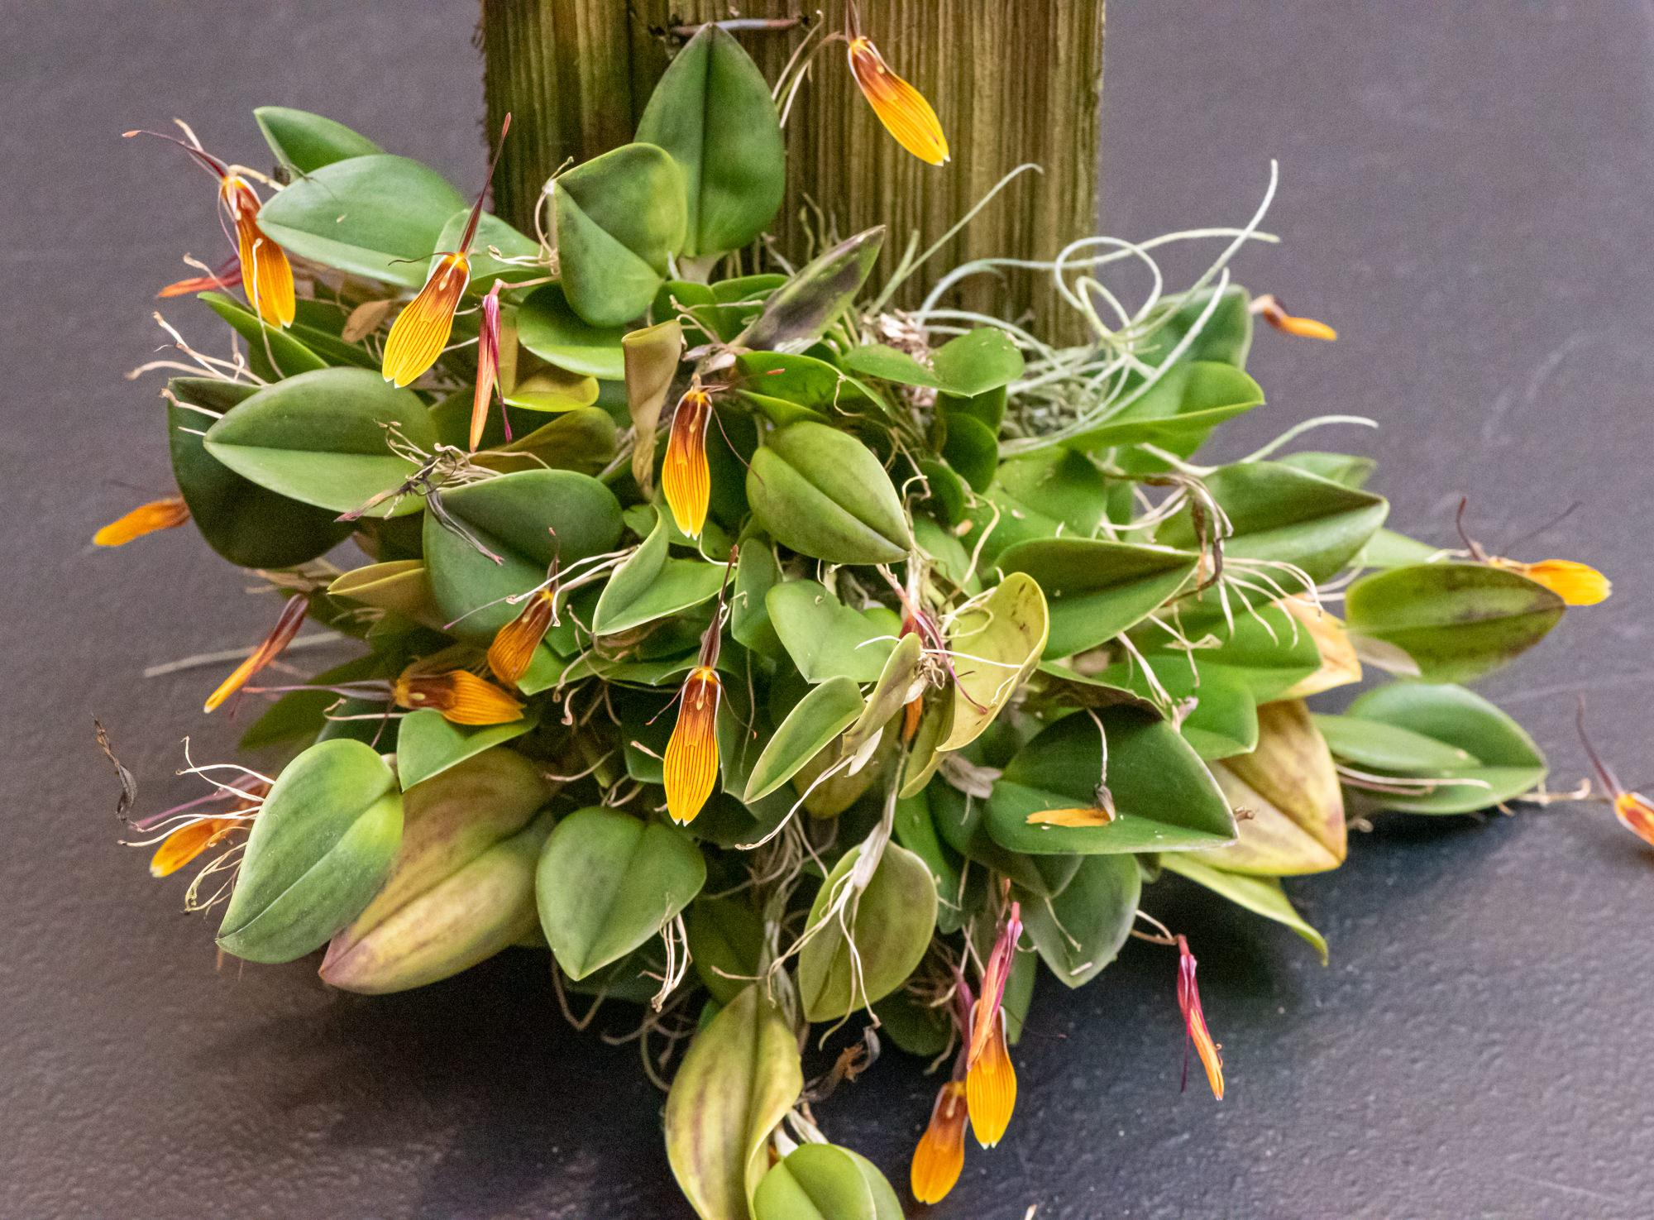
Restrepia schizosopala

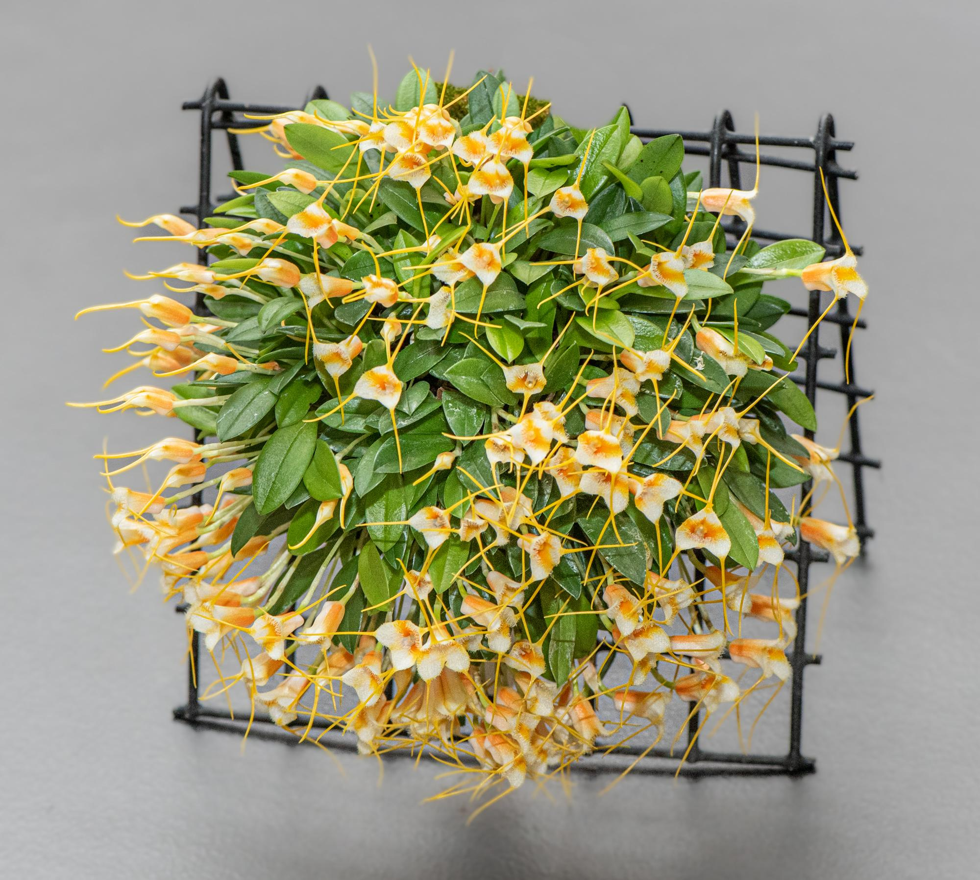
Masdevallia sotoana

And the winner is:

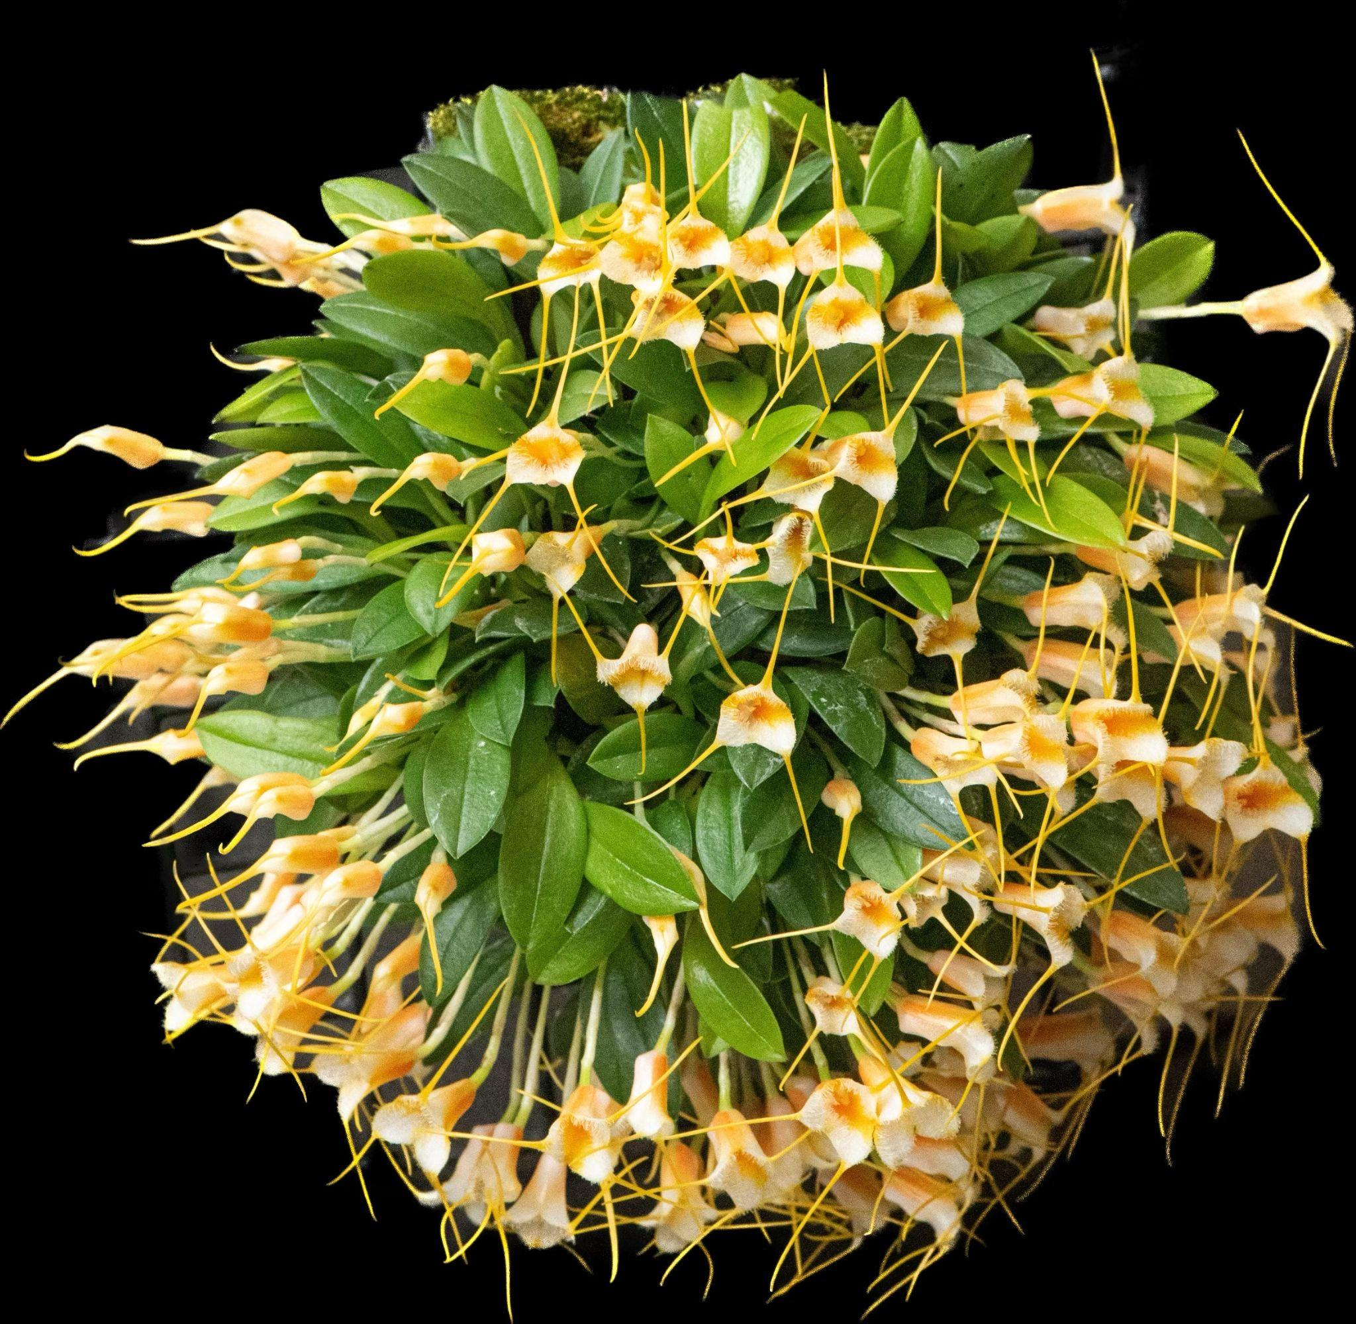

Robert Culver with Masdevallia sotoana

NWOS Post

Report From The December Meeting

Our President Steve Dorsey started the meeting by welcoming all who came to our holiday gathering.

Steve let all the members know that people with food allergies and special diets had desserts provided for them in the kitchen, for everyone else could get a free dessert with their meal at the food truck.

He then covered the raffle ticket system we used this year for our holiday plants. Members would need to check in with Mike Corey or Bill Leicht and get a raffle ticket which would be called later and allow members to go select the holiday plants.

The holiday plants were sourced from these three vendors this year. If you enjoyed them, please visit them online.

- Emerald City Orchids: http://emeraldcityorchids.com/
- Hillsview Gardens: https://www.hillsviewgardens.com/
- The Orchid Fix Nursery: https://www.theorchidfix.com/

Steve then briefly covered the Shoenfeld and Northen entry and voting tickets.

Steve then introduced the new board.

Officers, one-year term expiring Dec. 31 2023:
- President - Robert Culver
- 1st VP - Joseph Grienauer
- 2nd VP - Ben Johnson
- Treasurer - Bill Leicht
- Secretary - Sean Hoyt
Director positions, two-year term expiring Dec. 31, 2024:
- Diane Drisch
- Heather Harrington
- Yoshi Nagamatsu

Director positions, two-year term expiring Dec. 31, 2023:

- Brad Collins
- Pat Gossler
- Peter Maunsell
- Lori Lederman
- Andy Wright

- Past President - Steve Dorsey

We then voted on the new ByLaw changes which passed.

Steve then gave a special thank you to Mary Nichole for all her tireless work over the year for coming early to provide our coffee and other refreshments during the meeting and for ensuring there are holiday decorations for us during the holiday party.

We voted for the Shoenfeld and Northen tables. Andy Wright then reviewed the Shoenfeld table.

The Shoenfeld and Northen tables are discussed here.

Unlike previous years, we also had space for a Plant Table since we didn’t have a traditional potluck.

Here are some photos of our members and activities during the meeting as well as the Plant Table.

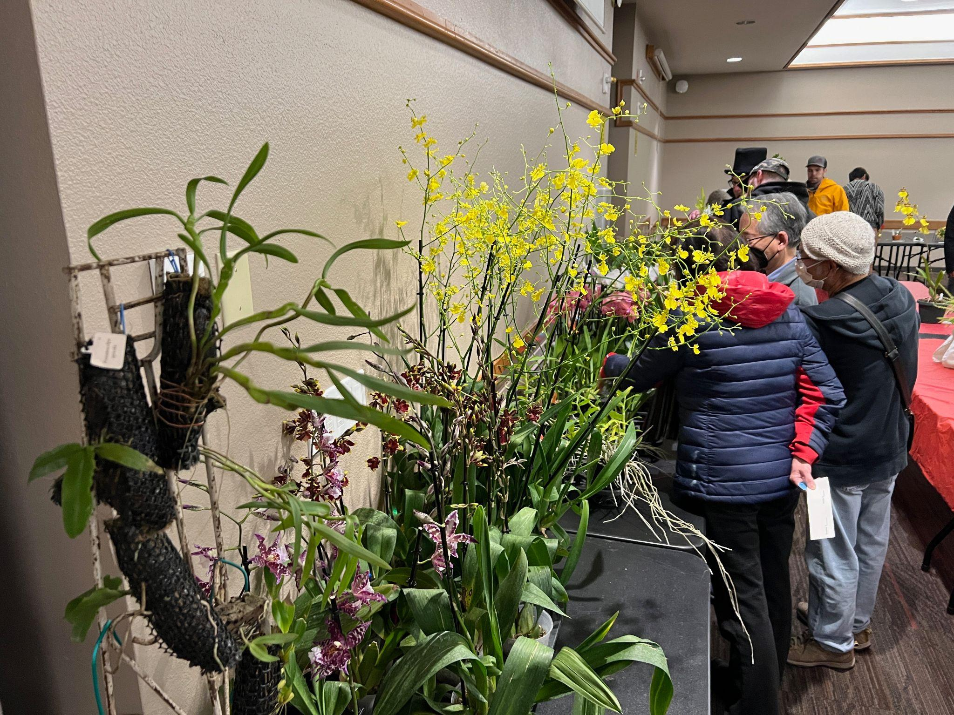
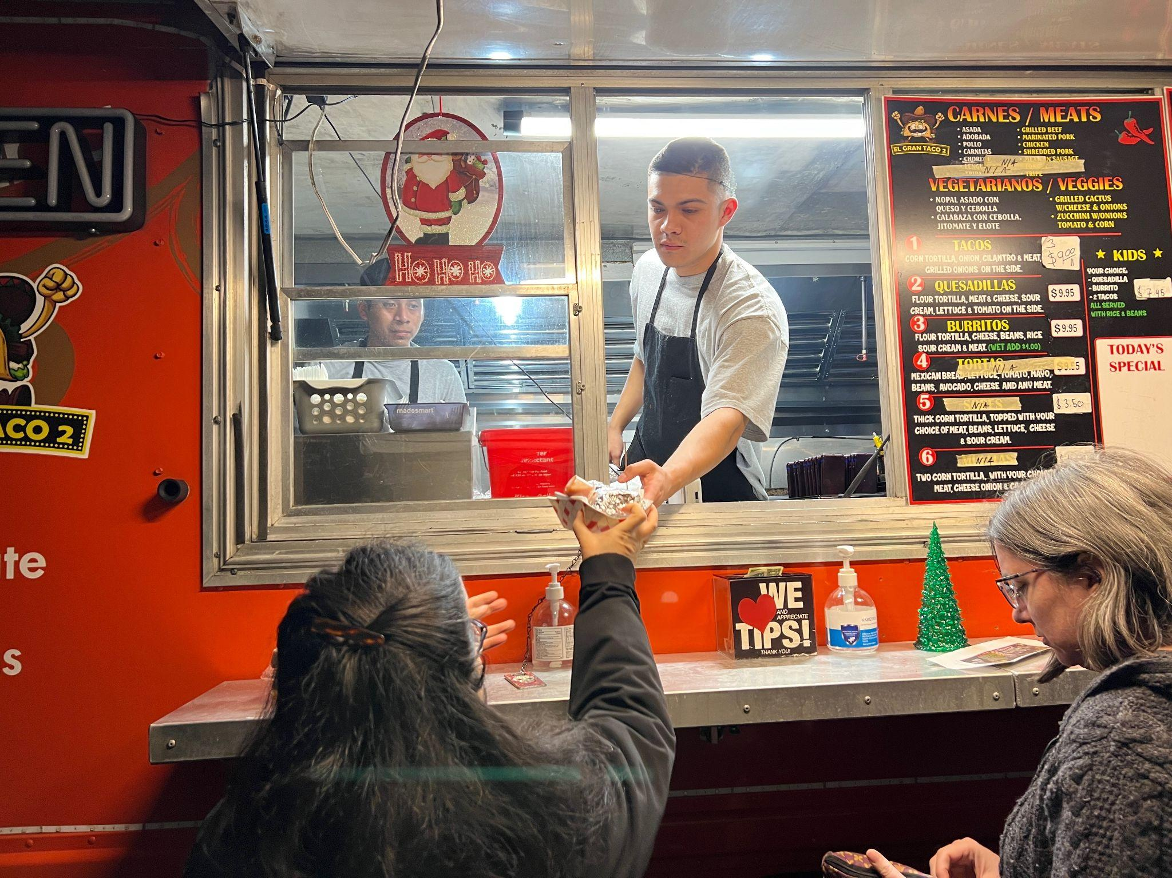

NWOS Post

Schedule of Upcoming Events

01/09/23 – NWOS meeting – Speaker: Tennis Maynard, "Trichopilias" Tennis will be speaking to us about this beautiful, yet underrepresented genus in many of our collections.

02/25/23 – NWOS Meeting – Annual Auction: This is our annual auction. It starts early with our preview party, nibbles, and bubbly, and ends up with tables and tables of plants for you to bid on. Many of these plants are hard to find and are rarely available outside of private collections.

This will be held at Shoreline Community College, building 9000 from 1:30 PM to 4:30 PM.

Please note the change of location and the change to Saturday afternoon.

03/13/23 – NWOS meeting – Annual Culture Clinic: This is our annual clinic when you can bring your questions, your problem plants and whatever is ailing something in your collection and the members that have experience with that plant or problem will answer your questions.

04/10/23 – NWOS meeting – Speaker: Jurahame Leyva, “Current Trends in Paphiopedilum Maudiae Breeding” Jurahame will be talking to us about the new trends in this easy-to-grow plant with its showy leaves and long-lasting flowers. It’s a rewarding plant for both novices and experts alike

05/08/23 – NWOS meeting – Speaker: Ron Parsons, “The Genus Dendrobium”

06/12/23 – NWOS meeting – June Food Truck Social: This is our annual social just before we take our summer break. We have a food truck outside and plants inside. We also announce the Gary Baker Service Award at this meeting.

09/11/23 – NWOS meeting – Speaker: Kelly McKracken, “Fragrant Miniatures” The most common question we get asked about plants is “is it fragrant?”; Many orchid growers select their plants based on whether the plant is fragrant. For those of you who grow in limited space, but still love a nose full of floral fragrance, this is the talk for you.

10/09/23 – NWOS meeting – Speaker: Andrew McGinnis, Growing Orchids in Grow Tents, Advanced Indoor Growing.

11/13/23 – NWOS meeting – Speaker: Alan Koch, “A New Look at Intergeneric Phalaenopsis” Phalaenopsis have been enjoyed by novice growers for the ease of growth and long lasting flowers. Intergeneric Phalaenopsis hybrids are easier to grow, maintain the long lasting flowers and often bloom more often than a normal Phalaenopsis. Another benefit from this line of breeding has been the creation of many fragrant hybrids. The bright colors, fragrant flowers and smaller hardier plants make this an interesting direction in orchids.
12/11/23 – NWOS meeting – Holiday Food Truck Social, introduction of new Officers, NWOS Annual Meeting report, Schoenfeld and Northen Orchid Awards, and Holiday Plant gifts.

Reminder for Officers & Board Members

The next board meeting is January 3rd which will be a transitional meeting consisting of both outgoing and incoming Officers and Board members. Meet at 7 p.m. at a location to be determined.

Shopping on Amazon? Use this link to earn $$ for the NWOS

If you go to https://smile.amazon.com and sign in to your account, you'll be given information about supporting various non-profits. You can type in "Northwest Orchid Society" and it will then send .5% of your purchase price to the organization.

It's really easy, but you have to remember to go in through the 'smile' subdomain when you place the order, otherwise, it will go through as a regular order.

NWOS Website Links

- Main website: Http://www.nwos.org
- Events Calendar: http://www.nwos.org/events
- Membership (including renewals): https://nwos.org/Membership/
- Newsletter - Current Issues: https://nwos.org/newsletters/
- Newsletter - Archived Issues: http://newsletter.nwos.org
- Show Information: https://nwos.org/nwos-fall-show/
- Facebook: http://www.facebook.com/nworchidsociety
- Instagram: https://www.instagram.com/nworchidsociety/
- Twitter: https://twitter.com/nworchidsociety

Special Announcements

Ecuagenera will be having a pop-up January 14/15 at Emerald City Orchids.
Joe has the full details on his Facebook Page.
The last day to pre-order is December 26. If you have questions, talk to Joe.

©2023 Northwest Orchid Society - All Rights Reserved

The opinions and recommendations published herein are those of the authors. The Northwest Orchid Society (NWOS) disclaims responsibility for any losses or damages that may be attributed to the use or misuse of any material or any opinion published in these articles and on the website. This website and the photographs, articles, and content are protected by copyright and no part of them may be reproduced or re-used without the permission of the author.

The Special Announcements (SA) section is provided as a courtesy to the readers of this newsletter for events that may be of general interest to the readers. The NWOS (1) makes no promises, warranties, or representations as to SA, including its completeness, accuracy, availability, timeliness, propriety, security, or reliability; (2) provides SA on an "AS IS" and "AS AVAILABLE" basis and any risk of using SA is assumed by you.

