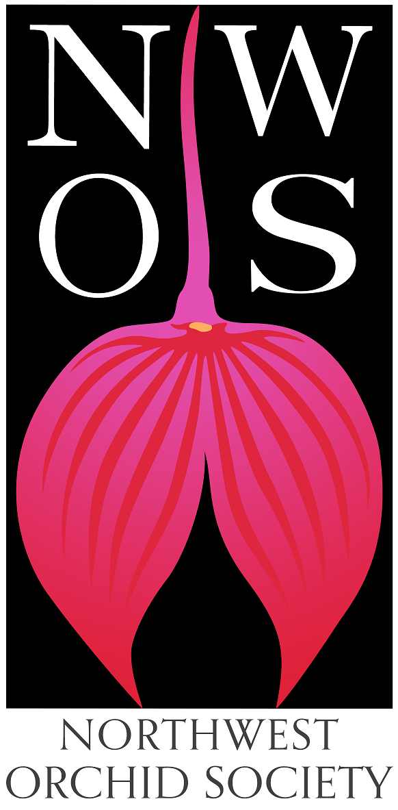
Northwest
Orchid News
February 2022
Volume 75, Issue 2

- About the February Meeting
- Meeting: February Culture Clinic
- Plant Table
- 2022 NW Flower & Garden Festival
- Membership Renewal Reminder
- Gary Baker Service Award
- Formation of Scholarship Criteria Review Committee
- NWOS Library
- NWOS Flower and Garden Festival Pre-Sale
- Volunteer Opportunities
- Growing Orchids Without Pots
- An Early History of The Northwest Orchid Society
- Report From the January Meeting
- Schedule of Upcoming Events
- Reminder for Officers & Board Members
- NWOS/Amazon Shopping Link
- NWOS Website Links

About the February Meeting
February 14, 2022 7 PM
Zoom only Meeting Zoom Registration

We will be making decisions for in-person or Zoom only meetings on a month by month basis so please watch your email notices, the website and the newsletter as we will update them with the latest information.

When we do return to in-person meetings the Covid protocol for the meetings will be shared monthly for attendees and is available at our web site located here: Covid Response – Northwest Orchid Society (nwos.org)

Meeting: February Culture Clinic
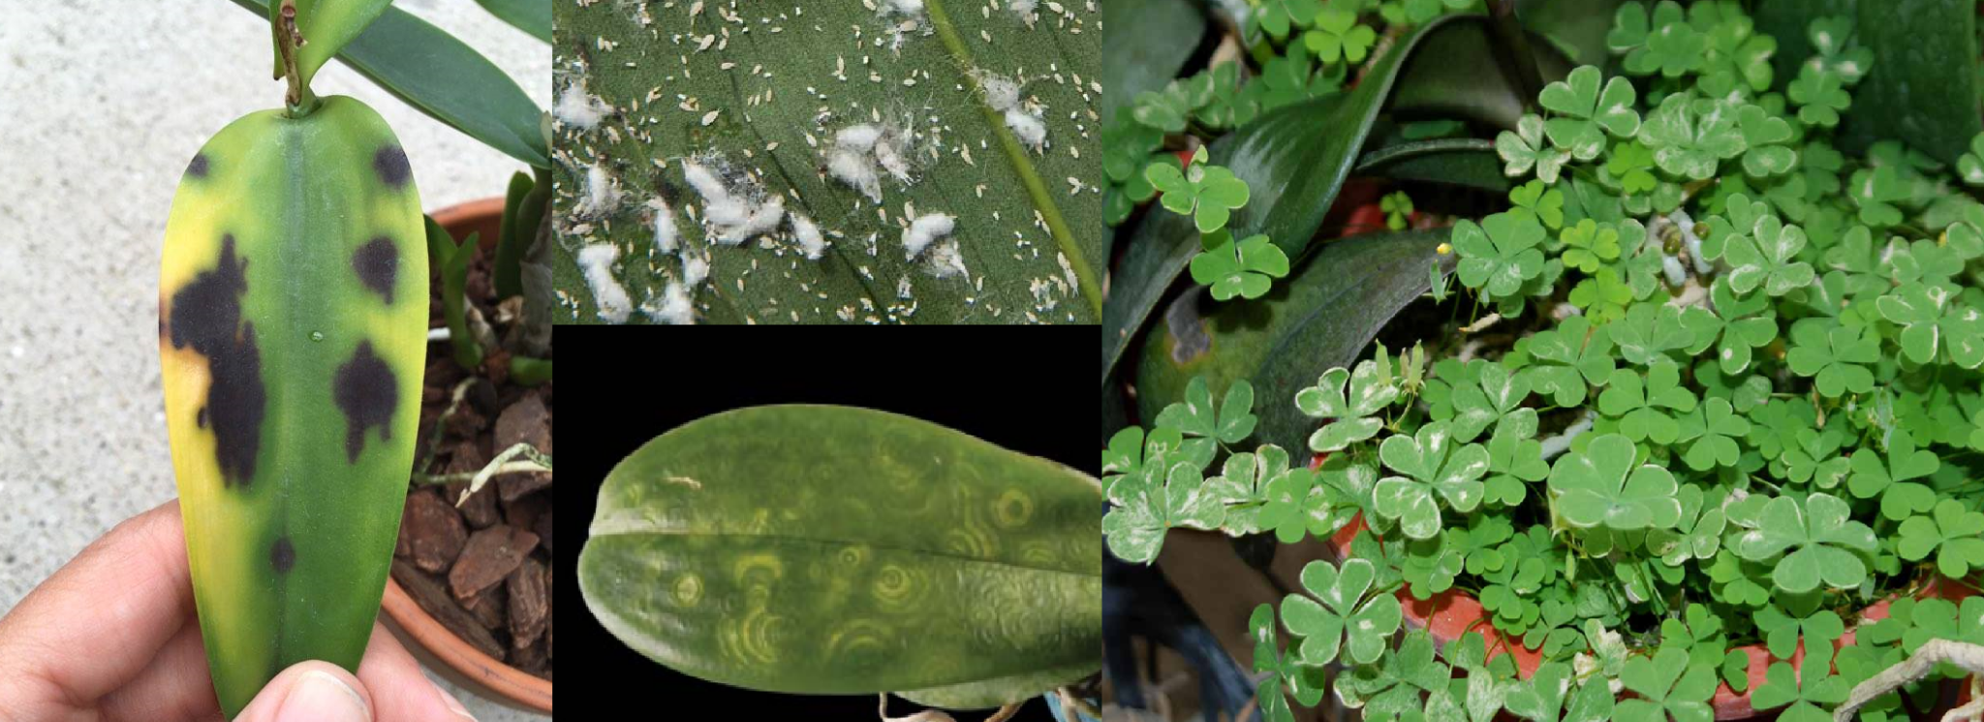

February is our culture clinic month. Andy Wright will be providing us with a short guide on orchid culture.

Orchid Villains Gallery

This is also an opportunity to ask your question on what's bugging your plants or get advice on why your plants might not be thriving. Send along your photos and questions to photos@nwos.org. We will have our panel of experts review the problems you send in and offer 'sage advice'.

Plant Table

For this month we are having a virtual plant table since we’re not meeting in person. We would like you to send in the pictures you capture not only of your own plants but pictures from the Flower and Garden Festival. Please send them to photos@nwos.org.

2022 NW Flower & Garden Festival

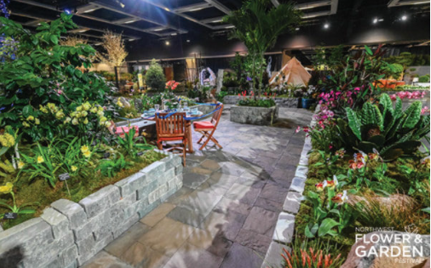

We have great information about how you can help us with our garden, how YOUR ORCHIDS can be the "stars of the Festival" within the garden and greenhouse, along with other garden details. Just check out the January newsletter at, January 2022 Newsletter or our NWOS website post at, January 2022 Newsletter Post .

2022 NW Flower & Garden Festival Plant Pickups

IF YOU BROUGHT ORCHIDS TO DISPLAY IN OUR GREENHOUSE, you must collect them either on Sunday Feb 13 after 6 pm (and before 8 pm) or on Monday Feb 14 before 2 pm.

Since the February 14th in-person meeting has changed to the virtual (Zoom Registration) arena, plants will not be transported to the Center for Urban Horticulture meeting place.

To gain entry to the Garden Floor at the Convention Center on Sunday evening after 6 pm or on Monday, obtain an orange "work pass" sticker from any 4th floor door guard or from the hand-carried freight elevator attendant in the parking garage beneath the Convention Center.

If you need to pick-up your orchids at a different time or day, please contact me by sending an email to FGS@NWOS.ORG. I will try to put you in contact with a member who will be there helping us teardown. Don't wait until Sunday the 13th to do this as I will be out of email range dismantling the garden. =)

~ Joff Morgan

Want to help us dismantle the 2022 Flower Show Garden?
If you're not doing anything on Monday, February 14 for an hour or two, we could use your help dismantling the rest of our garden and cleaning the site up. Ideally, we want to be finished and out of there by at least 6 pm. But I am hoping we can leave by 3 pm or earlier.

The more helpers we have, the faster it will all go!

Currently there are 5 of us who will be there at 9 am to continue any dismantling that was not completed the night before. This includes:

- wrapping the grapefruit tree in cold-protective blankets
- wrapping the tall palms in blankets for transport
- helping to load the foliage and moss on Zoo vehicles
- placing concrete pavers and blocks on their pallets
- placing granite bricks on their pallets
- stacking remaining pallets for pick up
- removing other items to trash and recycling dumpsters
- sweeping the floor

Do you want to help us?
- Send an email to FGS@NWOS.ORG to sign up!

- Then report to our garden on the 4th floor of the Convention Center. You will need to wear a mask and obtain an orange "work pass" sticker to gain entry.

The "work pass" sticker is available from any 4th floor door guard prior to entering the Show floor or the hand-carried freight elevator attendant in the parking garage (between Pike and Seneca streets on 8th Avenue).

Bring gloves and knee pads if you have them. Thanks much!

~ Joff Morgan

Orchid Vendors and Events and Northwest Flower and Garden Festival

There will be two Orchid Vendors at the 2022 NW Flower & Garden Festival.

Our very own member Joe Grienauer of "Emerald City Orchids" (Booth #2238) will be selling a variety of blooming and budding orchids, as well as dispensing advice on how to care for them.

Andy Philips of "Andy's Orchids" (Booth #2134) will be offering a myriad of mounted and potted orchid species.

Joe is also giving a talk on "Growing Orchids Like A Pro" on Saturday, February 12 at 1:30 pm on the DIY Stage.

So be sure to come to the Show between February 9 and 13. And walk away with some extra orchids for you and/or your sweetie. After all, Valentine's Day is the 14th.

~ Joff Morgan

Membership Renewal Reminder

It's time to renew your NWOS membership for 2022. Our membership period now goes by calendar year (Jan. 1 to Dec. 31). You can pay at most meetings by cash, check, or debit/credit card. Click HERE to pay online using Paypal on our Membership page.
You may also mail a check (payable to NWOS) to PO Box 51021, Seattle, WA 98115-1021.
New members may wish to complete the Membership Form and send it to the address above.
Dues are $30 for one person or $40 for two people at the same address. We also have a Youth membership of $15 for one person aged 22 or under. Dues are kept low to encourage membership but they cover only a small portion of the society's expenses.

Each single, dual and youth membership person will be considered an individual full-fledged member entitled to all privileges and benefits of the society (Members-only area of the website, voting, Holiday gift plants, sell plants at meetings/shows/auction, members-only summer BBQ, etc.).
Please contact Mike Cory for questions about your dues.

Gary Baker Service Award

Gary Baker was a long term member of the Northwest Orchid Society. As with another member of our society, Rebeca Northen, Gary has contributed significantly to the orchid world. Gary was a hybridizer with the Beall Orchid Company for decades where he produced many famous crosses, some of which are foundations of orchids still in production today. Later in life he would open a nursery in Woodinville that many of us visited, Baker and Chantry.
There are six hybrids named after Gary, and a Miltoniopsis hybrid with a clone named after Gary.

This award is given annually to the person who has contributed the most to the overall goals of the society in the prior year. The recipient is selected by the board from nominations made by the general membership. Honorees are presented with a crystal perpetual trophy engraved with their name.

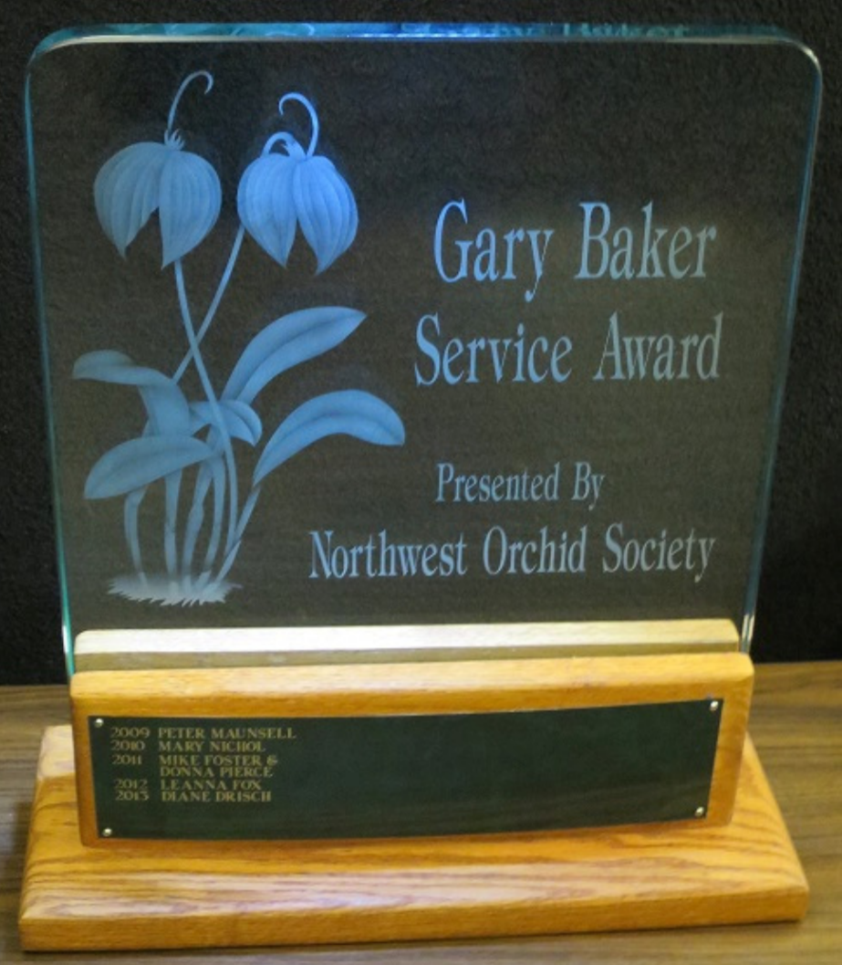
At this time the society solicits nominations from the general membership. If you have someone that you would like to nominate for service during the past year, please fill out one of the following forms and return it to Ben Johnson via email.

Gary Baker Service Award - Nomination Form - Word
Gary Baker Service Award - Nomination Form - PDF

NWOS Library

If you'd like to check out a book or tape from our Library, please contact our Librarian Joe Grienauer a minimum of 2 weeks before the next meeting. Besides email, you can give Joe your request at any meeting. For a list of library items please click here NWOS Library.

NWOS Flower & Garden Festival Pre-Sale

Sunday February 6th through Saturday February the 12th.

This year the society is giving people the opportunity to purchase the plants used for staging in the Flower and Garden Festival through a pre-sales prior to them going up for auction or for sale at the Mt Baker show. Individuals that volunteer for teardown at the festival on Sunday February the 13th and have their paid invoices with them will be able to select their plants individually. Individuals that do not volunteer will have their plants selected for them and they can pick them up at one of three collection points (North Seattle, Tacoma, Tri-Cities) or be held till the March meeting.

The sales are on a first come first serve basis. To order, send your request to sales@nwos.org.

Visit the NWOS Website for more details.

Volunteer Opportunities

There are lots of choices for participating and helping our society utilizing different skills, interests and available time.

- Potting Clinic Volunteers - We need volunteers for the potting clinic Saturday March 19th at Volunteer Park from 11AM to 2PM. If you are interested in helping please send an email to, volunteers@nwos.org
- Plant Table Photos - We need someone that will take photos of all the plants on the plant table along with their names and collect the sheets and then pass that along to the Communications Committee for the Newsletter and the website.
- Photos in General - We need everyone to send in your photos of events, it’s a lot more enjoyable if there are pictures of what was happening when we are all together, so send them in, photos@nwos.org.
- Scholarship Committee - We need a couple of volunteers to help Kathy Murray review the scholarship criteria. See the writeup below.
- Website Maintenance - We need someone that wants to help manage the society website. This includes building posts and pages in Wordpress, etc. There is plenty of love to go around with this one.

Formation of Scholarship Criteria Review Committee

The NWOS has offered scholarships to students in 2 and 4 year institutions, in the Pacific Northwest for orchid related research. Unfortunately, there have been declining research proposals and a failure to complete the research in some cases.

Kathy Murray has been asked by The Board to form a committee to review the processes and criteria for granting our annual scholarships. The purpose of this is to reimagine what can be done with this scholarship.

This is your opportunity to help shape research in a field for a hobby that we are all so passionate about.

Kathy needs at least two volunteers to help shape that vision and provide recommendations to The Board. Please reach out to Kathy Murray, the NWOS Scholarship Chair, at her email address: Riverhaven203@gmail.com

Growing Orchids Without Pots
By Steve Dorsey, Stevertd2010@gmail.com

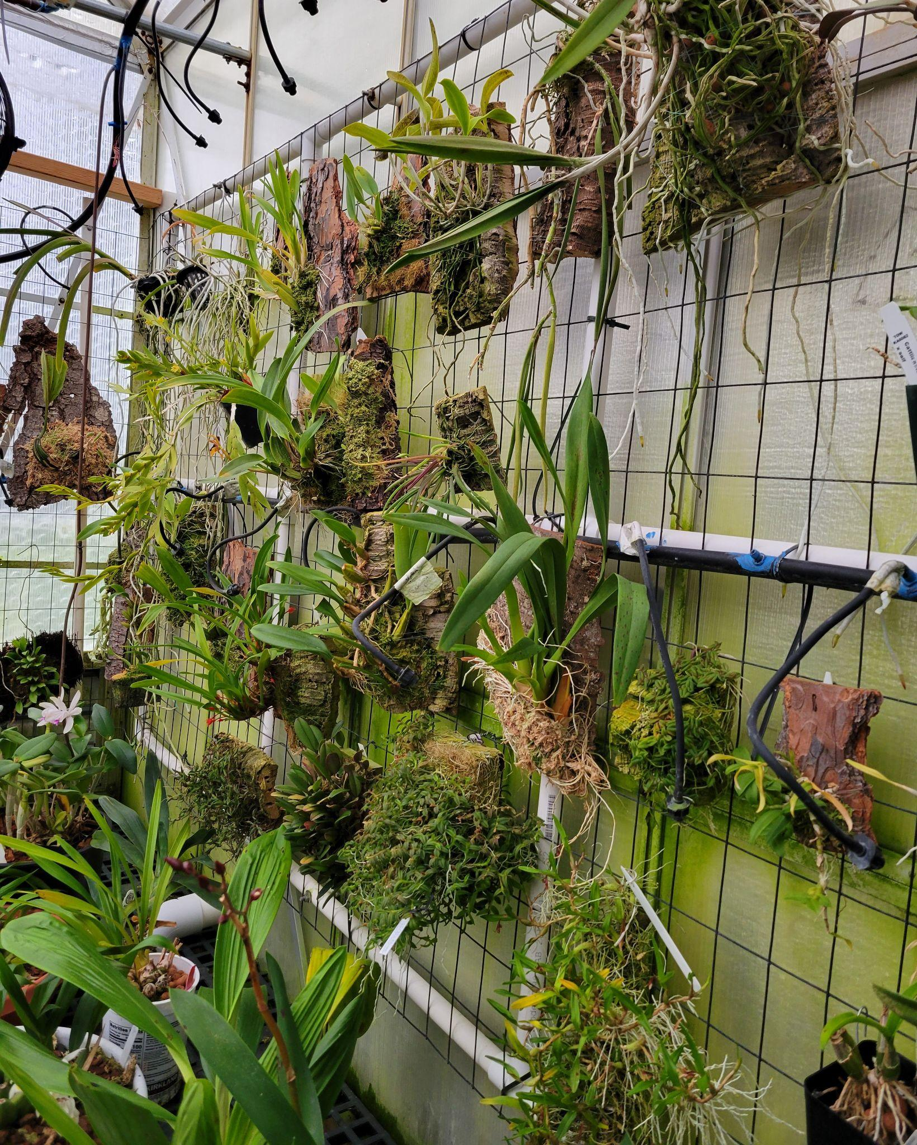

It’s a Jungle Out There

Spring Is Not In The Air

It’s still winter in Seattle and I would assume most people are not thinking of repotting their plants. The days are dark and the feeling of being engaged with spring activities seems far in the future. However, in my daily forays into my greenhouse, many of my plants are showing their anxious desire to get actively growing again. New roots are forming on many of my Cattleya in advance of the new growth soon to begin. The jungle will explode before you know it and everyone will be crying out for attention.

Time to Plan

NWOS has their potting clinic coming next month at the Conservatory. Now is the time to start planning your strategy of dealing with plants that have come to the end of their stay in the pots you purchased them in. Some will be fine remaining in the potted system, but this may be the time to consider those that would be better place on vertical piece of real estate instead.

It’s Only Natural

For epiphytes, resting and attaching to a tree is just par for the course and their natural habitat. If you grow Phalaenopsis for more than a year, you will see them exploring for new surfaces as their roots crawl out of the pot. While pots provide a convenient mode of growing orchids, it is definitely not their normal pattern.

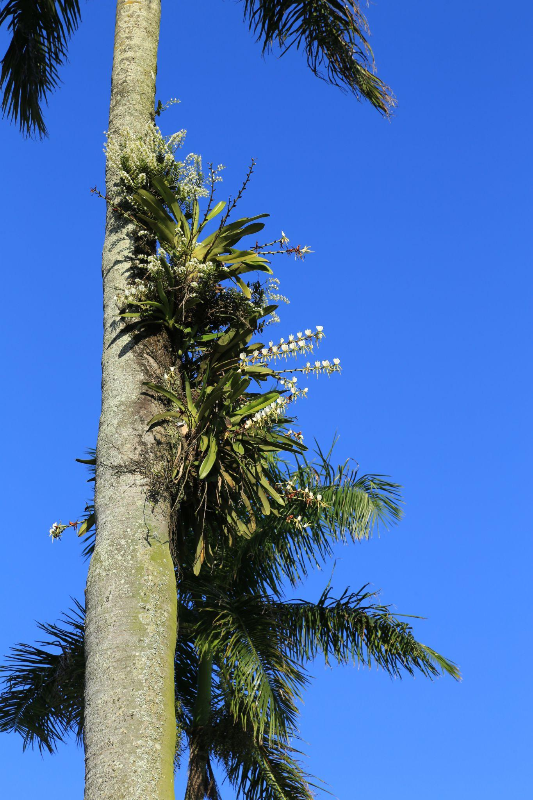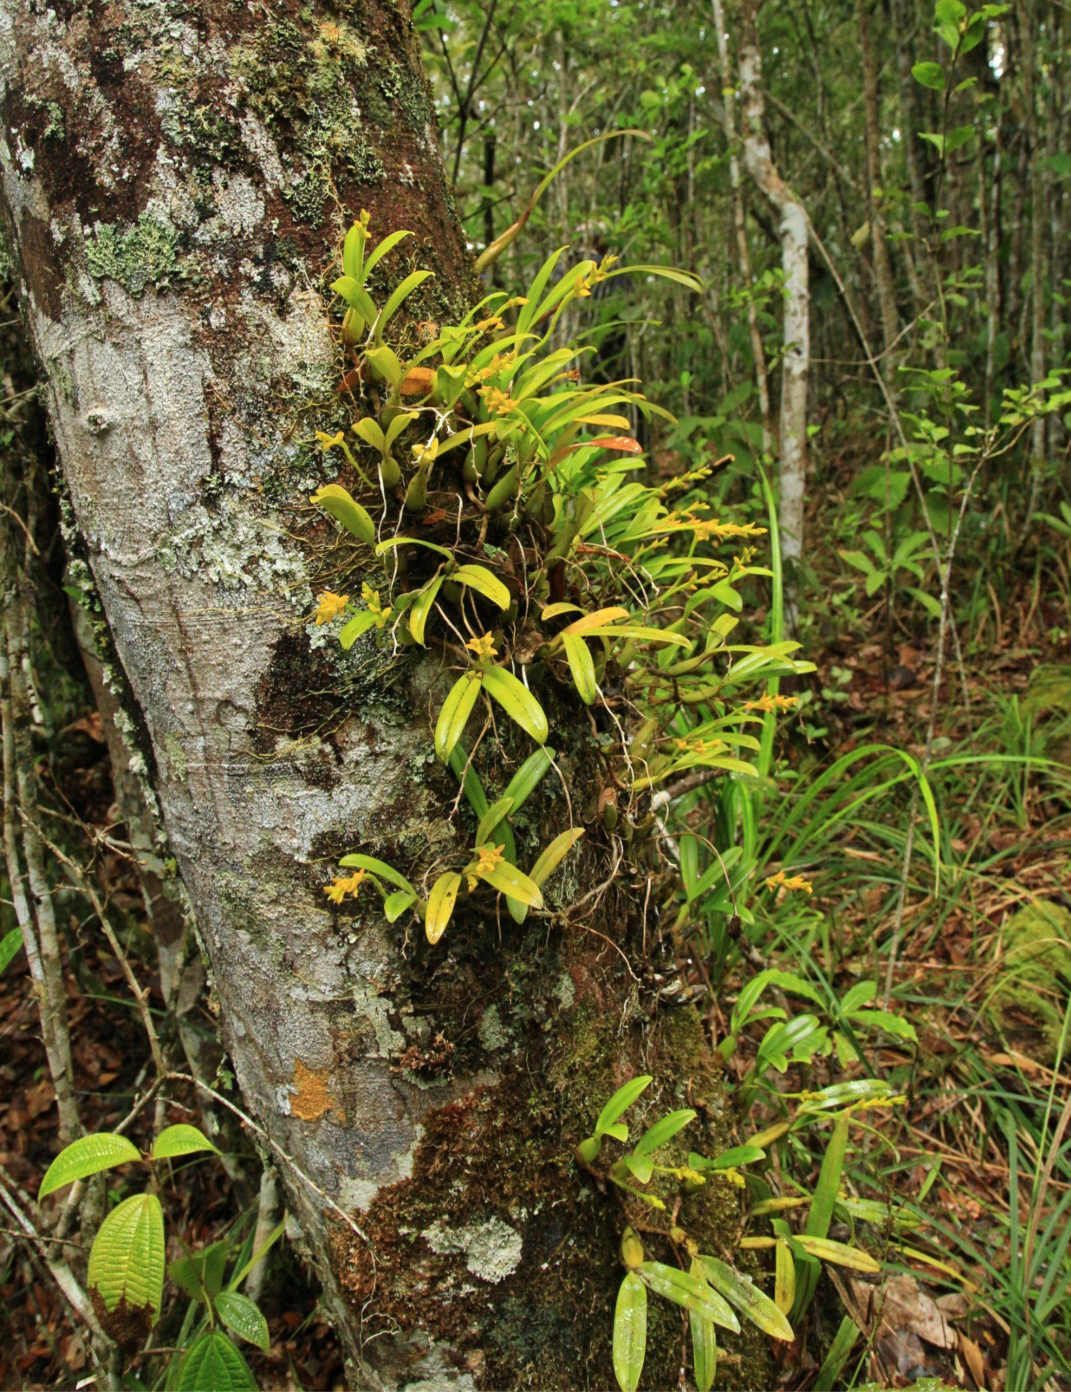
Angraecum and Oeoniella growing on a palm tree in Madagascar
Bulbophyllum growing on the side of a tree

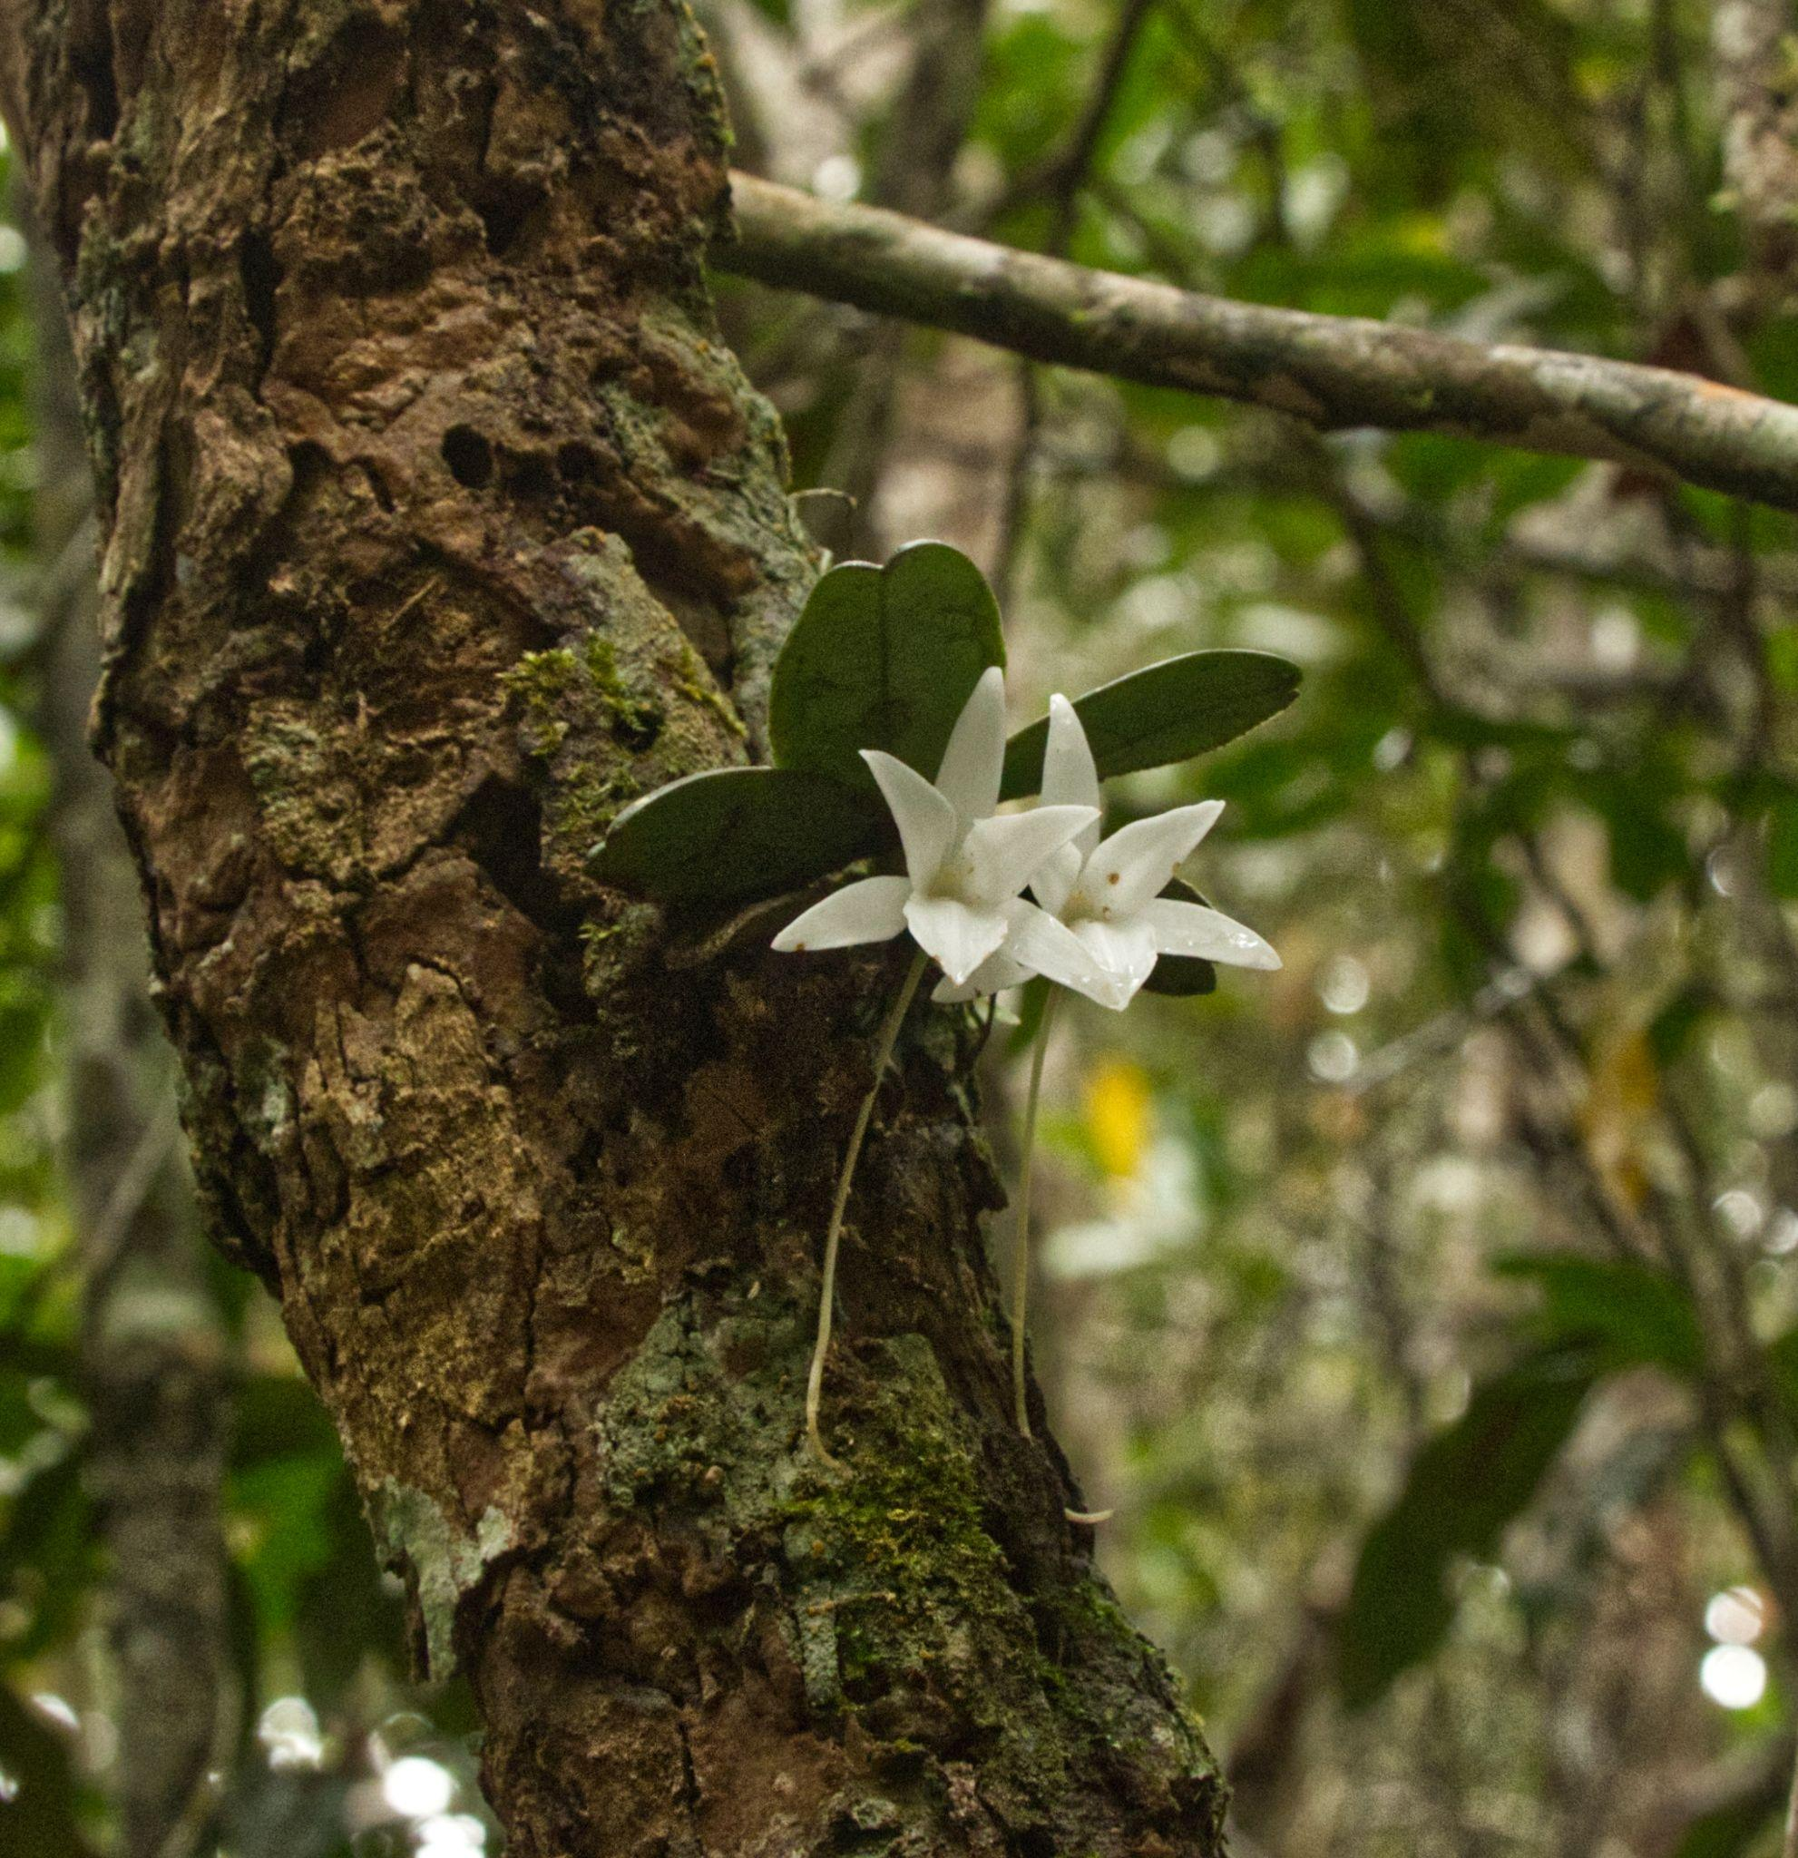
Aeranthes on a tree trunk
Getting Started

Growing orchids mounted may be referred to as growing on plaques, mounts, slabs, and rafts. It isn’t complicated and one of the easiest ways of growing. Like all orchids, timing is important as you want to do any readjustments of the plant when the new roots are starting to form. Moving a plant after the roots have developed will damage the roots and may set the plant back considerably or even lead to its death. As I said, I have many plants starting up for the season now, so keep an eye on your plants.

As with any growth medium or environment, it is important to secure the plant to the mount well. Any wobble of the base is sure to be a problem. I typically use an old fishing line (about 6 to 10 lb monofilament) to secure the plant to the plaque. There are many possibilities of substrate to choose from. Traditionally people have used cork bark which is very nice, but sometimes expensive or difficult to obtain the amount you want. I have received some mounted on pine bark and have used it with success. Other bark can be fine also, along with tree fern fiber slabs, osmunda chunks, and even a synthetic product named Epiweb. The goal is to have a long lasting material that won’t deteriorate quickly. I have used limbs even as shown on this Sophronitis.

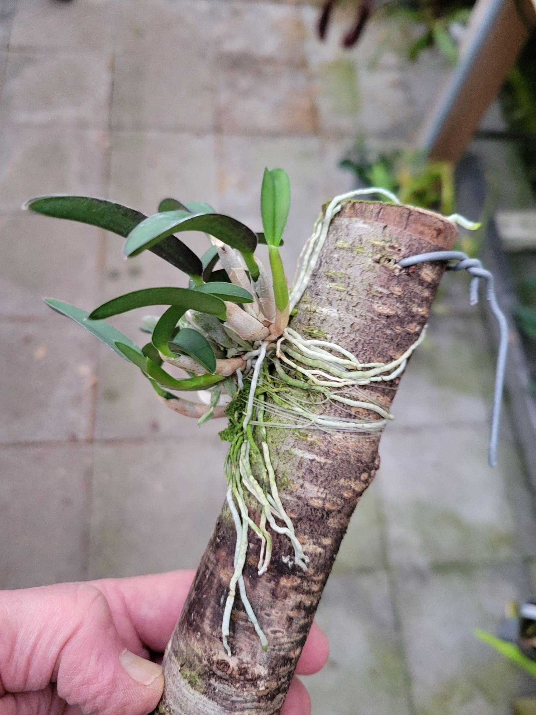
Sophronitis growing on tree limb
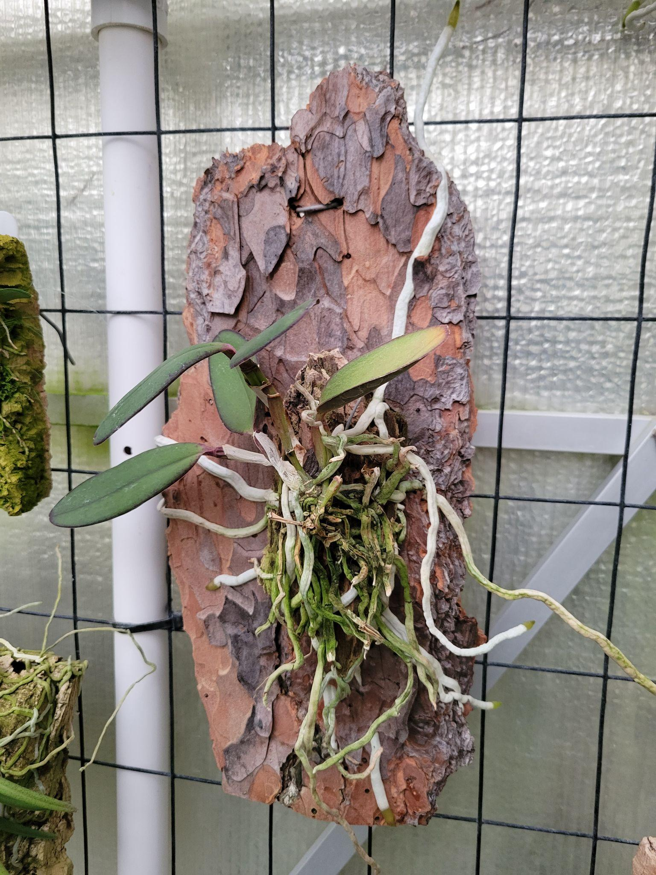
Cattleya schilleriana growing on pine bark
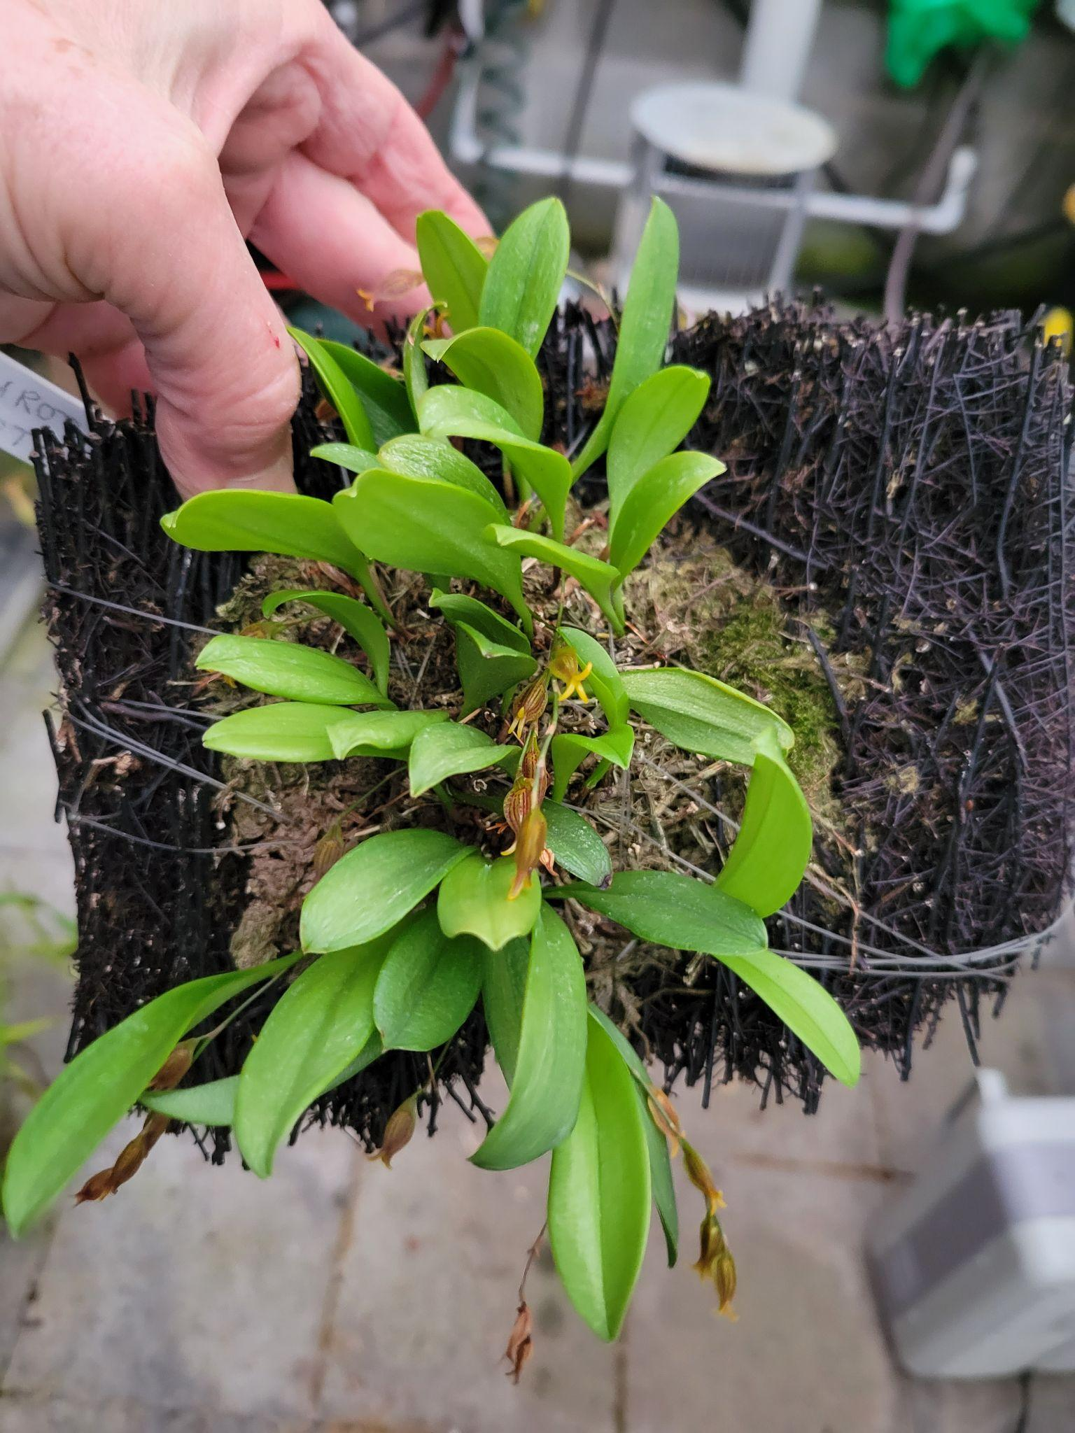Pleurothallid growing on osmunda fiber slab. Note fishing line holding the plant while adapting
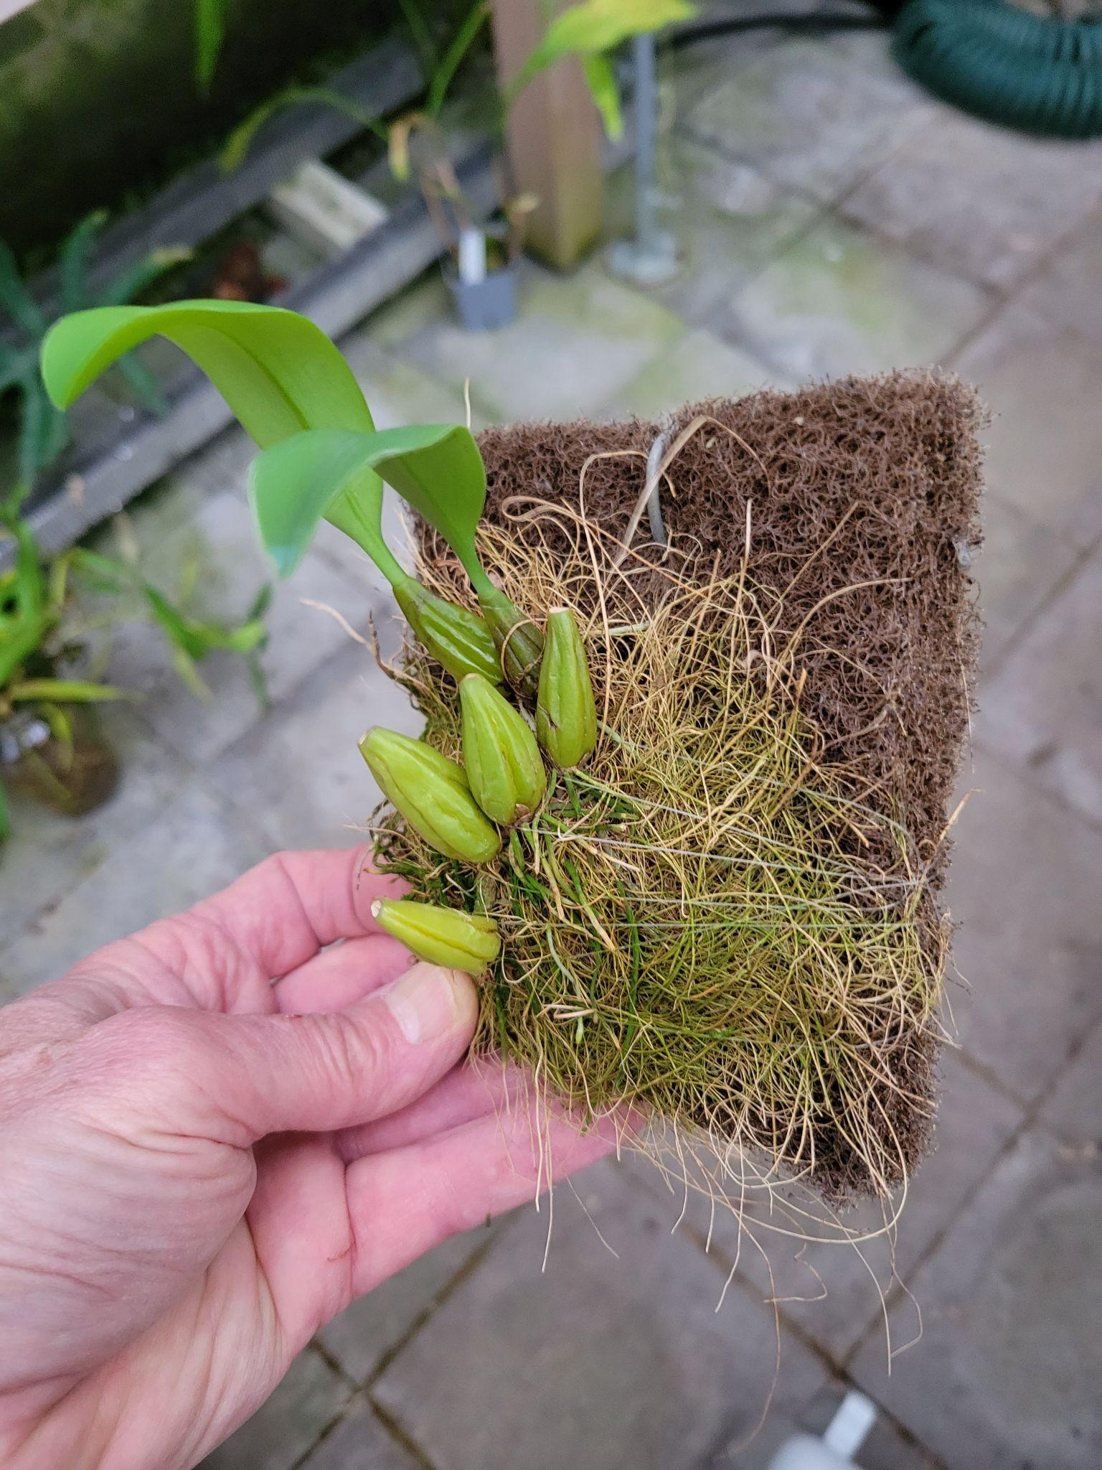
Bulbophyllum growing on Epiweb mount

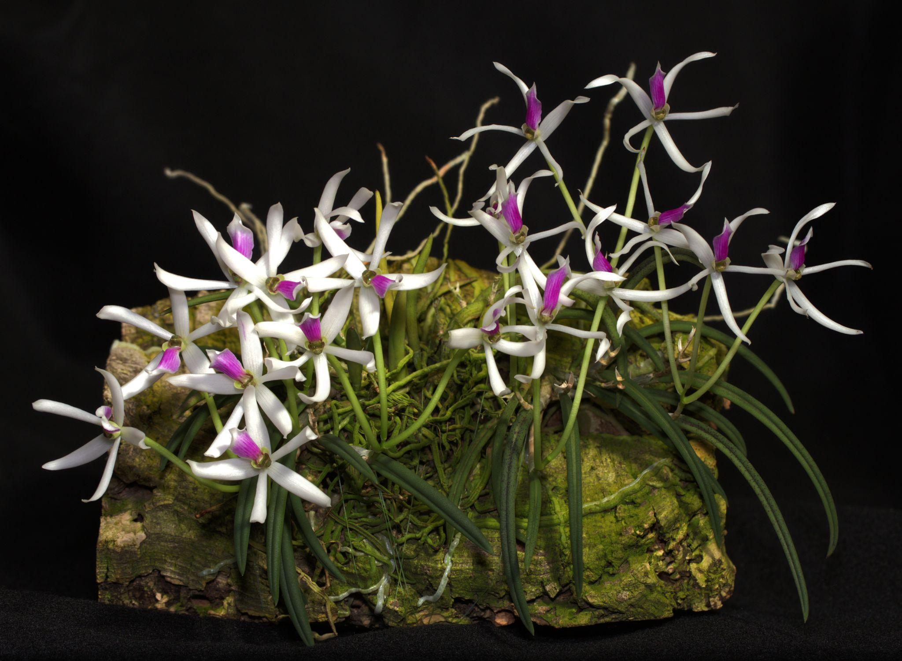
Leptotes bicolor growing on traditional cork bark mount
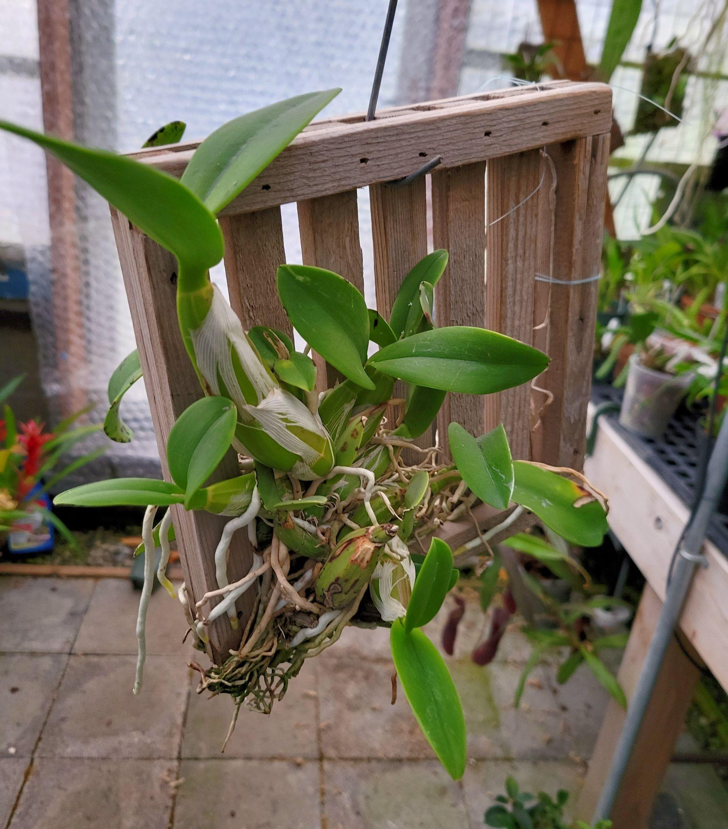
Even slats of wood to support can work

Once the plants have been attached to their new home, they will attach the new roots to the mount. This is a process known as thigmotropism. You have seen this with vines that adapt to the limbs they attach as the tendrils wrap around the structure available. The roots are seeking support for the plant and after they grow a bit, the fishing line can be removed and the plant will remain stable.

I have collected and successfully used bark from trees in Washington state, but I do treat them with pesticide and a sanitizer such as Physan 20 before doing so. You should always clean and disinfect any growing pot or mount before using. I would advise against using any wood from the coast or salt water areas as the salt will be detrimental for any plant and difficult to remove.

Care and Culture tips

One of the things I like about growing on mounts is the ease of which it is to know when to water. As they do in their native setting, they dry out more quickly. It is very difficult to over water a mounted orchid. I have fewer issues with disease than with potted plants. But you do have to water more frequently. Indoor growers may have to provide humidity by grouping plants or using a humidifier in the vicinity of the plants. But I have done so with a rolling rack which I used for potted plants additionally. I put boot trays under to deal with water or overspray when I misted the plants. I fertilize at a very weak rate and this allows for a constant amount of low intensity so that the plants can absorb what they need without burning them. I don’t have to worry about remembering how often I fed them.

Perhaps you will see some plants that always crawl out of their pots in a vertical fashion. These might be ones to consider mounting. Look at the pattern of growth and let that guide you for what would be their best media to be in or on. So let your concerns of trying something new take a rest and go for the wild side of orchid growing. After all, it’s natural!

Happy growing!

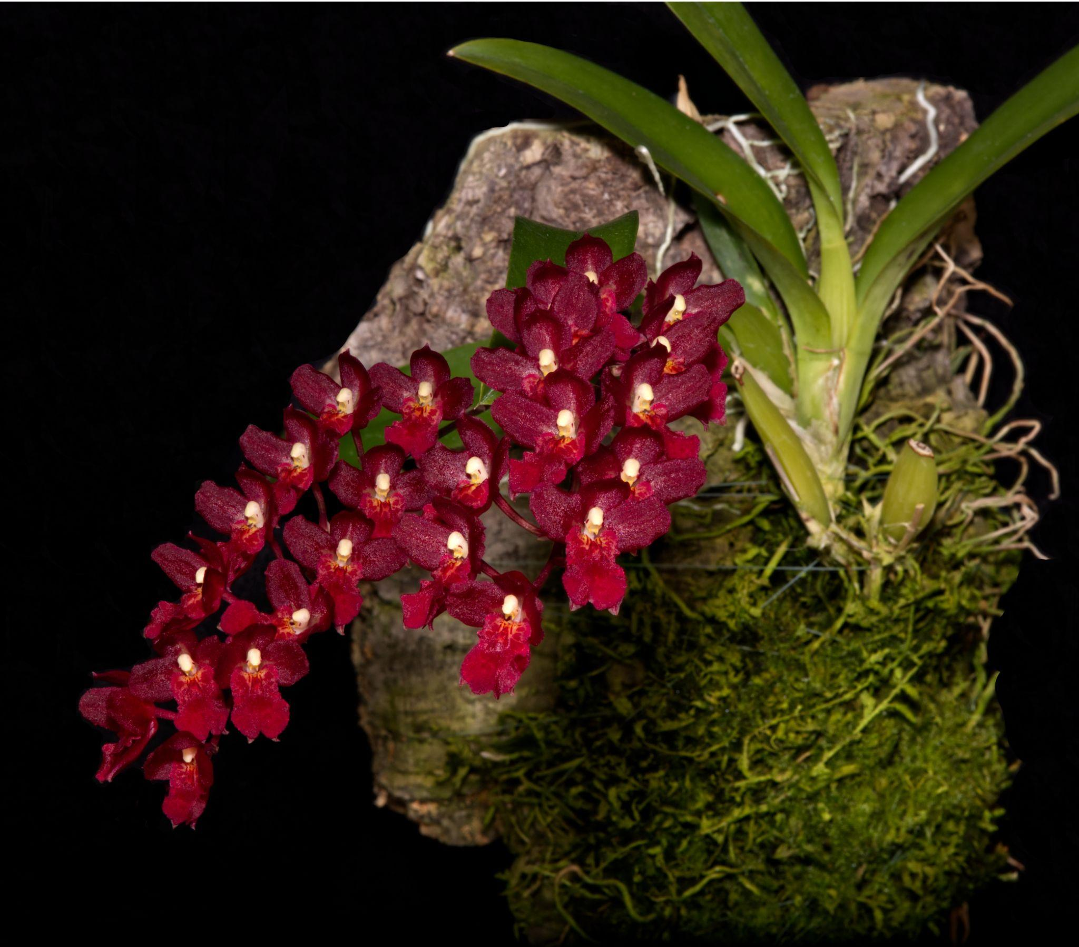
Howeara Lava Burst ‘Puanani’ AM/AOS

An Early History of The Northwest Orchid Society

~ Original author unknown, data entry by Joff Morgan

The following text came from the "Seventeenth Annual Spring Orchid Show" brochure. The Show was held at Washington Mutual Saving Bank, 2nd & Spring, March 8-10, 1965. The article is entitled “Fifteen Years of Progression”.

"The Northwest Orchid Society was founded in 1947 on the groundwork laid by the Puget Sound Orchid Society, formed a few years earlier. Mr. Thomas C. Kirkwood had moved into this area from California, bringing a fairly large greenhouse, a stock of orchid plants and a wealth of knowledge in the growing of orchids. He was the "spark plug" in the formation of the new society. To Mr. Kirkwood is due the credit for fostering orchid growing among amateurs in Washington.

For the first seventeen months the Northwest Orchid Society meetings were held at intervals; however, two successful orchid shows under the sponsorship of the Orthopedic Guild were held at the Olympic Hotel during this period.

The Northwest Orchid Society became affiliated with the American Orchid Society in February, 1949. In the summer of 1949, several prominent members decided the infant society was ready to stand on its feet and should be fully organized with by-laws, duly elected officers, and a permanent meeting place and date. The recommendations of this group were presented to the membership and approved. In the fall of 1949, the Northwest Orchid Society was underway."

This was a year of pioneering -- the objectives being to attain a membership of 100, starting a society library and the issuance of a society bulletin. The first editor was Mr. D. J. Torrance.

With the original objectives attained, the society felt it was capable of sponsoring a show on its own and in March, 1950, the Third Annual Spring Orchid Show was held in the auditorium of the P. I. Building. This undertaking entailed much effort, but with the cooperation of an enthusiastic membership, the show was a success both from attendance and financial standpoints. Exhibits were received from Massachusetts, Tennessee, England and Thailand. This was the first show at which American Orchid Society award judging was held and two plants were awarded: C. Stalin ‘Ashcroft’ AM-AOS and Cym. Santa Barbara AM-AOS. These were the first Awards of Merit given in the Northwest.

Another notable event during the year was the donation of the Mr. W. J. Pilz orchid collection to the Seattle Park Department. The transaction was negotiated through the Northwest Orchid Society.

The first year ended with the annual dinner at the Rainier Club. It had been a year of hard work, but the dinner plant exhibit table gave a good indication of the quality and quantity of plants to be seen in the future.

During the ensuing five years, the society grew and prospered. Each year a successful show was held. The Puget Sound Orchid Society was merged with the Northwest Orchid Society in the Spring of 1952. In January, 1953, the Northwest Orchid Society affiliated with the Orchid Digest Corporation and in March, 1954, Mr. Joseph Peacock was elected Vice-President of that organization.

Perhaps the outstanding event in the history of the Northwest Orchid Society was the Fifth Annual Western Orchid Congress held September 1-4, 1956, in Seattle. The Congress was sponsored by the Orchid Digest Corporation with the Northwest Orchid Society as host. The American Orchid Society Board of Trustees was a guest of the Northwest Orchid Society and held its fall meeting while in Seattle attending the Congress. This was the first time an Orchid Congress had been held in the Pacific Northwest and delegates from 22 orchid societies west of the Mississippi attended. Some 250 registered for the Congress.

The Congress included an orchid show. There were many social events and the programs featured a series of lectures, forums and panels -- the moderators and speakers being prominent orchid authorities. The climax of the Congress was a boat trip to Kiana Lodge and a salmon barbeque. Those who attended this Congress still talk about the wonderful time they had in the Northwest.

1957 saw the establishment of Orchid Digest Regional Award Judging in the Northwest.

For the 1958 Spring Show, it was decided a change in location would be desirable and with civic thought in mind, the location was changed to the Seattle Art Museum with the Museum participating in the financial returns.

At the start of the fiscal year 1958, Ribbon Judging was initiated at the monthly meetings with a Hi-Scorer Trophy being awarded at the end of each quarter to the exhibitor having the most points in the Novice-Amateur and Private Grower classes. This innovation greatly increased the quality and quantity of plants brought to the monthly exhibit table.

1959 was “ladies year.” All of the officers and a number of the Trustees elected this year were women members of the society. Mr. G. Ferguson Beall and Dr. Jackson K. Holloway, charter members of the Northwest Orchid Society, were elected honorary Life Trustees.
Having served as Trustee and Executive Vice-President, Mr. G. Ferguson Beall was elected President of the American Orchid Society in May of 1960. The Northwest Orchid Society felt highly honored to have one of its members elected to this position and feted Mr. Beall with a dinner at the Sunset Club.

Again wishing to recognize services rendered, the society honored Mr. Joseph Peacock, a charter member, by electing him an Honorary Life Trustee in September, 1961.

After several years’ lapse, the Northwest Orchid Society Bulletin was again published under the editorship of Mr. E. K. Field.

With the ever-increasing number of orchid growers, the need for additional judging areas was necessary, resulting in Seattle being selected by the American Orchid Society as the Northwest Regional Judging area in April, 1964. Judging is held each month and growers from all over the world are privileged to send flowers here for judging.

Mr. William E. Farrell, having served as Vice-President of the Orchid Digest Corporation, was elected President in September, 1962. Again, the Northwest Orchid Society was honored by having the capabilities of one of its members recognized.

The following year an American Orchid Society Flower Evaluation Class was formed, the purpose being to instruct members to better evaluate blooms of both species and hybrids. In 1963 Mr. A. L Smith was appointed Chairman of Judging for Orchid Digest Corporation for seven regions which comprise all Orchid Digest affiliated societies west of the Mississippi. Again the Northwest Orchid Society received merited recognition.

April, 1964, in appreciation for many years of valued service to the society, Mr. and Mrs. D. J. Torrance were elected Honorary Life Trustees of the Northwest Orchid Society.

With the formulation of plans for the 1964 Spring Orchid Show, it was felt an address more centrally located would give the general public a better opportunity to view these lovely blooms; consequently, the 1964 Spring Orchid Show was held in the Main Office of Washington Mutual Savings Bank. The 1964 show being an outstanding success, it is being repeated again this year.

Looking back over the past fifteen years, the interest and growth in the hobby of orchid growing has been phenomenal and there is every indication that this interest will continue to grow.”

Report From The January Meeting

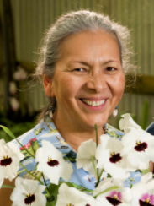
Our January meeting was held virtually via Zoom. President Steve Dorsey opened the meeting by welcoming folks who were joining us for the first time. George Grantham gave an update on our recent show and sale at the Volunteer Park Conservatory. Gordon Cromwell updated us about the upcoming NW Flower & Garden Festival and our plans for a garden which will include a real greenhouse.

Our speaker, Theresa Hill, reviewed Paphiopedlium charlesworthii. She covered its natural history, it’s cultivation as well as its multiple forms. Culture was covered along with the contributions this species provides in its hybrids.

Here are a couple of the color forms of Pahiopedium charlesworthii.

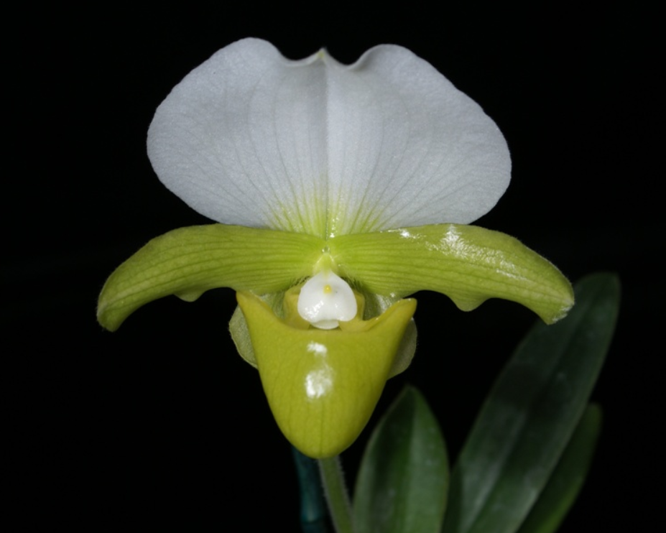

Paph charlesworthii ‘Anne’s Jewel’

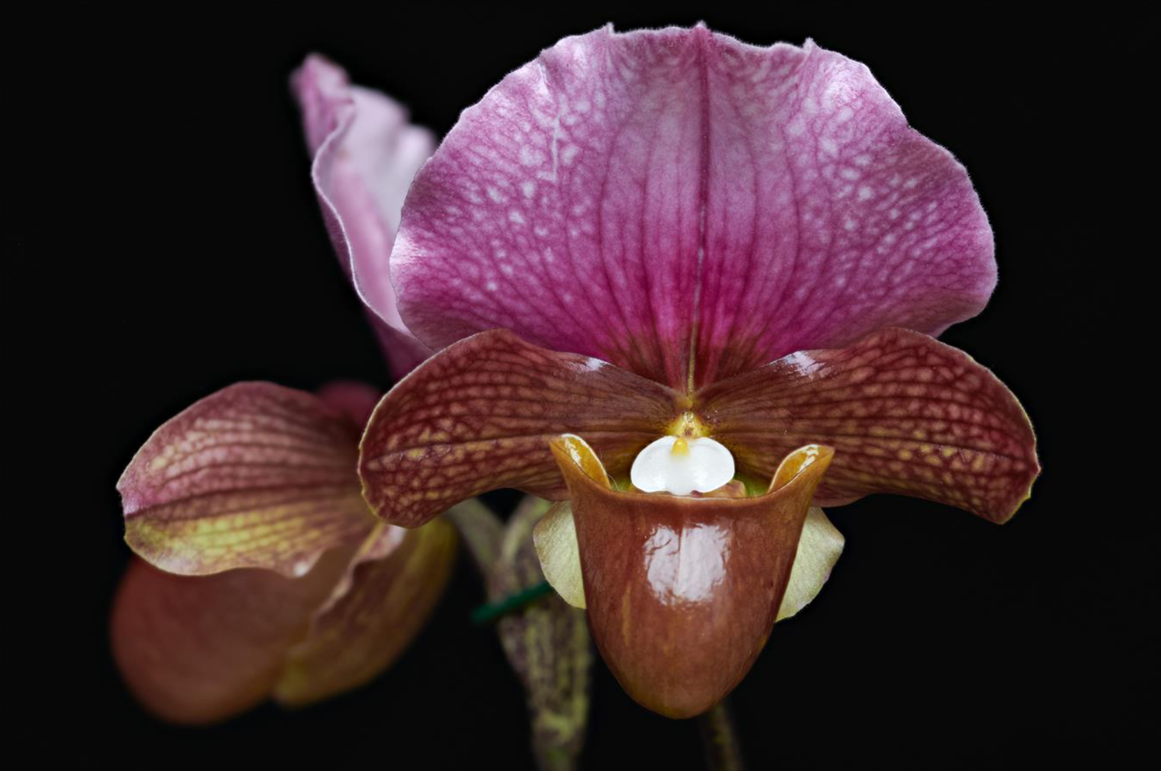

Paph charlesworthii ‘Dark Skies’

Robert Culver reviewed the virtual plant table.

These are several selected images from the January meeting. To see the rest of the photos of January's plant table, please follow the link to go to the online gallery.

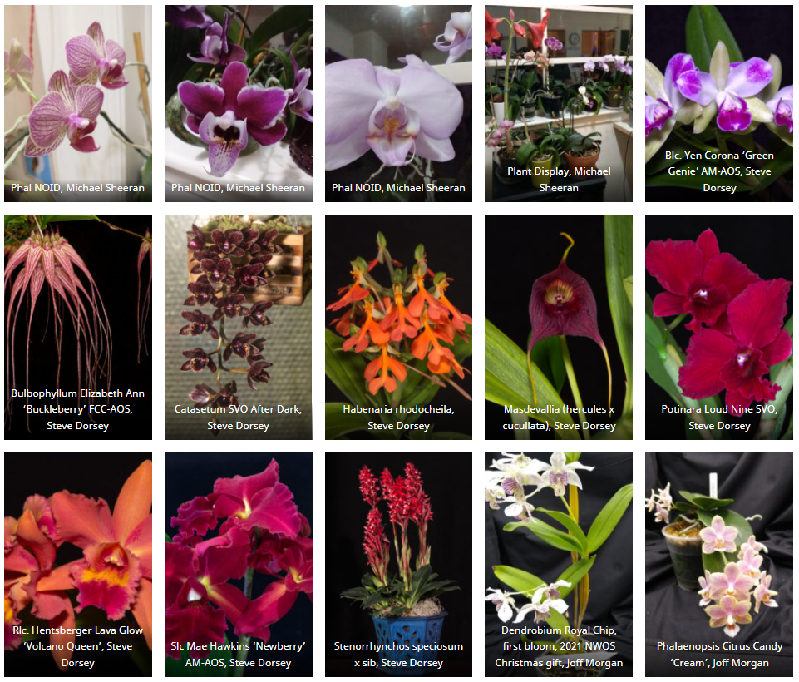
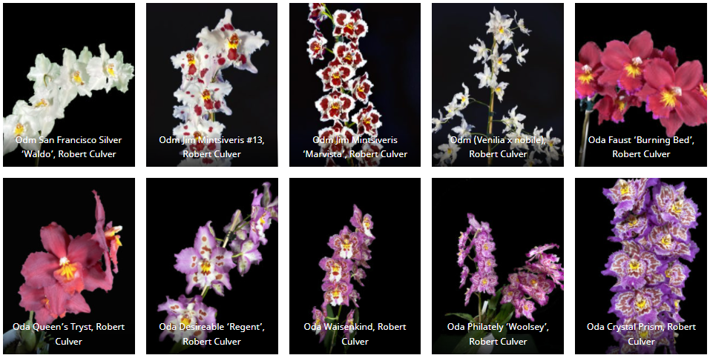

Schedule of Upcoming Events
02/14/22 – NWOS meeting - Culture Clinic
03/14/22 – NWOS meeting – Spring Auction
03/19/22 - Potting Clinic – 11AM to 2PM at the Volunteer Park Conservatory
04/11/22 – NWOS meeting – Speaker: Kelly McKracken, “Artificial Lighting”
05/09/22 – NWOS meeting – Speaker: Tyler Albrecht, “An Exploration of the Fluffy and Puffy Parvisepalum Paphiopedilums”
06/13/22 – NWOS meeting – June Potluck: The June Potluck is the last meeting before our summer break. Enjoy socializing during dinner. This is also the meeting where we present the Gary Baker service award. Additionally, we are offered a presentation by the past year’s scholarship recipient.
8/xx/22 - NWOS Summer Picnic: The NWOS will have a summer picnic for its members. Check back soon for the date.
09/12/22 – NWOS meeting – Speaker: Tom Ethridge, “Odontoglossums Then and Now, Has Anything Changed?”
09/30/22 – NWOS Annual show setup at the Volunteer Park Conservatory.
10/01-10/02/22 – NWOS Annual show and sale at the Volunteer Park Conservatory.
10/10/22 - NWOS meeting – TBA
11/14/22 - NWOS meeting – Speaker: Peter Lin, “Neofinetia and Its Hybrids”
12/12/22 – NWOS meeting – Speaker:TBA , Scholarship Recipient Report, introduction of new Officers, NWOS Annual Meeting report, Schoenfeld and Northen Orchid Awards, and Holiday Plant gifts.

Reminder for Officers & Board Members
The next board meeting is Tuesday, February 1st which will be at 7 p.m. and hosted over ZOOM. Check your email for the Zoom registration link and agenda. Future meetings are tentatively scheduled for March 1, May 3, September 6, and November 8th

Shopping on Amazon? Use this link to earn $$ for the NWOS

If you go to https://smile.amazon.com and sign in to your account, you'll be given information about supporting various non-profits. You can type in "Northwest Orchid Society" and it will then send .5% of your purchase price to the organization.

It's really easy, but you have to remember to go in through the 'smile' subdomain when you place the order, otherwise it will go through as a regular order.

NWOS Website Links

- Main website: Http://www.nwos.org
- Events Calendar: http://www.nwos.org/events
- Membership (including renewals): https://nwos.org/Membership/
- Newsletter - Current Issues: https://nwos.org/newsletters/
- Newsletter - Archived Issues: http://newsletter.nwos.org
- Show Information: http://nwos.orchid-society.net/ShowTime/Show2021/Show.html
- Facebook: http://www.facebook.com/nworchidsociety
- Instagram: https://www.instagram.com/nworchidsociety/
- Twitter: https://twitter.com/nworchidsociety

©2022 Northwest Orchid Society - All Rights Reserved

The opinions and recommendations published herein are those of the authors. The Northwest Orchid Society disclaims responsibility for any losses or damages that may be attributed to the use or misuse of any material or any opinion published in these articles and on the website. This website and the photographs, articles and content are protected by copyright and no part of them may be reproduced or re-used without the permission of the author.

